

BRISBANE CITY COUNCIL
BRISBANE CITY COUNCIL LOCAL LAW (THE GABBA TRAFFIC AREA) 2000

Consolidated as at 19 February 2013

BRISBANE CITY COUNCIL
LOCAL LAW (THE GABBA TRAFFIC AREA) 2000

SUMMARY OF PROVISIONS

Section Page

PART 1—PRELIMINARY

1. Citation 2
2. Objects 2
3. Definitions 2

PART 2—AMENDMENT OF PARKING AND CONTROL OF TRAFFIC LOCAL LAW

4. Local law Amended 2
5. Amendment of Part 5, Section 2 2
6. Replacement of Schedule 1 to Part 5 2

PART 3—THE GABBA TRAFFIC AREA

7. Traffic area 4
8. Name of Traffic area 4

PART 4—REGULATION OF PARKING

9. Regulation of Parking 5
10. Commencement of Regulation of Parking 5

THE SCHEDULE
ENDNOTES

PART 1 - PRELIMINARY

Citation

1. This local law may be cited as Brisbane City Council Local Law (The Gabba Traffic Area) 2000.

Objects

2. The object of this local law is to provide for Council's regulation of parking by time in a particular part of the City (a "traffic area").

Definitions

3. (1) In this local law:-

“City” means the area comprised in the City of Brisbane under the City of Brisbane Act 1924;

“Council” means the Brisbane City Council;

“official traffic sign” has the meaning given to it in the Transport Operations (Road Use Management) Act 1995;

“park” has the meaning given to it in the Transport Operations (Road Use Management) Act 1995;

“traffic area” has the meaning given to it in the Transport Operations (Road Use Management) Act 1995.

PART 2—AMENDMENT OF PARKING AND CONTROL OF TRAFFIC LOCAL LAW

Local law Amended

4. This Part amends the Parking and Control of Traffic Local Law.

Amendment of Part 5, s.2(1)

5. (1) Section 2(1)—

omit—

‘ described in Schedule 1 to this Part’

insert—

‘the boundaries of which are defined by the black bordering indicated on the map in the Schedule’

Replacement of Schedule 1 to Part 5

6. Schedule 1—

omit, insert—
THE SCHEDULE

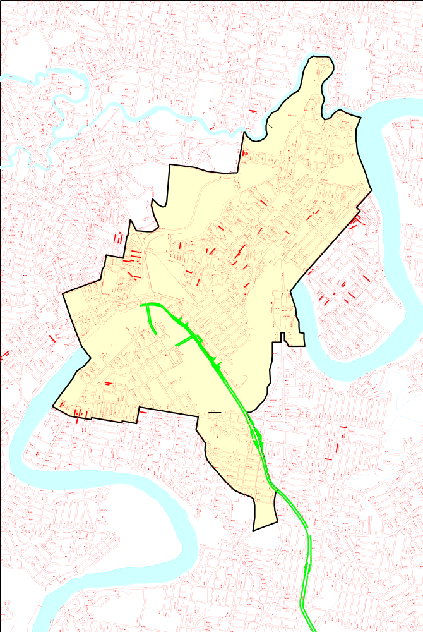

PART 3—THE GABBA TRAFFIC AREA

Traffic area

7. The part of the City the boundaries of which are defined by the black bordering indicated on the map in the Schedule is declared to be a traffic area.

Name of Traffic area

8. The traffic area declared under section 7 is named The Gabba Traffic Area.

PART 4—REGULATION OF PARKING

Regulation of Parking

9. Parking in The Gabba Traffic Area is allowed only for the maximum time specified on the official traffic signs mentioned in section 10 at the dates and times specified on those official traffic signs.

Infringement notice penalty – 0.75 penalty units.

Commencement of Regulation of Parking

10. The regulation of parking under section 9 commences on the day after official traffic signs indicating how parking is regulated under section 9 are installed by Council on the road at every road entry to The Gabba Traffic Area.
THE SCHEDULE

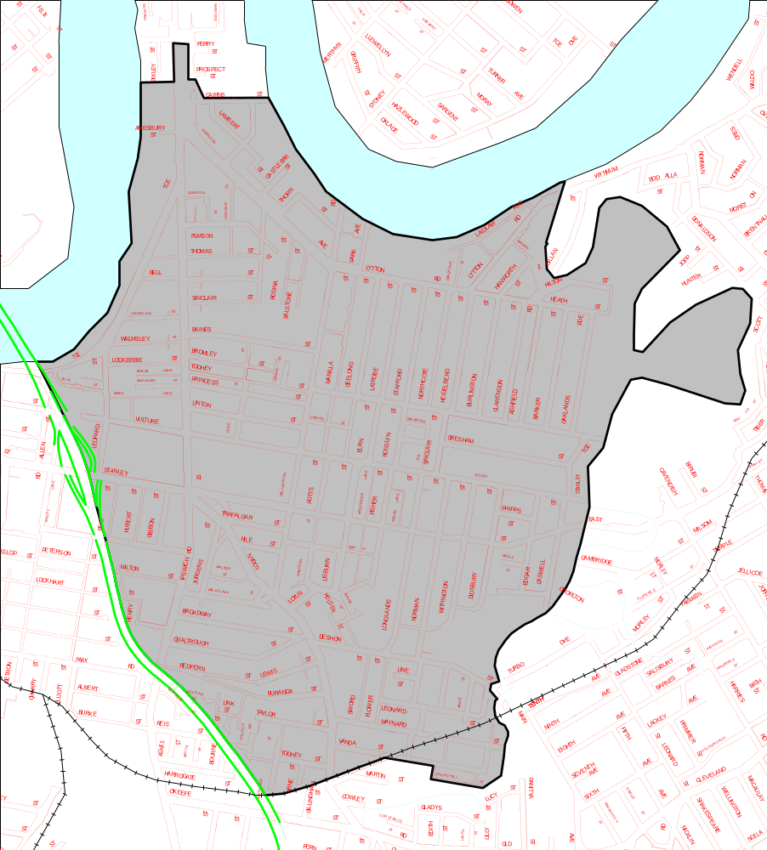

Endnotes

List of amendments

PART 4 REGULATION OF PARKING
s 9 amd Parking and Control of Traffic and other Local Laws Amending Local Law 2009 s 11; Administrative Arrangements Amending Local Law 2013 s 31

See section 108 of the Transport Operations (Road Use Management) Act 1995

