Brisbane City Council

Annual Operational Plan Progress and Quarterly Financial Report

September 2022

Table of Contents

Section 1 – Quarterly Financial Report 4
Financial results 5
Statement of comprehensive income 9
Statement of financial position 10
Statement of changes in equity 11
Statement of cash flows 12
Section 2 – Annual Operational Plan Progress Report 13
Program 1 – Transport for Brisbane 14
Program 2 – Infrastructure for Brisbane 16
Program 3 – Clean, Green and Sustainable City 18
Program 4 – Future Brisbane 21
Program 5 – Lifestyle and Community Services 23
Program 6 – City Standards, Community Health and Safety 26
Program 7 – Economic Development 28
Program 8 – City Governance 31
Businesses 34
Section 3 – Commercialised Businesses 36
Transport for Brisbane 37
City Parking 39

Overview and basis of preparation

This report has been prepared to meet the reporting requirements of the City of Brisbane Regulation 2012 (the Regulation) and relates to the 2022-23 financial year.

The First Budget Review figures have been used for the approved annual budget 2022-23.

Amounts included in this report are rounded to the nearest thousand ($000) or millions ($m) unless otherwise stated. Amounts may not add to the correct subtotals or totals due to rounding.

Section 1 – Quarterly Financial Report

The Quarterly Financial Report represents a special purpose financial report prepared specifically to meet the requirements of the Regulation and are not required to be audited. This report includes the statements of comprehensive income, financial position, changes in equity and cash flows for the period ended September 2022. The recognition and measurement requirements of the Australian Accounting Standards have been applied in preparing the quarterly financial report. For a summary of significant accounting policies used, refer to the notes to Council’s general purpose financial statements for the year ended 30 June 2022.

Section 2 – Annual Operational Plan Progress Report

The Annual Operational Plan progress report is a written assessment of Council’s progress towards implementing the 2022-23 Annual Operational Plan. Council’s operations are focussed on achieving the strategic directions through the Annual Plan, delivered via the projects and services of Council’s programs and business units.

This section includes the financial results at the program and business level in relation to the annual budget. This also reports on highlights and significant updates for each program and business during the period.

Section 3 – Commercialised Businesses

This section provides the Annual Performance Plan report for Council’s commercialised business units including Transport for Brisbane and City Parking. Transport for Brisbane commercial business include the activities in the Transport for Brisbane business unit and the activities in Transport for Brisbane and other programs in Section 2. City Parking forms part of the Infrastructure for Brisbane program in Section 2. In accordance with the Regulation, the progress of these commercialised business activities against the Annual Plan is reported in this section.

Section 1 – Quarterly Financial Report

Financial results

Council’s unaudited financial report for the period ended September 2022 is shown on pages 9 to 12.

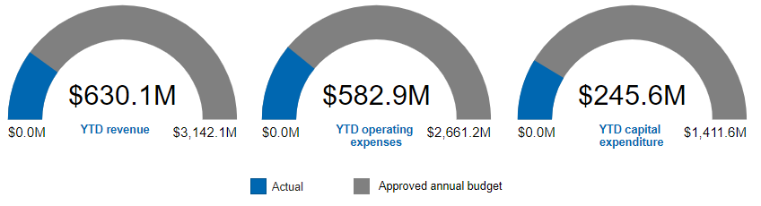

Revenue

Council’s revenue is below budget during the period mainly due to:
Rephased grants and subsidies relating to the South East Queensland rainfall and flooding event 2022 (SEQRFE 2022). This will continue to be monitored throughout the year.
Partly offset by earlier than anticipated grants and subsidies revenue mainly relating to the Urban Congestion Fund and higher than anticipated grants and subsidies relating to the Boosting Apprenticeship Commencements program in the Transport for Brisbane commercial business. These are expected to be adjusted in the next budget review or materially align with the annual budget at the end of the financial year.
Rephased fees and charges for development assessment and building applications fees and fees and charges mainly relating to parking infringements. This will continue to be monitored throughout the year and be adjusted in a future budget review if required.
Partly offset by higher than anticipated other revenue, mainly relating to external demand for asphalt and quarry sales. This is expected to materially align with the annual budget at the end of the financial year.

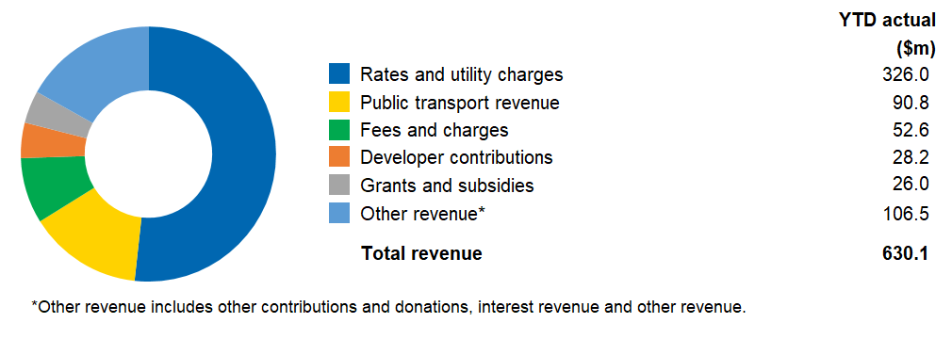

Operating expenses

Council’s operating expenses are below budget mainly due to:
Rephased expenditure in the City Governance program, mainly relating to the phasing of corporate cost allocations to projects. This is expected to materially align with the annual budget at the end of the financial year.
Rephased expenditure in the Infrastructure for Brisbane program, mainly relating to asset depreciation and loss on disposal expense. This is expected to materially align with the annual budget at the end of the financial year.
Rephased expenditure in the Future Brisbane program, relating to the Future Development Services Enablement Project and development assessment and regulatory activities. This will continue to be monitored throughout the year.
Partly offset by increased production in the City Standards business to meet higher than anticipated external demand for asphalt and quarry sales. This is expected to be adjusted in the next budget review.

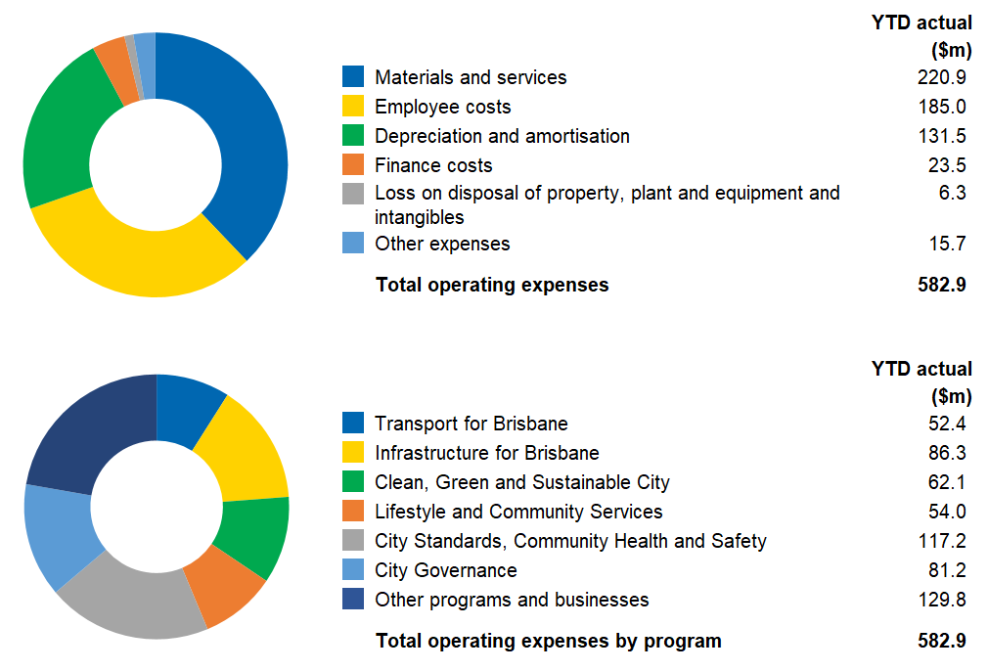

Capital expenditure

Council’s capital expenditure is below budget during the period mainly due to:
Rephased expenditure in the Transport for Brisbane program, mainly relating to the Brisbane Metro and Green Bridges Program. These are expected to materially align with the annual budget at the end of the financial year.
Partly offset by accelerated expenditure in the Infrastructure for Brisbane program, mainly relating to projects including Roads Network Resurfacing, Rochedale Road and Priestdale Road, Major Traffic Improvements – Intersections, Traffic Signals Hardware Equipment, Moggill Road Corridor Upgrade, Beams Road and Gresham Street Bridge. These are expected to materially align with the annual budget by the end of the financial year.

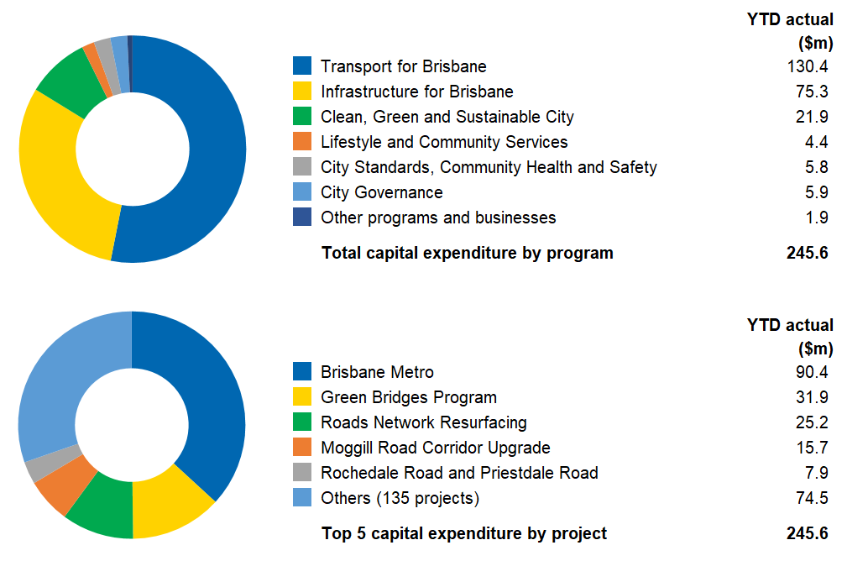

Financial position overview

Council’s net assets increased by $41.5 million compared to June 2022, mainly in accumulated surplus as a result of an increase in operating capability for the period. Refer to statement of financial position on page 10.

Measures of financial sustainability

Financial ratios provide Council with insights about its liquidity, operational efficiency and financial sustainability. The financial ratios for the period are as follows:

 | Actual* | Budget#
Operating surplus ratio  Measures the extent to which operating revenue raised covers operational expenses only or are available for capital funding purposes or other purposes. | 1.04% | -3.23%
Cash cover ratio  Measures the extent to which available cash covers operational cash expenses. | 7.5 | 6.0
Leverage ratio  Measures the extent to which Council is utilising debt borrowings. | 6.6 | 6.1
Debt per capita  Measures Council’s debt relative to population. | $2,279 | $2,453
*The actual ratios for the period are annualised to be comparable to the annual budget ratios.
#Approved annual budget 2022-23.

The above ratios exclude the impact of service concession arrangements. Council's budget ratios result from Council’s anticipated operational and capital activities to implement the Annual Plan.

The operating surplus ratio is above budget mainly due to the higher operating revenue compared to operating expenses for the period.

Statement of comprehensive income

For the period ended  September 2022 | YTD actual | Approved annual budget  2022-23 | YTD actual September 2021
 | $000 | $000 | $000
Revenue
Rates and utility charges | 337,591 | 1,363,739 | 320,833
Less discounts and rebates | (11,601) | (44,752) | (11,995)
 | 325,990 | 1,318,987 | 308,838
Grants and subsidies | 25,996 | 453,943 | 20,797
Developer contributions | 28,232 | 280,739 | 28,088
Other contributions and donations | 1,592 | 10,299 | (34)
Fees and charges | 52,609 | 240,190 | 48,820
Public transport revenue | 90,833 | 372,964 | 90,903
Interest revenue | 4,624 | 4,099 | 852
Other revenue | 100,263 | 460,888 | 106,514
 | 304,149 | 1,823,122 | 295,940
 | 630,139 | 3,142,109 | 604,778
Expenses
Employee costs | 185,043 | 827,686 | 172,811
Materials and services | 220,891 | 1,051,181 | 191,628
Depreciation and amortisation | 131,463 | 555,614 | 136,456
Finance costs | 23,500 | 102,032 | 21,439
Loss on disposal of property, plant and equipment and intangibles | 6,340 | 57,700 | 2,667
Capital grant expenses* | - | 15,627 | -
Other expenses | 15,684 | 51,318 | 13,828
 | 582,921 | 2,661,158 | 538,829
Increase in operating capability | 47,218 | 480,951 | 65,949
Other comprehensive income
Items that will not be reclassified to operating capability
Increase (decrease) in asset revaluation surplus | (4,830) | 466,129 | (1,501)
Movements in cash flow and cost of hedging reserves | (900) | 8,159 | 1,442
 | (5,730) | 474,288 | (59)
Total comprehensive income | 41,489 | 955,239 | 65,890
*Transfer of Brisbane Metro assets to the Queensland Government.

Statement of financial position

As at  23 September 2022 | Actual | Approved  annual budget  2022-23 | Actual  June 2022
 | $000 | $000 | $000
Assets
Current assets
Cash and cash equivalents | 645,520 | 350,851 | 529,013
Receivables | 86,963 | 84,505 | 152,182
Inventories | 19,043 | 19,841 | 19,137
Other | 140,782 | 120,171 | 153,585
Assets classified as held for sale | 2,817 | - | 2,817
 | 895,125 | 575,368 | 856,733
Non-current assets
Investment in associate | 2,158,143 | 2,158,143 | 2,158,143
Other investments | 201,223 | 202,043 | 201,305
Derivative financial instruments | 5,050 | - | 5,949
Property, plant and equipment | 29,420,068 | 30,815,016 | 29,285,413
Intangibles | 162,780 | 143,329 | 168,586
Lease right of use assets | 417,503 | 385,783 | 433,668
Superannuation defined benefit plan | 21,086 | 21,086 | 21,086
 | 32,385,853 | 33,725,400 | 32,274,150
Total assets | 33,280,978 | 34,300,768 | 33,130,883
Liabilities
Current liabilities
Payables | 434,886 | 421,783 | 305,264
Other financial liabilities | 88,315 | 103,509 | 88,315
Lease liabilities | 82,663 | 88,718 | 82,596
Provisions | 232,347 | 227,146 | 235,526
Service concession liabilities | 59,595 | 60,147 | 59,595
Other | 161,653 | 121,081 | 121,081
 | 1,059,459 | 1,022,384 | 892,377
Non-current liabilities
Payables | 4,739 | 7,713 | 7,713
Other financial liabilities | 2,290,241 | 2,533,235 | 2,312,511
Lease liabilities | 458,389 | 417,196 | 476,223
Provisions | 131,594 | 143,131 | 131,593
Service concession liabilities | 1,681,393 | 1,648,608 | 1,696,292
Other | 131,492 | 91,080 | 131,992
 | 4,697,848 | 4,840,963 | 4,756,324
Total liabilities | 5,757,307 | 5,863,347 | 5,648,701
Net community assets | 27,523,671 | 28,437,421 | 27,482,182
Community equity
Asset revaluation surplus | 13,942,577 | 14,413,536 | 13,947,407
Cash flow and cost of hedging reserves | (9,059) | - | (8,160)
Accumulated surplus | 13,590,153 | 14,023,885 | 13,542,935
Total community equity | 27,523,671 | 28,437,421 | 27,482,182

Statement of changes in equity

For the period ended  September 2022 | Total | Asset  revaluation  surplus | Cash flow and cost of hedging reserves | Accumulated surplus
 | $000 | $000 | $000 | $000
Balance at beginning of year | 27,482,182 | 13,947,407 | (8,160) | 13,542,935
Increase in operating capability | 47,218 | - | - | 47,218
Other comprehensive income | (5,729) | (4,830) | (899) | -
Balance at period end | 27,523,671 | 13,942,577 | (9,059) | 13,590,153
For the approved annual budget  June 2023 | Total | Asset  revaluation  surplus | Cash flow and cost of hedging reserves | Accumulated surplus
 | $000 | $000 | $000 | $000
Balance at beginning of year | 27,482,182 | 13,947,407 | (8,159) | 13,542,934
Increase in operating capability | 480,951 | - | - | 480,951
Other comprehensive income | 474,288 | 466,129 | 8,159 | -
Balance at period end | 28,437,421 | 14,413,536 | - | 14,023,885

Statement of cash flows

For the period ended  September 2022 | YTD actual | Approved annual budget  2022-23 | YTD actual September 2021
 | $000 | $000 | $000
Cash flows from operating activities
Receipts
Rates and utility charges | 367,124 | 1,317,258 | 342,329
Fees and charges | 43,519 | 239,917 | 42,291
Public transport revenue | 99,090 | 372,964 | 99,166
Subsidies and grants | 7,312 | 124,425 | 11,340
Contributions | 232 | 1,639 | 193
GST received from Australian Taxation Office | 29,837 | - | 26,584
Interest | 2,591 | 4,099 | 814
Dividends and participation returns received | 15,000 | 144,209 | 40,000
Other | 69,972 | 236,015 | 55,933
 | 634,677 | 2,440,526 | 618,650
Payments
Employee costs | (185,937) | (822,449) | (171,885)
Materials and services | (190,400) | (946,061) | (214,324)
Finance costs | (23,500) | (100,272) | (21,439)
Other | (11,221) | (51,057) | (11,225)
 | (411,058) | (1,919,839) | (418,873)
Net cash from operating activities | 223,619 | 520,687 | 199,777
Cash flows from investing activities
Proceeds from disposal of property, plant and equipment and intangibles | 17,313 | 27,846 | 21,114
Payments for property, plant, equipment and intangibles | (245,556) | (1,411,646) | (157,278)
Receipts for capital contributions, donations, grants, subsidies and other capital revenue | 164,088 | 532,385 | 24,443
Net cash used in investing activities | (64,155) | (851,415) | (111,721)
Cash flows from financing activities
Net proceeds from working capital facility | - | - | 114,000
Proceeds from borrowings | - | 326,000 | -
Repayment of borrowings | (22,270) | (90,081) | (17,261)
Repayment of lease liabilities | (20,687) | (83,353) | (21,220)
Net cash provided by (used in) financing activities | (42,957) | 152,566 | 75,519
Net increase (decrease) in cash and cash equivalents held | 116,507 | (178,162) | 163,575
Cash and cash equivalents at beginning of year | 529,013 | 529,013 | 100,981
Cash and cash equivalents at period end | 645,520 | 350,851 | 264,556

Section 2 – Annual Operational Plan Progress Report

Program 1 – Transport for Brisbane

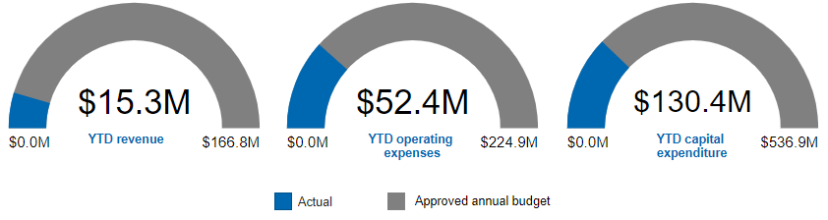

Program financial results

Overall, revenue for the period is on track against budget.

Operating expenses are below budget during the period mainly due to:
Rephased expenditure in the Providing Active Transport Infrastructure strategy, primarily due to efficiencies achieved in completing the immediate and short-term bikeway network flood recovery work. This will continue to be monitored throughout the year and be adjusted at a future budget review if required.
Rephased expenditure in the Providing High Quality Ferry Services strategy, mainly relating to activities for ferry services and maintenance. This is expected to materially align with the annual budget at the end of the financial year.

Capital expenditure is below budget during the period mainly due to:
Rephased expenditure in the Brisbane Metro strategy, mainly relating to the Brisbane Metro project. This is expected to materially align with the annual budget at the end of the financial year.
Rephased expenditure in the Providing Active Transport Infrastructure strategy, mainly relating to the Green Bridges Program. This is expected to materially align with the annual budget at the end of the financial year.
Rephased expenditure in the Providing Active Transport Infrastructure strategy, primarily due to efficiencies achieved in completing the short-term bikeway network flood recovery work which included restoration of connectivity in and around two locations along Kedron Brook Bikeway near Royal Parade, Alderley and Kalinga Park, Kalinga. This will continue to be monitored throughout the year and be adjusted at a future budget review if required.

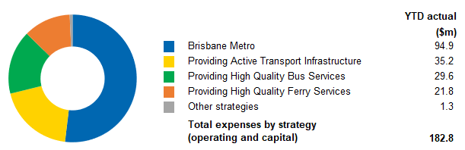

Highlights and updates on key program strategies from the Annual Operational Plan

Strategy | Highlights and updates
Providing Active Transport Infrastructure | Commenced construction (marine piling) of the Kangaroo Point Green Bridge and Breakfast Creek Green Bridge.  Works well underway at five project sites to reinstate connectivity of the Kedron Brook Bikeway following the SEQRFE 2022.  Completed signage and lighting restoration following damage caused by the SEQRFE 2022, which impacted 170 kilometres of the active transport network across more than 55 bikeways and shared paths.  Completed construction works resulting in the connection of footpaths near St Margaret's Anglican Girls School on Kidston Street and Towers Street, Ascot, for the Safer Paths to School Suburban Works Program. This work improved access to safe and connected pathways for students and teachers travelling to and from the school.  Completed removals of bicycle deflection rails (commonly known as ‘banana bars’) at Robertson Park, Taringa; Tandara Street, The Gap; and Bungama Street and Blackwood Street, Deagon.  Commenced trial of two solar powered Bicycle Awareness Monitors, with installation at Kangaroo Point Bikeway, approaching the Riverlife Adventure Centre, for those travelling northbound and southbound.  Commenced e-scooter rack trial in July, with installation of two  e-scooter racks in the Central Business District (CBD).
Providing High Quality Ferry Services | Commenced construction of replacement CityCat.  Awarded contract for two flood recovery works packages to reinstate eight ferry terminals impacted by the SEQRFE 2022.
Brisbane Metro | Cultural Centre station upgrade and precinct enhancement works have commenced, with the temporary Cultural Centre station Platform 2 being relocated.  Commenced construction works for the end of route charging at the University of Queensland Lakes station.  Successfully completed required testing activities on the pilot metro vehicle to achieve the initial fleet order notice and an order for the remaining 59 vehicles was placed.  Displayed the pilot metro vehicle at this year's Royal Queensland Show (Ekka), attracting more than 15,500 visitors.  Prepared for community consultation in October 2022, with significant progress made in developing network engagement communication tools and materials.  Achieved significant progress in the construction of the new depot in Rochedale, with the completion of the administration building pad.

Program 2 – Infrastructure for Brisbane

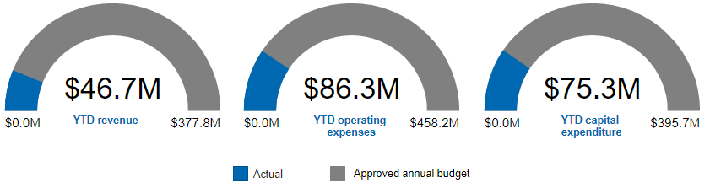

Program financial results

Revenue is above budget during the period mainly due to:
Earlier than anticipated grants and subsidies revenue mainly relating to the Urban Congestion Fund. This is expected to materially align with the annual budget at the end of the financial year.
Partly offset by lower than anticipated grants and subsidies revenue mainly relating to the Urban Congestion Fund. This is expected to be adjusted in the next budget review and be deferred to future years.

Operating expenses are below budget during the period mainly due to:
Rephased expenditure in the Maintain and Improve the Network strategy, mainly relating to asset depreciation and loss on disposal. This is expected to materially align with the annual budget at the end of the financial year.
A reallocation from operating expenses to capital expenditure in the Build the Transport Network strategy, mainly relating to the Moggill Road Corridor Upgrade project (refer to offset in capital expenditure). This is expected to be adjusted in the next budget review.

Capital expenditure is above budget during the period mainly due to:
Accelerated expenditure in the Maintain and Improve the Network strategy, mainly relating to the Roads Network Resurfacing project. This is expected to materially align with the annual budget at the end of the financial year.
Accelerated expenditure in the Build the Transport Network strategy, mainly relating to projects including Rochedale Road and Priestdale Road, Major Traffic Improvements – Intersections, Traffic Signals Hardware Equipment, Moggill Road Corridor Upgrade, Beams Road and Gresham Street Bridge. These are expected to materially align with the annual budget by the end of the financial year.
A reallocation from operating expenses to capital expenditure in the Build the Transport Network strategy, mainly relating to the Moggill Road Corridor Upgrade project (refer to offset in operating expenses). This is expected to be adjusted in the next budget review.

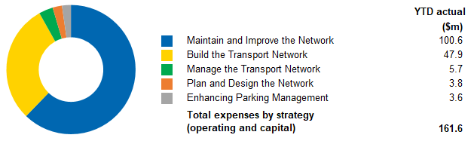

Highlights and updates on key program strategies from the Annual Operational Plan

Strategy | Highlights and updates
Build the Transport Network | Implemented a major traffic switch for the Moggill Road Corridor Upgrade, from the roundabout to a temporary signalised intersection while works continue.  Completed the finalisation works of the Gresham Street Bridge, including opening the eastern footpath drainage and landscaping, after delays due to an adjacent sewer upgrade project and the SEQRFE 2022.  Completed the construction of improvements at the intersection of Allison Street at Abbotsford Road in Bowen Hills, enhancing access for pedestrians and improving safety for all road users.  Completed the construction of corridor improvements along Tingal Road, Wynnum; and Weller Road, Tarragindi; enhancing access and safety for all road users.  Completed the construction of improvements across the Kamarin Street Precinct, Manly West, enhancing access, safety and amenity across the precinct.  Completed works at the intersection of Melton Road and Hows Road, Nundah as part of the Major Traffic Improvements – Intersections Suburban Works Program. As part of this program, works have also commenced at two intersections: Enoggera Road, Moran Street and Lloyd Street, Alderley; and Kelvin Grove Road and Blamey Street, Kelvin Grove.
Maintain and Improve the Network | Completed 92 Pavement Design Reports for the annual road resurfacing program.
Manage the Transport Network | Displayed Footy SAM on Speed Awareness Monitors (SAM) to celebrate the National Rugby League (NRL) and Australian Football League (AFL) Grand Finals in September 2022.
Enhancing Parking Management | Commenced Pay by App Only trial at Spring Hill. Trial outcomes will be considered for future on-street parking planning.

Program 3 – Clean, Green and Sustainable City

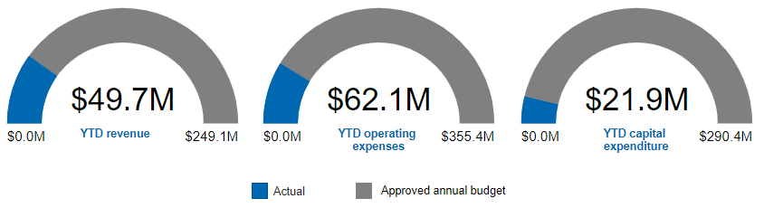

Program financial results

Revenue is above budget during the period mainly due to:
Earlier than anticipated reimbursement from the Queensland Government for the Roma Street and South Bank Parklands capital expenditure plan. This is expected to materially align with the annual budget at the end of the financial year.
Earlier than anticipated revenue associated with the capitalisation of assets from prior year projects. This will continue to be monitored throughout the year.

Operating expenses are below budget during the period, mainly due to:
Rephased expenditure in the Community Engagement and Partnerships strategy, mainly relating to the Brisbane Sustainability Agency Pty Ltd – Operations and Green Heart Sustainability Events projects, due to timing of payments for funding agreements.
Rephased expenditure in the Grow, Improve and Maintain Brisbane’s Conservation Reserves Network strategy, mainly relating to the Wipe Out Weeds project.

Operating expenses are expected to materially align with the annual budget at the end of the financial year.

Overall, capital expenditure for the period is on track against budget and includes the following offsetting variances:
Rephased expenditure in the Grow, Improve and Maintain Brisbane's Network of Urban Parks strategy, mainly relating to the Delivering Sports Parks for Brisbane project. This will continue to be monitored throughout the year and be adjusted at a future budget review if required.
Partly offset by rephased expenditure in the Grow, Improve and Maintain Brisbane's Conservation Reserves Network strategy, mainly relating to the Bushland Acquisition Program due to earlier than anticipated acquisitions. This is expected to materially align with the annual budget at the end of the financial year.

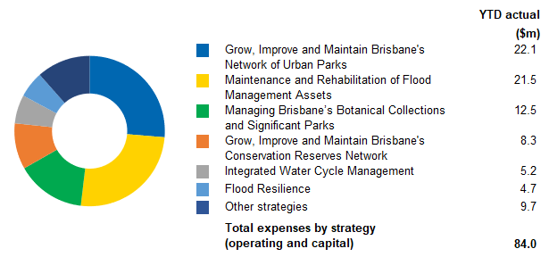

Highlights and updates on key program strategies from the Annual Operational Plan

Strategy | Highlights and updates
Community Engagement and Partnerships | Provided 3860 free native plants to Brisbane’s residents, schools, clubs and community groups.
Safe, Confident and Ready Community | Facilitated 292,132 FloodWise Property Report downloads by residents and industry and 144,675 views of Council’s Flood Awareness Maps.
Grow, Improve and Maintain Brisbane's Conservation Reserves Network | Welcomed 44,662 visitors to Brisbane’s three Environment Centres – Karawatha, Downfall Creek and Boondall Wetlands, with 8825 visitors also participating in various Community Engagement Programs.  Hosted 3889 students in Environment Centre school’s programs.  Planted over 4800 plants across 11.1 hectares under the Environmental Offsets project.  Five planned burns covering 55.3 hectares undertaken to date.
Grow, Improve and Maintain Brisbane's Network of Urban Parks | Released Victoria Park/Barrambin Draft Master Plan for community consultation.  Delivered three Scooter Tracks at Paul Conti Park, Hemmant; Kathleen Street Park, Richlands; and Wittonga Park, The Gap.  Completion of two Ninja Courses at Whites Hill Reserve, Holland Park; and Doulton Street Park, Calamvale.  Procurement for the Sun Safe Suburban Playgrounds is underway to deliver the first phase. Delivery anticipated to start after the Christmas/New Year period, as the design and manufacture of shade sails can take up to 12 weeks with current lead times.  Construction works are progressing at the Nudgee Recreation Reserve Sports Park, with current works focussing on the remediation of the former landfill.  Delivered 13 parks projects with a further 16 in progress (as listed in the Suburban Works Program).
Integrated Water Cycle Management | Transformed Hanlon Park/Bur’uda at Stones Corner from a  100-year-old concrete drain into a thriving community greenspace with a natural waterway, adventure playground, shared pathways and public art which officially opened in July 2022.
Flood Resilience/  Maintenance and Rehabilitation of Flood Management Assets | Delivered six drainage construction and rehabilitation projects with a further eight in progress (as listed in the Suburban Works Program).

Program 4 – Future Brisbane

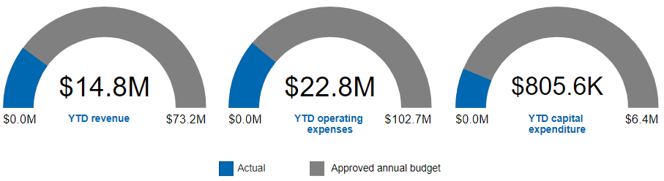

Program financial results

Revenue is below budget during the period mainly due to rephased development assessment and building applications fees. This will continue to be monitored throughout the year.

Operating expenses are below budget during the period mainly due to rephased expenditure in the Development Regulation strategy, relating to the Future Development Services Enablement Project and development assessment and regulatory activities. This will continue to be monitored throughout the year.

Capital expenditure is below budget during the period mainly due to rephased expenditure in the Design Brisbane strategy relating to the Village Precincts Projects. This is expected to materially align with the annual budget at the end of the financial year.

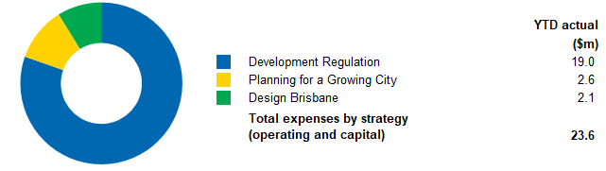

Highlights and updates on key program strategies from the Annual Operational Plan

Strategy | Highlights and updates
Planning for a Growing City | Neighbourhood Planning  Provided draft Eight Mile Plains gateway and draft Sandgate district neighbourhood plans to the Queensland Government for approval.  Updated draft Bridgeman Downs neighbourhood plan following comments received during the public consultation period.  Preparing draft Nathan, Salisbury and Moorooka neighbourhood plans.  South East Queensland Regional Plan Review  Review of the South East Queensland Regional Plan by the Queensland Government to commence in early 2023.
Design Brisbane | Botanica  Renewed the contract with the Museum of Brisbane for the Botanica 2023 curation, production and delivery.  Completed artist public expression of interest.  Village Precinct Projects  Completed Stage Two engagement for Boondall, Milton and Upper Mt Gravatt Village Precinct Projects.  Completed Stage One engagement for the Rosalie Village Precinct Project.  Completed Coorparoo Village Precinct Project in early October 2022. Tarlina Lane Festival was delivered in October 2022.  Completed Camp Hill Village Precinct Project in early October 2022.  The Art Platform, Mount Coot-tha Botanic Gardens  Completed the installation of The Art Platform artwork. The commission was awarded to a prestigious Aboriginal artist.  Outdoor Gallery (ODG)  Completed the Indigenous Art Program exhibition.  Launched new exhibition <play/ground>.  Digital Art Collection  Launched the latest commission series in combination with ODG exhibition and the Inner Sparks engagement program.  Public Art Collection  Commenced major restoration on the artwork ‘Poinsettia Riverfire’.  Restored and reinstalled the figurative sculpture of Steele Rudd located at the Speakers Corner, King George Square.  Artforce Brisbane  Delivered 21 traffic signal box and two pad-mount transformer artworks.  Creative Lighting  Progressing the design of the new creative lighting project for Nundah Village.
Development Regulation | Backflow Prevention Device Tagging  Continued user acceptance testing for an automated form in preparation for release in October 2022.  Future Development Services Enablement Project  Continued the delivery of the pilot solution as planned. The project is now advanced in its pilot design and development stage with adjusted pilot schedule and scope.

Program 5 – Lifestyle and Community Services

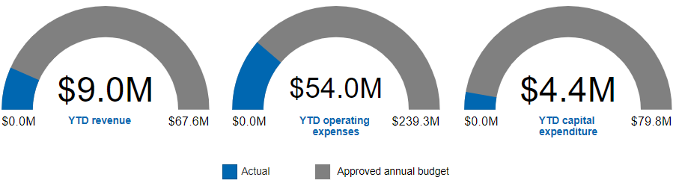

Program financial results

Revenue is below budget during the period mainly due to rephased grants and subsidies relating to the February 2022 Flood Damage – Community Assets project. This will continue to be monitored throughout the year.

Operating expenses are below budget during the period mainly due to:
Lower than anticipated expenditure in the following strategies:
Brisbane's Libraries strategy relating to activities for the purchase and management of library collections and the maintenance and enhancement of libraries.
City Venues Management strategy relating to activities for the golf courses.
Develop and Deliver Customer Services strategy relating to activities for customer service solutions.
Community Facilities strategy relating to the February 2022 Flood Damage – Community Assets project.

These are expected to be adjusted in the next budget review.

Rephased expenditure in the following strategies:
City Venues Management strategy relating to activities for the aquatic centres.
Develop and Deliver Customer Services strategy relating to activities for customer service delivery.

These are expected to materially align with the annual budget at the end of the financial year.

Capital expenditure is below budget during the period mainly due to:
Rephased expenditure in the Community Facilities strategy, mainly relating to the February 2022 Flood Damage – Community Assets project. This will continue to be monitored throughout the year.
Rephased expenditure in the City Venues Management strategy, mainly relating to the Pool Refurbishment project. This is expected to materially align with the annual budget at the end of the financial year.

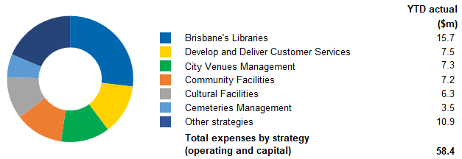

Highlights and updates on key program strategies from the Annual Operational Plan

Strategy | Highlights and updates
Festivals and Events | Supported 30 festivals including Brisbane Festival 2022, which hosted 500 performances across Brisbane, employing over 1250 artists and arts workers including over 130 Aboriginal and Torres Strait Islander artists.
Cultural Activities | A total audience of 10,120 people have attended the City Entertainment program’s weekly Lord Mayor’s City Hall Concerts.
Brisbane’s Libraries | Achieved more than 1.2 million visits to Council’s libraries.  Provided and managed more than 2.4 million loans and downloads from library collections and resources.  Continued progress of New Everton Park Library project - public tender period closed in early August 2022, currently in tender evaluation stage.
Community Health and Wellbeing | Council’s Active and Healthy Parks Program delivered more than 4300 activity sessions across Brisbane.
Diverse and Inclusive Communities | Published Council’s Reconciliation Action Plan (RAP) in August 2022. The deliverables outlined in Council’s RAP further embed Council’s approach to reconciliation while supporting Aboriginal and Torres Strait Islander communities and ensuring the Brisbane of tomorrow is even better than the Brisbane of today.  Commenced delivery of accessibility upgrades under Council’s Inclusive Brisbane Plan at community facilities and venues with works at four sites on track for completion in 2022-23, including accessible adult change facilities at Langlands Pool to assist persons with disability to participate in water activities.
Community Facilities | Completed construction of two projects under the Community Facility Improvement Program, supported by the Australian Government’s Local Roads and Community Infrastructure Program:  New clubhouse at Brisbane Metropolitan Touch Association, Whites Hill Reserve, Camp Hill.  Refurbishment of the heritage-listed former Paddington Substation community facility.
Preserve and Maintain City Hall and King George Square Precinct | Hosted more than 20 civic and community events at Brisbane City Hall.
City Venues Management | More than 54,000 patrons attended the Sir Thomas Brisbane Planetarium.  More than 410,000 visitors to Council’s 22 pools.
City Engagement | More than 16,200 site visits to Your City Your Say online engagement platform since July 2022.  Your City Your Say program membership increased from 13,086 to 13,573 since July 2022.
Develop and Deliver Customer Services | Approved 106 filming approvals through the Business Hotline.  Promoted 55 not-for-profit organisations, community and cultural events and awareness campaigns by lighting up Council assets, such as Orange Sky July, State of Origin, Ekka and the Centenary of Queensland Country Women’s Association.  Council’s Contact Centre maintained high satisfaction ratings for customers with 94% overall satisfaction with the service provided by Contact Centre consultants.

Program 6 – City Standards, Community Health and Safety

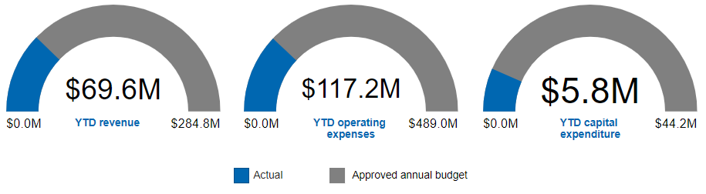

Program financial results

Revenue is below budget during the period mainly due to rephased fees and charges mainly relating to parking infringements. This will continue to be monitored throughout the year and be adjusted at a future budget review if required.

Operating expenses are below budget during the period mainly due to:
Rephased expenditure in the Community Health strategy, mainly relating to the Workload Management System Replacement project.
Rephased expenditure in the Trees and Parks Maintenance strategy. This will continue to be monitored throughout the year.
Rephased expenditure in the Effective Waste Stream Management and Reduction strategy.

Capital expenditure is below budget during the period mainly due to:
Rephased expenditure in the Maintaining the City Infrastructure strategy, mainly relating to the Footpath and Bikeway Reconstruction and the Suburban Enhancement Fund projects.
Rephased expenditure in the Effective Waste Stream Management and Reduction strategy, mainly relating to the Brisbane Landfill Optimisation project.

Operating and capital expenditure are expected to materially align with the annual budget at the end of the financial year.

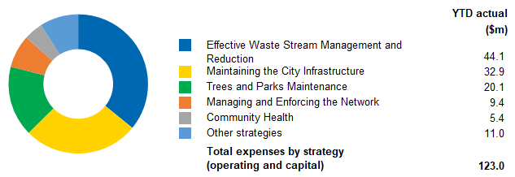

Highlights and updates on key program strategies from the Annual Operational Plan

Strategy | Highlights and updates
Maintaining the City Infrastructure | Cut 1300 hectares of grass across roadside, parks and verges.  Maintained 673 square metres of bikeways across Brisbane.  Graded 34,350 square metres of unpaved roads across Brisbane.  Completed planned maintenance across approximately 7491 square metres of road pavement and reactive maintenance across more than 7623 potholes.
Trees and Parks Maintenance | Cut 70,000 hectares of grass across Council parks.
Effective Waste Stream Management and Reduction | Diverted 6800 tonnes of green waste from landfill through household green top bins.  Diverted more than 17,000 tonnes of recyclables from landfill through household yellow top bins.  Facilitated online training through the Waste Smart Kindy program for 110 educators.  Rescheduled Go-live for the Integrated Customer Contact System Replacement from October to late November 2022. The duration of the system integration testing has taken longer than planned.  Brisbane Landfill Optimisation – Cell 8 flood rectification work and weather proofing will be completed at the end of October 2022. Project is on track for completion by the end of the calendar year.
Community Health | Conducted 1295 Eat Safe Brisbane food safety audits, with 85% of Brisbane’s licenced food businesses rated 3 stars and above.  Vaccination of 1425 infants at Council immunisation clinics.

Program 7 – Economic Development

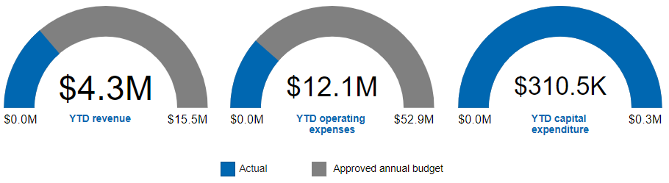

Program financial results

Revenue for the period is materially on track against budget.

Operating expenses are below budget during the period mainly due to:
Rephased expenditure in the Growing an Olympic City strategy, relating to activities for the Brisbane 2032 Olympic and Paralympic Games and Virtus Oceania Asia Games 2022.
Rephased expenditure in the Economic Strategy and Support strategy, mainly relating to city analytics and innovation activities.

Operating expenses are expected to materially align with the annual budget at the end of the financial year.

Capital expenditure for the period relates to the Albert Street Amenity Block Greening Project and is materially on track against budget.

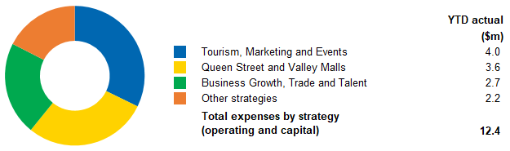

Highlights and updates on key program strategies from the Annual Operational Plan

Strategy | Highlights and updates
Economic Strategy and Support | Suburban Business Hub Nundah  Continued to deliver business capacity building training sessions including drop-in sessions with Council experts on food licensing and procurement.  Delivered the ‘Showcasing Brisbane’ initiative which allows three makers and one artist to display their products or artwork in the Hub.  Supporting Business Partnerships, Growing Precincts Together  Commenced this initiative at two locations: Racecourse Road, Ascot; and Rosalie Village, Paddington.  Virtual Brisbane  Completed the Virtual Brisbane 2021 base model update.
World Class City Centre | CitySafe  Provided an effective response and management service in the Central Business District (CBD) and Fortitude Valley (Valley) precincts.  Purchased one additional CitySafe Rapid Deployment Camera.
Queen Street and Valley Malls | Completed the Albert Street Amenity Block Greening Project.  Celebrated Queen Street Mall’s 40th anniversary in August 2022 resulting in the highest foot traffic to date for 2022.  Delivered multi-cultural program celebrating Moon Festival in September 2022, supporting 32 businesses.  Promoted and supported the Valley’s ‘eat, shop and play’ options and activations through 16 website articles, 69 @myvalleybne Instagram and social media posts, supporting 89 businesses.  Supported five emerging live music artists via ‘Weekly Live and Local’ activations commencing September 2022.
Growing an Olympic City | Brisbane 2032 Host City  Continued to work with partners on Brisbane 2032 Olympic and Paralympic Games venue precincts, including launch of the Breakfast Creek Sports Precinct Concept.  Continued to work with all Games partners on governance arrangements.  Participated in Games legacy and strategy workshops with all Games partners.  Continued to partner with Sport Inclusion Australia to deliver the Virtus Oceania Asia Games 2022.  International Relations and Multicultural Affairs  Engaged a professional conference organiser for the 2023 Asia Pacific Cities Summit.  Rescheduled the Lord Mayor’s Multicultural Business Dinner and Awards due to the passing of Her Majesty The Queen Elizabeth II.
Business Growth, Trade and Talent | Delivered 24 workshops and 30 mentoring sessions with 627 event attendees and 868 coworking drop-ins.  Completion of Women in Business Grants pre-launch and on track for launch date in early October 2022.  Generated three new investment leads through business relations trip to Singapore.  Hosted a Private Label Forum for global online retailer Amazon at the Brisbane Business Hub for 20+ local companies.  Hosted a two-day inbound Trade Mission in partnership with a United Kingdom-based global sports event consultancy group.
Tourism, Marketing and Events | Extended the ‘Here’s to Adventure’ destination marketing campaign, generating 4500 bookings, over $850,000 economic impact and 20,000 interstate competition entries.  Continued business development activity and bidding for national and international Business Events, securing 10 bid wins anticipated to generate $13.9 million in economic activity and support 93  full-time equivalent (FTE) jobs in the local economy.  Attracted five future Major Events generating an anticipated $16.3 million in economic activity and supporting 505 FTE jobs in the local economy.  Supported the delivery of 27 Business and Major Events.

Program 8 – City Governance

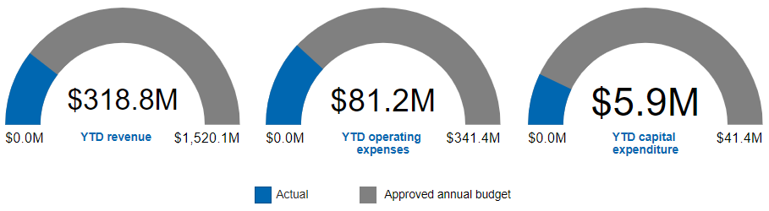

Program financial results

Revenue is below budget during the period mainly due to:
Rephased revenue from dividends to be declared in October 2022. This is expected to materially align with the annual budget at the end of the financial year.
Rephased revenue from rates and utility charges relating to commercial and residential properties. This is expected to materially align with the annual budget at the end of the financial year.
Partly offset by earlier than anticipated revenue from interest on deposits. This will continue to be monitored throughout the year and be adjusted at a future budget review if required.

Operating expenses are below budget during the period mainly due to:
Rephased expenditure in the Financially Sustainable Council strategy, mainly relating to the phasing of corporate cost allocations to projects.
Rephased expenditure in the Well Governed City strategy, mainly relating to the treatment of cost allocations for insurance premiums.
Rephased expenditure in the Talented, Capable and Efficient Council strategy, mainly relating to the Enterprise Resource Planning (ERP) Digital Program and the Field Worker Mobility project.
Partly offset by accelerated expenditure in the Safe and Resilient City strategy, mainly relating to the February 2022 Flood Damage – Counter Disaster Operations project.

Capital expenditure is below budget during the period mainly due to:
Rephased expenditure in the Financially Sustainable Council strategy, mainly relating to capitalised interest on major projects.
Rephased expenditure in the Asset Performance and Optimisation strategy, mainly relating to the Fleet Replacement Program.

Operating expenses and capital expenditure are expected to materially align with the annual budget at the end of the financial year.
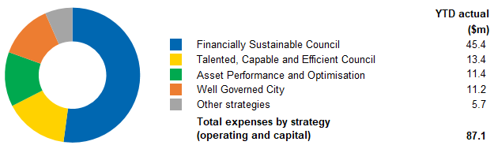

Highlights and updates on key program strategies from the Annual Operational Plan

Strategy | Highlights and updates
Well Governed City | Supported the administration, organisation and functioning of six Council meetings, 48 Committee meetings and 10 Civic Cabinet meetings held during the period.  Processed 145 Right to Information and Information Privacy applications during the period.
Informed and Engaged City | Supported the development and communication of Council plans and strategies including the Reconciliation Action Plan, Rebuild and Recover: Flood Resilience Action Plan and 2021-22 Annual Report.  Promoted and raised awareness of Council initiatives through communication campaigns and media coverage of the Brisbane Severe Weather Alert, Super Sandbag weekends, progress on the Brisbane Metro project and the launch of the Victoria Park/Barrambin Master Plan.  Hosted more than 36 civic events including multiple courtesy calls, Country Women’s Association 100-year Birthday Morning Tea, Lord Mayor’s Charitable Trust Fashion Show, Brisbane Fashion Festival Civic Reception, National Flag Day and Social Enterprise World Forum Civic Reception.  Council made Australian history by hosting the largest Citizenship Ceremony with the most conferees attending a ceremony. During the month of August 2022, Council held three back-to-back ceremonies, conferring a total of 5800 new citizens in three days.
Safe and Resilient City | Supported Council-wide action on the 2022 Flood Review Recommendations and Flood Resilience Action Plan to support Council’s preparedness for the 2022-23 severe weather season and future disaster events.  Increased subscribership to the Brisbane Severe Weather Alert service with 4020 new subscribers registered during the period, bringing the total subscribers to 176,830 ahead of a major promotional campaign during severe weather season.  Developed and rolled out a training program for Councillors and ward offices to provide an overview of disaster management and raise awareness of Councillor responsibilities before, during and after a severe weather event.
Financially Sustainable Council | Facilitated the application and approval process for the $1,000 rates rebate for ratepayers whose homes were rendered uninhabitable by the SEQRFE 2022. Approximately $300,000 in rebates were approved during the period.  Operationalised the introduction of new rating categories to encourage more properties to be available on the long-term rental market. This means houses and units rented to paying guests for temporary accommodation purposes will pay higher rates.  Continued to support Brisbane's senior citizens through Council's 40% pensioner rates rebate, providing financial relief of over $5 million during the period.
Asset Performance and Optimisation | Continued to manage ongoing supply chain impacts to Council’s Fleet Replacement Program.  Delivered the new Enoggera Ward Office after Council’s lease at the previous site was unable to be continued.
Talented, Capable and Efficient Council | Onboarded 81 new participants to Council’s employment pathway initiatives, bringing the total number of participants to 210 during the period. This includes apprenticeships, pre-trade work experience, traineeships, cadetships, tertiary work experience, graduate and emerging capabilities programs, as well as the disABILITY ACTION at WORK project.  Reviewed and updated the Organisational Zero Harm Strategy for 2022-2026. This strategy supports Council’s leaders and workers to understand their role in achieving the aspirational goal of Zero Harm across all of Council’s workplaces.  On track to achieve Council’s 80% local buy target with $332 million invested with local suppliers during the period.  On track to achieve Council’s $10 million spend target with $3.8 million invested with social enterprises during the period.  Contract executed for the Field Worker Mobility Solution, enabling the next phase of the project.  Delivered nine tactical improvements across the HR/Payroll, Procurement, Asset Management and Finance through the Enterprise Resource Planning (ERP) Digital Program.  Progressed the Spatial Enablement Program, with contract executed for Council’s new spatial hosted service provider.  Continued to rollout robotic process automations across Council to improve efficiency, saving approximately 500 hours per month in manual tasks.  Delivered 53 system and process modernisation initiatives, leveraging cross-functional teams and agile tools and processes to deliver tactical improvements across Council.

Businesses

Transport for Brisbane

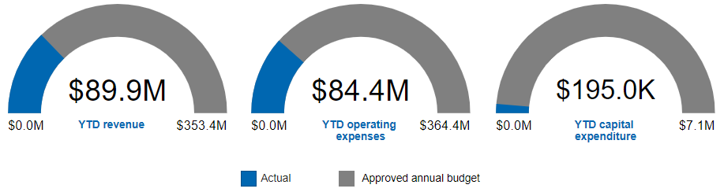

Refer to Section 3 for the Transport for Brisbane commercial business performance results.

City Projects Office

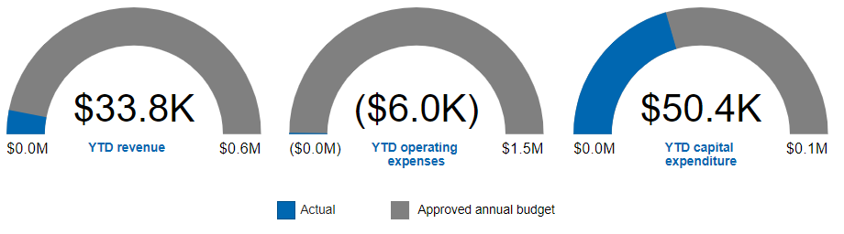

Revenue is above budget for the period due to higher demand for City Projects Office external works.

Operating expenses are below budget for the period mainly due to rephased expenditure in the Digital Data Management Solution and the City Projects Office Tools of Trade projects.

Capital expenditure is above budget for the period due to rephased expenditure in the City Projects Office Tools of Trade project.

Revenue, operating expenses and capital expenditure are expected to materially align with the annual budget at the end of the financial year.

City Standards

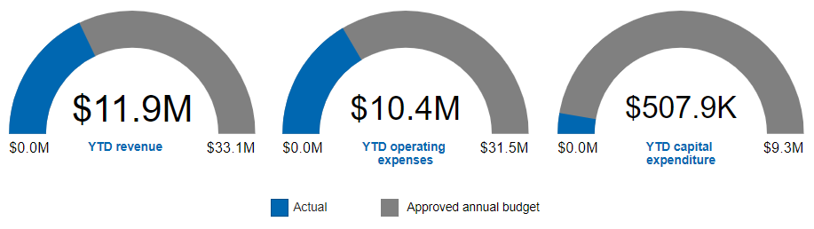

Revenue is above budget during the period mainly due to higher than anticipated external demand for asphalt and quarry sales.

Operating expenses are above budget during the period mainly due to increased production needed to meet higher than anticipated external demand for asphalt and quarry sales.

Revenue and operating expenses are expected to be adjusted in the next budget review.

Capital expenditure for the period is on track against budget.

Section 3 – Commercialised Businesses

Transport for Brisbane

Objective

The objective of Transport for Brisbane is to provide frequent, reliable and safe services, more often, and at the most comfortable standard possible for our passengers.

Performance measures and targets

 | Actual
Bus patronage – number of passengers carried | 14.6 million
Ferry patronage – number of passengers carried | 0.5 million

Council is on track in achieving the non-financial targets for the year:
mean customer satisfaction with bus services of not less than 6.5
mean customer satisfaction with CityCat and ferry services of not less than 7.0.

Financial summary

For the period ended  September 2022 | YTD actual | Approved annual budget  2022-23
 | $000 | $000
Revenue | 89,941 | 353,367
Expenses | 82,568 | 361,333
Program operating profit (loss) before income tax | 7,373 | (7,966)
Reconciliation to Transport for Brisbane business activity
Net impact of revenue and expenses shown in other programs | 6,754 | 30,024
Operating profit (loss) before income tax | 14,127 | 22,058
Income tax expense | 1,869 | 3,073
Operating profit (loss) after income tax | 12,258 | 18,985

Revenue and expenses reported in other programs, mainly in the Transport for Brisbane program, have been added to reflect all of Transport for Brisbane's National Competition Policy (NCP) activities.

Revenue (excluding those reported in other programs) is above budget during the period mainly due to higher than anticipated grants and subsidies relating to the Boosting Apprenticeship Commencements program. Translink revenue is also above budget due to the reimbursement of fuel and COVID-19 sanitising activities, as well as the contracted annual CPI increase being higher than budgeted. These are expected to be adjusted in the next budget review or will continue to be monitored throughout the year.

Operating expenses (excluding those reported in other programs) are below budget during the period mainly due to rephased labour costs, which will continue to be monitored throughout the year. This is partly offset by accelerated fuel costs and higher than anticipated expenditure relating to COVID-19 sanitising costs. These will continue to be monitored throughout the year or be adjusted in the next budget review.

The net impact shown in other programs is above budget during the period mainly due to higher than anticipated revenue relating to Transport partnerships, which is expected to be adjusted in the next budget review.

City Parking

Objective

City Parking is committed to delivering parking services that meet customer needs by delivering value for money, accessible and reliable parking services.

Performance measures

 | Actual
Average number of vehicles per bay per day in King George Square Car Park | 2.23
Average number of vehicles per bay per day in Wickham Terrace Car Park | 0.89

Financial summary

For the period ended  September 2022 | YTD actual | Approved annual budget  2022-23
 | $000 | $000
Revenue | 2,115 | 11,425
Expenses | 2,423 | 9,804
Program operating profit (loss) before income tax | (308) | 1,621
Income tax expense | - | 486
Operating profit (loss) after income tax | (308) | 1,135

City Parking revenue and expenses for NCP activities are reported mainly in the Infrastructure for Brisbane program.

Revenue is below budget during the period mainly due to rephased parking fees and vehicle turnover. This will continue to be monitored throughout the year.

Operating expenses are on track against budget.

