Headfort Street Park

Site map
For Community Engagement – November 2023

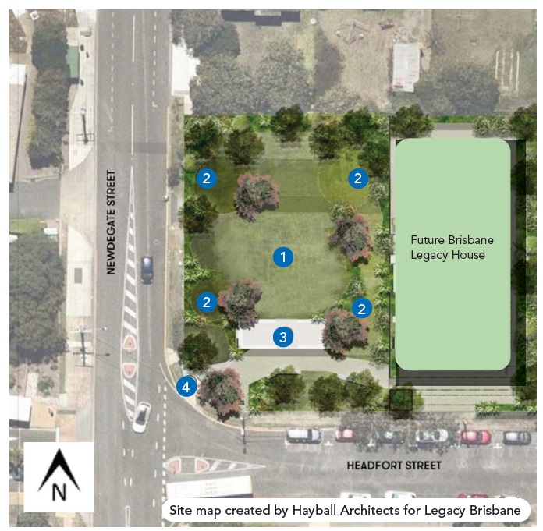

Legend

Proposed features
- Informal play and recreation
- Green open spaces or seating

Heritage features
- Covered outdoor area incorporating part/rebuilt heritage façade
- Entrance heritage gates.

Note:

- Land allocated for Brisbane Legacy House is out of scope for Brisbane City Council’s parkland design
- The site map and images are indicative only. Further design, planning and investigations are required to enable final design.
- Site map created by Hayball Architects for Legacy Brisbane.

