Wynnum Road and Hemmant-Tingalpa Road intersection upgrade

Concept plan

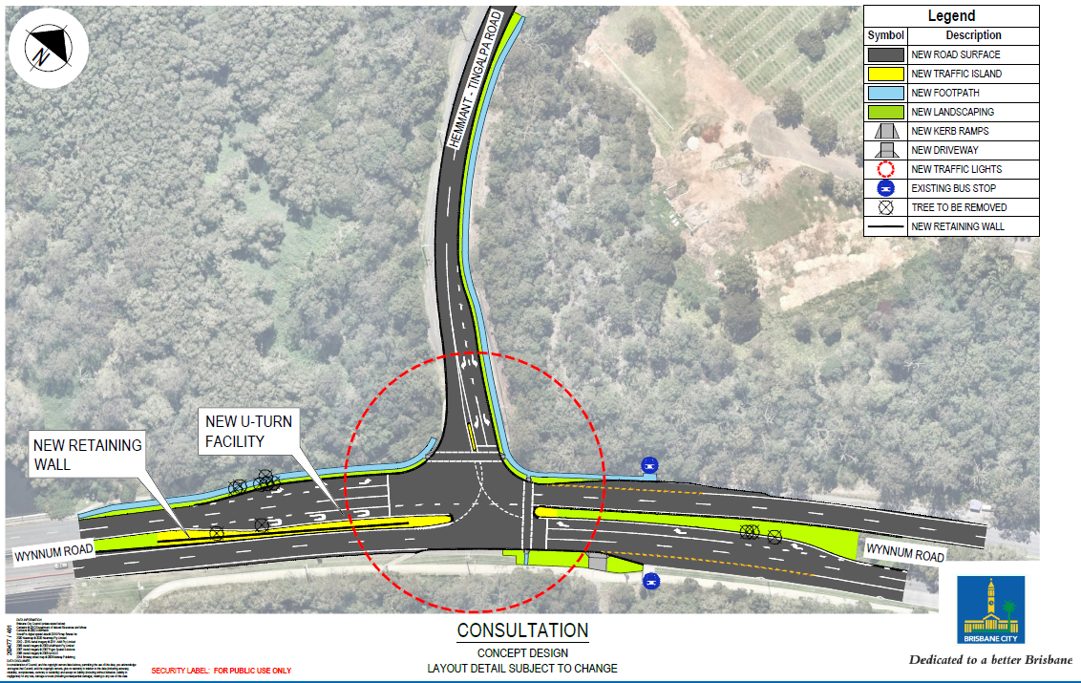
Tingalpa

For more information about the project, please call the project team on 1800 669 416 or email cityprojects@brisbane.qld.gov.au.

