Dear Neighbour,

I am writing to you about the <<insert vehicle colour and make/ model>> that has been at <<X location>> for approximately <<X amount of time>>. <<I feel that this vehicle (has been abandoned/is unslightly/is dilapidated) OR I have confirmed this vehicle is unregistered>> and it is negatively impacting the amenity of the area.

If this vehicle belongs to you, could you please take reasonable action to remove it from the area or relocate the vehicle onto your property.

Council’s approach to unmanaged vehicles is available on their website (brisbane.qld.gov.au) or by scanning the QR code I have added below.

I would prefer not to make a complaint to Council as I am trying to be a good neighbour, however the vehicle has genuinely become a concern.

Thank you for your understanding and cooperation in this matter.
Warm regards,
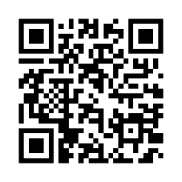
A Concerned Resident.

