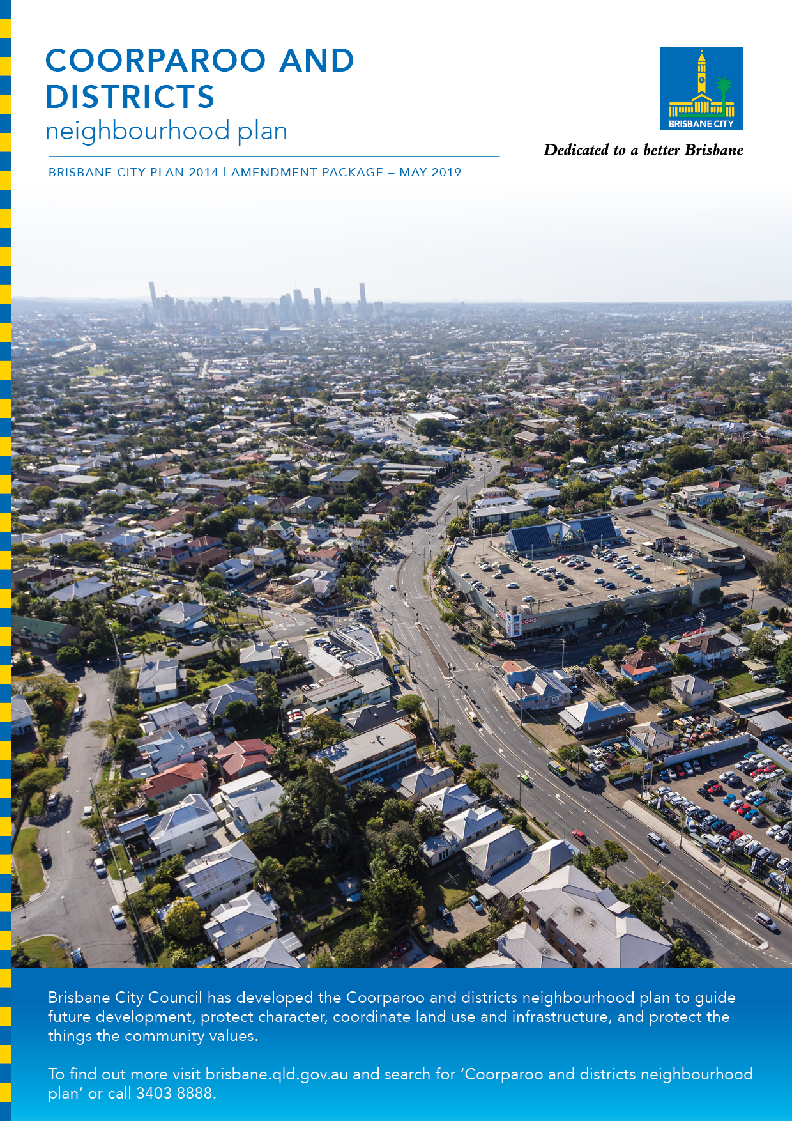

Coorparoo and Districts neighbourhood plan

Brisbane City Plan 2014 Amendment Package – May 2019

Table of Contents

Part A: Explanatory Notes 3
Community engagement 6
Neighbourhood Plan outcomes 8
Part B: Major Amendment v16.00/2019 18
Part 1 Amendment of Part 1 (About the planning scheme) 19
Part 2 Amendment of Part 5 (Tables of assessment) 21
Part 3 Amendment of Part 7 (Neighbourhood plans) 25
Part 4 Amendment of Part 8 (Overlays) 47
Part 5 Amendment of Schedule 2 (Mapping) 52
Part 6 Amendment of Schedule 6 (Planning scheme policies) 58
Part 7 Amendment of Appendix 2 (Table of amendments) 65
Supplement 1—A3 Map Tiles 66

Part A: Explanatory Notes

Glossary
Abbreviation | Term
the planning scheme | Brisbane City Plan 2014
Council | Brisbane City Council
CPT | Community Planning Team
LGIP | Local Government Infrastructure Plan
MCU | Material change of use as defined in the Planning Act 2016
NPP | Neighbourhood plan precinct
ROL | Reconfiguring a lot as defined in the Planning Act 2016
the neighbourhood plan | Coorparoo and districts neighbourhood plan
the amendment package | Coorparoo and districts neighbourhood plan amendment package

Purpose
The purpose of these explanatory notes is to provide context for the amendment package including the key outcomes of the neighbourhood plan and the process undertaken to develop the neighbourhood plan. The explanatory notes do not form part of the amendment package.

Background
Council proposes to adopt the amendment package to guide future development and coordinate land use within the neighbourhood plan area, which includes Greenslopes, Holland Park, and parts of Coorparoo, Camp Hill, and Holland Park West. The amendment package forms a major amendment to the planning scheme and has been prepared in accordance with Queensland Government requirements.
The amendment package consists of a new neighbourhood plan code for Coorparoo and districts, revised zones and overlay mapping and consequential amendments to the planning scheme. The amendment package will guide future development in the Coorparoo and districts area. The amendment package also includes associated amendments to parts of the existing Holland Park—Tarragindi district neighbourhood plan.
Council commenced the neighbourhood planning process in the Coorparoo and districts area in October 2015. On 5 February 2016, the Minister confirmed State interests to be considered when preparing a major amendment, in accordance with Statutory Guideline 01/16 Making and amending local planning instruments. The Coorparoo and Districts Draft Neighbourhood Plan Strategy (the draft strategy) was released in October 2016 for public consultation from 4 October 2016 to 31 October 2016. Feedback received on the draft strategy, along with feedback received through the CPT and the broader community throughout the planning process to date, has been used in the preparation of the amendment package. Internal Council stakeholders and Queensland Government agencies have also been involved in preparing the amendment package.
On 20 February 2018, the Minister completed the first State interest review and approved the commencement of the public notification period. Statutory consultation was undertaken on the draft amendment package from 16 April 2018 to 8 June 2018 in accordance with Queensland Government requirements. During the statutory consultation period, 421 submissions were received (397 were properly made). Council revised the amendment package following consideration of these submissions and referred the amendment package to the Queensland Government for approval to adopt. On 13 February 2019, the Queensland Government advised Council that the amendment could be adopted into the planning scheme.
The amendment package has been prepared in line with the following objectives for the neighbourhood plan area.
- Plan for future growth nodes, being Greenslopes, Greenslopes Mall and Holland Park, to provide for opportunities for growth in accordance with the Strategic framework within the planning scheme.
- Enhance vibrancy around the centres and seek improved public realm and built form outcomes across the plan area.
- Resolve housing character concerns in Suburban Living Areas including the perceived tension between land zoned Low-medium density residential where the Traditional building character overlay applies.
- Focus on the Logan Road corridor, which presents an opportunity to integrate land use and infrastructure planning, in particular aligning growth with public and active transport.
- Coordinate land use and infrastructure planning for transport, community facilities, parks and stormwater networks.

What are neighbourhood plans?
‘Create a city of neighbourhoods’ is one of eight principles outlined in Council’s Brisbane’s Future Blueprint.
Council creates neighbourhood plans to guide development in local communities, and to ensure that each area retains and enhances its own special character and qualities. The neighbourhood plan is the product of technical investigations undertaken by Council, as well as feedback received from the community and other stakeholders over the course of the neighbourhood plan’s preparation.
A neighbourhood plan refines planning provisions to meet the needs of the local community while also maintaining the neighbourhood plan area’s residential character. A neighbourhood plan is part of Council’s planning scheme. A neighbourhood plan does not duplicate planning provisions that are already contained in the planning scheme (assessment criteria for overlays, for example) as a neighbourhood plan is a component part of the planning scheme and is not a standalone statutory document.
It is important to recognise that a neighbourhood plan cannot:
- reduce the scale of existing development
- stop already approved development, even if construction has not commenced.
Infrastructure planning occurs as part of the LGIP and will be reviewed following the adoption of the amendment package.

Community engagement

Engagement for the neighbourhood plan
The neighbourhood planning process commenced in late 2015 and involved a series of community engagement stages. The process commenced with an online survey, information kiosks and the formation of a CPT. The CPT met four times between 25 November 2015 and 4 May 2016.
The draft strategy was released in October 2016 and proposed key ideas for consideration and community feedback. Feedback on the draft strategy was incorporated into the amendment package, which was released for statutory public consultation from 16 April 2018 to 8 June 2018. The amendment package was revised to incorporate the feedback raised in the submissions.

Summary of community engagement activities
The following table is a summary of the key community engagement activities that informed the development of the neighbourhood plan.
Event type | Date and location | Topic
Online survey | Available on Council’s website from 19 November 2015 until 30 March 2016 | Online survey for residents, workers, business operators and community groups to share their ideas for the future of the area
Information kiosks | 24 October 2015 – Martha Street shops and Cavendish Road shops, Coorparoo | Provide information about the project and gather ideas from the community
 | 29 October 2015 – Greenslopes Mall
 | 20 October 2016 – Greenslopes Mall
 | 22 October 2016 – Martha Street shops, Coorparoo
CPT meetings | 25 November 2015 – Easts Leagues Club, Coorparoo | Developing and reviewing the draft strategy, with input and advice from a nominated group of CPT members from the local community
 | 10 February 2016 – Easts Leagues Club, Coorparoo
 | 13 April 2016 – Easts Leagues Club, Coorparoo
 | 4 May 2016 – Easts Leagues Club, Coorparoo
Talk to a Planner sessions | 4 November 2015 – East Leagues Club, Coorparoo | Gather ideas from the local community about the future of the area
 | 24 October 2015 – Martha Street shops, Coorparoo
 | 20 October 2016 – Greenslopes Mall
Community Information sessions | 10 May 2018 – Easts League Club, Coorparoo | Consultation on the proposed amendment package
 | 12 May 2018 – Greenslopes Bowls Club
 | 19 May 2018 – Coorparoo Presbyterian Church

Neighbourhood Plan outcomes

Neighbourhood plan boundary
The neighbourhood plan focuses on the suburbs of Greenslopes and Holland Park, and parts of Coorparoo, Camp Hill, and Holland Park West.
The neighbourhood plan area includes the following precincts and sub-precincts:
- Logan Road precinct (NPP-001)
- Logan Road 5-6 storey sub-precinct (NPP-001a)
- Logan Road 3 storey sub-precinct (NPP-001b)
- Greenslopes Private Hospital precinct (NPP-002)
- Stephens Mountain precinct (NPP-003)
- Stephens Mountain reserve sub-precinct (NPP-003a)
- Stephens Mountain west sub-precinct (NPP-003b)
- Earl Street precinct (NPP-004).
The neighbourhood plan boundary and precincts are outlined in Figure 1.

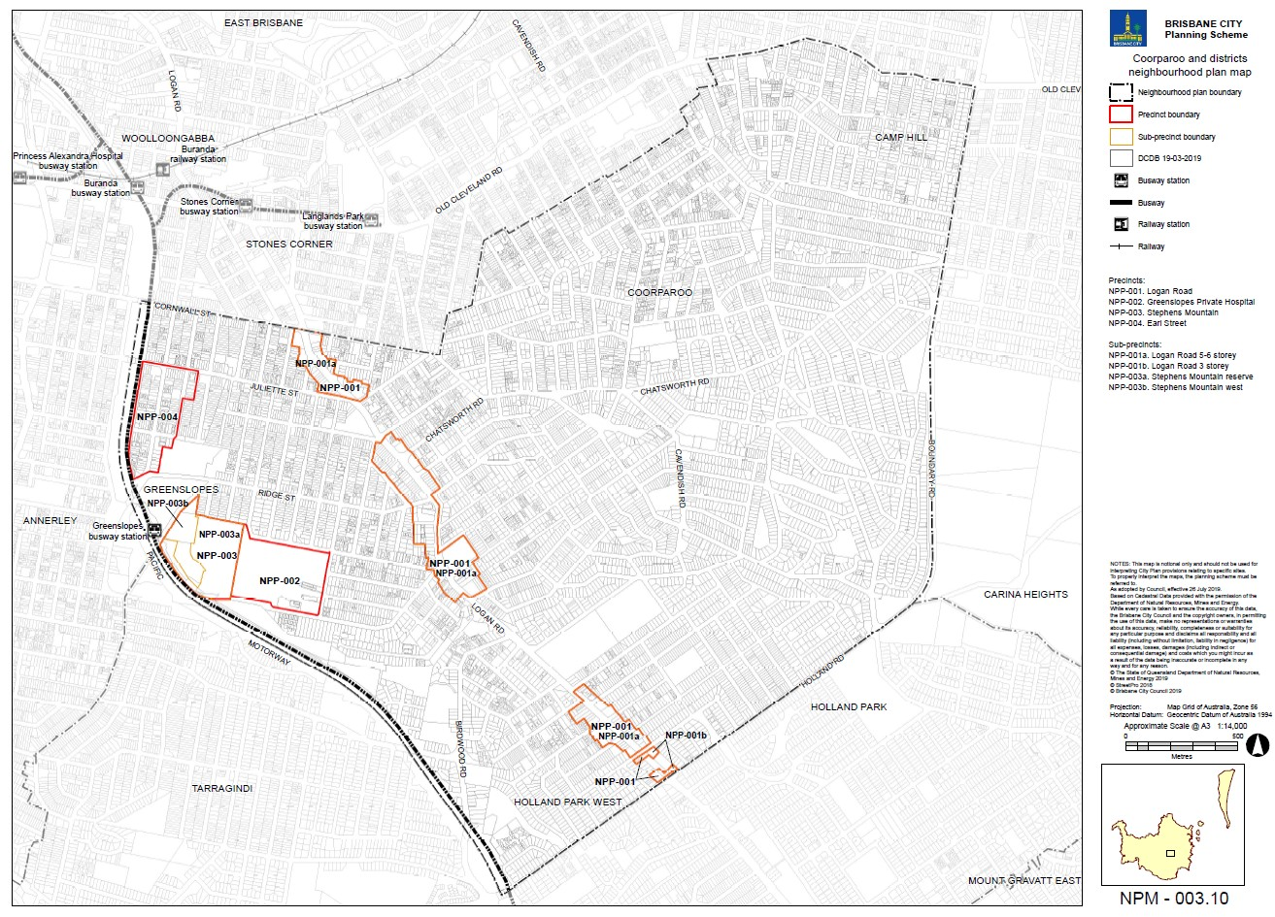

Figure 1—Coorparoo and districts neighbourhood plan area and precincts

Key planning outcomes
The amendment package will ensure that new development responds to key state-wide, regional and local planning outcomes.

Response to State Planning Policy July 2017
As an integrated part of the planning scheme, the amendment package supports the State interests outlined in the State Planning Policy July 2017. In particular, the amendment package promotes the following State interests:
- Housing supply and diversity – by focusing increased densities around existing centres, services and facilities including along Logan Road
- Liveable communities – by creating liveable and well-designed communities that support resident wellbeing and enhance quality of life
- Development and construction – by supporting economic growth through the facilitation of a range of residential, commercial, and retail development opportunities
- Cultural heritage – by providing ongoing protection for existing heritage and through an extensive identification of additional places for heritage protection;
- Biodiversity – by protecting existing open space and rezoning land to the Conservation zone
- Infrastructure integration – by aligning infrastructure and land use planning and ensuring that the future operation of utility and transport infrastructure is not compromised by development
- Transport infrastructure – by improving active transport connections.

Response to the South East Queensland Regional Plan 2017 – ShapingSEQ
The amendment package supports the following policies of the South East Queensland Regional Plan 2017 – ShapingSEQ:
- Goal 1 Grow and Goal 4 Sustain – by accommodating growth in an existing urban area within the Urban Footprint locating diverse housing types in proximity to the existing centres
- Goal 3 Connect – by prioritising the use of active transport networks in an existing urban area and locating higher density residential development and potential employment generators in an existing urban area close to the Brisbane central business district, and in proximity to existing and planned transport infrastructure
- Goal 3 Connect and Goal 5 Live – by facilitating high amenity residential development close to public transport and encouraging good quality subtropical design outcomes
- Goal 5 Live – by preserving the character and heritage of the Coorparoo and districts area.

Response to the planning scheme’s Strategic framework
The amendment package is aligned with the Strategic framework of the planning scheme.

Response to local planning outcomes
The amendment package will enhance economic growth in the area by allowing a range of commercial, retail, mixed use and residential development in the centres on Logan Road, and by protecting the continued function of other neighbourhood centres in the area.
The amendment package will deliver simpler and more consistent development controls by confirming the areas considered most suitable for Low-medium density residential zoning and those areas where character housing protection is prioritised. It also allows for a greater mix of housing diversity in the neighbourhood plan area, providing housing choice in areas close to employment, transport and services.
The amendment package promotes the neighbourhood plan area’s existing built and natural attributes while facilitating a mix of housing types and commercial activities and the appropriate transitioning of increased densities.

Summary of changes
The amendment package consists of the following key components:
- changes to the Strategic framework
- changes to the tables of assessment
- Coorparoo and districts neighbourhood plan code, including four precincts:
  - Logan Road precinct
    - Logan Road 5-6 storey sub-precinct
    - Logan Road 3 storey sub-precinct
  - Greenslopes Private Hospital precinct
  - Stephens Mountain precinct
    - Stephens Mountain reserve sub-precinct
    - Stephens Mountain west sub-precinct
  - Earl Street precinct
- revised neighbourhood plan code and precincts for Holland Park—Tarragindi neighbourhood plan, reflecting the change in boundary
- revised zones
- changes to overlay mapping
- changes to planning scheme policies.

Amendment summary

Table 1—Amendment Summary
Part | Planning scheme reference | Amendment | Corresponding part of amendment package
Part 1  (About the planning scheme) | Table 1.2.2—Neighbourhood plans precincts and sub-precincts | Insert new row before Darra—Oxley neighbourhood plan for Coorparoo and districts neighbourhood plan precincts with the following precincts:  Logan Road precinct (NPP-001)  Greenslopes Private Hospital precinct (NPP-002)  Stephens Mountain precinct (NPP-003)  Stephens Mountain reserve sub-precinct (NPP-003a)  Stephens Mountain west sub-precinct (NPP-003b)  Earl Street precinct (NPP-004). | Part 1.1 (1)
 | Table 1.2.2—Neighbourhood plans precincts and sub-precincts | Amend Holland Park—Tarragindi district neighbourhood plan precincts. | Part 1.1 (2)
Part 5  (Tables of Assessment) | Section 5.5 Categories of development and assessment—Material change of use | Insert a new Park row in Table 5.5.12—Open space zone. | Part 2.1 (3)
 | Section 5.9 Categories of development and assessment—Neighbourhood plans | Insert row before Darra—Oxley neighbourhood plan in Table 5.9.1—Neighbourhood plan categories of development and assessment. | Part 2.2 (4)
 | Section 5.9 Categories of development and assessment—Neighbourhood plans | Insert new Coorparoo and districts neighbourhood plan categories of development and assessment tables Tables 5.9.82.A, B, C and D before Darra—Oxley neighbourhood plan Table 5.9.19.A—Darra—Oxley district neighbourhood plan: material change of use. | Part 2.2 (5)
 | Section 5.10 Categories of development and assessment—Overlays | Insert point (iv) under MCU in Table 5.10.12—Heritage overlay. | Part 2.3 (6)
Part 7 (Neighbourhood Plan) | Table 7.1.1—Neighbourhood plan codes | Insert new row for the Coorparoo and districts neighbourhood plan code as 7.2.3.10 and insert new map NPM-003.10. | Part 3.1 (7)
 | Section 7.2 Neighbourhood plan codes | Insert the new Coorparoo and districts neighbourhood plan code, including supporting figures. | Part 3.2 (8)
 | Section 7.2 Neighbourhood plan codes | Amend Holland Park—Tarragindi neighbourhood plan code to remove precincts, figures and renumber sequential and consequential numbering. | Part 3.3 (9) to (21)
Part 8  (Overlays) | Section 8.2.12  Heritage overlay code | Insert new rows in Table 8.2.12.3, Section B—If in the Area adjoining heritage sub-category before Section C and amend sequential and consequential numbering. | Part 4.1 (22) and (23)
 | Section 8.2.19  Significant landscape tree overlay code | Insert new rows of significant landscape tree sites for Camp Hill and Coorparoo, Greenslopes and Holland Park. | Part 4.2 (24) to (26)
Schedule 2 (Mapping) | SC2.1 Strategic framework maps,  SFM-003 | Amend SFM-003 Brisbane selected transport corridors and growth nodes strategic framework map gazettal date within Table SC2.1.1. | Part 5.1 (27)
 | SC2.1 Strategic framework maps,  SFM-003 | Amend SFM-003 Brisbane selected transport corridors and growth nodes strategic framework map to change growth nodes A4, A5 and A6 from Growth Node—Future to Growth Node—Planned | Part 5.2 (28)
 | SC2.2 Zone maps,  ZM-001  (Map tiles 28, 29, 35, 36) | Insert zone map changes to tiles 28, 29, 35, 36 within Table SC2.2.1—Zone Maps. | Part 5.3 (29)
 | SC2.2 Zone maps,  ZM-001  (Map tile 28) | Amend ZM-001 zone map tiles to include changes to zoning in Coorparoo and districts neighbourhood plan area. | Part 5.4 (30)
 | SC2.2 Zone maps,  ZM-001  (Map tile 29) | Amend ZM-001 zone map tiles to include changes to zoning in Coorparoo and districts neighbourhood plan area. | Part 5.4 (31)
 | SC2.2 Zone maps,  ZM-001  (Map tile 35) | Amend ZM-001 zone map tiles to include changes to zoning in Coorparoo and districts neighbourhood plan area. | Part 5.4 (32)
 | SC2.2 Zone maps, ZM-001  (Map tile 36) | Amend ZM-001 zone map tiles to include changes to zoning in Coorparoo and districts neighbourhood plan area. | Part 5.4 (33)
 | SC2.3 Neighbourhood plan maps | Insert Coorparoo and districts neighbourhood plan map within Table SC2.3.1. | Part 5.5 (34)
 |  | Amend Gazettal date for Holland Park—Tarragindi district neighbourhood plan map within Table SC2.3.1. | Part 5.5 (35)
 | SC2.3 Neighbourhood plan maps,  Table SC2.3.1—Neighbourhood plan maps | Insert NPM-003.10 Coorparoo and districts neighbourhood plan map. | Part 5.6 (36)
 |  | Amend the NPM-008.1 Holland Park—Tarragindi district neighbourhood plan map to reflect changes to precincts and the revised plan boundary. | Part 5.6 (37)
 | SC2.4 Overlay maps | Insert rows for overlay map tile changes in Table SC2.4.1—Overlay maps. | Part 5.7 (38) to (44)
 | SC2.4 Overlay maps,  OM-003.2  Commercial character building overlay map | Amend the overlay map (tile 36) to include revised commercial character building site classifications. | Part 5.8 (45)
 | SC2.4 Overlay maps,  OM-004.1  Dwelling house character overlay map | Amend the overlay map (tile 28, 29, 35 and 36) to include revised properties. | Part 5.8 (46) to (49)
 | SC2.4 Overlay maps,  OM-008.1 Heritage overlay map | Amend the overlay map (tiles 29 and 36) to identify additional properties for heritage protection. | Part 5.8 (50) and (51)
 | SC2.4 Overlay maps,  OM-016.2  Pre-1911 building overlay map | Amend the overlay map (tiles 28, 29, 35 and 36) to include revised pre-1911 buildings. | Part 5.8 (52) to (55)
 | SC2.4 Overlay maps,  OM-019.1 Significant landscape tree overlay map | Amend the overlay map (tiles 28, 29, 35 and 36) to identify significant landscape trees in the neighbourhood plan area. | Part 5.8 (56) to (59)
 | SC2.4 Overlay maps,  OM-019.2  Streetscape hierarchy overlay map | Amend the overlay map (tiles 28, 29, 35 and 36) to include revised streetscape hierarchy classifications. | Part 5.8 (60) to (63)
 | SC2.4 Overlay maps,  OM-020.1  Traditional building character overlay map | Amend the overlay map (tiles 28, 29, 35 and 36) to include revised neighbourhood and local building character classifications. | Part 5.8 (64) to (67)
Schedule 6  (Planning scheme policies) | SC6.16 Infrastructure design planning scheme policy, Chapter 5.3 Neighbourhood plans and other locations | Insert new row 5.3.3.3 Coorparoo and districts in Table 5.1.2—Locality streets within Neighbourhood plan areas and other locations. | Part 6.1 (68)
 | SC6.16 Infrastructure design PLANNING SCHEME POLICY, Chapter 5.3 Neighbourhood plans and other locations | Insert new section 5.3.3.3 Coorparoo and districts streetscape locality advice and supporting figure. | Part 6.1 (69)
 | SC6.29 Structure planning PLANNING SCHEME POLICY, Section 1.1 Relationship to planning scheme | Insert rows above Lower Oxley Creek north neighbourhood plan code to include Coorparoo and districts neighbourhood plan code in the table. | Part 6.2 (70)
Appendix 2  (Table of Amendments) | Table AP2.1—Table of amendments | Insert date of adoption and effective date, planning scheme version number, amendment type and summary of amendments as a result of the neighbourhood plan. | Part 7.1 (71)

Part B: Major Amendment v16.00/2019

It is hereby certified that this is a true and correct copy of Brisbane City Plan 2014 Major Amendment v16.00/2019 made, in accordance with the Sustainable Planning Act 2009, by Brisbane City Council.

Dyan Currie
Chief Planner, City Planning and Economic Development
City Planning and Sustainability
Brisbane City Council

Part 1 Amendment of Part 1 (About the planning scheme)

1.1 Amendment of section 1.2 (Planning scheme components)
- Section 1.2 Planning scheme components, Table 1.2.2—Neighbourhood plans precincts and sub-precincts–
insert before Darra—Oxley neighbourhood plan:
‘
Coorparoo and districts neighbourhood plan | NPP-001: Logan Road  NPP-001a: Logan Road 5-6 storey  NPP-001b: Logan Road 3 storey  NPP-002: Greenslopes Private Hospital  NPP-003: Stephens Mountain  NPP-003a: Stephens Mountain reserve  NPP-003b: Stephens Mountain west  NPP-004: Earl Street
’.
- Section 1.2 Planning scheme components, Table 1.2.2—Neighbourhood plans precincts and sub-precincts, Holland Park—Tarragindi district neighbourhood plan
‘
Holland Park—Tarragindi district neighbourhood plan | NPP-001: Parkland  NPP-002: Greenslopes Busway Station  NPP-002a: Energex depot  NPP-002b: Stephens Mountain  NPP-002c: Nicholson Street  NPP-002d: Greenslopes Hospital  NPP-003: Greenslopes Mall district centre  NPP-004: Greenslopes central neighbourhood centre  NPP-005: Holland Park central district centre  NPP-006: Kuring-gai Avenue neighbourhood centre  NPP-007: Reservoir parkland  NPP-008: Hillside character
’–
omit, insert:
‘
Holland Park—Tarragindi district neighbourhood plan | NPP-001: Greenslopes Busway Station  NPP-002: Kuring-gai Avenue neighbourhood centre  NPP-003: Reservoir parkland  NPP-004: Hillside character
’.

Part 2 Amendment of Part 5 (Tables of assessment)

2.1 Amendment of section 5.5 (Categories of development and assessment—Material change of use)
- Section 5.5 Categories of development and assessment—Material change of use, Recreation zones, Table 5.5.12—Open space zone—
omit, insert:
‘
Park | Accepted development
 | If in the Stephens Mountain reserve sub-precinct (Coorparoo and districts neighbourhood plan/NPP-003a) | Not applicable
 | Accepted development, subject to compliance with identified requirements
 | If not in the Stephens Mountain reserve sub-precinct (Coorparoo and districts neighbourhood plan/ NPP-003a) and complying with all acceptable outcomes in the Park code | Not applicable
 | Assessable development—Code assessment
 | If not in the Stephens Mountain reserve sub-precinct (Coorparoo and districts neighbourhood plan/ NPP-003a) and complying with all acceptable outcomes in the Park code | Park code
’.

2.2 Amendment of section 5.9 (Categories of development and assessment—Neighbourhood plans)
- Section 5.9 Categories of development and assessment—Neighbourhood plans, Table 5.9.1—Neighbourhood plan categories of development and assessment changes–
insert before Darra—Oxley neighbourhood plan:
‘
Coorparoo and districts neighbourhood plan | Change | No change | No change | No change
’.
- Section 5.9 Categories of development and assessment—Neighbourhood plans–
insert new tables before Table 5.9.19.A—Darra—Oxley district neighbourhood plan: material change of use:
‘

Table 5.9.82.A—Coorparoo and districts neighbourhood plan: material change of use
Use | Categories of development and assessment | Assessment benchmarks
If in the neighbourhood plan area
MCU, if assessable development where not listed in this table | No change | Coorparoo and districts neighbourhood plan code
If in the Greenslopes Private Hospital precinct (NPP-002)
Any | Assessable development—Impact assessment
 | If involving a new premises or an existing premises with an increase in gross floor area, where building height exceeds five storeys | The planning scheme including:  Coorparoo and districts neighbourhood plan code
If in the Low-medium density residential zone (2 or 3 storey mix zone precinct), Low-medium density residential zone (Up to 3 storeys zone precinct) or Medium density residential zone
Any | Assessable development—Impact assessment
 | If involving a new premises or an existing premises with an increase in gross floor area, where development exceeds 45% site cover | The planning scheme including:  Coorparoo and districts neighbourhood plan code
If in the Mixed use or Centre zones
Any | Assessable development—Impact assessment
 | If involving a new premises or an existing premises with an increase in gross floor area, where development exceeds 45% site cover | The planning scheme including:  Coorparoo and districts neighbourhood plan code

Table 5.9.82.B—Coorparoo and districts neighbourhood plan: reconfiguring a lot
Development | Categories of development and assessment | Assessment benchmarks
ROL, if assessable development | No change | Coorparoo and districts neighbourhood plan code

Table 5.9.82.C—Coorparoo and districts neighbourhood plan: building work
Development | Categories of development and assessment | Assessment benchmarks
Building work, if assessable development | No change | Coorparoo and districts neighbourhood plan code

Table 5.9.82.D—Coorparoo and districts neighbourhood plan: operational work
Development | Categories of development and assessment | Assessment benchmarks
Operational work, if assessable development | No change | Coorparoo and districts neighbourhood plan code
’.

2.3 Amendment of section 5.10 (Categories of development and assessment—Overlays)
- Section 5.10 Categories of development and assessment—Overlays, Table 5.10.12—Heritage overlay categories of development and assessment changes, MCU, (b) a dwelling house other than –
insert additional point (b) (iv):
‘
MCU involving a new premises or an existing premises with an increase in gross floor area, if in the Area adjoining heritage sub-category and adjoining a local heritage place, where not for:  - a park; or  - a dwelling house other than:  - in the Sherwood—Graceville district neighbourhood plan area; or  - in the Bulimba district neighbourhood plan area which is set back from the street less than the heritage place; or  - in the Bulimba district neighbourhood plan area which is of a height greater than the heritage place; or  - in the Coorparoo and districts neighbourhood plan area | Assessable development—Code assessment
 | -  Note—If the MCU is impact assessable in the zone or neighbourhood plan, then the category of assessment is not lowered to code assessment. | Heritage overlay code—purpose, overall outcomes and outcomes in sections B and C
’.

Part 3 Amendment of Part 7 (Neighbourhood plans)

3.1 Amendment of section 7.1 (Preliminary)
- Section 7.1 Preliminary, Table 7.1.1—Neighbourhood plan codes, 7.2.3–
insert before 7.2.4.1 Darra—Oxley district neighbourhood plan:
‘
7.2.3.10 | Coorparoo and districts neighbourhood plan | NPM-003.10
’.

3.2 Amendment of section 7.2 (Neighbourhood plan codes)
- Section 7.2 Neighbourhood plan codes, 7.2.3.10 Coorparoo and districts neighbourhood plan code–
insert before 7.2.4.1 Darra—Oxley district neighbourhood plan:
‘

7.2.3.10 Coorparoo and districts neighbourhood plan code

7.2.3.10.1 Application
- This code applies to assessing a material change of use, reconfiguring a lot, operational work or building work in the Coorparoo and districts neighbourhood plan area if:
- Assessable development where this code is an applicable code identified in the assessment benchmarks column of a table of assessment for a neighbourhood plan (section 5.9); or
- Impact assessable development.
- Land in the Coorparoo and districts neighbourhood plan area is identified on the NPM-003.10 Coorparoo and districts neighbourhood plan map and includes the following precincts:
- Logan Road precinct (Coorparoo and districts neighbourhood plan/NPP-001):
- Logan Road 5-6 storey sub-precinct (Coorparoo and districts neighbourhood plan/NPP 001a);
- Logan Road 3 storey sub-precinct (Coorparoo and districts neighbourhood plan/NPP 001b).
- Greenslopes Private Hospital precinct (Coorparoo and districts neighbourhood plan/NPP-002);
- Stephens Mountain precinct (Coorparoo and districts neighbourhood plan/NPP-003):
- Stephens Mountain reserve sub-precinct (Coorparoo and districts neighbourhood plan/NPP-003a);
- Stephens Mountain west sub-precinct (Coorparoo and districts neighbourhood plan/NPP 003b).
- Earl Street precinct (Coorparoo and districts neighbourhood plan/NPP-004).
- When using this code, reference should be made to section 1.5, section 5.3.2 and section 5.3.3.
Note—The following purpose, overall outcomes, performance outcomes and acceptable outcomes comprise the assessment benchmarks of this code.
Note—This neighbourhood plan includes a table of assessment with variations to categories of development and assessment. Refer to Table 5.9.82.A, Table 5.9.82.B, Table 5.9.82.C and Table 5.9.82.D.
Note—Significant vegetation is defined in the Vegetation planning scheme policy.

7.2.3.10.2 Purpose
- The purpose of the Coorparoo and districts neighbourhood plan code is to provide finer grained planning at a local level for the Coorparoo and districts neighbourhood plan area.
- The purpose of the Coorparoo and districts neighbourhood plan code will be achieved through overall outcomes including overall outcomes for each precinct of the neighbourhood plan area.
- The overall outcomes for the neighbourhood plan area are:
- A mix of housing densities and types serves the needs of the community, including the neighbourhood plan area’s young adult and elderly populations, as well as key workers, particularly in proximity to major employment nodes, centres and major public transport nodes and corridors.
- Identified character housing and traditional character streetscapes are retained and protected.
- Development reinforces the development of discrete centres along the Logan Road corridor with a diverse mix of land uses.
- Higher-intensity residential uses cluster in and around each centre, contributing to their vitality and viability.
- Development demonstrates high-quality built form and public realm outcomes that contribute to a strong sense of place and the creation of high quality streetscapes.
- The ecological, landscape and visual values of Stephens Mountain are retained.
- Remnant vegetation on Stephens Mountain is protected.
- Development of the Greenslopes Private Hospital respects the setting of a predominantly residential locality and maximises accessibility between the hospital and the Greenslopes Busway station.
- Development on Newdegate Street between Denman Street and Headfort Street provides a mix of centre and community activities that is complementary to the Greenslopes Private Hospital.
- Development is of a height, scale and form which is consistent with the amenity, character and infrastructure assumptions intended for the relevant precinct, sub-precinct or site.
- Development adjacent to public spaces is designed to increase casual surveillance and activation of the public space.
- Logan Road precinct (Coorparoo and district neighbourhood plan/NPP-001) overall outcomes are:
- The Logan Road precinct accommodates residential and commercial growth along Logan Road.
- Development within the District centre zone has a focus on centre activities that promote active street frontages while also accommodating complementary residential uses.
- Development within the Mixed use zone incorporates centre activities or residential uses that support the growth in the District centre zone and maintain an active street frontage.
- The Medium density residential zone provides for a mix of dwelling types.
- Development reinforces the built form character of Logan Road as a commercial main street, and transitions sensitively to adjoining uses within lower density residential zones.
- Greenslopes Private Hospital precinct (Coorparoo and district neighbourhood plan/NPP-002) overall outcomes are:
- Development in the Greenslopes Private Hospital precinct allows for the continued operation and intensification of the hospital within its current site area.
- The expansion of the hospital and associated medical activities into the surrounding residential area is not supported.
- Development minimises adverse impacts to the surrounding residential environment.
- Building bulk, scale and height around the perimeter of the site incorporates a sensitive transition to the surrounding residential area.
- Residential activities such as short-term accommodation and other uses that support the functions of the hospital are appropriate in this precinct.
- Development does not include car parking adjacent to Denman Street and Newdegate Street frontages, and car parking is sleeved by office or other uses that activate the street frontage and contribute to passive surveillance.
- Development provides for:
- high-quality urban design, particularly for those buildings that are highly visible from surrounding suburbs and major transport thoroughfares such as the Pacific Motorway and the South East Busway;
- active street frontages, particularly to Newdegate and Denman Streets, such as associated medical activities and where possible, hospital functions that are accessible for pedestrians and address the street frontage;
- a range of design techniques and other measures encouraging surveillance of public streets and spaces to improve pedestrian and cyclist safety;
- active and public transport integration between the site and the nearby cycle links and the Greenslopes Busway station.
- Stephens Mountain precinct (Coorparoo and districts neighbourhood plan/NPP-003) overall outcomes are:
- Development is designed to retain the landscape, habitat and ecological values of Stephens Mountain.
- Development is sensitive to the natural topography and complements the natural values of Stephens Mountain.
- Stephens Mountain reserve sub-precinct (Coorparoo and districts neighbourhood plan/NPP-003a) overall outcomes are:
- development is designed to complement the scenic landscape and contributes to passive recreation values.
- Stephens Mountain west sub-precinct (Coorparoo and districts neighbourhood plan/NPP-003b) overall outcomes are:
- any future development must be in accordance with an approved structure plan which considers the entire area zoned Emerging community;
- development located on the area zoned Emerging community, has consideration of the development constraints and does not adversely affect the character or environmental value of the land;
- development provides for land uses that provide an active frontage to the Greenslopes Busway station and plaza.
- Earl Street precinct (Coorparoo and districts neighbourhood plan/NPP-004) overall outcomes are:
- The precinct accommodates primarily multiple dwelling uses.
- Development facilitates all-abilities access to public transport infrastructure, including Greenslopes Busway station, by creating comfortable and safe active transport and streetscape networks.
- Development increases casual surveillance, activation and access to sporting fields and open space at Thompson Estate Reserve.
- Development respects and enhances the visual prominence of the expansive sporting fields and open space at Thompson Estate Reserve.
- Development incorporates subtropical architecture with high-quality design.
- Development maintains a human-scale streetscape and promotes activation of the street through the location of parking, servicing and vehicle entrances.

7.2.3.10.3 Performance outcomes and acceptable outcomes

Table 7.2.3.10.3.A—Performance outcomes and acceptable outcomes

Performance outcomes | Acceptable outcomes
PO1  Development is of a height, scale and form that achieves the intended outcome for the precinct, improves the amenity of the neighbourhood plan area, contributes to a cohesive streetscape and built form character and is:  - consistent with the anticipated density and assumed infrastructure demand;  - aligned to community expectations about the number of storeys to be built;  - proportionate to and commensurate with the utility of the site area and frontage width;  - designed so as not to cause a significant and undue adverse amenity impact to adjoining development. | AO1  Development complies with the number of storeys in Table 7.2.3.10.3.B.  Note—Neighbourhood plans will mostly specify a maximum number of storeys where zone outcomes have been varied in relation to building height. Some neighbourhood plans may also specify height in metres. Development must comply with both parameters where maximum number of storeys and height in metres are specified.  Note—Council’s Independent Design Advisory Panel may be invited to provide advice on development, to facilitate high quality development, in accordance with the provisions of the Independent design advisory panel planning scheme policy.
PO2  Development minimises impacts on existing significant vegetation and provides replacement vegetation on the site of an advanced size and maturity where significant vegetation is removed. | AO2.1  Development of buildings, structures, driveways, vehicle cross-overs and hard-stand areas are designed and sited to maximise the retention of vegetation on the site and adjacent street trees.
AO2.2
Significant vegetation removed as a result of the development is replaced with vegetation of advanced size and maturity.
PO3  Development provides a high level of amenity for adjoining residential buildings and incorporates subtropical design principles to support healthy, energy efficient living. | AO3.1  Development incorporates the following subtropical design principles:  - cross-ventilation in and around buildings by use of building forms, breezeways, open courtyards and landscaped areas;  - sun shading of openings;  - suitable building orientation;  - building form that maximises amenity, street activity and pedestrian connectivity;  - deep planting within setbacks along common boundaries and frontages.
AO3.2
Development is designed to ensure that adjoining residential buildings:
- retain access to natural light, sunlight and breeze;
- maintain privacy through the positioning of balconies or habitable rooms.
If in the Logan Road precinct (Coorparoo and districts neighbourhood plan/NPP-001)
PO4  Development accommodates buildings that are sited to:  - contribute to a cohesive streetscape and built form character;  - address the street and reinforce the built form character of Logan Road as a commercial main street;  - provide a high-quality streetscape with a strong pedestrian focus through landscape and footpath works that are consistent with the desired role and function of each street indicated in the streetscape hierarchy;  - avoid significant and undue adverse amenity impact to adjoining lower density residential development;  - enable existing and future buildings to be well separated from each other to allow for light penetration, air circulation, views, vistas and privacy;  - maintain and enhance the established vegetation and deep planting in the locality. | AO4.1  Development provides rear boundary setbacks in accordance with the planning scheme where identified on Figure a.
AO4.2
Development is orientated towards the Logan Road frontage and designed to enhance a main street character.
AO4.3
Development locates car parking areas underground or in areas behind the building and not discernible from the Logan Road frontage.
AO4.4
Development incorporates a vegetation buffer a minimum of 5m wide along rear and side boundaries where adjoining a residential site.
AO4.5
Development provides a landscape screen, that is not occupied by refuse bins or other back of house activities, that is capable of achieving a height of 10m to 12m at maturity to maintain visual privacy to residences.
PO5  Development:  - has an activated, pedestrian-friendly and human-scale façade;  - incorporates active ground floor uses;  - promotes public realm safety and provides ample casual surveillance opportunities. | AO5.1  Development ensures non-residential uses are located on the ground storey directly adjoining and accessible to streets, pathways, or open space.
AO5.2
Development includes balconies, living areas, entries and windows that overlook the street, pathways or open space.
If in the Greenslopes Private Hospital precinct (Coorparoo and districts neighbourhood plan/NPP-002)
PO6  Development is designed to provide a transition from larger buildings in the interior of the site to a height, scale and form around the periphery of the site that is compatible with future development envisaged in surrounding residential areas as indicated in Figure b. | AO6  No acceptable outcome is prescribed.
PO7  Development positively contributes to the setting of the Greenslopes Private Hospital in its residential locality by:  - addressing the street with an engaging building form incorporating uses with an active frontage, and the use of windows and doors that allow for activity, visual connection and surveillance of the street in the locations identified in Figure b;  - siting and designing carparks to minimise the impact on the quality of the streetscape and the amenity of nearby residents in terms of location, bulk, form and amenity impacts including noise, light and odour. | AO7  No acceptable outcome is prescribed.
PO8  Development complements and enhances the landscape and visual character of the locality. | AO8  Development provides a landscaped 6m setback to all road frontages that:  - incorporates existing vegetation;  - does not include structures such as car parking, servicing areas, mechanical exhausts and plant, balconies and patios;  - includes covered walkways and other pedestrian shelters required for the functioning of the pedestrian network throughout the site.
PO9  Development on the site achieves a high level of integration with public and active transport. | AO9  Development on the site supports active and public transport through:  - provision of onsite facilities for public transport integration and connections with the Greenslopes Busway station to the Greenslopes Private Hospital;  - location of a secure pedestrian and cyclist entrance at the south western corner of the site to connect with existing pedestrian and cyclist networks;  - provision of end-of-trip facilities with secure parking, showers and lockers in accordance with Austroads standards and the Transport, access, parking and servicing code.
If in the Stephens Mountain precinct (Coorparoo and districts neighbourhood plan/NPP-003)
PO10  Development minimises impacts on existing vegetation and provides replacement vegetation on the site of advanced size and maturity where similar vegetation is removed. | AO10.1  Development is designed and sited to maximise retention of existing vegetation on-site.
AO10.2
Vegetation removed as a result of development is replaced with vegetation of advanced size and maturity that contributes to the ecological character of the area.
If in the Stephens Mountain reserve sub-precinct (Coorparoo and districts neighbourhood plan/NPP-003a)
PO11  Development provides for passive recreation and the retention of significant landscape features and ecological values. | AO11  No acceptable outcome is prescribed.
If in the Stephens Mountain west sub-precinct (Coorparoo and districts neighbourhood plan/NPP-003b)
PO12  Development is undertaken in accordance with a structure plan that is prepared for the entire developable land area and in accordance with the Structure planning planning scheme policy.  Note—A structure plan prepared in accordance with the Structure planning planning scheme policy can assist in demonstrating achievement of this outcome and is a useful tool to integrate development layout with all relevant spatial attributes as addressed in overlays and neighbourhood plans. | AO12  Development is consistent with a structure plan prepared in accordance with the Structure planning planning scheme policy and which addresses site context and setting by responding to:  - important view corridors and the visual values of Stephens Mountain;  - the proximity of Stephens Mountain to the site, maximising scenic amenity through building separation and view corridors from both the Greenslopes Busway station, any internal road connection and within the development site generally;  - natural hazards including bushfire and flooding;  - flora and fauna;  - vegetation management;  - services and infrastructure;  - soil and topography;  - stormwater and water quality management;  - housing density;  - transport network;  - active transport connections, particularly to the Greenslopes Private Hospital, Greenslopes Busway station and nearby open space.
PO13  Development has building height, scale and form that:  - is responsive to and below the peak of Stephens Mountain to maintain Stephens Mountain as a prominent landmark in the locality;  - allows for a visual connection between public and privately-owned spaces, to enhance casual surveillance and activate the public space;  - provides active uses overlooking Barnsdale Place, the Greenslopes Busway station, plaza, parks and open space;  - provides for a varying level of intensity and scale across the site to respond to site constraints and activate internal and external public spaces. | AO13  Development:  - is of a height and scale determined following a visual assessment and is to a maximum height of RL 40m;  - maximises casual surveillance of the walking/cycle path, Greenslopes Busway station, parks and open space through measures including the orientation of living areas to these areas.
PO14  Development considers public access and movement through the site by:  - providing for a plaza of useable areas and dimensions;  - the design and siting of the plaza that promotes pedestrian and cycle movement through the public space and options for flexible use of the space. | AO14  Development includes a plaza of a minimum size of 1,200m² accessible to the Greenslopes Busway station which is publicly accessible any time of the day.
PO15  Development enhances and capitalises on the landscape, ecological and visual values of the precinct by:  - retaining significant vegetation and providing sufficient space between buildings for trees and landscaping;  - protecting key environmental areas on Stephens Mountain. | AO15  No acceptable outcome is prescribed.
If in the Earl Street precinct (Coorparoo and districts neighbourhood plan/NPP-004)
PO16  Development respects and enhances the amenity, visual appearance and uses of the sporting fields, parks and open space at Thompson Estate Reserve by:  - increasing casual surveillance to parks and open space;  - providing access to parks and open space;  - being sited and designed to avoid undue adverse impact or overshadowing to parks and open space. | AO16  Development:  - incorporates expansive decks, balconies and verandahs which:  - have a minimum dimension of 3m;  - are directly accessible from living spaces;  - are orientated to directly overlook public spaces;  - provides safe access to parks and open space;  - does not cause adverse overshadowing to parks and open space.
PO17  Development is designed to promote integration with the footpath and provide a safe, enjoyable and continuous pedestrian environment with minimal obstruction or interruption from vehicular crossovers and manoeuvring. | AO17.1  Development has clearly identifiable pedestrian entries from the adjoining streets.
AO17.2
Development includes individual pedestrian entries for each ground storey dwelling facing a public street.
AO17.3
Development provides convenient access for pedestrians and cyclists to local transport networks, key destinations and public transport facilities.
AO17.4
Development minimises:
- vehicular crossovers or driveways;
- at-grade or otherwise visible car parking;
- service vehicle access across the footpath.

Table 7.2.3.10.3.B—Maximum building height
Development | Number of storeys
Where in the NPP-001 Logan Road precinct, sub-precinct 1a
If within the District centre zone | 6
If within the Mixed use zone | 5
Where in the NPP-001 Logan Road precinct, sub-precinct 1b
If within the Mixed use zone | 3
Where in the NPP-002 Greenslopes Private Hospital precinct
Any development within 20m of a road boundary | 3
All other development | 5
Where in the NPP-004 Earl Street precinct and in the Medium density residential zone
Development of a site area less than 800m² | 3
Development of a site area that is larger than 800m² and smaller than 1,200m² | 4
Development of a site area 1,200m² or greater | 5
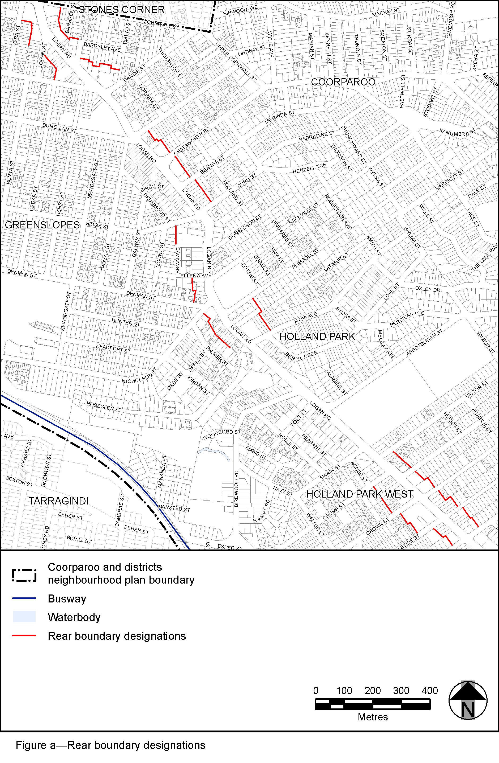
View the high resolution of Figure a—Rear boundary designations (PDF file size is 616Kb)
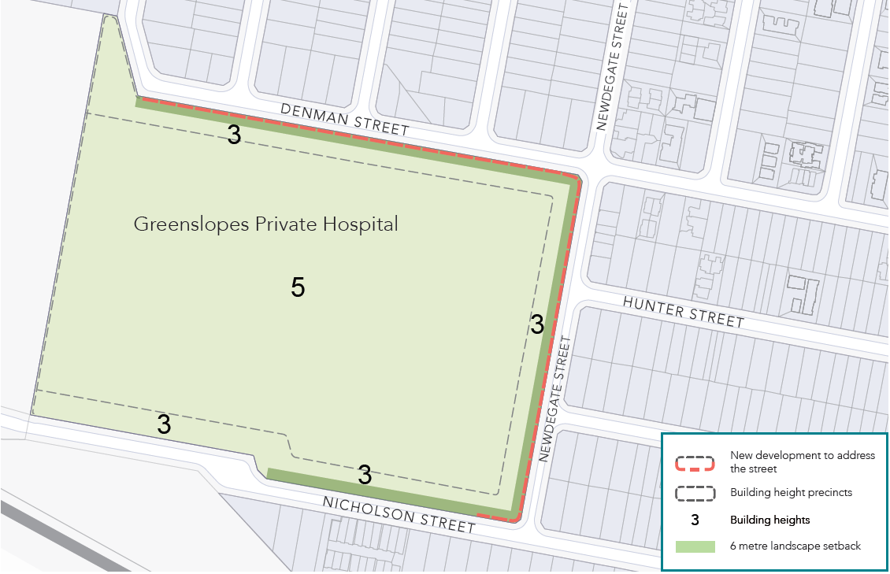

Figure b—Greenslopes Private Hospital precinct

View the high resolution of Figure b—Greenslopes Private Hospital precinct (PDF file size is 352Kb)
’.

3.3 Amendment of section 7.2 (Neighbourhood plan codes)
- Section 7.2 Neighbourhood plan codes, 7.2.8.1 Holland Park—Tarragindi district neighbourhood plan code–
omit, insert:
‘

7.2.8.1 Holland Park—Tarragindi district neighbourhood plan code

7.2.8.1.1 Application

- This code applies to assessing a material change of use, reconfiguring a lot, operational work or building work in the Holland Park—Tarragindi neighbourhood plan area if:
- assessable development where this code is an applicable code identified in the assessment benchmarks column of a table of assessment for a neighbourhood plan (section 5.9); or
- impact assessable development.
- Land in the Holland Park—Tarragindi district neighbourhood plan area is identified on the NPM-008.1 Holland Park—Tarragindi district neighbourhood plan map and includes the following precincts:
- Greenslopes Busway Station precinct (Holland Park—Tarragindi district neighbourhood plan/NPP-001);
- Kuring-gai Avenue neighbourhood centre precinct (Holland Park—Tarragindi district neighbourhood plan/NPP-002);
- Reservoir parkland precinct (Holland Park—Tarragindi district neighbourhood plan/NPP-003);
- Hillside character precinct (Holland Park—Tarragindi district neighbourhood plan/NPP-004).
- When using this code, reference should be made to section 1.5, section 5.3.2 and section 5.3.3.

Note—The following purpose, overall outcomes, performance outcomes and acceptable outcomes comprise the assessment benchmarks of this code.
Note—This neighbourhood plan includes a table of assessment with variations to categories of development and assessment. Refer to Table 5.9.53.A, Table 5.9.53.B, Table 5.9.53.C and Table 5.9.53.D.
Note—Hillside character areas are steeper residential areas containing traditional character housing and significant ridgelines. Hillside character is derived from the relationship of buildings to their physical setting. Traditional character housing built following an historic subdivision pattern and located on well-treed hillsides results in a unique character of important visual significance in the local context. Hillside character is retained and enhanced through sympathetic development that minimises visual impact within its visual catchment.

7.2.8.1.2 Purpose

- The purpose of the Holland Park—Tarragindi district neighbourhood plan code is to provide finer-grained planning at a local level for the Holland Park—Tarragindi district neighbourhood plan area.
- The purpose of the Holland Park—Tarragindi district neighbourhood plan code will be achieved through overall outcomes including overall outcomes for each precinct for the neighbourhood plan area.
- The overall outcomes for the Holland Park—Tarragindi district neighbourhood plan area are:
- A mix of housing densities and types serves the needs of the community, especially the neighbourhood plan area’s young adult and elderly populations. Identified character housing is retained with higher density housing encouraged in proximity to major employment nodes and public transport.
- Sandy, Ekibin and Norman Creeks are protected and enhanced for their ecological and recreational values.
- The landscape and ecological values of Wellers Hill Reservoir and Tarragindi Hill Reservoir are retained and enhanced.
- Public transport use is facilitated by upgrading pedestrian and cyclist access from employment nodes, centres and residential precincts to the Greenslopes and Holland Park Busway stations. Relaxation of parking requirements in the vicinity of the Busway stations is inconsistent with outcomes sought due to potential commuter parking conflicts.
- Significant views and vistas are protected. Development proposed in visually prominent locations such as major ridgelines and hill tops is designed to achieve minimal visual impact. Development forms that require cut and fill and disturbance of vegetation are avoided.
- Development is of a height, scale and form which is consistent with the amenity and character, community expectations and infrastructure assumptions intended for the relevant precinct, sub-precinct or site and is only developed at a greater height, scale and form where there is both a community need and an economic need for the development.
- Greenslopes Busway Station precinct (Holland Park—Tarragindi district neighbourhood plan/NPP-001) overall outcomes are:
- This precinct provides a range of housing types and other land uses including parks and community facilities in close proximity to the Greenslopes Busway station.
- Any non-residential and multiple dwelling development in this precinct contributes to the upgrading of the pedestrian environment, including provision of footpaths, street trees and other improvements to the accessibility of the Greenslopes Busway station.
(5) Kuring-gai Avenue neighbourhood centre precinct (Holland Park—Tarragindi district neighbourhood plan/NPP-002) overall outcomes are:
- This precinct provides convenience functions supporting the surrounding residential locality and Holland Park West Busway station.
- The built form and character of the precinct as a traditional suburban strip shopping centre is maintained.
- Development provides and incorporates upgraded walking paths, street trees and improvements to connections between the centre and footpaths leading to Holland Park West Busway station.
(6) Reservoir parkland precinct (Holland Park—Tarragindi district neighbourhood plan/NPP-003) overall outcomes are:
- This precinct contains Wellers Hill reservoir and Tarragindi Hill Reservoir which perform two important functions as a water storage and supply facility and as a park with bushland, scenic landscape and passive recreation values.
- Development complements the natural values of the site and avoids impacting surrounding residential amenity or the utility installation function of the reservoirs.
(7) Hillside character precinct (Holland Park—Tarragindi district neighbourhood plan/NPP-004) overall outcomes are:
- Hillside character is maintained, retained and enhanced through sympathetic development that minimises visual impact within its visual catchment.
- Development along major ridgelines in the precinct contributes to a consistent rhythm and sense of scale along the ridgeline when viewed from the surrounding visual catchment.
- Residential development in particular provides for:
- the appearance of traditional character houses uniformly spaced and stepped across well-treed hillsides;
- compatible building height, bulk and proportions;
- construction methods, such as posts or piers, that minimise the amount of alteration to site topography;
- alteration to site topography.

7.2.8.1.3 Performance outcomes and acceptable outcomes

Table 7.2.8.1.3.A—Performance outcomes and acceptable outcomes
Performance outcomes |  | Acceptable outcomes
General
PO1  Development is of a height, scale and form that achieves the intended outcome for the precinct, improves the amenity of the neighbourhood plan area, contributes to a cohesive streetscape and built form character and is:  - consistent with the anticipated density and assumed infrastructure demand;  - aligned to community expectations about the number of storeys to be built;  - proportionate to and commensurate with the utility of the site area and frontage width;  - designed to avoid a significant and undue adverse amenity impact to adjoining development;  - sited to enable existing and future buildings to be well-separated from each other and to avoid affecting the potential development of an adjoining site.  Note—Development that exceeds the intended number of storeys or building height can place disproportionate pressure on the transport network, public space or community facilities in particular.  Note—Development that is over-scaled for its site can result in an undesirable dominance of vehicle access, parking and manoeuvring areas that significantly reduce streetscape character and amenity. |  | AO1  No acceptable outcome is prescribed.
If in the Greenslopes Busway Station precinct (Holland Park—Tarragindi district neighbourhood plan/NPP-001)
PO2  Development:  - complements and enhances the existing residential and landscape character of the locality;  - retains significant vegetation and provides sufficient areas between buildings for the provision of trees and landscaping that uses locally occurring native species, in accordance with the Planting species planning scheme policy. |  | AO2  No acceptable outcome is prescribed.
If in the Kuring-gai Avenue neighbourhood centre precinct (Holland Park—Tarragindi district neighbourhood plan/NPP-002)
PO3  Development improves pedestrian facilities and streetscape amenity. | AO3.1  Development enhances the Kuring-gai Avenue Convenience Centre by street tree planting and landscaping in accordance with Figure a.
AO3.2
Development provides active street frontages to increase pedestrian activity in the centre in accordance with Figure a.
AO3.3
Development on Lot 21 on RP65585 is set back to retain views from Marshall Road to the centre in accordance with Figure a.
PO4  Development minimises impacts to the surrounding residential area. | AO4  Development that incorporates a vegetation buffer a minimum of 5m wide along rear and side boundaries where adjoining a residential site, provides a landscape screen capable of achieving a height of 10m to 12m at maturity that is not occupied by refuse bins or other back-of-house activities, to maintain visual privacy to residences.
If in the Hillside Character precinct (Holland Park—Tarragindi district neighbourhood plan/NPP-004)
Development pattern and form
PO5  Development for residential uses is:  - compatible with traditional character house scale;  - designed and sited to retain and reinforce the predominant development pattern and form of:  - separate allotments, whether or not the site area exceeds predominant lot sizes in the area or the site is an amalgamation of allotments;  - buildings of a traditional character house scale uniformly spaced and consistently stepped across well-treed hillsides when viewed from the visual catchment. | AO5.1  Development ensures the building footprint, boundary setbacks and siting in relation to adjoining development reflect the predominant development pattern and form of development in the area.
AO5.2
Development ensures buildings feature orthogonal plan forms with outside walls aligned with those on adjoining allotments or within the development.
Building height, scale and proportions
PO6  Development for residential uses achieves height, scale and proportions that are compatible with traditional character houses when viewed from the visual catchment. | AO6.1  Development of large buildings is designed to appear as a series of separate blocks, each of a size and scale similar to that of a traditional character house, using:  - physical separation;  - significant recesses and projections of the exterior wall plane;  - articulation through steps in the horizontal plane of the roof;  - roof geometry incorporating significant variety such as pitched roofs of a minimum 27.5 degree pitch;  - elevational and roof treatment in a variety of materials, colours and finishes compatible with traditional character houses to achieve the appearance of separate blocks.
AO6.2
Development only excludes building heights in the zone code where:
- using traditional character elements or site-responsive construction methods has resulted in non-compliance with the maximum building height;
- any additional building height or storeys are incorporated into a building form appearing to comply with maximum building height such as through additional storeys being incorporated into a roof-space area.
Note—Site–responsive construction methods, such as posts or piers, minimise the amount of alteration to site topography. Traditional character elements are pitched roofs of a minimum 27.5 degree pitch.
AO6.3
Development only exceeds the site cover prescribed acceptable outcome where the development is designed to reduce building bulk in accordance with AO6.1.
AO6.4
Development ensures the height of eaves reflects the predominant pattern and form of the area:
- along undulating ridgelines;
- horizontally across hillsides;
- vertically down hillsides.
AO6.5
Development ensures the length of an elevation treatment above ground level without variation, articulation or openings is no more than 10m.
PO7  Development is designed, sited and landscaped to minimise the impact of incompatible building bulk. | AO7  No acceptable outcome is prescribed.
PO8  Development along ridgelines does not dominate the skyline and is designed and sited to contribute to a consistent rhythm and sense of scale along the ridgeline when viewed from the visual catchment. | AO8  No acceptable outcome is prescribed.
Landscape character, physical setting and topography
PO9  Development minimises impacts on existing significant vegetation and provides replacement vegetation on the site of an advanced size and maturity where significant vegetation is removed. | AO9.1  Development of buildings, structures, driveways and hard-stand areas are designed and sited to maximise the retention of vegetation on the site.
AO9.2
Significant vegetation removed as a result of the development is replaced with vegetation of advanced size and maturity that contributes to the special character of the area.
Note—Trees featuring a trunk diameter width of 250mm or greater measured at 1m above ground level are considered significant vegetation. Advanced size and maturity is vegetation of 100L minimum stock size planted in sufficient quantity to achieve a total canopy area of 50% of the removed vegetation when mature.
PO10  Development for residential purposes must be designed to retain or reinforce the landscape character and physical setting of the locality and designed and situated to break up building bulk such that development appears:  - as a collection of separate buildings uniformly sited on well-treed hillsides; or  - separate buildings consistently spaced along major ridgelines. | AO10.1  Development provides communal open space and ground-storey private open space for residential development at a minimum dimension of 5m.
AO10.2
Development provides boundary setbacks that are a minimum of:
- 6m to the rear boundary;
- 12m to the rear boundary on sites steeper than 1 in 8 gradient (long axis from the front boundary to rear boundary of the site);
- 6m to any adjoining site’s front or rear boundary in the case of rear allotments;
- car parking and manoeuvring areas are located at least 3m from rear boundaries;
- the setback is planted to provide a dense landscape screen.
Note—In the case of corner lots, the rear boundary is that boundary which abuts other rear boundaries.
PO11  Development, including buildings or other structures, driveways and hard-stand areas, must be designed and sited to minimise cut and fill disturbance on the site. | AO11.1  Development incorporates:  - foundation systems of a type that minimise disturbance to the landscape, such as post and pier type foundations;  - slab-on-ground foundations only on those parts of a site with gradients less than 1 in 8 and where no cut and fill is required or cut and fill is minimal;  - benching, cut and fill, or construction of retaining walls of a minor nature only and designed so as not to be noticeable after construction has been completed;  - driveways and hard-stand areas only on those parts of a site with gradients less than 1 in 4.  Note—Cut and fill is considered to be of a minor nature where fill does not exceed 1m or the combined height of any retaining wall and fence does not exceed 2m.
AO11.2
Development sets back retaining walls from any boundary and are stepped or terraced and landscaped to soften visual impact.

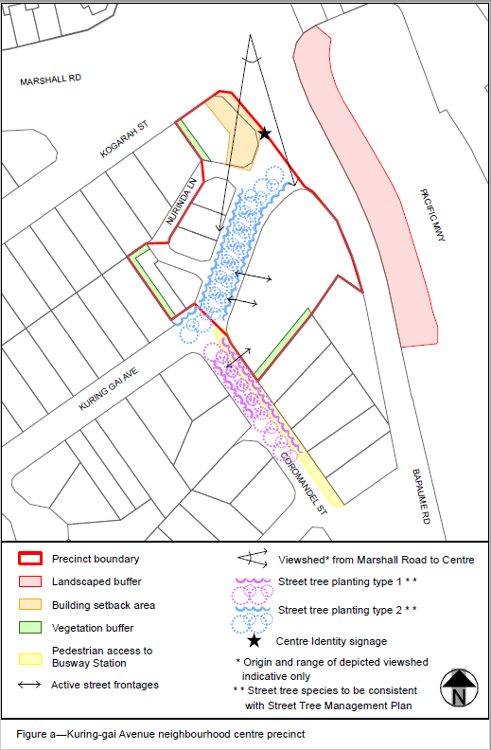
View the high resolution of Figure a—Kuring-gai Avenue neighbourhood centre precinct (PDF file size is 71 Kb)
’.

Part 4 Amendment of Part 8 (Overlays)

4.1 Amendment of section 8.2.12 (Heritage overlay code)
- 8.2.12 Heritage overlay code, Table 8.2.12.3 Performance outcomes and acceptable outcomes, Section B—If in the Area adjoining heritage sub-category,
insert before Section C—General performance outcomes and acceptable outcomes for the Heritage overlay:
‘
Additional performance outcomes and acceptable outcomes if in the Coorparoo and districts neighbourhood plan area
PO25  Development, including a dwelling house, does not diminish the streetscape contribution, setting, views or vistas of a heritage place from the street or public realm. | AO25  No acceptable outcomes is prescribed.
PO26  Development complements the existing setting of a heritage place, is of a sympathetic scale and bulk, and does not create an overbearing appearance or significantly impacts on its privacy or amenity. | AO26  No acceptable outcomes is prescribed.
’.
- 8.2.12 Heritage overlay code, Table 8.2.12.3 performance outcomes and acceptable outcomes, Section C—General performance outcomes and acceptable outcomes for the Heritage overlay
omit, insert:
‘
Additional performance outcomes and acceptable outcomes if in the City Centre neighbourhood plan area
PO27  Development provides ongoing protection of significant building fabric and vegetation during and after construction. | AO27  Development involving structural demolition or excavation that may impact upon a heritage place complies with a heritage place construction management plan.  Note—The Management plans planning scheme policy provides guidance on the preparation of a heritage place construction management plan.
PO28  Development for reconfiguring a lot on or adjoining a heritage place does not result in an allotment size, configuration or pattern which would potentially result in the setting or views of a heritage place being adversely affected. | AO28  No acceptable outcome is prescribed.
Additional performance outcomes and acceptable outcomes if in the Lutwyche Road corridor neighbourhood plan area
PO29  Development on or adjoining a heritage place does not diminish the following:  - heritage value;  - streetscape contribution;  - setting;  - significant views and vistas of the heritage place.  Note—These provisions only apply to development adjoining a place in the State heritage place sub-category where development does not require referral to SARA (refer to the Regulation).  Note—To demonstrate compliance with the performance criteria, a heritage impact assessment report is to be submitted demonstrating to the Council’s satisfaction that the development will not detract from or diminish the cultural heritage significance of the heritage place.  Generally the following points are to be considered when proposing a development adjacent to or affecting a heritage place:  - development is of a sympathetic scale and bulk and does not attempt to replicate or mimic the architectural detailing of all or part of the heritage place;  - development creates an appropriate high-quality interface for the heritage place by using building setbacks and screening measures such as mature trees;  - development of a new premises complements the existing streetscape and maintains the views of a heritage place from the street or public places;  - where a new building abuts a street elevation of a heritage place, a clear definition or transition between the old and new is created and projecting elements such as canopies, awnings, sunshades, banners and signage, do not substantially interrupt views of a heritage place from the street or a public place. | AO29  No acceptable outcome is prescribed.
PO30  Development involving premises on or adjoining Conon is of a suitable height and scale and is set back from common boundaries to ensure that the development does not overshadow Conon and its gardens.  Note—To demonstrate compliance with the performance outcome a heritage impact assessment report is to be submitted demonstrating to Council’s satisfaction that the development will not detract from or diminish the cultural heritage significance of the heritage place. | AO30  No acceptable outcome is prescribed.

’.

4.2 Amendments to section 8.2.19 (Significant landscape tree overlay code)
- Section 8.2.19 Significant landscape tree overlay code, Table 8.2.19.3.C—Significant landscape trees in specific locations–
insert before Doolandella:
‘
Camp Hill
Delonix regia poinciana | 21 Bovelles Street (front garden) | L28 RP40007
Delonix regia poinciana | 26 Carranya Street (front garden) | L71-72 RP13109
Araucaria cunninghamii hoop pine | 24 Grant Street (back garden) | L276 RP40830
Araucaria cunninghamii hoop pine | 27 Martha Street (back garden) | L4 RP43089
Lophostemon confertus Queensland brush box | 18 Warilda Street (front garden) | L31-32 RP13111
Eucalyptus tereticornis forest red gum | 53 Warilda Street (back garden) | L4 RP42013
Araucaria cunninghamii hoop pine | 94 Waverley Road (back garden) | L4 RP59401
Coorparoo
Cassia siamia kassod tree | 56 Beresford Terrace (front garden) | L21 RP48327
Araucaria cunninghamii hoop pine | 3 Brae Street (north corner of block) | L4 SP169100
Ficus benjamina weeping fig | 15 Brae Street (back garden) | L55-57 RP13064
Jacaranda mimosifolia jacaranda | 49 Buena Vista Avenue (front garden) | L3 RP71085
Eucalyptus tereticornis forest red gum | 93 Canopus Street (Crucis Street frontage) | L1 RP75689
Araucaria cunninghamii hoop pine | 236 Cavendish Road (east corner) | L2 RP53434
Jacaranda mimosifolia jacaranda | 349 Cavendish Road (front garden) | L28 RP45846
Ficus benjamina weeping fig | 89 Chatsworth Road (east side of block) | L19-20 RP13218
Flindersia australis crows ash | 171 Chatsworth Road (front garden) | L2 RP90810
Delonix regia poinciana | 16 Greens Road (front garden) | L1 RP102393
Araucaria cunninghamii hoop pine | 28 Kelsey Street (back garden) | L2 RP76212
Araucaria cunninghamii hoop pine | 118 Lade Street (back garden) | L2-3 RP13229
Araucaria cunninghamii hoop pine | 37 Nicklin Street (back garden) | L95 RP13046
Araucaria cunninghamii hoop pine | 25 Wellstead Avenue (back garden) | L47 RP13068
2 x Mangifera indica mango | 23 Welwyn Crescent (south corner of block) | L99 RP43565
Araucaria cunninghamii hoop pine | 28 Wills Street (back garden) | L62 RP42395
Brachychiton rupestris Queensland bottle tree | 63 York Street (front garden) | L63-64 RP13068
’ .
- Section 8.2.19 Significant landscape tree overlay code, Table 8.2.19.3.C—Significant landscape trees in specific locations–
insert before Hemmant:
‘
Greenslopes
2 x Eucalyptus saligna blue gum | 30 Baron Street (rear garden) | L353 RP37417
Eucalyptus tereticornis forest red gum | 21 Dansie Street (front garden) | L0,1-4 SP132636
2 x Araucaria cunninghamii hoop pine, Ficus benjamina weeping fig | 40 Dansie Street (back garden) | L1 RP13004
Delonix regia poinciana | 117 Earl Street (front garden) | L2 RP76457
Ficus benjamina weeping fig | 8 Hunter Street (front garden) | L225-226 RP12906
Mangifera indica mango | 70 Marquis Street (front garden) | L296 RP81261
Mangifera indica mango | 72 Marquis Street (front garden) | L50-51 SP261733
Eucalyptus grandis rose gum | 76 Peach Street (side garden) | L11 SP151589
Araucaria cunninghamii hoop pine | 148 Sackville Street (rear garden) | L51 RP13229
Ficus benjamina weeping fig | 68 Thomas Street (rear garden) | L20 RP42490
Ficus benjamina weeping fig | 27 Vera Street (rear garden) | L356-357 RP12942
Ficus benjamina weeping fig | Corner Logan Road and Beanga Street | Adjacent to L86 RP13206
’ .
- Section 8.2.19 Significant landscape tree overlay code, Table 8.2.19.3.C—Significant landscape trees in specific locations–
insert before Kelvin Grove:‘
Holland Park
Jacaranda mimosifolia jacaranda | 96 Abbotsleigh Street (back garden) | L11 RP48807
Araucaria cunninghamii hoop pine | 173 Abbotsleigh Street (back garden) | L3 RP68825
Araucaria cunninghamii hoop pine | 20 Raff Avenue (rear garden) | L13 RP13250
Ficus benjamina weeping fig | 66 Raff Avenue (rear garden) | L20 RP13251
Holland Park West
Syzygium oleosum blue lilly-pilly | 12 Hamel Road (front garden) | L7 RP58410
Delonix regia Poinciana | 37 Hamel Road (north corner of block) | L1 RP63805
1 x Ficus oblique small-leaved fig  1 x Delonix regia poinciana | 1008 Logan Road (front of property) | L1 RP865356
’.

Part 5 Amendment of Schedule 2 (Mapping)

5.1 Amendment to Schedule 2.1 (Strategic framework maps)
- Schedule 2 Mapping, SC2.1 Strategic framework maps, Table SC2.1.1—Strategic framework maps–
omit, insert:
‘
Not applicable | SFM-003 | Brisbane selected transport corridors and growth nodes strategic framework map | 26 July 2019
’.

5.2 Amendment to Strategic framework maps
- Schedule 2 Mapping, SC2.1 Strategic framework map, SFM-003–
omit, insert:
SC2.1 Strategic framework map, SFM-003 Brisbane selected transport corridors and growth nodes strategic framework map-refer to Supplement 1a.

5.3 Amendment to Schedule 2.2 (Zone maps)
- Schedule 2 Mapping, SC2.2 Zone maps, Table SC2.2.1—Zone Maps–
insert after last row:
‘
Not applicable | ZM-001 | Zoning map  Map tiles 28, 29, 35 and 36 | 26 July 2019
’.

5.4 Amendment to Zone maps
- Schedule 2 Mapping, SC2.2 Zone Maps, ZM-001 (Tile 28)
omit, insert:
SC2.2 Zone maps, ZM-001 (Tile 28)–refer to Supplement 1b.
- Schedule 2 Mapping, SC2.2 Zone Maps, ZM-001 (Tile 29)
omit, insert:
SC2.2 Zone maps, ZM-001 (Tile 29)–refer to Supplement 1c.
- Schedule 2 Mapping, SC2.2 Zone Maps, ZM-001 (Tile 35)
omit, insert:
SC2.2 Zone maps, ZM-001 (Tile 35)–refer to Supplement 1d.
- Schedule 2 Mapping, SC2.2 Zone Maps, ZM-001 (Tile 36)
omit, insert:
SC2.2 Zone maps, ZM-001 (Tile 36)–refer to Supplement 1e.

5.5 Amendment to Schedule 2.3 (Neighbourhood plan maps)
- Schedule 2 Mapping, SC2.3 Neighbourhood plan maps, Table SC2.3.1 — Neighbourhood plan maps–
insert:
‘
NPM-003.10 | Coorparoo and districts neighbourhood plan map | 26 July 2019

’.
- Schedule 2 Mapping, SC2.3 Neighbourhood plan maps, Table SC2.3.1—Neighbourhood plan maps, NPM-008.1 Holland Park—Tarragindi district neighbourhood plan map 30 June 2014–
omit, insert:
‘
NPM-008.1 | Holland Park—Tarragindi district neighbourhood plan map | 26 July 2019
’.

5.6 Amendment to Neighbourhood plan maps
- Schedule 2 Mapping, NPM-003.10 Coorparoo and districts neighbourhood plan map–
insert:
NPM-003.10 Coorparoo and districts neighbourhood plan map–refer to Supplement 1f.
- Schedule 2 Mapping, NPM-008.1 Holland Park—Tarragindi district neighbourhood plan map–
omit, insert:
NPM-008.1 Holland Park—Tarragindi district neighbourhood plan map–refer to Supplement 1g.

5.7 Amendment to Schedule 2.4 (Overlay maps)
- Schedule 2 Mapping, SC2.4 Overlay maps, Table SC2.4.1—Overlay maps–
insert before OM-003.3:
‘
OM-003.2 | Commercial character building overlay map  Map tile 36 | 26 July 2019
’.
- Schedule 2 Mapping, SC2.4 Overlay maps, Table SC2.4.1—Overlay maps–
insert before OM-005.1:
‘
OM-004.1 | Dwelling house character overlay map  Map tiles 28, 29, 35 and 36 | 26 July 2019
’.
- Schedule 2 Mapping, SC2.4 Overlay maps, Table SC2.4.1—Overlay maps–
insert before OM-009.1:
‘
OM-008.1 | Heritage overlay map  Map tiles 29 and 36 | 26 July 2019
’.
- Schedule 2 Mapping, SC2.4 Overlay maps, Table SC2.4.1—Overlay maps–
insert before Q:
‘
OM-016.2 | Pre-1911 building overlay map  Map tiles 28, 29, 35 and 36 | 26 July 2019
’.
- Schedule 2 Mapping, SC2.4 Overlay maps, Table SC2.4.1—Overlay maps–
insert before OM-019.2:
‘
OM-019.1 | Significant landscape tree overlay map  Map tiles 28, 29, 35 and 36 | 26 July 2019
’.
- Schedule 2 Mapping, SC2.4 Overlay maps, Table SC2.4.1—Overlay maps–
insert before OM-020.1:
‘
OM-019.2 | Streetscape hierarchy overlay map  Map tiles 28, 29, 35 and 36 | 26 July 2019
’.
- Schedule 2 Mapping, SC2.4 Overlay maps, Table SC2.4.1—Overlay maps–
insert OM-020.2:
‘
OM-020.1 | Traditional building character overlay map  Map tiles 28, 29, 35 and 36 | 26 July 2019
’.

5.8 Amendment to Overlay maps
- Schedule 2 Mapping, OM-003.2 Commercial character building overlay map (Tile 36)–
omit, insert:
OM-003.2 Commercial character building overlay map (Tile 36)–refer to Supplement 1h.
- Schedule 2 Mapping, OM-004.1 Dwelling house character overlay map (Tile 28)–
omit, insert:
OM-004.1 Dwelling house character overlay map (Tile 28)–refer to Supplement 1i’.
- Schedule 2 Mapping, OM-004.1 Dwelling house character overlay map (Tile 29)–
omit, insert:
OM-004.1 Dwelling house character overlay map (Tile 29)–refer to Supplement 1j.
- Schedule 2 Mapping, OM-004.1 Dwelling house character overlay map (Tile 35)–
omit, insert:
OM-004.1 Dwelling house character overlay map (Tile 35)–refer to Supplement 1k.
- Schedule 2 Mapping, OM-004.1 Dwelling house character overlay map (Tile 36)–
omit, insert:
OM-004.1 Dwelling house character overlay map (Tile 36)–refer to Supplement 1l.
- Schedule 2 Mapping, OM-008.1 Heritage overlay map (Tile 29)–
omit, insert:
OM-008.1 Heritage overlay map (Tile 29)–refer to Supplement 1m.
- Schedule 2 Mapping, OM-008.1 Heritage overlay map (Tile 36)–
omit, insert:
OM-008.1 Heritage overlay map (Tile 36)–refer to Supplement 1n.
- Schedule 2 Mapping, OM-016.2 Pre-1911 building overlay map (Tile 28)
omit, insert:
OM-016.2 Pre-1911 building overlay map (Tile 28)–refer to Supplement 1o.
- Schedule 2 Mapping, OM-016.2 Pre-1911 building overlay map (Tile 29)
omit, insert:
OM-016.2 Pre-1911 building overlay map (Tile 29)–refer to Supplement 1p.
- Schedule 2 Mapping, OM-016.2 Pre-1911 building overlay map (Tile 35)
omit, insert:
OM-016.2 Pre-1911 building overlay map (Tile 35)–refer to Supplement 1q.
- Schedule 2 Mapping, OM-016.2 Pre-1911 building overlay map (Tile 36)
omit, insert:
OM-016.2 Pre-1911 building overlay map (Tile 36)–refer to Supplement 1r.
- Schedule 2 Mapping, OM-019.1 Significant landscape tree overlay map (Tile 28)–
omit, insert:
OM-019.1 Significant landscape tree overlay map (Tile 28)–refer to Supplement 1s.
- Schedule 2 Mapping, OM-019.1 Significant landscape tree overlay map (Tile 29)–
omit, insert:
OM-019.1 Significant landscape tree overlay map (Tile 29)–refer to Supplement 1t.
- Schedule 2 Mapping, OM-019.1 Significant landscape tree overlay map (Tile 35)–
omit, insert:
OM OM-019.1 Significant landscape tree overlay map (Tile 35)–refer to Supplement 1u.
- Schedule 2 Mapping, OM-019.1 Significant landscape tree overlay map (Tile 36)–
omit, insert:
OM-019.1 Significant landscape tree overlay map (Tile 36) refer to Supplement 1v.
- Schedule 2, Mapping OM-019.2 Streetscape hierarchy overlay map (Tile 28)–
omit, insert:
OM-019.2 Streetscape hierarchy overlay map (Tile 28)–refer to Supplement 1w.
- Schedule 2, Mapping OM-019.2 Streetscape hierarchy overlay map (Tile 29)–
omit, insert:
OM-019.2 Streetscape hierarchy overlay map (Tile 29)–refer to Supplement 1x.
- Schedule 2, Mapping OM-019.2 Streetscape hierarchy overlay map (Tile 35)–
omit, insert:
OM-019.2 Streetscape hierarchy overlay map (Tile 35)–refer to Supplement 1y.
- Schedule 2, Mapping OM-019.2 Streetscape hierarchy overlay map (Tile 36)–
omit, insert:
OM-019.2 Streetscape hierarchy overlay map (Tile 36)–refer to Supplement 1z.
- Schedule 2 Mapping OM-020.1 Traditional building character overlay map (Tile 28)–
omit, insert:
OM-020.1 Traditional building character overlay map (Tile 28)–refer to Supplement 1aa.
- Schedule 2 Mapping OM-020.1 Traditional building character overlay map (Tile 29)–
omit, insert:
OM-020.1 Traditional building character overlay map (Tile 29)–refer to Supplement 1ab.
- Schedule 2 Mapping OM-020.1 Traditional building character overlay map (Tile 35)–
omit, insert:
OM-020.1 Traditional building character overlay map (Tile 35)–refer to Supplement 1ac.
- Schedule 2 Mapping OM-020.1 Traditional building character overlay map (Tile 36)–
omit, insert:
OM-020.1 Traditional building character overlay map (Tile 36)–refer to Supplement 1ad.

Part 6 Amendment of Schedule 6 (Planning scheme policies)

6.1 Amendment to Schedule 6.16 (Infrastructure design planning scheme policy)
- Schedule 6 Planning scheme policies (PLANNING SCHEME POLICY), SC6.16 Infrastructure design planning scheme policy, Chapter 5 Streetscape locality advice, Table 5.1.2—Locality streets within Neighbourhood plan areas and other locations–
insert before 5.3.4.1 Dutton Park—Fairfield:
‘
5.3.3.3 | Coorparoo and districts
’.
- Schedule 6 Planning scheme policies (PLANNING SCHEME POLICY), SC6.16 Infrastructure design planning scheme policy, Chapter 5.3 Neighbourhood plan areas and other locations–
insert:
‘

5.3.3.3 Coorparoo and districts

5.3.3.3.1 Location and extent
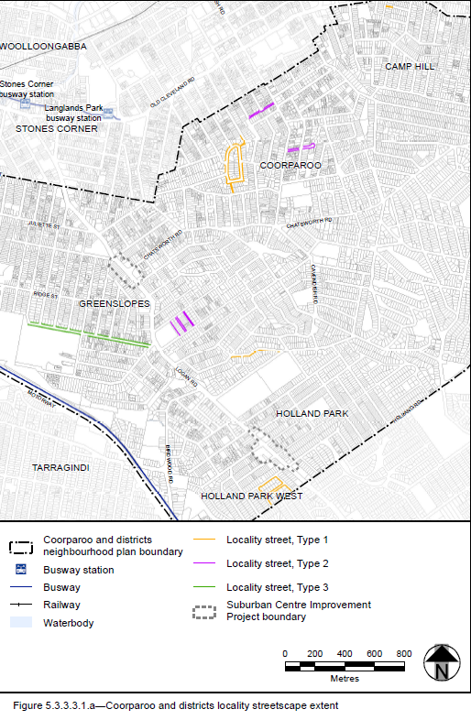

Figure 5.3.3.3.1.a—Coorparoo and districts locality streetscape extent
- The locality streets in the Coorparoo and districts neighbourhood plan area are indicated on the Coorparoo and districts locality streetscape extent map in Figure 5.3.3.3.1.a.
- All streetscape works occurring within the locality streets indicated in Figure 5.3.3.3.1.a must comply with the character specified in this document.
- Streetscapes outside these areas may be developed in keeping with this character, at the discretion of the developer and subject to Council approval.

5.3.3.3.2 Standard footway elements and materials
- These locality guidelines are to be read in conjunction with Chapter 3 Road corridor design of the Infrastructure design planning scheme policy.
- Footway upgrades are to include new surfacing, new or reinstated kerb and channel, driveways, pedestrian kerb crossings, tactile markers, roof water drainage line connections, service pit lids, street trees, garden beds, furniture and pedestrian lighting applicable to the streetscape type.
- The scope, layout and detail of the footway upgrades are to be agreed on a site by site basis through the development assessment process.

5.3.3.3.3 Streetscape hierarchy

5.3.3.3.3.1 Streetscape types overview
- The locality streets within the Coorparoo and districts neighbourhood plan area are exceptions to the standard streetscape hierarchy.
- The streetscape type and specifications for locality streets in this area are outlined in Table 5.3.3.3.3.1A and shown in Figure 5.3.3.3.1.a.

Table 5.3.3.3.3.1A—Streetscape type and specifications
Component | Locality Streets Type 1 in Coorparoo and districts neighbourhood plan area
Verge width | As existing verge width
Description | Full width turf
Driveways | Broom finished concrete
Furniture | No furniture
Trees | Street trees are permitted in accordance with the footway width requirements set out in Table 5.3.3.3.3.1B.  Streets trees include:  - medium and small crown trees to be planted at minimum 2m spacing, if within garden beds, or minimum 6m spacing outside of garden beds  - large crown feature trees to be planted at minimum 10m centres.  Distance:  - all tree centrelines are 750mm from the nominal face of the kerb.  Layout:  - trees planted in a single row at the rear of kerb;  - to be planted as singles and in pairs or clusters.

Component | Locality Streets Type 2 in Coorparoo and districts neighbourhood plan area
Verge width | As existing verge width
Description | 1.2m wide⁽¹⁾ concrete footpath in turf
Unobstructed pavement width | Refer to Table 5.3.3.3.3.1B, as applicable
Paving Materials | Broom finished concrete
Tactile markers  (consistent with BSD-5218) | Type: Concrete tactile paver  Supplier: Chelmstone, Urbanstone or approved equivalent  Colour: CCS ‘Voodoo’
Driveways | Broom finished concrete
Furniture | No furniture
Trees | Street trees are permitted in accordance with the footway width requirements set out in Table 5.3.3.3.3.1B.  Streets trees include:  - a mix of tree species laid out in an informal manner with clusters of trees  - medium and small crown trees to be planted at minimum 2m spacing, if within garden beds, or minimum 6m spacing outside of garden beds  - large crown feature trees to be planted at minimum 10m centres.  Distance:  - all tree centrelines are 750mm from the nominal face of the kerb and a minimum of 600mm from the edges of the pavement.  Layout:  - a mix of species, in a single row at the rear of kerb;  - to be planted as singles and in pairs or clusters.
Notes: (1) Where existing verge width allows.

Component | Locality Streets Type 3 in Coorparoo and districts neighbourhood plan area
Verge width | As existing verge width
Description | 1.8m wide concrete footpath in turf  Concrete footpath abuts the property boundary
Unobstructed pavement width | Refer to Table 5.3.3.3.3.1B, as applicable
Pavement Materials | Broom finished concrete
Tactile markers  (consistent with BSD-5218) | Type: Concrete tactile paver  Supplier: Chelmstone, Urbanstone or approved equivalent  Colour: CCS ‘Voodoo’
Driveways | Broom finished concrete
Furniture | No furniture
Trees | Street trees are permitted in accordance with the footway width requirements set out in Table 5.3.3.3.3.1B.  Streets trees include:  - a mix of tree species laid out in an informal manner with clusters of trees;  - medium and small crown trees to be planted at minimum 2m spacing, if within garden beds, or minimum 6m spacing outside of garden beds  - large crown feature trees to be planted at minimum 10m centres.  Distance:  - all tree centrelines are 1350mm from the nominal face of the kerb and a minimum of 600mm from the edges of the pavement.  Layout:  - a mix of species, in a single row at the rear of kerb;  - to be planted as singles and in pairs or clusters.
Turf strip adjacent kerb – minimum width | 1.8m – varying width
Turf strip at rear of verge | 0m
Tree planting beds – minimum widths | 1.2m

Table 5.3.3.3.3.1B—Footway width exceptions
Existing verge widths (from nominal face of kerb) | Garden beds | Street trees | Pathway width Locality Street Type 1 | Pathway width Locality Street Type 2 | Pathway width Locality Street Type 3
Less than 1.65m | No garden beds | No | No path | Full width | Full width
1.65m - 2.49m | No garden beds | No | No path | 1.2m | 1.2m
2.5m and wider | No garden beds | Yes | No path | 1.2m | 1.8m

5.3.3.3.4 Planting – Locality Street Types 1 and 2

5.3. 3.3.4.1 Street trees
- Street trees are permitted as identified in Table 5.3.3.3.4.1A and each street has an approved street tree species to fit with the character within the precinct.
- Street trees are to be:
- laid out in an informal manner
- medium and small crown trees to be planted at minimum 2m spacing, if within garden beds, or minimum 6m spacing outside of garden beds
- large crown feature trees to be planted at minimum 10m centres.
- Trees are to be planted in garden beds.
- Table 5.3.3.3.4.1A sets out the approved street tree species for use on the various streets within the Coorparoo and districts neighbourhood plan area.

Table 5.3.3.3.4.1A—Street trees
Street | Street tree
Lamrock Street (north side) | Buckinghamia celsissima
Doughty Avenue (south side) | Buckinghamia celsissima Delonix regia
Curlewis Street (south side) | Xanthostemon chrysanthus  Jacaranda mimosifolia
Ontario Street | Syzygium australe  Delonix regia
Percival Terrace | Delonix regia  Bauhinia purpurea
Letchworth Road | Delonix regia  Buckinghamia celsissima
Regal Street (in the crescent between Letchworth Road and Welwyn Crescent) | Delonix regia  Buckinghamia celsissima
Howard Street | Delonix regia  Buckinghamia celsissima
Welwyn Crescent | Delonix regia  Buckinghamia celsissima
Welwyn Crescent (off MacKay Street) | No trees
Regal Street (off Letchworth Road and Macaulay Street) | No trees

5.3.3.3.5 Planting – Locality Street Type 3

5.3.3.3.5.1 Street trees
- Street trees are permitted and section 3.7.5 Design standards for street tree planting sets out the approved street tree species for use on the various streets within the Coorparoo and districts area.
- Each street has a minimum of two approved street tree species to encourage variety and diversity within the precinct.
- Where two or more street trees are required on the same development frontage, a mixture of the appropriate species as listed in section 3.7.5 Design standards for street tree planting is required.
’.

6.2 Amendment to Schedule 6.29 (Structure planning planning scheme policy)
- Schedule 6 Planning scheme policies (PLANNING SCHEME POLICY), SC6.29 Structure planning planning scheme policy, Section 1.1 Relationship to planning scheme, above Ferny Grove—Upper Kedron neighbourhood plan code–
insert:
‘
Coorparoo and districts neighbourhood plan code
Table 7.2.3.10.3.A | PO10 | All
’.

Part 7 Amendment of Appendix 2 (Table of amendments)

7.1 Amendment to Appendix 2 (Table of amendments)
- Appendix 2 Table of Amendments, Table AP2.1—Table of amendments–
insert:
‘
28 May 2019 (adoption) and 26 July 2019 (effective) | V16.00/2019 | Major and minor | Major amendment to planning scheme (2.3A.4 of MAALPI);  Minor amendment to planning scheme policy (Schedule 1, Section 6 b) of MGR)  Refer to Amendment v16.00/2019 for further detail.
’.

Supplement 1—A3 Map Tiles

