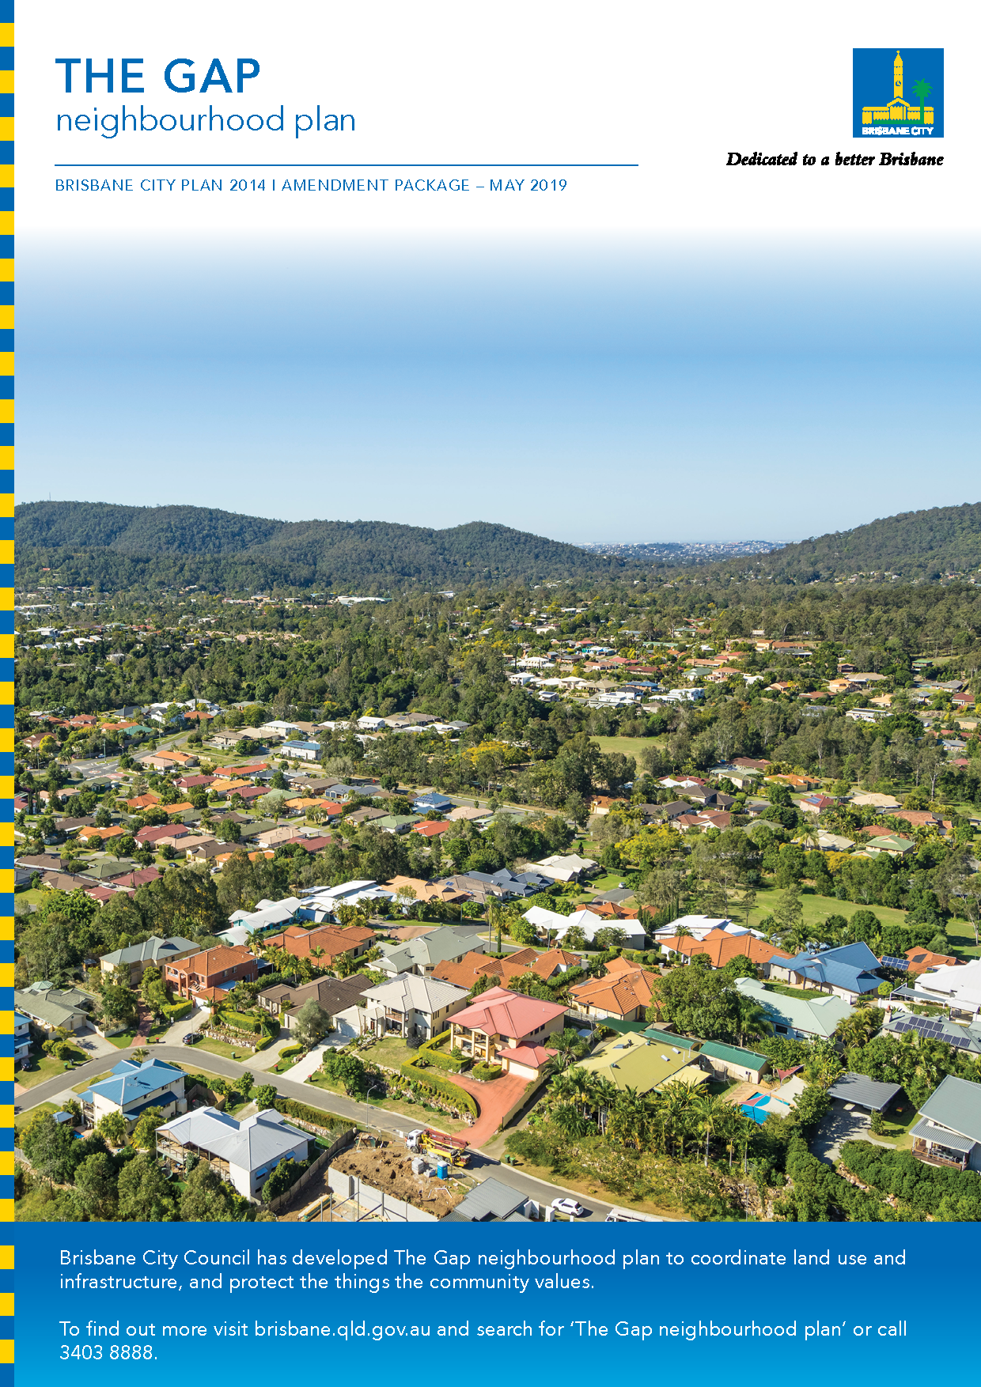
Table of Contents
Part A: Explanatory Notes 2
Purpose 3
Introduction 3
Background 3
Key planning outcomes 5
Key changes 6
Integration with City Plan 9
Amendment summary 9
Community engagement 11
Conclusion 12
Part B: Major Amendment v15.00/2019 13
Part 1 Amendment of Part 1 (About the planning scheme) 14
1.1 Amendment of section 1.2 (Planning scheme components) 14
Part 2 Amendment of Part 5 (Tables of assessment) 15
2.1 Amendment of section 5.9 (Categories of development and assessment—Neighbourhood plans) 15
Part 3 Amendment of Part 7 (Neighbourhood plans) 16
3.1 Amendment of section 7.1 (Preliminary) 16
3.2 Amendment of section 7.2 (Neighbourhood plan codes) 17
Part 4 Amendment of Part 8 (Overlays) 24
4.1 Amendment to section 8.2.19 (Significant landscape tree overlay code) 24
Part 5 Amendment of Schedule 2 (Mapping) 25
5.1 Amendment to Schedule 2.2 (Zone maps) 25
5.2 Amendment to Table SC2.2.1 (Zone maps) 26
5.3 Amendment to Schedule 2.3 (Neighbourhood plan maps) 27
5.4 Amendment to Table SC2.3.1 (Neighbourhood plan maps) 28
5.5 Amendment of Schedule 2.4 (Overlay maps) 29
Part 6 Amendment of Planning scheme policies 33
Part 7 Amendment of Appendix 2 (Table of amendments) 34
7.1 Amendment to Appendix 2 (Table of Amendments) 34
Supplement 1—A3 Map tiles 35
Supplement 1a Zoning map, Tile 19 35
Supplement 1b The Gap neighbourhood plan map NPM-020.5 36
Supplement 1c Dwelling house character overlay map, Tile 19 37
Supplement 1d Significant landscape tree overlay map, Tiles 19 and 27 38

Part A: Explanatory Notes

Purpose

The purpose of these explanatory notes is to provide context to The Gap neighbourhood plan (the neighbourhood plan) amendment package (the amendment package), including the key outcomes of the neighbourhood plan and the process undertaken to develop the neighbourhood plan. The explanatory notes do not form part of the amendment package.

Introduction

This document has been prepared to provide assistance in interpreting the amendment package, which will become an amendment to Brisbane City Plan 2014 (City Plan).

The amendment package sets out the statutory amendments required to City Plan to incorporate the neighbourhood plan. It contains two parts – this explanatory statement (for information only), and the amendment that specifies the statutory changes. The amendment consists of a new neighbourhood plan code for The Gap, revised zones and overlay mapping, and consequential amendments to City Plan.

Background

Brisbane City Council (Council) proposes to introduce the neighbourhood plan to guide future development in The Gap. The amendment package forms a major amendment to City Plan and has been prepared in accordance with Queensland Government requirements.

Council commenced the neighbourhood planning process for The Gap in April 2016. The Gap neighbourhood plan draft strategy (the draft strategy) was released for community consultation from October 2017 to December 2017. Feedback received from the community on the draft strategy, as well as feedback received through the Community Planning Team (CPT), has been used in the preparation of the amendment package. Internal Council stakeholders and Queensland Government agencies have also been involved in preparing the amendment package. More information about the community engagement undertaken to inform this amendment package is outlined in the Community engagement section.

The neighbourhood plan has been prepared to help maintain the suburban lifestyle in The Gap and seeks to achieve the following outcomes.
- Support and promote the Suburban Living Area function as outlined in the Strategic framework of City Plan, including the provision of housing choice for older and younger residents.
- Confirm the role of The Gap Village Shopping Centre and enhance this location as a place for locals to meet, shop, dine and work.
- Manage the interface between the Greenspace System and Suburban Living Area.
- Protect the urban character of the area.
- Provide an opportunity for the local community to input into the future planning for the area.

What are neighbourhood plans?

Neighbourhood plans guide development in local communities, to ensure that each area retains and enhances its own special character and qualities. Currently, there is no neighbourhood plan for The Gap, so development is regulated by the citywide provisions included in City Plan and other Queensland Government legislation.

The neighbourhood plan will refine City Plan to better suit the local area and provide additional planning provisions above those already provided. These additional planning provisions are intended to address important local issues.

Neighbourhood plans cannot:
- reduce the scale of existing development or make it harder for property owners to lawfully develop their existing property
- stop already-approved development, even if building has not commenced yet.

Further information is provided in the Integration with City Plan section.

Neighbourhood plan boundary

The neighbourhood plan focuses on the suburb of The Gap and also small portions of Keperra, Upper Kedron and Mt Coot-tha. The Gap is a unique area, located only 12 km from the Brisbane Central Business District but is also close to large areas of ecological significance such as Mt Coot-tha and D’Aguilar National Park. The neighbourhood plan boundary is outlined in Figure 1.

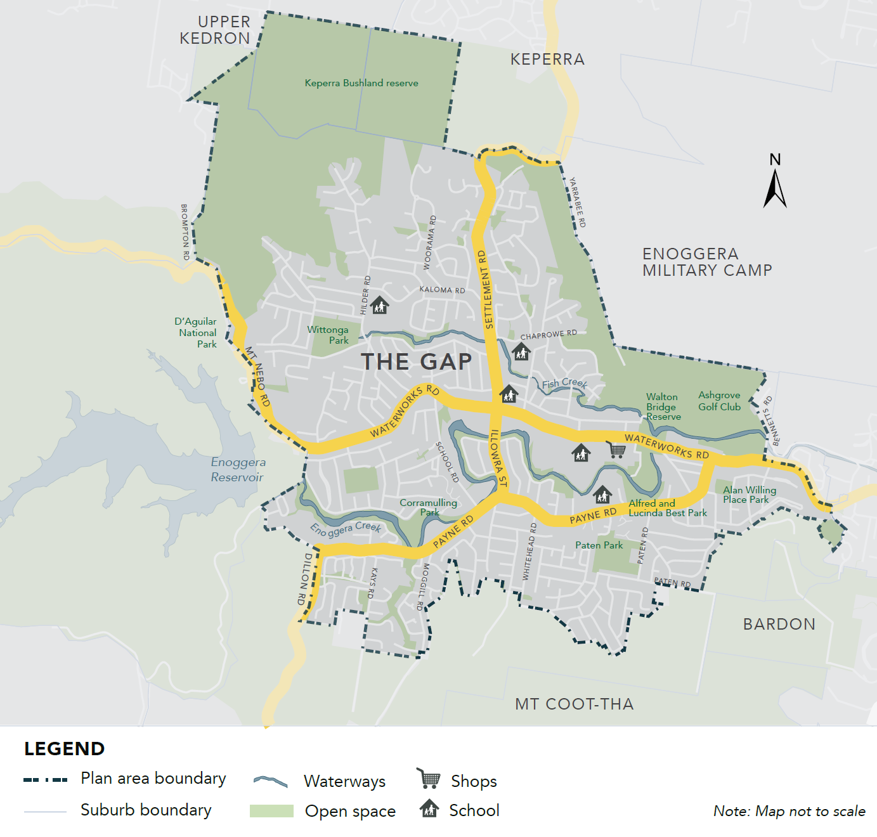
Figure 1—The Gap neighbourhood plan boundary

Key planning outcomes

The amendment package will ensure that new development responds to key State, regional and local planning outcomes.

Response to the South East Queensland Regional Plan 2017 – ShapingSEQ
The amendment package supports the policies of the South East Queensland Regional Plan 2017 – ShapingSEQ by:
- protecting and enhancing the biodiversity network to support the natural environment (Goal 4 Sustain: Biodiversity)
- encouraging good quality subtropical design outcomes (Goal 5 Live: Valuing good design and Working with the weather).
- locating diverse housing types in proximity to the existing centre (Goal 1 Grow: Efficient land use, Focusing density and Housing diversity; and Goal 4 Sustain: Affordable living).
- Reviewing land on the border of the Urban Footprint and encouraging growth to occur within the current Urban Footprint.

Response to the State Planning Policy July 2017
Together with City Plan, the amendment package supports and integrates the State interests outlined in the State Planning Policy July 2017. The amendment package promotes economic growth and housing diversity by focusing a limited amount of increased density around existing centres, services and facilities (Liveable communities and housing: Housing supply and diversity, State interest policy 1). New development is to be responsive to ecological values such as biodiversity features and encouraged in locations that avoid or minimise impacts on the environment (Environment and heritage, State interest policy 3).

Response to City Plan’s Strategic framework
The Gap is identified in City Plan’s Strategic framework as a Suburban Living Area. The provisions included in the amendment support this outcome.

Response to local planning outcomes
The Gap is not expected to change significantly over the next 10 years. However, there is a need to provide different sizes and types of homes in The Gap so that younger people, older people and people with different household sizes can all find housing that suits their needs.

The neighbourhood plan will refine City Plan to better suit local conditions and will protect existing character by providing further guidance about the scale, location and type of future development. The amendment package responds to local planning outcomes, as it seeks to protect the suburban character of the area while providing some housing diversity in appropriate locations, protecting the green and leafy values and established vegetation in the area, and encouraging the revitalisation of The Gap Village Shopping Centre as a place for locals to meet, relax, shop and work.

Further details about how the amendment package achieves these outcomes are provided below.

Key changes

The amendment package consists of the following key components:
- The Gap neighbourhood plan code
  - The Village precinct
  - Potential development areas precinct
- land use zoning – changes to the land use zone applied to specific properties
- supporting changes to overlays.

The following provides an overview of these changes.

The Gap neighbourhood plan code
The Gap neighbourhood plan code seeks to retain the residential character of The Gap. The key provisions included in the code include the following.
- Retention of the suburban character and local residential amenity, with no changes proposed to the existing Low density residential zone across the vast majority of the neighbourhood plan area.
- Establishment of a precinct identifying potential development areas over several sites to provide additional certainty regarding the developable portion of the land; the portion of the site that is not appropriate for development due to ecological features; and density and built form guidance so that development is of an appropriate scale and form. See the Potential development areas precinct section for more information.
- Retention of existing large shade trees and provision of deep planting and subtropical landscaping in new developments.
- Encouraging diverse types of housing on the northern fringe of The Gap Village shopping centre, in proximity to shops, retail and transport, including adaptable housing.
- Establishment of a precinct providing design and accessibility guidance for The Gap Village shopping centre, encouraging a high-quality pedestrian environment, improved access and pleasant urban streetscape.

The Village precinct
The Village precinct (see Figure 2) is intended to encourage the revitalisation of The Gap Village Shopping Centre as a place for the community to shop, recreate and work, and encourage a high-quality pedestrian environment and pleasant urban streetscape. A limited number of townhouses and units are encouraged on the northern side of Waterworks Road, in proximity to shops, retail and transport, to support The Gap Village shopping centre. Adaptable housing is also provided for in this precinct.

The precinct includes The Village centre sub-precinct which provides additional guidance for the redevelopment of The Gap Village shopping centre, including vehicular and pedestrian access, design outcomes and activating frontages.

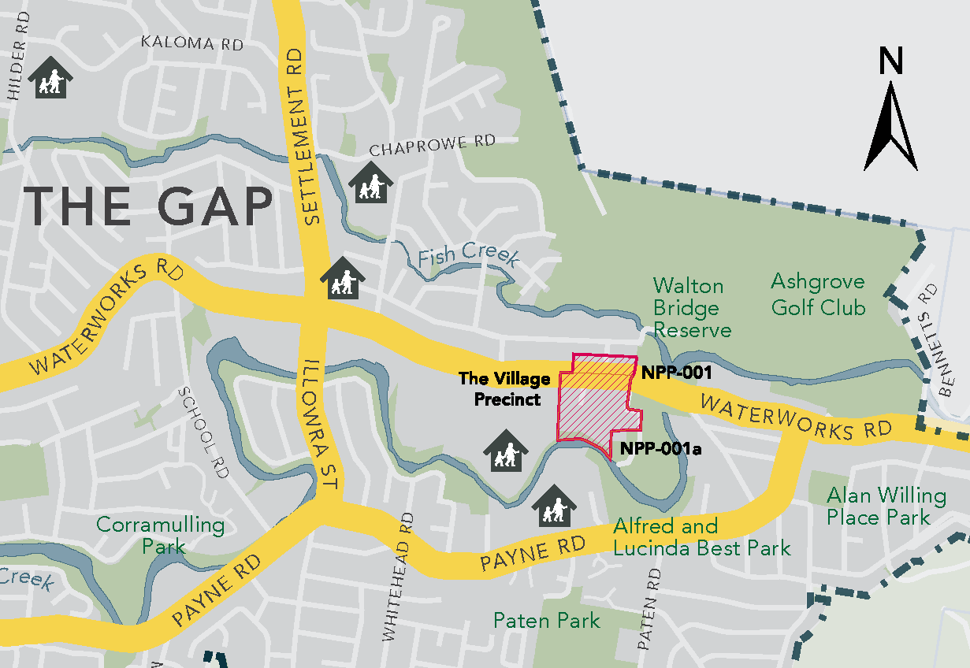
Figure 2—The Village precinct

Potential development areas precinct
The amendment package establishes a precinct identifying potential development areas over several sites in The Gap (see Figure 3). These sites are currently zoned Emerging community and are to be rezoned to Low density residential. The precinct and supporting provisions clarify which portion of each site can be used for the development footprint and which part of the site is not intended for development, based on ecological features.

The precinct is supported by provisions relating to density provisions, so that development is of an appropriate scale and form suitable considering the location of land, services, amenity, ecological features and existing patterns of development.

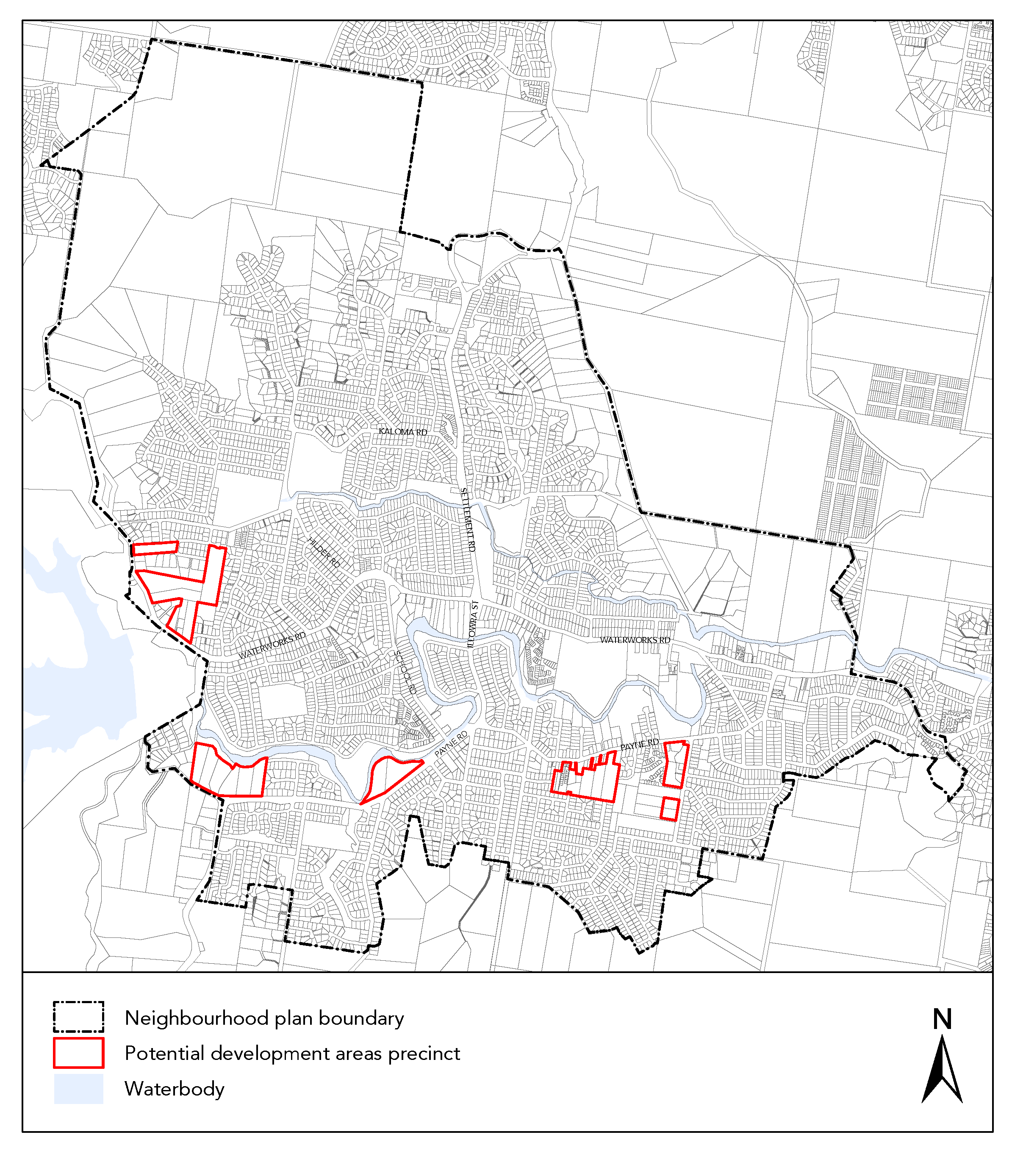Figure 3—Potential development areas precinct

Land use zoning
There are several zone changes in the amendment package to ensure that the zoning suitably reflects the desired land use outcomes for the area. Please refer to the zoning map in Supplement 1a for more detail.

Overlay changes
The amendment package proposes changes to the:
- Significant landscape tree overlay to include an additional 11 established trees
- Dwelling house character overlay to reflect properties which have been rezoned for residential uses.

Please refer to the overlay maps in Supplement 1c and 1d for more information.

Integration with City Plan

Neighbourhood plans address matters at the local level and provide more detailed planning guidance when it is not provided in other parts of City Plan. Items dealt with in other parts of City Plan are not replicated in the neighbourhood plan.

The neighbourhood plan does not propose to amend minimum lot sizes or subdivision within the Low density residential zone, as this is already regulated at a citywide level. City Plan allows for a variety of different property and lot sizes to cater for the needs of our growing city. This includes catering for the increasing number of single and couple households, new affordable housing types, and changes in the way people are living. The specific rules and expectations around subdividing a lot depend on several factors such as the size of the lot, the zone, and the location of the land.

Biodiversity and natural values are protected at a citywide level through the Biodiversity areas overlay code, which is used to protect Brisbane’s areas of ecological significance. This allows Council to assess the impact development may have on the ecological features of the site on a case by case basis.

For more information on various parts of City Plan, please see Council’s fact sheets by visiting the Council's website and searching ‘fact sheets’.

Amendment summary

Table 1—Amendment summary
City Plan part | City Plan reference | Proposed amendment | Part B part
Part 1 (Planning scheme components) | Table 1.2.2—Neighbourhood plans precincts and sub-precincts | Insert The Gap neighbourhood plan precincts:  NPP-001 The Village  NPP-001a The Village centre  NPP-002 Potential development areas | Part 1
Part 5 (Tables of assessment) | Table 5.9.1—Neighbourhood plan categories of development and assessment changes | Insert The Gap neighbourhood plan categories of development and assessment. | Part 2
 | Table 5.9.81.A—The Gap neighbourhood plan: material change of use  Table 5.9.81.B—The Gap neighbourhood plan: reconfigure a lot  Table 5.9.81.C—The Gap neighbourhood plan: building work  Table 5.9.81.D—The Gap neighbourhood plan: operational work | Insert The Gap neighbourhood plan categories of development and assessment tables. | Part 2
Part 7 (Neighbourhood plans) | Table 7.1.1—Neighbourhood plan codes | Insert a row for The Gap neighbourhood plan and map number. | Part 3
 | Section 7.2 Neighbourhood plan codes | Insert new The Gap neighbourhood plan code, including supporting figures. | Part 3
Part 8 (Overlays) | Section 8.2.19 Significant landscape tree overlay code, Table 8.2.19.3.C—Significant landscape trees in specific locations | Insert news rows for significant landscape trees identified in The Gap. | Part 4
Schedule 2 (Mapping) | SC2.2 Zone maps, ZM-001 (Map tile 19) | Update zone map tile to include changes in zoning in The Gap. | Part 5
 | SC2.2 Zone maps, Table SC2.2.1—Zone maps | Reference the amended zone map within the relevant table. | Part 5
 | SC2.3 Neighbourhood plan maps, NPM-020.5 The Gap neighbourhood plan map | Insert new The Gap neighbourhood plan map reflecting neighbourhood plan boundary and precincts. | Part 5
 | SC2.3 Neighbourhood plan maps, SC2.3.1—Neighbourhood plan maps | Reference the neighbourhood plan map within the relevant table. | Part 5
 | SC2.4 Overlay maps, OM-004.1 Dwelling house character overlay map (Map tile 19) | Amend the overlay map. | Part 5
 | SC2.4 Overlay maps, OM-019.1 Significant landscape tree overlay map (Map tiles 19 and 27) | Amend the overlay map. | Part 5
 | SC2.4 Overlay maps, Table SC2.4.1—Overlay maps | Reference the overlay map within the relevant table. | Part 5
Appendix 2 (Table of amendments) | Table AP2.1—Table of amendments | Insert date of adoption and effective date, planning scheme version number, amendment type and summary of amendments as a result of the neighbourhood plan. | Part 6

Community engagement

Engagement for the neighbourhood plan

The neighbourhood planning process involves a series of community engagement stages. The process commenced in mid 2016 with an online survey, information kiosks and the formation of a CPT. The CPT met five times between September 2016 and October 2017.

The draft strategy was released in October 2017 and was open for public consultation from 27 October 2017 to 8 December 2017. The draft strategy proposed key ideas for consideration, based on community feedback, technical studies and planning studies. It was based around the following four themes.
- Green and leafy spaces – preserve the suburb’s green leafy character and provide more ways for locals to enjoy and access nature.
- Housing for all – retain the suburban character of The Gap and ensure there is suitable housing for everyone to stay in the area through all stages of life.
- Community connections – make it easier for locals to access existing facilities and services.
- Centres for village life – allow centres to grow into places to live, work and play and give new life to the neighbourhood, bring new business opportunities, and manage growth in a sustainable way.

The key issues raised during the community consultation period included the following.
- Traffic volumes on the road network and the adverse impact of additional vehicle trips generated from recent developments within The Gap and adjoining suburbs.
- Form of recent development, particularly townhouses, considered inconsistent with the green and leafy character of The Gap.
- The Gap Village Shopping Centre could be improved to provide more services and facilities to the local community and better connections with adjoining parks and residential areas.

Public consultation was undertaken on The Gap neighbourhood plan draft amendment package (the draft amendment package) from 30 July 2018 to 10 September 2018, following the Queensland Government’s review and approval to commence consultation.

A total of 119 submissions was received (including 105 properly-made submissions), via online and post. The key issues raised through the submissions were as follows.
- Support for maintaining the existing green and leafy suburban character of The Gap, including ecological values and green spaces.
- Concerns about the proposal to rezone a portion of land on the northern side of Waterworks Road, near The Gap Village shopping centre, from Low density residential zone to the Medium density and Low-medium density residential zones.
- Concerns about the road network (both within The Gap itself, and within the surrounding area), congestion, and transport options.
- Comments about how The Gap Village Shopping Centre functions currently and how it may change in the future to continue to serve the local community.

The draft amendment package was revised to incorporate feedback raised in the submissions.

Summary of Minister communication activities

In July 2016, the Minister confirmed State interests to be considered when preparing a major amendment, in accordance with the Statutory Guideline 01/16 Making and amending local planning instruments. The neighbourhood plan aligns with all State interests.

In June 2018, the Minister completed the first State interest review and approved the commencement of the public notification period.

In February 2019, the Minister completed the second State interest review and approved the amendment package to proceed to adoption by Council.

Summary of community engagement activities

Following is a summary of the key community engagement activities that have informed the development of the neighbourhood plan.

Event type | Date and location | Topic
Information kiosks | 20 September 2016  The Gap Village Shopping Centre | Consultation as part of the project background research stage
21 September 2016
The Gap Village Shopping Centre
CPT | 15 September 2016 | The CPT met with Council to provide local knowledge and input into the neighbourhood plan
 | 13 October 2016
 | 10 November 2016
 | 8 December 2016
 | 26 October 2017
Information kiosks | 1 November 2017  The Gap Village Shopping Centre | Consultation to obtain feedback on the draft strategy
2 November 2017
The Gap Village Shopping Centre
Information kiosks | 24 November 2017  The Gap Village Shopping Centre | Consultation on citywide planning, including the draft strategy
2 December 2017
Walton Bridge Reserve
Community information sessions | 23 August 2018  Ashgrove Golf Club | Consultation on the proposed amendment package
25 August 2018
Ashgrove Golf Club

Conclusion

The purpose of these explanatory notes is to provide context to the amendment package including the key outcomes of the neighbourhood plan. Additional detail about the specific provisions included in the amendment package is provided in Part B.

Part B: Major Amendment v15.00/2019
It is hereby certified that this is a true and correct copy of Brisbane City Plan 2014 Major Amendment v15.00/2019 made, in accordance with the Sustainable Planning Act 2009, by the Brisbane City Council.

Dyan Currie
Chief Planner, City Planning and Economic Development
City Planning and Sustainability
Brisbane City Council

Part 1 Amendment of Part 1 (About the planning scheme)

1.1 Amendment of section 1.2 (Planning scheme components)
- Section 1.2 Planning scheme components, Table 1.2.2—Neighbourhood plans precincts and sub-precincts–
insert before Toombul—Nundah neighbourhood plan:
‘
The Gap neighbourhood plan | NPP-001: The Village  NPP-001a: The Village centre  NPP-002: Potential development areas
’.

Part 2 Amendment of Part 5 (Tables of assessment)

2.1 Amendment of section 5.9 (Categories of development and assessment—Neighbourhood plans)
- Section 5.9 Categories of development and assessment—Neighbourhood plans, Table 5.9.1—Neighbourhood plan categories of development and assessment changes–
insert before Toombul—Nundah neighbourhood plan:
‘
The Gap neighbourhood plan | No change | No change | No change | No change
’.
- Section 5.9 Categories of development and assessment—Neighbourhood plans–
insert before Table 5.9.64.A Toombul—Nundah neighbourhood plan:
‘

Table 5.9.81.A—The Gap neighbourhood plan: material change of use
Use | Categories of development and assessment | Assessment benchmarks
If in the neighbourhood plan area
MCU, if assessable development | No change | The Gap neighbourhood plan code

Table 5.9.81.B—The Gap neighbourhood plan: reconfiguring a lot
Development | Categories of development and assessment | Assessment benchmarks
If in the neighbourhood plan area
ROL, if assessable development | No change | The Gap neighbourhood plan code

Table 5.9.81.C—The Gap neighbourhood plan: building work
Development | Categories of development and assessment | Assessment benchmarks
Building work, if assessable development | No change | The Gap neighbourhood plan code

Table 5.9.81.D—The Gap neighbourhood plan: operational work
Development | Categories of development and assessment | Assessment benchmarks
Operational work, if assessable development | No change | The Gap neighbourhood plan code
’.

Part 3 Amendment of Part 7 (Neighbourhood plans)

3.1 Amendment of section 7.1 (Preliminary)
- Section 7.1 Preliminary, Table 7.1.1—Neighbourhood plan codes–
insert before 7.2.21 Intentionally blank - as no neighbourhood plan beginning with ‘U’:
‘
7.2.20.5 | The Gap neighbourhood plan | NPM-020.5
’.

3.2 Amendment of section 7.2 (Neighbourhood plan codes)
- Section 7.2 Neighbourhood plan codes–
insert before Wakerley neighbourhood plan code:
‘

7.2.20.5 The Gap neighbourhood plan code

7.2.20.5.1 Application
- This code applies to assessing a material change of use, reconfiguring a lot, operational work or building work in The Gap neighbourhood plan area if:
- assessable development where this code is an applicable code identified in the assessment benchmarks column of a table of assessment for a neighbourhood plan (section 5.9); or
- impact assessable development.
- Land in The Gap neighbourhood plan area is identified on NPM-020.5 The Gap neighbourhood plan map and includes the following precincts:
- The Village precinct (The Gap neighbourhood plan/NPP-001):
- The Village centre sub-precinct (The Gap neighbourhood plan/NPP-001a);
- Potential development areas precinct (The Gap neighbourhood plan/NPP-002).
- When using this code, reference should be made to section 1.5, section 5.3.2 and section 5.3.3.
Note—The following purpose, overall outcomes, performance outcomes and acceptable outcomes comprise the assessment benchmarks of this code.
Note—This neighbourhood plan includes a table of assessment with variations to categories of development and assessment. Refer to Table 5.9.81.A, Table 5.9.81.B, Table 5.9.81.C and Table 5.9.81.D.

7.2.20.5.2 Purpose
- The purpose of The Gap neighbourhood plan code is to provide finer-grained planning at a local level for The Gap neighbourhood plan area.
- The purpose of The Gap neighbourhood plan code will be achieved through overall outcomes including overall outcomes for each precinct of the neighbourhood plan area.
- The overall outcomes for the neighbourhood plan area are:
- Development in The Gap is characterised by low density housing on suburban lots, complemented by established vegetation.
- Development of centre activities meets the retail, commercial, community and service needs of the local community, and are located in the existing centre zone category.
- Development responds to existing vegetation and land with ecological features.
- Development is of a high quality design incorporating subtropical design principles.
- Development adjacent to public open space increases casual surveillance and activation of the public open space.
- Development is of a height, scale and form which is consistent with the amenity, character, community expectations and infrastructure assumptions intended for the relevant precinct, sub-precinct or site.
- The Village precinct (The Gap neighbourhood plan/NPP-001) overall outcomes are:
- The precinct provides for the commercial, retail and entertainment needs of residents and visitors.
- Development for residential uses includes adaptable housing to meet the needs of the existing and future residents, support ageing in place and provide housing suited to elderly, single and young adult occupants.
- Development in The Village centre sub-precinct (The Gap neighbourhood plan/NPP-001a):
- supports a high level of accessibility within the sub-precinct and facilitates connections between Walton Bridge Reserve, surrounding residential uses, public transport and The Gap Village shopping centre, as identified in Figure a;
- is of high quality urban design catering to residents’ needs.
- The Potential development areas precinct (The Gap neighbourhood plan/NPP-002) overall outcomes are:
- Building envelope plans or development footprint plans are located wholly outside the areas of ecological features identified in Figure b.
- Development must be in accordance with an approved structure plan which considers how the proposed development will integrate with the surrounding uses and infrastructure, and protect ecological features identified in Figure b.
- Development does not exceed a maximum of 18 dwellings per hectare sited on a range of lot sizes consistent with the existing pattern of development.

Note—Densities are to be calculated excluding parts of the site that are identified in Figure b as having ecological features. Areas identified as having ecological features in Figure b may still form part of the development provided they do not contribute to the calculation of residential yield, and any building envelope plans or development footprint plans are wholly excluded from all areas identified as having ecological features.

7.2.20.5.3 Performance outcomes and acceptable outcomes

Table 7.2.20.5.3.A—Performance outcomes and acceptable outcomes
Performance outcomes | Acceptable outcomes

General
PO1  Development retains significant vegetation and provides substantial areas for landscaping and shade tree planting consistent with the character of the neighbourhood plan area and subtropical climate of the area. | AO1.1  Development retains significant vegetation within the property boundaries.  Note—Significant vegetation is defined in the Vegetation planning scheme policy.
AO1.2
Development is designed and located so that a new building, car parking, driveway or a crossover will not adversely impact the long-term viability of existing significant vegetation.
Note—Significant vegetation is defined in the Vegetation planning scheme policy.
AO1.3
Development provides deep-planting areas that:
- are a minimum of 15% of the site area;
- are exclusively for landscaping;
- are able to accommodate trees planted in natural ground;
- are 100% open to the sky;
- can be accessed for maintenance purposes.
Note—Landscape design incorporates planting in accordance with the Planting species planning scheme policy.
PO2  Development incorporates subtropical design principles to support healthy, energy efficient living in a local subtropical climate and reflects the suburban character of the area. | AO2  Development incorporates the following subtropical design principles:  - cross-ventilation in and around buildings by use of building forms, opening and windows, breezeways, open courtyards and landscaped areas;  - sun shading of openings;  - suitable building orientation;  - limited building depth to allow sunlight to penetrate into open space and living areas during winter;  - private open space of a suitable size and proportion, landscaped to provide shade from the summer sun and promote Brisbane’s climate and atmosphere;  - building form that maximises amenity, street activity and pedestrian connectivity;  - deep planting within setbacks along common boundaries and frontages.
PO3  Development mitigates adverse impacts to ecological features and visual amenity through:  - site design that is responsive to topography and land constraints;  - retention of existing vegetation;  - siting larger lots on steeper land;  - minimising impacts from site earthworks including cutting, filling and retaining walls. | AO3  No acceptable outcome is proposed.
If in The Village precinct (The Gap neighbourhood plan/NPP-001)
PO4  Development for dual occupancy or multiple dwelling meets a diverse range of community needs by providing adaptable housing that is responsive to changing lifecycles. | AO4  Development for dual occupancy or multiple dwelling provides housing and associated outdoor living areas, which are:  (a) adaptable to different persons and households with differing mobility needs;  (b)constructed in accordance with Table 9.3.14.3.D of the Multiple dwelling code.
If in The Village centre sub-precinct (The Gap neighbourhood plan/NPP-001a)
PO5  Development facilitates the integrated development of the centre which includes:  - publicly accessible shaded plazas and active frontages;  - hardstand space to locate a mobile library vehicle;  - an internal road layout that provides minimal impact to connecting roads, links with the surrounding parkland and ensures natural shade and safe pedestrian movements, vehicular and service vehicle access;  - improved pedestrian connections to Walton Bridge Reserve, specifically the amphitheatre, skate bowl and playing fields on the eastern side and public transport;  - improved pedestrian connections and active frontages to Enoggera Creek bikeway through a lookout gateway for improved casual surveillance;  - improved signage for key entry points;  - an arcade with a design, width, layout and ground-storey treatment that promotes activation and surveillance. | AO5  Development is in accordance with Figure a.
If in the Potential development areas precinct (The Gap neighbourhood plan/NPP-002)
PO6  Development is designed to retain and enhance ecological features, including existing vegetation, wildlife habitat and movement functions, and landscape character. | AO6.1  Development does not locate building envelope plans or development footprint plans in areas of ecological features identified in Figure b.
AO6.2
Development has a development footprint of a size and location that:
- retains the majority of existing vegetation;
- minimises loss or fragmentation of existing vegetation;
- is close to the lot boundary that has street access;
- protects the existing ecological features;
- minimises edge effects.

Note—Any bushfire management zone, asset protection zone or similarly defined area approved as part of a bushfire management plan used for bushfire management purposes is considered to be a bushfire management footprint plan. A building protection zone can comprise both the development footprint plan and the bushfire management footprint plan.
PO7  Development is designed to accommodate dwelling houses on a range of lot sizes consistent with existing development pattern and size. | AO7  Development achieves a maximum of 18 dwellings per hectare.
PO8  Development is undertaken in accordance with a structure plan that is prepared for the precinct and in accordance with the Structure planning planning scheme policy and which addresses site context and setting by responding to:  - transport infrastructure;  - stormwater infrastructure;  - density and scale of adjoining development;  - ecological features.  Note—A structure plan prepared in accordance with the Structure planning planning scheme policy can assist in demonstrating achievement of this outcome and is a useful tool to integrate development layout with all relevant spatial attributes as addressed in overlays and neighbourhood plans. | AO8  Development is consistent with an approved structure plan prepared in accordance with the Structure planning planning scheme policy.

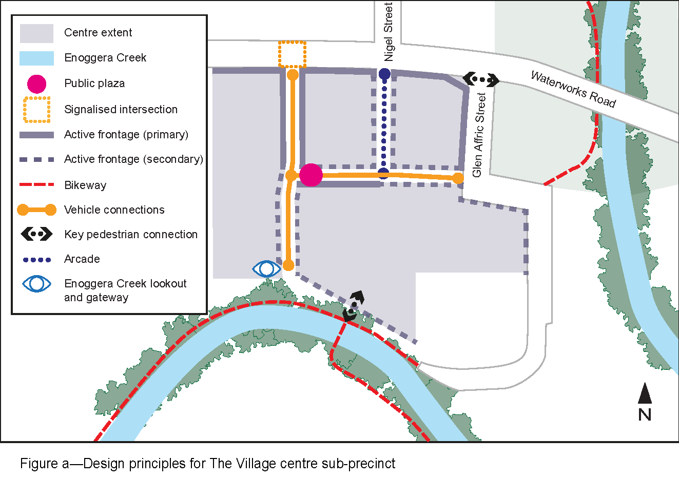

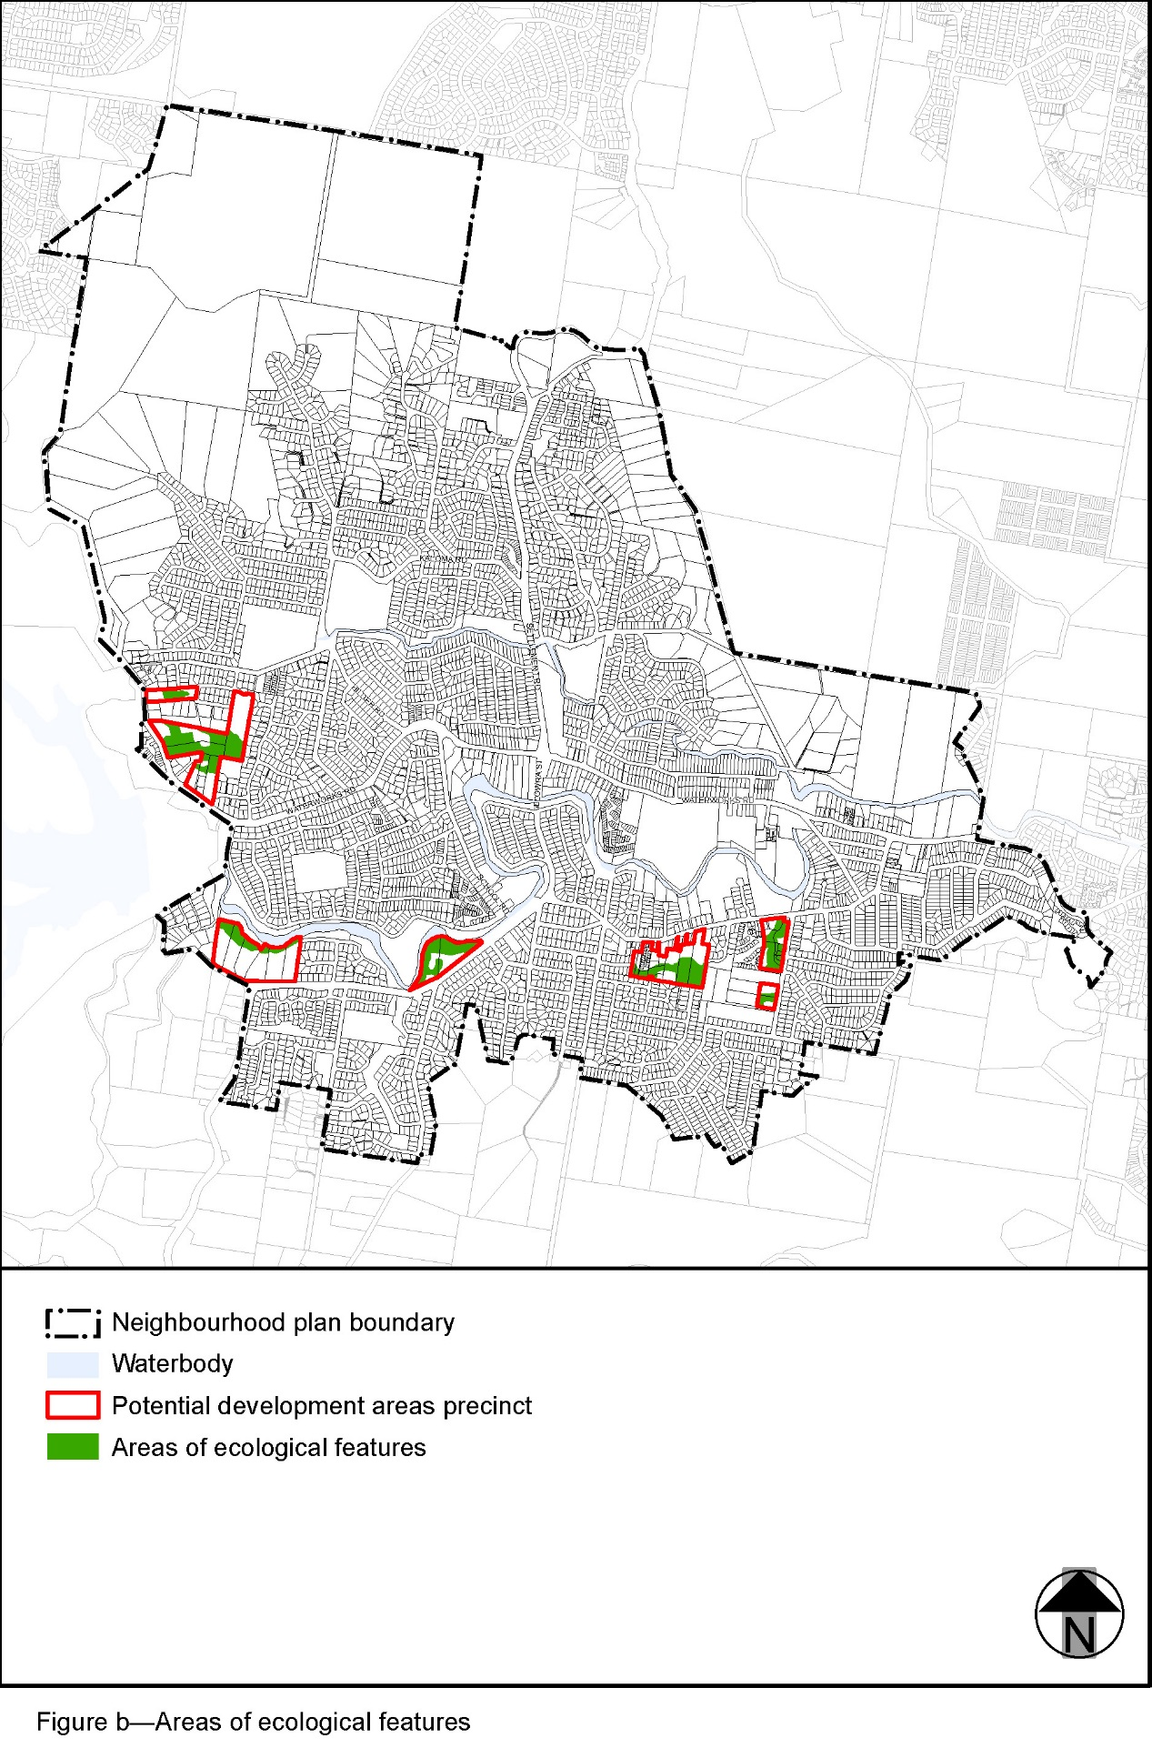
’.

Part 4 Amendment of Part 8 (Overlays)

4.1 Amendment to section 8.2.19 (Significant landscape tree overlay code)
- Section 8.2.19 Significant landscape tree overlay code, Table 8.2.19.3.C—Significant landscape trees in specific locations–
insert before Upper Kedron:
‘

The Gap
Ficus macrophylla Moreton bay fig | 2 Bottletree Place (Kaloma Road frontage) | L4 RP184855
Eucalyptus grandis flooded gum | 14 Desbet Street (front garden) | L7 RP152933
Eucalyptus tereticornis forest red gum | 54 Glenbrae Street (Bombala Street frontage) | L87 RP100453
Ficus benjamina weeping fig | 106 Payne Road (on verge outside of property) | L3 RP103106
Araucaria cunninghamii hoop pine | 201 Payne Road (front garden) | L5 RP78738
Eucalyptus tereticornis forest red gum | 208 Payne Road (front of lot) | L20 RP95610
Delonix regia poinciana | 20 Sassafras Street (front garden) | L41 RP110812
Eucalyptus tereticornis forest red gum | 65 School Road (northern corner) | L20 RP95610
Ficus obliqua small-leaved fig | 81 School Road (front of lot) | L12 RP95610
Eucalyptus tereticornis forest red gum | 6 Tullira Street (on verge boundary) | L115 RP139939
Eucalyptus tereticornis forest red gum | 1073 Waterworks Road (rear north corner of lot) | L1 RP153630
’.

Part 5 Amendment of Schedule 2 (Mapping)

5.1 Amendment to Schedule 2.2 (Zone maps)
- Schedule 2 Mapping, SC2.2 Zone maps, ZM-001 (Tile 19)
‘
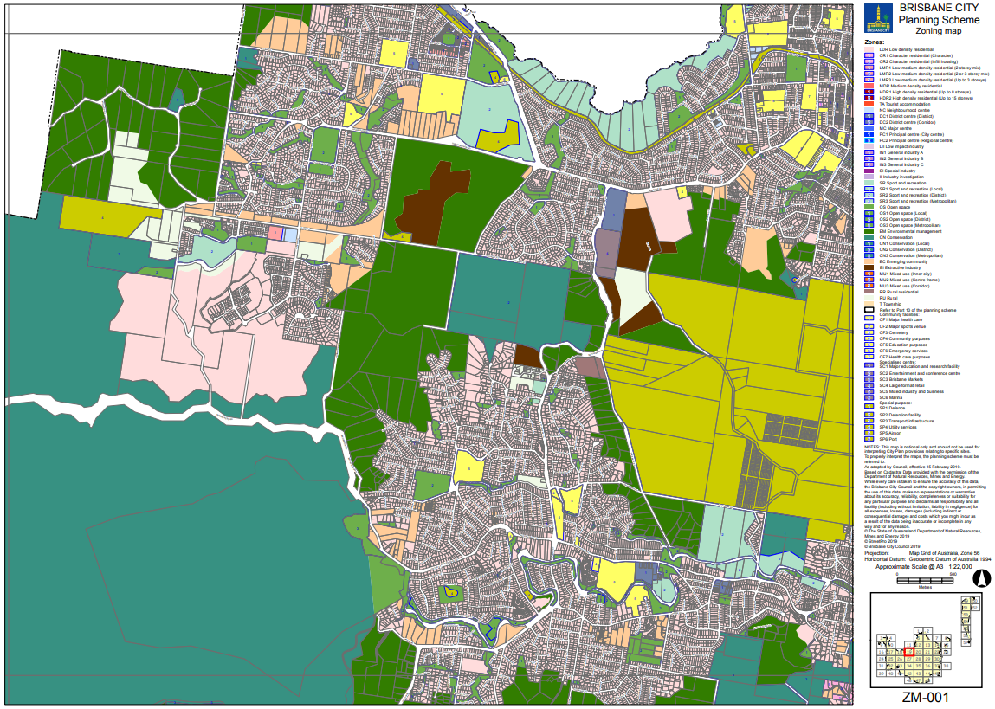
’–
omit, insert: SC2.2 Zone maps, ZM-001 (Tile 19)–refer to Supplement 1a.

5.2 Amendment to Table SC2.2.1 (Zone maps)
- Schedule 2 Mapping, SC2.2 Zone maps, Table SC2.2.1—Zone maps–
insert after Gazettal date 15 February 2019:
‘
Not applicable | ZM-001 | Zoning map  Map tile 19 | 31 May 2019
’.

5.3 Amendment to Schedule 2.3 (Neighbourhood plan maps)
- Schedule 2 Mapping, SC2.3 Neighbourhood plan maps, NPM-020.5 The Gap neighbourhood plan map–
‘
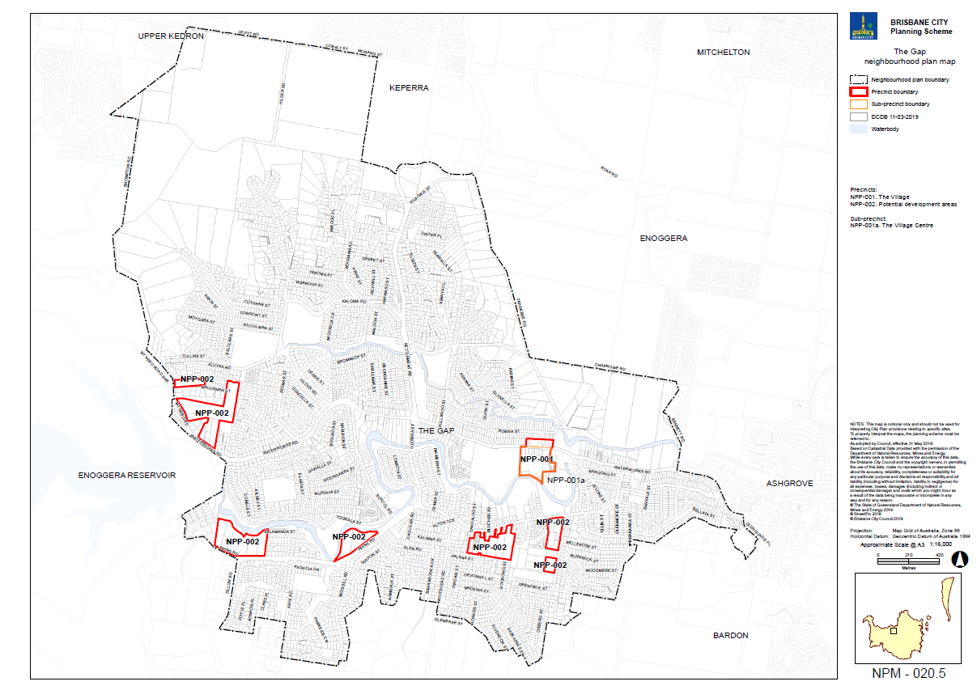
’–
insert: NPM-020.5 The Gap neighbourhood plan map–refer to Supplement 1b.

5.4 Amendment to Table SC2.3.1 (Neighbourhood plan maps)
- Schedule 2 Mapping, SC2.3 Neighbourhood plan maps, Table SC2.3.1—Neighbourhood plan maps–
insert before U, Intentionally left blank:
‘
NPM-020.5 | The Gap neighbourhood plan map | 31 May 2019
’.

5.5 Amendment of Schedule 2.4 (Overlay maps)
- Schedule 2 Mapping, SC2.4 Overlay maps, OM-004.1 Dwelling house character overlay map (Tile 19)
‘
’–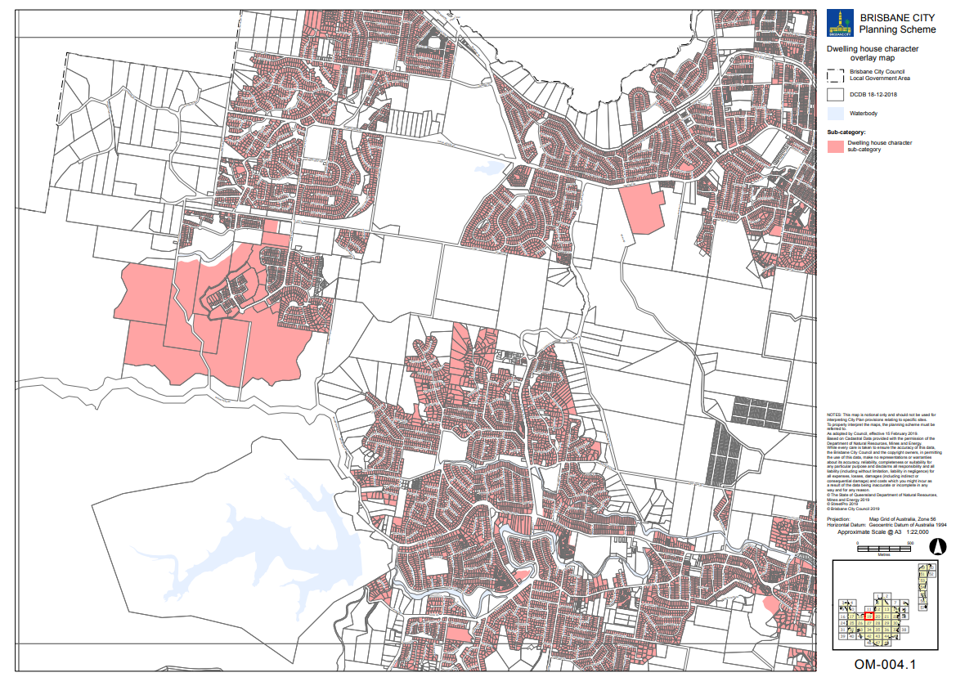
omit, insert: OM-004.1 Dwelling house character overlay map (Tile 19)–refer to Supplement 1c.

- Schedule 2 Mapping, SC2.4 Overlay maps, OM-019.1 Significant landscape tree overlay map (Tile 19)
‘
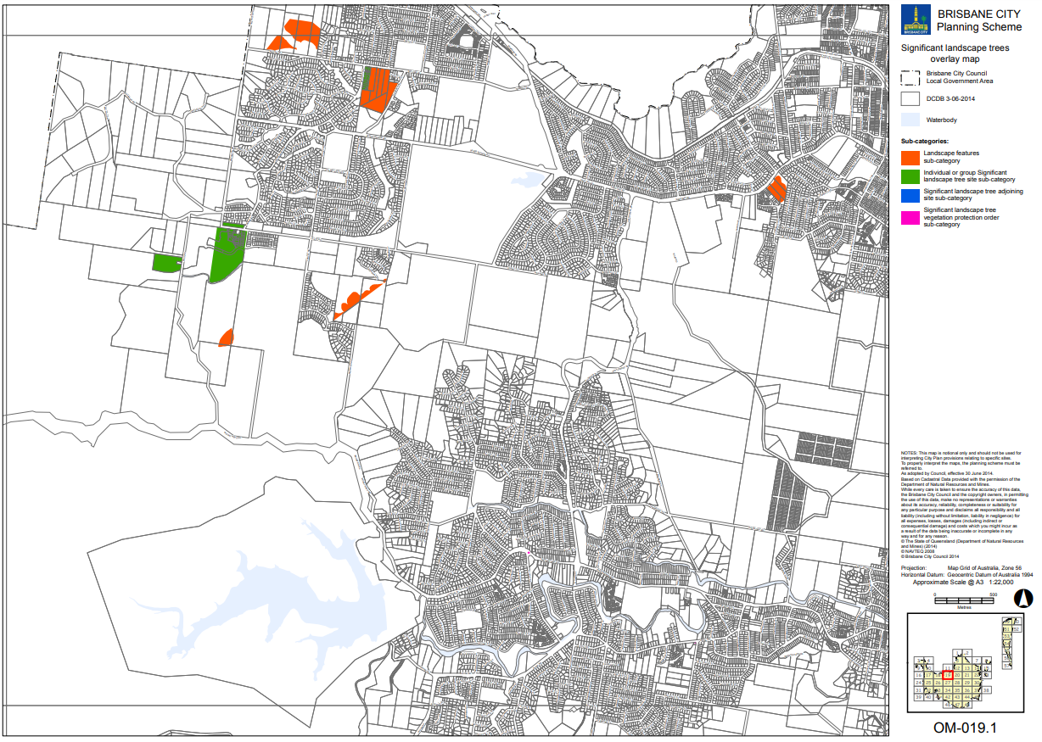
’–
omit, insert: OM-019.1 Significant landscape tree overlay map (Tile 19)–refer to Supplement 1d.

- Schedule 2 Mapping, SC2.4 Overlay maps, OM-019.1 Significant landscape tree overlay map (Tile 27)
‘
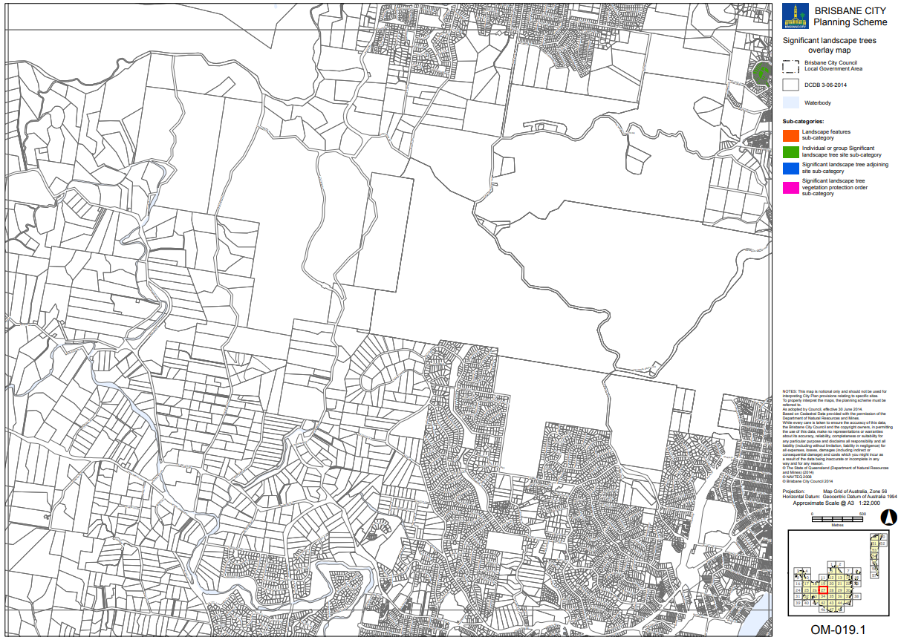
’–
omit, insert: OM-019.1 Significant landscape tree overlay map (Tile 27)–refer to Supplement 1d.

5.6 Amendment of Table SC2.4.1 (Overlay maps)
- Schedule 2 Mapping, SC2.4 Overlay maps, Table SC2.4.1—Overlay maps–
insert before OM-005.1, Extractive resources overlay map (all tiles, other than where specified below), 30 June 2014:
‘
OM-004.1 | Dwelling house character overlay map  Map tile 19 | 31 May 2019
’.
- Schedule 2 Mapping, SC2.4 Overlay maps, Table SC2.4.1—Overlay maps–
insert before OM-019.2, Streetscape hierarchy overlay map (all tiles, other than where specified below), 30 June 2014:
‘
OM-019.1 | Significant landscape tree overlay map  Map tiles 19 and 27 | 31 May 2019
’.

Part 6 Amendment of Planning scheme policies
- Schedule 6 Planning scheme policies, SC6.24 Planting species planning scheme policy, Chapter 1.1 Relationship to planning scheme–insert before ‘Significant landscape tree overlay code’:

‘
The Gap neighbourhood plan code
Table 7.2.20.5.3.A | AO1.3 | All
’.

- Schedule 6 Planning scheme policies, SC6.29 Structure planning planning scheme policy, Chapter 1.1 Relationship to planning scheme–
insert before ‘Wynnum Manly neighbourhood plan code’:
‘
The Gap neighbourhood plan code
Table 7.2.20.5.3.A | PO8 note | All
’.

Part 7 Amendment of Appendix 2 (Table of amendments)

7.1 Amendment to Appendix 2 (Table of Amendments)
- Appendix 2 Table of amendments, Table AP2.1—Table of amendments–
insert after v14.00/2019:
‘
14 May 2019 (adoption) and 31 May 2019 (effective) | V15.00/2019 | Major and minor | Major Amendment to planning scheme (2.3A.4 of MAALPI).  Minor amendment to planning scheme policy (Schedule1, Section 6 b) of MGR)  Refer to Amendment v15.00/2019 for further detail.
’.

Supplement 1—A3 Map tiles

Supplement 1a Zoning map, Tile 19
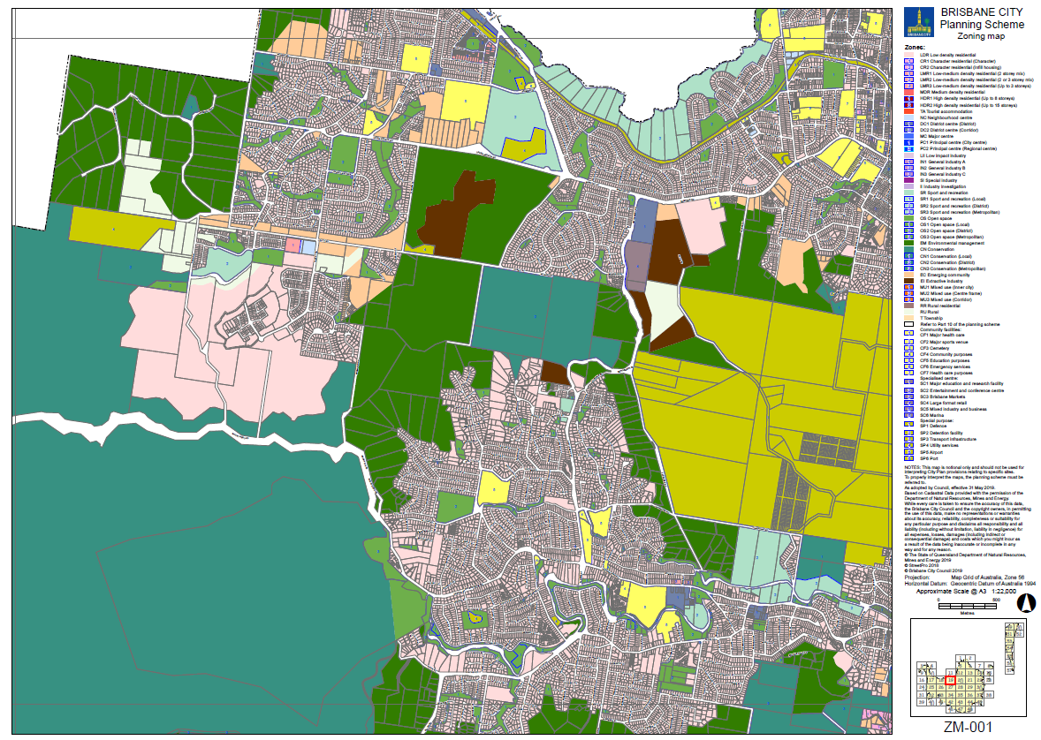

Supplement 1b The Gap neighbourhood plan map NPM-020.5
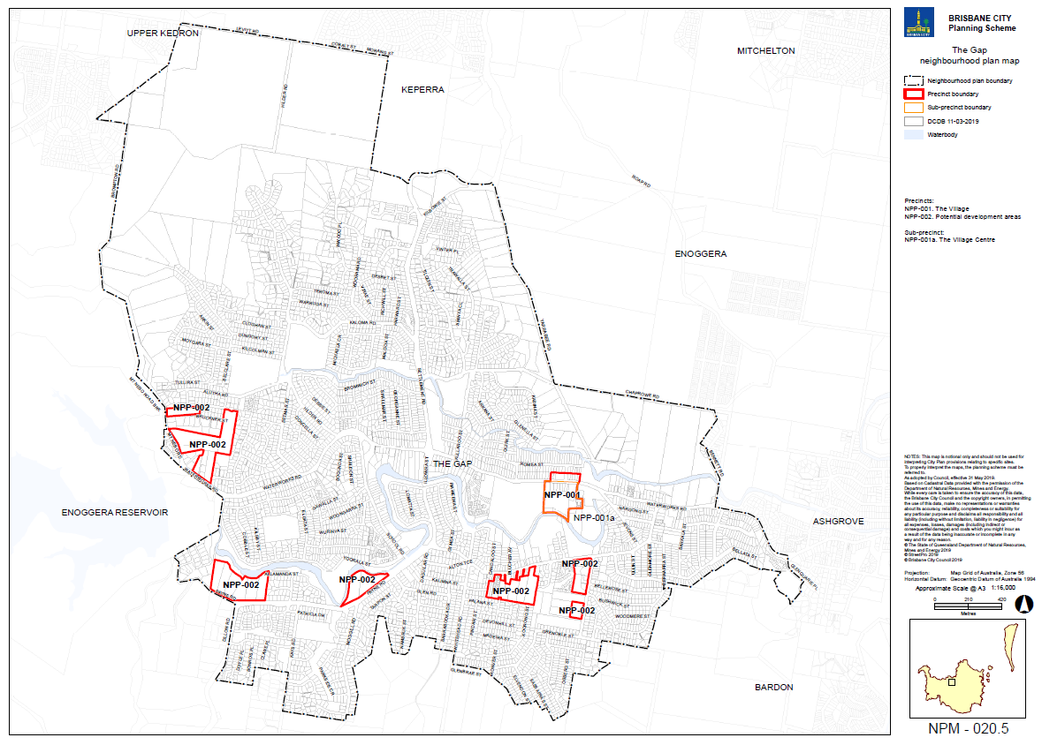

Supplement 1c Dwelling house character overlay map, Tile 19
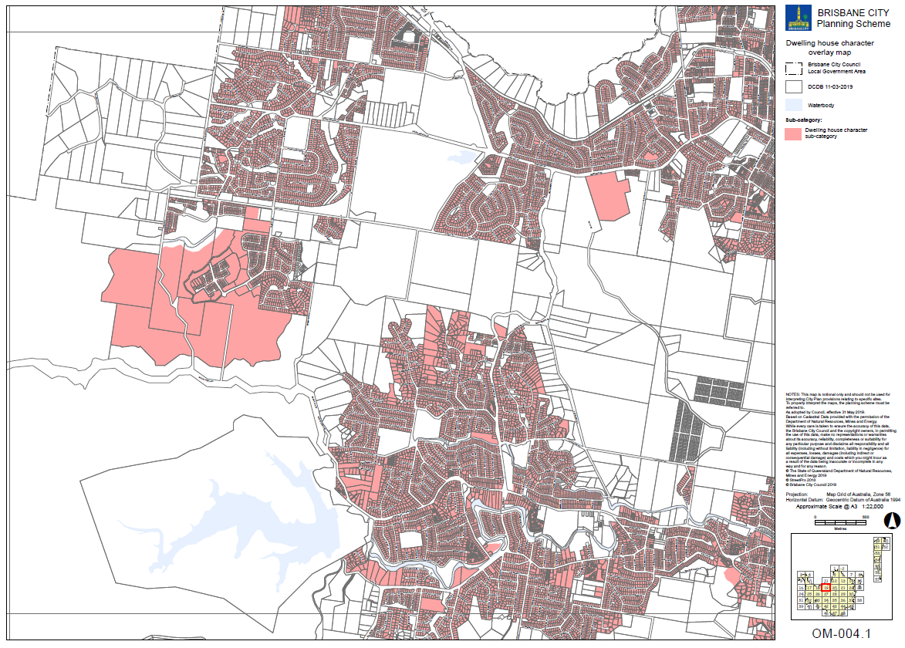

Supplement 1d Significant landscape tree overlay map, Tiles 19 and 27
