Designated area for drones

Canterbury Park, Bald Hills

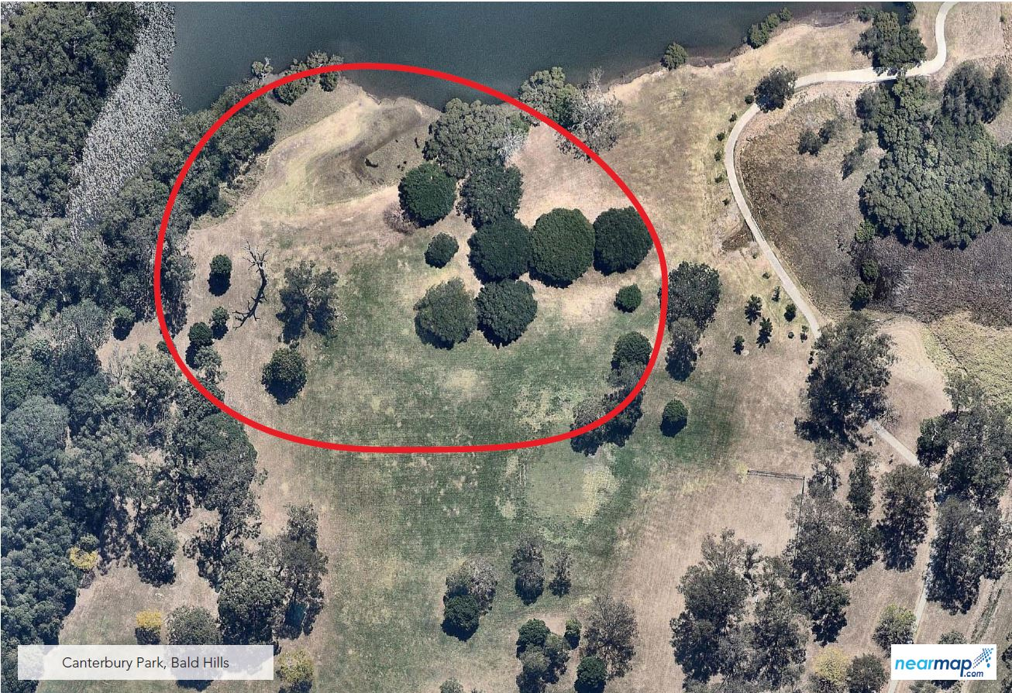

The designated area for Canterbury Park in Bald Hills is in the north end of the park, near the banks of the South Pine River. Signage is provided on site.

