Designated area for drones

Carindale Recreation Reserve, Carindale

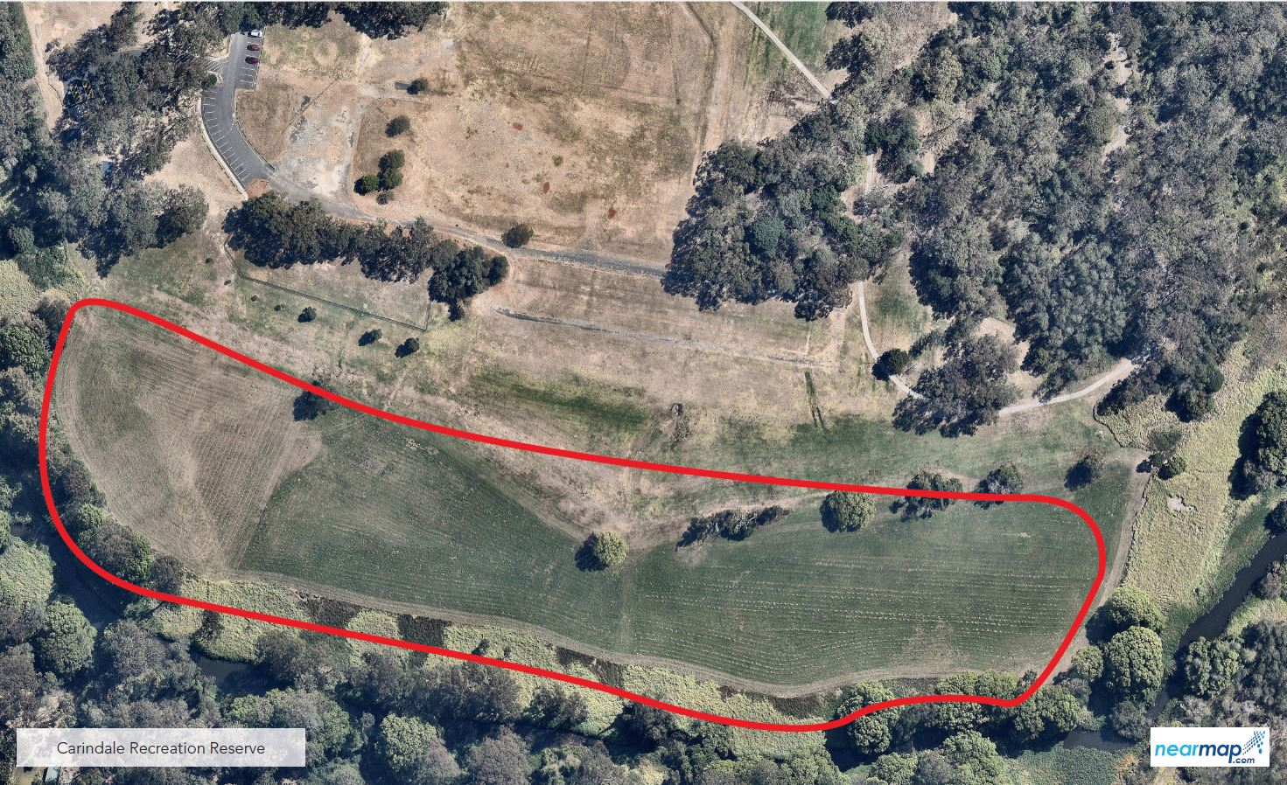

The designated area for Carindale Recreation Reserve in Carindale is in the southern part of the park along Bulimba Creek, behind the dog off-leash area and car parking. Signage is provided on site.

