Designated area for drones

Cliveden Park, Fig Tree Pocket

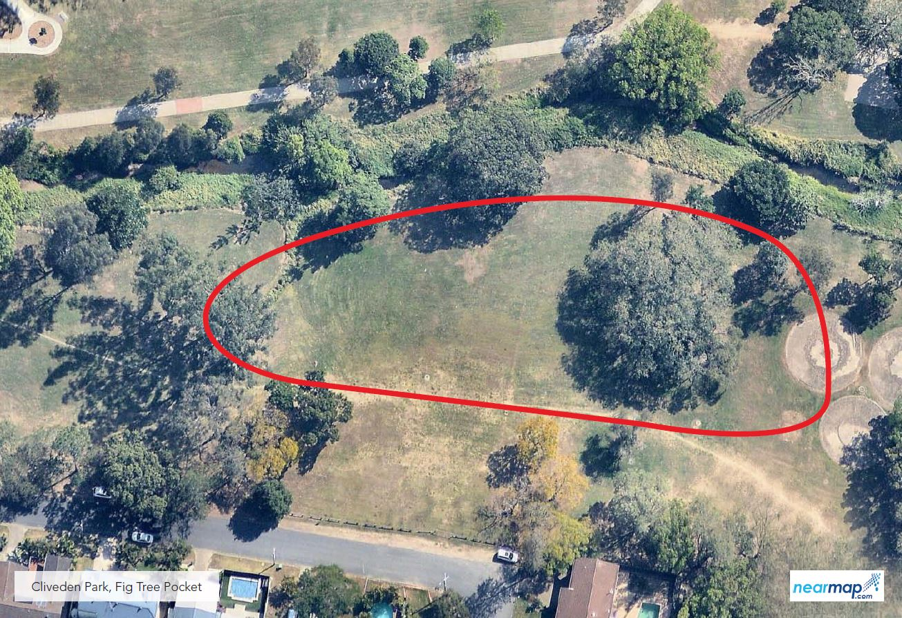

The designated area for Cliveden Park in Fig Tree Pocket is in the east of the playground on Moorfields Street, near the corner of Cottesmore Street. Signage is provided on site.

