Designated area for drones

Lacey Road Park, Carseldine

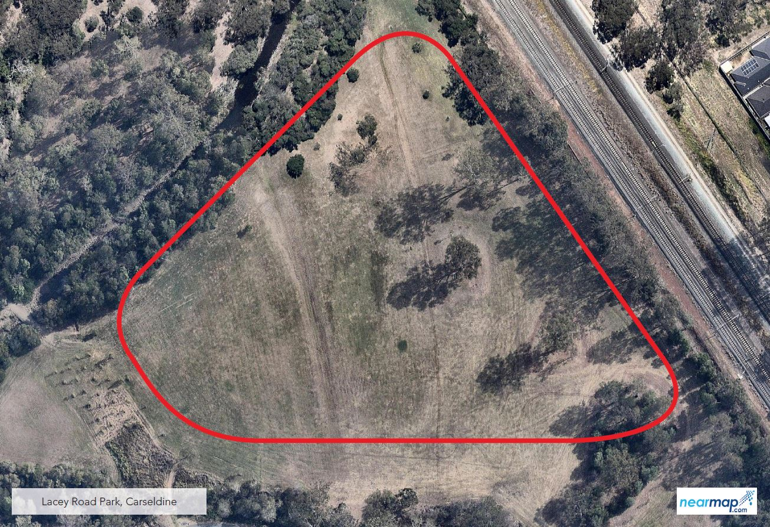

The designated area for Lacey Road Park in Carseldine is in the eastern end of the park, near Roghan Road. Signage is provided on site.

