Designated area for drones

Moggill Ferry Reserve, Moggill

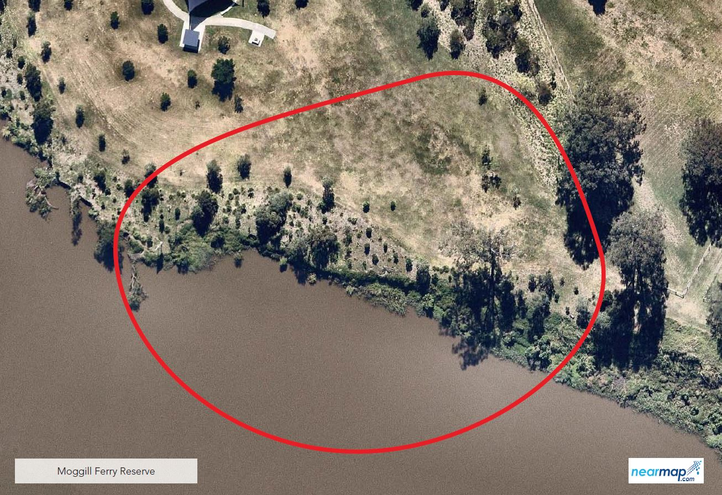

The designated area for Moggill Ferry Reserve in Moggill is behind the car park and shelter, near the banks of the Brisbane River. Signage is provided on site.

