Designated area for drones

The Common Park, Coorparoo

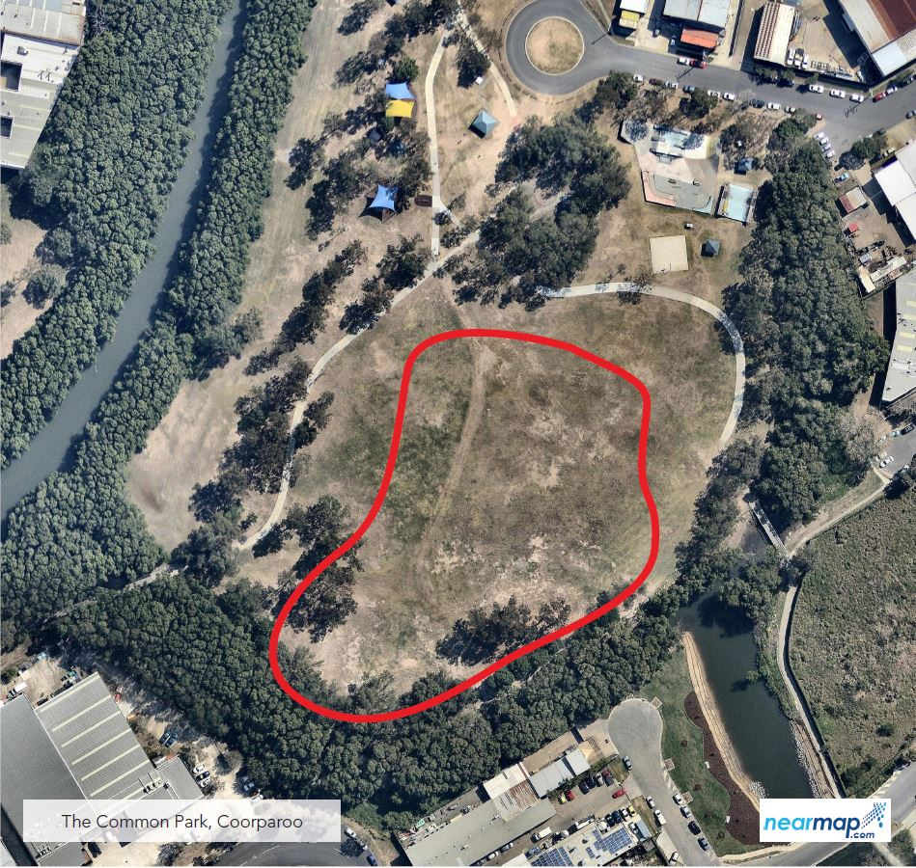

The designated area for The Common Park in Coorparoo is south of the playground and picnic shelters. Signage is provided on site.

