Designated area for drones

Voyager Drive Park, Kuraby

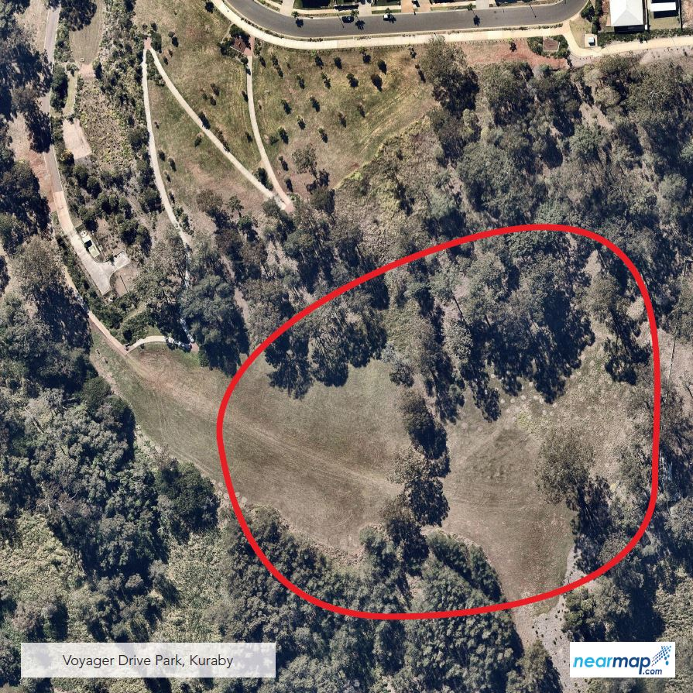

The designated area for Voyager Drive Park in Kuraby is east of the pathway near Pioneer Drive, towards the bottom of the hill. Signage is provided on site.

