Community Hall Tender

FACILITY FACT SHEET

Community Hall - Sunnybank Community Centre

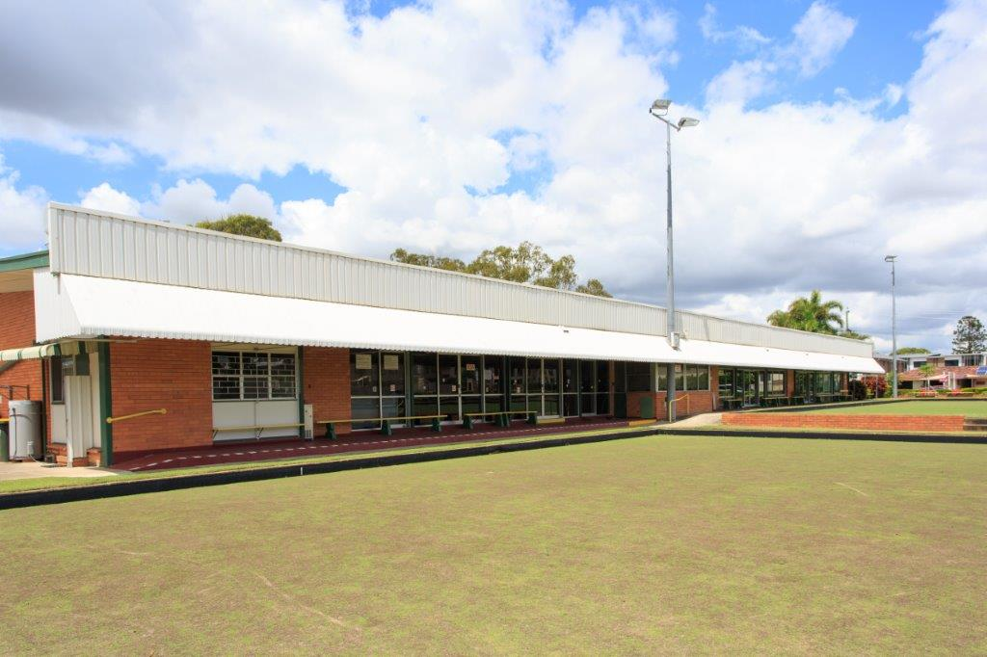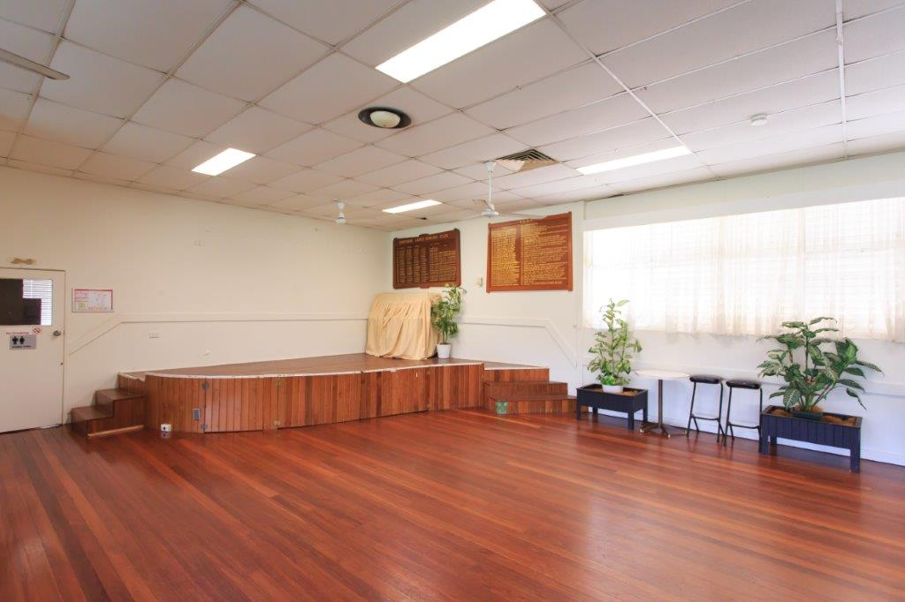

Brisbane City Council is now seeking tender applications for the licence of the hall space at Sunnybank Community Centre (former Sunnybank Bowls Club) located at 65 Gager Street, Sunnybank.

Site summary

This is an exciting opportunity for an eligible community organisation or group to have use of the hall space for one day, per week (weekends are not included). Please indicate in your application, your organisations preference for either:

- Monday, 8:00am to 5:00pm
- Tuesday, 8:00am to 5:00pm
- Wednesday, 8:00am to 5:00pm
- Thursday, 8:00am to 5:00pm
- Friday, 8:00am to 5:00pm

The facilty is a single storey hall space located within a building that was once a bowls club. It has a hall area of 226sqm, toilets, and a reheat kitchen (not a licenced commercial kitchen). Please note there is no available onsite storage space. Each organisation is required to set up and pack down within the allocated times mentioned above, with no items able to be left behind at the facility.

Inspection
This facility will be open for inspection on Thursday, 26 September 2019 at 3.00pm and Friday, 4 October 2019 at 10.00am. To attend this site inspection, please email community.halls@brisbane.qld.gov.au or call Community Halls on (07) 3407 0811 and ask to speak to Project Officer for further information.

Tenure
Licence term up to 12 months.

Fees and charges
The cost of the permit is payable by the licensee and is outlined in Council's schedule of fees and charges.
The permit fee will be $495.10 per annum.

How do I apply?
If your organisation is interested in this opportunity you can visit www.brisbane.qld.gov.au and search for, ‘Community facility tender 2019’ to submit your application, you will need to meet the eligibility criteria and submit a response to the key selection criteria prior to midnight Monday 14 October 2019.

For more information visit www.brisbane.qld.gov.au or call Council on (07) 3403 8888.

Aerial view of site



