Western Pullenvale Ward public transport research

Brisbane City Council is getting your home quicker and safer by taking coordinated action to fix traffic congestion. Creating more travel options means residents spend less time on the road and more time doing what’s important.

The travel needs of Brisbane’s residents and visitors are ever changing. To ensure services continue to meet the community’s needs, Council will be undertaking research to understand their view and experiences using public transport within Moggill, Anstead, Bellbowrie, Karana Downs, Mt Crosby, Pullenvale and Pinjarra Hills.

These services include:
- route P443 (Moggill to City – pre-paid fare rocket)
- route 444 (Moggill to City BUZ)
- Karana Downs Personalised Public Transport (PPT) service.

Council would like to know how, why, when and where you travel to and from, to see if any changes could be made to make the services more effective and better meet the community’s needs. This could include improvements to timetables, travel routes and key destinations for the existing PPT and bus services.

This research project does not cover the public transport fare structure, which is the responsibility of TransLink, or changes to infrastructure like bus stops, bus interchanges or road networks.

Council will share your feedback with TransLink for consideration in future planning. Any bus service improvement ideas from this study will need to be approved by TransLink, as they have overall responsibility for public transport in Queensland.

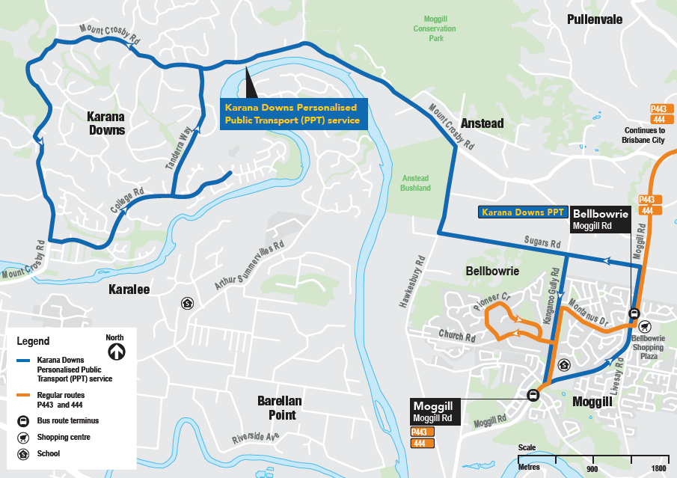

Have your say

To find out more about the western Pullenvale Ward public transport, search visit brisbane.qld.gov.au and search ‘Pullenvale Ward public transport’, call Council on 3403 8888 or visit us at one of the following information sessions.

- Thursday 31 October
5.30 - 7.30pm, Kenmore Village Shopping Centre
9 Brookfield Road, Kenmore

- Saturday 9 November
10am – 12 noon, Bellbowrie Shopping Plaza
37 Birkin Road, Bellbowrie

