Paddington Terraces Village Precinct Grant Project – Investigation Area

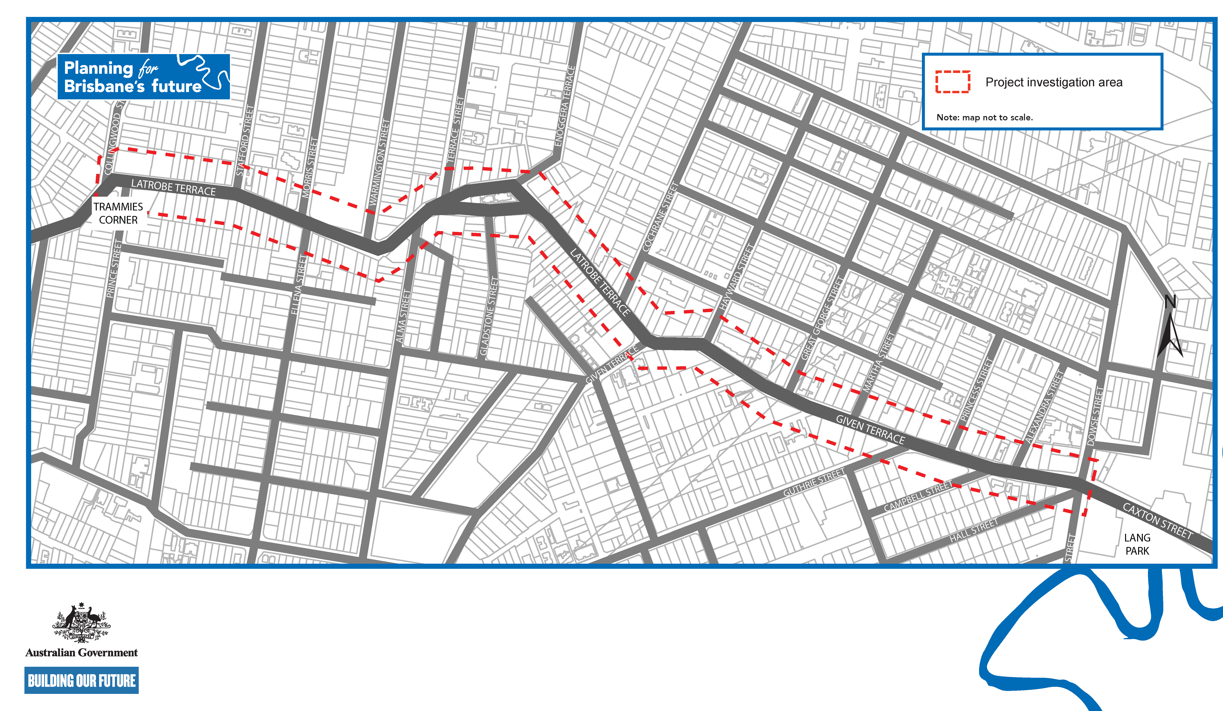

For more information visit brisbane.qld.gov.au and search ‘Village Precinct Projects’ or call Brisbane City Council on 3403 8888.

