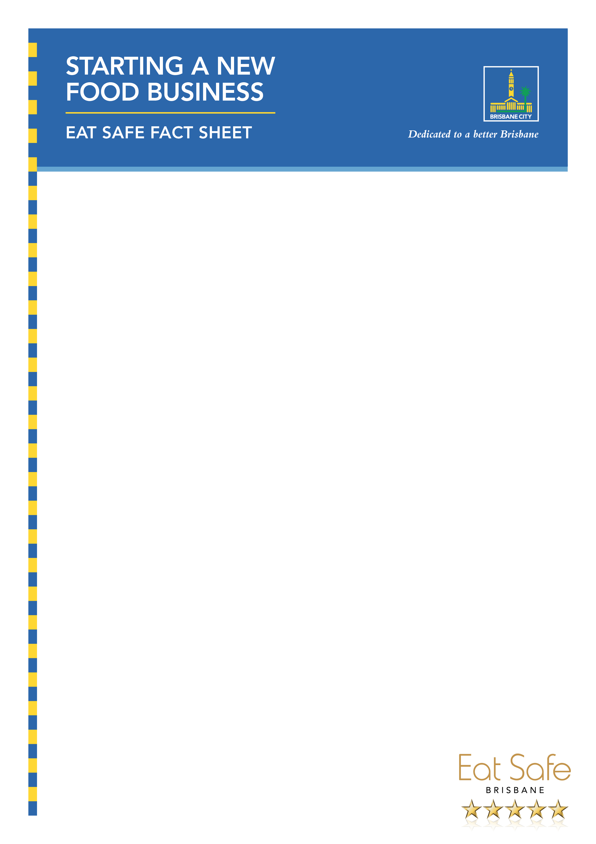

Starting a new food business – Eat Safe fact sheet

Brisbane City Council is committed to promoting safe food practices in order to support small businesses and protect the health of our city’s residents and visitors.

If you are building, fitting out or setting up a new food business, such as a café, restaurant, takeaway, mobile food vehicle, catering business, annual temporary food stall or food manufacturing business you may need a food business licence.

This fact sheet outlines steps you need to take to apply for a licence.

Step 1 – Check other approvals
Before you apply for your food business licence, check for other required approvals. You may need:
- planning approval – contact Council’s Business Hotline on 133BNE (133 263)
- building approval – contact a building certifier
- plumbing and drainage approval – contact Council’s Business Hotline on 133 BNE (133 263)
- trade waste permit – contact Queensland Urban Utilities
- footpath dining permit – contact Council’s Business Hotline on 133 BNE (133 263)
Brisbane City Council is committed to promoting safe food practices in order to support small businesses and protect the health of our city’s residents and visitors.

If you are building, fitting out or setting up a new food business, such as a café, restaurant, takeaway, mobile food vehicle, catering business, annual temporary food stall or food manufacturing business you may need a food business licence.

This fact sheet outlines steps you need to take to apply for a licence.

Process overview
- Check other approvals
- Submit a design application
- Design assessment and decision
- Submit a food business licence application
- Licence application assessment
- Licence decision

Quick tips
- Submit your licence application no more than 20 business days before you want to open your business.
- Use the food business final inspection checklist – taking over an existing business, to help prepare for your final inspection.

Quick tips
- Submit your licence application no more than 20 business days before you want to open your business.
- Use the food business final inspection checklist – taking over an existing business, to help prepare for your final inspection.

Process overview
- Check other approvals
- Submit a design application
- Design assessment and decision
- Submit a food business licence application
- Licence application assessment
- Licence decision

Step 1 – Check other approvals
Before you apply for your food business licence, check for other required approvals. You may need:
- planning approval – contact Council’s Business Hotline on 133BNE (133 263)
- building approval – contact a building certifier
- plumbing and drainage approval – contact Council’s Business Hotline on 133 BNE (133 263)
- trade waste permit – contact Queensland Urban Utilities
footpath dining permit – contact Council’s Business Hotline on 133

Step 2 – Submit a design application

Prepare plans
You will need to submit plans with your design application. Council will use these plans to assess whether your application meets the requirements of the Food Act 2006 and food safety standards.

Your plans should include:
- name, address and contact details of the architect, draftsperson, builder or shopfitter
- drawing scale and date when plans were drafted
- name of the food business operator
- address of the premises
- trading name.

What type of plans do you need?
You will need to submit electronic copies of the following plans (A3 or A4 size) and information to help Council assess your application quickly.
- Site plan (scale 1:200), including:
  - location within the street and/or building
  - location of the grease trap (if needed)
  - location of staff toilets.
- Floor plan (scale 1:50), including:
  - layout of the food premises
  - location of equipment, fixtures and drainage
  - list of fixtures and equipment
  - finishes of floors and coving, walls, ceilings and benches.
- Sectional elevations (scale 1:50), including:
  - side views of the food preparation and storage areas
  - ceiling heights
  - wall and floor clearances of benches, equipment and fixtures.
- Exhaust ventilation (only required if you are installing a mechanical exhaust ventilation system over your cooking equipment; scale 1:50), including:
  - location in kitchen
  - dimensions
  - discharge points
  - angles of filters
  - building form 15 – compliance certificate (required after installation).

The ‘Preparing a food business application’ page on Council’s website features examples of a site plan, floor plan and mechanical exhaust ventilation plans. These will help you better understand the standard required and information needed for your plans.

Application submission
Once you have your plans ready, you can submit your application using the Food Business Approvals form by searching ‘food business approvals ‘on Council’s website. Credit card payment is required. You will need to attach your plans and provide information about the type of food you will be preparing and selling.

How to avoid delays
- Hand-drawn plans should be neat, legible and drawn to scale
- Plans should be detailed, including information on the finishes to floors, coving, walls, ceilings and benches
- Applications in a company name should list directors or members of the management committee
- Food preparation areas need to contain the sectional elevations or the side view
- To read about the common food business application problems, visit Council’s website and search ‘common food business application problems’.

Step 3 – Design assessment and decision
Council may take up to 20 business days to assess your design application. Council will check if your design meets the requirements of the Food Act 2006 and food safety standards. The Queensland Government Design and fit-out guide for food businesses will help you understand Council’s requirements, including:
- providing enough space for all activities, food and equipment
- making structures, fittings and equipment suitable for easy cleaning and sanitising
- ensuring the design prevents entry of pests, dust, fumes, smoke and other contaminants
- setting up the flow of food through the business to prevent food contamination, e.g. flow of food is in one direction, from receipt to storage, preparation, packing, serving to the customer and disposal
- ensuring overall design is appropriate for the proposed activities.
Council may request more information from you, such as reports and more plans, to assess your application.

After your application has been assessed, Council will let you know if your application has been approved, refused or if there any conditions or changes to the design approval.

You should only start fit-out or construction following your design application approval.

Step 4 – Submit a food business licence application
The food business licence application can be submitted online using the Application for Food Business Approvals online form. You should submit your licence application no more than 20 business days before you want to start operating. It is recommended that you submit your food safety qualifications and details of any formal food safety training you have attended.

Step 5 – Licence application assessment
Properly made applications will be assessed within 20 business days. Council will assess your suitability to hold a licence and the suitability of the premises. You will also be issued an Eat Safe Brisbane star rating at this time.

Your suitability
When assessing your suitability, Council may consider:
- your skills and knowledge to sell safe and suitable food
- your employees or contractors’ skills and knowledge to sell safe and suitable food
- any previous food safety related enforcement action taken against you
- anything else relevant to your ability to handle or sell safe and suitable food.

Premises suitability and inspection
Before your licence is issued, a Council officer will conduct a final inspection of your premises to check if it has been constructed in line with the approved plans and meets the requirements of the Food Safety Standards. To arrange a date and time for your final inspection, contact Council approximately one week before construction is due to finish.

Key tips to avoid delays
- Include a list of directors or members of the management committee with your application.
- Ensure your application is properly made, including correct names, addresses and the food business licence category on the form.
- Use the Food business final inspection checklist to help you prepare for your final inspection and to check your business is ready to start trading.

Step 6 – Licence decision
After your licence application has been assessed, Council will let you know whether your application has been approved, refused or if there are any conditions on your licence.

Once your licence application has been approved, you will receive a food business licence certificate. Display this certificate in an area easily visible to customers and visitors. Find out more information on managing your food business and food business licence renewal in the Operating your food business fact sheet.

Eat Safe Brisbane star rating
A Council officer will conduct an Eat Safe Brisbane audit and you will be issued a star rating.

For further information:
Visit brisbane.qld.gov.au and search ‘Eat Safe’ or contact Council’s Business Hotline on 133 BNE (133 263) to find out more.

