Backyard Burning

Dear Neighbour,
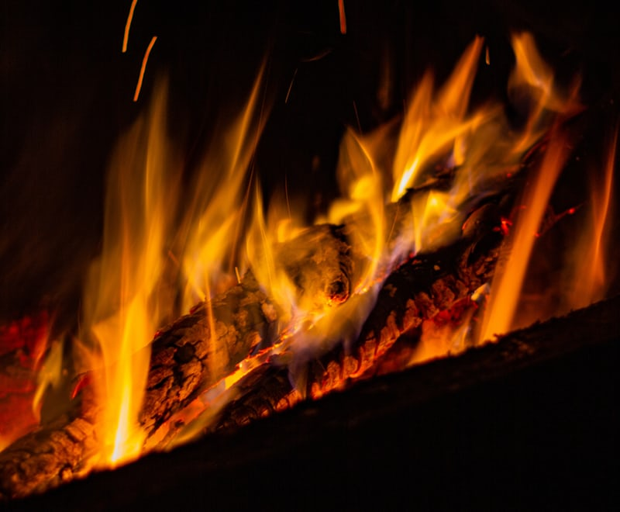
You may not be aware of Brisbane City Council’s requirements with respect to lighting fires in a residential area. I am writing to you to let you know that backyard burning activity at your premises is having a negative impact on our health.
Smoke and vapours from fires can have serious effects on health, especially for children, elderly people and people who already suffer with a respiratory or heart condition.
For your information, Council has regulations to control smoke, ash and fumes as a result of lighting fires in residential and commercial areas
Council has provided this letter and the information below to assist in mutually resolving the matter, by ensuring that everyone is aware of these requirements.
I have decided to let you know about the issue, as I am sure you would like the opportunity to review these requirements and resolve this matter yourself.
Regards,
Your neighbour.

Important Information About Lighting Fires in Brisbane.
Waste incineration is not allowed
You cannot light a fire within Council boundaries except for any of the following reasons:
- where the fire is used to cook food for human consumption in a barbecue or similar structure (but not a fire on the ground);
- for approved theatrical or similar approved entertainment events;
- where the subject land is included in the Rural area classification (Brisbane City Plan 2014) and neither the height, width or length of the material to be consumed exceeds two metres;
- where a permit has been issued by Queensland Fire and Emergency Services;
- where the fire is required to be lit by a notice under section 69 of the Fire and Emergency Services Act 1990;
As of the 1 June 2020, Council commenced a trial allowing small outdoor fires in small braziers and firepits for heating purposes, provided:
- the brazier or fire pit is not causing a smoke impact on neighbours and the residents of other premises;
- the fire is contained in a brazier or firepit which is constructed so as to prevent the escape of fire or any burning material contained within;
- the brazier or firepits is not on the ground and is of a design that allows the flow of air into the fire from below and the sides of the fire to enable oxygenation and minimise the production of smoke
- the fire is isolated from other flammable and combustible materials (organic and inorganic) on the property and upon adjacent properties;
- the fire is made using only clean, dry, properly seasoned wood or charcoal or other smokeless fuel;
- painted or treated wood, plastics or any other rubbish must not be burnt as these emit hazardous chemicals
- the brazier/ firepit is set back at safe distance from every property boundary and the outermost projection of any nearby buildings or structures;
- a responsible person over the age of 18 is in attendance at the fire at all times and until the time that the fire is completely extinguished;
- the fire is never left unattended and children are actively supervised when around the fire.
- only one brazier/ firepit is used on a property at any one time;
- the fire is put out with water. Do not cover with sand or dirt or let the fire burn overnight.
- the fire has not been lit during a total fire ban issued by the QFES or in contravention of any other fire restriction issued by the QFES;
- the fire must have minimal flame height;
- in circumstances where the maintaining of the fire is not creating a smoke nuisance for other nearby residents;
- does not breach the Environmental Protection Act 1994 by causing an environment nuisance; and
- a reasonable and prudent person would not otherwise consider that the fire is causing an unacceptable risk of harm to a person(s), or risk of damage to property or protected vegetation.

A brazier is a portable heater, designed to hold hot coals, generally taking the form of an upright standing or hanging metal bowl or box. It always has sides but does not always have a roof or a grill. It is predominately used for heating purposes only.
If you are burning fuel for heating or cooking, never burn anything except seasoned dry firewood or commercial hot coals or gas.
Council may issue you with an on-the-spot fine for lighting a fire for any other purpose.
A person using a brazier or fire pit is still required to comply with the Environmental Protection Act 1994 by preventing environmental nuisance and smoke impacts. Tips on how to minimise smoke include:
- Refrain from burning leaves and green or damp wood in a brazier
- Make sure your wood has been seasoned for 8 months, stored in a dry, aerated area, off the ground and sheltered from the rain. Stack the wood in a way that lets air flow through the wood pile, on top a pallet and do not cover with a tarp as this will trap moisture.
- Start the fire using small kindling and do not load the fire with large logs until the fire is burning well, or you will smother the fire and create smoke.
- Locate your fire away from your property boundary
- If you are having trouble avoiding smoke, consider whether your brazier needs more air holes in the base or sides to encourage the drawing of oxygen through the fire. Please also be aware that commercially bought firewood may not have been properly seasoned and requires further drying out before use.
- Use a multipurpose, smokeless fuel.

For more information, you can visit www.brisbane.qld.gov.au and search ‘Smoke, Ash or Fumes Complaints” in the search menu.

