COMMERCIAL ROAD AND DOGGETT STREET INTERSECTION

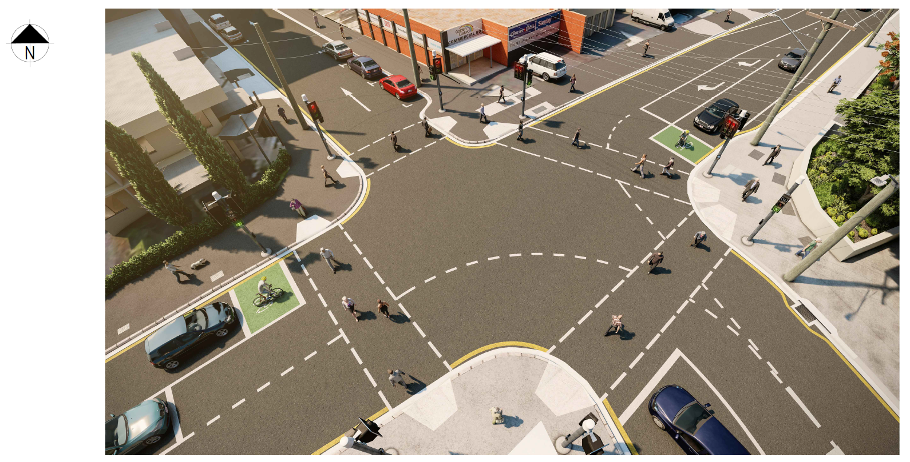
NEWSTEAD

For more information about the project, please call the Project Team on 1800 884 681.

