Station Avenue, Northgate Pedestrian bridge replacement works

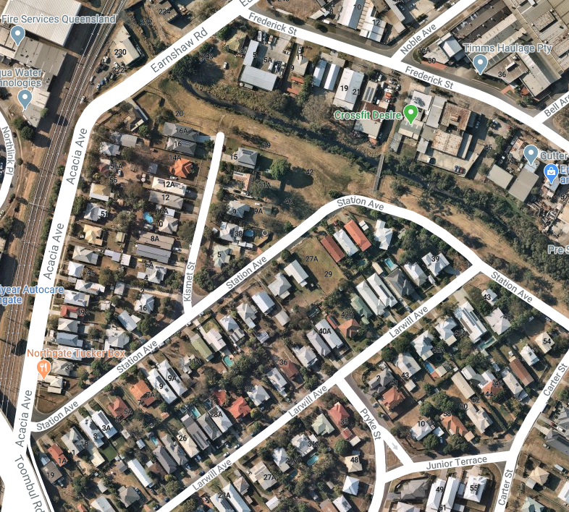
Bridge closure and detour map
Detour
Bridge closed

