Manly Harbour Village Precinct Project –

Site investigation area

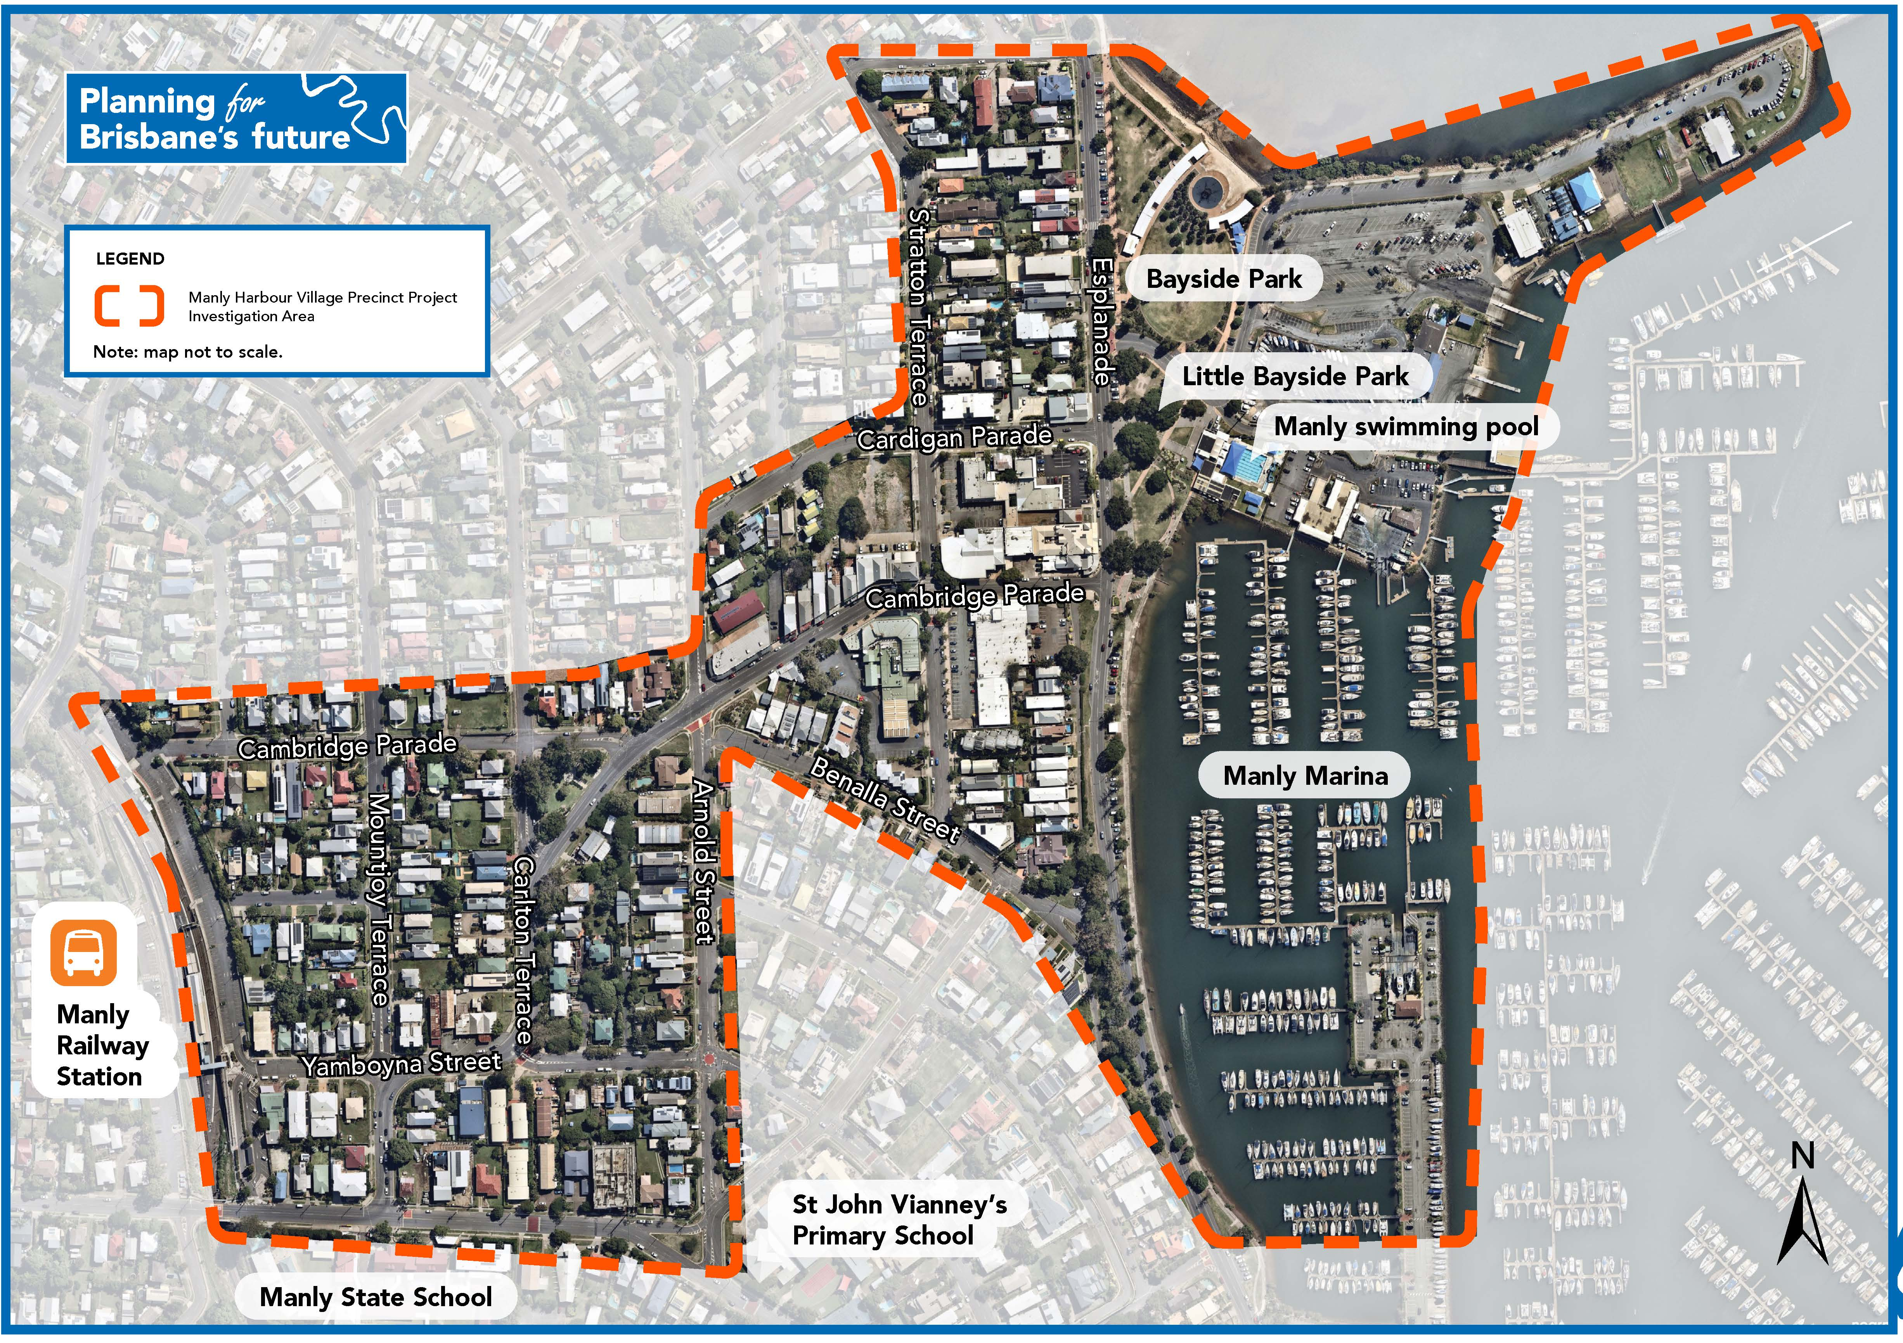

For more information visit brisbane.qld.gov.au and search ‘Village Precinct Projects’ or call
Brisbane City Council on 3403 8888.

