Breakfast Creek Green Bridge
Concept Design Consultation Report

November 2020

Contents
1. Executive Summary 1
2. Introduction 3
2.1 Purpose of this report 3
3. Background 4
3.1 About the Green Bridges Program 4
3.2 About the Breakfast Creek Green Bridge 5
3.3 Overview of key stakeholders 6
3.4 Previous engagement activities 6
4. Consultation approach 8
4.1 Purpose and objectives 8
4.2 Methods 8
4.3 Timeframes 9
5. Communication activities 10
5.1 Communication tools 10
5.2 Key stakeholder notifications 12
5.3 Media and social media 12
5.4 Reach of communication activities 14
6. Stakeholder and community consultation activities 15
6.1 Summary of participation across all activities 15
6.2 Online feedback survey 15
6.3 Community information sessions 15
6.4 Pop-up events 16
6.5 Key stakeholder briefings 17
6.6 Submissions 17
6.7 Other correspondence 17
7. Summary of feedback 18
7.1 Overarching feedback themes 18
7.2 Formal submissions 19
7.3 Online survey results 21
8. Conclusion 25
8.1 Next steps 26
Appendix A. Breakfast Creek Green Bridge project plan i
Appendix B. List of stakeholders notified ii

Executive Summary
Brisbane City Council is building new green bridges across Brisbane, which will make it even easier to get around our city on foot, by bike or scooter, or by connecting with public transport. The new bridges will link Kangaroo Point to the Brisbane Central Business District (CBD), Toowong to West End, St Lucia to West End, as well as a new crossing at Breakfast Creek.
The Breakfast Creek Green Bridge (BCGB) and extension to the Lores Bonney Riverwalk will cater for pedestrians and cyclists and provide an enhanced active transport link along the river from the inner city to the northern suburbs. It will also enhance recreational experiences along the Brisbane River.
In August 2020, Council publicly released the BCGB concept design, marking the next round of community consultation on the project. The concept design outlines the proposed bridge alignment, landing points, and structural form, as well as potential design features and upgrades to ongoing connections to the active transport network.
Across a four-week consultation period, residents, businesses and other stakeholders were invited to provide feedback on the design. Communication activities included a project newsletter distributed to local residents and businesses, updated content on Council’s website, including a fly through animation, project plans and artist’s impressions of the design, and email notifications.
During the consultation period, feedback was provided at six community information sessions and via an online feedback survey, the project’s 1800 hotline and dedicated email inbox. The project team also met with local key stakeholder groups and received formal submissions. In total, approximately 800 people participated in the BCGB consultation program, including 360 attendees at information sessions and 357 responses to the online survey.
Following the consultation period, Council reviewed and analysed all feedback to determine overall support for the design and identify key themes and issues for further consideration. Overall, feedback indicated general positive support for the concept design, with 70% of survey respondents either completely or somewhat in favour of the overall design. Key feedback raised by residents and stakeholders included:
- general support for the skewed alignment from Newstead Park across Breakfast Creek to connect with the Lores Bonney Riverwalk, and the proposed arch bridge form
- support for minimum six-metre pathway on the bridge, separation between pedestrians and cyclists, an accessible bridge grade for people with disability, and measures to ensure the safety of all bridge and path users
- maintaining the existing access to Breakfast Creek for creek / river users is important, along with minimising impacts on creek access during construction
- some suggestions for shade cover or a viewing / rest node as part of the bridge design
- suggestions for new landscaping and pathways to reflect the existing heritage character of Newstead Park and Breakfast Creek, and for impacts on existing trees and green space to be minimised
- requests for dedicated cyclist facilities on Newstead Avenue and Newstead Terrace, with wider paths, better signage and improved lighting
- suggestions for other upgrades to the active transport network, such as an improved cycling connection to Sandgate Road / Albion from Breakfast Creek
- interest in whether the existing road bridge could be upgraded, and if the design of the BCGB would prevent the replacement of the existing road bridge in the future if required
- some preference for an alternative green bridge alignment across Breakfast Creek, such as closer to the existing road bridge or at the mouth of the creek.

Council acknowledges some feedback requesting consideration of alternative alignments for the BCGB, and some concerns around the proposed arch design.
As part of the concept design development, Council investigated a number of alignment options. Options involving an alignment closer to the existing road bridge were not progressed as this would require costly relocation of significant existing public utilities, provide a poor quality connection for cyclists with a tight turning radius, and potentially impact the ability to upgrade or replace the road bridge in the future.
In addition, options involving an alignment closer to the mouth of Breakfast Creek were investigated, however were not progressed as they would significantly impact on the existing heritage features and views to and from Newstead House, and provide poor connectivity to the surrounding precinct and active transport network.
Council also investigated a range of bridge form options, including designs with piers in the creek or a cable-stay mast. Following these investigations, an arch-style bridge was selected as it would maintain the existing navigational channel and vessel height clearance, could span Breakfast Creek in a single span to avoid adverse flooding impacts, and cause the least obstruction to existing views.
Based on the above, and the general positive support for the concept design, Council is progressing the BCGB based on the skewed alignment from the north-west corner of Newstead Park to Kingsford Smith Drive and Cameron Rocks Reserve, and the arch bridge form. The exact alignment, landing locations and bridge form will continue to be refined through the detailed design phase in 2021.
Other feedback from consultation on the concept design will help inform the final design for the BCGB, which will be refined through the detailed design phase for the project in 2021. Procurement activities are well underway, with three tenderers shortlisted to bid for the right to construct the BCGB.
Council will continue to keep local residents and stakeholders informed about the project and will provide further information about expected construction impacts and the final design later in 2021. Following award of a contract in 2021, construction of the BCGB is expected to start in late 2021, with the bridge expected to be complete by late 2023, subject to approvals.

Introduction
Council is delivering new green bridges, which will get more cars off the road and give people more choice when it comes to travel. The new bridges will link Kangaroo Point to the Brisbane CBD, Toowong to West End, St Lucia to West End as well as a new crossing at Breakfast Creek.
The BCGB will provide an improved walking and cycling link between the new Lores Bonney Riverwalk, which was delivered as part of Council’s Kingsford Smith Drive upgrade, and the inner city. Feedback from the community has played a critical role in the development of the project to date. Council is committed to providing ongoing opportunities for residents, businesses and other stakeholders to help shape the planning and delivery of the green bridge, and keeping the community informed as the project progresses.
Following an initial consultation phase in late 2019, Council undertook further technical investigations and assessments in early-mid 2020 to inform the development of the BCGB concept design. In August and September 2020, Council released the concept design, marking the next round of community consultation on the project.
The concept design outlines the bridge alignment, landing points, and structural form, as well as proposed design features and upgrades to ongoing connections to the active transport network.
In August and September 2020, Council also undertook consultation on the draft reference design for the Kangaroo Point Green Bridge (KPGB). A separate report has been prepared to outline the outcomes of consultation on the KPGB. Where consultation activities or feedback received related to both projects, it has been included in this report.

Purpose of this report
This report has been prepared to outline the results of community consultation on the BCGB concept design during August and September 2020:
This report provides:
- background to the Green Bridges Program (GBP) and the BCGB
- the objectives, approach and timeframes of the consultation program
- an overview of the communication tools used throughout the consultation period, including media, social media, direct mail, digital communication and stakeholder notifications
- participation results from all consultation activities and feedback channels, including community information sessions, pop-up events, an online survey and stakeholder briefings
- a summary of the key feedback themes for the BCGB concept design, based on an analysis of community and stakeholder feedback, and results of the online survey
- proposed next steps for the BCGB, including issues for further investigation by the project team.

Background

About the Green Bridges Program
Council is building new green bridges across Brisbane, which will make it even easier to get around our city on foot, by bike or scooter, or by connecting with public transport.
The new bridges will link Kangaroo Point to the CBD, Toowong to West End, St Lucia to West End, as well as a new crossing at Breakfast Creek. A map showing the location of each green bridge is outlined in Figure 1.
Council is getting on with the job of delivering the GBP) to help stimulate the local economy and create jobs as the coronavirus impacts continue to be felt across the city.
Construction of the KPGB and BCGB is on track to start in late 2021, with both bridges expected to be complete by the end of 2023, subject to approvals.
Planning for the Toowong to West End and St Lucia to West End Green Bridges has reached the next phase, with Council now seeking community feedback on potential alignment options for each bridge.
The outcomes of consultation, along with further technical investigations and assessments will inform the preparation of a preliminary business case for these projects in 2021.
Council is also committed to investigating other locations for a fifth green bridge and will make more information available as planning progresses.
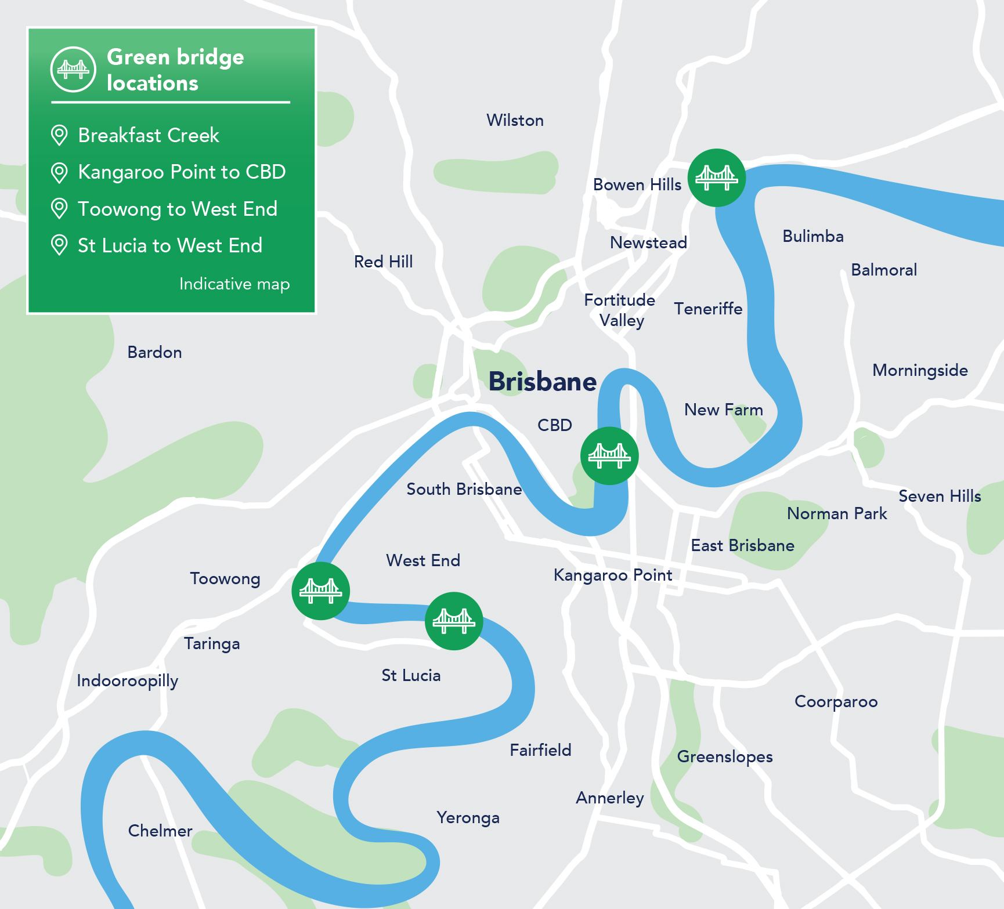
Figure 1 - Green bridge locations.

About the Breakfast Creek Green Bridge
The BCGB and extension to the Lores Bonney Riverwalk will cater for pedestrians and cyclists and provide an enhanced active transport link along the Brisbane River from the inner city to the northern suburbs. It will also enhance recreational experiences along the river. Initial consultation on the project was undertaken in late 2019 as part of the GBP’s early planning phase. Council has completed a detailed analysis of all feedback received and prepared an Initial Consultation Outcomes report.
Key feedback received on this bridge during the initial consultation phase included:
- general support for the proposed alignment, with around 62% of people supporting this alignment
- general support for improved connectivity for cyclists and pedestrians between the Lores Bonney Riverwalk and the inner city, with approximately 50% of survey respondents indicating they would use the bridge daily or weekly.
Following the initial consultation phase, and further technical investigations, a skewed alignment has been identified that connects the north-west corner of Newstead Park to Kingsford Smith Drive and Cameron Rocks Reserve. A plan showing the alignment and concept design is included in Appendix A.
This alignment has been selected because it:
- minimises impacts on key heritage places, including Newstead House and Newstead Park
- provides a comfortable and accessible connection for all bridge users, that is compliant with the Disability Discrimination Act 1992 (DDA)
- avoids impacts to significant public utility infrastructure
- maintains the ability for vessels to access Breakfast Creek
- minimises flooding impacts in Breakfast Creek
- future proofs potential options to upgrade the Breakfast Creek Road bridge and the east-west boardwalk connection.
The concept design for the project includes:
- a distinctive arch bridge span across Breakfast Creek with a length of about 80m
- dedicated pathways for pedestrians and cyclists, with a minimum width of 6m
- an upgraded extension to the Lores Bonney Riverwalk at Cameron Rocks Reserve
- a new landing plaza at Newstead Park, with landscape and urban design features to integrate with the unique heritage and landscape setting
- ongoing active transport connections to Breakfast Creek Road and Newstead Avenue
- As part of the development of the bridge design, Council is investigating opportunities for other design features such as shade, lighting, way finding and rest nodes.
The concept design was informed by a range of technical studies and investigations, including an analysis of bridge alignment and form options, flooding and environmental assessments, and consideration of visual and social impacts, as well as community feedback. The concept design was released for a four-week community consultation period from Monday 24 August to Friday 18 September 2020.
During this period, Council also commenced procurement activities for the construction of the BCGB, with the release of the invitation for Expressions of Interest (EOI) on 14 September 2020. Following the EOI process, three tenderers have been shortlisted to bid for the right to construct the BCGB.
Feedback from this consultation phase will help inform the final design for the green bridge, ahead of awarding a contract and starting construction of the BCGB in late 2021, subject to approvals.

Overview of key stakeholders
The BCGB project area includes the Brisbane suburbs of Newstead, Windsor, Albion, Hamilton, Bowen Hills, Clayfield and Ascot. Prior to commencing engagement activities, Council completed an analysis of the key stakeholders with an interest in the BCGB. Broadly, these groups include:
- Elected representatives: the local, state and federal elected representatives for the project area which includes:
  - Hamilton Ward
  - State electorates of McConnell and Clayfield
  - Federal electorate of Brisbane
- Internal Council stakeholders: Council’s elected representatives, senior leaders, and areas of Council that may be impacted by the design or construction of the BCGB
- Corridor stakeholders: this includes landholders, residents and property owners adjacent to or in close proximity to the project area, local businesses, road and path users, and utility and infrastructure providers
- Creek and river users: this includes community sailing / rowing groups, mooring users, cruise and ferry operators and boating associations
- Government departments and agencies: Queensland and Australian government departments, representatives and bodies
- Industry representatives: this includes contractors, designers, professional associations and peak bodies
- Advocacy and interest groups: groups representing local community and business interests, active and public transport, and environmental issues.

Previous engagement activities
The table below outlines the previous communication and engagement activities undertaken for the BCGB. To date, activities have focussed on introducing and raising high-level awareness of the overarching program and seeking feedback on a proposed bridge alignment.
Activity | Purpose | Timing
Green Bridges Program announced | Provided initial, high-level information about the GBP to Brisbane residents. Tactics included a page on Council’s website, a letter from the Lord Mayor to residents in selected suburbs, and a Living in Brisbane advertisement. | Late March 2019 – late May 2019
2019/2020 budget announcement | Outlined Council’s funding commitment to the GBP through Council budget communication activities. Supporting collateral included TV, outdoor and digital advertising, as well as social media and a city-wide mail out. | Mid-June – late June 2019
Initial community consultation | First phase of community consultation on the GBP to introduce residents and stakeholders to the program, build excitement and interest, and seek initial feedback on each of the bridges to help inform further project planning. Council released a proposed alignment for the BCGB extending from the Lores Bonney Riverwalk, to Breakfast Creek Road at Newstead. Engagement activities included a DL flyer mailout, webpage updates, online survey, community information sessions, pop-ups and stakeholder briefings. | Monday 11 November – Friday 6 December 2019
Release GBP Initial Consultation Outcomes report | Release of the GBP Initial Consultation Outcomes report which outlines key findings from the initial community consultation phase and next steps for each green bridge project. Awareness was raised through a media announcement, webpage update, email to database and stakeholder notifications, Councillor briefing notes and contact centre update. | Late March 2020
Targeted key stakeholder engagement | Meetings with adjacent / impacted and / or sensitive stakeholders to seek input into the development of the concept design, including the final alignment, landing locations and bridge form. Engagement activities included meetings, briefings and formal correspondence. | June – July 2020
Table 1 - Previous engagement activities.

Consultation approach

Purpose and objectives
The purpose of the consultation program was to share the BCGB concept design with residents, businesses and other stakeholders and collect their feedback to help inform the final bridge design, prior to construction starting in late 2021.

Council’s key objectives for this phase of consultation were to:
- seek detailed community feedback on the project’s concept design, landing locations and design features (e.g. shade, viewing points, pedestrian and cycle facilities)
- outline how the bridge will connect to the wider active transport network
- communicate the potential impacts of the project design and timings for project delivery
- reinforce the need for the bridge and why it is being delivered
- further understand community and stakeholder values, concerns and opportunities
- provide a variety of channels for residents and stakeholders to give feedback and share ideas
- identify stakeholder and communications risks and impacts that will need to be managed during the project’s construction phase
- generate excitement and interest in the features and benefits of the project.

Methods
A range of activities were undertaken across four key areas as part of the consultation program:
- Communication and media: a program of communication and media activities were designed to create awareness and communicate project features, benefits and timeframes amongst the broader community. Opportunities for the community to provide feedback were also promoted via these methods.
- Community consultation: a series of consultation activities provided the opportunity for the community to learn more about the project and give feedback on the project.
- Stakeholder engagement: individual meetings and briefings were offered to a variety of key stakeholders. During the consultation period, the project team met with an elected representative and an advocacy group.
- Feedback and reporting: a variety of opportunities and platforms were provided to ensure the community and stakeholders could provide their feedback. These platforms were widely promoted to maximise community involvement.
This process is outlined in Figure 2.
Commence the BCGB concept design for consultation:
- Media announcement
- Release of concept design
- Project newsletter
- Updated website content
- 2 x pop-up events
- Social media and advertising
- Stakeholder notifications

Receive feedback
- Online survey
- 6 x community information sessions
- Meetings with key stakeholders
- 1800 project hotline
- Project inbox
- Formal correspondence

Consultation period concludes
- Issue close-out communications
- Review and analyse feedback and survey results
- Prepare Consultation Report

Figure 2 - Consultation process.

Timeframes
The consultation program involved a formal, advertised, four-week consultation period from Monday 24 August to Friday 18 September 2020. Formal submissions and feedback received in the weeks following the consultation period have also been included in this report.
The following table outlines the key milestones in the consultation program.
Activity | Date
Media announcement (Lord Mayor invited the community to have their say on the BCGB concept design, webpages updated with information sessions details) | 18 August 2020
Consultation period starts  (online survey and new webpages go-live, advertising commenced) | 24 August 2020
Project newsletter delivered to households in local project area  Stakeholder notifications distributed | 24 – 28 August 2020
Community information sessions (6) and pop-up events (2) held across project area, and briefings with key stakeholders | 24 August – 18 September 2020
Formal consultation period concludes (online survey closes) | 18 September 2020
Table 2 - Key consultation program milestones.

Communication activities

Communication tools
This section outlines the communication activities undertaken to raise awareness of the BCGB concept design and the opportunities for the community and stakeholders to provide feedback during the consultation period.

Project newsletter and flyer
The table below summarises the project newsletter and flyer that was distributed to stakeholders in the project area during the consultation period.
Activity | Description | Distribution channel/s
BCGB project newsletter August 2020 | An A4 four-page full colour newsletter was produced. The newsletter provided information about the BCGB including details of the concept design and how to provide feedback. | - 29,474 residents and businesses in Newstead, Windsor, Albion, Hamilton, Bowen Hills, Clayfield and Ascot  - Pop up events and community information sessions  - Stakeholder briefings  - Hamilton and Central Ward Offices
Project flyer | A DL flyer to promote the BCGB and KPGB projects, raise awareness around the four-week consultation period and encourage people to have their say. | - Pop-up events and community information sessions.
Table 3 - Summary of project newsletter and flyer distribution during consultation period (August to September 2020).

Digital communication
The table below summarises the digital communication tools used during the consultation period.
Activity | Description | Distribution channel/s
Council website | The BCGB webpage was updated with a background and overview of the concept design, information session details, feedback survey and media library with a project plan, artist’s impressions and a fly-through animation. | - Promoted via all communication channels
Fly-through animation | A one-minute fly-through animation was produced for the BCGB to outline the project and demonstrate some features of the concept design. | - Council website  - Council YouTube channel  - Media
Online feedback survey | An online survey enabled the community to provide feedback on BCGB concept design. Respondents were asked to provide their overall level of support for the concept design as well as comment on specific design features. | - Promoted via all communication channels
Email update – launch of consultation | An email update was sent on 1 September 2020 to the GBP subscriber database encouraging participation in the community consultation program. | - Distributed to approximately 2,600 subscribers
CityCat advertising | A static advertisement was placed on CityCat TV screens to promote the consultation opportunities and encourage the community to provide their feedback. | - CityCat TV screens
Project video | The GBP video was updated to promote the program and reflect the status of each green bridge. The video promotes the fast-tracking of the BCGB and includes the fly-through animation of the concept design. | - Council website  - Council YouTube channel  - Media  - Social Media
Social media | Council’s existing social media channels (Facebook, Twitter and LinkedIn) were used to promote the community information sessions and encourage feedback. Content included the BCGB artist’s impressions and GBP video. | - Facebook  - Twitter  - LinkedIn
Key stakeholder notifications | Notifications (letters, briefing notes and emails) were sent to 58 key stakeholders. Briefing notes were issued to Councillors in Hamilton and Central (neighbouring) Wards. | - Email  - Mail
Internal Council channels | The BCGB concept design and community consultation information was promoted on Council’s internal communication channels, encouraging Council staff to have their say. | - What’s News  - Digital screens  - Council Intranet homepage  - Executive Manager updates  - Brisbane City Council Yammer  - Brisbane Infrastructure News
Living in Brisbane | An article in the September 2020 edition highlighted the BCGB concept design and the community consultation opportunities. | - Residents across Brisbane  - Council website
Table 4 - Summary of digital communication activities during consultation period (August to September 2020).

Collateral and other tools
The table below summarises the other communication tools used during the consultation period.
Activity | Description | Distribution channel/s
Consultation posters | A series of posters were developed to provide information about topics including:  - overall project alignment  - bridge landing locations  - artist’s impressions  - project overview and benefits. | - Community information sessions  - Stakeholder briefings  - Website
Consultation aerial maps | Laminated aerial maps of the project area were produced and used during consultation. The map showed the bridge alignment, surrounding suburbs and key points of interest. | - Community information sessions  - Stakeholder briefings  - Council website
Pull-up banner | A pull-up banner using project messaging and an artist’s impression of the BCGB was produced for use at community and stakeholder events. | - Community information sessions
A-Frame sign | A-frame signage was produced for use at BCGB consultation events. | - Pop-up events  - Community information sessions
Artist’s impressions | Artist’s impressions of the BCGB concept design were used on the website, in publications, media, social media, as well as on all consultation materials. Artist’s impressions included:  - Landing plaza at Newstead Park  - Bridge approach from Lores Bonney Riverwalk  - Aerial view of BCGB  - Bridge viewed from Breakfast Creek Road | - Council website  - Various collateral
Contact Centre scripting | Updated scripting with information about the community information sessions and other channels available for the community to provide their feedback, was provided to Council’s Contact Centre. | - Contact Centre staff
Contact cards | Business cards with project team contact details and the web address were utilised for distribution at engagement events and stakeholder briefings. | - Community information sessions  - Pop-up events  - Stakeholder briefings
Table 5 - Summary of communication collateral and other tools used during the consultation period (August to September 2020).

Key stakeholder notifications
To raise awareness of the consultation period, notifications including briefing notes and emails, were sent to 57 key stakeholders during the consultation period. This included:
- local, state and federal elected representatives for the project area
- corridor stakeholders
- river and mooring users
- government departments and agencies
- industry bodies
- advocacy, community and interest groups.
A detailed list of the stakeholders notified is outlined in Appendix B.

Media and social media

Media coverage
On Tuesday 18 August 2020, Lord Mayor Adrian Schrinner launched community consultation for the BCGB concept design via a media announcement. This announcement invited the community to have their say by attending an upcoming community information session or completing the online feedback survey.
During the consultation period, there were 76 media clips mentioning the GBP as outlined in the table below:
Medium | No. of media clips | Reach
Online news | 46 | 62.9M
Print | 2 | 195k
Television | 28 | 284k
Total media clips: 76 |  | Total media reach: 66.9M
Table 6 - Summary of media reach during consultation period (August to September 2020).

Social media advertising
Council’s existing social media channels were used throughout the consultation program to promote the community information sessions and to encourage residents and stakeholders to provide their feedback.
A total of four sponsored posts and three organic posts were made on Council’s Facebook, Twitter and LinkedIn accounts during the consultation period. Sponsored posts were geographically targeted to the Brisbane central region. A summary of the performance of these posts is outlined in the table below:
Measure | Sponsored posts results (Facebook) | Organic posts results (Twitter and LinkedIn) | Total
Number of posts | 4 | 3 | 7
Reach | 129,089 | 56,519 | 185.6k
Link clicks | 5,162 | 2,917 | 8.1k
Table 7 - Summary of social media metrics (24 August - 18 September 2020).

Social media coverage
During the consultation period, a total of 261 posts were made on social media referencing the consultation for the BCGB and KPGB. A summary of some of the top performing posts is outlined below.
Date | Outlet | Platform | Topic | Reach
18 August 2020 | 7 News Brisbane | Facebook | Release of the bridge designs | 871k
18 August 2020 | 10 News First Queensland | Facebook | KPGB and BCGB bridge designs revealed | 47k
18 August 2020 | Courier Mail | Facebook | Have your say | 534k
18 August 2020 | RACQ | Facebook | Encourage community to have their say | 14k
18 August 2020 | My Brisbane | Facebook | Exciting new artist’s impressions and fly-through released | 23k
19 August 2020 | Brisbane Times | Twitter | KPGB and BCGB budget | 290k
19 August 2020 | Your Neighbourhood | Facebook | Designs and fly-through revealed | 14k
15 September 2020 | Brisbane City Council | Twitter | Have your say | 313k
17 September 2020 | Bicycle Queensland | Facebook | Summary of briefing with GBP team | 21k
Total number of social media posts: 261 |  |  |  | Total reach: 4.5M
Table 8 - Summary of social media commentary (August to September 2020).

Council website
Following the Lord Mayor’s media announcement on 18 August 2020, the GBP webpages were updated to encourage the community to have their say. Updates to the BCGB webpage included a background and overview of the concept design, information session details, feedback survey and media library with project plans, artist’s impressions and a fly-through animation. Throughout the consultation period, there were 4,269 unique page views on the BCGB webpage, and a total of 26,802 unique page views across all GBP webpages.

Reach of communication activities
The table below provides a summary of reach across all communication activities.
Communication activity | Reach
Targeted mailouts | 29,474 households
Website | 26,802 unique page views
Flyers distributed at pop-up events | 56 flyers distributed
Email update to distribution list | 2,600 recipients
Social media | 185,608 people reached
Key stakeholder notifications | 58 stakeholders notified
Total number of people reached | 244.6k
Table 9 - Summary of reach of communication activities (August to September 2020).

Stakeholder and community consultation activities
This section provides a summary of the formal stakeholder and community consultation activities undertaken during the consultation period.

Summary of participation across all activities
A summary of participation across all consultation activities for the BCGB during the consultation period is outlined below. This includes late feedback and formal submissions received in the weeks following the consultation period.
Consultation activity | Participation and feedback
Online feedback survey – BCGB | 357 survey responses
Community information sessions –BCGB and KGB combined | 6 sessions  360 attendees  117 feedback forms
Pop-up events – BCGB | 2 pop-up events  56 flyers distributed
Stakeholder briefings – BCGB | 2 briefings
Detailed written submissions – BCGB | 8 submissions
Calls to the project hotline – all enquiries  (1800 318 166) | 16 calls
Emails received to the project inbox with feedback – BCGB GreenBridges@brisbane.qld.gov.au | 33 emails
Other correspondence received by the Lord Mayor and local Councillors (directed to the project team) – BCGB | 21 pieces of correspondence
Registrations for GBP updates | 198 people registered
Table 10 - Summary of participation across all consultation activities (August to September 2020).

Online feedback survey
The online survey consisted of a series of feedback questions about the overall BCGB design, design of the landing locations and other design features. The survey was accessible via a link from Council’s website and was promoted via the project newsletter, social media advertising, email notifications and other communication channels.
The survey was responded to 357 times with respondents having to answer all questions. Refer to Section 7 for the detailed results and feedback from the online survey, along with demographics of survey respondents.

Community information sessions
During the consultation period, six community information sessions were held at local venues located near the proposed landing locations for the KPGB and BCGB. Across all sessions there were 360 attendees and 117 feedback forms completed.
Each session was staffed by members of the project team from a range of disciplines. Residents were able to drop into a session to provide their feedback and ask questions about the project. Information posters were displayed at each venue, along with large aerial maps showing the proposed alignment for the BCGB and KPGB.
The sessions were promoted through the project newsletter, pop-up events, Council website and social media posts.
The below table provides details of the six community information sessions held during the consultation period:
Date | Time | Location | Attendees | Pieces of feedback
29 August 2020 | 9am-12pm | Newstead Park, Newstead | 65 | 25
3 September 2020 | 11am-2pm | Queen Street Mall, Brisbane City | 55 | 21
5 September 2020 | 9am-12pm | Captain Burke Park, Kangaroo Point | 65 | 28
9 September 2020 | 4pm-7pm | Queensland Multicultural Centre, Kangaroo Point | 20 | 13
12 September 2020 | 10am-1pm | Cameron Rocks Reserve, Hamilton | 35 | 11
13 September 2020 | 8am-3pm | Riverside Markets, City Botanic Gardens | 120 | 19
Total |  |  | 360 attendees | 117 pieces of feedback
Table 11 - Summary of community information sessions (August to September 2020).

Pop-up events
During the consultation period, two pop-up events were held near the proposed landing locations for the BCGB. Across all the pop-up events, 56 flyers were handed out. Each session was staffed by two members of the project team.
Team members handed out flyers to people passing by, encouraged them to attend a community information session or complete the online survey. An A-frame sign was displayed at each location.
Date | Time | Location | Flyers distributed
2 September 2020 | 7-9am | Lores Bonney Riverwalk (near Cameron Rocks Reserve), Hamilton | 32
10 September 2020 | 4-6pm | Bretts Wharf Ferry Terminal, Hamilton | 24
Total |  |  | 56 flyers distributed
Table 12 - Summary of pop-up events (August to September 2020).

Key stakeholder briefings
During the consultation period, two individual meetings with key stakeholders were held. These are outlined below.
Date | Activity
28 August 2020 | Councillor David McLachlan, Hamilton Ward
14 September 2020 | Representatives from Bicycle Queensland
Total number of briefings: 2
Table 13 - Key stakeholder meetings during the consultation period (August to September 2020).

Submissions
During the consultation period, eight formal written submissions in relation to the BCGB were received from key stakeholder groups.
Stakeholder | Project/s | Date received
LSH Properties / Mercedes Benz Precinct | BCGB | 2 September 2020
CBD Bicycle User Group | BCGB & KPGB | 15 September 2020
Bicycle Queensland | BCGB & KPGB | 18 September 2020
Queensland Walks | BCGB & KPGB | 18 September 2020
Heart Foundation | BCGB & KPGB | 18 September 2020
Engineers Australia | BCGB & KPGB | 18 September 2020
RACQ | BCGB & KPGB | 18 September 2020
Queensland Heritage Council | BCGB | 1 October 2020
Total number of submissions: 8
Table 14 - Summary of submissions received (August to September 2020).

Other correspondence
During the consultation period, an additional 21 pieces of correspondence were received via the Lord Mayor’s office and local Ward offices, and forwarded to the project team.
Project | Count
Overarching GBP | 5
KPGB | 2
BCGB | 0
Other green bridges | 14
Total pieces of other correspondence: 21
Table 15 - Summary of other correspondence received (August to September 2020).

Summary of feedback

Overarching feedback themes
Throughout the consultation period, Council received a number of general comments and questions about the BCGB relating to a range of issues, including project benefits and impacts, timeframes, cost and funding. In addition, Council received detailed feedback on specific elements of the concept design, including the overall bridge form and alignment, the landing locations, connectivity to the ongoing transport network, and specific design features and treatments. This feedback was received at community information sessions and stakeholder briefings, via the online survey, and via correspondence to the project inbox and the project hotline.
A review of the feedback received across all activities during the consultation period was undertaken by the project team. Overall, feedback from residents, businesses and other stakeholders indicated general positive support for the concept design, with 70% of survey respondents either completely or somewhat in favour of the overall concept design.
Feedback recognised the design would provide a safer and more comfortable connection for pedestrian and cyclists across Breakfast Creek, improve connectivity and accessibility between the northern suburbs and the inner city, and integrate well with the surrounding environment.
Residents and key stakeholders also raised a number of issues for further consideration by Council during future stages of the project, including the need for additional improvements to ongoing active transport connections, management of project impacts on the local environment and heritage elements, and the need for more information around specific elements of the project design.
The table below provides a summary of the key themes that emerged during this review.
Feedback theme | Summary
Overall design | - General positive support for the concept design and providing a safer and more accessible connection across Breakfast Creek for active transport users  - The proposed arch design was generally considered attractive and complimentary to the existing surroundings  - Some concerns raised about the impacts of the concept design on existing views and heritage elements, particularly Newstead House  - The design of the BCGB should not prevent the replacement of the existing road bridge in the future if required
Bridge alignment | - General support for the proposed skewed alignment from Newstead Park across Breakfast Creek to connect with the Lores Bonney Riverwalk as it is logical and ‘makes sense’  - Some preference for an alternative green bridge alignment across Breakfast Creek, such as closer to the existing road bridge or at the mouth of the creek  - Interest in whether the existing road bridge could be upgraded rather than building a new green bridge
Pedestrian and cycle facilities | - Support for a minimum six-metre pathway on the bridge and for separation between pedestrians and cyclists  - Suggestions for signage and other measures to control the speed of cyclists and ensure safety for pedestrians  - Requests for the existing footpaths on the Breakfast Creek Road bridge to be maintained, particularly on the upstream side  - Requests to ensure the BCGB is accessible and comfortable for wheelchair users
Impacts on existing creek / river users | - Maintaining the existing navigational clearance height for Breakfast Creek and maintaining access for creek / river users is important  - The navigational channel underneath the bridge must consider the existing creek conditions and type of vessels that require access to the creek  - Impacts on creek users during construction should be minimised as much as possible, with limited closures or changes in access  - Some interest in flooding impacts and whether flood assessments had been undertaken
Other bridge design features | - Some suggestions for shade cover or a viewing / rest node as part of the bridge design  - Interest in whether fishing would be allowed from the bridge
Newstead Park landing | - Clear separation of pedestrian and cyclist movements with pathways required at the landing point to reduce conflicts and provide clear sightlines  - Some concerns about the potential impacts of the landing on existing trees, green space and memorials in Newstead Park, and requests for these impacts to be minimised  - Suggestions for cyclist facilities at the landing including a CityCycle station and bike parking  - Suggestions for new landscaping and pathways to reflect the existing character of Newstead Park and Breakfast Creek  - Interest in whether upgrades or changes are proposed to pathways within Newstead Park
Connection to Lores Bonney Riverwalk | - Some suggestions for a more direct connection from the bridge landing to the existing east-west boardwalk along Breakfast Creek  - Some concerns about lack of shade and hot temperatures on the existing sections of the Lores Bonney Riverwalk
Connections to Newstead Avenue / Newstead Terrace / Breakfast Creek Road | - Requests for dedicated cyclist facilities on Newstead Avenue and Newstead Terrace, with wider paths, better signage and improved lighting  - Requests for measures to improve safety and reduce conflicts between pedestrians and cyclists at the Newstead Riverwalk  - Suggestions to relocate the bus shelter on Breakfast Creek Road to provide better access for cyclists  - Suggestions for an improved cyclist facility along Breakfast Creek Road
Other connections to the active transport network | - Suggestions for an improved cycling connection to Sandgate Road / Albion from Breakfast Creek, and upgrades to the existing east-west boardwalk  - Suggestion for an upgraded underpass connection from Newstead Park to the Mercedes Benz Lifestyle Precinct
Other issues | - Some concerns the project cost is too high and the benefits don’t justify the investment  - Some preference for investment in other projects such as a green bridge from Bulimba to Teneriffe or new ferry terminals rather than the BCGB
Table 16 - Summary of key feedback themes.

Formal submissions
Through the consultation period, Council received a total of eight formal submissions on the BCGB concept design. This included submissions from adjacent property owners, advocacy groups, and industry bodies. Submissions received on the concept design were summarised, with each comment raised categorised by the issue raised to identify key themes. Key feedback themes raised through formal submissions are summarised in the table below.
Feedback theme | Issues raised in submission
Overall bridge design | - Support for the proposed BCGB location, value to the community / precinct and overall improvements to safety and convenience for walkers and riders  - Request for Council to consider opportunities for lighting, public art and rest nodes to be included in the project  - Some concerns the proposed arch design will impact on heritage views from the northern side of Breakfast Creek to Newstead House and Park
Pedestrian and cycle facilities | - Support for separated facilities for pedestrians and cyclists / scooters with a minimum 6 metre width  - Suggestion for a bridge deck surface treatment to differentiate from pedestrian and cycle path and provide equivalent to asphalt  - Requests for consideration of shade into bridge design and broader precinct
Newstead Park landing | - Careful consideration of height of vegetation and garden beds at Newstead Park landing is required to maintain sightlines  - Some concerns about pedestrian conflicts at Newstead Park landing plaza and its connection to existing / upgraded pathways
Ongoing connections to Newstead Avenue / Newstead Terrace / Breakfast Creek Road | - Requests for more information / clarity about the proposed improved active transport connections to Breakfast Creek Road and Newstead Avenue  - Concerns the proposed upgraded ‘bike only’ path in Newstead Park is likely to attract pedestrians, and suggestion for separate pedestrian path to connect the bridge landing to Newstead Avenue  - Suggestion for the path beside Newstead Avenue to be upgraded to connect with the Newstead Riverwalk shared path  - Suggestion that existing bends from Breakfast Creek Road to the Newstead Avenue path require correction to meet Austroad standards  - Request for protected bike lanes on Newstead Terrace  - Recommend options to improve the supporting cycle network by delivering formal bicycle facilities along Newstead Terrace and Newstead Avenue, and a new connection to Waterfront Park at Newstead  - Suggestions that the planning and implementation of infrastructure on the southern approach to the bridge be expedited including consideration of on-road cycle lanes
Connections to Lores Bonney Riverwalk | - Suggestion for careful consideration of sight lines at connection to the Lores Bonney Riverwalk
Heritage considerations | - Recognition that the landscaping of the heritage site at Newstead House and Park is significant  - Recognition of the land impacts required to land the BCGB in Newstead Park and suggestion for the BCGB to be located closer to the existing road bridge
Precinct planning | - Request for inclusion of Breakfast Creek Wharf in the study area for the BCGB and consideration of future developments in the area to enable strategic planning of the Breakfast Creek precinct
Table 17 - Summary of stakeholder formal submissions.

Online survey results
Through the online survey, 357 respondents provided feedback on the BCGB concept design. The key results, along with demographic information about survey respondents, are outlined in the section below.

Overall support for the concept design
Respondents were asked to indicate their level of overall support for the BCGB concept design. The graph below outlines the percentage of responses for each level of support.
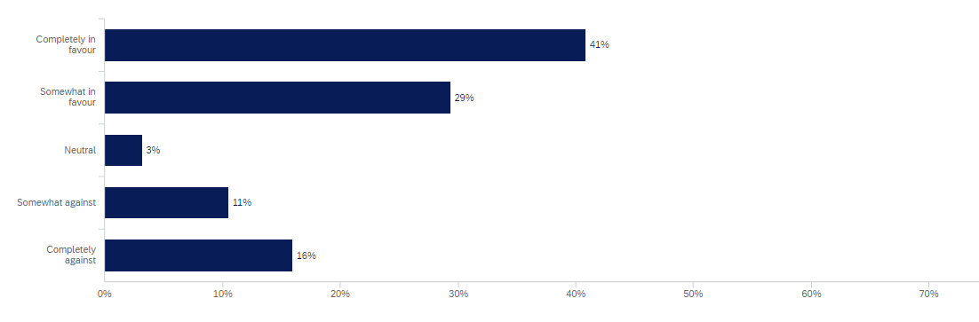
Respondents who were supportive of the concept design were asked what they liked about the design. Analysis of written responses identified the following common themes:
- Support for providing separated paths for pedestrians and cyclists across Breakfast Creek.
- The design will improve safety for active transport users who travel across Breakfast Creek.
- The design will significantly improve connectivity between the northern suburbs such as Ascot and Hamilton and the inner city.
- The proposed arch design is attractive and complements the existing surroundings.
- The design will encourage and promote greater uptake of active and green transport.
- The proposed skewed alignment across Breakfast Creek is logical and ‘makes sense’.
Respondents who were not supportive of the concept design were asked why they did not support the design and what could be done to improve it. Analysis of written responses identified the following common themes:
- Preference for an alternative green bridge alignment across Breakfast Creek, such as closer to the existing road bridge or at the mouth of the creek.
- Preference for Council to upgrade the existing bridge rather than build a new green bridge.
- Some concerns about the arch bridge form and the impacts on existing views and heritage elements, particularly Newstead House.
- Concerns that the project cost is too high and the benefits don’t justify the investment.
- Preference for a green bridge from Bulimba to Teneriffe rather than at Breakfast Creek.

Overall design features
Respondents were asked to rank the features of the concept design in order of importance.
The table below indicates the percentage of respondents that ranked each feature as the ‘most important’.
Features of the concept design | % of respondents rated ‘most important’
Dedicated cyclist and pedestrian paths | 55%
Improved connectivity to Newstead and the inner city | 15%
Recognition of heritage values of Newstead House and Newstead Park | 9%
Improved connectivity to the Lores Bonney Riverwalk and northern suburbs | 7%
Maintaining access to Breakfast Creek for boating and rowing | 6%
Landscaping and urban design elements (e.g. planting, seating) | 3%
Gentle and accessible bridge grade | 2%
Arch bridge design | 2%
New arrival plaza at Newstead Park | 1%
Table 18 - Summary of survey responses on design features.

Potential options under investigation
Respondents were asked to rank potential options under investigation by Council for inclusion in the final design in order of importance. The table below indicates the percentage of respondents that ranked each option as the ‘most important’.
Options under investigation | % of respondents rated ‘most important’
Enhanced active transport connection to Newstead Avenue | 30%
Enhanced active transport connection to Breakfast Creek Road | 22%
Shade cover | 19%
Opportunity for viewing / rest node with potential shade | 12%
Green design features | 8%
Interpretive signage recognising local history | 5%
Feature lighting | 3%
Public art | 2%
Table 19 - Summary of survey responses on options under investigation.

Survey respondent demographics
Gender of survey respondents
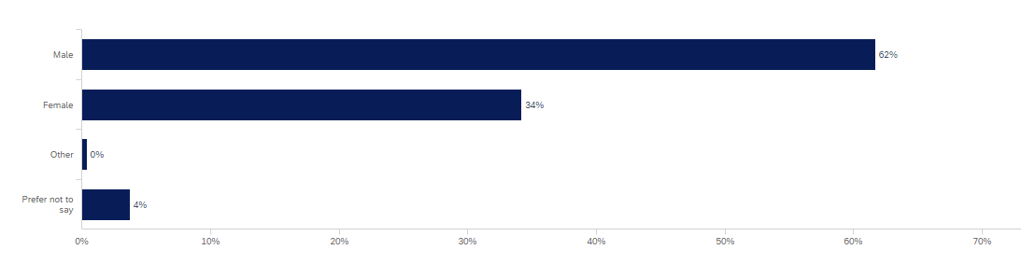
Age of survey respondents

Residential postcode of survey respondents
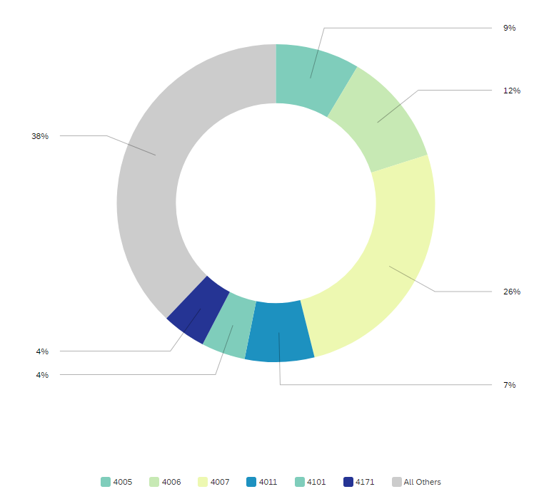

Conclusion
During August and September 2020, Council undertook community consultation with residents, businesses and other stakeholders on the BCGB concept design. During the four-week consultation period, feedback was provided at six community information sessions, via an online feedback survey, the project’s 1800 hotline and dedicated email inbox.
The project team also met with local stakeholder groups and received formal submissions. In total, around 800 people participated in the BCGB engagement program, including 360 attendees at information sessions and 357 responses to the online survey.
Following the consultation period, Council reviewed and summarised all feedback to determine overall support for the design and identify key themes and issues for further consideration. Overall, feedback indicated general positive support for the concept design, with 70% of survey respondents either completely or somewhat in favour of the overall design. Key feedback raised by residents and stakeholders included:
- general support for the skewed alignment from Newstead Park across Breakfast Creek to connect with the Lores Bonney Riverwalk, and the proposed arch bridge form
- support for a minimum six-metre pathway on the bridge, separation between pedestrians and cyclists, and measures to ensure the safety of all bridge and path users
- maintaining the existing access to Breakfast Creek for creek / river users is important, along with minimising impacts on creek access during construction
- some suggestions for shade cover or a viewing / rest node as part of the bridge design
- suggestions for new landscaping and pathways to reflect the existing heritage character of Newstead Park and Breakfast Creek, and for impacts on existing trees and green space to be minimised
- requests for dedicated cyclist facilities on Newstead Avenue and Newstead Terrace, with wider paths, better signage and improved lighting
- suggestions for other upgrades to the active transport network, such as an improved cycling connection to Sandgate Road / Albion from Breakfast Creek
- interest in whether the existing road bridge could be upgraded, and if the design of the BCGB would prevent the replacement of the existing road bridge in the future if required
- some preference for an alternative green bridge alignment across Breakfast Creek, such as closer to the existing road bridge or at the mouth of the creek.
Council acknowledges some feedback requesting consideration of alternative alignments for the BCGB, and some concerns around the proposed arch design.
As part of the development of the concept design, Council investigated a number of alignment options. Options involving an alignment closer to the existing road bridge were not progressed as this would:
- require costly relocation of significant existing public utilities, including major gas mains and trunk water mains
- impact the existing east-west pedestrian and cyclist boardwalk passing underneath the Breakfast Creek Road bridge on the northern side of Breakfast Creek
- provide a poor-quality connection for cyclists between Breakfast Creek Road and Kingsford Smith Drive, with a tight turning radius
- potentially impact the ability to upgrade or replace the road bridge in the future.

In addition, options involving an alignment closer to the mouth of Breakfast Creek were investigated. This option was not progressed as it would:
- significantly impact on the existing heritage features and views of Newstead Park and Newstead House
- provide poor connectivity to the surrounding precinct and active transport network.
The skewed alignment that connects the north-west corner of Newstead Park to Kingsford Smith Drive and Cameron Rocks Reserve was selected because it:
- minimises impacts on key heritage places, including Newstead House and Newstead Park
- provides a comfortable and accessible connection for all bridge users, that is compliant with DDA requirements
- avoids impacts to significant public utility infrastructure
- maintains the ability for vessels to access Breakfast Creek
- minimises any flooding impacts in Breakfast Creek
- future proofs potential options to upgrade the Breakfast Creek Road bridge and the east west boardwalk connection.
Council also investigated a range of bridge form options, including options with piers in the creek or a cable-stay mast design. The flood sensitive nature of Breakfast Creek requires a clear span bridge of approximately 80m. Assessments indicated any bridge concepts with piers in Breakfast Creek, in addition to the existing road bridge, would generate significant adverse flooding impacts.
In addition, the deep and soft ground conditions on the northern embankment indicate bridge options spanning 80m with a cable-stay main mast would require the mast to be on the Newstead Park side of the bridge, which would create significant obstruction to existing heritage views.
As such, an arch-style bridge was selected as it would maintain the existing navigational channel and vessel height clearance, avoid adverse flooding impacts, and cause the least obstruction to heritage views of Newstead House and Park.

Next steps
Based on the above, and the general positive support for the concept design, Council is progressing the BCGB based on the preferred skewed alignment and arch bridge form.
Other feedback from consultation on the concept design will help inform the final design for the BCGB, including the exact alignment, landing locations and bridge form, which will continue to be refined through the detailed design phase in 2021. Procurement activities are well underway, with three tenderers shortlisted to bid for the right to construct the BCGB.
Council will continue to keep local residents and stakeholders informed about the project and will provide further information about expected construction impacts and the final design in 2021. Updates will be provided on Council’s website, via project newsletters and social media, and through targeted engagement around specific project impacts and design elements with the local community.
This will include further information being provided throughout 2021 in relation to a range of issues, including, construction laydown areas, work hours, traffic management, property impacts and management of construction impacts such as noise, dust and vibration.
Subject to approvals, Council expects a construction contract to be awarded and construction of the BCGB to start in late 2021, with expected completion by late 2023.

Breakfast Creek Green Bridge project plan
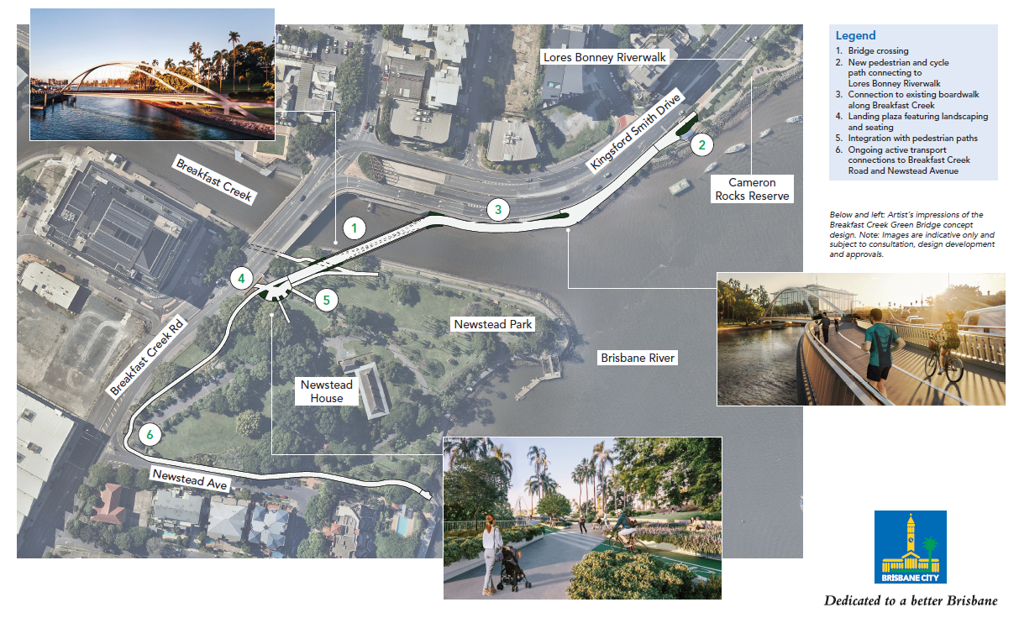

List of stakeholders notified
Groups | Stakeholder
Elected representatives | - Cr David McLachlan, Councillor for Hamilton Ward  - Tim Nicholls MP, State Member for Clayfield  - Grace Grace MP, State Member for McConnell  - Trevor Evans MP, Federal MP for Brisbane
Local businesses and property owners | - Newstead House Trust  - Mercedes Benz Brisbane  - LSH Properties  - Breakfast Creek Hotel  - Golden Gondola  - Simon Paroz and Co Boat Builders
River and creek users | - Brisbane GPS Rowing Club  - Brisbane River & Moreton Bay Cruises  - Boating Industry Association  - Commercial Rowing Club  - Dragon Boat Queensland  - Dragons Rowing Club  - Gardens Point boat harbour mooring users  - Kookaburra Showboat Cruises  - Mirimar Cruises  - Paddle Queensland  - Port of Brisbane  - Queensland Recreational Boating Council  - Rowing Queensland  - River City Cruises  - St Margaret’s Rowing Club
Community and advocacy groups | - Australian-American Association Queensland Division  - Bicycle Queensland  - Brisbane Road Runners Club  - Brisbane Airport BUG  - Brisbane North BUG  - Breakfast and Enoggera Creek Catchment Group  - Committee for Brisbane  - Cycling Brisbane  - CBD BUG  - EAST BUG  - Queensland Walks  - Habitat Brisbane  - Healthy Land and Water  - Heart Foundation  - Property Leaders Brisbane  - Property Council of Australia  - RACQ  - Royal Australian Navy Corvettes Association  - Space 4 Cycling  - Taxi Council  - Urban Development Institute of Australia
Government departments and agencies | - Active Transport Advisory Committee  - Cross River Rail Delivery Authority  - Department of Transport and Main Roads / TransLink  - Department of Transport and Main Roads Accessibility Reference Group  - Department of Environment and Science  - Department of Innovation and Tourism Industry Development  - Maritime Safety Queensland  - Queensland Police Service  - Queensland Fire and Emergency Services  - Queensland Ambulance
Table 20 - List of key stakeholders notified.

