Kangaroo Point Green Bridge
Draft Reference Design Consultation Report

November 2020

Contents
1. Executive Summary 1
2. Introduction 3
2.1 Purpose of this report 3
3. Background 4
3.1 About the Green Bridges Program 4
3.2 About the Kangaroo Point Green Bridge 5
3.3 Overview of key stakeholders 5
3.4 Previous engagement activities 6
4. Consultation approach 8
4.1 Purpose and objectives 8
4.2 Methods 8
4.3 Timeframes 9
5. Communication activities 10
5.1 Communication tools 10
5.2 Key stakeholder notifications 12
5.3 Media and social media 12
5.4 Reach of communication activities 14
6. Stakeholder and community consultation activities 15
6.1 Summary of participation across all activities 15
6.2 Online feedback survey 15
6.3 Community information sessions 15
6.4 Pop-up events 16
6.5 Key stakeholder briefings 16
6.6 Submissions 17
6.7 Other correspondence 17
7. Summary of feedback 18
7.1 Analysis of key feedback themes 18
7.2 Formal submissions 20
7.3 Online survey results 22
8. Conclusion 28
8.1 Next steps 29
Appendix A. Kangaroo Point Green Bridge project plan i
Appendix B. List of stakeholders notified ii

Executive Summary
Brisbane City Council is building new green bridges across Brisbane, which will make it even easier to get around our city on foot, by bike or scooter, or by connecting with public transport. The new bridges will link Kangaroo Point to the Brisbane Central Business District (CBD), Toowong to West End, St Lucia to West End, as well as a new crossing at Breakfast Creek.
The Kangaroo Point Green Bridge (KPGB) will cater for pedestrians and cyclists, making it easier to walk or cycle between Kangaroo Point and the CBD. It will also improve connectivity to the CBD with the city’s eastern and south-eastern suburbs.
In August 2020, Council publicly released the KPGB draft reference design, marking the next round of community consultation on the project. The draft reference design outlines the final bridge alignment, landing points, and structural form, as well as proposed design features and upgrades to ongoing connections to the active transport network.
Across a four-week community consultation period, residents, businesses and other stakeholders were invited to provide feedback on the design. Communication activities included a project newsletter distributed to local residents and businesses, updated content on Council’s website, including a fly-through animation, project plans and artist’s impressions of the design, and email notifications.
During the consultation period, feedback was provided at six community information sessions and via an online feedback survey, the project’s 1800 hotline and dedicated email inbox. The project team also met with local key stakeholder groups and received formal submissions. In total, around 1800 people participated in the KPGB consultation program, including 360 attendees at information sessions and 1038 responses to the online survey.
Following the consultation period, Council reviewed and summarised all feedback to determine overall support for the design and identify key themes and issues for further consideration. Overall, feedback indicated general positive support for the draft reference design, with 71% of survey respondents either completely or somewhat in favour of the overall design. Key feedback raised by residents and stakeholders included:
- positive support for the proposed bridge form, in particular the single-mast cable stay design, with some concerns raised around visual impacts
- support for shade cover along the length of the bridge, separated pathways for pedestrians and cyclists, and a food and beverage outlet on the bridge
- suggestions for the designs of the landing locations, including safety measures, additional connections to the local active transport network, and landscape and urban design features
- general support for the proposed underpass connection from Main Street to Deakin Street, with some suggestions for alternative designs
- interest in the timing and impacts of construction, including requests for more information about potential impacts on green space, vegetation and river users
- concerns from some mooring users / vessel owners about the proposed navigational clearance height of the bridge and potential loss of access to the Gardens Point Boat Harbour moorings for tall vessels.
While Council acknowledges concerns from some river users about the bridge height restricting access to the existing Gardens Point Boat Harbour moorings, Council can confirm the bridge design is being progressed with a navigational clearance height of 12.7 metres, which is no lower than the Captain Cook Bridge. This bridge height is required in order to provide an accessible gradient that meets the requirements of the Disability Discrimination Act 1992 (DDA) and removes the need for excessive ramping at each landing point.
A higher bridge would result in steeper grades towards the Alice Street landing in the Brisbane CBD, which would pose a safety risk for users with a disability, and subsequently would not meet DDA requirements.
Further, a bridge with an opening span that would allow a higher navigational clearance is not considered feasible as it would come at a significantly higher construction, maintenance and operational cost. This would not be an appropriate use of Council funds, particularly in the current economic climate as coronavirus impacts continue to be felt across the city. Council will continue to work closely with existing mooring and river users affected by the bridge navigational clearance height to manage the impacts of the change in access.
Other feedback on the draft reference design will help inform the final design for the KPGB, which will be refined through the procurement and detailed design phases of the project during 2021.
Procurement activities for the project are well underway, with two tenderers shortlisted to bid for the right to design and construct the KPGB. Subject to approvals, a contract is expected to be awarded in mid-2021, ahead of construction starting in late 2021 and expected completion by late 2023.
Council will continue to keep local residents, businesses and other stakeholders informed about the project, and will provide further information about expected construction impacts and the final design throughout 2021.

Introduction
Council is delivering new green bridges, which will get more cars off the road and give people more choice when it comes to travel. The KPGB is set to transform the way people travel between Kangaroo Point, the eastern suburbs and the CBD.
Feedback from the community has played a critical role in the development of the KPGB to date. Council is committed to providing ongoing opportunities for residents, businesses and other stakeholders to help shape the planning and delivery of the project, and keeping the community informed as the project progresses.
Following an initial consultation phase in late 2019, Council undertook further technical investigations and assessments in early 2020 to inform the development of the KPGB draft reference design. In August and September 2020, Council publicly released the draft reference design, marking the next round of community consultation on the project.
The draft reference design outlines the final bridge alignment, landing points, and structural form, as well as proposed design features and upgrades to ongoing connections to the active transport network.
In August and September 2020, Council also undertook consultation on the concept design for the Breakfast Creek Green Bridge (BCGB). A separate report has been prepared to outline the outcomes of consultation on the BCGB. Where consultation activities or feedback received related to both projects, it has been included in this report.

Purpose of this report
This report has been prepared to outline the results of community consultation on the KPGB draft reference design during August and September 2020:
This report provides:
- background to the Green Bridges Program (GBP) and the KPGB
- the objectives, approach and timeframes of the consultation program
- an overview of the communication tools used throughout the consultation period, including media, social media, direct mail, digital communication and stakeholder notifications
- participation results from all consultation activities and feedback channels, including community information sessions, pop-up events, an online survey and briefings with key stakeholders
- a summary of the key feedback themes for the KPGB draft reference design, based on an analysis of community feedback, and results of the online survey
- proposed next steps for the KPGB, including issues for further investigation by the project team.

Background

About the Green Bridges Program
Council is building new green bridges across Brisbane, which will make it even easier to get around our city on foot, by bike or scooter, or by connecting with public transport.
The new bridges will link Kangaroo Point to the CBD, Toowong to West End, St Lucia to West End, as well as a new crossing at Breakfast Creek. A map showing the location of each green bridge is outlined in Figure 1.
Council is getting on with the job of delivering the GBP to help stimulate the local economy and create jobs as the coronavirus impacts continue to be felt across the city.
Construction of the KPGB and BCGB is on track to start in late 2021, with both bridges expected to be complete by the end of 2023, subject to approvals.
Planning for the Toowong to West End and St Lucia to West End Green Bridges has reached the next phase, with Council now seeking community feedback on potential alignment options for each bridge.
The outcomes of consultation, along with further technical investigations and assessments will inform the preparation of a preliminary business case for these projects in 2021.
Council is also committed to investigating other locations for a fifth green bridge and will make more information available as planning progresses.
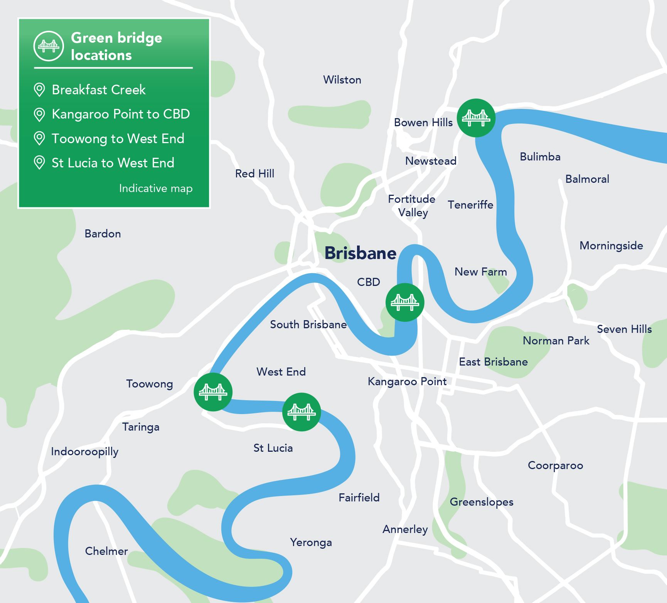

Figure 1 - Green bridge locations.

About the Kangaroo Point Green Bridge
The KPGB will cater for pedestrians and cyclists, making it easier to walk or cycle between Kangaroo Point and the CBD. It will also improve connectivity to the CBD with the city’s eastern and south-eastern suburbs.
A bridge connecting Kangaroo Point and the city centre has been considered since the 1860s. Council recommenced detailed planning in 2014 and in 2018 engaged consultants to undertake further technical studies on the bridge, including providing recommendations on a preferred alignment, landings and bridge options.
In September 2019, Council released the project’s preliminary business case key findings, which clearly demonstrated the benefits of the KPGB and value for money for Brisbane’s ratepayers. The preliminary business case identified a preferred alignment from the corner of Alice Street and Edward Street in Brisbane City to Scott Street at Kangaroo Point. This alignment provides:
- a safe and accessible connection
- a gentler slope on the bridge and at landing points
- more direct connections to existing pathways
- better visual outcomes.
Following strong support from the community on the preferred alignment during consultation in late 2019, Council undertook further technical investigations and assessments in early 2020 to inform the draft reference design. The draft reference design outlines the final bridge alignment, landing points, and structural form, as well as proposed design features and upgrades to ongoing connections to the active transport network. A plan showing the draft reference design is included in Appendix A.
Key features include:
- a river crossing between the corner of Alice Street and Edward Street in the CBD, and Scott Street at Kangaroo Point with a length of around 470m
- an elegant single-mast cable stayed structure, designed to complement the city skyline and minimise visual impacts
- dedicated cycle and pedestrian paths, with a minimum width of 6.8m along the length of the bridge, and a maximum grade of 1:20
- a navigable bridge clearance height of 12.7 metres (as per the Captain Cook Bridge), with provision for a 60m wide navigation channel
- a variety of places to pause and take in expansive river and city views
- sub-tropical design elements including landscaping, and shade along the length of the pedestrian path
- a proposed at-grade active transport connection from Main Street to Deakin Street at Kangaroo Point.
The KPGB draft reference design was released for a four-week community consultation period from Monday 24 August to Friday 18 September 2020. The purpose of consultation was to gain feedback from the community to help inform the final design for the green bridge, ahead of construction starting in late 2021, subject to approvals.
During this period, Council also commenced procurement activities for the design and construction of the KPGB, with the release of the invitation for Expressions of Interest (EOI) on 14 September 2020. Following the EOI process, two tenderers have been shortlisted to bid for the right to design and construct the KPGB. A contract is expected to be awarded in mid-2021, subject to approvals.

Overview of key stakeholders
The KPGB project area comprises the suburbs of Kangaroo Point and Brisbane City, along with the City Reach of the Brisbane River. Prior to commencing engagement activities, Council completed an analysis of the key stakeholders with an interest in the project. Broadly, these groups include:
- Elected representatives: the local, state and federal elected representatives for the project area which includes:
  - The Gabba and Central wards
  - State electorates of South Brisbane and McConnell
  - Federal electorates of Brisbane and Griffith
- Internal Council stakeholders: Council’s elected representatives, senior leaders, and areas of Council that may be impacted by the design or construction of the KPGB
- Corridor stakeholders: this includes landholders, residents and property owners adjacent to or in close proximity to the project area, local businesses, road and path users, and utility and infrastructure providers
- River users: this includes community sailing / rowing groups, mooring users, cruise and ferry operators and boating associations
- Government departments and agencies: Queensland and Australian government departments, agencies and bodies
- Industry representatives: this includes contractors, designers, professional associations and peak bodies
- Advocacy and interest groups: groups representing local community and business interests, active and public transport, and environmental issues.

Previous engagement activities
The table below outlines the previous communication and engagement activities undertaken for the KPGB. To date, activities have focussed on introducing and raising high-level awareness of the overarching program and seeking feedback on the preferred bridge alignment.
Activity | Purpose | Timing
Green Bridges Program announced | Provided initial, high-level information about the GBP to Brisbane residents. Tactics included a page on Council’s website, a letter from the Lord Mayor to residents in selected suburbs, and a Living in Brisbane advertisement. | Late March 2019 – late May 2019
2019/2020 budget announcement | Outlined Council’s funding commitment to the GBP through Council budget communication activities. Supporting collateral included TV, outdoor and digital advertising, as well as social media and a city-wide mail out. | Mid-June – late June 2019
Release of the KPGB Preliminary Business Case Key Findings report | Release of the KPGB Preliminary Business Case Key Findings report including the preferred alignment, indicative cost, benefits and impacts. Tactics included a media announcement, updated website content and content centre script. | Early September 2019
Initial community consultation | First phase of community consultation on the GBP to introduce residents and stakeholders to the program, build excitement and interest, and seek initial feedback on each of the bridges to help inform further project planning. Council sought more specific feedback on the KPGB, particularly in relation to the preferred alignment. Engagement activities included a four-page newsletter, webpage updates, online survey, community information sessions, pop-ups and stakeholder briefings. | Monday 11 November – Friday 6 December 2019
Release GBP Initial Consultation Outcomes report | Release of the GBP Initial Consultation Outcomes report which outlines key findings from the initial community consultation phase and next steps for each green bridge project. Awareness was raised through a media announcement, webpage update, email to database and stakeholder notifications, Councillor briefing notes and contact centre update. | Late March 2020
Targeted key stakeholder engagement | Meeting with adjacent / impacted and / or sensitive stakeholders to seek input into the development of the draft reference design. Engagement activities included meetings, briefings and formal correspondence. | June – July 2020
Table 1 - Previous engagement activities.

Consultation approach

Purpose and objectives
The purpose of the consultation program was to share the KPGB draft reference design with residents, businesses and other stakeholders and collect their feedback to help inform the final bridge design, prior to construction starting in late 2021.
Council’s key objectives for this phase of consultation were to:
- seek detailed community feedback on the project’s draft reference design, landing locations and design features (e.g. shade, viewing points, pedestrian and cycle facilities)
- outline how the bridge will connect to the wider active transport network
- communicate the potential impacts of the project design and timings for project delivery
- reinforce the need for the KPGB and why it is being delivered
- further understand community and stakeholder values, concerns and opportunities
- provide a variety of channels for residents and stakeholders to give feedback and share ideas
- identify stakeholder and communications risks and impacts that will need to be managed during the project’s construction phase
- generate excitement and interest in the features and benefits of the project.

Methods
A range of activities were undertaken across four key areas as part of the consultation program:
- Communication and media: a program of communication and media activities were designed to create awareness and communicate project features, benefits and timeframes amongst the broader community. Opportunities for the community to provide feedback were also promoted via these methods.
- Community consultation: a series of consultation activities provided the opportunity for the community to learn more about the project and give feedback on the project.
- Stakeholder engagement: individual meetings and briefings were offered and / or held with a variety of key stakeholders including elected representatives, local property owners, and community, business and advocacy groups.
- Feedback and reporting: a variety of opportunities and platforms were provided to ensure the community and stakeholders could provide their feedback. These platforms were widely promoted to maximise community involvement.
This process is outlined in Figure 2.
Commence the KPGB draft reference design consultation:
- Media announcement
- Release of draft reference design
- Project newsletter
- Updated website content
- 4 x pop-up events
- Social media and advertising
- Stakeholder notifications

Receive feedback
- Online survey
- 6 x community information sessions
- Meetings with key stakeholders
- 1800 project hotline
- Project inbox
- Formal correspondence

Consultation period concludes
- Issue close-out communications
- Review and analyse feedback and survey results
- Prepare Consultation Report

Figure 2 - Consultation process.

Timeframes
The consultation program involved a formal, advertised, four-week consultation period from Monday 24 August to Friday 18 September 2020. Formal submissions and feedback received in the weeks following the consultation period have also been included in this report.
The following table outlines the key milestones in the consultation program.
Activity | Date
Media announcement (Lord Mayor invited the community to have their say on the KPGB draft reference design, webpages updated with information session details) | 18 August 2020
Consultation period starts (online survey and new webpages go-live, advertising commenced) | 24 August 2020
Project newsletter delivered to households in local project area  Stakeholder notifications distributed | 24 August – 18 September 2020
Community information sessions (6) and pop-up events (4) held across project area, and briefings with key stakeholders | 24 August – 18 September 2020
Formal consultation period concludes (online survey closes) | 18 September 2020
Table 2 - Key consultation program milestones.

Communication activities

Communication tools
This section outlines the communication activities undertaken to raise awareness of the KPGB draft reference design and the opportunities for the community and stakeholders to provide feedback during the consultation period.

Project newsletter and flyer
The table below summarises the project newsletter and flyer that was distributed to local residents in the project area during the consultation period.
Activity | Description | Distribution channel/s
KPGB project newsletter August 2020 | An A4 6-page full colour newsletter was produced. The newsletter provided information about the KPGB including details of the draft reference design and how to provide feedback. | - 34,203 residents and businesses in Kangaroo Point, Woolloongabba, East Brisbane, Brisbane City and Spring Hill  - Pop up events and community information sessions  - Stakeholder briefings  - The Gabba and Central Ward Offices
Project flyer | A DL flyer to promote the KPGB and BCGB projects, raise awareness around the four-week consultation period and encourage people to have their say. | - Pop-up events and community information sessions
Table 3 - Summary of project newsletter and flyer distribution during consultation period (August to September 2020).

Digital communication
The table below summarises the digital communication tools used during the consultation period.
Activity | Description | Distribution channel/s
Council website | The KPGB webpage was updated with a background and overview of the draft reference design, information session details, feedback survey and media library with project plans, artist’s impressions and a fly-through animation. | - Promoted via all communication channels
Fly-through animation | A two-minute fly-through animation was produced to outline the project design and demonstrate the features of the KPGB. | - Council website  - Council YouTube channel  - Media
Online feedback survey | An online survey enabled the community to provide feedback on KPGB draft reference design. Respondents were asked to provide their overall level of support for the draft reference design as well as comment on the landing locations and specific design features. | - Promoted via all communication channels
Email update – launch of consultation | An email update was sent on 1 September 2020 to the GBP subscriber database encouraging participation in the community consultation program. | - Distributed to approximately 2,600 subscribers
CityCat advertising | A static advertisement was placed on CityCat TV screens to promote the consultation opportunities and encourage the community to provide their feedback. | - CityCat TV screens
Project video | The GBP video was updated to promote the program and reflect the status of each green bridge. The video promotes the fast-tracking of the KPGB and includes the fly-through animation of the draft reference design. | - Council website  - Council YouTube channel  - Media  - Social Media
Social media | Council’s existing social media channels (Facebook, Twitter and LinkedIn) were used to promote the community information sessions and encourage feedback. Content included the KPGB artist’s impressions, fly-through and GBP video. | - Facebook  - Twitter  - LinkedIn
Key stakeholder notifications | Notifications (letters, briefing notes and emails) were sent to 67 key stakeholders. Briefing notes were issued to Councillors in Central and The Gabba Wards. | - Email  - Mail
Internal Council channels | The KPGB draft reference design and community consultation information was promoted on Council’s internal communication channels, encouraging Council staff to have their say. | - What’s News  - Digital screens  - Council Intranet homepage  - Executive Manager updates  - Brisbane City Council Yammer  - Brisbane Infrastructure News
Living in Brisbane newsletter | An article in the September 2020 edition highlighted the KPGB draft reference design and the community consultation opportunities. | - Residents across Brisbane  - Council website
Table 4 - Summary of digital communication activities during consultation period (August to September 2020).

Consultation tools and collateral
The table below summarises the other communication tools used at events during the consultation period.
Activity | Description | Distribution channel/s
Consultation posters | A series of posters were developed to provide information about topics including:  - overall project alignment  - bridge landing locations  - artist’s impressions project overview and benefits. | - Community information sessions  - Stakeholder briefings  - Council website
Consultation aerial maps | Laminated aerial maps of the project area were produced and used during consultation. The map showed the bridge alignment, surrounding suburbs and key points of interest. | - Community information sessions  - Stakeholder briefings  - Website
Pull-up banner | A pull-up banner using project messaging and an artist’s impression of the KPGB was produced for use at community and stakeholder events. | - Community information sessions
A-frame sign | A-frame signage was produced for use at KPGB consultation events. | - Pop-up events  - Community information sessions
Artist’s impressions | Artist’s impressions of the KPGB draft reference design were used on the website, in publications, media, social media, as well as on all consultation materials. Artist’s impressions included:  - Bridge viewed from City Botanic Gardens  - Viewing and rest nodes  - City landing at Alice and Edward Streets  - Kangaroo Point landing at Scott Street  - Aerial view  - Bridge at night | - Council website  - Various collateral
Contact Centre scripting | Updated scripting with information about the community information sessions and other channels available for residents to provide their feedback, was provided to Council’s Contact Centre. | - Contact Centre staff
Contact cards | Business cards with project team contact details and the web address were utilised for distribution at engagement events and stakeholder briefings. | - Community information sessions  - Pop-up events  - Stakeholder briefings
Table 5 - Summary of communication collateral and other tools used during the consultation period (August to September 2020).

Key stakeholder notifications
To raise awareness of the consultation period, notifications including briefing notes and emails, were sent to 67 key stakeholders during the consultation period. This included:
- local, state and federal elected representatives for the project area
- corridor stakeholders
- river and mooring users
- government departments and agencies
- industry bodies
- advocacy, community and interest groups.
A detailed list of the stakeholders notified is outlined in Appendix B.

Media and social media

Media coverage
On Tuesday 18 August 2020, Lord Mayor Adrian Schrinner launched community consultation for the KPGB draft reference design via a media announcement. This announcement invited the community to have their say by attending an upcoming community information session or completing the online feedback survey.
During the consultation period, there were 76 media clips mentioning the GBP as outlined in the table below:
Medium | No. of media clips | Reach
Online news | 46 | 62.9M
Print | 2 | 195k
Television | 28 | 284k
Total media clips: 76 |  | Total media reach: 66.9M
Table 6 - Summary of media reach during consultation period (August to September 2020).

Social media advertising
Council’s existing social media channels were used throughout the consultation program to promote the community information sessions and to encourage residents and stakeholders to provide their feedback.
A total of four sponsored posts and three organic posts were made on Council’s Facebook, Twitter and LinkedIn accounts during the consultation period. Sponsored posts were geographically targeted to the Brisbane central region.
A summary of the performance of these posts is outlined in the table below:
Measure | Sponsored posts results (Facebook) | Organic posts results (Twitter and LinkedIn) | Total
Number of posts | 4 | 3 | 7
Reach | 129,089 | 56,519 | 185.6k
Link clicks | 5,162 | 2,917 | 8.1k
Table 7 - Summary of social media metrics (24 August - 18 September 2020).

Social media coverage
During the consultation period, a total of 261 posts on social media referenced the consultation for the KPGB and BCGB. A summary of some of the top performing posts is outlined below.
Date | Outlet | Platform | Topic | Reach
18 August 2020 | 7 News Brisbane | Facebook | Release of the bridge designs | 871k
18 August 2020 | 10 News First Queensland | Facebook | KPGB and BCGB bridge designs revealed | 47k
18 August 2020 | Courier Mail | Facebook | Have your say | 534k
18 August 2020 | RACQ | Facebook | Encourage community to have their say | 14k
18 August 2020 | My Brisbane | Facebook | Exciting new artist’s impressions and fly-through released | 23k
19 August 2020 | Brisbane Times | Twitter | KPGB and BCGB budget | 290k
19 August 2020 | Your Neighbourhood | Facebook | Designs and fly-through revealed | 14k
15 September 2020 | Brisbane City Council | Twitter | Have your say | 313k
17 September 2020 | Bicycle Queensland | Facebook | Summary of briefing with GBP team | 21k
Total number of social media posts: 261 |  |  |  | Total reach: 4.5M
Table 8 - Summary of social media commentary (August to September 2020).

Council website
Following the Lord Mayor’s media announcement on 18 August 2020, the GBP webpages were updated to encourage the community to have their say. Updates to the KPGB webpage included a background and overview of the draft reference design, information session details, feedback survey and media library with project plans, artist’s impressions and a fly-through animation. Throughout the consultation period, there were 6,900 unique page views on the KPGB webpage, and a total of 26,802 unique page views across all GBP webpages.

Reach of communication activities
The table below provides a summary of reach across all communication activities.
Communication activity | Reach
Targeted mailouts | 34,203 households
Website | 26,802 unique page views
Flyers distributed at pop-up events | 345 flyers distributed
Email update to distribution list | 2,600 recipients
Social media | 185,608 people
Key stakeholder notifications | 67 stakeholders notified
Total number of people reached | 249.6k
Table 9 - Summary of reach of communication activities (August to September 2020).

Stakeholder and community consultation activities
This section provides a summary of the formal stakeholder and community consultation activities undertaken during the consultation period.

Summary of participation across all activities
A summary of participation across all consultation activities for the KPGB during the consultation period is outlined below. This includes late feedback and formal submissions received in the weeks following the consultation period.
Consultation activity | Participation and feedback
Online feedback survey – KPGB | 1038 survey responses
Community information sessions – KPGB and BCGB combined | 6 sessions  360 attendees  117 feedback forms
Pop-up events – KPGB | 4 pop-up events  345 flyers distributed
Stakeholder briefings – KPGB | 7 briefings
Detailed written submissions – KPGB | 12 submissions
Calls to the project hotline – all enquiries  (1800 318 166) | 16 calls
Emails received to the project inbox with feedback - KPGB GreenBridges@brisbane.qld.gov.au | 59 emails
Other correspondence received by the Lord Mayor and local Councillors – KPGB | 2 pieces of correspondence
Registrations for GBP updates | 198 people registered
Table 10 - Summary of participation across all consultation activities (August to September 2020).

Online feedback survey
The online survey consisted of a series of feedback questions about the overall KPGB design, design of the landing locations and other design features. The survey was accessible via a link from Council’s website and was promoted via the project newsletter, social media advertising, email notifications and other communication channels.
The survey was responded to 1038 times with respondents having to answer all questions. Refer to Section 7 for the detailed results and feedback from the online survey, along with demographics of survey respondents.

Community information sessions
During the consultation period, six community information sessions were held at local venues located near the proposed landing locations for the KPGB and BCGB. Across all sessions there were 360 attendees and 117 feedback forms completed.
Each session was staffed by members of the project team from a range of disciplines. Residents were able to drop into a session to provide their feedback and ask questions about the project. Information posters were displayed at each venue, along with large aerial maps showing the proposed alignment for the KPGB and BCGB.
The sessions were promoted through the project newsletter, pop-up events, Council website and social media posts.
The below table provides details of the six community information sessions held during the consultation period:
Date | Time | Location | Attendees | Pieces of feedback
29 August 2020 | 9am-12pm | Newstead Park, Newstead | 65 | 25
3 September 2020 | 11am-2pm | Queen Street Mall, Brisbane City | 55 | 21
5 September 2020 | 9am-12pm | Captain Burke Park, Kangaroo Point | 65 | 28
9 September 2020 | 4pm-7pm | Queensland Multicultural Centre, Kangaroo Point | 20 | 13
12 September 2020 | 10am-1pm | Cameron Rocks Reserve, Hamilton | 35 | 11
13 September 2020 | 8am-3pm | Riverside Markets, City Botanic Gardens | 120 | 19
Total |  |  | 360 attendees | 117 pieces of feedback
Table 11 - Summary of community information sessions (August to September 2020).

Pop-up events
During the consultation period, four pop-up events for the KPGB were held at ferry terminals, parks and bridges near the proposed landing locations. Across all the pop-up events, 345 flyers were handed out. Each session was staffed by two members of the project team.
Team members handed out flyers to people passing by, encouraged them to attend a community information session or complete the online survey. An A-frame sign was displayed at each location.
Date | Time | Location | Flyers distributed
25 August 2020 | 4-6pm | Holman Street Terminal, Kangaroo Point | 70
27 August 2020 | 7-9am | Goodwill Bridge (near QUT Gardens Point landing) | 100
1 September 2020 | 4-6pm | City Botanic Gardens near Botanic Gardens Riverwalk | 60
8 September 2020 | 7-9am | Goodwill Bridge (near Southbank landing) | 115
Total |  |  | 345 flyers distributed
Table 12 - Summary of pop-up events (August to September 2020).

Key stakeholder briefings
During the consultation period, seven individual meetings with key stakeholders were held. These are outlined below.
Date | Activity
9 September 2020 | Representatives from Walan apartments, No. 2 Scott Street, Kangaroo Point
11 September 2020 | Councillor Jonathan Sri, The Gabba Ward
14 September 2020 | Representatives from Bicycle Queensland
16 September 2020 | Representatives from JGL Properties
16 September 2020 | Members of the Kangaroo Point Peninsula Business Group
22 September 2020 | Representatives from No. 1 Scott Street apartments, Kangaroo Point
23 September 2020 | Members of the Committee for Brisbane
Total number of briefings: 7
Table 13 - Key stakeholder meetings during the consultation period (August to September 2020).

Submissions
During the consultation period, 12 formal written submissions in relation to the KPGB were received from key stakeholder groups and elected representatives.
Stakeholder | Project/s | Date received
CBD Bicycle User Group | KPGB | 15 September 2020
St Vincent’s Health Australia | KPGB | 17 September 2020
Bicycle Queensland | KPGB & BCGB | 18 September 2020
Queensland Walks | KPGB & BCGB | 18 September 2020
Heart Foundation | KPGB & BCGB | 18 September 2020
East Bicycle User Group | KPGB | 18 September 2020
Engineers Australia | KPGB & BCGB | 18 September 2020
RACQ | KPGB & BCGB | 18 September 2020
Cancer Council Queensland | KPGB | 25 September 2020
Kangaroo Point Peninsula Business Group | KPGB | 25 September 2020
Committee for Brisbane | KPGB | 25 September 2020
Walan Apartments (No. 2 Scott St Kangaroo Point) | KPGB | 25 September 2020
Total number of submissions: 12
Table 14 - Summary of submissions received (August to September 2020).

Other correspondence
During the consultation period, an additional 21 pieces of correspondence were received via the Lord Mayor’s office and local Ward offices, and forwarded to the project team.
Project | Number
Overall GBP | 5
KPGB | 2
BCGB | 0
Other green bridge projects | 14
Total pieces of other correspondence: 21
Table 15 - Summary of other correspondence received (August to September 2020).

Summary of feedback

Analysis of key feedback themes
Throughout the consultation period, Council received a number of general comments and questions about the KPGB relating to a range of issues, including project benefits and impacts, timeframes, cost and funding. In addition, Council received detailed feedback on specific elements of the draft reference design, including the overall bridge form and design, the landing locations, connectivity to the ongoing transport network, and specific design features and treatments. This feedback was received at community information sessions and stakeholder briefings, via the online survey, and via correspondence to the project inbox and the project hotline.
A review of the feedback received across all activities during the consultation period was undertaken by the project team. Overall, feedback from residents, businesses and other stakeholders indicated general positive support for the draft reference design, with 71% of survey respondents either completely or somewhat in favour of the overall design.
Feedback recognised the design would significantly improve connectivity for pedestrians and cyclists between Kangaroo Point, the eastern suburbs and the CBD, provide a safe, accessible, and attractive experience for bridge users, and integrate well with the surrounding environment.
Residents and key stakeholders also raised a number of issues for further consideration by Council during future stages of the project, including the need for additional improvements to ongoing active transport connections, management of project impacts on local residents and property owners, and the need for more information about specific elements of the project design.
The table below provides a summary of the key themes that emerged during this review.
Feedback theme | Summary
Overall bridge design | - General positive support and excitement about the project and the draft reference design, including support for the proposed bridge form, in particular the single-mast cable stay design  - Suggestions for landscape elements to be included in the bridge design to help ‘soften’ the overall bridge form  - Some concerns about the visual impact of the mast, cables and the overall design on views to and from the CBD and Kangaroo Point  - Some suggestions for Council to consider alternative bridge forms or designs, including an opening span bridge or a bridge with a higher navigational clearance that would provide access for tall vessels
Pedestrian and cycle facilities | - Strong support for shade cover on the entire length of the pedestrian pathway, with some suggestions for shade cover over the cyclist pathway and landing locations  - Strong support for separated pedestrian and cyclist / scooter facilities on either side of the bridge, with some suggestions for alternative design elements (e.g. cycle lanes in the middle, physical barriers between pedestrians and cyclists, different surface treatments)  - Interest in how pedestrian safety and the speed of cyclists / scooters will be managed, particularly at conflict points such as landings and viewing nodes, with some suggestions for speed limits and clear signage
Rest / viewing nodes | - Rest / viewing nodes should maximise shade and weather protection, as well as provide views of the CBD skyline and Kangaroo Point Cliffs  - Strong support for a coffee cart or food and beverage outlet (e.g. bar) at the main rest / viewing node
City landing | - General support for the design and location of the City landing, and integration with the entrance to the City Botanic Gardens  - Some support for providing a direct ramp connection to the City Reach Boardwalk from the City landing of the bridge  - Some support for providing an expanded plaza area at the City landing, with more space for seating and pedestrians, and a potential food and beverage outlet, instead of a ramp connection to the City Reach boardwalk  - Support for the proposed signalised crossing on Edward Street and connectivity to the proposed CityLink Cycleway on Edward Street and Alice Street  - Suggestions for the central gate to the City Botanic Gardens to be open after-hours to provide access for cyclists  - Some concerns about impacts on the stone retaining wall, stairs and ramp at Edward Street and Alice Street
Scott Street landing | - General support for the proposed design of the Scott Street landing and improving connectivity to and from the Kangaroo Point peninsula, and the eastern suburbs  - Support for the proposed lift and stair connection to C.T. White Park and for improving connectivity from Scott Street to the Kangaroo Point riverwalk / pathways  - Some suggestions for a ramp connection for cyclists from Scott Street to C.T. White Park, with concerns existing cycle routes via Main Street or Thornton Street are too lengthy  - Some concerns about impacts on existing vegetation and green space at C.T. White Park, and nearby Brisbane River mangroves  - Suggestions for landscape, heritage and public art elements that recognise the history of C.T. White Park and the local area  - Some concerns from adjacent property owners and occupiers about privacy and security, and potential for conflicts between vehicle traffic and bridge users  - Suggestions for activation of the bridge abutment / underpass at C.T. White Park (e.g. rock climbing facilities, events space)
Main Street / Deakin Street underpass connection | - General support for the proposed underpass connection to Deakin Street underneath the Story Bridge  - Some concerns around local traffic impacts of the signalised crossing of Main Street and suggestions for other crossing types (e.g. raised crossing, zebra crossing)  - Requests for lower speed limit and other safety improvements on Main Street  - Interest in the design of cycle lanes and the footpath at Deakin Street  - Some suggestions for alternative routes (e.g. Baildon Street or the existing Thornton Street underpass) and greater activation of the area under the Story Bridge
Ongoing connections to the active transport network | - Requests for additional improvements to active transport connections at Kangaroo Point, particularly from the bridge landing to River Terrace and along the river to Mowbray Park in East Brisbane  - Suggestions for improvements to the Kangaroo Point riverwalk to provide better pedestrian and cyclist facilities  - Interest in how the bridge will connect to the proposed Citylink Cycleway in the CBD
Impacts on existing river users | - Concerns from some mooring users / vessel owners about the proposed navigational clearance height of the bridge (12.7m, as per the Captain Cook Bridge) and potential loss of access to the Gardens Point Boat Harbour moorings for taller vessels*  - Some interest from local residents in the impacts of the KPGB on existing ferry services in Kangaroo Point, particularly services from the Thornton Street Terminal*  - Requests for more information about the impacts of construction on river users
Project construction | - Interest in construction timings for the project and whether new or upgraded active transport connections will be delivered in the same timeframe  - Interest in the impacts of construction, particularly where construction site compounds will be located and whether any green space or vegetation will be impacted
Other feedback and issues | - Suggestions for names for the bridge  - Some concerns the project is not needed and that existing ferry services and bridges are sufficient to provide access between Kangaroo Point and the CBD  - Some concerns the project is too costly or not a value-for-money investment, or that expected benefits will not be realised  - Some suggestions for alternative bridge landing locations (e.g. Thornton Street or Eagle Street)
Table 16 - Summary of key feedback themes.
*Note: For Council’s responses to these issues, please refer to Section 7 – Conclusion.

Formal submissions
Through the consultation period, Council received a total of 12 formal submissions on the KPGB draft reference design. This included submissions from adjacent property owners, advocacy groups, and industry bodies. Submissions received on the draft reference design were summarised, with each comment raised categorised by the issue raised to identify key themes. Key feedback themes raised through formal submissions are summarised in the table below.
Feedback theme | Issues raised in submissions
Bridge design | - Support for bridge alignment from Scott Street to Alice Street / Edward Street  - Support for single-mast cable stay design  - Suggestions for alternative bridge form  - Consideration of integrated public art  - Requests for further information about potential visual impacts  - Support for multiple rest / viewing nodes  - Support for commercial activation of bridge at viewing nodes / landing points
Pedestrian and cycle facilities | - Requests for additional shade cover and innovative shade solutions  - Support for pedestrian and cyclist pathways  - Suggestion for bridge deck surface treatment similar to Goodwill Bridge  - Suggestion for new signalised crossings at bridge landing to prioritise pedestrians
City landing | - Support for signalised crossing to Edward Street  - Suggestion for direct ramp connection to City Reach Boardwalk suitable for cyclists and pedestrians  - Upgraded connections needed to broader cycling network / CityLink Cycleway  - Suggestion to provide after-hours access to City Botanic Gardens for cyclists  - Request for measures to address potential conflicts between pedestrians, cyclists and vehicles accessing City Botanic Gardens
Scott Street landing | - Concerns about potential pedestrian and cyclist conflicts at Scott Street  - Suggestion for alternative landing design to direct cyclists closer to Main Street crossing and underpass connection  - Suggestions for additional landscape and public art / interpretive design elements  - Support for retention of existing Poinciana tree as part of project design  - Request for ramp connection for cyclists to C.T. White Park  - Requests to ensure cyclist access is not impeded by bollards, seating or landscaping  - Suggestion for bus stops to be relocated nearby on Main Street
Main Street / Deakin Street underpass – supportive of proposed underpass | - Support for signalised intersection and underpass connection to Deakin Street  - Request for broader consideration of pedestrian / cyclist connections to Main Street to fulfil land use / planning intent for Kangaroo Point peninsula  - Suggestions for alternative connection via Baildon or Rotherham Streets  - Suggestion for alternatives to signalised crossing  - Suggestion to widen pathway to Story Bridge  - Suggestion for safety measures on Main Street (e.g. 10km/h speed limit)  - Request for further consultation on final design of intersection and underpass connection
Ongoing active transport connections – | - Suggestion for additional improvements to cycle connections to eastern suburbs  - Requests for more detail about connectivity to broader active transport network
Other feedback and issues | - Requests for amendments to Kangaroo Point Peninsula Neighbourhood plan to reflect final bridge alignment and changes to local connectivity
Table 17 - Summary of stakeholder formal submissions.

Online survey results
Through the online survey, 1038 respondents provided feedback on the KPGB draft reference design. The key results, along with demographic information about survey respondents, are outlined in the section below.

Overall support for the draft reference design
Respondents were asked to indicate their level of overall support for the KPGB draft reference design. The graph below outlines the percentage of responses for each level of support.
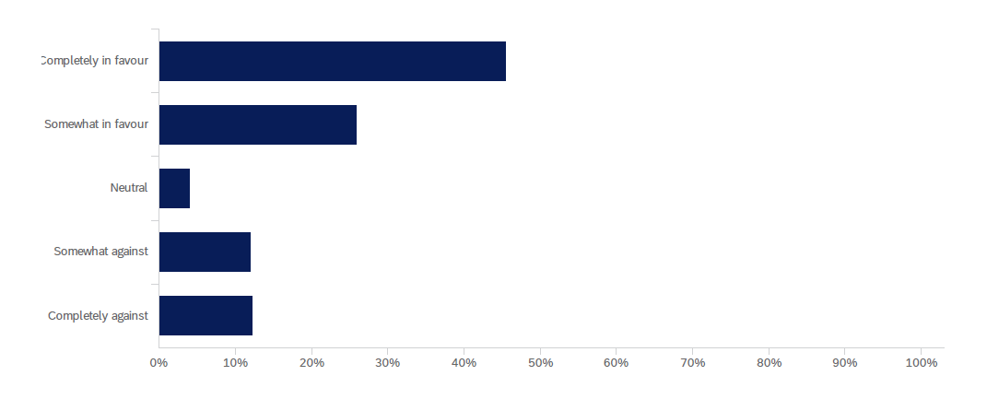
Completely in favour
12%
12%
4%
26%
45%
Respondents who were supportive of the draft reference design were asked what they liked about the design. Analysis of written responses identified the following common themes:
- Broad positive support for the single-mast cable stay design
- Recognition of improved connectivity benefits of the design
- The design encourages and promotes green / active transport
- Support for the separation of pedestrians and cyclists on the bridge deck
- Support for the proposed bridge alignment and general functionality of design
- Shade, landscaping elements and viewing / rest nodes are important design elements for bridge users.
Respondents who were not supportive of the draft reference design were asked why they did not support the design and what could be done to improve it. Analysis of written responses identified the following common themes:
- Concerns about the proposed navigational clearance height of the bridge and loss of access to the Gardens Point Boat Harbour moorings for taller vessels
- Some concerns about visual impacts of the bridge design, particularly the scale and bulk of the single mast and cable stays
- Some concerns the project is not needed or is too costly
- Preferences for green bridges at other locations or investment by Council in other projects
- Need for better connectivity to the broader active transport network at the bridge landing points.

Scott Street landing
Respondents were asked to indicate their level of support for the design of the bridge landing at Scott Street, Kangaroo Point. The graph below outlines the percentage of responses for each level of support.
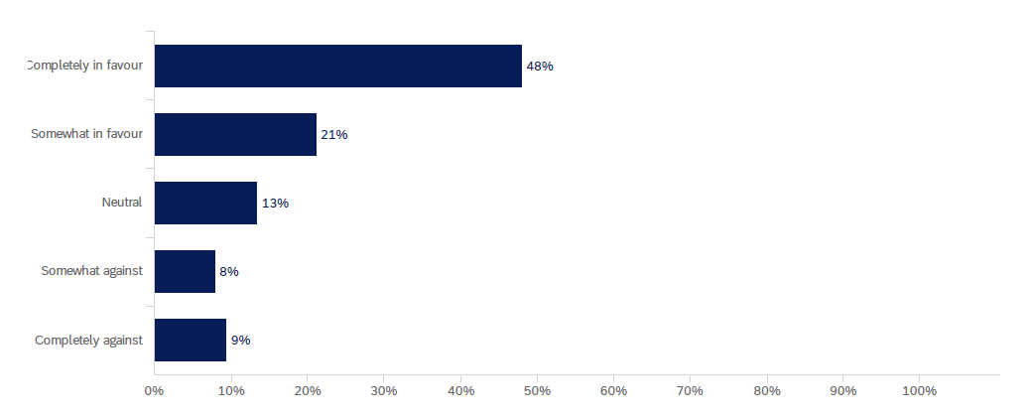
Completely in favour
Respondents who were supportive of the Scott Street landing design were asked what they liked about the design. Analysis of written responses identified the following common themes:
- General support for the landing location at Scott Street as a logical and convenient place to acess the bridge
- The landing will provide improved connectivity to the existing active transport network
- High-quality design that integrates well with the existing landscape and setting
- Support for the proposed active transport connection from Main Street to Deakin Street via an underpass.
Respondents who were not supportive of the Scott Street landing design were asked why they did not support the design and what could be done to improve it. Analysis of responses identified the following common themes:
- Some concerns about safety of pedestrians and cyclists interacting with general vehicle traffic
- Need for better pedestrian and cycling connections from the bridge landing to River Terrace and the Kangaroo Point riverwalk
- Preference for alternative landing locations for the bridge (e.g. Thornton Street)
- Concerns the project is not needed and the bridge landing at Kangaroo Point is unnecessary.

City landing
Respondents were asked to indicate their level of support for the design of the bridge landing at the corner of Edward and Alice streets in Brisbane City, which includes a direct ramp connection to the City Reach Boardwalk. The graph below outlines the percentage of responses for each level of support.
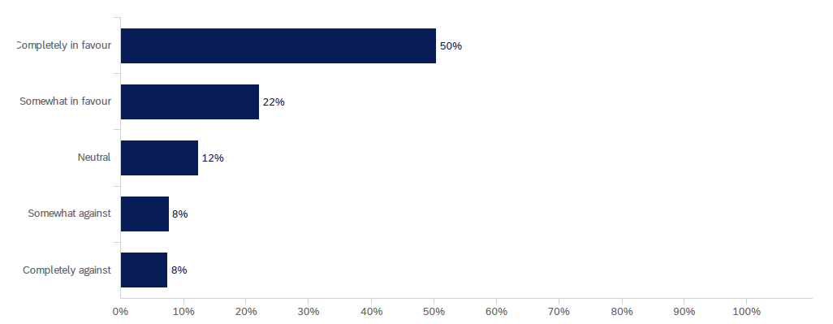
Completely in favour
Respondents who were supportive of the City landing design were asked what they liked about the design. Analysis of responses identified the following common themes:
- Support for the location of the bridge landing as it “makes sense”
- The landing location will improve connectivity and accessibility to the CBD for pedestrians and cyclists
- The landing design integrates well with the City Botanic Gardens and existing setting
- Some support for providing a direct ramp connection from the bridge landing to the City Reach Boardwalk.
Respondents who were not supportive of the City landing design were asked why they did not support the design and what could be done to improve it. Analysis of responses identified the following common themes:
- Concerns that the landing location and bridge height will impact on some users of the Gardens Points Boat Harbour moorings
- Concerns about the safety and separation of pedestrians and cyclists at this location, and potential for conflicts
- Concerns that a bridge to the CBD is not needed and the project is too costly.

City landing alternative option
Respondents were asked to indicate their level of support for the alternative landing option (expanded plaza area with no ramp connection) at the City landing. The graph below outlines the percentage of responses for each level of support.
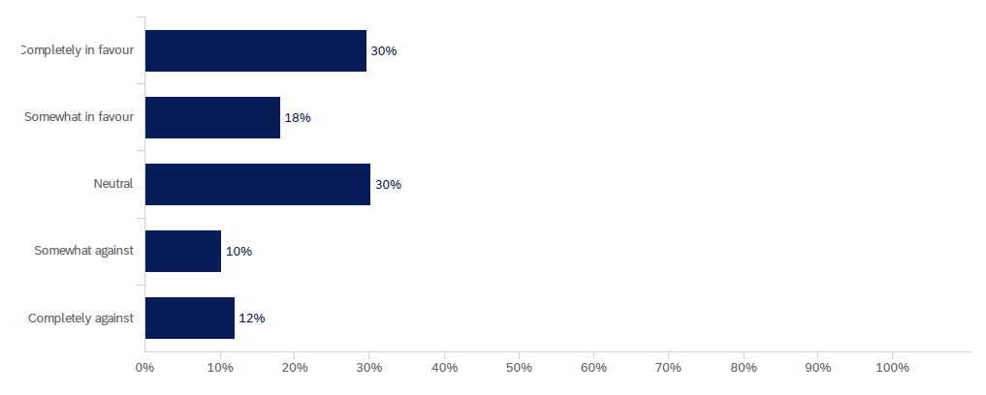
Completely in favour
Respondents who were supportive of the the alternative design option for the City landing were asked what they liked about the design. Analysis of written responses identified the following common themes:
- The design would provide improved opportunities for more viewing / seating / meeting space, and an additional food and beverage outlet
- The design would provide a more gentle, safer access to the City Reach Boardwalk via the City Botanic Gardens, rather than a direct ramp connection
- After-hours access to the City Botanic Gardens is needed for cyclists to ensure easy access to the City Reach Boardwalk.
Respondents who were not supportive of the alternative City landing design option were asked why they did not support the design and what could be done to improve it. Analysis of written responses identified the following common themes:
- The proposed design does not promote active transport, would remove direct access to the City Reach Boardwalk and provide poor connectivity for cyclists and pedestrians
- Additional seating / public space is not needed at this location and may create safety issues between pedestrians and cyclists

Overall design features
Respondents were asked to rank the features of the draft reference design in order of importance. The table below indicates the percentage of respondents that ranked each feature as the ‘most important’.
Features of the draft reference design | % of respondents rated ‘most important’
Dedicated cyclist and pedestrian paths | 52%
Ongoing connections to active and public transport networks | 18%
Shade cover on the pedestrian path | 15%
Landscaping and urban design elements | 6%
Single mast cable stay design | 5%
Opportunity for food and beverage outlet | 2%
Viewing / rest nodes | 2%
Seating | 1%
Table 18 - Summary of survey responses on design features.

Viewing / rest nodes
Respondents were asked to rank the features of the proposed viewing / rest nodes in order of importance. The table below indicates the percentage of respondents that ranked each feature as the ‘most important’.
Features of the viewing / rest nodes | % of respondents rated ‘most important’
Shade cover and weather protection | 41%
Views of the CBD skyline and Story Bridge | 25%
Incorporation of green design features | 11%
Frequency of nodes (i.e. shorter distances between each node) | 7%
Spaces to sit and relax | 7%
Views of the Kangaroo Point cliffs | 5%
Opportunities to purchase food and drink | 2%
Space for events and entertainment | 2%
Table 19 - Summary of survey responses on viewing / rest nodes.

Survey respondent demographics
Gender of survey respondents
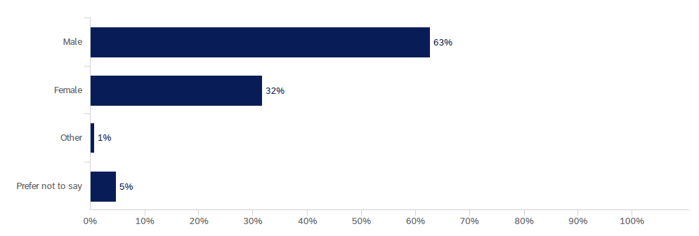

Age of survey respondents
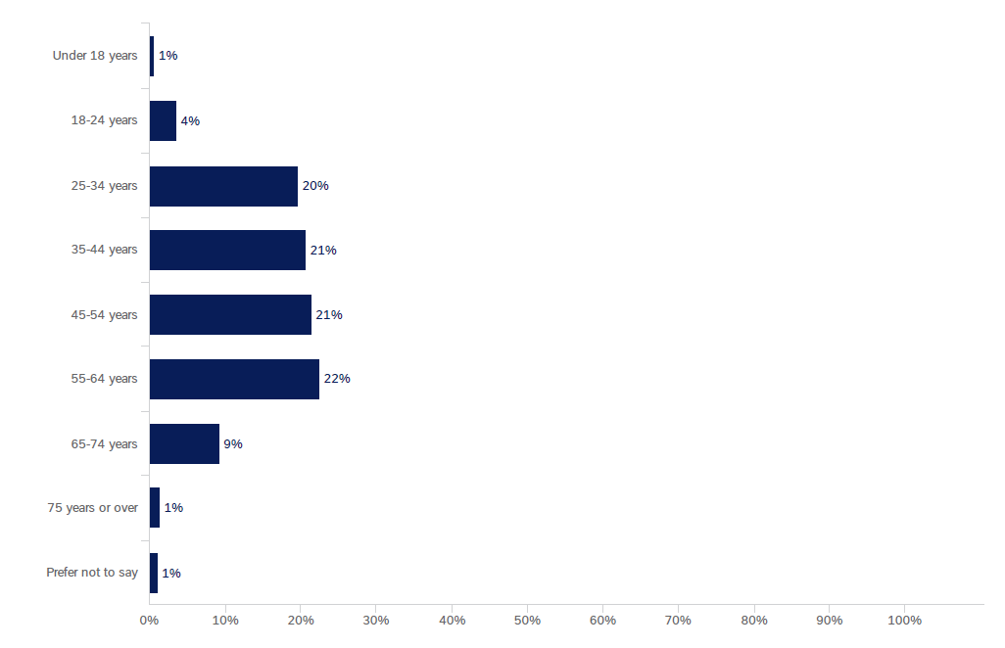
Residential postcode of survey respondents
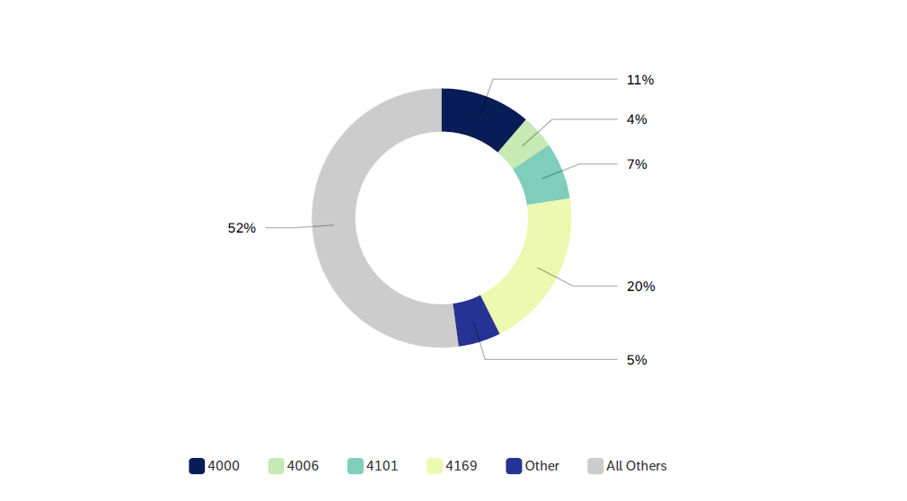

Conclusion
During August and September 2020, Council undertook community consultation with residents, businesses and other stakeholders on the KPGB draft reference design. During the four-week consultation period, feedback was provided at six community information sessions, via an online feedback survey, the project’s 1800 hotline and dedicated email inbox.
The project team also met with local stakeholder groups and received formal submissions. In total, around 1800 people participated in the KPGB engagement program, including 360 attendees at information sessions and 1038 responses to the online survey.
Following the consultation period, Council reviewed and summarised all feedback to determine overall support for the design and identify key themes and issues for further consideration. Overall, feedback indicated general positive support for the draft reference design, with 71% of survey respondents either completely or somewhat in favour of the overall design. Key feedback raised by stakeholders included:
- positive support for the proposed bridge form, in particular the single-mast cable stay design, with some concerns raised around visual impacts
- support for shade cover along the length of the bridge, separated pathways for pedestrians and cyclists, and a food and beverage outlet on the bridge
- suggestions for the designs of the landing locations, including safety measures, additional connections to the local active transport network, and landscape and urban design features
- general support for the proposed underpass connection from Main Street to Deakin Street, with some suggestions for alternative designs
- interest in the timing and impacts of construction, including requests for more information about potential impacts on green space, vegetation and river users
- some interest from local residents on the impacts of the KPGB on existing ferry services in Kangaroo Point, particularly services from the Thornton Street Terminal
- concerns from some mooring users / vessel owners about the proposed navigational clearance height of the bridge and potential loss of access to the Gardens Point Boat Harbour moorings for taller vessels.
While Council acknowledges concerns from some river users about the bridge height restricting access to the existing moorings, Council can confirm the bridge design is being progressed with a navigational clearance height of 12.7 metres, which is no lower than the Captain Cook Bridge. This bridge height is required in order to provide an accessible gradient that meets the requirements of the Disability Discrimination Act 1992 (DDA) and removes the need for excessive ramping at each landing point.
A higher bridge would result in steeper grades towards the Alice Street landing in the Brisbane CBD, which would pose a safety risk for users with a disability, and subsequently would not meet DDA requirements.
Further, a bridge with an opening span that would allow a higher navigational clearance is not considered feasible as it would come at a significantly higher construction, maintenance and operational cost. This would not be an appropriate use of Council funds, particularly in the current economic climate as coronavirus impacts continue to be felt across the city. Council will continue to work closely with existing moorings and river users affected by the bridge navigational clearance height to manage the impacts of the change in access.
Council also recognises some residents would like to see ferry services from the Thornton Street Terminal continue. In late October 2020, Council announced that it had sourced five new ‘KittyCats’ to undertake the CityHopper and Cross-River Ferry services from Holman Street Terminal on an interim timetable, starting in November 2020.
As part of this announcement, Council confirmed that ferry services will discontinue at Thornton Street Terminal as it is an older terminal that is not compatible with the modern KittyCat fleet, due to the difference in height between the older terminal and newer vessel. In addition, the Thornton Street Terminal will also be impacted by marine works during the construction of the KPGB, which is due to start in late 2021.
Due to the incompatibility with the new vessels and the KPGB construction impacts, Council has made the difficult decision to discontinue services at Thornton Street Terminal.
Kangaroo Point residents will continue to have ongoing access to ferry services from the Holman Street Terminal, while Council has also started plans to upgrade the Dockside Terminal to get it back into service as soon as possible.

Next steps
Feedback from consultation on the draft reference design will help inform the final design for the KPGB, which will be refined through the procurement and detailed design phases of the project during 2021.
Procurement activities are well underway, with two tenderers shortlisted to bid for the right to design and construct the KPGB. Subject to approvals, a contract is expected to be awarded in mid-2021, ahead of construction starting in late 2021 and expected completion by late 2023.
Council is committed to keeping residents, businesses, river users and all other stakeholders informed, and will provide ongoing opportunities to stay up-to-date on the project. Updates will be provided on Council’s website, via project newsletters and social media, and through targeted engagement around specific project impacts and design elements with the local community.
This will include further information being provided throughout 2021 in relation to a range of issues, including, construction laydown areas, work hours, traffic management, property impacts and management of construction impacts such as noise, dust and vibration.

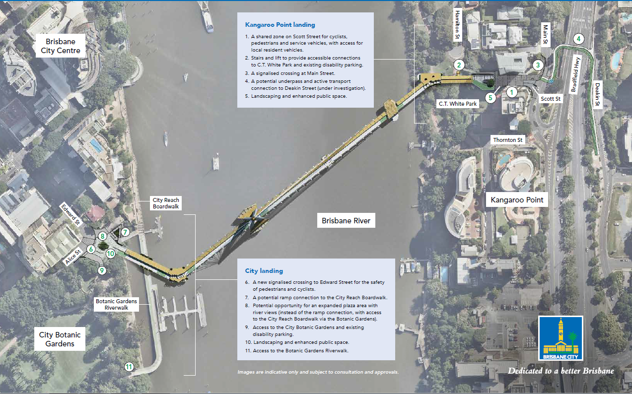
Kangaroo Point Green Bridge project plan

List of stakeholders notified
Groups | Stakeholders notified
Elected representatives | - Cr Jonathan Sri, The Gabba Ward  - Cr Vicki Howard, Central Ward  - Trevor Evans MP, Federal member for Brisbane  - Terri Butler MP, Federal member for Griffith  - Jackie Trad MP, State member for South Brisbane (at time of consultation)  - Grace Grace MP, State member for McConnell
Local residents and businesses | - No. 1 Scott Street  - No. 2 Scott Street (Walan apartments)  - Archipelago (Naval offices)  - Dexus  - JGL Properties  - QUT Gardens Point  - Riverside Markets  - Royal on the Park Brisbane  - Sebel Quay West Brisbane  - Dockside Marina  - Riverlife  - Stamford Plaza Hotel  - St Vincent’s Private Hospital  - Story Bridge Adventure Climb  - Story Bridge Hotel  - Destination Brisbane Consortium  - South Bank Corporation
River users | - Brisbane GPS Rowing Club  - Brisbane River & Moreton Bay Cruises  - Boating Industry Association  - Commercial Rowing Club  - Dragon Boat Queensland  - Gardens Point Boat Harbour mooring users  - Kookaburra Showboat Cruises  - Mirimar Cruises  - Paddle Queensland  - Port of Brisbane  - Queensland Recreational Boating Council  - Rowing Queensland  - River City Cruises
Community and advocacy groups | - Bicycle Queensland  - Brisbane Road Runners Club  - Committee for Brisbane  - Cycling Brisbane  - CBD BUG  - EAST BUG  - Queensland Walks  - Kangaroo Point and Districts Historical Society  - Kangaroo Point Free Business Networking Group  - Kangaroo Point Peninsula Business Association  - Habitat Brisbane  - Healthy Land and Water  - Heart Foundation  - Property Leaders Brisbane  - Property Council of Australia  - RACQ  - Space 4 Cycling  - Taxi Council  - Urban Development Institute of Australia
Government departments and agencies | - Active Transport Advisory Committee  - Cross River Rail Delivery Authority  - Department of Transport and Main Roads / TransLink  - Department of Transport and Main Roads Accessibility Reference Group  - Department of Environment and Science  - Department of Innovation and Tourism Industry Development  - Maritime Safety Queensland  - Queensland Police Service  - Queensland Fire and Emergency Services  - Queensland Ambulance
Table 20 - List of key stakeholders notified.

