Brisbane’s e-mobility strategy
DRAFT

November 2020

A message from the Public and Active Transport Chair

Brisbane is recognised around the world as a leader in e-mobility, being the first major city in Australia to introduce an e-scooter sharing scheme in 2018.

Brisbane City Council has a proud tradition of active transport innovation, establishing the nation’s second public bike hire service, CityCycle, in 2010.

A decade later, we are evolving to offer more travel options to meet the needs of our growing city, so residents can spend less time on the road and more time doing what’s important.

Council has developed Brisbane’s draft e-mobility strategy to provide guidance to private and public enterprise and support the use of sustainable and more energy-efficient transport options across Brisbane. This document outlines Council’s priorities on e-mobility including our policies, plans for infrastructure and safety considerations for future partnerships.

We could have said ’no’ to this technology, like other cities have done, but this would leave our residents and visitors worse off, with fewer options and less choice when it comes to getting around Brisbane. Our vision is for a connected city, where transport enhances liveability, supports business and investment, takes advantage of new technology and keeps riders and pedestrians safe.

We continue to learn lessons every day, improving e-mobility here in Brisbane and establishing best practice regulation of this sector in Australia.

By outlining a vision that looks to the future, we’re improving quality of life for residents while ensuring our city has the services and infrastructure to meet the needs of future generations.

Cr Ryan Murphy
Chair, Public and Active Transport Committee

Contents

Glossary 4
Growing a sustainable, liveable, inclusive and prosperous city 5
Introduction 6
E-mobility in Brisbane 7
Safety 9
Accessibility 10
Mobility 11
Agility 13
Infrastructure 15
Next steps 16

Glossary

Demand Responsive Transport (DRT)
A transport system that combines regular public transport and personalised taxi services in the one service to serve areas that lack traditional or frequent public transport.

E-mobility
Method of travel using wheeled electric devices, excluding motorised wheelchairs, with powered speeds of no more than 25 km/h. E-mobility is sometimes also referred to as e-wheeling.

E-devices
Electric devices, excluding motorised wheelchairs, with powered speeds of no more than 25 km/h. E-devices are sometimes also referred to as rideables.

E-bike
A bicycle that is power assisted by an electric motor of no more than 200 watts and with powered speeds of no more than 25 km/h.

E-scooter
A two-wheeled device with handlebars and with powered speeds of no more than 25 km/h.

First-and-last mile
The journey between a public transport service or a transport hub and the origin/destination.

Global Positioning System (GPS)
A satellite-based system that calculates the position of a device on the earth’s surface.

Micro-mobility
A term that encompasses travel by a range of small, lightweight devices operating with powered speeds of no more than 25 km/h.

Mobility as a Service (MaaS)
The integration of various forms of transport services into a single mobility service accessible on demand, typically via an app on a smart phone or device.

Mobility Data Specification (MDS)
A specification to enable sharing schemes to provide e-mobility data in a standard format to other agencies.

Personalised Public Transport (PPT)
Council’s system of taxi cabs that provide a hail-and-ride service on a set timetable and route.

Sharing scheme
A scheme where devices are publicly available for hire from a licenced operator.

Growing a sustainable, liveable, inclusive and prosperous city

Transport is essential to the functioning of our city. Our transport network connects people to work, study, services and entertainment, and moves goods, commodities and resources to ensure that our city’s economy thrives.

The Transport Plan for Brisbane – Strategic Directions (Transport Plan) is Council’s plan to guide the evolution of our city’s transport network over the next 25 years as Brisbane grows and evolves. E-mobility (also referred to as e-wheeling) is a key initiative of the Transport Plan and focuses on opportunities to encourage greater use of e-bikes, e-scooters and other emerging, sustainable e-mobility travel options.

Brisbane’s e-mobility strategy provides further direction to realise this key initiative, helping to meet the city’s needs as well as being flexible to respond to the opportunities and challenges ahead.

There are five key principles that underpin Council’s strategic direction in the adoption of e-mobility as part of the transport system.

Safety – the risk of incidents and crashes is minimised and the community has confidence in the safety of e-mobility devices, the users and of others.

Accessibility – coverage of sharing schemes reaches as many people as possible. E-mobility options have potential to complement the role of public transport and provide short distance transport options within communities so people can conveniently access local services, creating opportunities for local businesses.

Mobility – maximising the number of travel choices for all users of different ages and abilities. The convenience and flexibility of e-mobility devices provides a more attractive travel option than private vehicles.

Agility – the infancy of the industry and rapid technological change requires regulation and infrastructure provision that is adaptable to rapidly changing circumstances.

Infrastructure – supporting e-mobility sharing schemes with appropriate infrastructure will improve safety and public confidence in e-mobility.

Outcomes

- Private and public agencies are responsive and work together effectively to improve community awareness and ensure public confidence in e-mobility.
- E-mobility services are widely used in Brisbane, helping to connect communities with local services.
- Transport services and infrastructure help to enable e-mobility as a replacement for short car trips, especially for the first-and-last mile to public transport.
- The use of technology improves the efficiency and effectiveness of e-mobility networks and services in Brisbane.
- Our transport infrastructure helps the e-mobility industry to grow, improving safety and public confidence in e-mobility.

Introduction

Since the arrival of electric scooters in Brisbane in November 2018, more than 3.5 million rides have been taken by 600,000 riders.

The rapidly changing transport environment has brought about new technologies and ways to travel, offering opportunities to explore a broader range of private car alternatives.

Worldwide, cities are embracing e-mobility as part of their transport ecosystems. As accessibility and usage of e-mobility devices increases in Brisbane, opportunities for longer trips and the demand on our active transport infrastructure will also grow.

It is important for e-mobility policies to maximise community benefit, keep people safe and promote accessibility for all. Council’s e-mobility strategy has been developed to align with existing transport strategies, particularly those relating to access and inclusion and sustainability.

Brisbane: A shared e-mobility ecosystem

Council sees both privately owned and public e-mobility sharing schemes, managed by approved operators, as part of an overall e-mobility ecosystem.

To date, Council has not restricted or defined operating areas and has allowed full commercial freedom (apart from negotiated access fees) for the current e-scooter operators in Brisbane. Our key interest has been in ensuring community safety and accessibility through the regulation of a limited number of e-scooter operators, imposing caps on the operators and regularly auditing their positioning on streets.

Sharing scheme providers are beginning to offer a wider range of devices in response to changing demand. A consistent approach needs to be taken to facilitate the use of e-mobility devices and to guide future relationships with providers.

E-mobility in Brisbane

E-mobility, also referred to as e-wheeling, refers to a range of small, lightweight devices operating at powered speeds of no more than 25 km/h. These devices are either privately owned or hired by riders as part of a public, commercially operated, hire or sharing scheme.

E-mobility devices are predominantly battery powered electric bikes or ‘e-bikes’, electric scooters or ‘e-scooters’, electric skateboards or ‘e-skateboards’, electric pedal assisted or ‘pedelec’ bicycles and other mostly electric powered vehicles, such as Segways and ‘One-wheels’.

The relatively recent expansion of the e-mobility market, in part due to a dramatic reduction in manufacturing and charging costs, has increased its attractiveness as an alternative transport mode and created opportunities for business.

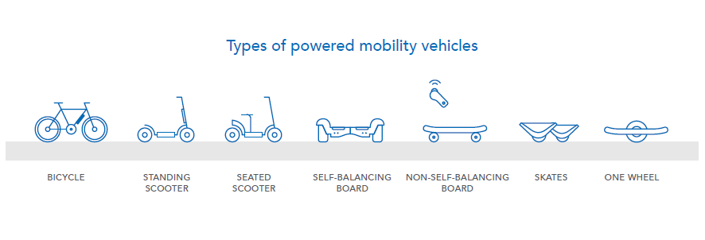

Benefits of shared e-mobility:

- Affordability – with short trips costing between $2 and $5, e-mobility is priced between public transport and rideshare/taxis over similar routes, providing users with an additional low-cost transport alternative.

- Convenience – moves people quickly and efficiently for the first-and-last mile of their journeys, getting people closer to their destination and extending active travel into steep terrain allowing people to ride further, regardless of personal fitness.

- Sustainability – reduces road congestion and pollution by replacing car trips with fuel efficient transport options that use green energy for charging and improve air quality. E-mobility devices can be used in conjunction with other modes, such as public transport, walking or riding, to provide a viable alternative to private car trips.

- Economic – in addition to local job creation, increased passing traffic close to businesses, either by foot, bicycle, or e-mobility device, encourages people to shop local. Health and wellbeing benefits are achieved by providing equitable access to e-mobility devices as an alternative active transport option.

- Safety – e-mobility devices are generally regarded to be as safe as cycling. Car trips that are replaced by e-mobility devices can help make streets safer for pedestrians, cyclists, scooter riders and drivers, particularly when there is careful management of interaction between e-mobility devices, pedestrians and other vehicles.

To help manage the community impact of e-scooters, jurisdictions have sought to regulate in the areas of public space usage, placing limitations on the number of operators, and limitations on the number of devices. Cities have allowed:

- any operator to compete on their streets for riders (‘competition within the market’);
- a tender for a monopoly operator (‘competition for the market’); or
- a limited set of operators, operating with different products and possibly geographical areas.

Many cities, including Brisbane, are moving towards allowing a limited set of sharing scheme operators, with a fee paid to the city for the right to operate.

A maximum cap is also often placed on the number of e-mobility devices provided by a particular operator. This helps to reduce the number of operators that must be administered and issues of scheme operation and compliance, reducing the risk to the city.

E-mobility in Brisbane

Oct 2010 To encourage more use of active transport, Council launches CityCycle, Australian’s first and largest public bicycle hire sharing scheme, with a total of 2000 bikes and 150 stations.

Dec 2018 Council permitted a three-month trial for Lime to operate 500 e-scooters on public land under the Public Land and Council Assets Local Law (2014). The trial was later extended to six months, and quantity increased to 750.

Mar 2019 Council reviewed the performance of e-scooters under the trial and undertook a market sounding of potential operators, and other jurisdictions, to determine the viability of e-scooter operations in Brisbane.

During the market sounding, more than twenty operators expressed interest in operating e-scooters in Brisbane and, backed by public demand (evidenced by more than 600,000 trips by the end of February 2019 alone), Council undertook a competitive procurement process for two operators with a combined cap of 1000 e-scooters.

July 2019 Two successful operators were appointed by Council. Lime and Neuron Mobility (Neuron) manage and operate 400 and 600 e-scooters respectively under separate Operating Agreements and Notices of Consent with a maximum three-year term consisting of an initial 12-month term, with the option to extend for two further 12-month periods.

Oct 2020 To fully embed e-mobility as a part of the city's transport network, Council launches its e-mobility strategy focusing on e-bikes, e-scooters and any other electrically powered vehicles that weigh less than 60 kilograms and have a maximum speed of 25km/h. This strategy excludes registered road vehicles, motorised wheelchairs and drones.

Safety

Outcome
Private and public agencies are responsive and work together effectively to improve community awareness and ensure public confidence in e-mobility.

Due to their relatively recent emergence and increase in popularity, both in Brisbane and internationally, there is limited data from research on the safety of e-mobility devices. As cities and countries adapt to this changing technology, new legislation, policy, and regulations are being put in place to manage safe use of e-mobility devices relative to other transport modes.

Of the admissions at the emergency department of a major hospital two months after the introduction of e-scooters in Brisbane, 28% had consumed alcohol and 20% rode without a helmet. However, studies have found that in general the injuries being sustained were relatively minor.

A study on micro-mobility published by the Organisation for Economic Co-operation and Development (OECD) concluded that the risk of an emergency department visit for an e-scooter rider is similar to that for cyclists.

Furthermore, the same study suggests that riding a motorcycle or moped is associated with over 11 times more fatalities than riding a bicycle in urban areas, controlling for the number of trips.

Manufacturers of e-mobility devices have demonstrated commitment to safety with design improvements, such as increasing the wheel size on e-scooters to improve stability and updating device firmware to resolve braking issues in the electronic control systems.

Cycling Brisbane is Council’s free membership program, helping people of all ages and abilities to get around our city by bike since 2014. Cycling Brisbane has more than 26,000 members, providing information on cycling routes and educational workshops on a range of topics from bicycle maintenance and rider safety, to children’s skills sessions and guided rides. The opportunity exists for the current Cycling Brisbane program to be expanded to include e-bikes, e-scooters and other e-mobility devices in the overall Cycling Brisbane outreach.

Direction
- Advocate for and participate in a state-wide safety program for e-mobility.
- Include e-mobility users in Council’s Cycling Brisbane program.
- Continue to advocate with the Queensland Government and the Queensland Police Service for stronger enforcement of helmet usage and safe riding in areas of high pedestrian presence.

Accessibility

Outcome
E-mobility services are widely used in Brisbane, helping to connect communities with local services.

E-mobility devices provide an opportunity for an additional, relatively low-cost, alternative to transport by private vehicles, enhancing social equity by providing increased transport options.

As manufacturing and charging costs reduce, and shared e-mobility schemes increase in popularity, it is becoming more affordable to own a personal e-mobility device and easier to access shared e-mobility devices. Different pricing schemes and alternative payment options for pensioners, students or people on low-incomes or without smart phones or internet access can ensure they are not excluded from the benefits of e-mobility sharing schemes.

Although e-mobility provides additional transport options for people, under Council’s City for Everyone: Inclusive Brisbane Plan 2019-2029, Council is committed to making it easier for people of all ages, abilities and backgrounds to be able to move around safely and easily including the option of e-mobility.

A solution to providing accessibility where traditional forms of public transport cannot reach, or it is impractical to provide, is DRT. DRT aims to provide the flexibility of the private vehicle through a public transport service. Council operates a hail-and-ride service that links neighbourhoods with public transport hubs on a set timetable and routes, known as PPT.

A trial of DRT by the Queensland Government in the Brisbane metropolitan area has shown a demand for neighbourhood journeys to and from homes to shopping centres, libraries and other community facilities. However, there are limitations around operating areas and hours, pick up and drop off locations and integration with public transport. By providing the possibility of a direct door-to-door service, e-mobility devices have potential to deliver the service and flexibility that DRT cannot.

Direction
- Encourage scheme operators to offer alternate scheme access, reduced pricing and other incentives to low-income earners or disadvantaged communities.
- Undertake consultation with community organisations on the impacts of e-mobility.
- Work with providers of e-scooter and e-bike hire services to investigate how services could be expanded to a neighbourhood transportation system.
- Investigate how these services may complement and expand on existing PPT and DRT services.

Mobility

Outcome
Transport services and infrastructure help to enable e-mobility as a replacement for short car trips, especially for the first-and-last mile to public transport.

Between 30-50% of riders report using e-scooters to replace car rides on their most recent trip, signalling the positive impact e-mobility solutions can have on reducing congestion and emissions by substituting for car travel.

In younger demographics (under 40), car ownership is a decreasing priority and at the same time, car sales are down year on year. This is the same demographic most likely to own or use e-mobility devices or sharing schemes. Analysis from the 2017 Brisbane Household Travel Survey found that half of all private vehicle trips are less than 4.7 kilometres, suggesting e-mobility could be used to replace these trips.
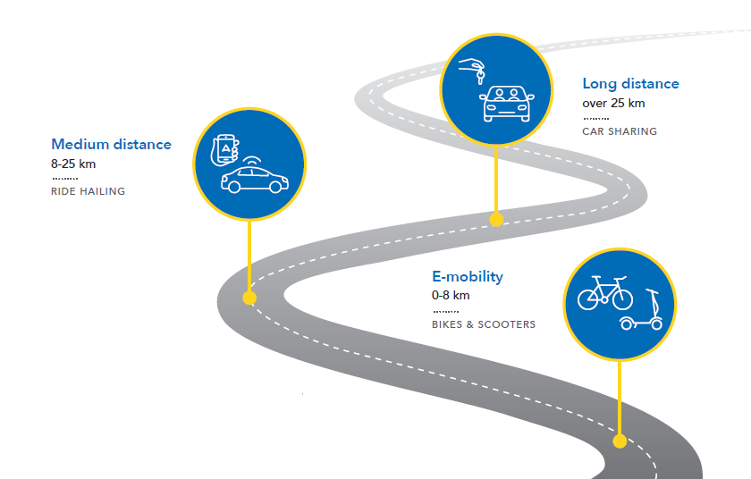

New challenges such as establishing first-and-last mile operations at public transport hubs and major community facilities require a new approach to regulation of the areas of operation, limitations on the number of operators, and limitations on the number of devices.

To support its investment in Brisbane Metro, Council is exploring the potential of e-bikes and e-scooters to provide a first-and-last mile option to link people between their home and the nearest public transport hub. Trial sites are being considered on the South East Busway with the criteria for selection being land use around the busway station and the limitations of parking availability around the station.

As has been found with the DRT trial, this function has further potential for success if it is integrated into community-based transport. Selection for trial sites needs to consider surrounding land use and the ability to link centres and village precincts more closely.

Under the current operating arrangements with shared schemes, Council has set a maximum cap of 1000 e-scooters across the city to manage safety and street clutter. The current geographic areas of e-scooter operation have been commercially determined by the operators and, as such, the cap essentially applies to the inner city.

With the competing demands for use of public open space in the inner city, a cap needs to be maintained. The different circumstances outside of the inner city require a different approach, and different approaches to caps may be required for e-scooter and e-bike hire schemes.

Direction
- Maintain a mandatory cap within the inner city.
- Investigate alternatives to caps on e-scooters and e-bikes citywide.
- Extend scheme operations into areas outside of the central business district (CBD) with low car-ownership and/or connections to public transport to encourage first-and-last mile travel.
- Seek opportunities for shared scheme operators to participate in first-and-last mile trials.

Agility

Outcome
Technology improves the efficiency and effectiveness of e-mobility, creating flexibility across Brisbane’s transport networks and services.

The development of lighter, higher-capacity lithium batteries (which has been referred to as the lithium revolution) and light electric motors is underpinning rapid technological development in the area of light e-mobility. In addition to new e-mobility devices being developed, so too are new business models and transport services in response to the rapidly evolving nature of shared e-mobility.

E-scooters have only emerged as a travel option in the last couple of years. Emergence of new e-mobility vehicle types, such as the Veemo from Vancouver, demonstrates what may be the next steps of development in this industry. This highlights the scope for innovation to rapidly produce new transport options and the importance of not being constrained by the physical characteristics of current devices and infrastructure.

The sudden appearance of e-mobility sharing schemes in cities and the need to accommodate these new modes of transport has resulted in many cities adopting short-term agreements with operators to facilitate growth and allow for flexibility.

Brisbane’s e-scooter operating agreements have extended to a maximum of three years with a review provision at the end of each year of operation. Other cities have authorised permits for 12 to 18 months. For example, following trials, the San Francisco Municipal Transportation Agency has continued to authorise e-scooter permits for a 12-month period but has considered a longer timeframe for dockless shared bicycles.

MaaS is an emerging transport model across the world with the potential to change the role and function of transport systems and services. It is an outcome-based mobility system which can be tailored to meet a person’s specific travel needs, to help encourage greater use of sustainable transport options.

Rather than having to locate, book, and pay for each mode of transportation separately, MaaS platforms can let users plan, book and pay for door-to-door trips using one tool such as an app.

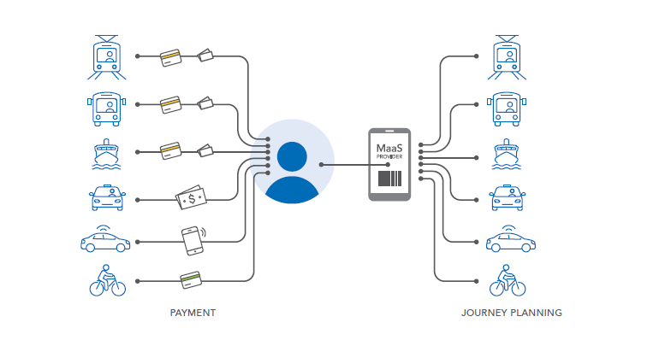

The University of Queensland (UQ) in partnership with the Queensland Government’s Department of Transport and Main Roads is proposing a trial of a MaaS smartphone application in early 2021, which will offer an integrated, multi-modal transport platform both to, from and within UQ’s St Lucia campus. It is proposed that participants in MaaS will include TransLink, ride-share providers, bicycle share and public e-scooter operators. For MaaS to operate properly, a key success factor is the willingness for operators of shared schemes to participate.

The sharing of data between private operators and Council allows for ongoing oversight of the success of schemes, demand hotspots and for future planning. However, operators are reporting different parameters according to their system. The Los Angeles Department of Transportation has created the MDS to ensure all e-bike and e-scooter operators report consistent data. The MDS is becoming the accepted data standard across the US and the western world.

Direction
- Review duration of operating agreements in line with other similar jurisdictions.
- Partner with trial sites in the facilitation of shared e-mobility participation in MaaS.
- Encourage shared scheme operators to participate in MaaS trials.
- Adopt the MDS to ensure all e-bike and e-scooter operators report consistent data.

Infrastructure

Outcome
Our transport infrastructure helps the e-mobility industry to grow, improving safety and public confidence in e-mobility.

Infrastructure used by e-mobility devices varies depending on the type of device. Under the current Queensland Road Rules, e-bikes, or pedal assisted bicycles, are treated as bicycles. They are permitted to operate using the full range of infrastructure available for use by non-powered bicycles.

E-scooters and other ‘rideables’ are more restricted in their permitted operating environments than e-bikes. E-scooters and other non-bicycle devices are not permitted to use on-road bicycle lanes, as bicycles can travel at speeds more compatible with general traffic, unlike e-scooters which are limited to 25 km/h. Instead, they are limited to footpaths, shared pathways and separated bicycle paths. E-scooters are permitted in general traffic lanes on local streets provided the speed limit is 50 km/h or less, there is no dividing line or centre median, and if the street is a one-way street it must have no more than one lane.

With developments in bicycle lane infrastructure offering better protection from general traffic, Council is supportive of the Queensland Road Rules being reviewed so the maximum benefits of on-road infrastructure investment can be realised.

In areas of high pedestrian activity, specific controls on the movement of e-devices may be required. The use of GPS and other locational technology scheme operators can assist in the compliance of riders in no-ride and slow zones. However, some challenges still exist in the accuracy of such devices and technology needs to be backed up with signage to regulate riders on privately owned devices. Signage needs to be clear and readable.

Under the existing operating agreements in Brisbane, e-scooters have provisions as to where they can be parked on footpaths. Due to the limited space on footpaths, particularly in the city centre, two designated parking spaces have been trialled in the CBD. To expand designated parking spaces, adequate parking facilities must be provided near known demand hotspots and operators must incentivise users to park their devices in the designated parking areas.

In the shared e-mobility context, which is targeted at short trips, charging is undertaken by the scheme operators and there would be minimal requirement for public charging facilities.

Direction
- Develop a plan for rolling out designated shared e-mobility parking areas across the inner city.
- Incentivise sharing scheme providers to encourage their customers to park in designated parking zones.
- Continue to advocate to the Queensland Government to expand the infrastructure available for use by e-mobility devices as the market calls for it.
- Consider potential contributions from scheme operators for the development of supporting infrastructure.
- Continue to facilitate scheme operators in improving locational technology.
- Work with the Queensland Government to improve signage for e-mobility devices.
- Consider any necessary additional charging facilities, whether private or public, through a review of provisions in the Brisbane CityPlan 2014 or possible direct investment in charging infrastructure as the market calls for it.

Next steps

Council is seeking input from the community and industry on Brisbane’s draft e-mobility strategy to ensure everyone has an opportunity to have their say on Brisbane’s transport future.

To have your say, visit brisbane.qld.gov.au and search ‘e-mobility’.

Following community and industry feedback, Council will finalise and publish the e-mobility strategy which will be used to guide future planning and help make e-mobility, including shared schemes, a part of our city’s transport network.

It will be Council’s responsibility to:
- promote and coordinate activities that relate to
- implementing the strategy
- encourage government, industry, private sector and the
- community involvement in Brisbane’s transport future
- monitor and track progress towards achieving the
- outcomes of the strategy.

A breakdown of Council responsibilities for moving e-mobility forward is shown below.

Elected representatives:
- Council
The elected body that adopts new local laws and approves major contracts.

- Establishment and Coordination (E&C) Committee
A statutory committee of Council, consisting of the Lord Mayor and all Committee chairs of the standing committees of Council. E&C has the delegation from Council to approve minor contracts and agreements.

- Public and Active Transport Committee
A standing committee of Council that meets to discuss public and active transport matters in Brisbane.

Policy administration:
- Brisbane Infrastructure
The division within Council responsible for transport policy and strategy setting, infrastructure development and road operations.

Operations management:
- Transport for Brisbane
The corporate division within Council responsible for bus network planning, operating and maintaining the bus fleet, and the management of the operating contracts for Brisbane ferries, and bus shelters, and operating agreements with shared e-mobility services, as well as public transport funding agreements with the Queensland Government.

Brisbane City Council
GPO Box 1434
Brisbane Qld 4001

Every effort is made to ensure that information is correct at time of printing
Printed on sustainable paper

CA20-1075679-02-5149
© 2020 Brisbane City Council

brisbane.qld.gov.au
3403 8888

/BrisbaneCityCouncil
@brisbanecityqld
@brisbanecitycouncil

Lime and Neuron riders as at 31 October 2020
Mitchell, G., Tsao, H., Randell, T., Marks, J., Mackay, P., 2019. Impact of electric scooters to a tertiary emergency department: 8-week review after implementation of a scooter share scheme. Emergency Medicine Australasia 31, 930–934. https://doi.org/10.1111/1742-6723.13356
Beck, S., Barker, L., Chan, A., Stanbridge, S., 2020. Emergency department impact following the introduction of an electric scooter sharing service. Emergency Medicine Australasia 32, 409–415.
OECD/ITF (2020) Safe Micromobility, ITF Corporate Partnership Board.
Lime Networks (June 2019) submission to Council
Federal Chamber of Automotive Industries
Transport Operations (Road Use Management - Road Rules) Regulation 2009

