Victoria Park Vision

Growing your Brisbane lifestyle with a world-class and iconic parkland that is uniquely Brisbane.

A message from the Lord Mayor

Brisbane is one of the best cities in the world and it keeps getting better, with Brisbane City Council transforming Victoria Park into a world-class public parkland.

In January 2020, we released a Victoria Park Draft Vision to show you how this precious greenspace could be protected for future generations and transformed into an inner-city sanctuary for residents and visitors.

Following a six-month consultation process, I’m now proud to present the Victoria Park Vision, which will map out the park’s transformation into a 64-hectare greenspace, showcasing our rich cultural heritage and beautiful outdoor lifestyle.

I want to make sure Victoria Park has something for everyone and your feedback has been at the forefront of this transformation, with more greenspace, improved accessibility and a better balance of natural elements incorporated into this final vision.

Victoria Park will strengthen Brisbane’s reputation as one of the world’s most liveable cities, while providing a uniquely Brisbane destination for people of all ages and abilities.

Thank you for helping to shape the Victoria Park Vision and I look forward to welcoming you into Brisbane’s biggest new public parkland from mid-2021.

Adrian Schrinner
Lord Mayor

Table of Contents
Victoria Park Vision 1
A message from the Lord Mayor 2
Table of Contents 3
Acknowledgment of Country 4
Shaping Brisbane’s biggest new park 4
Creating the vision 4
Releasing the vision 4
Timeline 5
Having your say 5
Creating the draft vision 6
Evolving the vision 6
Key feedback themes and changes 6
The Victoria Park Vision 8
What’s in a vision? 8
Principles 9
Guiding principles 9
Strategies 9
Room for water 10
Wetlands and waterholes 10
At the water’s edge 10
What did you say? 11
Connected habitats 11
Building biodiversity in an urban forest 11
Research and learning 12
Health and recreation 12
A natural high 12
Outdoor adventures 13
Active living 13
What did you say? 13
Connections 13
Reconnecting the park 13
Access for all – pathways, trails and cycleways 13
Turn-up-and-go transport 14
Car parking 14
What did you say? 15
Unique experiences 15
Active edges, quiet core 15
Complementary uses 15
Farming in the city 16
What did you say? 16
Cultural landscape 16
Rich layers 16
An ancient history with new stories to tell 16
A place to gather and learn 17
What did you say? 17
Creative expression 17
Art and activation 17
Design excellence 17
Climate-responsive design 18
What did you say? 18
Relationships and partnerships 18
Responsive design 18
Partnering for the future 19
What did you say? 19
Illustrative concept 19
A framework for the future 19

Acknowledgment of Country
Brisbane City Council acknowledges the Traditional Custodians of the land and their unique relationship with their ancestral Country. We pay respect to all Aboriginal and Torres Strait Islander Elders of Brisbane, and recognise their strength and wisdom.

Shaping Brisbane’s biggest new park

Council is converting the 18-hole golf course at Victoria Park into an expansive new park
following feedback from residents who have told Council they want more greenspaces with new places to relax. Your ideas will start taking shape from July 2021 and guide the park’s evolution for the next 50 years.

Victoria Park is one of Brisbane’s largest and oldest greenspaces. The Victoria Park Vision presents an opportunity to showcase our clean, green and sustainable lifestyle in a well-designed destination that puts Brisbane’s liveability attributes on the world stage.

More people are choosing to live and work in Brisbane, drawn by our subtropical climate and magnificent lifestyle. The city is strengthening as a tourism destination, attracting more domestic and international visitors to Brisbane each year before the coronavirus pandemic. The revitalisation of Victoria Park will aid economic recovery and play a part in bringing visitors back to our city.

As the city grows and inner-city housing evolves, our parks will play a greater role as places for residents to experience the natural world and retreat from city life. The coronavirus pandemic has only emphasised how much our residents love their parks and greenspaces. Victoria Park will be critical to Brisbane’s evolution as Australia’s most sustainable and liveable city, providing much needed open space for residents and giving the city a competitive edge in attracting tourists and workers.

“The Victoria Park Vision presents an opportunity to showcase our clean, green and sustainable lifestyle in a well-designed destination that puts Brisbane’s liveability attributes on the world stage.”

Creating the vision
More than 16,300 people helped create the draft vision for Victoria Park, with more than 5400 ideas shared through an online survey and community engagement events in August and September 2019. Feedback showed people want the park to be a natural place filled with native species, large shady trees, water features, all-ages activities, barbecues and creative playgrounds they can play in and enjoy.

Releasing the vision
The Victoria Park Draft Vision (draft vision) was released in January 2020 with consultation remaining open until July 2020. Feedback was sought through a citywide online survey, local resident drop-in sessions, stakeholder meetings and formal submissions from groups and individuals via email. In total, more than 2000 people and organisations had their say on the draft vision through the various feedback methods.

Overall, 86% of citywide and 88% of local resident survey respondents were completely or somewhat in favour of the draft vision document. This fantastic level of support let us know that there’s lots of elements in the draft vision that you want to see happen and we’ve kept them in the vision. We’ve also listened to elements you want to see more of, reduced or removed, and this feedback has influenced the changes you see in this Victoria Park Vision.

The Victoria Park Vision will guide the park’s evolution into an amazing new public parkland over the years to come. There will be plenty more opportunities to have your say on the future of Victoria Park in the years ahead.

A separate community engagement report has been prepared with more detailed information on the community feedback. Visit brisbane.qld.gov.au and search ‘Victoria Park Vision’ for more.

The Victoria Park Vision will inform further detailed investigations and design activities to prepare a master plan and implementation plan for Victoria Park for further feedback in 2021.

Timeline

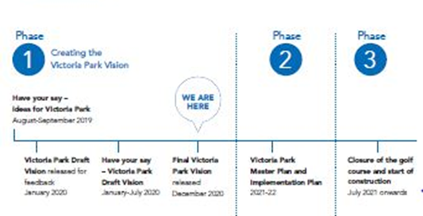

Having your say

Creating the draft vision
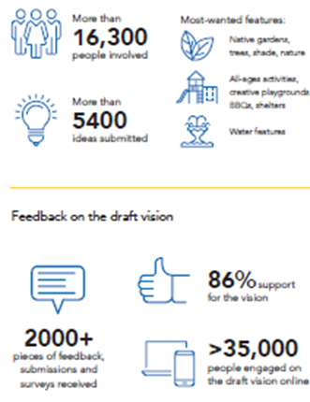

Feedback prior to the draft vision showed people want the park to be a natural place filled with native species, large shady trees and water they can play in and enjoy. You overwhelmingly said the draft vision achieved this for you!

Support for strategies
- Room for water
- Connected habitats
- Health and recreation
- Connections
- Unique experiences
- Cultural landscape
- Creative expression
- Relationships

Features to resolve in the master plan phase
- Car parking
- Golf course and golf complex (driving range, putt-putt, bistro)
- Productive gardens
- Dog off-leash areas
- Lake Barrambin
- The Wetlands
- Connector bridge
- New shared bridge
- Canopy Walk
- Cultural Hub

Evolving the vision
You spoke, we listened

While overall support for the vision is very high, an analysis of all feedback received has identified key themes and issues for the overarching vision statement, principles, strategies and illustrative concept.

General themes for improvement have been summarized in the following table, including how the draft vision has been changed because of your feedback. This will help inform the next phase in preparing the Victoria Park Master Plan (master plan) and Victoria Park Implementation Plan (implementation plan), including the scope for further detailed investigations and design activities.

Key feedback themes and changes

What Brisbane told us | What we are doing
Strong support for the draft vision overall at both citywide and local neighbourhood levels. | Overall vision statement, guiding principles and strategies remain unchanged to guide future master planning.
Restore the waterways and native habitats, with more greenspace and trees, and less buildings and hard infrastructure. | Increased greenspace area through reducing new building footprint area. Retain pathway and bridge infrastructure for all-abilities access across the park. The canopy cover target has been increased from 55% to 60%.
Keep it a public park with only small-scale activities that complement the park experience (e.g. visitor centre, kiosks, small restaurants, outdoor recreation, community and cultural events). | Proposed function facility removed and Tree House Lookout reduced in size and height. Some structures retained to provide park visitor services and leasable sites. Community-oriented events to be held at The Green amphitheatre.
Concerns from local residents over impacts such as traffic, parking, noise, lighting, events, security and opening hours. | The vision will guide further detailed studies that will inform changes during the master planning process, and where residents will have more opportunities to have their say. Operational, traffic, parking and security strategies are to be developed. Noise and light impacting residents and wildlife will be minimized through detailed design.
Provide safe and easy connection to and through the park for all ages and abilities. | The vision includes bridge, canopy walk and on-ground pathway infrastructure to allow pedestrian, wheelchair, pram and cycle access throughout the park.
Reconsider car parking spaces. Minimise car parking area inside the park to maximize greenspace. | Enhanced focus on improved public and active transport connections to and from the park. Undertake further detailed studies and prepare a transport strategy in the next phase to inform a managed car parking strategy for the site.
Provide a unique destination and avoid duplication of facilities at Roma Street and South Bank Parklands to ensure value for money. | Reinforce a unique identity for Victoria Park with revegetated forests, native bushland pockets and waterholes that speak of the site’s original landscapes and people. Replace large swimming pools found at other parks with more natural water play features.
Greater focus on the site’s importance to the local Aboriginal people and involve them in the park’s design and operation. | Continuing engagement with Traditional Custodian groups to determine appropriate design features and future educational and employment opportunities. Cultural landscape strategy expanded to show how the park acknowledges our history and celebrates our future, in a living landscape.
Various detailed comments on specific design  and operational elements. | Comments not addressed in the vision have been recorded and will inform the scope of further technical studies and detailed design of the master plan and future stages.
Retain as golf course. | The Victoria Park Golf Complex including the function centre, driving range and putt-putt mini-golf will continue to operate throughout planning, design and construction of new park upgrades. The 18-hole golf course will remain open while planning of the new park continues and is anticipated to close on 30 June 2021.

The Victoria Park Vision

Victoria Park will be a natural retreat, an urban park for adventure, discovery and reconnection.

You told us overwhelmingly this vision statement captures the essence of what you want in Brisbane’s biggest new park. The Victoria Park Vision capitalises on a once-in-a-generation chance to reshape the city around a deeper understanding of history, culture and nature.

This is your Victoria Park Vision, with something for everybody.

The park will be culturally authentic and reflect our dreams for the future. It will acknowledge, explore and celebrate the many layers of human contact with the landscape and the site’s significance to the local Aboriginal people of Brisbane and the wider region.

Revegetated forests, native bushland pockets and restored waterholes will speak of the site’s original landscapes.

A cultural and visitor centre will welcome residents and tourists and take them deeper into the park’s natural environment and the city’s heritage. This immersive park on the edge of the city centre will challenge, delight and inform.

Vibrant at the edges, the park will quieten at its core, offering space for contemplation, room for water and habitat for wildlife.

Reinstated natural systems will cool, cleanse, restore and inspire play, exploration and relaxation. From tree tops to gullies, opportunities to connect with nature will be everywhere.

Victoria Park will be a platform for public life, a sensory playground and a pillar of Brisbane’s healthy, outdoor lifestyle that will excite and inspire residents and visitors. It will be easy to access and hard to bid goodbye. Neighbours will embrace it as their own and visitors will return for more.

Activities will change with the times and seasons, but the park’s appeal will be timeless.

New enhancements to Victoria Park will be design-led to deliver high-quality places and spaces across the park that reflects Brisbane’s character, identity and climate.

Victoria Park is another way we’re making Brisbane better for future generations.

What’s in a vision?
The Victoria Park Vision is the first step in a long-term process of transforming one of Brisbane’s oldest parks into a world-class park for our city.

The vision forms the aspirational framework for how Victoria Park could grow, improve and evolve over time. It proposes some principles to follow, outlines strategies around different themes and provides an illustrative concept of how these strategies could be implemented
across the park. While some new features will be delivered soon after the golf course closes in June 2021, other major features of the plan may not be delivered for another 10 to 15 years. The restored urban forest habitat in the vision will take more than 50 years to be fully mature.

The design shown in the vision is not a fixed plan, rather it is a flexible spatial framework that provides a solid foundation and structure to guide future planning, design and construction works. The vision will now inform the preparation of a detailed master plan and implementation plan. Working with the community, this next master planning phase will include further investigations and engagement that may refine the overall layout, areas and elements of the vision to help
resolve issues that arise in this phase.

Revised master plans may be needed to respond to changes in the future, however the overall vision will remain to guide the protection and enhancement of Victoria Park into the future.

“Victoria Park will be a platform for public life, a sensory playground and a pillar of Brisbane’s healthy, outdoor lifestyle that will excite and inspire residents and visitors.”

Principles

Your ideas have inspired the design framework, which is formed by three principles and eight
strategies to articulate how the vision will be achieved and guide more detailed planning in
the years ahead.

The strategies consider the park’s unique history, the needs of the city and surrounding communities, environmental imperatives and opportunities offered by the site’s natural features and location.

Guiding principles

Recognition
Creating a place to respectfully celebrate the connection between culture, history and nature across past, present and future generations.
Restoration
Celebrating our unique interwoven landscapes and ecosystems.
Reconnection
Making transformational connections that stitch the parkland back into the city.

Strategies

Room for water
Lagoons, wetlands and a lake will bring water back to the site and restore natural cooling, cleansing and flood management systems.
Connected habitats
Revitalised ecosystems and restored habitats will draw wildlife back to the city and enrich our connection with nature.
Health and recreation
Outdoor adventures will challenge people of all ages and abilities, inspire active lifestyles, offer a natural experience in the city and support reconnection with the natural world for mental health.
Connections
Going green will be the easiest way to get to the park, with walking, cycling, bus and train the modes of choice. Every journey in the park itself will be an experience.
Unique experiences
Peaceful, natural spaces in the park’s quiet centre will be a striking counterpoint to its lively edge, where community life is played out.
Cultural landscape
The park will inspire sharing, the telling of stories and learning in the landscape, with opportunities to understand and engage with Brisbane’s cultural heritage.
Creative expression
World-class architectural forms and unique public spaces will enable cultural expression, facilitate community gatherings and make the park a showcase for visitors from around the globe.
Relationships and partnerships
Well-located links to neighbours and future partnerships will invite people into the park, adopting its spaces and places as their own.

Room for water

Restoring Victoria Park’s original waterways will re-establish natural cooling, cleansing and drainage systems that provide habitat for our wildlife.

Wetlands and waterholes
Victoria Park was once known for its chain of waterholes that ultimately flowed into the Brisbane River, but over time they were piped underground and forgotten. These waterholes were part of an important source of food for Brisbane’s Aboriginal people as they lived in and moved through the area, which some groups called Barrambin, the windy place.

Restoration works will see the land energised and cleansed by flowing water once again, through the creation of wetland waterholes and a large lake. Returning waterways to their natural state means stormwater from onsite built areas and surrounding suburbs can be captured, treated and released back into the water system or used to irrigate the park’s many grassy lawns and revegetation areas. It also builds flood resilience into the park so it can cope with heavy rains and recover quickly from inundation. Natural and mechanical filtration will ensure water quality is improved for the amenity of park users, while water stored in the landscape will help to cool the micro-climate of the park and encourage native wildlife to return.

At the water’s edge
Visitors will find many ways to interact with water. Boardwalks and trails will meander through wetlands, while small, intimate spaces and more generous multipurpose areas for gathering, events and art installations will line the water’s edge. People can interact with water at the exciting nature and water play gully or by taking a leisurely kayak or canoe across Lake Barrambin.

“Restoration works will see the land energised and cleansed by flowing water once again...”

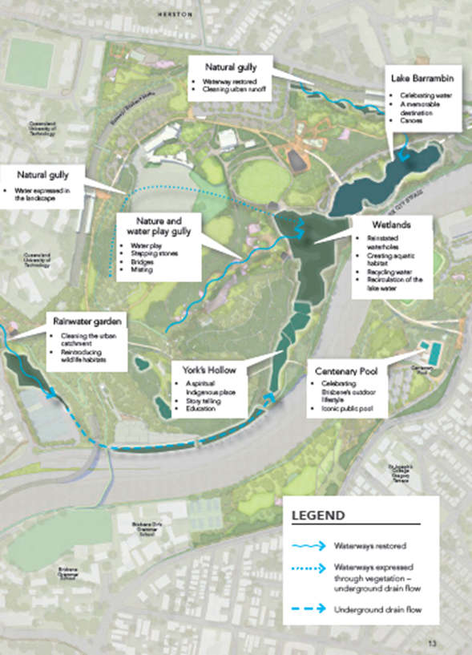

What did you say?
You want room for natural waterways and water features with less hard infrastructure. You support wetland and lake habitat restoration to cool the environment and encourage native plants and wildlife back into the city. You’d like to interact with water through activities such as kayaking or water play, but also provide some quieter areas with reduced access for wildlife and environmental education opportunities.

Connected habitats

Council is committed to protecting and enhancing almost 64 hectares of greenspace for future generations through the Victoria Park Vision.

Revegetating parts of Victoria Park with native species will ensure Brisbane remains Australia’s most biodiverse capital city and contribute to achieving Council’s goal of increasing Brisbane’s habitat cover.

Building biodiversity in an urban forest

Healthy, connected ecosystems are critical in maintaining a variety of plants and animals. Brisbane’s distinct ecosystems support thousands of species of native wildlife, and by planting native tree species in some areas of the park and creating freshwater wetlands and eucalypt forests, we hope to reintroduce urban fauna and bird life.

Improved shade cover will grow with rehabilitation and the creation of a new urban forest. The park’s wildlife-friendly land bridge will be retained and bird hides, viewing platforms and other structures will take people deeper into nature for up-close encounters. Moving toward the core, the park calms to enable solitude, exploration and reconnection with nature.

A remnant spotted gum woodland remains just outside the park’s western boundary and is protected under Queensland’s Nature Conservation Act 1992. Ecological corridors will link remnant habitat just outside the park and beyond with existing and expanded habitat inside the park. New forest and gum plantings inside the park will strengthen this essential habitat, which could become a resource for future research partnerships with universities and community groups.

The total tree canopy cover will increase from 10% to 60% over the next 50 years.

Research and learning

The park’s planting palette will consider further opportunities to explore the healing and cultural properties of native plants with nearby universities and research institutions, in collaboration with local Aboriginal people. Interpretive signage and education experiences will foster a deeper connection with nature and appreciation of ecological systems. Educational institutions and local Aboriginal people will be involved in species selection and to monitor and manage new vegetation, including species that will tolerate future climate changes.

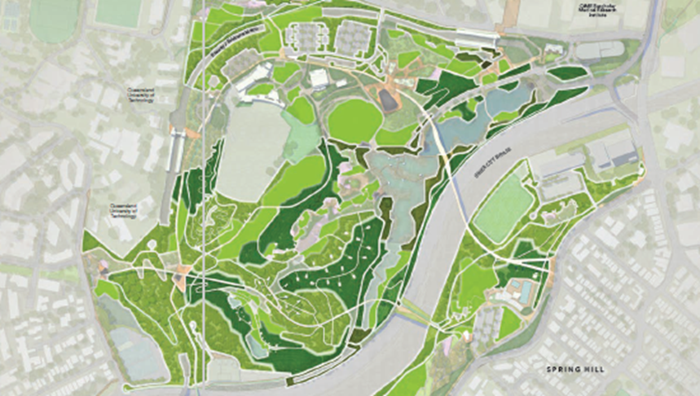

Health and recreation

With more to see and do at Victoria Park, people will connect with nature high in the tree tops, down in the gullies, out on boardwalks and within rocky waterholes. This natural retreat in the heart of the city will provide something for everybody and become a new setting for our relaxed, outdoor lifestyle.

A natural high
Council is protecting and expanding greenspace to make it easier for you to enjoy the lifestyle our great city has to offer. Victoria Park will grow Brisbane’s network of 2100 parks and become an outdoor tourism destination for the city.

Residents will have another natural retreat to support mental wellness. With the physical benefits of parks well-established, and the mental benefits now becoming clearer, Victoria Park will become a place to be out in nature, lower stress and feel happier.

Outdoor adventures
Nature-based recreation at Victoria Park will appeal to young and old, with something for everybody. At Adventure Valley, visitors will travel through the trees on the all-abilities high ropes course, while boulderers, mountain bikers and trail runners could challenge themselves on the rainforest trails and courses below.

Lake Barrambin will be ideal for kayaking, while the kids will love splashing about in the nature and water play gully, an all-ages wild-play area with water elements in a gully setting. Some activities will be available early, while others must wait for new vegetation plantings to mature before they can be established.

Active living
Families will gather on the park’s many sunny lawns and waterside picnic spots, and people will enjoy the running and cycling paths and trails, multi-sports park, skate bowl, tennis courts, playing field and cricket nets. Regardless of age, culture, mobility or background, residents and visitors will be inspired to head outdoors and live an active life. Our furry friends will be well catered for with dog off-leash areas across the park, including small-dog-only areas and possibly areas for dogs to cool down in water.

“Residents will have another natural retreat to support mental wellness.”

What did you say?
You want a wide variety of sports and recreational facilities in the park that are available for all ages and abilities, including spaces for dogs to play. While some of you will miss the golf course, most recognise the wider benefits of greater public access to the park and are happy some existing golf complex facilities have been retained. You support an outdoor recreation focus throughout the park and in Adventure Valley, but also want green, shady and quiet spaces for contemplation, meditation or just to relax and read a book. You want all facilities to be accessible for use by the community.

Connections

By expanding Brisbane’s active transport network and encouraging sustainable travel choices, Victoria Park will have more green transport infrastructure to get more cars off Brisbane roads. Victoria Park will reconnect the park to its neighbours and the wider community, giving everybody more choice when it comes to travel.

Reconnecting the park
Victoria Park is on the doorstep of the city centre. It’s a short bus ride from the CBD along the Northern Busway and two busway stations sit on the park’s edge. Expanding Brisbane’s active transport network and encouraging sustainable travel choices, Victoria Park will focus on providing more active travel and public transport infrastructure to and through the park to get more cars off the road and minimise traffic and parking issues on surrounding streets.

Access for all – pathways, trails and cycleways
New cycleways, extensive walking networks, new park entries and reoriented spaces around busway stations will improve public access to and through the park. Pathways will be designed to accommodate a broad range of park users, from pedestrians and commuter cyclists to leisurely bike riders and those with mobility devices or prams. New bridges and canopy walks will touch the site lightly between ridges to provide gentle grades to allow disabled access across the hilly park, while intimate discovery trails will crisscross at ground level. Cycling trips from northern suburbs to the CBD will be quicker with new direct north-south links on the park’s edge to the Enoggera Creek Bikeway and new North Brisbane Bikeway.

Turn-up-and-go transport
Introducing Brisbane Metro services on the busway and construction of a nearby Cross River Rail station will bring turn-up-and-go public transport to Victoria Park. Brisbane Metro will be a key part of Brisbane’s greater transport network, connecting the city to the suburbs. Changes to local streets will help manage traffic flow by slowing car speeds and making it safer for pedestrians and cyclists to get to the park.

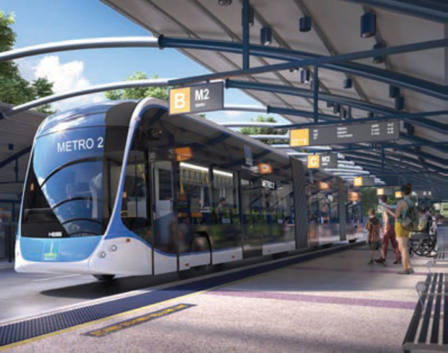

Car parking
In response to local residents concerns about parking and to ensure residents have the option to drive to the park, the next phase of the project will involve a traffic analysis study and car parking strategy to ensure park users that drive to the park will have adequate managed car spaces. We will investigate improved car parking opportunities, including considering a multi-level car park to minimise the footprint and reduce parking demand in surrounding streets.

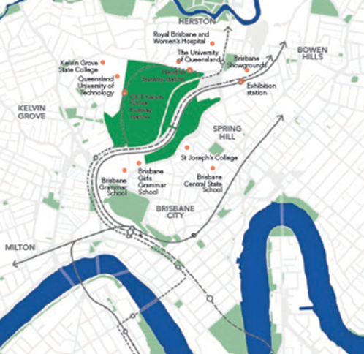

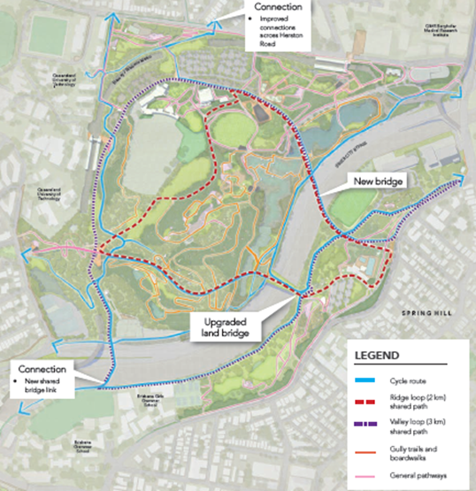

What did you say?
You want to travel to the park by convenient public and active transport, and a balanced approach to new parking spaces inside the park that minimises the loss of greenspace.

You want new pathway networks created inside the park and to surrounding neighbourhoods, with pathways designed to avoid conflicts between pedestrians, cyclists and other mobility device users.

You want the park to be accessible to all, particularly for our more elderly residents and those with limited mobility.

Unique experiences

A series of cultural and social venues at Victoria Park will provide hubs that draw in people of all ages to take part in community life, day and night. This is the place to be for daytime relaxing, nighttime recreation and city celebrations.

Active edges, quiet core
Community hubs, adventure areas, dining venues and dynamic cultural attractions will enliven the edge of Victoria Park, while nature takes centre stage in its quiet heart.

Almost 64 hectares of greenspace will be enhanced and protected for future generations, and new facilities will cluster around existing buildings and major entry points, with excellent walking, cycling and public transport access and easy links to surrounding neighbourhoods.

Moving toward the core, the park calms to enable solitude, exploration and reconnection with nature. Experiences at both the core and edges will evolve over time as the park matures, new plantings grow and community needs change. Lighting will be provided throughout the park to create safe and enjoyable nighttime experiences, while designed to not disturb neighbours or impact nocturnal wildlife.

Complementary uses
The popular golf course facility with driving range, putt-putt course, bistro and function centre will be part of a hilltop precinct. City views and expansive green lawns will make this the best spot for dining, events and community gatherings. New outdoor dining areas and kids play spaces provide areas for activity, while visitors can also journey into the forest or lakeside for a quieter dining or picnic experience. Visitors will be able to hire a kayak at the lake or take a guided tour of the high ropes course, while opportunities exist for school holiday and other active and healthy activities. These facilities will provide more opportunities to enjoy Brisbane’s beautiful climate and connect with family and friends in the places that make our city great.

Farming in the city
A gentle slope on the park’s southern side offers an ideal spot for community gardens, small urban farm or urban orchard with supporting facilities, a northern aspect for maximum sunshine and good access to surrounding neighbourhoods. It could provide a learning space for how locally grown fresh food in an urban setting can contribute to healthy places and healthy people.

What did you say?
You support having more to see and do in Victoria Park while maintaining a quiet and peaceful core with more shady natural areas for animals and plants. You want the park to host community-oriented events and other appropriate, complementary uses around the park to help you enjoy the place. You want sustainability education opportunities, including improved access to locally grown food for local residents who have no space to grow themselves or to provide nutritious food for our most vulnerable.

Cultural landscape

Victoria Park will be a world-class and iconic destination that celebrates the park and Brisbane’s heritage. It will become a living landscape that combines a stunning natural setting with art, history, local Aboriginal culture and nature to delight and educate residents and visitors.

Rich layers
Many Aboriginal people once knew Victoria Park as Barrambin, the windy place. Later, it became York’s Hollow before being renamed again in honour of Queen Victoria.

The heritage-listed park has had a variety of uses over thousands of years, from being an important Aboriginal camping and gathering site, to use as a public park, rifle range, early migrant camp, World War II military camp and later as a temporary housing camp and golf course. The new design preserves natural and built features, showcasing the park’s use over time, from the rocky gullies where Aboriginal children once played, to the heritage-listed golf clubhouse and the fairway on the ninth hole.

Design and details in the new park will reflect key stages in the site’s evolution through public art, paving, interpretive experiences and guided activities. The park will inspire sharing, the telling of stories and learning within the landscape, with opportunities to understand and engage with the park’s and Brisbane’s cultural heritage and history.

An ancient history with new stories to tell
For thousands of years the area of Victoria Park sat within a broader cultural landscape that included the greater Brisbane and Moreton Bay areas. Aboriginal cultural heritage and connection with the landscape will be acknowledged and celebrated in multiple ways.

The park once had rich natural habitats and species that supported a variety of Aboriginal groups of different custodial knowledge systems and languages.

Millennia-old pathways connecting the park to the wider region facilitated smaller local clan and larger multi-tribal gatherings for activities such as ceremonies, tribal games, foodways, burial rites, medicines and subsistence.

Restoring the park’s natural biological systems and values could provide Traditional Custodians a space to practice and revitalise their cultural traditions and customs in the park. Contemporary and innovative expression of biocultural traditions would have iconic appeal and relevance for residents and visitors, making Victoria Park a hub for Aboriginal cultural education and heritage experiences. Artworks, sensory discovery trails, performance, cultural festivals, guided tours and interactive learning experiences could all offer possible vehicles to enhance visitors’ understanding of a millennia-old culture and landscape.

Opportunities to understand our history and preserve and promote Aboriginal cultural heritage have been the subject of discussions with Traditional Custodians. Council has a genuine commitment to empower Traditional Custodians to self-identify appropriate cultural elements in the future park design including planting palettes and artwork. Employment opportunities could include events, education programs and ongoing park management.

A place to gather and learn
The new Cultural Hub and visitor centre will welcome visitors and take them deeper into the natural environment and the park’s cultural heritage. It will include shady outdoor plazas to welcome individuals and groups, and provide information and talks from guides before visitors explore the park’s many layers of human contact with the landscape and the local Aboriginal people’s cultural connections to place. Including exhibition and community space, a café, information desk and amenities, the Victoria Park cultural and visitor centre will be a ‘must do’ for visitors seeking an authentic and uniquely Brisbane experience.

What did you say?
You want to put Victoria Park on the map as a place that acknowledges, reflects on and celebrates the cultural heritage, history and significance of the site to local Aboriginal people. You want the process of designing and operating Victoria Park to be a leading example of authentic
reconciliation and empowerment of our First Nations people. You want Council to continue engaging with Traditional Custodians and heritage groups to incorporate appropriate
Indigenous and non-Indigenous design elements, historical features, place names, stories, education, tourism and employment opportunities in the park.

Creative expression

Global in appeal, but local in character, Victoria Park will showcase the richness of our community, culture and landscape, and become an outdoor setting for creativity.

Art and activation
Victoria Park will take arts and entertainment into the open air. Flexible, multipurpose outdoor spaces will host a year-round calendar of events, programmed to ensure the amenity of the park is maintained with a balance of quieter and busier periods. An eclectic array of pop-up activities, short-term exhibitions and performances will give residents and visitors more to see and do. The additional green celebration space will focus on hosting more community-based gatherings and events that are aligned with a parkland area.

Over time, sculptures and art will appear throughout the park and extend the visitor centre experience into the landscape and set the scene for temporary art installations, Indigenous arts and creative experimentation.

Design excellence
Architectural forms and unique public spaces reflecting the park’s cultural landscape will enable cultural expression, facilitate community gatherings and make the park a showcase for visitors from around the globe. The Design-led City – a design strategy for Brisbane will help guide the design of the park’s many open spaces, pathways, buildings, supporting infrastructure, structures and the spaces between them, ensuring quality design that reflects Brisbane’s character, identity and climate.

Sculptural buildings could offer a modern interpretation of traditional architecture, mimicking the form of the landscape and the design of Aboriginal gunyahs (shelters) or traditional fish traps. The Tree House would provide an iconic building with views to the CBD and out to Mt Coot-tha, and include a café or restaurant, amenities and lift to ensure all-abilities access to an elevated viewing platform. Architectural canopy pods could evolve over time to provide unique spaces for hire for small events.

Climate-responsive design
Architectural forms will reflect our love of space, sunlight and water, embracing the subtropical climate that has shaped Brisbane’s distinctive character. Shade structures, patterned screens, open edges, integrated artwork, light wells, transparent or semi-enclosed roofing and subtropical plantings will create light-filled sensory places to move through and enjoy. Natural ventilation will be a focus.

Structures will frame and enrich the public realm and sustainable building design will save water and energy, improve comfort and reduce operating costs. Victoria Park’s positive contribution towards the global response to carbon neutrality and climate resilience will inspire businesses and individuals to strive for the same goal.

What did you say?
You said you want public art, sculptures and architecture to blend with nature and outdoor experiences. You support the park having an iconic landmark, which could include a creatively designed building or structure, inspired by Indigenous or natural forms. You want places and spaces for creative expression such as arts performances and community-orientated events.

Relationships and partnerships

Victoria Park will leverage its unique position within the vicinity of tertiary campuses, research
precincts and creative facilities that make up Brisbane’s knowledge corridor to become a
place of learning, innovation and expression for generations to come.

Responsive design
Three of the city’s major knowledge precincts overlap at Victoria Park.
- The health and wellness precinct with the Herston Health Precinct on the northern boundary incorporating the Royal Brisbane and Women’s Hospital, QIMR Berghofer Medical Research Institute, Queensland Health facilities, The University of Queensland’s (UQ) core campus for clinical health teaching and research, and Herston Quarter, an emerging $1.1 billion health and wellbeing precinct. Multiple informal parks and sporting fields line the creek further north as part of the popular Enoggera Creek sport and recreation precinct.
- The arts, creativity and events precinct with the Queensland University of Technology’s (QUT) Creative Industries campus on the western boundary and Brisbane Showgrounds to the east.
- The research and education precinct with multiple schools, hospitals and research centres complementing the university campuses.

The park’s design is distinctly Brisbane and directly responds to the unique needs and characteristics of its neighbours. Herston and QUT Kelvin Grove busway stations become major gateways into the park, with new wide paths providing access to shady tree-filled or lakeside spaces for hospital visitors, patients and workers.

Walking paths between busway stations follow the preferred path of students moving between university campuses. Relocated tennis courts, a new playing field and cricket nets are ideally situated in Spring Hill closer to the schools that will use them. The park’s western entry directly joins with QUT’s campus, giving students, teachers and visitors easy access to primary commuter connections, while the eastern entry is a short walk to the showgrounds and local schools.

Partnering for the future
Council is committed to exploring academic, research and operational partnerships to activate the park and extend the influence of its neighbours during master planning. Ways to work with community groups, user groups, researchers and peak bodies will also be explored in designing and operating the park. For example, indoor and outdoor spaces could double as teaching spaces, open green areas could host festivals, wellness clinics and outdoor learning, architectural structures could become canvases for digital art or creative performances, and revegetation could sustain environmental and medical research or work placements to gain secondary and tertiary qualifications.

What did you say?
You support relationships being a key feature of the park so it is a place for all people of all ages and abilities. You support Victoria Park engaging with its neighbouring institutions, universities, schools, community groups and peak groups on joint partnerships and project collaborations.

Illustrative concept

This concept plan shows how the Victoria Park Vision could be realised on the ground. General and specific feedback received on the draft vision from residents and businesses has informed amendments to the concept plan, which is a flexible spatial framework that responds to the community’s ideas we heard during feedback phases.

A framework for the future
With the closure of the golf course in mid-2021, public access to the park will be Council’s first priority, allowing visitors to enjoy the greenspaces while it is being transformed into a natural retreat and urban park for adventure, discovery and reconnection. The Victoria Park Vision will be used as the basis for future detailed master planning. Council is committed to working with the community to advance the vision. The next master planning phase may see refinements in the overall layout, areas and elements of the concept plan because of further investigations, community engagement and issues that arise in this next phase.

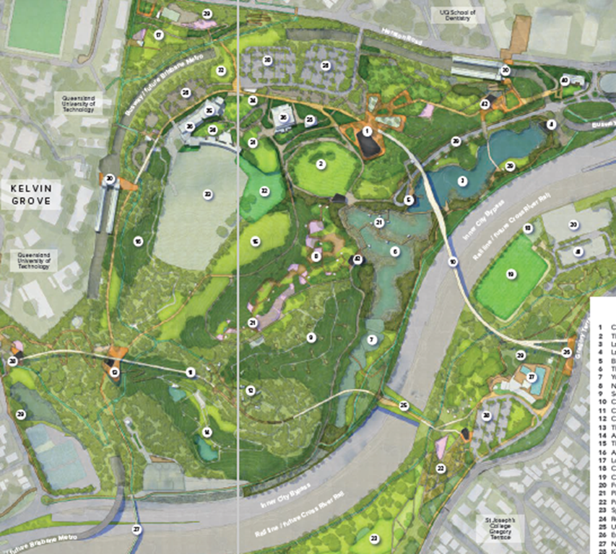

For more information on how Victoria Park will be transformed into an amazing
new public parkland, visit brisbane.qld.gov.au and search ‘Victoria Park Vision’.

Publication number: CA20-1092527-03-5189
© 2020 Brisbane City Council

