Footpath Dining Design Checklist
The following checklist has been developed to assist operators when submitting a footpath dining application as well as guiding officers when assessing the completed applications. The checklist includes mandatory design requirement as well as other design considerations.
Please note, setback distances and other clearances must consider the entire space required for the footpath dining activity, including when the proposed furniture is in use by patrons.

Mandatory design requirements
The mandatory requirements have been developed to ensure footpath dining activities:
- protect a safe and convenient passage for all footpaths and road users; and
- minimise adverse impacts on the amenity of the surrounding area; and
- protect and maintain access to footpath assets and infrastructure.
Proposals that do not meet the mandatory design requirements will not be supported.
The proposed footpath dining area will provide an unobstructed pedestrian zone of 2.4m in the Central Business District (please refer to Diagram A) and 2m in suburban locations (please refer to Diagram B). | Yes ☐  No ☐
The proposed footpath dining area will be setback at least 750mm from the face of the kerb (please refer to Diagram B).  Note: The face of the kerb is the nominal face of kerb as per the Brisbane Standard Drawing BSD-2001- Kerb Profiles. | Yes ☐  No ☐
The proposed footpath dining area will provide unobstructed access to and is setback at least 1.5m from:  - the landing of a kerb ramp  - a parking meter  - an Australia Post Box  - a public telephone  - Tactile Ground Surface Indicators for the visually impaired  - a CityCycle station  - street furniture including seats, bins, drinking fountains, information signs, bike racks etc.  Note: a kerb ramp is a ramp that gives access from a footpath to a roadway, with the form generally as shown in Brisbane Standard Drawing BSD-5231 – Kerb Ramp. | Yes ☐  No ☐
The proposed footpath dining area complies with the minimum clearances for bus passenger movement (please refer to Diagram C). | Yes ☐  No ☐
The proposed footpath dining area will not interfere with or hinder access to services and infrastructure such as traffic signal boxes, utility service pits, street lighting and emergency services infrastructure. | Yes ☐  No ☐
The proposed footpath dining area will be setback at least 500mm from tree grates and garden beds. | Yes ☐  No ☐
All furniture and other items associated with the footpath dining activity, such as tables, chairs, menu boards, heat burners, umbrellas, windbreakers, planter boxes, lighting and dropdown blinds, will:  - not be permanently fixed or attached to the footpath or any other public or private infrastructure located on the footpath.  - not cause damage to the footpath or any other public or private infrastructure.  - be positioned to facilitate the use of the footpath dining area by people with a disability (for example customers using manual/power wheelchairs and mobility scooters); and  - be fully contained within the proposed footpath dining area;  - be removed outside of approved footpath dining trading hours (excluding dropdown blinds); and  - in good working order and fit for purpose.  - be sturdy to resist movement in windy conditions.  - not inhibit sightlines, create a hazard or otherwise cause a nuisance for vehicles, pedestrians or cyclists. | Yes ☐  No ☐
Tables will have a maximum height of 900mm. | Yes ☐  No ☐
Dropdown sides to awnings or attached blinds to awning structures will:  - be made of a fully transparent, light-weight material with a finish that reduces glare (please refer to Diagram D); and  - aligned parallel to the kerb only (please refer to Diagram E); and  - be raised outside of the approved footpath dining trading hours. | Yes ☐  No ☐
Heat burners will be located at least 1.5m away from any footpath asset or infrastructure, this includes any part of a street tree. | Yes ☐  No ☐
Screens or windbreaks will:  - be no higher than 900mm above the pavement surface; and  - have a lower rail no greater than 125mm from the pavement surface. | Yes ☐  No ☐
Ropes, chains or materials of a similar kind will not be used to cordon off the footpath dining area. | Yes ☐  No ☐
Umbrellas will:  - be setback at least 500mm from existing mature street tree trunks and main branches; and  - have a minimum height of 2.1m from the footpath surface to the underside of the umbrella. | Yes ☐  No ☐
The footpath dining area will be kept in a clean and hygienic state at all times. | Yes ☐  No ☐
Council waste bins will not to be used as part of the food business operations. | Yes ☐  No ☐

Other design considerations
Is the proposed footpath dining area located on the kerb side of the footpath?  Footpath dining areas located on the kerb side of the footpath must allow all people, including visually and physically impaired persons to comfortably use the property boundary line (the building edge in the majority of cases) as a continuous point of reference when moving along the footpath. It also serves to keep footpath features (i.e. furniture, equipment, trees, etc.) to one side of the footpath, allowing a direct path of travel. Proposals that are not located on the kerb side of the footpath may be acceptable if it can be demonstrated that this is a more desirable option for all potential users of the footpath when considering the location of existing footpath infrastructure and activities. | Yes ☐  No ☐
Is the proposed footpath dining area setback at least 50m from an intersection or pedestrian crossing?  Where the proposal is within 50m from an intersection or pedestrian or pedestrian crossing, Council will assess the application to ensure the footpath dining activity will not inhibit sightlines, create a hazard or otherwise cause a nuisance for vehicles, pedestrians or cyclists. | Yes ☐  No ☐
Is the proposed footpath dining area setback at least 10m from a driveway?  Where the proposal is within 10m from driveway, Council will assess the application to ensure the footpath dining activity will not inhibit sightlines, create a hazard or otherwise cause a nuisance for vehicles, pedestrians or cyclists. | Yes ☐  No ☐
Is the proposed footpath dining area setback at least 25m from illuminated footpath advertising, such as freestanding advertisements, advertisements on bus shelters and advertisements at CityCycle stations?  Where the proposal is within 25m of illuminated footpath advertising Council will assess the application to ensure the proposed footpath dining area will not impact the sightlines to the illuminated footpath advertising. | Yes ☐  No ☐
Is the proposed footpath dining area set back at least 20m away from a residential premise?  Where the proposal is within 20m of a residential premise, Council will assess the application to ensure the proposed footpath dining area will not have adverse impacts on the amenity of surrounding residential premises. | Yes ☐  No ☐
Is the proposed footpath dining area located to facilitate an unobstructed 1.5m gap at least every 10.5m along the street edge (please refer to Diagram F)?  Proposals that cannot facilitate an unobstructed 1.5m gap at least every 10.5m along the street edge, may be acceptable if it can be demonstrated that the proposal will not have an adverse impact on a safe and convenient passage of all footpath and road users. | Yes ☐  No ☐
Is the proposed footpath dining area located adjacent to an on-street disability parking bay?  Where the proposal is adjacent to an on-street disability parking bay, Council will assess the application to ensure the proposed footpath dining area will not impact the safe and convenient use of the disability parking bay. | Yes ☐  No ☐
Is the proposed footpath dining area located adjacent to a taxi zone?  Where the proposal is adjacent to a taxi zone, Council will assess the application to ensure the proposed footpath dining area will not impact the safe and convenient use of the taxi zone. | Yes ☐  No ☐
Is the proposed footpath dining set back at least 1m from a loading zone?  Where the proposal is located within 1m of a loading zone, Council will assess the application to ensure the proposed footpath dining area will not impact the safe and convenient use of the loading zone. | Yes ☐  No ☐

Supporting Diagrams

Diagram A
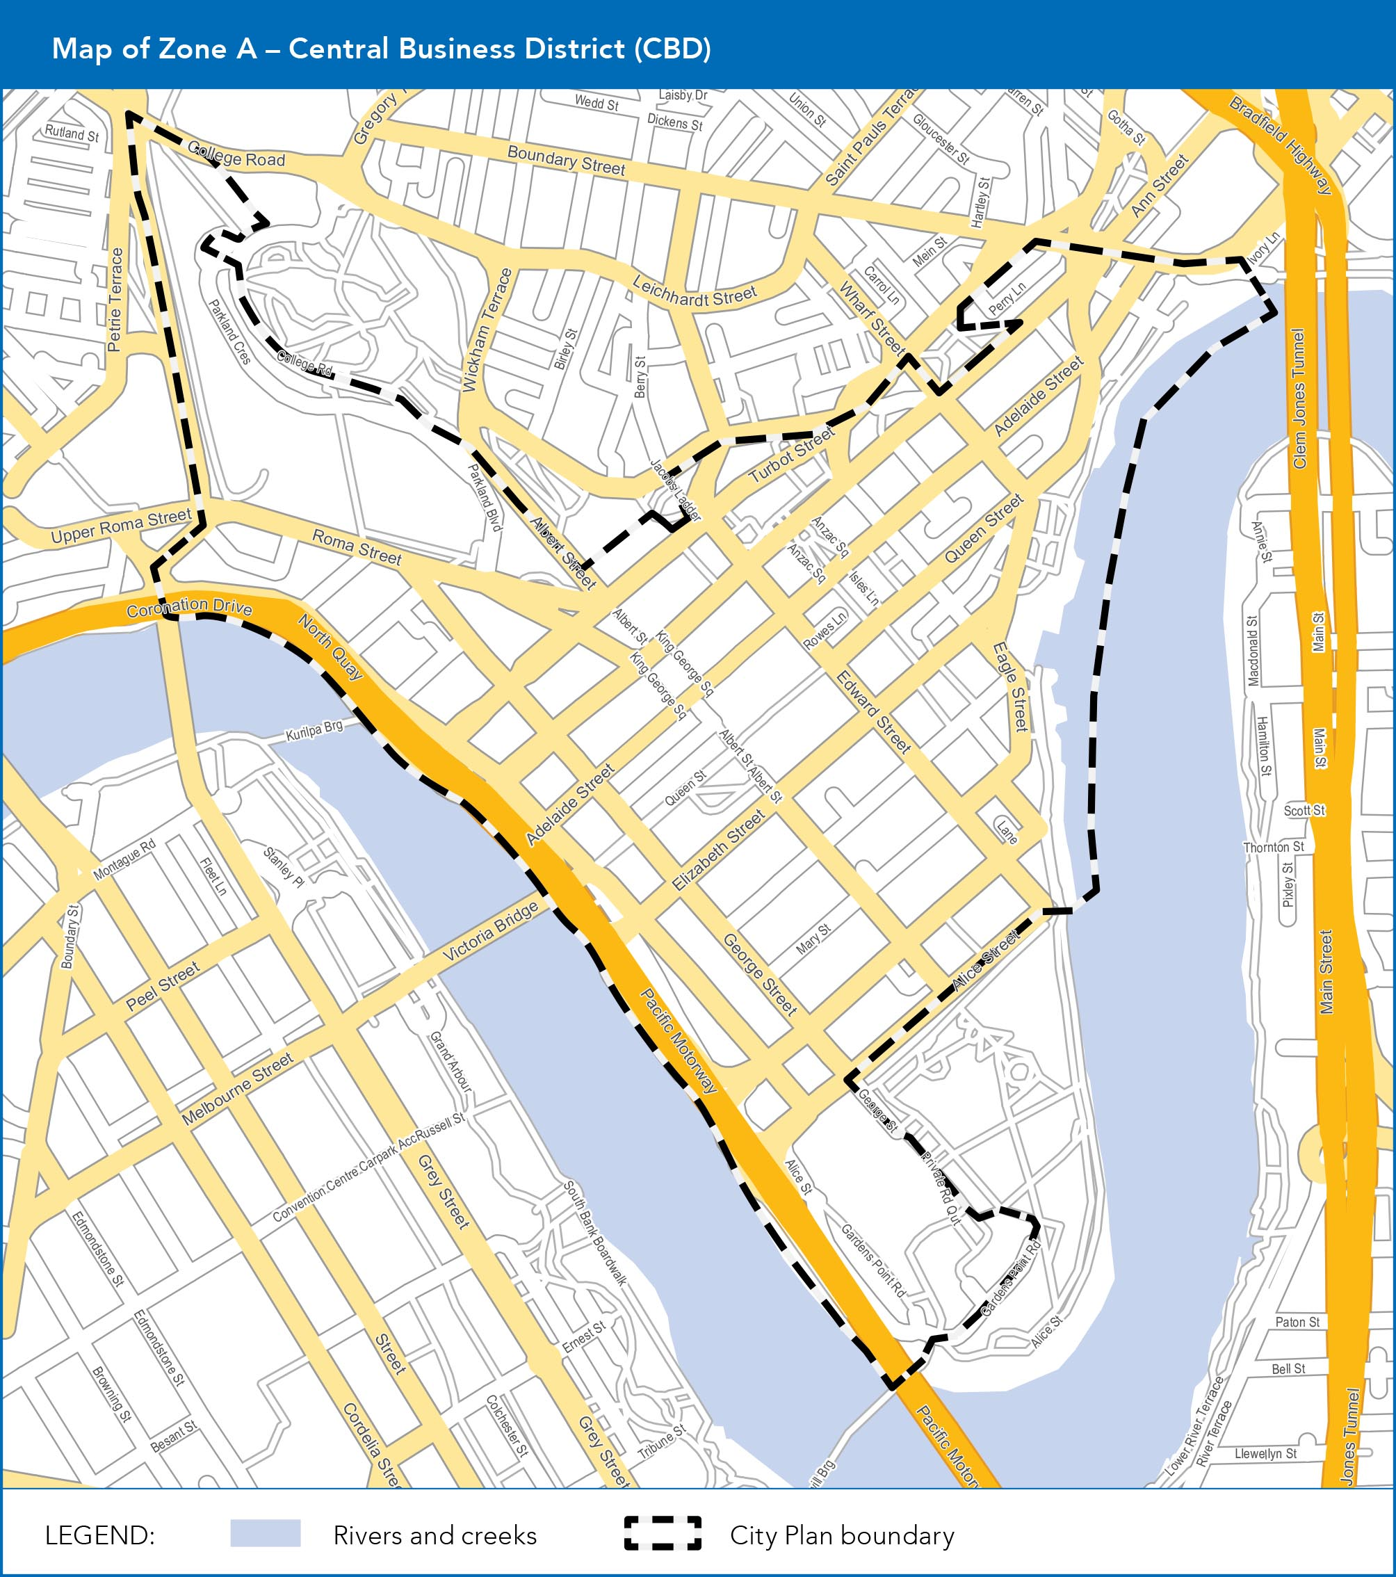

Diagram B
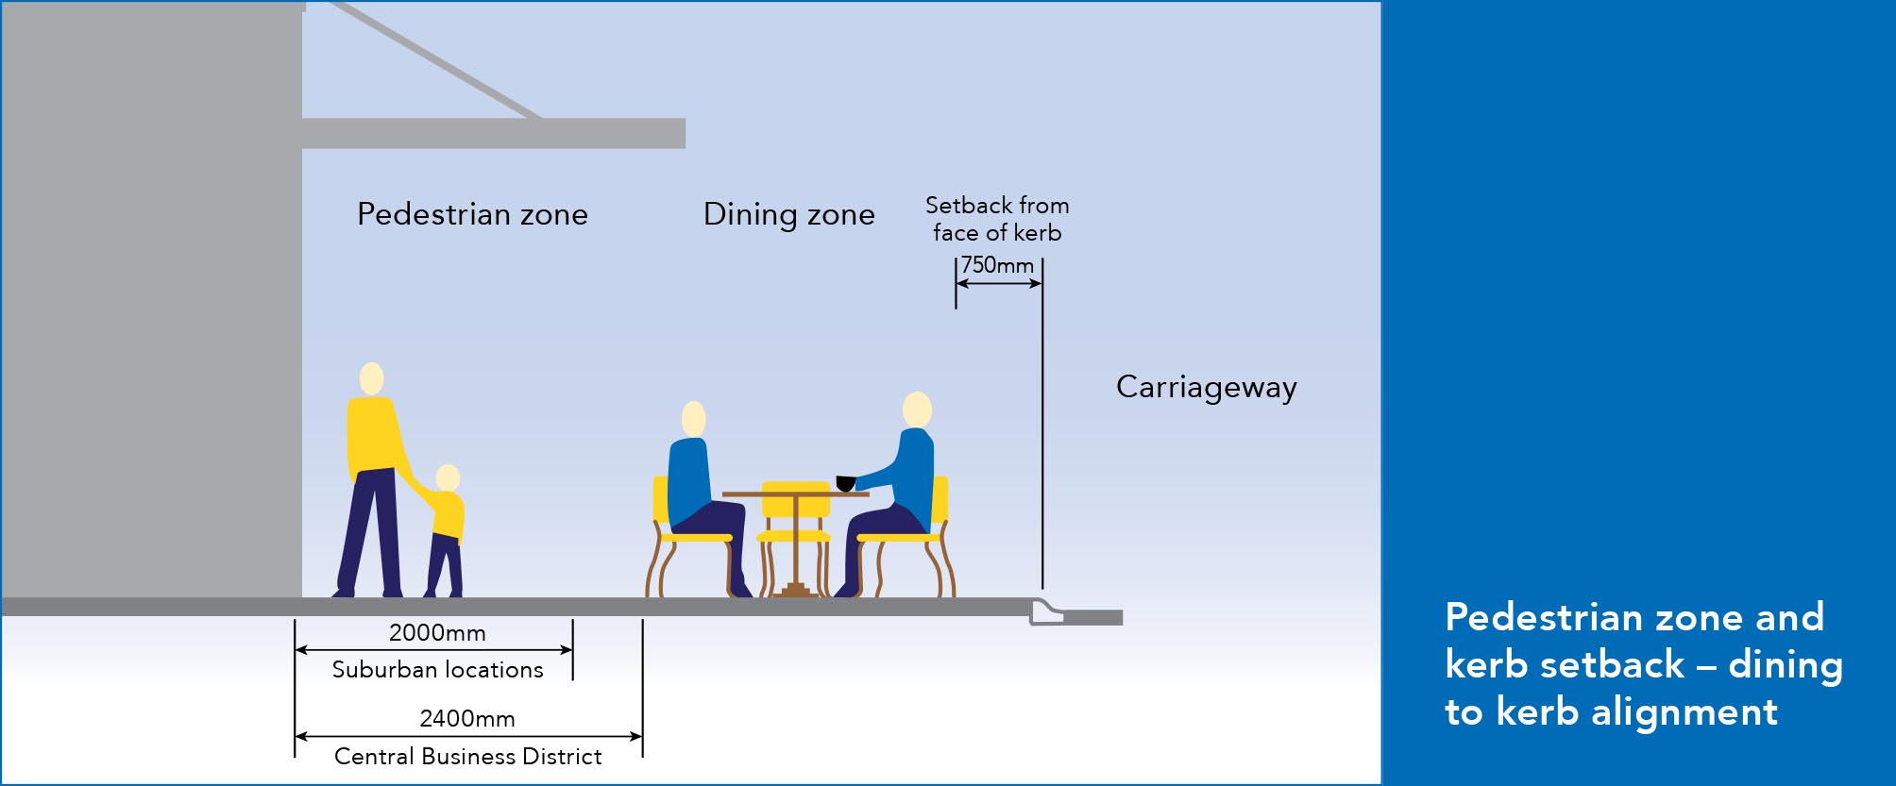
Note: The face of the kerb is the nominal face of kerb as per the Brisbane Standard Drawing BSD-2001- Kerb Profiles.

Diagram C
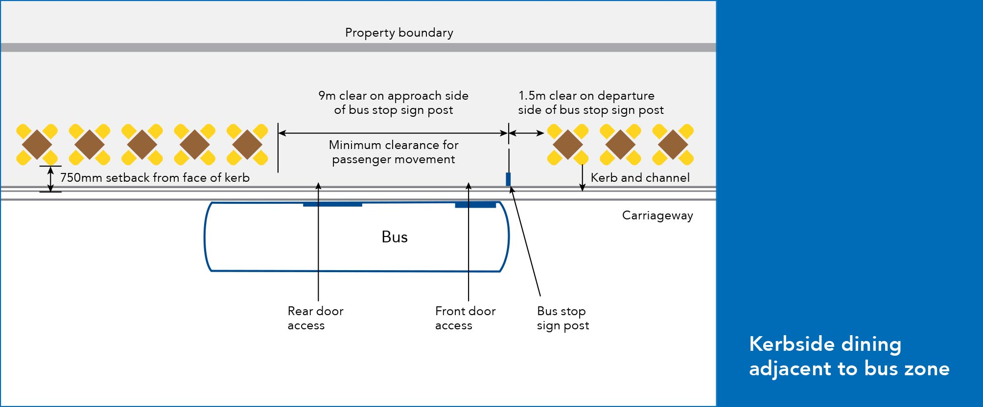
Note: The face of the kerb is the nominal face of kerb as per the Brisbane Standard Drawing BSD-2001- Kerb Profiles.

Diagram D
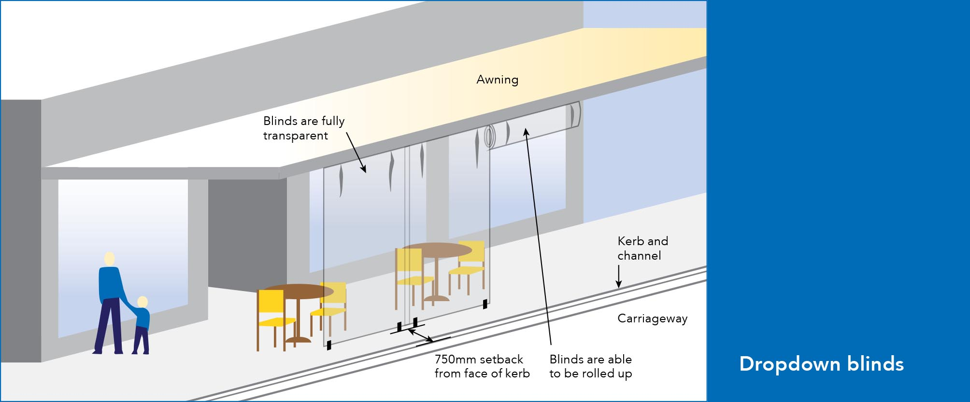
Note: The face of the kerb is the nominal face of kerb as per the Brisbane Standard Drawing BSD-2001- Kerb Profiles.

Diagram E
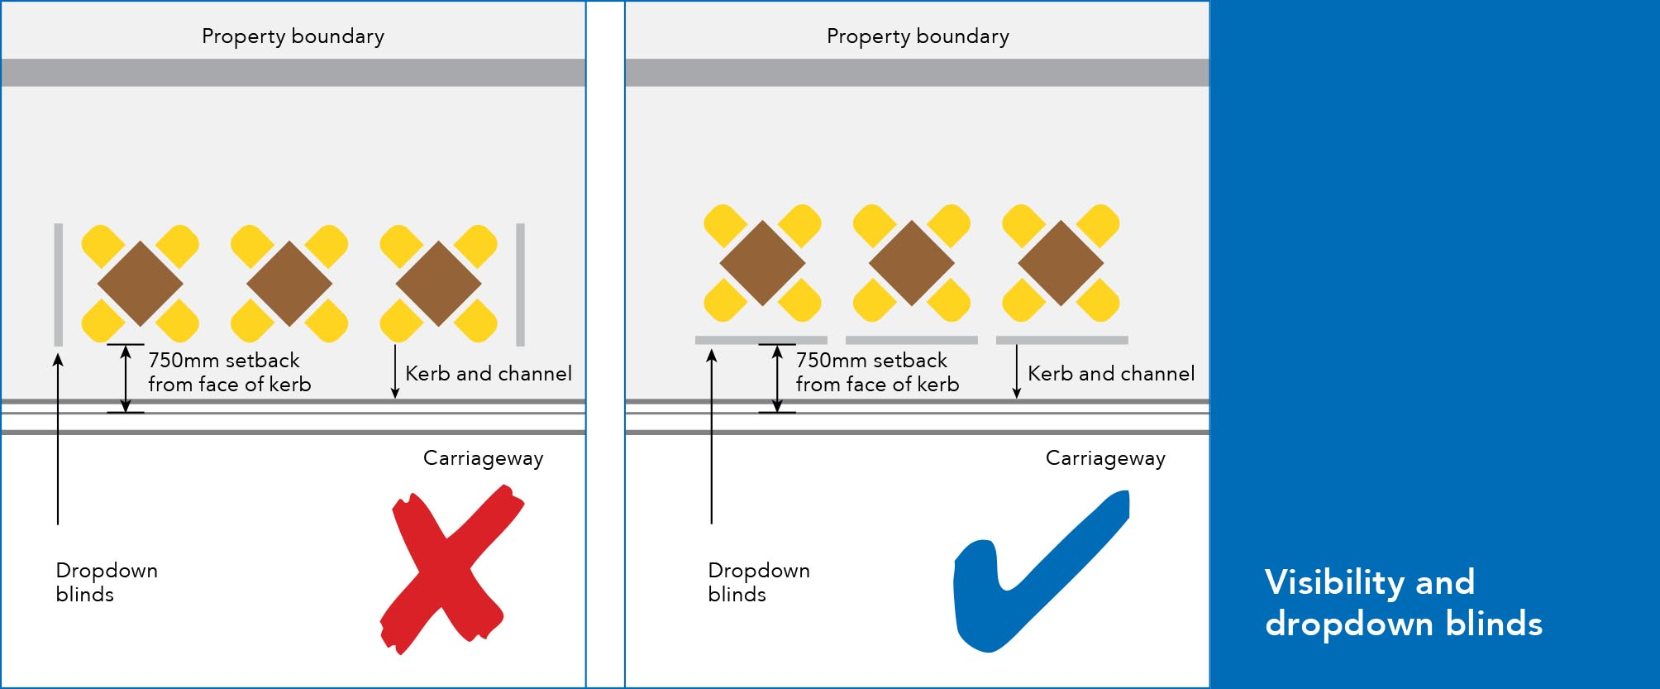
Note: The face of the kerb is the nominal face of kerb as per the Brisbane Standard Drawing BSD-2001- Kerb Profiles.

Diagram F
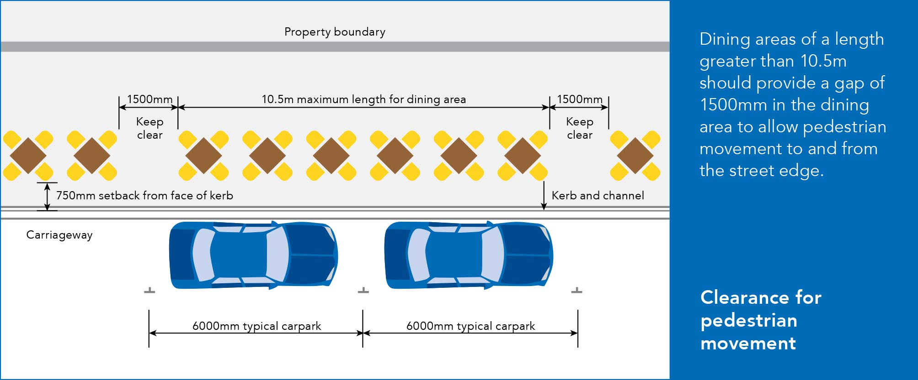
Note: The face of the kerb is the nominal face of kerb as per the Brisbane Standard Drawing BSD-2001- Kerb Profiles.

