North Brisbane Bikeway

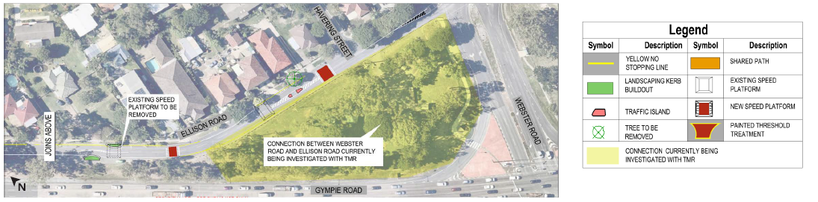
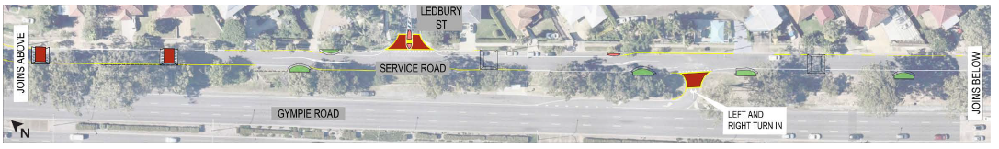
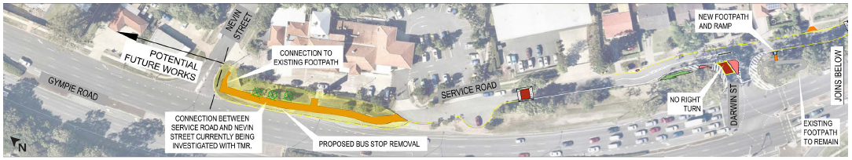
Chermside to Aspley (Webster Road to Nevin Street)

For more information about the project, please call the Project Team on 1800 884 681.

