Brickyard Road Bridge Replacement

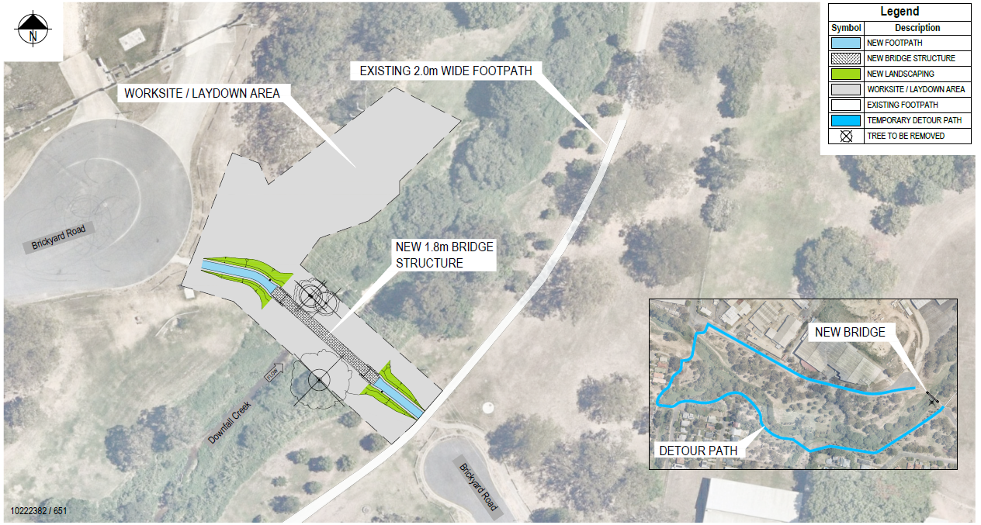
Geebung/Verginia
For more information about the project, please call the Project Team on 1800 884 681.

