



**Brisbane City Council**

**HEALTH SAFETY AND AMENITY SUBORDINATE LOCAL LAW 2012**



**Brisbane City Council**

HEALTH SAFETY AND AMENITY SUBORDINATE LOCAL LAW 2012

made under the

***City of Brisbane Act 2010***

Contents

Page

Part 1 Preliminary 2

1 Short title 2

2 Purpose 2

Part 2 Designation of areas for building appearance provisions 2

3 Designation of area for building appearance provisions 2

Schedule Area for building appearances 3

Part 1 Preliminary

1. Short title

This subordinate local law may be cited as the *Health Safety and Amenity Subordinate Local Law 2012*.

1. Purpose

The purpose of this subordinate local law is to prescribe an area of the City under Part 6A of the *Health Safety and Amenity Local Law 2009* about building appearances.

Part 2 Designation of areas for building appearance provisions

1. Designation of area for building appearance provisions

In accordance with section 24A of the *Health Safety and Amenity Local Law 2009,* the diagram in the Schedule designates the area of the City to which Part 6A of the local law about building appearances applies.

Schedule Area for building appearances

Section 3

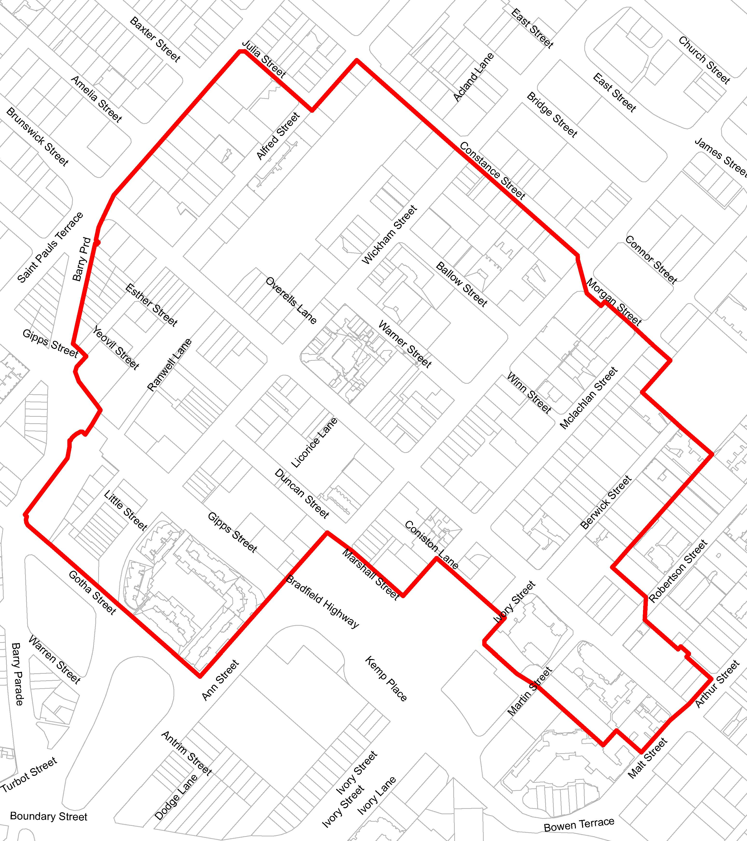

**The part of the above diagram outlined in red designates the area of the City to which Part 6A of the local law about building appearances applies.**