Coorparoo Junction Village Precinct Project –

Investigation area

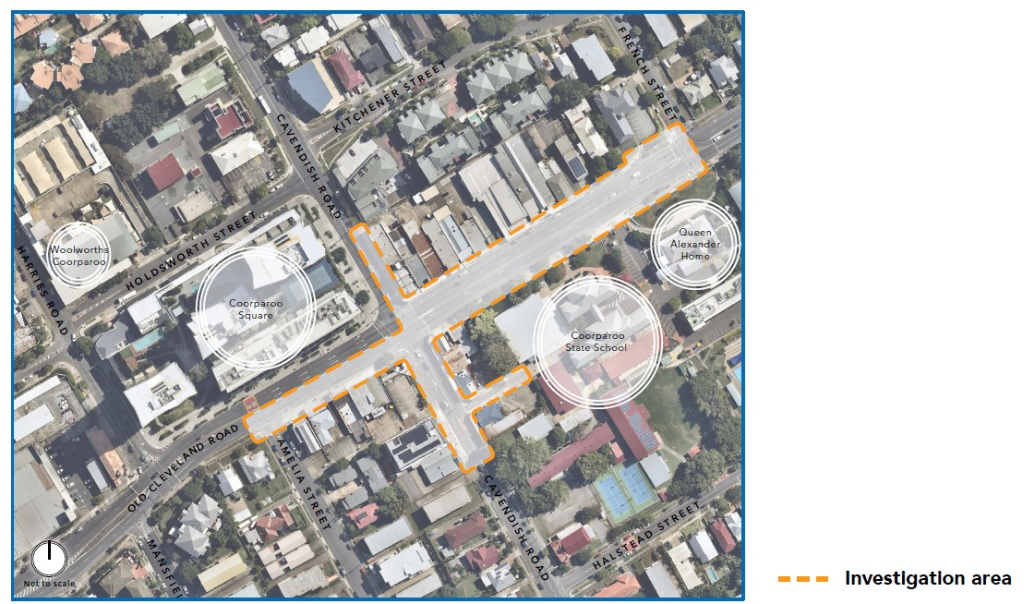

For more information visit brisbane.qld.gov.au and search ‘Village Precinct Projects’ or call
Brisbane City Council on 3403 8888.
CA21-364826-04-5390 © Brisbane City Council 2021

