North Brisbane Bikeway: Price Street to Kedron Brook project

Project introduction – October 2021

Brisbane City Council is pleased to release the proposed concept design for the North Brisbane Bikeway: Price Street to Kedron Brook project between Dickson Street, Wooloowin and Jackson
Street, Clayfield.

This project will complete the critical missing link between the Queensland Government’s North Brisbane Bikeway on Dickson Street and the Kedron Brook Bikeway at Jackson Street, via Junction Road.

The North Brisbane Bikeway is an important active transport corridor between the CBD and the northern suburbs, which we are delivering in partnership with the Queensland Government.

More people are choosing to ride a bike or e-mobility device in Brisbane every year, and this project is part of our commitment to expand our city’s active transport network with safe and convenient bikeways to encourage even more residents and visitors to explore our city.

We are proposing two different kinds of treatments to provide a high-quality active transport facility that meets the needs of the community and the local road network, including:
- a dedicated, separated bikeway on Dickson Street and Bonney Avenue, connecting the North Brisbane Bikeway stage 4 at Price Street with Junction Road
- a green street on Keith, Sydney and Jackson streets, between Junction Road and the Kedron Brook Bikeway, to create a shared, low speed onroad active travel route.
- We have designed different options within these two treatments – different signalised crossing locations on Dickson Street and different kinds of green streets on Keith, Sydney and Jackson streets.

You can read more about these options and see an overview map for the bikeway overleaf.

Benefits
- Provide a safe, connected and accessible active travel route for all experience levels
- Improve accessibility to local businesses, parks, sporting facilities, shopping centres and public transport
- Create more active travel opportunities by connecting two of Brisbane’s major bikeways
- Improve pedestrian crossing points

Have your say
We are inviting you to have your say on different design options within the project alignment to finalise the connection between Price Street and the Kedron Brook Bikeway.

Scan the QR code to find out more about the design options and complete an online survey.


You can also visit brisbane.qld.gov.au and search ‘North Brisbane Bikeway: Price Street to Kedron Brook’. The online survey closes on 12 November 2021.

You can speak with the project team at two community information sessions:
- Thursday 4 November 2021, 5pm-7pm at Eagle Junction Train Station
- Saturday 6 November 2021, 9am-11am at Kalinga Park (near Jackson Street)

Design options
You can view the project plan overleaf to see more detail about these different options.

Price Street to Junction Road (via Dickson Street and Bonney Avenue)
We are proposing to install a dedicated, separated two-way bikeway on Dickson Street and Bonney Avenue between Price Street and Junction Road. This will continue the separated facility between the Queensland Government’s recently completed bikeway and Junction Road. A new signalised crossing will be constructed at the Junction Road and Keith Street intersection to safely connect cyclists to a green street on Keith Street.

As the bikeway must cross to the eastern side of Dickson Street to safely connect with the new Junction Road/ Keith Street crossing, we are seeking feedback on the location of a new separated, signalised crossing on Dickson Street.

We have minimised parking loss wherever possible for both options on Dickson Street and Bonney Avenue.

Option 1 – crossing between Price and Thorrold streets
New signalised crossing on Dickson Street, south-west of Thorrold Street, to connect the bikeway on either side of the road.
- Priority crossings at Price Street and Bonney Avenue.
- Removing 30 car parks on Dickson Street, and 10 on Bonney Avenue.

Option 2 – crossing between Thorrold and Rawson streets
New signalised crossing on Dickson Street, west of Rawson Street to connect the bikeway on either side of the road.
- Priority crossings at Price Street, Thorrold Street and Bonney Avenue.
- Removing 29 car parks on Dickson Street, one on Thorrold Street, and 10 on Bonney Avenue.

Junction Road to Kedron Brook Bikeway (Keith, Sydney and Jackson streets)
We are proposing to create a green street on Keith, Sydney and Jackson streets to connect the separated bikeway on Junction Road to the Kedron Brook Bikeway.

A green street is a reduced speed environment that operates as both an active travel route and a local road, where drivers and riders share the existing road space.

We are seeking feedback on two options for green streets north of Junction Road – cycle street or advisory cycle lanes.

In both options, we are proposing to create a green street by:
- reducing the speed limit to 40 km/h on Keith, Sydney and Jackson streets
- installing traffic calming devices, including raised platforms at intersections and speed humps to reduce vehicle speeds
- creating a new traversable suburban roundabout at Sydney Street and Park Avenue to maximise efficiency for all road users.

Both green street options include traffic calming devices at the same locations across Keith, Sydney and Jackson streets, which require some localised parking removals.

Option A – Cycle Street
A cycle street is a low speed local road where riders and drivers share the road.

Riders are encouraged to travel closer to the centre of the road, with a painted buffer zone between on-street parking and the traffic lane (the ‘door zone’) to reinforce this behaviour.

Option A involves removing three car parks on Keith Street, five on Sydney Street and three on Jackson Street.

Option B – Advisory Cycle Lanes
Advisory cycle lanes include an area on both sides of the road for use by riders, which is delineated from a single central traffic lane by line marking.

Cars in the central traffic lane can use the advisory cycle lanes to safely pass oncoming traffic when no riders are present. Where riders are present, the person in front has the right of way.

Option B involves removing three car parks on Keith Street, 32 on Sydney Street and three on Jackson Street.
As Sydney street is a narrower street, parking on the southern side of the road requires removal.

Project overview

The North Brisbane Bikeway
Brisbane City Council and the Queensland Government are committed to delivering the North Brisbane Bikeway to connect the CBD and Brisbane’s northern suburbs. The Queensland Government Department of Transport and Main Roads completed stages 1 to 4 of the North Brisbane Bikeway project, with stage 4 recently completed on Dickson Street in early 2021.

The connection between the North Brisbane Bikeway and Kedron Brook Bikeway is an important missing link in Brisbane’s north, with Council investigating several options to connect these two major bikeways between 2017 and 2020.

Following feedback from the community over this period, Council is now planning to deliver this connection from Dickson Street at Price Street, Wooloowin to the end of Jackson Street, Clayfield, via Junction Road, Keith Street and Sydney Street.

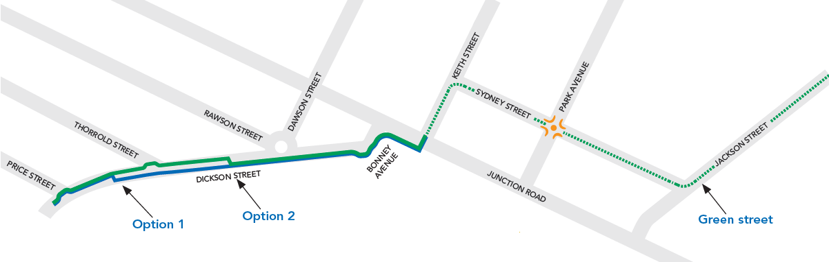

Project alignment
The North Brisbane Bikeway: Price Street to Kedron Brook project will extend the popular North Brisbane Bikeway route to create a high-quality, continuous cycle facility that improves safety, accessibility and connectivity for riders.

This connection will improve connectivity to key destinations in the local network, including the Brisbane Airport, Gateway North Bikeway, and public transport at Eagle Junction and Toombul. The alignment also fills a critical missing link in the broader cycling network, to create more than 40km of bikeway between the CBD and Redcliffe for residents, visitors and commuters to enjoy.

The project alignment is considered the most connected and accessible connection to the Kedron Brook Bikeway for riders of all experience levels.

Next steps
Council is currently in the planning phase for this project, with construction of the North Brisbane Bikeway: Price Street to Kedron Brook project dependent on the future allocation of funding.

All feedback received during consultation will be considered by Council and used to inform the final design for the project.

We are committed to keeping the community informed and will provide an update on this project when more information becomes available following
community consultation.

For more information
Visit brisbane.qld.gov.au and search ‘North Brisbane Bikeway: Price St to Kedron Brook’
Email bikewayprojects@brisbane.qld.gov.au
Call 1800 884 681 (business hours) 3403 8888 (24 hours)

North Brisbane Bikeway: Price Street to Kedron Brook
Proposed design options



