EIGHT MILE PLAINS GATEWAY

DRAFT NEIGHBOURHOOD PLAN

Key information | November 2021

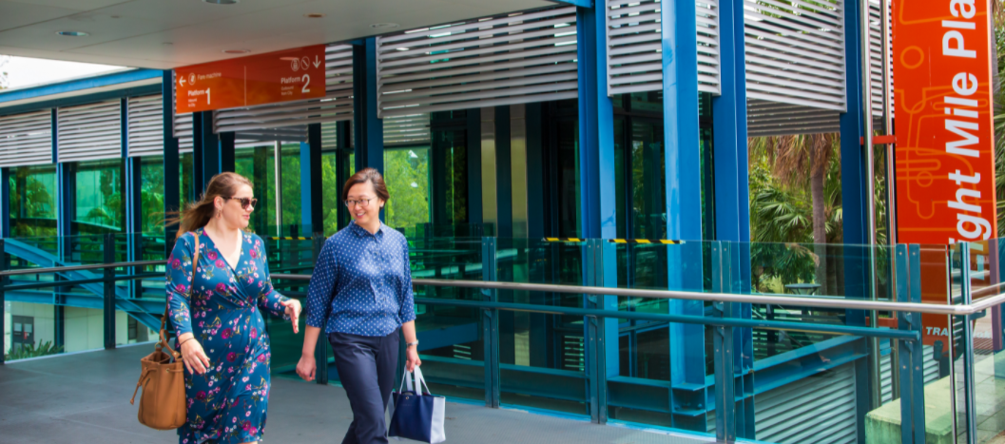

The Eight Mile Plains gateway area is one of the city’s key employment hubs with advanced manufacturing and technology parks that contribute to the city’s economic growth. The area also provides the southern gateway to Brisbane and is well connected to the region by the Gateway and Pacific motorways and Logan Road.

Council is proposing a new neighbourhood plan for this area, covering parts of Eight Mile Plains and Rochedale, to plan for the changing needs of the community for the next 10 years and beyond. The draft neighbourhood plan responds to opportunities associated with significant transport infrastructure investment, including the future Brisbane Metro station. It also provides for housing choice, protection of important environment areas and a new gateway business precinct.

The draft neighbourhood plan is based on technical reviews of the area and feedback received from the community about the draft strategy in 2019. The draft neighbourhood plan is now available for community feedback. Once adopted, the neighbourhood plan will become part of Brisbane City Plan 2014 (City Plan), which will guide future use of land in the area.

## The conversation so far

In late 2019, Council released a draft strategy about the future of the Eight Mile Plains area. Feedback on the draft strategy was provided through a survey, an interactive map, Community Planning Team meeting and information kiosks in November 2019.

For more information on the feedback provided see the feedback report on Council's website.

## Have your say

**Feedback is open on the draft neighbourhood plan from 8am Monday 8 November until midnight on Monday 6 December 2021.**

To view the details of the draft plan and find out how to have your say, visit brisbane.qld.gov.au and search ‘Eight Mile Plains Gateway Neighbourhood Plan’.

## The neighbourhood plan area

### *Acknowledgement of Country*

*Brisbane City Council acknowledges the Traditional Custodians of the land and their unique relationship with their ancestral country. We pay respect to all Aboriginal and Torres Strait Islander Elders of Brisbane, and recognise their strength and wisdom.*

The Eight Mile Plains gateway area is located approximately 15 kilometres south of the Brisbane city centre and includes parts of the suburbs of Eight Mile Plains and Rochedale.

Figure 1 - map of neighbourhood plan area.

This map is of a technical nature and as such is not accessible. For assistance interpreting this map, please contact Council on 07 3403 8888.

## Draft strategy feedback

Published for community feedback in November 2019, the Eight Mile Plains Gateway Neighbourhood Plan draft strategy received 65 responses. The table below summarises the key feedback received about the draft strategy and how Council has addressed this in the draft plan.

|  |  |
| --- | --- |
| **Key points raised** | **How has this been addressed in the draft amendment package** |
| Additional townhouses and other high density residential housing types, such as apartment buildings, in areas that do not have adequate infrastructure or in areas that have traditional suburban character, will negatively impact on the amenity of existing residents. | Low density housing will be retained in established residential areas.  A limited number of townhouses and multiple dwellings of up to two and three storeys in height are provided for in selected high priority locations such as near public transport.  Apartments and units up to five storeys in height are provided for in a small area along Underwood Road near the school, shops and the future Rochedale busway station.  Large residential developments will require structure planning to ensure that adequate infrastructure is provided, and the area’s values and local residential character are protected. |
| The area needs more retail and commercial activities such as cafes and shops. | Increases in residential growth and employment support the expansion of small shops and cafes within the Brisbane Technology Park and other key locations. The draft plan encourages this through changes to zoning and provision of mixed use buildings (i.e. buildings that operate as both commercial and retail). |
| Expansion of Brisbane Technology Park will place additional pressure on local infrastructure, such as local roads and on-street car parking. | The draft plan proposes to allow building height increases within Brisbane Technology Park (range of heights from three to eight storeys) to support the continued growth and evolution of this employment hub. New buildings are required to provide on-site parking to meet the needs of employees and any visitors to the site.  To minimise the impact on car parking availability in the area, the draft plan also encourages any new building and construction to provide improved pedestrian connections to public transport. |
| Walking and cycling infrastructure such as the pedestrian crossings across Logan Road, Miles Platting Road and over the Pacific Motorway need improvement. | The draft plan proposes a range of improvements to local streets over time such as widening footpaths and planting shade trees to make the walking and cycling infrastructure safer and more comfortable for users. These improvements will be delivered by new building and construction activity in the area. |
| On-street parking in the blocks north of Miles Platting Road has been identified as an ongoing issue. | Car parking requirements are managed by citywide policy in City Plan. Council will continue to ensure that any new building and construction in the area provides acceptable levels of car parking at rates already identified in City Plan.  This plan identifies that improved links to public and active transport are required to support and promote non-car based modes of transport (e.g. walking and cycling) within the area.  Council has made improvements to on-street car parking arrangements in the area, and has introduced further restrictions to expand ‘no parking’ areas. |

## How the draft plan responds to local planning outcomes

### Economy, industry and jobs

* Encourage local employment and retail opportunities by attracting and retaining advanced technology and manufacturing industries at key locations.
* Support the continued growth of Brisbane Technology Park and employment uses along Logan Road, including small cafes and shops to support local residents and workers.
* Support a new gateway business precinct at Miles Platting Road and School Road to capitalise on the strategic location close to arterial roads.

### Environment and open space

* Protect and enhance the environmental and habitat values of the Bulimba Creek (Boolimbah) corridor.
* Ensure that building and construction responds to environmental constraints and seeks to retain existing significant vegetation.
* Include additional lots in the Conservation zone to provide for increased protection of these areas.

### Housing choice

* Provide a variety of housing options close to public and active transport options (e.g. walking and cycling) and employment and services, including proposed changes along Holmead Road, the southern side of Miles Platting Road, Brisbane Technology Park, Levington Road and Underwood Road, close to the future Rochedale busway station.

### Infrastructure, active and public transport

* Improve links for public and active transport (such as walking and cycling).
* Support and promote non-car reliant modes of transportation for residents and workers to help reduce traffic congestion and on-street car parking in local streets.

### Public space and community facilities

* Encourage building and construction to deliver high-quality urban design and architecture contributing to the identity of Brisbane Technology Park through onsite amenities such as buildings, landscaping, public space and public art.
* Maintain existing public space within Brisbane Technology Park to contribute to the
* amenity for workers.
* Support the continued operation of established places of worship.

Visit brisbane.qld.gov.au and search ‘Eight Mile Plains Gateway Neighbourhood Plan’ to view times for information kiosks specific to the plan.

## Key proposed zone changes

The draft neighbourhood plan proposes changes to zones as shown in *Figure 2: Proposed zoning changes*. Visit [City Plan online](https://cityplan.brisbane.qld.gov.au/eplan/) to view full definitions of each zone.

Figure 2 - proposed zoning changes. 

This map is of a technical nature and as such is not accessible. For assistance interpreting this map, please contact Council on 07 3403 8888.

NOTE: draft for consultation purposes – subject to change. Updated based on Minister’s conditions received on 28 September 2021.

## Key proposed overlay changes

The draft neighbourhood plan proposes changes to the Dwelling house character overlay, Significant landscape tree overlay and Streetscape hierarchy overlay in City Plan to respond to more detailed planning.

## Draft Eight Mile Plains Gateway Neighbourhood Plan code

A significant portion of future development in the Eight Mile Plains gateway area will be regulated through the existing provisions contained within City Plan, in particular the zone and overlay provisions.

Neighbourhood plans address matters at the local or district level and may provide more detailed

planning for the zones. The draft Eight Mile Plains Gateway Neighbourhood Plan include precincts and sub-precincts to identify specific land uses, and to allow for variations in the zone and overlay code to better respond to the needs of the local area.

The draft Eight Mile Plains Gateway Neighbourhood Plan includes the following five precincts and corresponding sub-precincts:

* NPP-001: Brisbane Technology Park precinct
  + NPP-001a: Commercial and residential sub-precinct
  + NPP-001b: Mixed industry and business transition sub-precinct
  + NPP-001c: Mixed industry and business core sub-precinct
  + NPP-001d: Mixed industry and business periphery sub-precinct
* NPP-002: Busway station precinct
* NPP-003: Gateway business precinct
* NPP-004: Logan Road employment precinct
  + NPP-004a: Levington Road employment sub-precinct
* NPP-005: Potential development areas precinct
  + NPP-005a: Holmead Road sub-precinct

The draft neighbourhood plan code sets out specific provisions to address land uses, building heights, scale and form, and design requirements for new building and construction, in the different precincts.

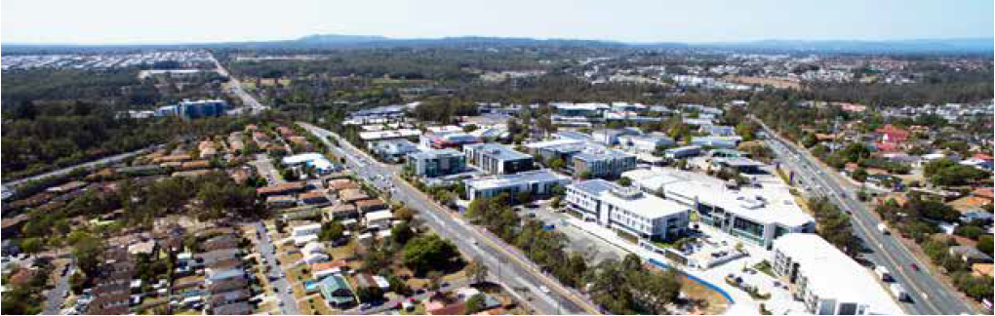

## Key proposed precincts

Figure 3 - proposed precincts.

This map is of a technical nature and as such is not accessible. For assistance interpreting this map, please contact Council on 07 3403 8888.

NOTE: draft for consultation purposes – subject to change. Updated based on Minister’s conditions received on 28 September 2021.

## Have your say

**For more information on the draft Eight Mile Plains Gateway Neighbourhood Plan,**

**and to have your say on the proposed plan, you can:**

* visit brisbane.qld.gov.au and search ‘Eight Mile Plains Gateway Neighbourhood Plan’
* submit feedback via City Plan online
* attend an information kiosk
  + Saturday 20 November 2021

9am-12pm

Brisbane Technology Park Conference Centre

1 Clunies Ross Court, (Brisbane Technology Park),

Eight Mile Plains

* + Wednesday 24 November 2021

2-4pm

5-7pm

The Glen Hotel, 24 Gaskell Street, Eight Mile Plains

* phone Council on 3403 8888
* email [neighbourhood.planning@brisbane.qld.gov.au](mailto:neighbourhood.planning@brisbane.qld.gov.au)
* write to:

Neighbourhood Planning

(Eight Mile Plains Gateway Neighbourhood Plan)

Brisbane City Council

GPO Box 1434

Brisbane Qld 4001

**Feedback closes at midnight on Monday 6 December 2021.**

**A family of three - mum, dad and adult son - eating and drinking at a local cafe.**