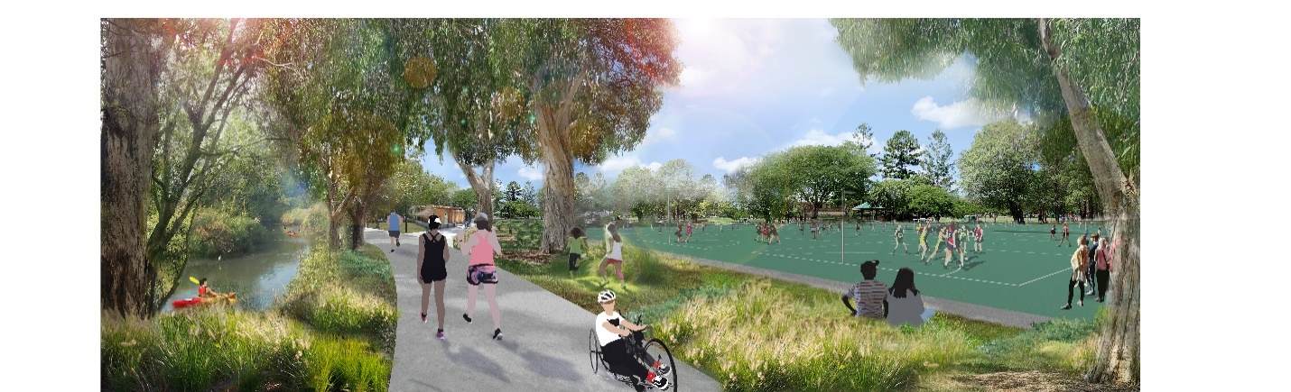

Enoggera Creek Sport and Recreation Draft Precinct Plan

Project update – November 2021
The Enoggera Creek Sport and Recreation Precinct is a valuable active green space in a growing city that offers, and will continue to offer, many active and healthy outcomes to the community.
Brisbane City Council, in partnership with the Australian Government and the local community, is creating a vision for the Enoggera Creek Sport and Recreation Precinct that will help guide future investment, growth and management of the 52-hectare inner-city parkland precinct.
Home to sport and informal green parks, a number of sporting and community organisations and over 10,000 registered members, the Enoggera Creek Sport and Recreation Precinct and parklands will continue to cater for sport, recreation, community groups and those local residents who use the precinct to relax and enjoy Brisbane’s beautiful climate.
Delivering valuable active greenspace, the Enoggera Creek Sport and Recreation Precinct Plan provides a long-term vision, while promoting inclusive participation in sport for all ages and abilities. The parklands will also promote an active lifestyle, facilities, services and infrastructure to meet the needs of our community for future generations.
Council would like to thank all sporting clubs, residents and community members who have had their say during the preliminary community engagement in 2018 and on the Draft Precinct Plan in March–April 2021. Your feedback has shaped, informed and refined the vision for the precinct which is presented as the revised Draft Precinct Plan in this newsletter.
As part of the planning for this iconic project, Council encourages the Brisbane community to have their say on the revised Draft Precinct Plan from Monday 8 November 2021. This round of consultation closes on Friday 4 February 2022 and will ensure the precinct continues to meet the needs of the Brisbane community now and in the future.

Funded by

Australian Government

BUILDING OUR FUTURE

Have your say
Council is seeking your feedback on the revised Draft Precinct Plan by Friday 4 February 2022.
Visit brisbane.qld.gov.au and search ‘Enoggera Creek Precinct Plan’ to have your say via the online survey, or by attending an upcoming Talk to the Planner session (see back page for details).

Find out more
For more information visit brisbane.qld.gov.au and search ‘Enoggera Creek Precinct Plan’ or contact the team on 07 3403 8888.

How your feedback has shaped the Draft Precinct Plan
Community and stakeholder feedback has been critical to the development of the Enoggera Creek Sport and Recreation Draft Precinct Plan.
Initial consultation on the project was undertaken in late 2018, with further consultation conducted with sporting clubs, associations, residents and community members in early 2021 to further guide and refine the development of the Draft Precinct Plan.

During March – April 2021 consultation:
- more than 2000 people had their say
- 1672 people completed the online survey
- Between 100 and 150 people attended each of the three community information sessions
- 301 people wrote to Council.

We listened and we are proposing
While the overall level of engagement for the Enoggera Creek Sport and Recreation Draft Precinct Plan has been supportive, feedback from sporting clubs, associations, local residents and community has highlighted some consistent themes.
The revised version of the Draft Precinct Plan considers and incorporates received feedback to represent the facility, sporting and recreation requirements, community needs and aspirations for the 52-hectares and parklands.

Upgrade and build new sporting fields
- The community supported improved community sports facilities.
- Detailed comments have been considered on the specific design and operational elements of the sporting facilities.
- Synthetic and hybrid playing surfaces have been incorporated into the precinct to better manage high activity and demand.
- Council will continue to engage with sporting groups to determine detailed sporting field design requirements and future development opportunities.

Retain and enhance the parkland environment, wildlife habitat and existing vegetation
- Existing wildlife and habitat throughout the precinct is highly valued and the protection, preservation and enhancement of the natural environment and biodiversity is important.
- Council acknowledges the need to protect the essential habitat vegetation areas, especially in Finsbury Park and along the Enoggera Creek corridor.
- Greenspace areas have been increased throughout the precinct and the footprint of new buildings and car park areas has been reduced.

Maintain access to greenspace
- Access to parks, green and open spaces, especially for recreation is highly valued.
- The new Windsor Sports and Community Park will further protect and expand greenspace to make it easier for you to enjoy the lifestyle our great city has to offer.
- Dedicated recreation greenspace at Langley Avenue Park.
- The relocation of softball and baseball to Finsbury Park, and cricket to Downey Park, was reconsidered. These sports will continue to be played at their existing locations to reflect this key stakeholder feedback.

Reconsider new car parking
- The positioning of new car parks has been reconsidered, with greater focus provided on formalising the existing informal car park areas.
- The proposed car park footprint has been reduced, and new street access removed, to minimise the impact on existing greenspaces.
- Council will enhance the focus on improved active transport connections.

Retain the existing dog off-leash area
- The Northey Street Park dog off-leash area has been retained and will remain in its current location.

Pedestrian, cycle connectivity and pathways
- Separate access for pedestrian and cycle connectivity has been provided throughout the precinct to encourage active and safer travel experiences for all ages and abilities.
- Enhanced precinct connections, shade and recreation nodes including a new pedestrian bridge connection from Clyde Road.

Traffic, noise, light and food impacts
- The revised Precinct Plan will inform further detailed design and design activities to prepare an implementation plan for further public engagement in the future.
- Operational, traffic and parking strategies will be developed to minimise adverse amenity impacts.
- Noise and light spill impacting residents and wildlife will be minimised through detailed design.

Find out more about the community consultation process
The consultation report, The journey thus far, outlines the community engagement activities conducted and the feedback received from stakeholders and the community. Visit brisbane.qld.gov.au and search ‘Enoggera Creek Precinct Plan’ to view or download the report.

Protecting and enhancing our city’s parkland
The Enoggera Creek Sport and Recreation Draft Precinct Plan is forming a vision for the future design and how the precinct can improve and evolve over time.
Feedback and ideas received to date have inspired the design framework, which was formed by the below four guiding principles to articulate how the vision for the precinct will be realised and will guide more detailed planning in the years ahead. The guiding principles consider the precinct’s unique history, the needs of the city and surrounding communities, environmental imperatives and opportunities offered by the precinct’s natural features and location.

Sport and recreation
Foster Brisbane’s active and outdoor lifestyle within a well-loved Brisbane precinct.

Community connections
Create a multi-functional inner-city precinct that caters to users of all ages and abilities, promotes social connection and healthy living.

Urban green
Increases greenspace, biodiversity, urban fauna habitat and tree cover, while decreasing the heat island effect within the urban fabric.

Healthy waterways
Promotes local food resilience, infiltration and connection to creeks while reinstating natural ecosystems, and storm-water management.
By delivering on a strong plan now, with a vision that looks to the future, Council is improving valuable active greenspace for residents while ensuring our city has the sport, recreation and community facilities to meet the needs of future generations.
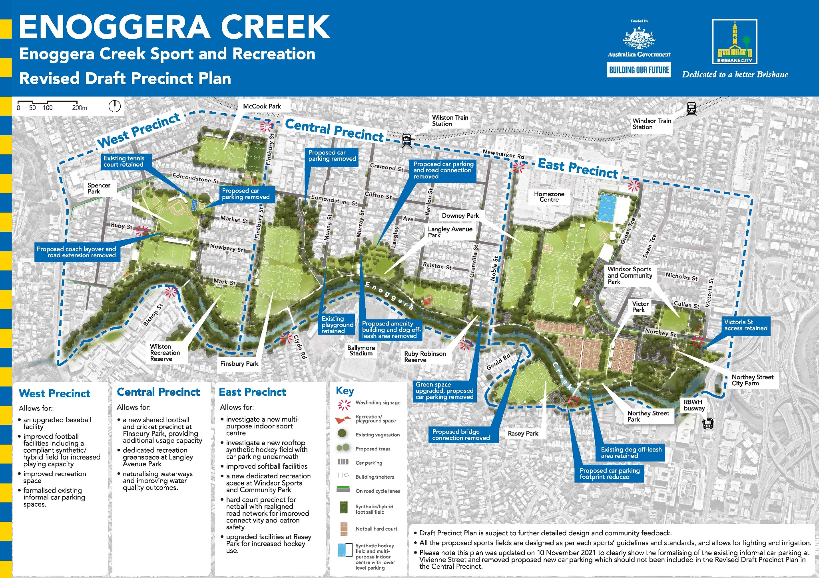

Project timeline

Late 2018 – early 2019
Initial consultation to gather insights on how the precinct is valued and used by stakeholders.

2019 – 2020
Draft Precinct Plan prepared based on community feedback and input.

March – April 2021
Draft Precinct Plan released for consultation with sporting groups, local residents and community.

November 2021 – February 2022
Consultation on the revised Draft Precinct Plan with sporting groups, local residents and community.

Have your say
To view the revised draft plan and provide feedback:
- visit brisbane.qld.gov.au and search ‘Enoggera Creek Precinct Plan’ and complete the online survey by Friday 4 February 2022
- register to attend a ‘Talk to the Planner’ session to view the revised version of the Draft Precinct Plan, provide your feedback and discuss the plan with the project team. Registrations and bookings are essential to attend these sessions.

Saturday 20 November 2021, 1:00pm–3:30pm
Multicultural Community Centre, International City Church
23 Foster Street, Newmarket QLD 4051

Sunday 21 November 2021, 10:00am–12:30pm
Ashgrove Library
87 Amarina Avenue, Ashgrove QLD 4060

Saturday 27 November 2021, 9:30am–12:00pm
Ashgrove Library
87 Amarina Avenue, Ashgrove QLD 4060

Saturday 27 November 202, 4:30pm–7:00pm
Grange Library
79 Evelyn Street, Grange QLD 4051
Please note: Sessions will be held in accordance with COVID Safe guidelines and session details are subject to change.
To register for project updates, including further opportunities to have your say, visit brisbane.qld.gov.au and search ‘Enoggera Creek Precinct Plan’ or contact the project team on 07 3403 8888.

