Bridgeman Downs neighbourhood plan

Brisbane City Plan 2014

Amendment Package – Public Notification

14/2/2022 to 28/3/2022

EDITOR'S NOTE: Subject to conditions issued by the Minister for State Development, Infrastructure, Local Government and Planning dated 21 October 2021.
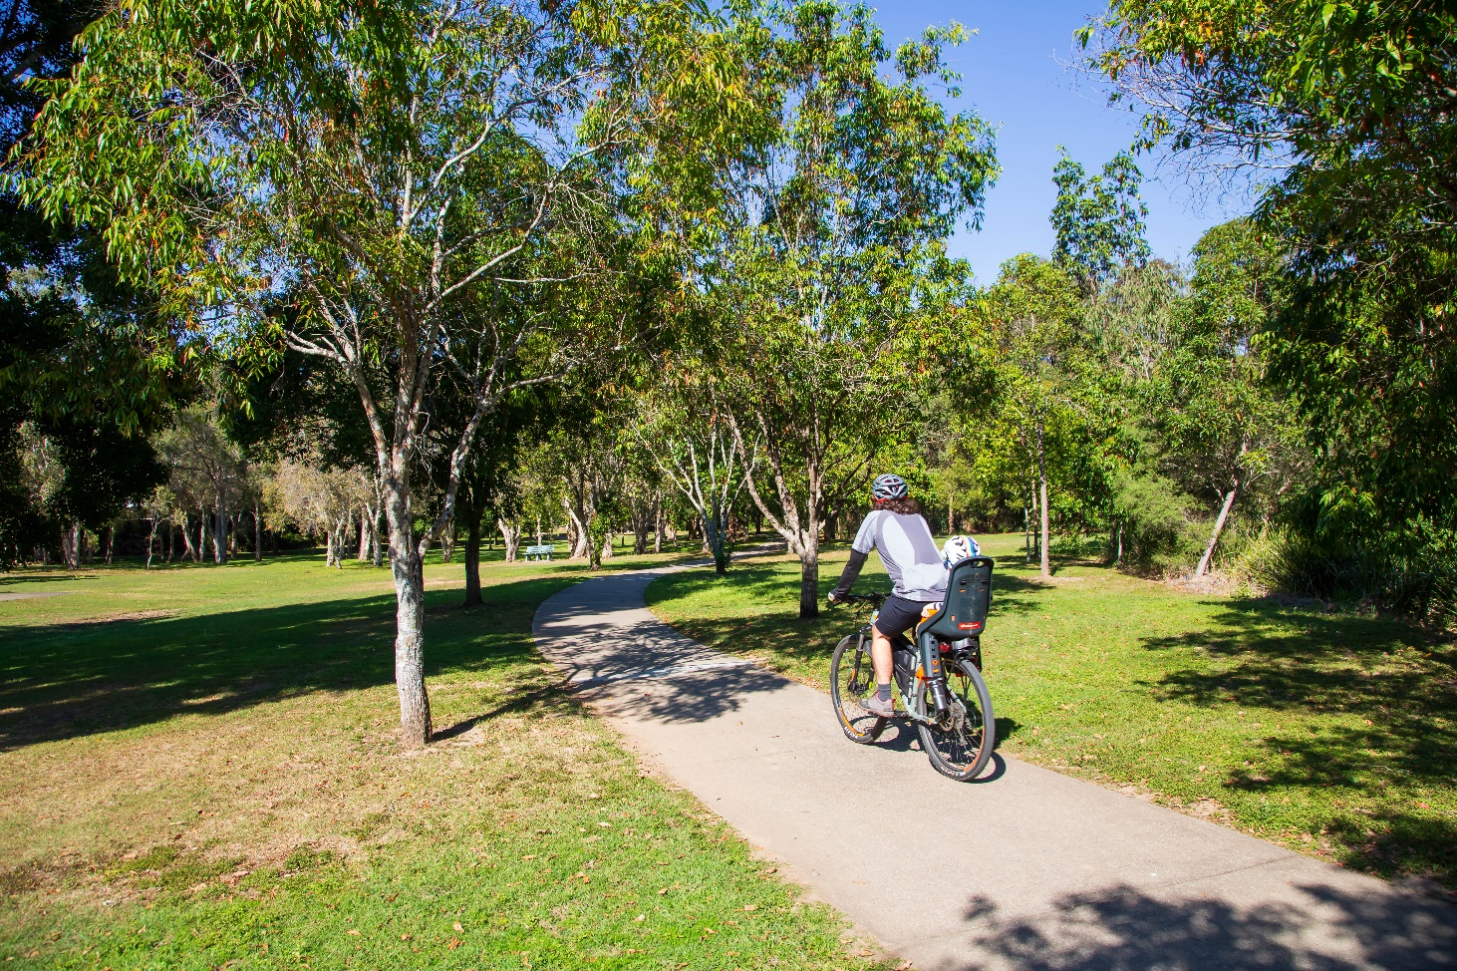

Table of Contents

EDITOR'S NOTE: Subject to conditions issued by the Minister for State Development, Infrastructure, Local Government and Planning dated 21 October 2021. 1
1
Table of Contents 2
Part A: Explanatory Notes 4
Glossary 5
Purpose 6
Introduction 6
Background 6
Community engagement 6
Draft strategy feedback 8
The neighbourhood plan boundary 9
Precincts 10
Key planning outcomes 11
State Interest Review 11
Proposed zone changes 12
Proposed overlay changes 14
Proposed planning scheme policy changes 17
Amendment Summary 17
Conclusion 21
Part B: Major amendment vx.00/20xx 22
Part 1 Amendment of Part 1 (About the planning scheme) 24
1.1 Amendment of section 1.2 (Planning scheme components) 24
Part 2 Amendment of Part 5 (Tables of assessment) 26
2.1 Amendment of section 5.9 (Categories of development and assessment—Neighbourhood plans) 26
Part 3 Amendment of Part 7 (Neighbourhood plans) 31
3.1 Amendment of section 7.1 (Preliminary) 31
3.2 Amendment of section 7.2 (Neighbourhood plan codes) 31
7.2.2.3 Bracken Ridge and district neighbourhood plan code 31
7.2.2.5 Bridgeman Downs neighbourhood plan code 49
7.2.13.1 McDowall neighbourhood plan code 62
Part 4 Amendment of Part 8 (Overlays) 65
4.1 Amendment to section 8.2.19 (Significant landscape tree overlay code) 65
Part 5 Amendment of Schedule 2 (Mapping) 68
5.1 Amendment to SC2.2 (Zone maps) 68
5.2 Amendment to Table SC2.2.1 (Zone maps) 68
5.3 Amendment to SC2.3 (Neighbourhood plan maps) 68
5.4 Amendment to Table SC2.3.1 (Neighbourhood plan maps) 68
5.5 Amendment of Schedule 2.4 (Overlay maps) 70
5.6 Amendment of Table SC2.4.1 (Overlay maps) 71
Part 6 Amendment of Schedule 6 (Planning scheme policies) 72
6.1 Amendment to Schedule 6.29 Structure planning planning scheme policy 72
Part 7 Amendment of Appendix 2 (Table of amendments) 74
7.1 Amendment to Appendix 2 (Table of amendments) 74
Supplement 1—A3 Map Tiles 75

Part A: Explanatory Notes

Glossary

Abbreviation | Term
the Act | Planning Act 2016
amendment package | Bridgeman Downs neighbourhood plan amendment package
City Plan | Brisbane City Plan 2014
The draft plan | Bridgeman Downs neighbourhood plan
the Guideline | Minister’s Guideline and Rules (September 2020)
MCU | Material change of use as defined in the Act
the neighbourhood plan | Bridgeman Downs neighbourhood plan
PSP | Planning scheme policy
the planning scheme | Brisbane City Plan 2014
LGA | Local Government Area
LGIP | Local Government Infrastructure Plan

Purpose

The purpose of these explanatory notes is to provide context to the Bridgeman Downs neighbourhood plan amendment package (the amendment package), including the key outcomes sought and the process undertaken to develop the neighbourhood plan. The explanatory notes are for information only and do not form part of the amendment package.

Introduction

Brisbane City Council (Council) has prepared the Bridgeman Downs neighbourhood plan to guide future development and coordinate land use and infrastructure over a 10-year period and beyond. This neighbourhood plan is intended to amend those parts of the Bracken Ridge and district neighbourhood plan and McDowall-Bridgeman Downs neighbourhood plan that reference parts of the Bridgeman Downs. Once adopted, the neighbourhood plan will become part of Brisbane City Plan 2014 (the planning scheme).

The statutory amendment process used to amend a planning scheme is governed by the Planning Act 2016 and the Minister’s Guidelines and Rules. Under these rules, amendments to the planning scheme, including the adoption of neighbourhood plans, must be reviewed and approved by the Queensland Government. Community consultation is also required as part of this process.

The Bridgeman Downs amendment package includes:
- the draft Bridgeman Downs neighbourhood plan code;
- changes to the existing Bracken Ridge and district neighbourhood plan and McDowall-Bridgeman Downs neighbourhood plans as a consequence of boundary changes to create the Bridgeman Downs neighbourhood plan;
- changes to zones;
- changes to overlay mapping; and
- changes to planning scheme policies.

The Bridgeman Downs neighbourhood plan amendment package contains two parts − these explanatory notes (for information only) (Part A), and the proposed amendment that specifies the proposed statutory changes to the planning scheme (Part B).

Background

Council commenced the neighbourhood planning process in September 2019 and released a draft strategy for consultation in October 2020. The draft strategy was based on initial community input, including online survey responses and insights from the neighbourhood plan Community Planning Team, as well as background research and technical studies undertaken by Council. The draft strategy introduced a vision and identified key themes shaping future development of the area. A guide for implementing key strategies and actions was also identified. The draft strategy was available for community feedback from 19 October 2020 to 16 November 2020.

Feedback on the draft strategy, technical investigations and engagement with internal and external stakeholders was used to inform the neighbourhood plan and the amendment package. Internal Council stakeholders have also been involved in preparing the amendment package.

Community engagement

The neighbourhood planning process involved a series of community engagement stages. The neighbourhood planning process commenced in September 2019. An online survey to inform the draft strategy was carried out from 9 September 2019 to 21 October 2019 and the Community Planning Team (CPT) met three times between October 2019 and February 2020.

Feedback received during the three CPT meetings informed the draft strategy. The draft strategy was released for public consultation from 19 October 2020 to 16 November 2020. Feedback on the draft strategy was used to inform the amendment package.

Table 1 provides a summary of the key community engagement activities that informed the development of the neighbourhood plan.

Table 1: Key community engagement summary
Event type | Date and location | Number of people
Newsletter | 9 August 2019 | Bridgeman Downs residents and absentee owners
Online issues survey | 9 September 2019 to 21 October 2019 | 182
Interactive mapping | 9 September 2019 to 21 October 2019 | 165
Community Planning Team | CPT Meeting 1 – 30 October 2019 | 27
 | CPT Meeting 2 – 27 November 2019 | 18
 | CPT Meeting 3 – 12 February 2020 | 16
E-bursts (email updates) | Launch – September 2019  Update – February 2020  Draft strategy release – October 2020  Draft strategy reminder – October 2020 | Bridgeman Downs residents and absentee owners
Information kiosks | 24 October 2020  Aspley Hypermarket | 72
 | 4 November 2020  30 Ridley Road, Bridgeman Downs – Anglican Church Hall | 56
Online discussions | 21 October 2020 to 6 November 2020 | 6
Draft strategy | 19 October 2020 to 16 November 2020 | 215

Draft strategy feedback

The draft strategy received 215 responses. Table 2 provides a summary of key issues raised and how they are addressed in the draft amendment package.

Table 2: Summary of key issues and responses

Key issues raised by community | How addressed in the draft amendment package
Comments regarding Theme 1 - protecting the environment and greenspace
Protect natural habitat  - Conserve habitat in backyards  - Maintain and enhance waterway health  - Grow our urban forest | The draft amendment package proposes that:  - land with ecological or waterway values (as specified in an overlay map or figure), or significant vegetation, be protected from inappropriate development;  - development protects and enhances native habitat and fauna movement along Albany Creek, Cabbage Tree Creek, South Pine River and tributaries, and the east-west ecological corridors between Cabbage Tree Creek and Albany Creek, in the area south of Albany Creek Road;  - development minimises impacts to existing hydrology, creek, geomorphology and provide stormwater quantity and quality management to protect and enhance waterway health;  - significant landscape trees be identified and protected; and  - a range of lot sizes be provided to provide sufficient space for the retention of habitat in backyards.
Comments regarding Theme 2 - residential neighbourhoods
Housing design and choice  - Restrict townhouses and apartments  - Support single homes in suburban development  - Support large lots in proposed large lot area  - Maintain acreage areas  - New house design includes views of open space | The draft amendment package proposes that:  - dwelling houses be established on acreage and suburban lots;  - multiple dwellings are not developed in the Low density residential zone;  - four residential precincts be established, each with different lot sizes to respond to local character, infrastructure, environmental and other constraints;  - acreage lots be retained in parts of the neighbourhood plan area; and  - development be sited and designed to overlook parks or community facilities to encourage increased safety through surveillance.
Comments regarding Theme 2 - residential neighbourhoods
- Mitigate risk from natural hazards  - Mitigate risks to people and property from nearby industry and powerlines  - Protect and celebrate built history | The draft amendment package proposes that:  - provisions be included to identify and mitigate existing and potential bushfire and flood hazards;  - provisions be included to ensure that sensitive uses are not impacted by industrial activities (in the adjoining local government area) or crematorium uses in key precincts;  - provisions be included to mitigate the visual impact of the existing high voltage powerlines through building orientation and vegetated buffers/screening in key precincts;  - one new local heritage sites be identified and protected through the existing Heritage overlay code.
Comments regarding Theme 3 - infrastructure and services
- Improve the area’s open space and park network  - Create multi-functional open space corridors  - Development to align with theme 3 map | The draft amendment package proposes that:  - open space, parks and community facilities meet the needs of the community and are located in safe and accessible locations that are well connected;  - the Local Government Infrastructure Plan (LGIP) provides requirements for future park requirements; and  - provisions be included to align with Theme 3: Integrated infrastructure and services map included in the draft strategy.
- Comments on infrastructure provision and connections  - Comments on improving infrastructure (stormwater, local roads and footpaths, cycle connections)  - Comment on community access to public infrastructure (open space, community facilities)  - Comment for a neighbourhood centre | The draft amendment package proposes that:  - changes proposed as part of the plan be supported by amendments to the LGIP;  - the LGIP amendments consider public infrastructure (roads, stormwater, parks and community facilities), and align with external service providers (water and sewerage);  - development be carried out in an orderly sequence and ensures a cost-efficient provision and extension of sewerage, water, stormwater, transport, public parks and community facilities infrastructure networks; and  - a new neighbourhood centre that can cater for local convenience shopping and services is supported where need and locational criteria can be met.

The neighbourhood plan boundary

The neighbourhood plan area comprises the suburb of Bridgeman Downs. The amendment package boundary overlaps with the existing Bracken Ridge and district neighbourhood plan and McDowall-Bridgeman Downs neighbourhood plans and consequential amendments to those existing neighbourhood plans are detailed in the amendment package.

The neighbourhood plan boundary and precincts are outlined in Figure 1.
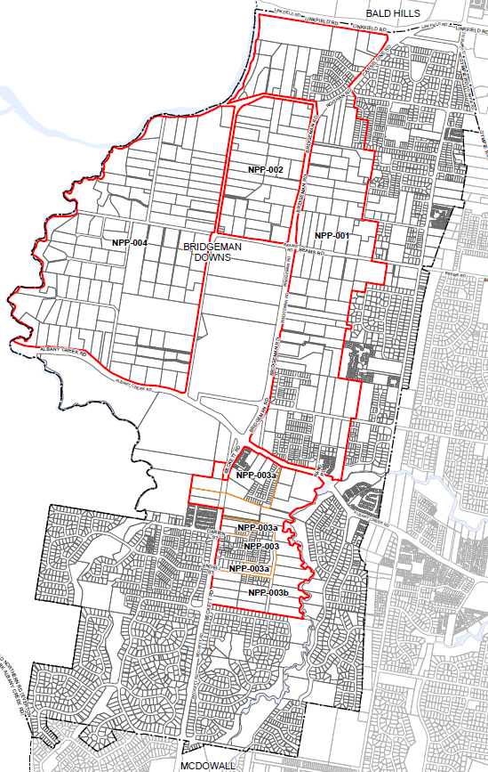
Figure 1: Bridgeman Downs neighbourhood plan boundary and precincts

Precincts

Neighbourhood plans include precincts and may also include sub-precincts. Precincts have been identified to address or provide for particular land uses, character, infrastructure or other site characteristics (e.g. environmental values), and have a specific set of provisions to achieve those outcomes. Located within a precinct, sub-precincts are smaller portions of the overall precinct, and have more detailed provisions to achieve the intended land use outcomes.

The draft plan proposes four precincts within the draft neighbourhood plan area. One of these precincts has sub-precincts. The proposed precincts are outlined in Figure 1 below and also detailed in Part B of the draft amendment package. These precincts provide specific guidance on the types of uses and development outcomes supported in these locations and include:
- NPP-001: Bridgeman Downs residential precinct;
- NPP-002: Roghan Road south precinct;
- NPP-003: Beckett Road precinct;
  - NPP-003a: Residential living sub-precinct;
  - NPP-003b: Environmental living sub-precinct; and
- NPP-004: Albany Creek precinct.

Key planning outcomes

The amendment package is aligned with City Plan’s Strategic framework. Under the strategic framework, the neighbourhood plan area is identified as a suburban living area. The draft amendment package supports CityShape 2031 by providing for new low density residential areas which seek to retain and protect identified ecological and waterway values.

The draft amendment package seeks to do the following:
- Confirm future development potential for residential and local centres that support the suburban living area function as outlined in the Strategic framework of the planning scheme;
- Provide for acreage and suburban lots that protect ecological values and contribute to the neighbourhood character of well separated houses in a bushland setting;
- Ensure that multiple dwellings are not accommodated in the Low density residential zone;
- Provide for buildings that create a distinctive subtropical character by ensuring that building design, spacing and orientation is responsive to the city’s climate;
- Provide services and facilities to meet the needs of the existing and future community, such as parks, stormwater, sewer and other utilities;
- Protect and enhance environmental and biodiversity values along Albany Creek, Cabbage Tree Creek, South Pine River and tributaries and east-west ecological corridors;
- Ensure that development protects existing hydrology, creek geomorphology and provides stormwater quantity and quality management to protect and enhance waterway health;
- Mitigate potential impacts arising from industrial (adjoining local government area), crematorium and high voltage power lines; and
- Ensure that development provides for road, pedestrian and cycle networks that achieve integrated safe and legible connections.

State Interest Review
On 21 October 2021 Council received conditions from the Minister for State Development, Infrastructure, Local Government and Planning following the State interest review of the draft plan. These conditions changed parts of the draft amendment package including provisions, figures and overlay maps.

Proposed zone changes

The draft amendment package proposes changes to zones that include the following:
- Changing some lots in the Rural zone to the Low density residential zone, Emerging community zone, Communities facilities (Cemetery zone precinct) zone; Community facilities (Community purposes zone precinct) zone or Special Purpose (Utility services zone precinct) zone;
- Changing some lots in the Emerging community zone to the Low density residential, Environmental management and Open space zones;
- Changing one lot in the Low density residential zone to the Neighbourhood centre zone.

Proposed zoning changes in the neighbourhood plan are shown in Figure 2.
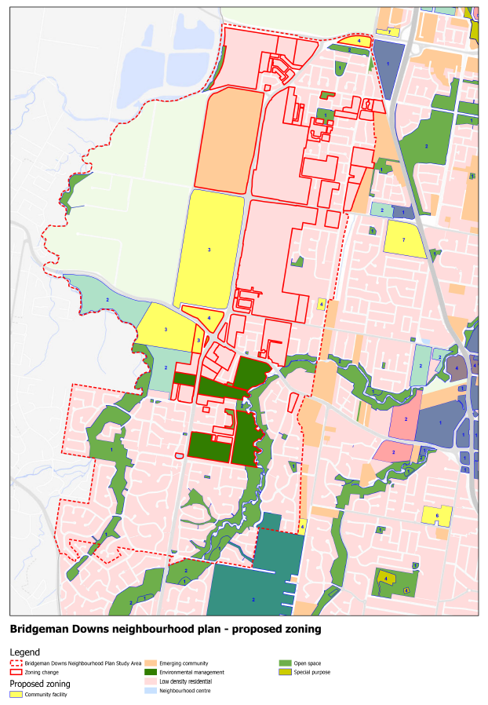
Figure 2: Key areas of proposed zoning changes

Proposed overlay changes

The neighbourhood plan is supported by changes to overlay maps. Overlay maps identify areas that have a specific constraint, opportunity or sensitivity that require additional assessment benchmarks or provisions to be considered in development assessment.

The amendment package proposes changes to the planning scheme’s Dwelling house character overlay, Heritage overlay (refer Figure 3), Road hierarchy overlay, Significant landscape tree overlay (refer Figure 4), Streetscape hierarchy overlay and Waterway corridors overlay.

Refer to Table 3 – Amendment Summary and Part B for details on the proposed amendments.
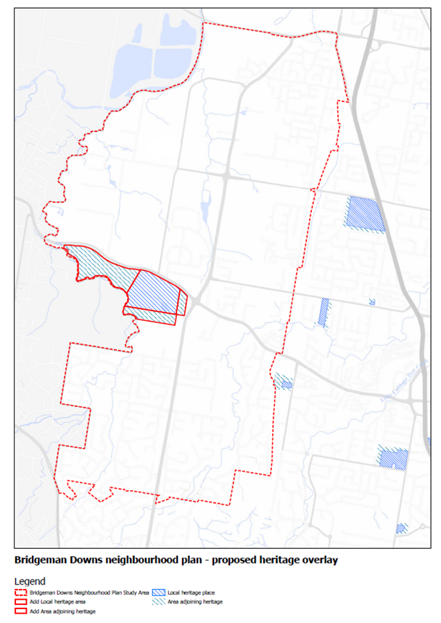
Figure 3: Heritage overlay changes map
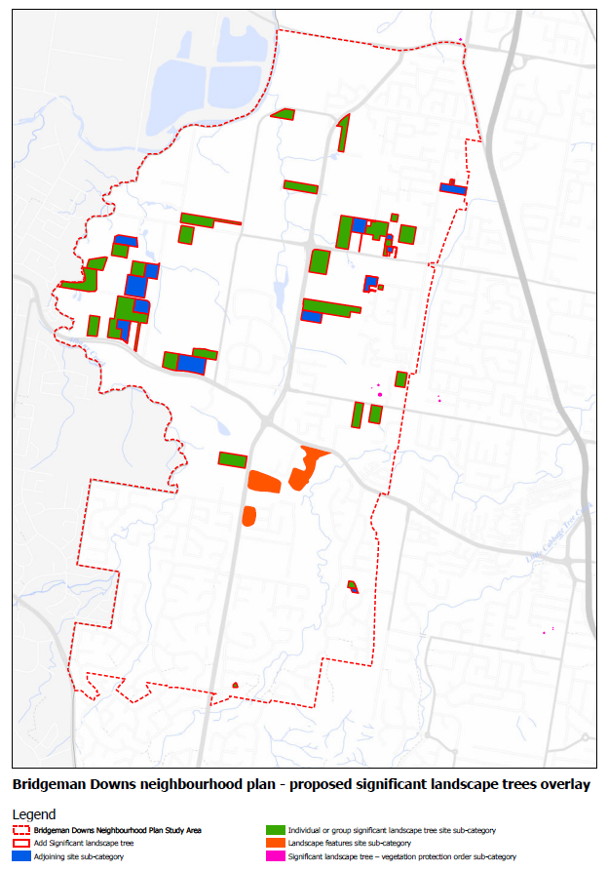
Figure 4: Significant landscape tree overlay change map

Proposed planning scheme policy changes

Planning scheme policies are included in Schedule 6 of the planning scheme. These policies provide additional information and guidance on a variety of local planning matters including:
- how to satisfy planning scheme assessment benchmarks (requirements);
- urban design solutions for particular locations and forms of development;
- content requirements and methodology for preparing technical reports and plans;
- technical and engineering standards;
- procedures and responsibilities; and
- characteristics of cultural heritage sites.

The neighbourhood plan code includes acceptable outcomes and performance outcomes that reference the Infrastructure design planning scheme policy and Structure planning planning scheme policy.

The proposed planning scheme policy amendments can be viewed in Part B. Refer to Table 3 – Amendment Summary and Part B for details on the proposed amendments.

Amendment Summary

Table 3: Amendment Summary
Part | Planning scheme reference | Proposed amendment | Part B amendment reference
Part 1 (About the planning scheme) | Table 1.2.2 -Neighbourhood plans precincts and sub-precincts | Amend the row for the Bracken Ridge and district neighbourhood plan and replace with the following precincts:  - NPP-001: Carseldine residential  - NPP-002: Taigum residential  - NPP-003: West Aspley  - NPP-004 Relocatable home parks  - NPP-005: Bracken Ridge east  - NPP-006: Bald Hills village centre  - NPP-007: Zillmere industrial  - NPP-008 Gawain Road centre  - NPP-009: Bald Hills  - NPP010: North Bald Hills  - NPP011: Bracken Ridge Road  - NPP012: North Bracken Ridge  - NPP-013: Zillmere centre. | Part 1.1 (1)
Part 1 (About the planning scheme) | Table 1.2.2 -Neighbourhood plans precincts and sub-precincts | Add new row for the Bridgeman Downs neighbourhood plan, with the following precincts:  - NPP-001: Bridgeman Downs residential  - NPP-002: Roghan Road south  - NPP-003: Beckett Road  - NPP-003a: Residential living  - NPP-003b: Environmental living  - NPP-004: Albany Creek. | Part 1.1 (2)
Part 1 (About the planning scheme) | Table 1.2.2 -Neighbourhood plans precincts and sub-precincts | Amend the row for the McDowall-Bridgeman Downs neighbourhood plan to read:  - McDowall neighbourhood plan: Nil. | Part 1.1 (3)
Part 5 (Tables of assessment) | Table 5.9.1 -Neighbourhood plan categories of development and assessment changes | Add new row for the Bridgeman Downs neighbourhood plan and indicate changes to material change of use and reconfiguring a lot. | Part 2.1 (4)
 | Table 5.9.1 -Neighbourhood plan categories of development and assessment changes | Amend the McDowall-Bridgeman Downs neighbourhood plan to McDowall neighbourhood plan and retain the categories of development and assessment changes. | Part 2.1 (5)
 | Table 5.9.9.A -Bracken Ridge and district neighbourhood plan: material change of use | Amend precinct numbers from “If in the Relocatable home parks precinct (NPP-005)…” to “If in the Relocatable home parks precinct (NPP-004)…” | Part 2.1 (6)
 | Table 5.9.83.A -Bridgeman Downs neighbourhood plan: material change of use | Include new table of assessment for Bridgeman Downs neighbourhood plan: material change of use to include Emergency services, Residential care facility and Retirement facility as Impact assessment with assessment benchmarks. | Part 2.1 (7)
 | Table 5.9.83.B -Bridgeman Downs neighbourhood plan: reconfiguring a lot | Include new table of assessment for Bridgeman Downs neighbourhood plan: reconfiguring a lot to include Low density residential zone as Impact assessment if not complying with minimum and average lot sizes with assessment benchmarks. | Part 2.1 (8)
 | Table 5.9.83.C -Bridgeman Downs neighbourhood plan: building work | Include new table of assessment for Bridgeman Downs neighbourhood plan: building work – “No change” with assessment benchmarks. | Part 2.1 (9)
 | Table 5.9.83.D -Bridgeman Downs neighbourhood plan: operational work | Include new table of assessment for Bridgeman Downs neighbourhood plan: operational work – “No change” with assessment benchmarks. | Part 2.1 (10)
 | Table 5.9.40.A -McDowall-Bridgeman Downs neighbourhood plan: material change of use | Amend McDowall-Bridgeman Downs neighbourhood plan to McDowall neighbourhood plan and retain the categories of development and assessment changes. Update reference to neighbourhood plan code to reflect changed name. | Part 2.1 (11)
 | Table 5.9.40.B -McDowall-Bridgeman Downs neighbourhood plan: reconfiguring a lot | Amend McDowall-Bridgeman Downs neighbourhood plan to McDowall neighbourhood plan and retain the categories of development and assessment changes. Update reference to neighbourhood plan code to reflect changed name. | Part 2.1 (12)
 | Table 5.9.40.C -McDowall-Bridgeman Downs neighbourhood plan: building work | Amend McDowall-Bridgeman Downs neighbourhood plan to McDowall neighbourhood plan and retain the categories of development and assessment changes. Update reference to neighbourhood plan code to reflect changed name. | Part 2.1 (13)
 | Table 5.9.40.D -McDowall-Bridgeman Downs neighbourhood plan: operational work | Amend McDowall-Bridgeman Downs neighbourhood plan title to McDowall neighbourhood plan and retain the categories of development and assessment changes. Update reference to neighbourhood plan code to reflect changed name. | Part 2.1 (14)
Part 7 Neighbourhood Plan | Section 7.1 Preliminary | Amend Table 7.1.1, Insert 7.2.2.5 Bridgeman Downs neighbourhood plan. Insert Map reference NPM-002.5 | Part 3.1 (15)
 | Section 7.1 Preliminary | Amend Table 7.1.1, replace the 7.2.13.1 McDowall-Bridgeman Downs neighbourhood plan to 7.2.13.1 McDowall neighbourhood plan. | Part 3.1 (16)
 | Section 7.2 Neighbourhood plan codes | Amend 7.2.2.3 Bracken Ridge and district neighbourhood plan code to address consequential amendments. | Part 3.2 (17)
 | Section 7.2 Neighbourhood plan codes | Insert 7.2.2.5 Bridgeman Downs neighbourhood plan code. | Part 3.2 (18)
 | Section 7.2 Neighbourhood plan codes | Amend 7.2.13.1 McDowall-Bridgeman Downs neighbourhood plan code to McDowall neighbourhood plan code and address consequential amendments. | Part 3.2 (19)
Part 8 (Overlays) | Table 8.2.19.3.C -Significant landscape trees in specific locations | Amend the Significant landscape tree overlay code to include additional significant landscape trees in the suburb of Bridgeman Downs. | Part 4.1 (20)
 | Table 8.2.19.3.C -Significant landscape trees in specific locations | Amend the Significant landscape tree overlay code to include additional significant landscape trees in the suburb of Bridgeman Downs. | Part 4.1 (21)
Schedule 2 (Mapping) | SC2.2 Zone Maps - ZM-001 (Map tiles 5 and 12) | Amend Map tiles 5 and 12 to include changes in the Bridgeman Downs neighbourhood plan area. | Part 5.1 (22)
 | SC2.2 Zone maps,  Table SC2.2.1 - Zone maps | Amend Table SC2.2.1 to include new gazettal date for ZM-001 (Map Tiles 5 and 12). | Part 5.2 (23)
 | SC2.3 Neighbourhood plan maps, NPM-002. | Amend NPM-002.3 Bracken Ridge and district neighbourhood plan map. | Part 5.3 (24)
 | SC2.5 Neighbourhood plan maps, NPM-002.5 | Amend NPM-002.5 Bridgeman Downs neighbourhood plan map. | Part 5.3 (25)
 | SC2.13.1 Neighbourhood plan maps, NPM-013.1 | Amend NPM-013.1 McDowall-Bridgeman Downs neighbourhood plan map to McDowall Neighbourhood plan map. | Part 5.3 (26)
 | SC2.3 Neighbourhood plan maps,  Table SC2.3.1—Neighbourhood plan maps | Amend Table SC2.3.1 Neighbourhood plan maps to include new gazettal date for NPM-002.3. Bracken Ridge and district neighbourhood plan. | Part 5.4 (27)
 | SC2.3 Neighbourhood plan maps,  Table SC2.3.1—Neighbourhood plan maps | Amend Table SC2.3.1 Neighbourhood plan maps to include new gazettal date for NPM-002.5. Bridgeman Downs neighbourhood plan. | Part 5.4 (28)
 | SC2.3 Neighbourhood plan maps,  Table SC2.3.1—Neighbourhood plan maps | Amend Table SC2.3.1 Neighbourhood plan maps to update name to NPM-013.1 McDowall neighbourhood plan and include new gazettal date. | Part 5.4 (29)
 | SC2.4 Overlay maps | Amend OM-004.1 Dwelling house character overlay map (Map tiles 5 and 12). | Part 5.5 (30)
 |  | Amend OM-008.1 Heritage overlay map (Map tile 12). | Part 5.5 (31)
 |  | Amend OM-018.2 Road hierarchy overlay map (Map tiles 5 and 12). | Part 5.5 (32)
 |  | Amend OM-019.1 Significant landscape tree overlay map (Map tiles 5 and 12). | Part 5.5 (33)
 |  | Amend OM-019.2 Streetscape hierarchy overlay map (Map tiles 5 and 12). | Part 5.5 (34)
 |  | Amend OM-023.2 Waterway corridors overlay map (Map tiles 5 and 12). | Part 5.5 (35)
 | SC2.4 Overlay maps,  Table SC2.4.1 | Amend Table SC2.4.1 to include new gazettal date for OM-004.1 Dwelling house character overlay map (Map tiles 5 and 12). | Part 5.6 (36)
 |  | Amend Table SC2.4.1 to include new gazettal date for OM-008.1 Heritage overlay map (Map tile12). | Part 5.6 (37)
 |  | Amend Table SC2.4.1 to include new gazettal date for OM-018.2 Road hierarchy overlay map (Map tile 5 and 12). | Part 5.6 (38)
 |  | Amend Table SC2.4.1 to include new gazettal date for OM-019.1 Significant landscape tree overlay map (Map tiles 5 and 12). | Part 5.6 (39)
 |  | Amend Table SC2.4.1 to include new gazettal date for OM-019.2 Streetscape hierarchy overlay map (Map tiles 5 and 12). | Part 5.6 (40)
 |  | Amend Table SC2.4.1 to include new gazettal date for OM-023.2 Waterway corridors overlay map (Map tiles 5 and 12). | Part 5.6 (41)
Schedule 6 Planning scheme policies | SC6.29 Structure planning planning scheme policy, 1 Introduction | Amend table in 1.1 Relationship planning scheme to include Bridgeman Downs neighbourhood plan. | Part 6.1 (42)
 | SC6.29 Structure planning planning scheme policy, 1 Introduction | Amend Table 3.2.1 - Minor road connections within Neighbourhood plan areas and other locations to include reference to Bridgeman Downs neighbourhood plan. | Part 6.1 (43)
 | SC6.29 Structure planning planning scheme policy, 1 Introduction | Amend Table 3.2.1 - Minor road connections within Neighbourhood plan areas and other locations to delete McDowall-Bridgeman Downs neighbourhood plan. | Part 6.1 (44)
Appendix 2 (Table of Amendments) | Table AP2.1 - Table of amendments | Insert date of adoption and effective date, planning scheme version number, amendment type and summary of amendments as a result of the neighbourhood plan. | Part 7.1 (45)

Conclusion

The neighbourhood planning process for Bridgeman Downs commenced in September 2019. The draft plan has considered a range of technical studies, feedback received from the community and stakeholders and proposes a range of changes to the planning scheme including a new Bridgeman Downs neighbourhood plan code, changes to zones, overlays and planning scheme policies.

Part B: Major amendment vx.00/20xx

It is hereby certified that this is a true and correct copy of Brisbane City Plan 2014 Major Amendment vx.xx/20xx made, in accordance with the Planning Act 2016, by Brisbane City Council.

John Cowie
Acting Manager
City Planning and Economic Development
Brisbane City Council

Part 1 Amendment of Part 1 (About the planning scheme)

1.1 Amendment of section 1.2 (Planning scheme components)
- Section 1.2 Planning scheme components, Table 1.2.2—Neighbourhood plans precincts and sub-precincts–
‘
Bracken Ridge and district neighbourhood plan | NPP-001: Carseldine residential  NPP-002: Bridgeman Downs residential  NPP-003: Taigum residential  NPP-004: West Aspley residential  NPP-005: Relocatable home parks  NPP-006: Bracken Ridge east  NPP-007: Bald Hills village centre  NPP-008: Zillmere industrial  NPP-009: Gawain Road centre  NPP-010: Bald Hills/Bridgeman Downs  NPP011: Bridgeman Downs  NPP-012: North Bald Hills  NPP-013: Bracken Ridge Road  NPP-014: North Bracken Ridge  NPP-015: Zillmere centre
’–
omit, insert:
‘
Bracken Ridge and district neighbourhood plan | NPP-001: Carseldine residential  NPP-002: Taigum residential  NPP-003: West Aspley residential  NPP-004: Relocatable home parks  NPP-005: Bracken Ridge east  NPP-006: Bald Hills village centre  NPP-007: Zillmere industrial  NPP-008: Gawain Road centre  NPP-009: Bald Hills  NPP-010: North Bald Hills  NPP-011: Bracken Ridge Road  NPP-012: North Bracken Ridge  NPP-013: Zillmere centre
’.

- Section 1.2 Planning scheme components, Table 1.2.2—Neighbourhood plans precincts and sub-precincts–

insert:
‘
Bridgeman Downs neighbourhood plan | NPP-001: Bridgeman Downs residential  NPP-002: Roghan Road south  NPP-003: Beckett Road  NPP-003a: Residential living sub-precinct 3a  NPP-003b: Environmental living sub-precinct 3b  NPP-004: Albany Creek
’.
- Section 1.2 Planning scheme components, Table 1.2.2—Neighbourhood plans precincts and sub-precincts–
‘
McDowall-Bridgeman Downs neighbourhood plan | Nil

Omit, insert:
‘
McDowall neighbourhood plan | Nil
’.

Part 2 Amendment of Part 5 (Tables of assessment)

2.1 Amendment of section 5.9 (Categories of development and assessment—Neighbourhood plans)
- Section 5.9 Categories of development and assessment—Neighbourhood plans, Table 5.9.1—Neighbourhood plan categories of development and assessment changes–

insert:
‘
Bridgeman Downs neighbourhood plan | Change | Change | No change | No change
’.

- Section 5.9 Categories of development and assessment—Neighbourhood plans, Table 5.9.1—Neighbourhood plan categories of development and assessment changes–
‘
McDowall-Bridgeman Downs neighbourhood plan | No change | No change | No change | No change
’.

omit, insert:
‘
McDowall neighbourhood plan | No change | No change | No change | No change
’.

- Section 5.9 Categories of development and assessment—Neighbourhood plans, Table 5.9.9.A Bracken Ridge and district neighbourhood plan: material change of use–
omit, insert:
‘
Table 5.9.9.A—Bracken Ridge and district neighbourhood plan: material change of use
Use |  | Categories of development and assessment | Assessment benchmarks
If in the neighbourhood plan area
MCU, if assessable development where not listed in this table |  | No change | Bracken Ridge and district neighbourhood plan code
If in the Relocatable home parks precinct (NPP-004), where in the 2 or 3 storey mix zone precinct of the Low-medium density residential zone
MCU, if assessable development | Assessable development—Impact assessment
 | If reducing the number of:  - relocatable dwellings, for a relocatable home park; or  - sites for caravans, self-contained cabins, tents or similar structures for the public for short-term holiday purposes, for a tourist park |  | The planning scheme including:  Bracken Ridge and district neighbourhood plan code  Applicable development code  Low-medium density residential zone code  Prescribed secondary code
’

- Section 5.9 Categories of development and assessment—Neighbourhood plans, Table 5.9.83.A Bridgeman Downs neighbourhood plan: material change of use–

insert:
‘
Table 5.9.83.A—Bridgeman Downs neighbourhood plan: material change of use
Use | Categories of development and assessment |  | Assessment benchmarks
If in the neighbourhood plan area
MCU, if assessable development where not listed in this table | No change |  | Bridgeman Downs neighbourhood plan code
Emergency services | Assessable development—Impact assessment
 | - | The planning scheme including:  Bridgeman Downs neighbourhood plan code  Community facilities code  Applicable zone code
Residential care facility | Assessable development—Impact assessment
The planning scheme including:
Bridgeman Downs neighbourhood plan code
Retirement and residential care facility code
Applicable zone code
Prescribed secondary code
Retirement facility | Assessable development—Impact assessment
The planning scheme including:
Bridgeman Downs neighbourhood plan code
Retirement and residential care facility code
Applicable zone code
Prescribed secondary code
’.
- Section 5.9 Categories of development and assessment—Neighbourhood plans, Table 5.9.83.B Bridgeman Downs neighbourhood plan: reconfiguring a lot–

insert:
‘
Table 5.9.83.B—Bridgeman Downs neighbourhood plan: reconfiguring a lot
Zone | Categories of development and assessment | Assessment benchmarks
ROL, if assessable development where not listed in this table | No change | Bridgeman Downs neighbourhood plan code
If in the Bridgeman Downs residential precinct (NPP-001), or in the Beckett Road precinct (NPP-003) where in the Residential living sub-precinct (NPP-003a)
Low density residential zone | Assessable development—Impact assessment
 | If not complying with minimum and average lot sizes in Table 7.2.2.5.3.B of the Bridgeman Downs neighbourhood plan code. | The planning scheme including:  Bridgeman Downs neighbourhood plan code  Subdivision code  Low density residential zone code  Prescribed secondary code
’.
- Section 5.9 Categories of development and assessment—Neighbourhood plans, Table 5.9.83.C Bridgeman Downs neighbourhood plan: building work–

insert:
‘
Table 5.9.83.C—Bridgeman Downs neighbourhood plan: building work
Development | Categories of development and assessment | Assessment benchmarks
Building work if assessable development | No change | Bridgeman Downs neighbourhood plan code
’.
- Section 5.9 Categories of development and assessment—Neighbourhood plans, Table 5.9.83.D Bridgeman Downs neighbourhood plan: operational work–

insert:
‘
Table 5.9.83.D—Bridgeman Downs neighbourhood plan: operational work
Development | Categories of development and assessment | Assessment benchmarks
Operational work, if assessable development | No change | Bridgeman Downs neighbourhood plan code
’.
- Section 5.9 Categories of development and assessment—Neighbourhood plans, Table 5.9.40.A McDowall-Bridgeman Downs neighbourhood plan: material change of use–

omit, insert:
‘
Table 5.9.40.A—McDowall neighbourhood plan: material change of use
Use | Categories of development and assessment | Assessment benchmarks
MCU, if assessable development | No change | McDowall neighbourhood plan code
’.
- Section 5.9 Categories of development and assessment—Neighbourhood plans, Table 5.9.40.B McDowall-Bridgeman Downs neighbourhood plan: reconfiguring a lot–

omit, insert:
‘
Table 5.9.40.B—McDowall neighbourhood plan: reconfiguring a lot
Development | Categories of development and assessment | Assessment benchmarks
ROL, if assessable development | No change | McDowall neighbourhood plan code
’.
- Section 5.9 Categories of development and assessment—Neighbourhood plans, Table 5.9.40.C McDowall-Bridgeman Downs neighbourhood plan: building work–

omit, insert:
‘
Table 5.9.40.C—McDowall neighbourhood plan: building work
Development | Categories of development and assessment | Assessment benchmarks
Building work, if assessable development | No change | McDowall neighbourhood plan code
’.
- Section 5.9 Categories of development and assessment—Neighbourhood plans, Table 5.9.40.D McDowall-Bridgeman Downs neighbourhood plan: operational work–

omit, insert:
‘
Table 5.9.40.D—McDowall neighbourhood plan: operational work
Development | Categories of development and assessment | Assessment benchmarks
Operational work, if assessable development | No change | McDowall neighbourhood plan code
’.

Part 3 Amendment of Part 7 (Neighbourhood plans)

3.1 Amendment of section 7.1 (Preliminary)
- Section 7.1 Neighbourhood plans, 7.1.1–Neighbourhood plan codes–
insert:
‘
Neighbourhood plan code reference |  | Neighbourhood plan code | Neighbourhood plan map
7.2.2 | 7.2.2.5 | Bridgeman Downs neighbourhood plan | NPM-002.5
’.
- Section 7.1 Neighbourhood plans, 7.1.1–Neighbourhood plan codes–
omit, insert:
‘
Neighbourhood plan code reference |  | Neighbourhood plan code | Neighbourhood plan map
7.2.13 | 7.2.13.1 | McDowall neighbourhood plan | NPM-013.1
’.

3.2 Amendment of section 7.2 (Neighbourhood plan codes)
- Section 7.2 Neighbourhood plans, 7.2.2.3. Bracken Ridge and district neighbourhood plan code–
omit, insert:
‘

7.2.2.3 Bracken Ridge and district neighbourhood plan code
7.2.2.3 Bracken Ridge and district neighbourhood plan code
7.2.2.3.1 Application
- This code applies to assessing a material change of use, reconfiguring a lot, operational work or building work in the Bracken Ridge and district neighbourhood plan area if:
  - assessable development where this code is an applicable code identified in the assessment benchmarks column of a table of assessment for a neighbourhood plan (section 5.9); or
  - impact assessable development.
- Land in the Bracken Ridge and district neighbourhood plan area is identified on the NPM-002.3 Bracken Ridge and district neighbourhood plan map and includes the following precincts:
  - Carseldine residential precinct (Bracken Ridge and district neighbourhood plan/NPP-001);
  - Taigum residential precinct (Bracken Ridge and district neighbourhood plan/NPP-002);
  - West Aspley residential precinct (Bracken Ridge and district neighbourhood plan/NPP-003);
  - Relocatable home parks precinct (Bracken Ridge and district neighbourhood plan/NPP-004);
  - Bracken Ridge east precinct (Bracken Ridge and district neighbourhood plan/NPP-005);
  - Bald Hills village centre precinct (Bracken Ridge and district neighbourhood plan/NPP-006);
  - Zillmere industrial precinct (Bracken Ridge and district neighbourhood plan/NPP-007);
  - Gawain Road centre precinct (Bracken Ridge and district neighbourhood plan/NPP-008);
  - Bald Hills precinct (Bracken Ridge and district neighbourhood plan/NPP-009);
  - North Bald Hills precinct (Bracken Ridge and district neighbourhood plan/NPP-010);
  - Bracken Ridge Road precinct (Bracken Ridge and district neighbourhood plan/NPP-011);
  - North Bracken Ridge precinct (Bracken Ridge and district neighbourhood plan/NPP-012);
  - Zillmere centre precinct (Bracken Ridge and district neighbourhood plan/NPP-013).

Note—The following purpose, overall outcomes, performance outcomes and acceptable outcomes comprise the assessment benchmarks of this code.
Editor's note–Part of the neighbourhood plan area is covered by the Fitzgibbon priority development area which Economic Development Queensland is responsible for planning under the Economic Development Act 2012.

- When using this code, reference should be made to section 1.5, section 5.3.2 and section 5.3.3.
Note—This neighbourhood plan includes a table of assessment with variations to categories of development and assessment. Refer to Table 5.9.9.A, Table 5.9.9.B, Table 5.9.9.C, and Table 5.9.9.D.

        - Purpose
- The purpose of the Bracken Ridge and district neighbourhood plan code is to provide finer grained planning at a local level for the Bracken Ridge and district neighbourhood plan area.
- The purpose of the Bracken Ridge district neighbourhood plan code will be achieved through overall outcomes including overall outcomes for each precinct of the neighbourhood plan area.
- The overall outcomes for the neighbourhood plan area are:
  - Development creates functional and integrated communities.
  - Land subject to development constraints or character or environmental values indicated in a figure in this neighbourhood plan code or shown on an overlay map is protected from inappropriate development to maintain its character, natural and ecological significance.
  - Development protects and enhances biodiversity, native habitat and fauna movement.
  - Open space, parks and recreational facilities meet the needs of the community and are located in accessible locations that are well connected within the neighbourhood plan area.
  - Development in a potential development area addresses the location of the land, availability of services, environmental constraints, amenity, and existing patterns of development, to ensure an integrated development outcome.
  - Residential development provides for a mix of housing types, styles and densities.
Note—Densities and yields are to be calculated excluding parts of the site that are not within a potential development area. These include areas with development constraints or character or environmental values identified in overlay maps. Yields and maximum gross floor area for multiple dwellings and dual occupancy are to be calculated across the potential development area including all access ways and roads respectively.
  - Multiple dwellings are not accommodated in the Low density residential zone, including where in a precinct or potential development area.
  - Pedestrian and cyclist paths provide safe and legible connections between residential areas and key destinations including centres, community facilities, major parks and conservation reserves, and public transport nodes.
  - Development is of a height, scale and form which is consistent with the amenity and character, community expectations and infrastructure assumptions intended for the relevant precinct, sub-precinct or site and is only developed at a greater height, scale and form where there is both a community need and economic need for the development.
- Carseldine residential precinct (Bracken Ridge and district neighbourhood plan/NPP-001) overall outcome is:
  - Development in the Emerging community zone between Gympie Road and Dorville Road is for residential uses in accordance with Figure b.
- Taigum residential precinct (Bracken Ridge and district neighbourhood plan/NPP-002) overall outcomes are:
  - Development in the Emerging community zone is in accordance with Figure c.
  - Future development of the retirement facility land on Handford Road and Roghan Road includes a public road that allows for integration with the surrounding community including access to community services, shopping and other facilities.
  - A neighbourhood centre is intended at the junction of Handford Road and Roghan Road to serve the retail, commercial, entertainment, community uses and other needs of the local community.
  - Business and centre activities do not expand outside of this identified neighbourhood centre.
  - Retirement facilities are located along significant public transport routes near the Taigum centre.
  - Multiple dwellings are accommodated within the precinct, where not in the Low density residential zone, and may be up to 5 storeys where located on sites greater than 1.5ha and building siting, landscaping, vehicle movements and the relationship to adjacent sites can be effectively managed. Refer to Figure c.
- West Aspley residential precinct (Bracken Ridge and district neighbourhood plan/NPP-003) overall outcome is:
  - The precinct has well-integrated low density residential development that protects and enhances the environmental and recreation values of Cabbage Tree Creek. Refer to Figure d.
- Relocatable home parks precinct (Bracken Ridge and district neighbourhood plan/NPP-004) overall outcomes are:
  - Relocatable home parks that provide affordable housing and short-term tourist accommodation remain in this precinct.
  - Redevelopment for other than relocatable home parks uses includes affordable housing for low-income households.
- Bracken Ridge east precinct (Bracken Ridge and district neighbourhood plan/NPP-005) overall outcome is:
  - Development protects habitat and biodiversity values including wetland and waterway corridors that support safe fauna movement from the Deagon wetlands to Cabbage Tree Creek.
- Bald Hills village centre precinct (Bracken Ridge and district neighbourhood plan/NPP-006) overall outcomes are:
  - Bald Hills village functions as a neighbourhood centre catering for the convenience, service, bar and hotel and food and drink outlet needs of the community.
  - The centre includes a safe, pedestrian-friendly street shopping environment and places for people to meet and interact.
  - Development is contained within the existing village centre boundary, minimises impacts on surrounding residential amenity and maintains and enhances the existing character streetscape.
- Zillmere industrial precinct (Bracken Ridge and district neighbourhood plan/NPP-007) overall outcomes are:
  - This precinct provides a source of local employment through industry activities.
  - Industrial development and associated activities are managed to mitigate impacts on residents in the surrounding area.
  - The Queensland Government is encouraged to complete the pedestrian and cycle access link between Carseldine and Zillmere railway stations in future development of the State-controlled land in Pineapple Street.
- Gawain Road centre precinct (Bracken Ridge and district neighbourhood plan/NPP-008) overall outcomes are:
  - This precinct functions as a neighbourhood centre catering for the needs of the local community.
  - Development of the centre is contained within the existing centre.
  - Development minimises impacts on surrounding residential amenity, and maintains and enhances the existing low density residential streetscape.
  - Development provides a safe, pedestrian-friendly street shopping environment that is well connected to Harold Dean Park and provides spaces that support social interaction and community uses.
  - The precinct includes a mix of centre activities and community facilities along with multiple dwellings that can provide for a variety of housing options.
- Bald Hills precinct (Bracken Ridge and district neighbourhood plan/NPP-009) overall outcomes are:
  - Areas of unserviced land in Bald Hills as indicated in Figure a do not accommodate urban development until such time as the Pine Rivers North and Pine Rivers South key resource areas (KRA 59 and KRA 60 respectively) are amended or deleted from the SPP.
Note—Refer to the Extractive resources overlay code for details of separation areas and buffers that apply to provide a suitable distance between incompatible uses to ameliorate impacts.
  - No development than otherwise permitted in the Rural zone will be supported until flooding impacts, local infrastructure provision and biodiversity issues have been sufficiently resolved through a comprehensive structure plan that addresses the following elements:
    - provision of a road network that is interconnected with the established road hierarchy and minimises the number of vehicular entry points to Linkfield Connection Road and Gympie Road;
    - provision of pedestrian and bicycle pathway connections to local destinations including the Bald Hills railway station to the north and recreation and sporting facilities to the east;
    - connection to the Cabbage Tree Creek sewerage catchment system using gravity feed without relying on pressurised sewer pipelines;
    - an interface between land to be developed and land to be conserved as open space that is delineated by a public road allowing for surveillance opportunities and enhanced public safety;
    - development outcomes that are compatible with established uses and do not result in increased hazard risk;
    - provision of a corridor park along the South Pine River catchment that contributes to community life and identity with the provision of conveniently located active open space and recreation opportunities, including pedestrian paths and bikeways and that actively manages waterway corridors, wetlands and vegetation areas.
Note—A structure plan prepared in accordance with the Structure planning planning scheme policy can assist in demonstrating achievement of this overall outcome.
- North Bald Hills precinct (Bracken Ridge and district neighbourhood plan/NPP-010) overall outcome is:
  - No development than is otherwise permitted in the Rural zone is accommodated due to a lack of infrastructure.
- Bracken Ridge Road precinct (Bracken Ridge and district neighbourhood plan/NPP-011) overall outcomes are:
  - This precinct is to be redeveloped for low density residential uses in accordance with Figure g.
  - A sport and recreation area is located at the eastern end of the precinct to cater for a range of sporting activities, in accordance with Figure g.
  - Development provides a landscaped buffer to the Gateway Motorway and Tinchi Tamba Wetlands and adequately mitigates noise impacts generated by the Gateway Motorway.
  - Council-owned land at 401 Bracken Ridge Road being part of Lot 194 on RP208282 is potentially developable in conjunction with adjoining lots.
- North Bracken Ridge precinct (Bracken Ridge and district neighbourhood plan/NPP-012) overall outcomes are:
  - The area immediately to the east of Bald Hills Creek sited between Forestlea Street and the Tinchi Tamba Wetlands serves as a buffer between residential development and the Tinchi Tamba Wetlands, in accordance with Figure h.
  - Only uses that align with the Rural zone criteria for this area are accommodated. No further reconfiguration or development of other urban uses occurs in this part of the precinct due to constraints including flooding, environmental values, waterway corridors and proximity to the Gateway Motorway.
  - Development in the emerging community development area located between Rainwood Street and the Gateway Motorway is in accordance with Figure h and includes a landscape buffer to the Gateway Motorway and mitigates noise impacts generated by the Gateway Motorway.
- Zillmere centre precinct (Bracken Ridge and district neighbourhood plan/NPP-013) overall outcomes are:
  - Development provides ground-level active frontages with visual connections between interior and outdoor spaces such as shop entrances and display windows and incorporates attractive landscaping, lighting and pedestrian shelter such as awnings.
  - Existing traditional building facades along street frontages are maintained.
  - Development west of Handford Road incorporates ‘timber and tin’ materials and is designed to complement the established traditional character of the area.
  - Development is designed to complement the use of the centre for special events, and building design, orientation and landscaping of corner sites on the intersection of Zillmere Road and Handford Road contribute to the visual significance of this intersection.
  - Combined pedestrian and vehicular shared spaces, as shown in Figure i, are located off the public street network and include car parking areas, driveways and pedestrian-friendly environments that effectively integrate with centre development.
  - Clearly legible pedestrian links such as laneways or arcades are well integrated within the centre in order to connect combined pedestrian and vehicular spaces to Zillmere Road and Handford Road, in accordance with Figure i.

7.2.2.3.3
Performance outcomes and acceptable outcomes
Table 7.2.2.3.3.A— Performance outcomes and acceptable outcomes
Performance outcomes |  | Acceptable outcomes
General
PO1  Development is of a height, scale and form that achieves the intended outcome for the precinct, improves the amenity of the neighbourhood plan area, contributes to a cohesive streetscape and built form character and is:  - consistent with the anticipated density and assumed infrastructure demand;  - aligned to community expectations about the number of storeys to be built;  - proportionate to and commensurate with the utility of the site area and frontage width;  - designed so as not to cause a significant and undue adverse amenity impact to adjoining development;  - sited to enable existing and future buildings to be well separated from each other and to not prejudice the development of an adjoining site.  Note—Development that exceeds the intended number of storeys or building height can place disproportionate pressure on the transport network, public space or community facilities in particular.  Note—Development that is over-scaled for its site can result in an undesirable dominance of vehicle access, parking and manoeuvring areas that significantly reduce streetscape character and amenity. |  | AO1  Development complies with the number of storeys and building height in Table 7.2.2.3.3.B.  Note—Neighbourhood plans will mostly specify a maximum number of storeys where zone outcomes have been varied in relation to building height. Some neighbourhood plans may also specify height in metres. Development must comply with both parameters where maximum number of storeys and height in metres are specified.
If in the Bald Hills village centre precinct (Bracken Ridge and district neighbourhood plan/NPP-006)
PO2  Development in a centre ensures built form is consistent with the commercial built form of a traditional suburban street, remains compact and walkable, and ensures integration with the surrounding residential areas and links to public transport. |  | AO2.1  Development is in accordance with Figure e.
AO2.2
Development provides a building form which includes:
- a sufficient pedestrian pavement width consistent with existing development to allow on-street activity;
- awning structures provided over pedestrian footpaths;
- buildings sited on the front property alignment facing the road.
If in the Carseldine residential precinct (Bracken Ridge and district neighbourhood plan/NPP-001), Taigum residential precinct (Bracken Ridge and district neighbourhood plan/NPP-002), West Aspley residential precinct (Bracken Ridge and district neighbourhood plan/NPP-003), Bracken Ridge east precinct (Bracken Ridge and district neighbourhood plan/NPP-005), Bracken Ridge Road precinct (Bracken Ridge and district neighbourhood plan/NPP-011) or the North Bracken Ridge precinct (Bracken Ridge and district neighbourhood plan/NPP-012)
PO3  Development for residential uses integrates and connects with surrounding communities and where containing habitat and biodiversity values facilitates safe fauna movements through the area. | AO3  Development within each precinct is consistent with the following:  - Carseldine residential precinct (Bracken Ridge and district neighbourhood plan/NPP-001) – Figure b;  - Taigum residential precinct (Bracken Ridge and district neighbourhood plan/NPP-002) – Figure c;  Note—Locations identified for multiple dwellings in Figure c} applies only to land in the Emerging community zone. Multiple dwellings are not accommodated in the Low density residential zone.  - West Aspley residential precinct (Bracken Ridge and district neighbourhood plan/NPP-003) – Figure d;  - Bracken Ridge Road precinct (Bracken Ridge and district neighbourhood plan/NPP-011) – Figure g;  - North Bracken Ridge precinct (Bracken Ridge and district neighbourhood plan/NPP-012) – Figure h.
PO4  Development must utilise established district sewerage infrastructure. |  | AO4  Development is designed and constructed to access the existing Cabbage Tree Creek sewerage system via gravity feed.
If in the Taigum residential precinct (Bracken Ridge and district neighbourhood plan/NPP-002) where:
in the Emerging community zone;
for a multiple dwelling;
on a site 15,000m² or greater in area
PO5  Development size and bulk:  - results in a low–medium to medium density building form that integrates with the established built form and minimises impacts, including overshadowing and overlooking on adjoining low and low–medium density developments;  - maintains a low to low–medium density streetscape. |  | AO5.1  Development has a maximum gross floor area of 80% of the site area.
AO5.2
Development provides a landscape buffer that is planted with advanced species along boundaries to an adjoining site that has been developed at a lower building height.
If in the Bracken Ridge Road precinct (Bracken Ridge and district neighbourhood plan/NPP-011), where in the Sport and recreation zone and for indoor sport and recreation
PO6  Development must provide adequate visual screening to adjoining residential areas and to the Gateway Motorway. |  | AO6.1  Development provides a landscape buffer of 3m along the common boundary with residential uses.
AO6.2
Development provides a landscape buffer of 6m along the site boundary to the Gateway Motorway.
If in the Relocatable home parks precinct (Bracken Ridge and district neighbourhood plan/NPP-004), where involving the removal of a relocatable home and on a site indicated in Figure a, Figure c and Figure f
PO7  Development must address and mitigate the social and health impacts created by the removal of the relocatable home.  Note—A social health impact assessment report prepared in accordance with the Social health impact assessment planning scheme policy can assist in demonstrating achievement of this outcome. |  | AO7  No acceptable outcome is prescribed.

Table 7.2.2.3.3.B—Maximum building height
Development |  | Building height (number of storeys) |  |  |  | Building height (m) | Underside eaves height (m)
If in the Bald Hills village centre precinct (Bracken Ridge and district neighbourhood plan/NPP-006)
Any development in this precinct. |  | 3 |  |  |  | Not specified | Not specified
If in the Taigum residential precinct (Bracken Ridge and district neighbourhood plan/NPP-002)
Development for a multiple dwelling in the Emerging community zone, where on a site 15,000m² or greater in area and identified as Multiple dwellings (to 5 storeys) in Figure c. | 2 storeys where adjoining 1 storey residential uses and within 10m of side or rear boundaries |  |  |  |  | Not specified | Not specified
 | 3 storeys where adjoining 2 storey residential uses and within 10m of side or rear boundaries |  |  |  |  | Not specified | Not specified
 | 5 at the centre of the site |  |  |  |  | 16 at the centre of the site | Not specified
 | 2 at the street frontage |  |  |  |  | Not specified | Not specified
If in the Gawain Road centre precinct (Bracken Ridge and district neighbourhood plan/NPP-008)
Development of a multiple dwelling in the Neighbourhood centre zone | 3 storeys where a minimum of 2 storeys are for residential uses |  |  |  | Not specified |  | 9.5
If in the Bracken Ridge Road precinct (Bracken Ridge and district neighbourhood plan/NPP-011)
Development of a site in the Sport and recreation area shown in Figure g, where for indoor sport and recreation and within 6m of adjoining residential premises |  |  | Not specified | 9.5 |  |  |  | Not specified
Development of a site in the Sport and recreation area shown in Figure g, where for indoor sport and recreation not within 6m of adjoining residential premises |  |  | Not specified | 15 |  |  |  | Not specified
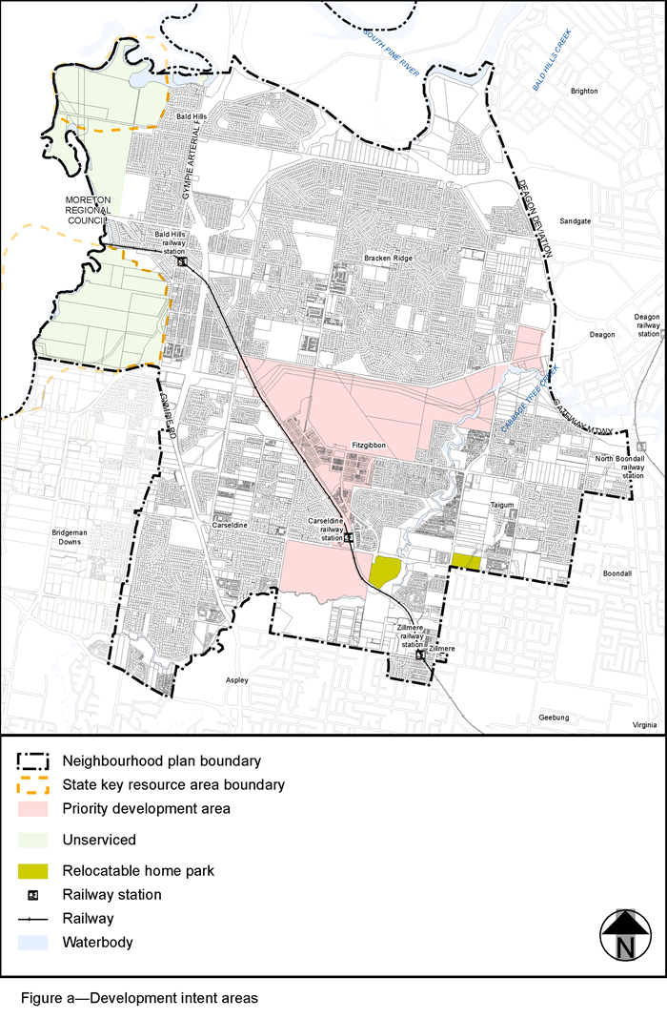
View the high resolution of Figure a—Development intent areas
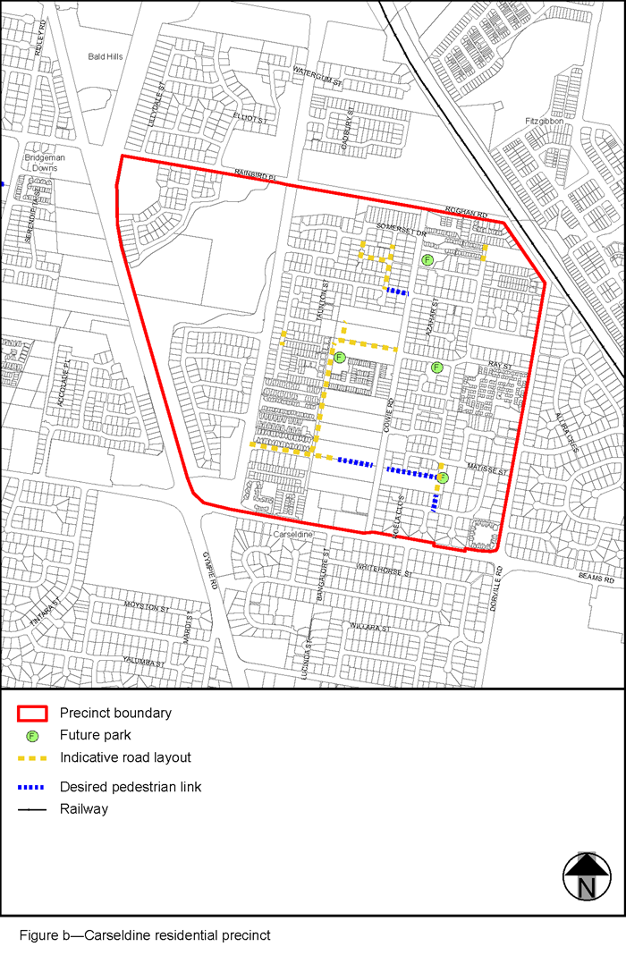
View the high resolution of Figure b—Carseldine residential precinct
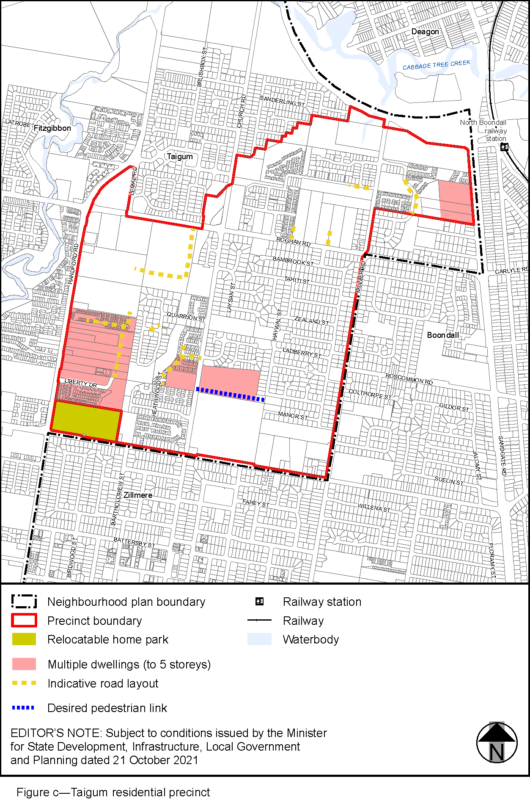
View the high resolution of Figure c—Taigum residential precinct
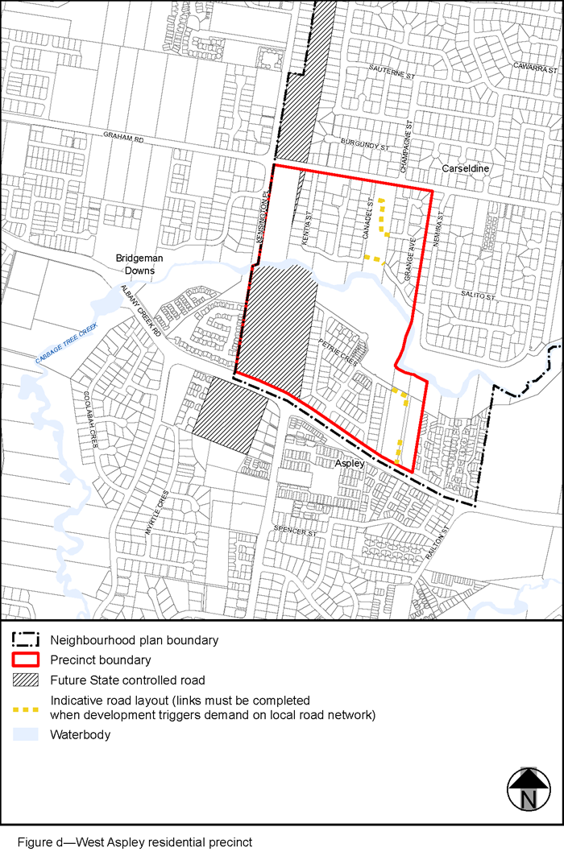
View the high resolution of Figure d—West Aspley residential precinct
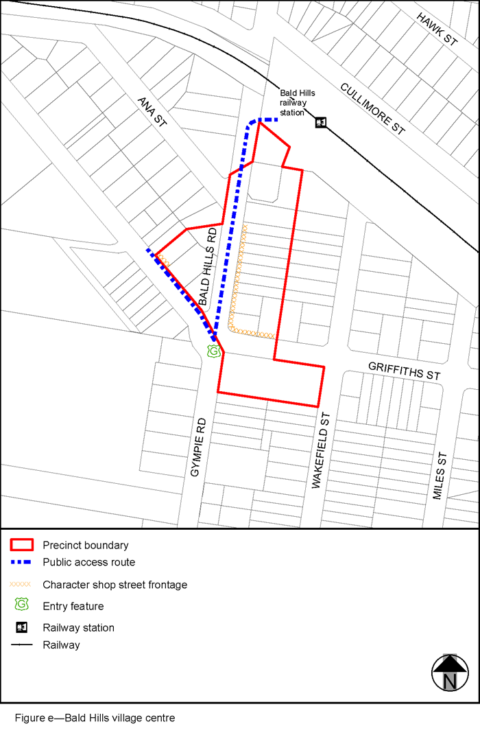
View the high resolution of Figure e—Bald Hills village centre
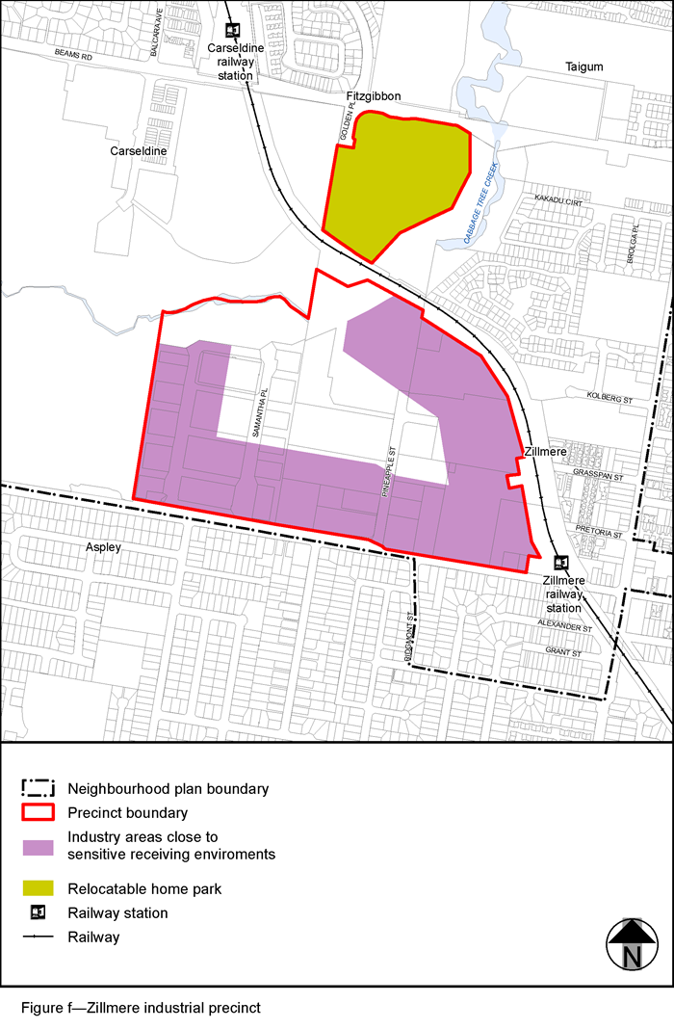
View the high resolution of Figure f—Zillmere industrial precinct
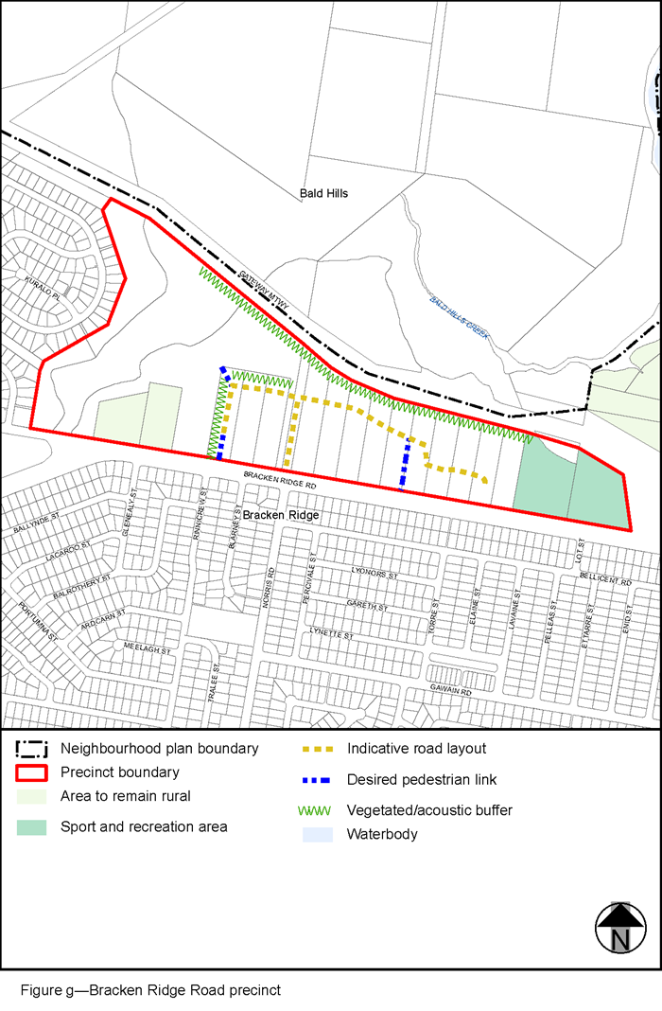
View the high resolution of Figure g—Bracken Ridge Road precinct
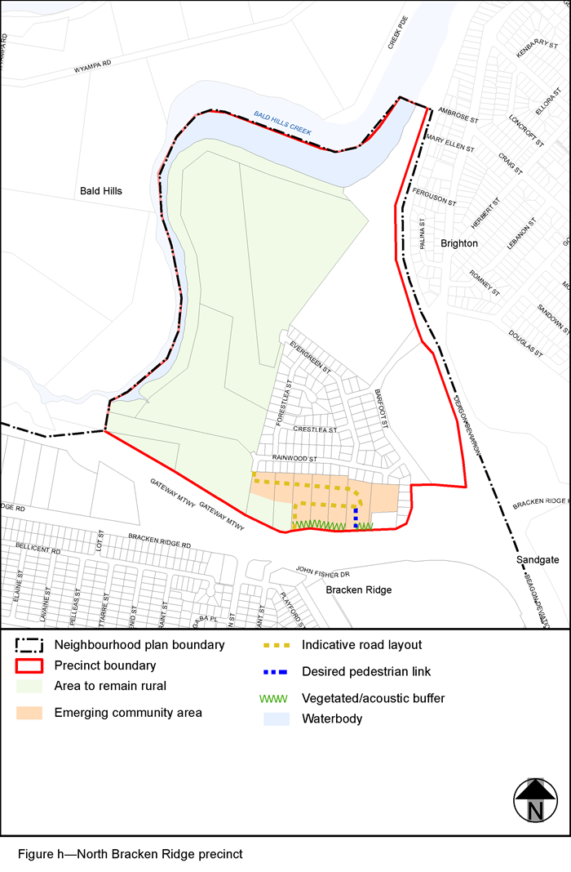
View the high resolution of Figure h—North Bracken Ridge precinct
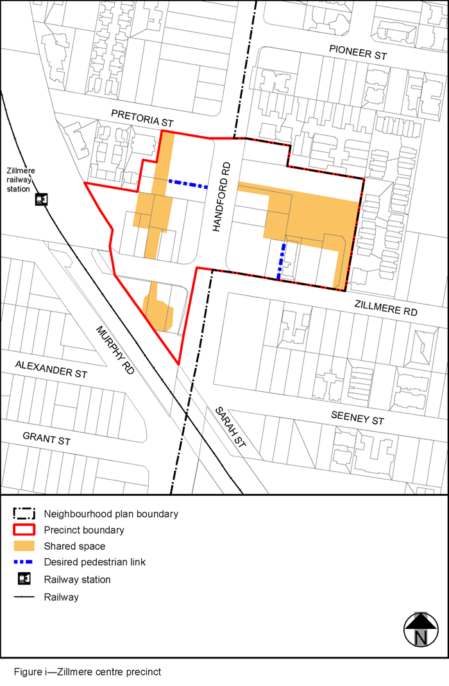
View the high resolution of Figure i—Zillmere centre precinct
Note—Locations identified for multiple dwellings in Figure d applies only to land in the Emerging community zone. Multiple dwellings are not accommodated in the Low density residential zone.

- Section 7.2 Neighbourhood plans, 7.2.2.5. Bridgeman Downs neighbourhood plan code–
insert:
‘

7.2.2.5 Bridgeman Downs neighbourhood plan code
7.2.2.5 Bridgeman Downs neighbourhood plan code
7.2.2.5.1 Application
- This code applies to assessing a material change of use, reconfiguring a lot, operational work or building work in the Bridgeman Downs neighbourhood plan area if:
  - assessable development where this code is an applicable code identified in the assessment benchmarks column of a table of assessment for a neighbourhood plan (section 5.9); or
  - impact assessable development.
- Land in the Bridgeman Downs neighbourhood plan area is identified on the NPM-002.5 Bridgeman Downs neighbourhood plan map and includes the following precincts:
  - Bridgeman Downs residential precinct (Bridgeman Downs neighbourhood plan/NPP-001);
  - Roghan Road south precinct (Bridgeman Downs neighbourhood plan/NPP-002);
  - Beckett Road precinct (Bridgeman Downs neighbourhood plan/NPP-003):
    - Residential living sub-precinct (Bridgeman Downs neighbourhood plan/NPP-003a);
    - Environmental living sub-precinct (Bridgeman Downs neighbourhood plan/NPP-003b);
  - Albany Creek precinct (Bridgeman Downs neighbourhood plan/NPP-004).
- When using this code, reference should be made to section 1.5, section 5.3.2 and section 5.3.3.
Note—The following purpose, overall outcomes, performance outcomes and acceptable outcomes comprise the assessment benchmarks of this code.

- Note—This neighbourhood plan includes a table of assessment with variations to categories of development and assessment. Refer to Table 5.9.83.A, Table 5.9.83.B, Table 5.9.83.C and Table 5.9.83.D.

7.2.2.5.2 Purpose
- The purpose of the Bridgeman Downs neighbourhood plan code is to provide finer grained planning at a local level for the Bridgeman Downs neighbourhood plan area.
- The purpose of the Bridgeman Downs neighbourhood plan code will be achieved through overall outcomes including overall outcomes for each precinct of the neighbourhood plan area.
- The overall outcomes for the neighbourhood plan area are:
  - Development is characterised by low density housing on acreage and suburban lots that contribute to the neighbourhood character of well separated houses in a bushland setting.
  - Multiple dwellings are not accommodated in the Low density residential zone, including where in a precinct or a potential development area.
  - Non-residential uses (except for a community use) are not accommodated in the Emerging community zone or Environmental management zone, including where in a precinct or a potential development area.
  - Development is of a height, bulk, scale, form and density which is consistent with the amenity and character, community expectations and infrastructure assumptions intended for the relevant precinct and site.
  - Development reinforces a distinctive subtropical character by ensuring that building design, spacing and orientation are responsive to the city’s climate.
  - Development in a potential development area identified in Figure a achieves an integrated development outcome by responding to the availability of infrastructure and services, environmental constraints, industrial hazards, amenity and existing patterns of development.
  - Land subject to ecological or waterway values as specified in an overlay map or Figure a, or significant vegetation, is protected from inappropriate development in order to maintain its natural and ecological significance.
  - Development protects and enhances ecological features, including biodiversity, native habitat and safe fauna movement along all tributaries of Albany Creek, Cabbage Tree Creek and South Pine River, and the east-west ecological corridors between Cabbage Tree Creek and Albany Creek, in the area south of Albany Creek Road.
  - Development minimises impacts to existing hydrology, creek geomorphology and provides stormwater quantity and quality management to protect and enhance waterway health.
  - Development is carried out in an orderly sequence, consistent with the availability of infrastructure and services. Development that brings forward a requirement for new infrastructure only occurs if that infrastructure is provided as part of a development.
  - Open space, parks and community facilities meet the needs of the community and are located in safe and accessible locations that are well connected.
  - Development provides for road, pedestrian and cycle networks that achieve integrated safe and legible connections between residential areas and key destinations including centres, community facilities, parks and open space and public transport.
  - Development in the Bridgeman Downs residential precinct (NPP-001), Roghan Road south precinct (NPP-002), Albany Creek precinct (NPP-004) or Cemetery zone precinct of the Community facility zone ensures that sensitive uses are not impacted by industrial activities (including air, odour and noise impacts) in the adjoining local government area or crematorium uses.
  - Development in the Bridgeman Downs residential precinct (NPP-001) or Albany Creek precinct (NPP-004) mitigates the visual impact of the existing high voltage powerlines through building orientation and use of vegetated buffers or screening.
- Bridgeman Downs residential precinct (Bridgeman Downs neighbourhood plan/NPP-001) overall outcomes are:
  - Development provides low density residential uses on suburban lots which facilitates well separated houses and vegetated backyards and protects and enhances ecological, waterway and landscape values.
  - Development for low density residential uses is limited to potential development areas identified in Figure a and has a minimum lot size of 500m² and 700m² for a rear lot.
Note—Development for residential uses with lots smaller than the lot size stated for the Bridgeman Downs residential precinct (Bridgeman Downs neighbourhood plan/NPP-001) is not supported.
  - A single, consolidated and centrally located new neighbourhood centre is provided in the area north of Graham Road and south of Roghan Road to serve the local retail, commercial and community needs of existing and future residents, subject to demonstrating an economic and community need.
  - Development provides for the continued function of the north-south ecological corridor across Roghan Road.
- Roghan Road south precinct (Bridgeman Downs neighbourhood plan/NPP-002) overall outcomes are:
  - Development provides low density residential uses on large suburban lots which protect and enhance ecological, waterway and landscape values.
  - Development for low density residential uses is limited to potential development areas identified in Figure a and has a minimum lot size of 700m² and average lot size of 1000m².
Note—Development for residential uses with lots smaller than the lot size stated for the Roghan Road south precinct (Bridgeman Downs neighbourhood plan/NPP-002) is not supported.
- Beckett Road precinct (Bridgeman Downs neighbourhood plan/NPP-003) overall outcomes are:
  - Development provides for the continued function of the east-west ecological corridor between Cabbage Tree Creek and Albany Creek, in the area south of Albany Creek Road.
  - Residential living sub-precinct (Bridgeman Downs neighbourhood plan/NPP-003a) overall outcomes are:
    - Development provides low density residential uses on suburban lots which facilitates well separated houses and vegetated backyards, protects and enhances ecological, waterway and landscape values.
    - Development for low density residential uses is limited to potential development areas identified in Figure a and has a minimum lot size of 400m² and 600m² for a rear lot.
Note—Development for residential uses with lots smaller than the lot size stated for the Residential living sub-precinct (Bridgeman Downs neighbourhood plan/NPP-003a) is not supported.
  - Environmental living sub-precinct (Bridgeman Downs neighbourhood plan/NPP-003b) overall outcome is:
    - Development maintains dwelling houses on large acreage lots to minimise impact on and disturbance of ecological features, waterway corridors and preserve landscape values.
- Albany Creek precinct (Bridgeman Downs neighbourhood plan/NPP-004) overall outcomes are:
  - Development maintains dwelling houses on large acreage lots to preserve character and landscape amenity and minimise impact on and disturbance of ecological features and waterway corridors. Land in this precinct is not intended to be developed for urban purposes (other than those uses permitted in the Rural zone).
  - Development provides for the continued function of the north-south ecological corridor located at the southern end of Albany Creek Road.
Note—A minimum lot size of 10ha applies to reconfiguration of a lot for lands in the Rural zone as specified in Table 9.4.10.3.B of the Subdivision code.

7.2.2.5.3 Performance outcomes and acceptable outcomes
Table 7.2.2.5.3.A – Performance outcomes and acceptable outcomes

Performance outcomes | Acceptable outcomes
PO1  Development is of a height, bulk, scale, form and density that achieves the intended suburban living outcome, improves the amenity of the neighbourhood plan area, contributes to a cohesive streetscape and subtropical built form character and is:  - consistent with the anticipated density and assumed infrastructure demand;  - consistent with the intended form and character of the area and aligned to community expectations about the building height and lot size;  - designed to avoid an adverse amenity impact to adjoining development;  - sited to enable existing and future buildings to be well separated from each other and to not prejudice the development of an adjoining site;  - designed to ensure sufficient space between buildings for trees and landscaping, including the retention of significant vegetation.  Note—Development that exceeds the intended number of storeys or building height can place disproportionate pressure on the transport network, public parks or land for community facilities network in particular.  Note—Development that exceeds the intended density of dwellings per hectare stated in this neighbourhood plan is not supported.  Note—Significant vegetation is identified and classified within the Vegetation planning scheme policy. | AO1.1  Development does not exceed a maximum building height of two storeys and 9.5 metres.  Note—Neighbourhood plans will mostly specify a maximum number of storeys where zone outcomes have been varied in relation to building height. Some neighbourhood plans may also specify height in metres. Development must comply with both parameters where maximum number of storeys and height in metres are specified.
AO1.2
Development complies with the lot size (minimum and average) and maximum density set out in Table 7.2.2.5.3.B.

Note—Development must comply with all parameters in Table 7.2.2.5.3.B.
AO1.3
Development incorporates the following subtropical design principles:

- suitable lot orientation;
- building form that maximises amenity, street activity and pedestrian connectivity;
- deep planting within setbacks along common boundaries and frontages.
PO2  Development siting and layout:  - locates buildings and structures outside areas of ecological or waterway value;  - minimises disturbance to and enhances ecological features, waterway values and visual amenity;  - either:  - retains significant vegetation; or  - compensatory planting is established to restore habitat and provide a subtropical landscape setting.  Note—This can be demonstrated by undertaking an ecological assessment and tree survey plan. Guidance is provided within the Biodiversity areas planning scheme policy, Planting species planning scheme policy and Vegetation planning scheme policy.  Note—Significant vegetation is identified and classified within the Vegetation planning scheme policy. | AO2.1  Development ensures that the development footprint is not located in areas with waterway and ecological features shown on Figure a.
AO2.2
Lot layout is designed to retain and incorporate significant vegetation.
Refer to Figure c.
AO2.3
Landscaping uses locally occurring native species.
Note—For suitable plant species, refer to the Planting species planning scheme policy.
AO2.4
Development is designed and sited to avoid waterway fragmentation and ensures that:
- no additional boundaries cross waterway corridors;
- the waterway corridors are retained within a single lot.
Refer to Figure c.
PO3  Development provides a transport network that:  - facilitates a clear, legible and logical road hierarchy;  - ensures the safety, efficiency and function of the road hierarchy;  - supports the provision of emergency service access;  - caters for and integrates pedestrian and cyclists facilities;  - includes road reserves of sufficient width to maximise space for on-street car parking, pedestrian paths, on-street cycling, and street tree planting;  - protects ecological features and waterway corridors;  - minimises impact from natural hazards. | AO3.1  Development provides a safe and integrated local road network as indicated in Figure b, and:  - includes future road connections to the surrounding road network in particular to existing local and major roads;  - is capable of carrying emergency service vehicles;  - limits the number of individual vehicle access points to Bridgeman Road, Beams Road and Beckett Road;  - only includes cul-de-sac or no through road designs when no other alternative is available.  Note—While the road layout may include no through roads such as a cul-de-sac in limited circumstances, the pedestrian and bicycle network may not.  Note—Pedestrian and bicycle networks should be designed in conjunction with the design of the road network and lot layout.
AO3.2
Development provides roads that prioritise pedestrians and cyclists within a low-speed traffic environment and that accommodate:
- pedestrian footpaths;
- on-street cycling;
- on-street car parking;
- generous street tree planting.
AO3.3
Development ensures that roads are not located in areas with waterway and ecological features as shown on Figure a.
AO3.4
Development provides a local road network that contributes to bushfire hazard mitigation.
PO4  Development provides stormwater management infrastructure that is:  - integrated with Council owned urban infrastructure; or  - located on common property for community title development; or  - located in a public park only where the utility, amenity or function of the public park is not reduced. | AO4  Development includes stormwater management infrastructure that is:  - provided in common property for the community title development; or  - located in new road, drainage reserves or other Council owned land in accordance with the standards in the Infrastructure design planning scheme policy and Brisbane Standard Drawings; or  - located in public parkland only where:  - the park comprises an area of at least 1 hectare;  - it does not occupy more than 5% of the total land surface;  - it does not reduce the range of quality of recreational opportunities available in the park according to the intended function and desired standards of service for the park type;  - it incorporates landscaping consistent with the character of a public park;  - it is sited to be easily accessible for maintenance purposes;  - design elements support the surrounding local aesthetic, public amenity and safety so that the quality of passive recreation is not reduced.
PO5  Development is sited and designed to promote activation and support increased safety through surveillance of existing and future parks and community facilities.  Note—The Local Government Infrastructure Plan or Long term infrastructure plans identify public parks and land for community facilities. | AO5  Development, where adjoining an existing or future park or community facility is oriented to overlook the park or community facility with large windows, balconies or courtyards designed to provide casual surveillance opportunities.
PO6  Development protects and maintains the waterway health and stability of existing waterways and the water quality of stormwater discharges to Albany Creek and other receiving waterways. | AO6.1  Development retains and rehabilitates existing dams and waterbodies where within waterway corridors and undertakes remedial works as required to ensure their stability to flood flows.  Note—Designs are to be in accordance with the standards in the Infrastructure design planning scheme policy.
AO6.2
Development reinstates or rehabilitates natural riparian and aquatic vegetation to improve waterway health.
Development for material change of use or reconfiguring a lot for:
- sites greater than 2,500m²; or
- six or more lots/dwellings.
PO7  Development occurs in an efficient and orderly manner and provides for an integrated, safe and functional community which addresses site context and setting by responding to:  - ecological and waterway features:  - protecting and enhancing significant vegetation and ecological features;  - protecting soil stability;  - preserving waterway topography;  - ensuring appropriate stormwater and water quality management regimes (refer to Figure d);  - natural hazards:  - identifying and mitigating existing and potential future bushfire and flood hazards;  - density and scale:  - ensuring maximum densities are not exceeded;  - ensuring minimum and average lot sizes are not exceeded;  - infrastructure and services:  - providing or extending appropriate infrastructure or services.  Note—A structure plan prepared in accordance with the Structure planning planning scheme policy can assist in demonstrating achievement of this outcome and is a useful tool to integrate development layout with all relevant spatial attributes as addressed in overlays and neighbourhood plans.  Note—The priority infrastructure area identifies the area prioritised for the provision of trunk infrastructure to service the existing and assumed future urban development.  Note—Significant vegetation is identified and classified within the Vegetation planning scheme policy.  Note—Minimum and average lot sizes, and maximum density are specified in Table 7.2.2.5.3.B. | AO7  Development is consistent with a structure plan, prepared in accordance with the Structure planning planning scheme policy.
Development for Centre activities
PO8  Development provides a single, consolidated and centrally located neighbourhood centre located north of Graham Road and south of Roghan Road within the Bridgeman Downs residential precinct (NPP-001) that:  - is of a scale which is consistent with surrounding detached housing and reflects the low density scale of this precinct;  - offers small-scale, low impact local convenience services;  - does not compromise the commercial, retail or community service role and function of nearby centre activities;  - manages the impact on the amenity and character of adjacent residential use;  - demonstrates a community and economic need;  - does not compromise the safe function and operation of the local road network.  Note—This can be demonstrated in a transport impact assessment report prepared and certified by a Registered Professional Engineer Queensland in accordance with the Transport, access, parking and servicing planning scheme policy and Infrastructure design planning scheme policy (Traffic impact assessment and definitions section). | AO8.1  Development provides a single, consolidated and centrally located neighbourhood centre that does not exceed a gross floor area of 1,500m².  Note—Council will request the submission of an economic analysis for any application that proposes a gross floor area in excess of this amount.
AO8.2
Development:

- only provides for the local convenience needs of the local resident population;
- demonstrates both a community and economic need.
Note—Council will request the submission of an economic analysis to demonstrate economic need.
AO8.3
Development:

- is located within the Bridgeman Downs residential precinct (NPP-001);
- has frontage to a major road;
- provides vehicle access from a suburban road, a district road or neighbourhood road.
AO8.4
Development is located more than 400m from existing or approved centre activities.

If in the Bridgeman Downs residential precinct (Bridgeman Downs neighbourhood plan/NPP-001), Roghan Road south precinct (Bridgeman Downs neighbourhood plan/NPP-002), Albany Creek precinct (Bridgeman Downs neighbourhood plan/NPP-004) or Cemetery zone precinct of the Community Facility zone
PO9  Development provides separation distances between potentially incompatible land uses that:  - protects the amenity of sensitive uses from odour or noise disturbance and impacts from air quality;  - avoids prejudicing the continuation of lawfully established industrial activities or crematorium uses.  Note–An air quality impact report prepared in accordance with the Air quality planning scheme policy can assist in demonstrating achievement of this performance outcome.  Note—A noise impact assessment report prepared in accordance with the Noise impact assessment planning scheme policy can assist in demonstrating achievement of this performance outcome. | AO9.1  Development does not locate a sensitive use within 500m of an existing or approved industrial activity.  Note—This distance is to be measured between the property boundary of the industrial activity to the property boundary of the sensitive use.
AO9.2
Development does not locate a sensitive use within 50m of a crematorium stack.

Note—This distance is to be measured between the property boundary of the industrial activity to the property boundary of the sensitive use.

Table 7.2.2.5.3.B—Lot criteria
 | Maximum density | Minimum lot size | Average lot size
Bridgeman Downs residential precinct (Bridgeman Downs neighbourhood plan/NPP-001) | 18 dwellings per hectare | 500m² and 700m² for a rear lot | N/A
Roghan Road south precinct (Bridgeman Downs neighbourhood plan/NPP-002) | 12 dwellings per hectare | 700m² | 1000m²
Residential living sub-precinct (Bridgeman Downs neighbourhood plan/NPP-003a) | 20 dwellings per hectare | 400m² and 600m² for a rear lot | N/A

Note—Minimum lot size is calculated:
- including the land area of an easement in favour of Council or truncation to be dedicated as road at the time the lot is created, provided the minimum rectangle dimension is accommodated within the balance area of the lot.
- excluding the access way to a rear lot or the area of any easement that also serves as an access way.

Note—Residential development densities and yields are to be calculated including all access ways and roads but excluding parts of the site that are not within a potential development area. Additional exclusions include, but are not limited to, constraints identified in overlay maps and precinct figures.

Note—Development with lots smaller than the lot size stated in this neighbourhood plan is not supported.

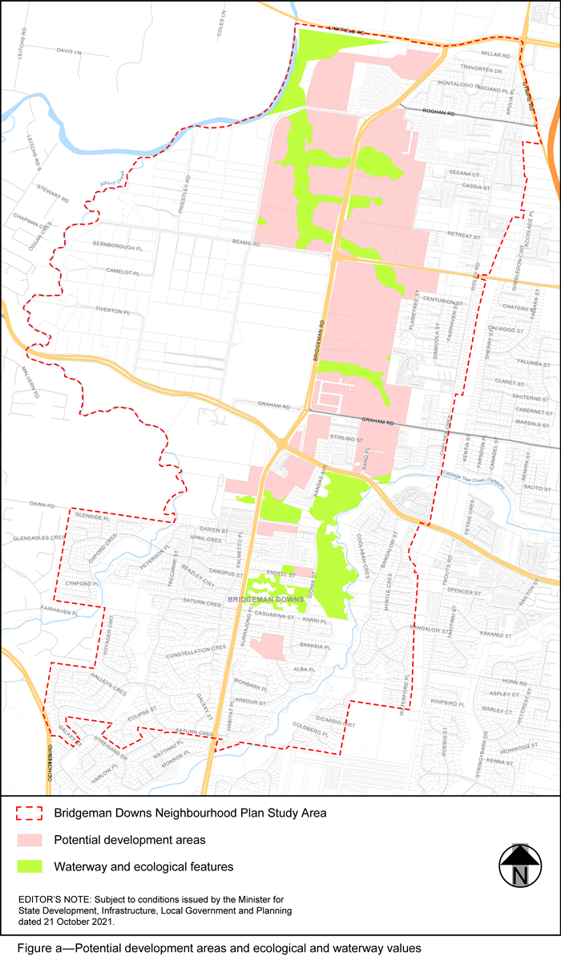
View the high resolution of Figure a—Potential development areas and ecological and waterway values
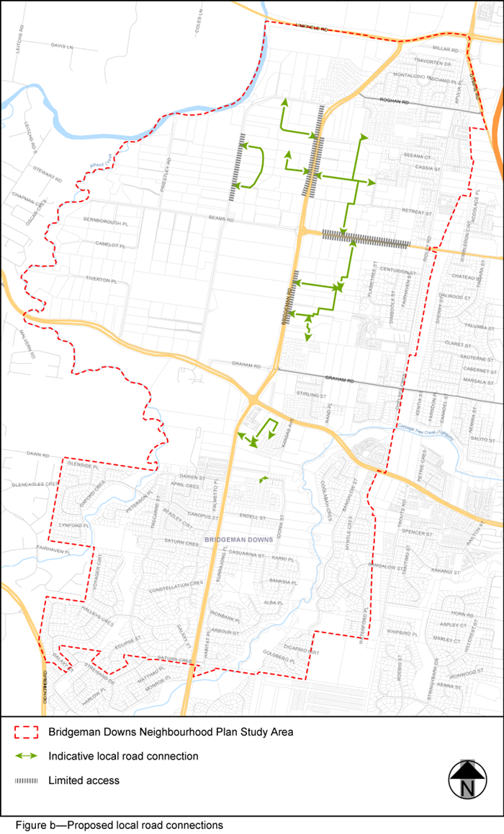
View the high resolution of Figure b—Proposed local road connections
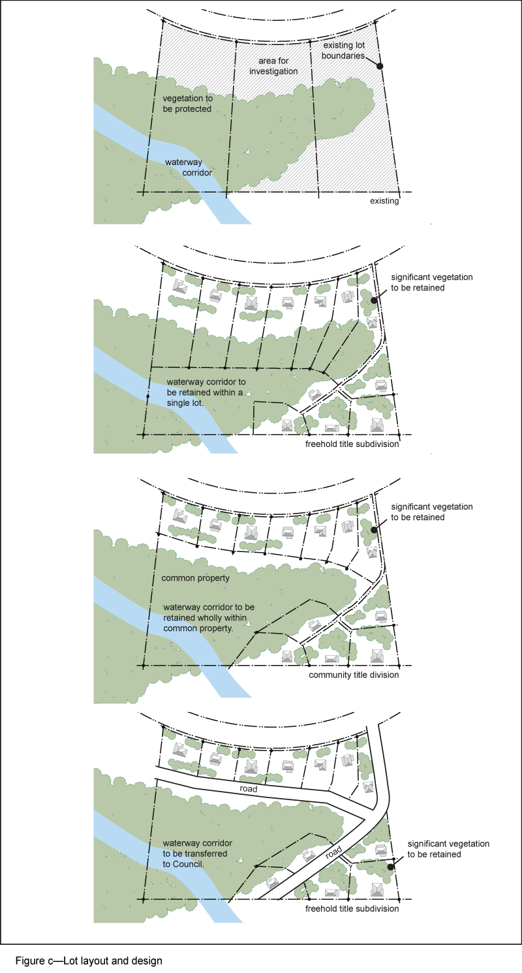
View the high resolution of Figure c—Lot layout and design
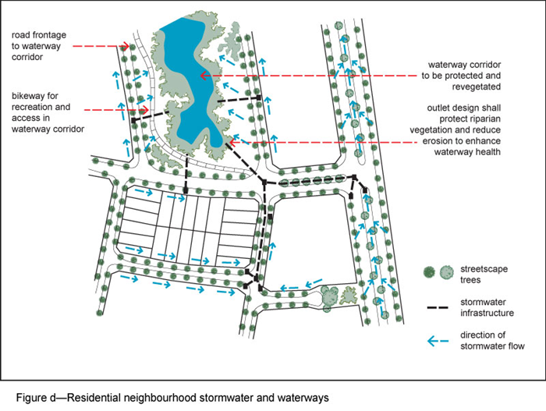
View the high resolution of Figure d—Residential neighbourhood stormwater and waterways
’

- Section 7.2 Neighbourhood plans, 7.2.13.1. McDowall-Bridgeman Downs neighbourhood plan code–
omit, insert:
‘

7.2.13.1 McDowall neighbourhood plan code
7.2.13.1.1 Application
- This code applies to assessing a material change of use, reconfiguring a lot, operational work or building work in the McDowall neighbourhood plan area if:
  - assessable development where this code is an applicable code identified in the assessment benchmarks column of a table of assessment for a neighbourhood plan (section 5.9); or
  - impact assessable development.
- Land in the McDowall neighbourhood plan area is identified on the NPM-013.1 McDowall neighbourhood plan map.
- When using this code, reference should be made to section 1.5, section 5.3.2 and section 5.3.3.
Note—The following purpose, overall outcomes, performance outcomes and acceptable outcomes comprise the assessment benchmarks of this code.
Note—This neighbourhood plan includes a table of assessment. Refer to Table 5.9.40.A, Table 5.9.40.B, Table 5.9.40.C and Table 5.9.40.D.
7.2.13.1.2 Purpose
- The purpose of the McDowall neighbourhood plan code is to provide finer grained planning at a local level for the McDowall neighbourhood plan area.
- The purpose of the McDowall neighbourhood plan code will be achieved through overall outcomes.
- The overall outcomes for the neighbourhood plan area are:
  - Development creates functional and integrated communities.
  - Land subject to development constraints, character or environmental values specified in Figure a or shown on an overlay map is protected from inappropriate development in order to maintain its character, natural and ecological significance.
  - Open space, parks and recreational facilities meet the needs of the community and are located in accessible locations that are well connected within the neighbourhood plan area.
  - Residential development provides for a mix of housing types, styles and densities.
Note—Development in a potential development area specified in Figure a addresses the location of the land, availability of services, environmental constraints, amenity, and existing patterns of development to ensure an integrated development outcome.
Note—Densities and yields for residential development are to be calculated excluding parts of the site that are not within a potential development area. These include areas with development constraints or character or environmental values identified in overlay maps. Yields and maximum gross floor area for multiple dwellings and dual occupancy are to be calculated across the potential development area including all access ways and roads respectively.
  - Multiple dwellings are not accommodated in the Low density residential zone, including where in a potential development area.
  - Land in the Emerging community zone in a potential development area:
    - includes a mix of larger lot sizes, retains existing vegetation and minimises development in vegetated or other scenically important areas;
    - has a built form no greater than 2 storeys in height;
    - locates higher density development in the cleared parts of this area and comprises clusters of development surrounded by a high proportion of landscaping and open space.
  - Neighbourhood centres identified in the neighbourhood plan serve the retail, commercial, community and service needs of the local community. Centre activities do not expand outside the sites already included in a zone in the centre zones category.

7.2.13.1.3 Performance outcomes and acceptable outcomes

Table 7.2.13.1.3—Performance outcomes and acceptable outcomes
Performance outcomes | Acceptable outcomes
No performance outcomes are prescribed. | No acceptable outcomes are prescribed.
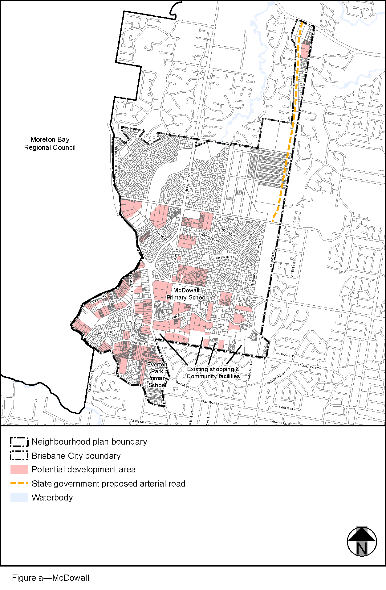
View the high resolution of Figure a—McDowall
’

Part 4 Amendment of Part 8 (Overlays)

4.1 Amendment to section 8.2.19 (Significant landscape tree overlay code)
- Section 8.2.19 Significant landscape tree overlay code, Table 8.2.19.3.C—Significant landscape trees in specific locations sub category –

Insert rows in ‘Bridgeman Downs’ section before 181 Graham Road:‘

Eucalyptus grandis Flooded gum |  |  | 459 Albany Creek Road (front eastern boundary) |  |  |  |  |  | L2 RP868571
Eucalyptus sp. Gum tree |  |  |  |  | 509 Albany Creek Road (rear north eastern corner) |  |  |  |  | L2 RP93242
Ficus macrophylla Moreton Bay fig |  |  |  |  | 515 Albany Creek Road (front east side) |  |  |  |  | L3 RP93242
Eucalyptus grandis Flooded gum |  |  | 543 Albany Creek Road (front boundary, centre) |  |  |  |  |  | L5 RP93242
2 x Eucalyptus tereticornis Forest red gum |  |  | 831 Beams Road (back garden) |  |  |  |  |  | L4 RP201956
Corymbia citriodora Lemon scented gum |  |  | 837 Beams Road (rear north eastern corner) |  |  |  |  |  | L1 RP201956
2 x Eucalyptus spp. Gum trees |  |  | 879 Beams Road (front entrance) |  |  |  |  |  | L3 SP227361
Corymbia citriodora Lemon scented gum | 888 Beams Road (front garden) |  |  |  |  |  | L2 RP219782
Eucalyptus major Grey gum | 1016 Beams Road (west side of block) |  |  |  |  |  | L6 RP853250
Eucalyptus tereticornis Forest red gum | 452 Beckett Road (front right of site) |  |  |  |  |  |  |  | L11 SP227442
2 x Eucalyptus tereticornis Forest red gum | 7 Booyong Place (rear of lot) |  |  |  |  |  |  |  | L4 SP205030
Eucalyptus tereticornis Forest red gum |  |  | 117 Bridgeman Road (front right) |  |  |  |  |  |  | L63 RP847648
Group of Eucalyptus tereticornis Forest red gum |  |  | 123 Bridgeman Road (front of site) |  |  |  |  |  |  | L1 RP29305
Ficus macrophylla (Moreton Bay fig) |  |  |  | 169 Bridgeman Road (front garden) |  |  |  |  |  |  | L1 RP219782
Corymbia henryi Large leaved spotted gum  3 x Eucalyptus tereticornis Forest red gum |  |  |  | 240 Bridgeman Road (centre and southern boundary) |  |  |  |  |  |  | L3 RP228201
Eucalyptus tereticornis Forest red gum |  |  | 14 Bronson Street (southern boundary, centre) |  |  |  |  |  | L5 RP806325
4 x Eucalyptus tereticornis Forest red gum |  |  | 110 Camelot Place (back boundary and front corner) |  |  |  |  |  | L9 RP896841
Group of Eucalyptus spp. Gum trees | 125 Camelot Place (rear of block) |  |  |  |  |  |  | L3 RP896842
4 x Eucalyptus tereticornis Forest red gum | 170 Camelot Place (front left) |  |  |  |  |  |  | L6 RP896842
3 x Eucalyptus and Corymbia sp. Gum trees |  |  | 22 Centurion Street (Flametree frontage) |  |  | L46 RP151158
2 x Eucalyptus microcorys Tallowwood |  |  | 12 Cotswold Place (south side of garden) |  |  | L1 RP896825
Corymbia intermedia Pink bloodwood |  |  | 1 Flametree Street (southern boundary) |  |  |  |  | L13 RP817243
Eucalyptus sp. Gum tree |  |  | 7 Flametree Street (northern boundary) |  |  |  |  | L0 GTP934
3 x Araucaria cunninghamii Hoop pine |  | 176 Graham Road (front right) |  |  |  |  |  | L40 SP281153
‘.
- Section 8.2.19 Significant landscape tree overlay code, Table 8.2.19.3.C—Significant landscape trees in specific locations sub category –

Insert rows in ‘Bridgeman Downs’ section after 181 Graham Road:
‘
Corymbia henryi Large leaved spotted gum |  |  | 188 Graham Road (centre middle) |  |  |  | L1 RP71365
Araucaria cunninghamii Hoop pine |  |  | 15 Hoop Pine Place (front garden) |  |  |  | L36 RP817255
Eucalyptus grandis Flooded gum | 8 Neville Road (Beams Road frontage) |  |  |  |  |  |  | L5 RP75707
Group of Eucalyptus tereticornis Forest red gum | 28 Retreat Street (mature Eucalypts front garden) |  |  |  |  |  |  | L3 RP46081
Eucalyptus tereticornis Forest red gum |  | 31 Retreat Street (left side garden) |  |  |  | L3 SP214868
Delonix regia Poinciana |  | 50 Retreat Street (front garden) |  |  |  | L2 RP178844
2 x Araucaria cunninghamii Hoop pine |  |  |  | 30 Ridley Road (north and west sides) |  |  | L1 RP172120
Ficus virens White fig |  |  |  | 2036 Roghan Road (front garden) |  |  | L3 SP227362
2 x Eucalyptus sp. Gum | 2108 Roghan Road (front of site) |  |  |  |  |  | L1 RP54766
Group of Eucalyptus tereticornis Forest red gum | 40 Tiverton Place (front of site) |  |  |  |  |  | L14 RP858993
Group of Araucaria spp. Bunya and Hoop pines |  |  |  |  | 60 Tiverton Place (front right corner of garden) |  |  |  | L12 RP858993
Group of Eucalyptus microcorys Tallowwood and Eucalyptus tereticornis Forest red gum |  |  |  |  | 95 Tiverton Place (southern boundary and northern portion of site) |  |  |  | L101/102 SP242194
’.

Part 5 Amendment of Schedule 2 (Mapping)

5.1 Amendment to SC2.2 (Zone maps)
- Schedule 2 Mapping, SC2.2 Zone maps, ZM-001 (Tiles 5 and 12)–
omit, insert:
SC2.2 Zone Maps, ZM-001 (Tiles 5 and 12)–refer to supplement 1a.

5.2 Amendment to Table SC2.2.1 (Zone maps)
- Schedule 2 Mapping, SC2.2 Zone maps, Table SC2.2.1—Zone Maps–
insert after Gazettal date, <<date>>:
‘
Not applicable | ZM-001 | Zoning map  Map tiles 5 and 12 | xx x xxxx
’–

5.3 Amendment to SC2.3 (Neighbourhood plan maps)
- Schedule 2 Mapping, SC2.3 Neighbourhood plan maps, NPM-002.3 Bracken Ridge and district neighbourhood plan map–
omit, insert:
NPM-002.3 Bracken Ridge and district neighbourhood plan map - refer to Supplement 1b.
- Schedule 2 Mapping, SC2.3 Neighbourhood plan maps, NPM-002.5 Bridgeman Downs neighbourhood plan map–
omit, insert:
NPM-002.5 Bridgeman Downs neighbourhood plan map - refer to Supplement 1b.
- Schedule 2 Mapping, SC2.3 Neighbourhood plan maps, NPM-013.1 McDowall-bridgeman Downs neighbourhood plan map–
omit, insert:
NPM-013.1 McDowall neighbourhood plan map - refer to Supplement 1b.

  - Amendment to Table SC2.3.1 (Neighbourhood plan maps)
- Schedule 2 Mapping, SC2.3 Neighbourhood plan maps, Table SC2.3.1—Neighbourhood plan maps–
insert after Gazettal date, <<date>>:
‘
Not applicable | NPM-002.3 | Bracken Ridge and district neighbourhood plan map | xx x xxxx

- Schedule 2 Mapping, SC2.3 Neighbourhood plan maps, Table SC2.3.1—Neighbourhood plan maps–
insert after Gazettal date, <<date>>:
‘
Not applicable | NPM-002.5 | Bridgeman Downs neighbourhood plan map | xx x xxxx
’
- Schedule 2 Mapping, SC2.3 Neighbourhood plan maps, Table SC2.3.1—Neighbourhood plan maps–
insert after Gazettal date, <<date>>:
‘
Not applicable | NPM-013.1 | McDowall neighbourhood plan map | xx x xxxx

  - Amendment of Schedule 2.4 (Overlay maps)

- Schedule 2 Mapping, SC2.4 Overlay maps, OM-004.1 Dwelling house character building overlay map (Tiles 5 and 12)–
omit, insert:
OM-004.1 Dwelling house character overlay map (Tiles 5 and 12)–refer to Supplement 1d.
- Schedule 2 Mapping, SC2.4 Overlay maps, OM-008.1 Heritage overlay map (Tile12) –
omit, insert:
OM-008.1 Heritage overlay map (Tile12)–refer to Supplement 1e.
- Schedule 2 Mapping, SC2.4 Overlay maps, OM-018.2 Road hierarchy overlay map (Tiles 5 and 12)–
omit, insert:
OM-018.2 Road hierarchy overlay map (Tile 5 and 12)–refer to Supplement 1f.
- Schedule 2 Mapping, SC2.4 Overlay maps, OM-019.1 Significant landscape tree overlay map (Tiles 5 and 12)–
omit, insert:
OM-019.1 Significant landscape tree overlay map (Tiles 5 and 12)–refer to Supplement 1g.
- Schedule 2 Mapping, SC2.4 Overlay maps, OM-019.2 Streetscape hierarchy overlay map (Tiles 5 and 12)–
omit, insert:
OM-019.2 Streetscape hierarchy overlay map (Tiles 5 and 12)–refer to Supplement 1h.
- Schedule 2 Mapping, SC2.4 Overlay maps, OM-023.2 Waterway corridors overlay map (Tiles 5 and 12)–
omit, insert:
OM-023.2 Waterway corridors overlay map (Tiles 5 and 12)–refer to Supplement 1i.

5.6 Amendment of Table SC2.4.1 (Overlay maps)
- Schedule 2 Mapping, SC2.4 Overlay maps, Table SC2.4.1—Overlay maps–
insert before OM-005.1 Extractive resources overlay map, 30 June 2014:
‘
OM-004.1 | Dwelling house character overlay map  Map tiles 5 and 12 | <<date>>
’.
- Schedule 2 Mapping, SC2.4 Overlay maps, Table SC2.4.1—Overlay maps–
insert before OM-009.1 Industrial amenity overlay map, 30 June 2014:
‘
OM-008.1 | Heritage overlay map  Map tile12 | <<date>>
’.
- Schedule 2 Mapping, SC2.4 Overlay maps, Table SC2.4.1—Overlay maps–
insert before OM-019.1 Significant landscape tree overlay map, 30 June 2014:
‘
OM-018.2 | Road hierarchy overlay map  Map tile 5 and 12 | <<date>>
’.
- Schedule 2 Mapping, SC2.4 Overlay maps, Table SC2.4.1—Overlay maps–
insert before OM-019.2 Streetscape hierarchy overlay map, 30 June 2014:
‘
OM-019.1 | Significant landscape tree overlay map  Map tiles 5 and 12 | <<date>>
’.
- Schedule 2 Mapping, SC2.4 Overlay maps, Table SC2.4.1—Overlay maps–
insert before OM-020.2 Transport air quality corridor overlay map, 30 June 2014:
‘
OM-019.2 | Streetscape hierarchy overlay map  Map tiles 5 and 12 | <<date>>
’.
- Schedule 2 Mapping, SC2.4 Overlay maps, Table SC2.4.1—Overlay maps–
insert before OM-023.3 Wetlands overlay map, 30 June 2014:
‘
OM-023.2 | Waterway corridors overlay map  Map tiles 5 and 12 | <<date>>
’.

Part 6 Amendment of Schedule 6 (Planning scheme policies)

6.1 Amendment to Schedule 6.29 Structure planning planning scheme policy
- Schedule 6 Planning scheme policies, SC6.29 Structure planning planning scheme policy, 1 Introduction, 1.1 Relationship to planning scheme–
insert after Banyo-Northgate neighbourhood plan code Table 7.2.2.1.3.A, AO13 note, All:
‘
Bridgeman Downs neighbourhood plan code
Table 7.2.2.5.3.A | PO7 note and AO7 | All
’.
- Schedule 6 Planning scheme policies, SC6.29 Structure planning planning scheme policy, 3 Preparing a planning scheme, 3.2 Step 1 – Site and context assessment–Table 3.2.1
insert after Bracken Ridge and district neighbourhood plan code Table 3.2.1:
‘
Neighbourhood plan area | Minor road connection description
Bridgeman Downs neighbourhood plan code | Local road connection between Kansas Avenue and Beckett Road  Local road connection between Purser Street and Idonia Street  Local road connection between Beams Road and Bridgeman Road  Local road connection between Retreat Street and Beckett Road  Local road connection between Roghan Road and Bridgeman Road  Neighbourhood road connection between Darien Street and Needham Place
’.
- Schedule 6 Planning scheme policies, SC6.29 Structure planning planning scheme policy, 3 Preparing a planning scheme, 3.2 Step 1 – Site and context assessment–Table 3.2.1
delete after Ferny Grove-Upper Kedron neighbourhood plan code Table 3.2.1:
‘
Neighbourhood plan area | Minor road connection description
McDowall-Bridgeman Downs neighbourhood plan code | Neighbourhood road connection between Wendon Way and Canopus Street  Neighbourhood road connection between Darien Street and Idonia Street  Neighbourhood road connection between Albany Creek Road and Darien Street/Idonia Street
’.

Part 7 Amendment of Appendix 2 (Table of amendments)

7.1 Amendment to Appendix 2 (Table of amendments)
- Appendix 2 Table of Amendments, Table AP2.1—Table of amendments–
insert after vxx.xx/20xx:
‘
<<date>> (adoption) and <<date>> (effective) | vxx.xx/20xx | Major | Major amendment to planning scheme (Chapter 2, Part 4 of MGR).  Major amendment to planning scheme policy (Schedule 1, Section 7 of MGR)  Refer to Amendment vxx.xx/202x for further detail.
’.

Supplement 1—A3 Map Tiles

