Paddington Terraces Village Precinct Project –

Paddington Terraces Kooka! Trail map

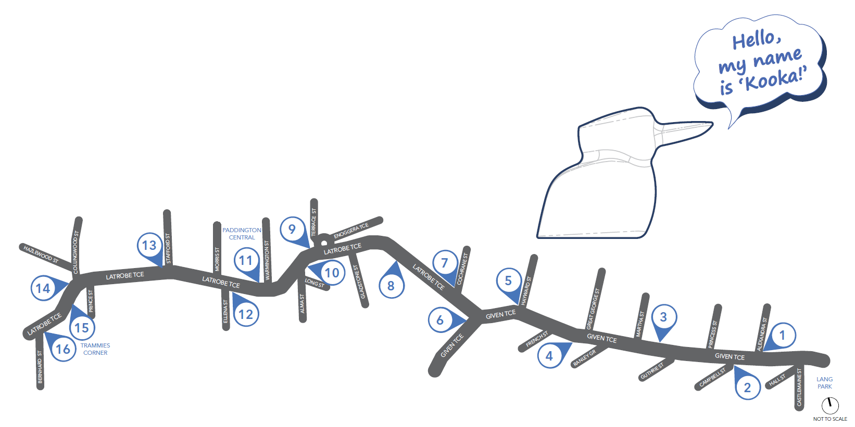

The Paddington Terraces Kooka! Trail will lead you on a creative placemaking trail along the Paddington terraces, celebrating their unique character and heritage, encouraging exploration and creating an inviting and distinctive centre.

Kooka! is an ode to the iconic native Australian kookaburra and its place within the Paddington neighbourhood. Its call spreads throughout the suburb, from a low hiccuping chuckle, then throwing its head back in playful raucous laughter, a friendly reminder that nature is all around us.

Trail artwork title, commissioning date and artist name includes:
- #1 Latrobe kookaburra (2022) Zoe Porter
- #2 Vista (2022) Rick Hayward
- #3 A very large bill (2022) Hailey Atkins
- #4 Bird of a feather (2022) Stephen Mok
- #5 Evening perfume (2022) Phoebe Paradise
- #6 Astronomical dusk (2022) Shilo Engelbrecht
- #7 A very large bill (2022) Hailey Atkins
- #8 Home (2022) Tori-Jay Mordey
- #9 Yellow trumpet tree (2022) Spectator Jonze
- #10 Meet the neighbours – wings of Paddington & A bugs life (2022) Ronelle Reid
- #11 Care & At night (2022) Tori-Jay Mordey
- #12 Paddington labyrinth (2022) Jade Thompson
- #13 Kooka! in the hood & Confetti Kooka! (2022) Debra Hood
- #14 Love the view from here (2022) Jordan Azcune
- #15 Well the plants will be happy (2022) Phoebe Paradise
- #16 Catholic immigrants (2022) Michelle Jae Andrews.

For more information visit brisbane.qld.gov.au and search ‘Village Precinct Projects’ or call Brisbane City Council on 3403 8888.

