Fact Sheet

Nudgee Recreation Reserve Improvement project Remediation Works

WHY IS THIS WORK HAPPENING?
The Reserve was a former landfill in the 1970s. The remediation standards applied back then were different to today’s standards.

In the past, this has resulted in the batters of the landfill having no cap and vegetation being planted directly into the waste pile.

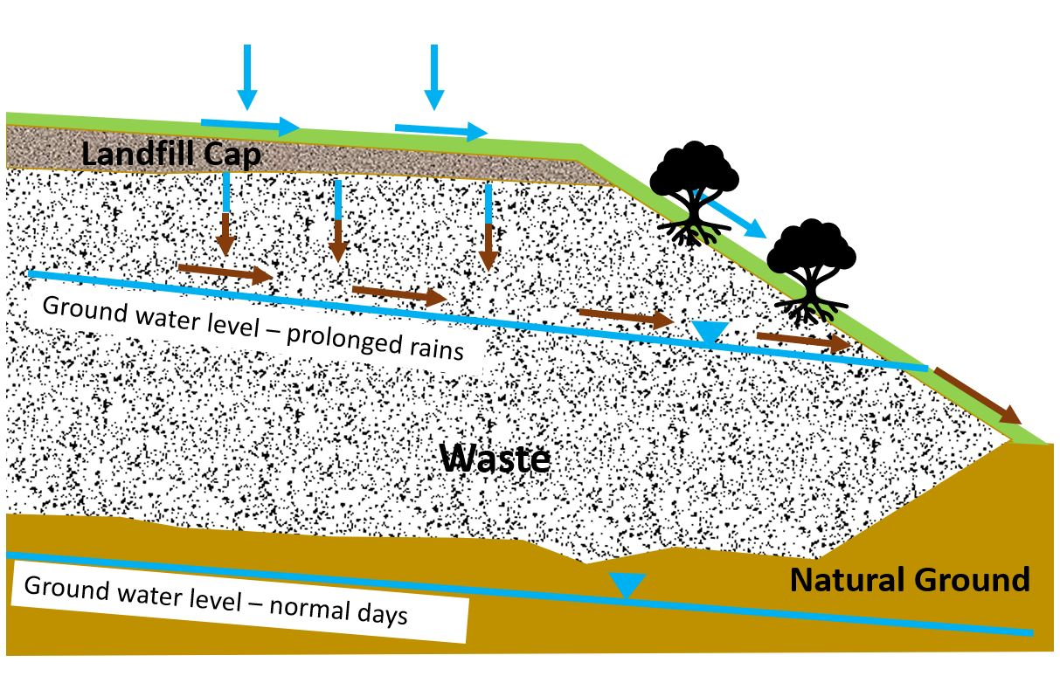
Leachate is the contaminated liquid that is created from water filtering through waste. Almost all old landfills do not have leachate containment systems.

Nudgee Recreation Reserve: Existing Condition

Leachate volume depends on:
- Rainfall intensity and duration
- Permeability of landfill cap

Leachate toxicity depends on:
- Age of landfill
- Waste composition
- Climate / temperature

Any leachate generated from the site has the potential to make its way directly into Nundah Creek.

WHAT DOES THIS WORK INCLUDE?
As part of the remediation works, Council will need to clear a significant amount of vegetation that borders the railway line, including trees and undergrowth.

This is required to allow full remediation and capping of the waste pile and landfill batters that extend into this vegetation. This cap will assist to provide a barrier to the waste and prevent further leachate generation within the landfill.

Where appropriate, planting of vegetation above the landfill cap will be incorporated as part of the works. This will generally be low scale shrubs so that roots do not re-enter into the capped waste pile.

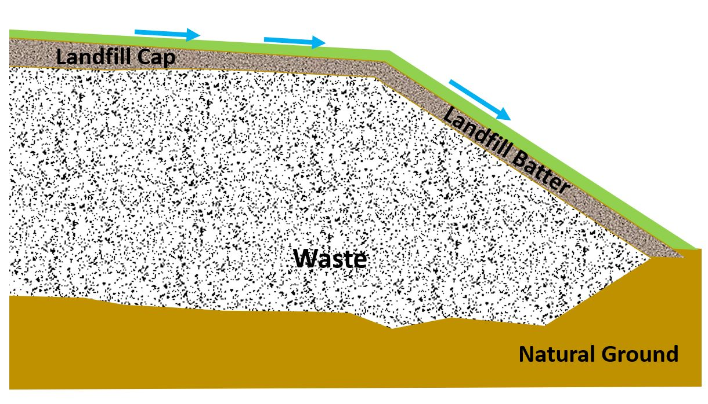

Nudgee Recreation Reserve: Planned Condition

Remediation works will improve environmental outcomes and health and safety for the general public.

FOR MORE INFORMATION
If you would like to read more about this project, please visit brisbane.qld.gov.au and search ‘Nudgee Recreation Reserve project’
For more information please contact us on:
Phone: 1800 884 681 (business hours)
After hours: 3403 8888

