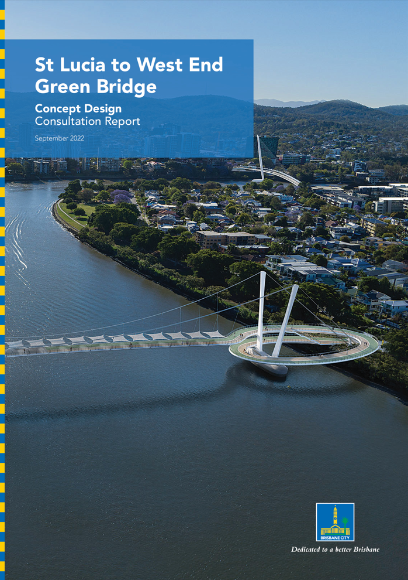
m

Contents
1. Executive Summary 2
2. Introduction 4
2.1 Purpose of this report 4
3. Background 5
3.1 About the Green Bridges Program (GBP) 5
3.2 About the St Lucia to West End Green Bridge 6
3.3 Key stakeholders 8
3.4 Previous engagement activities 9
4. Consultation approach 10
4.1 Purpose and objectives 10
4.2 Methods 10
4.3 Timeframes 11
5. Communication activities 12
5.1 Communication tools 12
5.2 Media and social media 15
5.3 Reach of communication activities 17
6. Stakeholder and community consultation activities 18
6.1 Summary of participation across all activities 18
6.2 Online feedback survey 18
6.3 Community information sessions 18
6.4 Pop-up events 19
6.5 Key stakeholder meetings and briefings 20
6.6 Formal submissions 20
6.7 Other correspondence 21
7. Summary of feedback 22
7.1 Analysis of key feedback themes 22
7.2 Stakeholder submissions 25
8. Online survey results 27
8.1 Overall support for the concept design 27
8.2 Overall design features 28
8.3 St Lucia landing 28
8.4 West End landing 29
8.5 Bridge usage 29
8.6 Survey respondent demographics 31
9. Conclusion 32
9.1 Next steps 33
Appendix A. Concept design project plan i
Appendix B. List of key stakeholders ii

Executive Summary
Brisbane City Council (Council) is building new green bridges to make it easier to get around the city on foot, by bike or scooter, and by connecting with public transport. The St Lucia to West End Green Bridge (SLWEGB) will make it easier to walk or ride between St Lucia, The University of Queensland (UQ), West End, Highgate Hill and the CBD. Together with the Toowong to West End Green Bridge (TWEGB), it will connect to the city’s green transport networks, enhancing the river loop riding and walking experiences.
From 15 November 2021 to 28 February 2022, Council undertook community consultation on the concept designs for both the SLWEGB and TWEGB. At this time, Council also released the key findings of the preliminary business cases for each project. The consultation period followed an initial consultation phase in late 2019, and further consultation on bridge alignment options from late 2020 to early 2021.
Residents, businesses and other key stakeholders were invited to provide their feedback on the concept design for the SLWEGB, which is based on the preferred alignment from the riverfront of Guyatt Park, St Lucia to Orleigh Park (near Morry Street), West End. Council hosted a range of activities that allowed residents to provide feedback on the concept design for the SLWEGB. This included:
- 10 information sessions at local venues in St Lucia, Toowong and West End, with a total of 776 attendees
- six pop-up visits at ferry terminals, train stations and bridges near the proposed landing locations, with a total of 359 flyers handed out to attendees
- an online survey hosted on Council’s website, with 440 responses on the SLWEGB received
- meetings with key stakeholders with an interest in the proposed projects.
In total, 595 pieces of feedback were received for the SLWEGB concept design, including via the online survey, email, phone, letter and at information sessions.
Following the consultation period, Council reviewed and summarised all feedback to determine overall support for the SLWEGB concept design, as well as key issues for consideration during the next phase of the project.
Overall, key feedback included:
- general support for the SLWEGB concept design, with 76% of online survey respondents completely or somewhat supportive of the proposed design
- mixed overall feedback on the SLWEGB, with some people questioning the need / demand for the project, particularly if the TWEGB is delivered
- mixed responses to the proposed dual mast suspension bridge form, with some positive feedback that it is attractive, modern and suited to the area, and some concerns it is obtrusive / unattractive and impacts on local amenity
- concerns around the durability and functionality of the proposed shade cover, as well as requests for additional shade cover on the bridge approach ramps
- some support for providing improved accessibility and connectivity for people of all ages and abilities between St Lucia and West End, and increasing walking and riding access to riverside parkland, UQ and public transport services
- some concerns from local residents about the design and location of the St Lucia landing at Guyatt Park, including impacts on riverfront open space, existing vegetation, existing park facilities and the safety of park users
- mixed feedback on the West End landing design, with some positive feedback that it minimises impacts on Orleigh Park, and some concerns the over-water circular ramp is out of scale with the surrounds
- interest in how bridge users will safely and easily connect with destinations in St Lucia and West End, and what upgrades to local roads / pathways may be required
- interest in potential construction timing and impacts, particularly from local residents and river users.
While planning for the SLWEGB and TWEGB was paused in 2022 to prioritise flood recovery activities across Brisbane, feedback on the concept designs will play a critical role in the future development of the projects, including final design treatments, ongoing connections to the city-wide walking and riding network, and management of impacts during construction.
Council will seek additional contributions from the Queensland and Australian governments to help Council deliver these critical projects. If funding is secured during the flood recovery effort, Council will consider progressing the detailed design and procurement process for the SLWEGB and TWEGB to ensure they can be delivered sooner than anticipated.
Council will keep the community informed about the new green bridges and will provide a further opportunity for feedback on the SLWEGB and TWEGB during future phases of project planning.

Introduction
Council is building new green bridges across Brisbane to make it even easier for residents and visitors to get around our city. The SLWEGB will make it easier to walk or ride between St Lucia, The University of Queensland (UQ), West End, Highgate Hill and the CBD.
Feedback from the community has played a critical role in the development of the SLWEGB to date. Council is committed to working with the community to deliver the SLWEGB to help shape our city’s future, making Brisbane an even better place to live, work and relax for generations to come.
Further to an initial consultation phase in late 2019, Council undertook consultation on a shortlist of alignment options for SLWEGB from late 2020 to early 2021. Following the outcomes of this consultation, and additional investigations undertaken to inform a preliminary business case, Council released a concept design for the SLWEGB for community feedback in November 2021, marking the next round of community consultation on the project.
At this time, Council also commenced consultation on a concept design for the TWEGB. A separate report has been prepared to outline the outcomes of consultation on the TWEGB. Where consultation activities or feedback received related to both projects, it has been included in this report.

Purpose of this report
This report has been prepared to outline the results of community and stakeholder consultation on the SLWEGB concept design from 15 November 2021 to 28 February 2022.
This report provides:
- background on the Green Bridges Program (GBP)
- overview of the SLWEGB and concept design
- the objectives, approach and timeframes of the consultation program
- a summary of the communication tools used throughout the consultation period, including media, social media, direct mail, digital communication and stakeholder notifications
- participation results from all consultation activities and feedback channels, including community information sessions, pop-up events, an online survey, briefings with key stakeholders and feedback received by phone, email and letter
- a summary of the key feedback themes for the SLWEGB concept design, based on a detailed analysis of all community feedback, results of the online survey and formal submissions received
- proposed next steps for the SLWEGB.

Background

About the Green Bridges Program (GBP)
Council is delivering more transport options and responding to our growing population, making it easier for residents and visitors to travel around our city now and into the future. Building and investing in Brisbane’s roads, bridges, footpaths, bike paths and e-mobility options is creating world-class public and active transport that will help residents navigate the city easily, and will leave a lasting legacy as we set our sights on the Brisbane 2032 Olympic and Paralympic Games.
Council’s new green bridges are a vital part of this plan, making it even easier for our residents and visitors to get around our city on foot, by bike or scooter, or by connecting with public transport. The bridges will provide a new link from Kangaroo Point to the CBD, a new crossing at Breakfast Creek and new links from Toowong to West End and St Lucia to West End. A map showing the location of each green bridge is outlined in Figure 1.
The creation of new green bridges is a key initiative of Council’s Transport Plan for Brisbane – Implementation Plan 2018. Building green bridges also supports the implementation of Brisbane’s e-mobility strategy 2021, which focuses on opportunities to encourage greater use of e-bikes, e-scooters and other emerging, sustainable e-mobility travel options.
In June 2022, the GPB was included in Infrastructure Australia’s Infrastructure Priority List as an early-stage proposal, confirming the program is economically significant to the nation and recognising the role it will play in shaping our city for generations to come.
Council’s commitment of investing up to $550 million to deliver the GBP remains on track, with construction of both the Kangaroo Point and Breakfast Creek Green Bridges underway and expected to be complete by 2024.
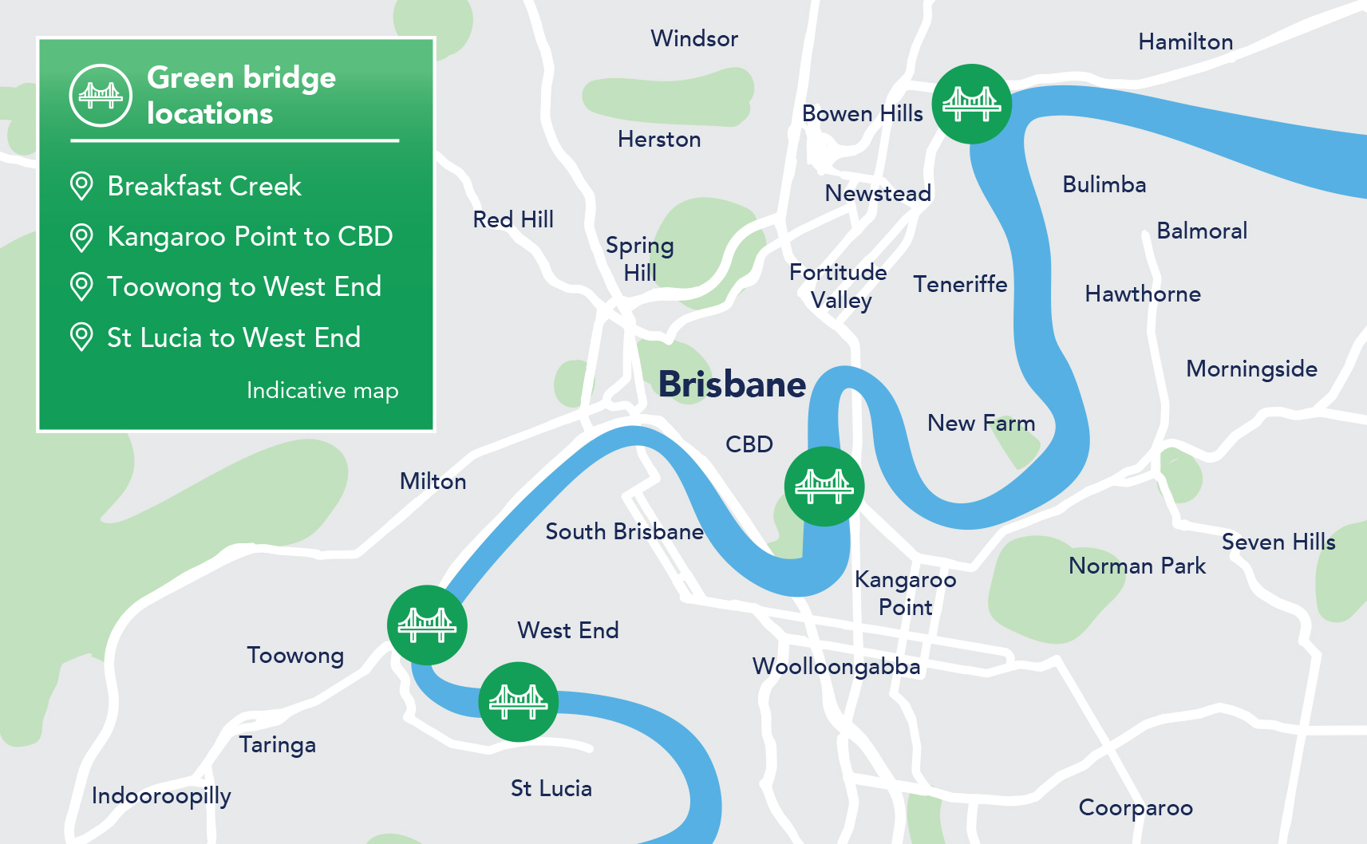
Figure 1 – Green bridge locations.

About the St Lucia to West End Green Bridge
The SLWEGB will make it easier to walk or ride between St Lucia, UQ, West End, Highgate Hill and the CBD.
The new green bridge will:
- improve green transport connections to St Lucia and UQ, particularly from the inner south, inner west and CBD
- deliver greater accessibility to public transport for St Lucia residents, including high-frequency bus services in West End travelling to the CBD and Fortitude Valley
- improves access to riverside parks and green spaces for residents and visitors.

Together with the proposed TWEGB, it will:
- create a more direct route between the Bicentennial Bikeway and the UQ St Lucia campus
- connect to the city’s existing green transport networks, enhancing the river loop walking and riding experiences.

Background
Community and stakeholder feedback has been critical to the development of the SLWEGB. Initial consultation and pre-feasibility investigations for the project were undertaken in late 2019 as part of the GBP early planning phase. Council completed a detailed analysis of all feedback received and prepared an Initial Consultation Outcomes report, which was released on Council’s website in March 2020.
Throughout 2020, Council completed further technical investigations and studies on potential alignments and landing locations for the SLWEGB. This included traffic and transport modelling, environmental studies, site investigations and initial cost estimates. Based on these studies, Council released a shortlist of alignment options for community feedback from November 2020 to March 2021.
Council reviewed and analysed all feedback received on the alignment options and prepared a consultation summary document and detailed consultation report, which were released in May 2021.
Overall feedback included:
- general positive support for the alignment from Guyatt Park, St Lucia to Orleigh Park (near Morry Street), West End
- requests for impacts to green space at landing locations to be minimised
- interest in more information being made available, including a business case, to outline the demand for the project and the benefits it will deliver.
Further detail is available in the SLWEGB Alignment Options Consultation Report and Summary, which can both be downloaded from Council’s website.

About the concept design
In November 2021, Council released a concept design for the SLWEGB for community feedback. The concept design is based on the preferred alignment from the riverfront of Guyatt Park, St Lucia to Orleigh Park (near Morry Street), West End. The design aims to provide an elegant structure that responds to its suburban setting and seamlessly integrates into the surrounding park and residential setting on both sides of the river.
Key features include:
- a ground anchored long-span suspension bridge with four gently inclined masts, with a total length of about 310m
- dedicated pathways for pedestrians and cyclists, with a minimum width of 6m and accessible grades
- a bridge clearance height of 11.4m, with provision for a 70m wide navigation channel
- ensures CityCats can continue to operate safely at the West End and Guyatt Park ferry terminals
- rest points with seating and viewing opportunities at each end of the bridge
- shade across the full width of the main bridge span
- an over-water circular ramp at the West End landing that minimises impacts on Orleigh Park
- a ramp and improved park space incorporated into the central riverfront section of Guyatt Park.
The concept design was prepared for the purposes of preparing a cost estimate and preliminary business case and seeking community feedback. The design is not final and will be subject to further development during future stages of project planning. A project plan showing the SLWEGB concept design is included in Appendix A.

About the preliminary business case
Based on the concept design, Council prepared a preliminary business case for the SLWEGB, which has been informed by a range of initial economic, transport and technical investigations that have assessed the costs, benefits and feasibility of the project.
The preliminary business case indicates the SLWEGB would provide a value for money investment for Brisbane ratepayers, delivering improved accessibility and green transport options which will result in reduced congestion, increased economic activity and health benefits. Key benefits include:
- boosts inner city movement and cross river access
- better connects existing green transport routes, including the Bicentennial Bikeway to UQ, and creates new strategic corridors in the inner city
- reduces reliance on private vehicle trips and decreases vehicle emissions
- supports growing e-mobility ridership
- supports a clean, green and sustainable city and healthy lifestyle.
Further detail is available in the SLWEGB Preliminary Business Case key findings, which can be downloaded from Council’s website.

Key stakeholders
The SLWEGB project area comprises the inner city suburbs of St Lucia, West End and Highgate Hill along with the St Lucia Reach of the Brisbane River. Prior to commencing engagement activities, Council completed an analysis of the key stakeholders who were potentially affected by, or with an interest in, the project.
Broadly, these groups include:
- Elected representatives: the local, state and federal elected representatives for the project area which includes:
  - Walter Taylor and The Gabba wards
  - State electorates of Maiwar and South Brisbane
  - Federal electorates of Ryan and Griffith
- Internal Council stakeholders: Council’s elected representatives, senior leaders, and areas of Council that may be impacted by the design, construction or operation of the SLWEGB
- Corridor stakeholders: this includes Aboriginal and Torres Strait Islander groups, residents and property owners adjacent to or near the preferred alignment, local businesses, road and path users, and utility and infrastructure providers
- River users: this includes community sailing / rowing groups, mooring users, cruise and ferry operators and boating associations
- Advocacy and interest groups: groups representing local community and business interests, active and public transport, and environmental issues
- Government departments and agencies: Queensland and Australian government departments, agencies and bodies
- Industry representatives: this includes professional associations and peak bodies.
A detailed list of key stakeholders is outlined in Appendix B.

Previous engagement activities
The table below outlines the previous communication and engagement activities undertaken for the SLWEGB. To date, activities have focused on introducing and raising high-level awareness of the overarching GBP and seeking feedback on proposed bridge alignments and landing locations for the SLWEGB.
Activity | Purpose | Timing
GBP announcement | Provided initial, high-level information about the GBP to Brisbane residents. Tactics included a page on Council’s website, a letter from the Lord Mayor to residents in selected suburbs, and a Living in Brisbane advertisement. | Late March – late May 2019
2019/20 Council budget announcement | Outlined Council’s funding commitment to the GBP through Council budget communication activities. Supporting collateral included TV, outdoor and digital advertising, as well as social media and a city-wide mail out. | Mid-June – late June 2019
Initial community consultation | First phase of community consultation on the GBP to introduce residents and stakeholders to the program, build excitement and interest, and seek initial feedback on each of the bridges to help inform further project planning. Council sought feedback on a proposed alignment for the SLWEGB extending from Guyatt Park at St Lucia to Orleigh Park, near Forbes Street at West End. Engagement activities included a DL flyer mailout, webpage updates, online survey, community information sessions, pop-ups and stakeholder briefings. | 11 November – Friday 6 December 2019
Release GBP Initial Consultation Outcomes report | Release of the GBP Initial Consultation Outcomes report which outlines key findings from the initial community consultation phase and next steps for each bridge project. Awareness was raised through a media announcement, webpage update, email to database and stakeholder notifications, Councillor briefing notes and Contact Centre update. At this time, it was announced that the SLWEGB and TWEGB would be progressed as pedestrian and cycling connections only. | Late March 2020
Consultation on alignment options | Community consultation on a shortlist of alignment options and landing locations for the SLWEGB, to help inform the selection of a preferred bridge alignment. Engagement activities included a project newsletter distributed to local residents, webpage updates, an online survey, community information sessions, pop-ups and stakeholder briefings. | 23 November 2020 –31 March 2021
Release outcomes from alignment options consultation | Release of SLWEGB and TWEGB consultation summaries and reports which outline key findings from the alignment options consultation phase and next steps for each project. Awareness was raised through a media announcement, webpage update, email to database and stakeholder notifications, Councillor briefing notes and Contact Centre update. At this time, the preferred bridge alignments for the SLWEGB and TWEGB were announced. | 25 May 2021
Table 1 - Previous engagement activities.

Consultation approach

Purpose and objectives
The purpose of the consultation program was to present the concept design and key findings of the preliminary business case for the SLWEGB and collect feedback from residents, businesses and other stakeholders to inform future stages of the project.
Council’s key objectives for this phase of consultation were to:
- outline the concept design based on the preferred alignment including potential bridge form, layout of landing locations and key design features
- seek detailed community feedback on the concept design to help finalise the bridge design and business case for the project
- release the key findings of the preliminary business case including patronage estimates, estimated cost range, transport / economic / city-shaping benefits, options analysis and project need
- further understand local community and stakeholder values, concerns and interests
- provide a variety of channels for residents and stakeholders to give feedback and ask questions
- build awareness of the SLWEGB project and its benefits.

Methods
A range of activities were undertaken across four key areas as part of the consultation program:
- Communication and media: a program of communication and media activities were designed to create awareness and communicate project information, benefits and timeframes amongst the broader community. Opportunities for the community to provide feedback were also promoted via these methods.
- Community consultation: a series of consultation activities provided the opportunity for the community to learn more about the project and give feedback on the proposed concept design.
- Stakeholder engagement: individual meetings and briefings were offered and / or held with a variety of key stakeholders including elected representatives, corridor stakeholders and community, business and advocacy groups.
- Feedback and reporting: a variety of opportunities and platforms were provided to ensure the community and stakeholders could provide their feedback. These platforms were widely promoted to maximise community involvement.
This process is outlined below in Figure 2.
Commence consultation period:
- Project newsletter distributed
- Updated website content
- 6 x pop-up events
- Social media and advertising
- Stakeholder notifications

Release SLWEGB concept design and preliminary business case key findings:
- Media announcement
- Release information about the SLWEGB concept design and preliminary business case
Receive feedback:
- Online survey
- 10 x community information sessions
- Meetings with key stakeholders
- 1800 project hotline
- Project inbox
- Formal correspondence

Consultation period concludes:
- Issue close-out communications
- Review and analyse all feedback and survey results
- Prepare consultation report

Figure 2 – Consultation process.

Timeframes
Community consultation on the concept design for the SLWEGB and the TWEGB was advertised as a 15-week period from Monday 15 November 2021 to 28 February 2022.
Formal submissions and feedback received in the period shortly after the consultation period closed have also been included in this report.
The following table outlines the key milestones in the consultation program.
Activity | Date
Consultation period commenced (online survey and updated webpages go-live, media and advertising commenced) | 15 November 2021
Project newsletter delivered to households in local project area and stakeholder notifications distributed | 15 – 19 November 2021
Email to GBP subscriber database distributed | 15 November 2021
Community information sessions (10) and pop-up events (6) held across the project area | 15 November 2021 – 16 February 2022
Reminder notifications to subscriber database and key stakeholders | 7 – 11 February 2022
Formal consultation period concluded (online survey closed) | 28 February 2022
Table 2 – Consultation program milestones (15 November 2021 – 28 February 2022).

Communication activities

Communication tools
This section outlines the communication activities undertaken to raise awareness of SLWEGB and the TWEGB consultation program and the opportunities for the community and stakeholders to provide feedback on the concept designs.

Print communications
The table below summarises the print communications distributed to local residents in the project area during the consultation period.
Activity | Description | Distribution channel/s
Project update newsletter November 2021 | An A4 8-page full colour newsletter was distributed between 15 November to 19 November 2021 in West End, St Lucia, Toowong, Auchenflower, Milton, Taringa, Highgate Hill and Dutton Park. The newsletter provided information about the SLWEGB and TWEGB including project background, benefits and timings, details of each concept design and how to provide feedback. | - 37,493 households and businesses  - Pop-up events and community information sessions  - Stakeholder briefings  - Council website  - The Gabba Ward and Walter Taylor Ward Offices
Preliminary business case key findings document | An A4 24-page full colour document was released that summarised the key findings of the investigations and assessments undertaken for the SLWEGB preliminary business case. The document included information about the concept design, including artist impressions and plans. | - Council website  - Community information sessions
Project flyer | A DL flyer was produced to promote the SLWEGB and TWEGB projects, raise awareness around the consultation period and encourage people to have their say. | - Pop-up events and community information sessions
Living in Brisbane newsletter | Updates in the December 2021 and February 2022 editions highlighted community consultation opportunities for the SLWEGB and TWEGB. | - Distributed to households across Brisbane  - Council website
Table 3 - Summary of print communications distributed during consultation period (15 November 2021 to 28 February 2022).

Digital communications
The table below summarises the digital communication tools used during the consultation period.
Activity | Description | Distribution channel/s
Council website | The SLWEGB webpage was updated with project information including:  - about the project and concept design  - media library with artist impressions and fly-through animation  - information session details and links to the online feedback survey  - preliminary business case key findings  - project background and benefits  - project timeline. | - Promoted via all communication channels
Online feedback survey | An online survey enabled the community to provide feedback on the concept design for the SLWEGB. Respondents were asked to provide their overall level of support for the concept design with other questions to identify priority / importance of key design features and how they would use the green bridge. | - Promoted via all communication channels
Email updates to subscriber database | An email update was sent on 15 November 2021 to the GBP subscriber database encouraging participation in the community consultation program.  A follow-up email with a reminder of the consultation close date was issued in early February 2022. | - Distributed to approximately 3,000 subscribers
Key stakeholder notifications | To raise awareness of the consultation program and encourage participation, notifications were sent to around 80 key stakeholder groups or representatives.  A follow-up notification with a reminder of the consultation close date was issued during w/c 7 February 2022. | - Email
Briefing notes | Briefing notes were issued to The Gabba and Walter Taylor Ward Councillors on 15 November 2021 to advise of the release of the concept designs and provide details of the consultation program. | - Email
CityCat advertising | A static advertisement was placed on digital screens on-board CityCat services to promote the consultation opportunities and encourage the community to provide their feedback. | - CityCat digital screens
Social media | Council’s existing social media channels (Facebook, LinkedIn and Twitter) were used to promote community information sessions and encourage feedback. Content included artist impressions and a fly-through animation of the SLWEGB and TWEGB. | - Facebook  - Twitter  - LinkedIn
Internal Council channels | Community consultation opportunities for the SLWEGB and TWEGB were promoted on Council’s internal communication channels, encouraging Council staff to have their say. | - What’s News  - Digital screens  - Council Intranet homepage  - Executive Manager updates
Table 4 - Summary of digital communication activities during consultation period (15 November 2021 to 28 February 2022).

Consultation tools and collateral
The table below summarises the other communication tools used at events during the consultation period.
Activity | Description | Distribution channel/s
Consultation posters | The following A1 posters were developed to provide information about the project:  - 1 x SLWEGB about the concept design  - 1 x SLWEGB about the project  - 1 x SLWEGB location plan  - 1 x SLWEGB landing locations  - 1 x SLWEGB and TWEGB artist impression of both bridges and key benefits. | - Community information sessions  - Stakeholder briefings
Pull-up banner | A pull-up banner was utilised at community and stakeholder events. | - Community information sessions
A-frame signage | A-frame signage encouraging people to have their say on the SLWEGB and TWEGB was produced for use at community consultation events. | - Pop-up events  - Community information sessions
Artist impressions | The following artist impressions of the concept designs were released:  - Aerial view of the SLWEGB concept design  - SLWEGB rest point with seating and viewing opportunities  - Proposed riverside park and plaza at the Toowong landing of the SLWEGB  - Landing plaza at St Lucia for the SLWEGB  - Aerial view of the West End landing for the SLWEGB  - Landing plaza at West End for the SLWEGB  - Combined aerial view of the concept designs for the SLWEGB and TWEGB. | - Media  - Council website  - Social media  - Consultation posters
3D animation | A one-minute fly-through 3D animation was produced to outline the preferred alignments and concept designs for the SLWEGB and TWEGB. | - Media  - Council website  - Social media
Contact Centre scripting | Updated scripting with information about the community information sessions and other channels available for residents to provide their feedback, was provided to Council’s Contact Centre. | - Contact Centre staff
Contact cards | Business cards with project team contact details and the web address were utilised for distribution at engagement events and stakeholder briefings. | - Community information sessions  - Stakeholder briefings
Table 5 - Summary of communication collateral and other tools used during consultation period
(15 November 2021 to 28 February 2022).

Media and social media

Traditional media coverage
Council publicly announced the release of the concept designs and key findings of the preliminary business cases for the SLWEGB and TWEGB on 15 November 2021. The announcement invited the community to have their say by attending an upcoming community information session, contacting the project team or completing the online feedback survey.
Following the announcement, there were approximately 34 media clips mentioning the SLWEGB and TWEGB and consultation during the consultation period as outlined in the table below.
Medium | No. of media clips | Reach
Online/Print | 30 | 23.5M
Radio | 2 | 21.5M
TV | 2 | 500K
Total media clips: 34 |  | Total media reach: 45.5M
Table 6 - Summary of media reach during consultation period (15 November 2021 to 28 February 2022).

Social media advertising
Council’s existing social media channels were used throughout the consultation program to promote the community information sessions and online surveys, and to encourage residents and stakeholders to provide their feedback.
A total of three sponsored posts and four organic posts were made on Council’s Facebook, LinkedIn and Twitter accounts during the consultation period. Sponsored posts were geographically targeted to the Brisbane central region. A summary of the performance of these posts is outlined in the table below:
Measure | Results
Total posts | 7
Reach | 107,248
Clicks (including clicks on photos) | 5,005
Engagements | 1,297
Table 7 - Summary of social media engagement (19 November 2021 to 2 February 2022).

Social media coverage
Key stakeholders, including elected representatives, advocacy and interest groups, media outlets and members of the local community raised awareness of the SLWEGB and TWEGB and consultation period via social media.
Approximately 50 posts on social media referenced information regarding consultation including:
- promotion of community information sessions
- sharing views on the concept design and preliminary business case including design features, benefits and impacts
- commentary encouraging people to complete online surveys.
A summary of posts with the highest reach, split into three key categories, is outlined below.
Date | Outlet | Platform | Content summary | Reach
Elected representatives
15 November 2022 | Lord Mayor Adrian Schrinner | Facebook/  Twitter | Consultation is now open until the end of February 2022 for West End Green Bridges. | 19K
15 November 2022 | Councillor Jonathan Sriranganathan, The Gabba Ward | Facebook | Concept designs for the new Toowong-West End and St Lucia-West End pedestrian and cycling bridges have been released – shows concern for the lack of connectivity from the St Lucia bridge to UQ and the Toowong bridge, particularly on the West End side. | 27K
15 November 2022 | Councillor James Mackay, Walter Taylor Ward | Facebook | Toowong to West End Green Bridge concept design released | 2.2K
15 November | Michael Berkman – State Member for Maiwar | Facebook | Council released some concept designs and details on consultation for both the Toowong to West End and St Lucia to West End Green Bridges. | 13K
16 November 2022 | Amy MacMahon – State Member for South Brisbane | Facebook | Council releasing some concept designs and business cases for both Toowong to West End and St Lucia to West End Green Bridges. | 8.2K
Community groups
15 November 2022 | West End Community Association | Facebook | Council has released the designs for the Green Bridges. Toowong bridge is priority. | 6K
15 November 2022 | Brisbane West BUG | Facebook | Preliminary designs for Green Bridges, community consultation is open on these designs now. | 1.5K
26 November 2022 | Brisbane CBD BUG | Facebook | Team Schrinner has released new images for the proposed Toowong – West End and West End – St Lucia Green Bridges. | 4.4K
27 November 2022 | Space4Cycling Brisbane | Facebook | A good turn-out to Council's consultation session about the Toowong and St Lucia green bridges. | 5K
Media outlets
15 November 2022 | ABC Brisbane | Twitter | Council releases West End green bridges designs for public comment. | 300K
15 November 2022 | Brisbane Times | Facebook | The designs for two new green bridges in Brisbane have been revealed, with works possibly starting in 2024. | 186K
15 November 2022 | 10 News First QLD | Facebook | Council unveiling concept designs for bridges to link Toowong and St Lucia to West End. | 66K
15 November 2022 | Westender | Facebook | Community to have their say on the designs for the proposed green bridges. | 3.5K
19 November 2022 | Inner City Brisbane News | Facebook | Have your say on the concept design for Toowong to West End Green Bridge by completing an online survey or attending an information session. | 5K
Table 8 - Summary of social media posts with highest reach (15 November 2021 to 28 February 2022).

Council website
The GBP webpages on Council’s website were updated on 15 November 2021 at the start of the consultation period. The SLWEGB webpage was updated to include an overview of the concept design, information session details and links to the online feedback survey, preliminary business case key findings, media library with artist impressions and the fly-through animation, project timelines, benefits and background. Throughout the consultation period, there were 5,655 unique page views on the SLWEGB webpage, and a total of 21,670 unique page views across all GBP webpages.

Reach of communication activities
The table below provides a summary of reach across all communication activities.
Communication activity | Reach
Targeted mailouts | 37,493
Website | 21,670
Email updates to distribution list | 3,067
Social media | 107,248
Key stakeholder notifications | 80
Total number of people reached | 169,558
Table 9 - Summary of reach of communication activities (15 November 2021 to 28 February 2022).

Stakeholder and community consultation activities
This section provides an overview of the formal stakeholder and community consultation activities undertaken during the consultation period for the SLWEGB.

Summary of participation across all activities
A summary of participation across all formal consultation activities for the SLWEGB during the consultation period is outlined below. This includes feedback and formal submissions received shortly after the consultation period closed.
Consultation activity | Participation and feedback
Online feedback survey – SLWEGB | 440 completed responses
Community information session attendees – SLWEGB and TWEGB combined | 776 attendees
Community information session feedback – SLWEGB | 100 feedback forms
Pop-up events – SLWEGB and TWEGB combined | 359 flyers distributed
Stakeholder briefings and property owner meetings – SLWEGB | 2 briefings / meetings
Formal written stakeholder submissions – SLWEGB | 5 formal submissions
Calls to the project hotline – SLWEGB  (1800 318 166) | 3 calls
Emails received to the project inbox with feedback – SLWEGB  GreenBridges@brisbane.qld.gov.au | 39 feedback emails
Other correspondence received by the Lord Mayor and local Councillors – SLWEGB | 6 pieces of correspondence
Registrations for GBP email updates – SLWEGB and TWEGB combined | 351 registrations
Table 10 - Summary of participation across all consultation activities (15 November 2021 to 28 February 2022).

Online feedback survey
An online survey enabled the community to provide feedback on the concept design for the SLWEGB. Respondents were asked to provide their overall level of support for the concept design, indicate the most important design features for the bridge and landings, and specify how they would use the green bridge. The survey was accessible via a link from Council’s website and was promoted via the project update, social media advertising, email notifications and other communication channels.
Council received a total of 440 completed responses to the SLWEGB survey. Refer to Section 8 for the detailed results from the online survey, along with demographics of survey respondents.

Community information sessions
During the consultation period, 10 community information sessions were held at local venues located near the landing locations for the SLWEGB and the TWEGB. Across all sessions there were 776 attendees, with 100 feedback forms completed for the SLWEGB.
Each session was staffed by members of the project team from a range of disciplines. Residents were able to drop into a session to provide their feedback and ask questions about the project. Information posters were displayed at each venue, along with large artist impressions and maps showing the concept designs for the SLWEGB and TWEGB. The sessions were promoted through the project newsletter, pop-up events, Council website and social media posts.
Note: Due to the impacts of COVID-19, an information session scheduled for Toowong library on 6 February 2022 was cancelled.
The table below provides details of the 10 community information sessions held during the consultation period:
Date | Time | Location | Total attendees | Total  feedback forms
17 November 2021 | 10am-1pm | UQ St Lucia campus (Campbell Place), 280-284 Sir Fred Schonell Drive, St Lucia | 51 | 15
20 November 2021 | 9am-12 noon | Guyatt Park, Laurence Street, St Lucia | 70 | 57
24 November 2021 | 11am-2pm | Queen Street Mall (Wintergarden entrance), Queen Street, Brisbane CBD | 100 | 6
27 November 2021 | 9am-12 noon | Orleigh Park at Montague Road, West End | 80 | 17
29 November 2021 | 4-7pm | Toowong Library (meeting rooms), 9 Sherwood Road, Toowong | 25 | 15
30 November 2021 | 4-7pm | St Lucia Bowls Club, 9 Carr Street, St Lucia | 4 | 2
4 December 2021 | 6am-2pm | West End Markets, Davies Park, Montague Road and Jane Street, West End | 170 | 8
8 December 2021 | 4-7pm | South Brisbane Sailing Club, 68 Hill End Terrace, West End | 26 | 10
12 February 2022 | 6am-2pm | West End Markets, Davies Park, Montague Road and Jane Street, West End | 150 | 2
16 February 2022 | 10am-2pm | UQ St Lucia Market Day, 280-284 Sir Fred Schonell Drive, St Lucia | 100 | 2
Total |  |  | 776 | 134
Table 11 - Summary of community information sessions (15 November 2021 to 28 February 2022).

Pop-up events
During the consultation period, six pop-up events for the SLWEGB and TWEGB were held at high-traffic locations in the project area. Across all pop-up events, 359 flyers were handed out. Each session was staffed by two members of the project team.
Team members handed out flyers to people passing by, encouraging them to attend a community information session or complete the online survey. An A-frame sign was displayed at each location.
Date | Time | Location | Flyers distributed
16 November 2021 | 7.30-9am | Eleanor Schonell Bridge, Dutton Park | 70
18 November 2021 | 7-8.30am | Guyatt Park ferry terminal, St Lucia | 100
24 November 2021 | 4.30-6pm | Regatta ferry terminal, Toowong | 43
25 November 2021 | 4.30-6pm | Toowong train station, Toowong | 78
2 December 2021 | 6.30-8am | West End ferry terminal, West End | 40
7 December 2021 | 7-8.30am | West End riverwalk, near Forbes Street, West End | 28
Total |  |  | 359
Table 12 - Summary of pop-up events (15 November 2021 to 28 February 2022).

Key stakeholder meetings and briefings
During the consultation period, Council proactively offered briefings to 32 stakeholder groups, including Aboriginal and Torres Strait Islander groups, elected representatives, local community and advocacy groups, and river users. In total, two individual meetings and briefings with key stakeholders were held in relation to the SLWEGB. These are outlined below.
Date | Activity
2 December 2021 | Briefing to Cr Jonathan Sriranganathan, The Gabba Ward
18 February 2022 | Briefing to members of the Expert Panel on Maritime Safety including South Brisbane Sailing Club, Rowing Queensland, West End Canoe Club and Sailing Australia
Total number of briefings: 2
Table 13 - Key stakeholder meetings during the consultation period (15 November 2021 to 28 February 2022).

Formal submissions
During the consultation period, five formal written submissions in relation to the SLWEGB were received from key stakeholders. Refer to Section 7 for a summary of feedback from formal submissions.
Stakeholder | Bridge | Date received
Bicycle Queensland / Brisbane CBD Bicycle User Group | SLWEGB/TWEGB | 23 February 2022
Queensland Walks | SLWEGB/TWEGB | 25 February 2022
Expert Panel on Maritime Safety | SLWEGB/TWEGB | 28 February 2022
West End Community Association | SLWEGB/TWEGB | 28 February 2022
Kurilpa Futures | SLWEGB/TWEGB | 1 March 2022
Total number of submissions: 5
Table 14 - Summary of submissions received (15 November 2021 to 1 March 2022).

Other correspondence
During the consultation period, an additional 48 pieces of feedback regarding the SLWEGB were received via the Lord Mayor, Councillors, and the dedicated GBP inbox and hotline.
Feedback channel | Pieces of feedback
Correspondence to Lord Mayor and Councillors | 6
Emails to GBP inbox | 39
Calls to GBP hotline | 3
Total pieces of other correspondence | 48
Table 15 - Summary of other correspondence received (15 November 2021 to 1 March 2022).

Summary of feedback

Analysis of key feedback themes
Throughout the consultation period, Council received a number of general comments and questions about the SLWEGB relating to a range of issues, including project benefits, timeframes and priority. In addition, Council received detailed feedback on the concept design, including suggestions for improvements to the bridge features and landing locations.
Residents and key stakeholders also raised a number of issues for further consideration by Council during future stages of the project, including the need for additional improvements to ongoing active transport connections, and the management of project impacts on local residents, property owners and river users during construction and operation of the SLWEGB.
The feedback was received at community information sessions and stakeholder briefings, via the online survey, and via correspondence to the project inbox, project hotline, Lord Mayor and Councillors. A review of the feedback received across all activities during the consultation period was undertaken by the project team. The table below provides a summary of the key themes that emerged during this review.

Feedback theme | Summary
Overall support | - General positive feedback on the SLWEGB concept design and ensuring the bridge is accessible and comfortable for people of all ages and abilities.  - Mixed overall feedback on the SLWEGB, with some people questioning the need / demand for the project, particularly if the TWEGB is delivered, and some people preferring alternative projects, bridge alignments or landing point locations.  - Some support for providing improved accessibility and connectivity between St Lucia and West End, and increasing walking and riding access to riverside parkland, UQ and public transport services.  - Concerns around the impact the SLWEGB will have on the amenity and usage of Guyatt Park and Orleigh Park, and safety of park users mixing with increased number of cyclists / e-mobility users.
Bridge design features | - Mixed responses to the bridge form, with some positive feedback that it is attractive, modern and suited to the area, and some concerns it is obtrusive / unattractive and impacts on local amenity.  - Support for shade cover along the length of the bridge, with some requests for continuous shade at the bridge landings and additional weather protection along the bridge deck, as well as concerns about the maintenance / durability of the shade sails.  - Support for dedicated pathways for pedestrians and cyclists to ensure safety, and for an accessible bridge grade that suits all users.  - Some concerns expressed around the impact of the bridge mast and deck on views from riverside properties, and preference for different colour / materials.  - Some concerns the bridge, ramps and landings are too large and imposing on the natural landscape of the river, Orleigh Park and Guyatt Park.  - Suggestion for lift / escalators at landings to reach bridge deck and avoid ramps.  - Requests for green design features including vegetation / gardens on the bridge, as well as solar panels.  - Suggestion for the provision of viewing / resting platforms on the bridge deck, particularly on the western side of the bridge looking towards Mount Coot-tha.
West End landing (Orleigh Park) | - Some positive support for the landing design as it is 'attractive' and minimises impacts on Orleigh Park.  - Support for a stair connection from the bridge landing to avoid pedestrians using the over-water circular ramp to access the bridge deck.  - Mixed feedback on the design of the over-water circular ramp, with some concerns it is unattractive and out of scale with the surrounds, and some preference for a ramp integrated into Orleigh Park (similar to Guyatt Park landing).  - Requests to minimise hard surfaces / concrete structures at the West End landing, and maximise green space / vegetation.  - Support to introduce safety measures to manage interactions between cyclists, pedestrians, road traffic and park users.
St Lucia landing (Guyatt Park) | - Concerns about the impact of the landing design on riverfront space, existing vegetation and playground at Guyatt Park, with some suggestions to build a ramp over the river to reduce impact on park space (similar to Orleigh Park landing).  - Interest in which trees will be impacted and where relocated park facilities (playground, BBQ, seating etc.) will be located within Guyatt Park.  - Concerns raised about increased cycle movements and impact on the safety and amenity of people using Guyatt Park, particularly children and older people.  - Suggestions for an alternative landing location in Guyatt Park upstream of ferry terminal and closer to Laurence Street.  - Some concern expressed that the ramp access is not suitable for people with disabilities or limited mobility.  - Some support for improved connectivity and access for West End and South Brisbane residents to UQ travelling via Guyatt Park.
Ongoing connections to the active and public transport network | - General support for providing improved connectivity to public transport services and the local walking and cycling network.  - Support for the SLWEGB and TWEGB together enabling a more comfortable cycling connection between Toowong and UQ that avoids hilly terrain in St Lucia.  - Interest in whether any changes will be made to Macquarie Street to provide upgraded cycle access to UQ, and whether this will impact parking / property owners / existing street users.  - Suggestions for upgraded connection to and from the bridge landing in Guyatt Park to the bus stop on Sir Fred Schonell Drive, as well as towards Hiron Street and Macquarie Street.  - Interest in whether dedicated cycle paths would be provided from the bridge landing at West End along Orleigh Street to the proposed TWEGB, and concerns about increasing the size of pathways within Orleigh Park.  - Suggestion to reduce the speed limit on Macquarie Street and Orleigh Street / Hill End Terrace to 30 km/h to improve safety for cyclists and pedestrians.  - General suggestion to improve wayfinding to / from connecting pathways to help promote frequent, safe usage.  - Interest in whether both the Guyatt Park and West End ferry terminals would continue to operate once the bridge was completed.
Impact on river users | - Support for the proposed navigational channel and location of bridge piers close to the riverbanks.  - Request for Council to consider additional safety measures and design improvements to reduce risk of injury to non-motorised river users from collisions.  - Interest in how Council will communicate with groups such as sailing and rowing clubs around project impacts during construction of the bridge.
Requests to minimise impacts on the local community and environment | - Concerns raised around safety of residents and bridge users at night, and impacts from lighting, loitering and increased noise.  - Concerns around impacts on parking in local streets from bridge users, and interest in whether more parking will be provided.  - Concerns raised over impacts on existing vegetation, including the juvenile Moreton Bay fig tree in Orleigh Park.
Project need / and priority | - Some people questioned whether the SLWEGB was needed / would attract sufficient users due to the distance of the landing from UQ, and lack of other attractive destinations near the bridge landings.  - Some people suggested the SLWEGB should not be progressed until the TWEGB was delivered and the demand for an additional bridge could be assessed.  - A small number of people queried whether the cost of the SLWEGB was justified and if it would provide value for money for Council and ratepayers.  - Interest in the transport and economic assessments undertaken for the preliminary business case, and how project benefits had been assessed.
Other feedback and issues | - Some people suggested a preference for Council to invest in other projects, including:  - free and more frequent cross-river ferry services  - improved cycle connections to UQ and to Toowong from St Lucia.  - Some suggestions for the bridge to accommodate general vehicles, public transport or motorised scooters / mopeds.  - Some expressed a preference for other green bridge alignments, including between UQ St Lucia and Boundary Street, West End, and from Laurence Street, St Lucia to West End.
Table 16 - Analysis of overarching feedback received for the SLWEGB (15 November 2021 to 28 February 2022).

Stakeholder submissions
Through the consultation period, Council received a total of 5 formal submissions on the SLWEGB. This included submissions from local community and advocacy groups, and property owners in the project corridor.
Submissions received have been summarised and outlined in the table below.
Date received | Summary of submission
23 February 2022 | Bicycle Queensland and Brisbane CBD Bicycle User Group (BUG)  - Strong support for the SLWEGB and TWEGB, stating they will be ‘extremely positive game changers’ for Brisbane residents and visitors.  - Agree that both bridges will connect more residents to parks, cafes, businesses, and public transport, as well as education facilities, such as the University of Queensland, via active transport modes.  - Support the incorporation of gentle bridge gradients to cater for people of all ages and abilities, as well as shading along the bridges.  - Request Council consider:  - expanding the radius of the landing ramp in Guyatt Park, citing potential conflicts between bicycle/e-scooter and pedestrian traffic under the current ‘figure 8’ ramp design  - incorporating stair access to the landing ramp from the ferry terminal pathway.  - Support the minimalist design of the SLWEGB and subsequent negligible impacts on amenity and views for local residents.
25 February 2022 | Queensland Walks  - Strong support for the GBP to reduce congestion and successfully encourage more people to access active and public transport options.  - Request to reconsider the SLWEGB alignment and prioritise its function as a key active transport corridor between the UQ St Lucia campus and West End.  - Request to improve connecting footpaths and shared pathways with a focus on wayfinding and accessibility to help promote safe, frequent usage.  - Request to consider broader strategies, such as Walkable Brisbane, and the general safety of pathway users, impacts to local neighbourhoods, accessibility and inclusion measures, and appropriate amenities such as viewing and resting points.
28 February 2022 | Expert Panel on Maritime Safety (comprising South Brisbane Sailing Club, Rowing Queensland, Australian Sailing, West End Canoe Club)  - Proposed locations and designs of both bridges are preferable to other options, such as bridges with two or more closely spaced piers, in limiting risks to human safety.  - Imposed safety risk to water users is considered moderate to high, however it is likely to be acceptable upon the adoption of further mitigation measures, including:  - completion of a collision analysis between powered and unpowered craft, as well as bridge piers  - speed controls on powered recreational and commercial craft  - pier collar / skirt design reduces risk of boat or person entrapment in all conditions  - construction accounts for usage patterns of watercraft without causing unacceptable safety impacts.
28 February 2022 | West End Community Association (WECA)  - Remain unsupportive of the SLWEGB due to concerns about whether the cost of the project was justified and if it would provide value for money for Council and ratepayers.  - General concerns with the impact on green space at Orleigh Park, including mature trees, as well as possible impacts to property, privacy and amenity at / nearby the landing points.  - Request to prevent net loss of public green space and assets within the affected suburbs.
1 March 2022 | Kurilpa Futures  - Support for both projects to effectively service the needs of active transport users.  - Specific positive features of the design include the pedestrian-cycle pathway separation, shading and stair accessibility at the Guyatt Park landing.  - Request to consider and outline how existing active transport networks will integrate with proposed landings.  - Request the provision of battery-supported solar panels to satisfy bridge power requirements.  - Request for carbon and vegetation offsets ensuring no net loss, or preferably net gain, and transparent reporting.  - Request to minimise visual and auditory impact of design and incorporate public art into the final design.
Table 17 - Summary of stakeholder formal submissions (15 November 2021 to 1 March 2022).

Online survey results
Through the online survey, Council received a total of 440 responses providing feedback on the SLWEGB concept design. The key results, along with demographic information about survey respondents, are outlined in the section below.

Overall support for the concept design
Respondents were asked to indicate their level of overall support for the SLWEGB concept design. The graph below outlines the percentage of responses for each level of support.
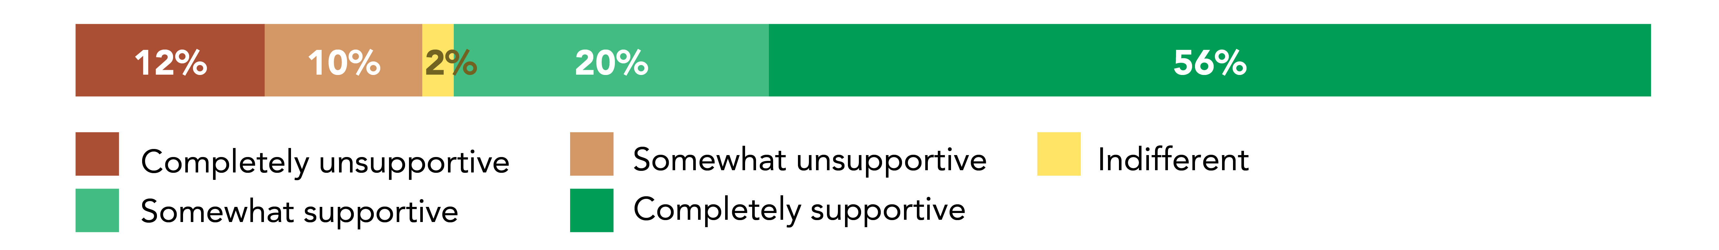
Respondents were asked to outline what they liked about the design. A review of all survey responses identified the following common themes:
- Some support for the dual mast suspension bridge design, with some respondents indicating it was attractive, elegant and appropriate for the setting
- General support for improved walking, cycling and e-mobility connectivity between destinations in St Lucia and West End, including UQ, riverside parks and public transport services
- Separation of pedestrians and cyclists on the bridge deck, and an accessible bridge grade catering for all users are important features of the design
- Support for shade cover over the full length of the bridge deck, with some requests to extend cover to ramps and landing points
- Some support for the St Lucia landing design and integration of the bridge approach into Guyatt Park
- Some support for the West End landing design as it minimises impacts on Orleigh Park by incorporating the over-water circular ramp.
Respondents were asked to outline why they did not support the design and how it could be improved. A review of all survey responses identified the following common themes:
- Concerns around the visual impact / need for the over-water circular ramp design at Orleigh Park, and impacts to park facilities and amenity
- Concerns around impacts to Guyatt Park, particularly loss of useable riverside park space and amenities, and safety impacts on park users and pedestrians
- Concerns about the design, durability and functionality of the proposed shade solution, and desire for additional shade on the bridge approach ramps
- Concerns about the visual impacts of the bridge form, including the scale of the bridge masts and colour / style of the design.

Overall design features
Respondents were asked to indicate what features they valued most about the SLWEGB concept design. The graph below outlines the percentage of respondents that ranked each feature as the ‘most important’.
Note: Survey respondents could select up to three features as most important.
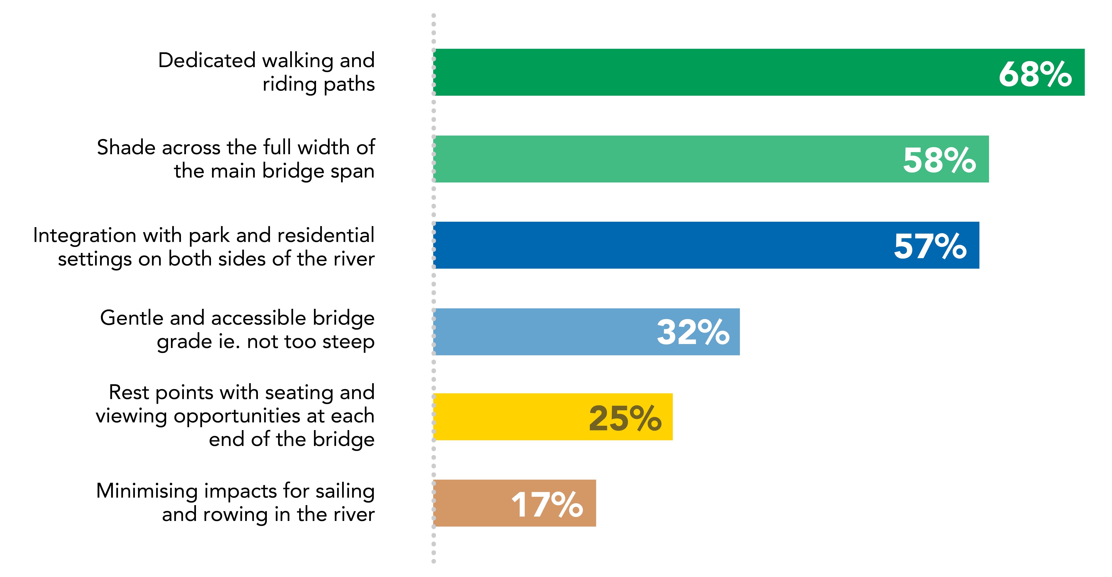

St Lucia landing
Respondents were asked to indicate what they valued most about the design and location of the St Lucia landing. The graph below outlines the percentage of respondents that ranked each feature as the ‘most important’.
Note: Survey respondents could rank their top four responses.
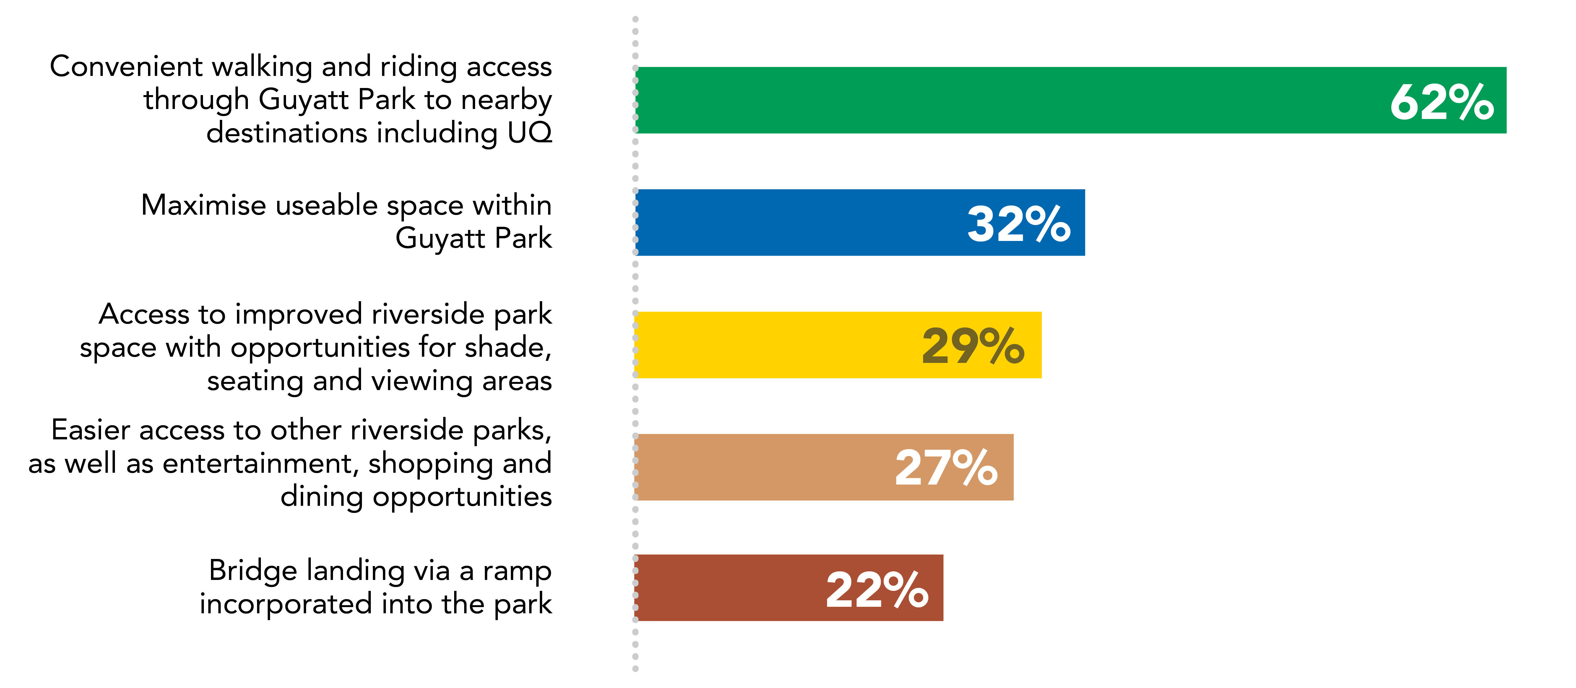

West End landing
Respondents were asked to indicate what they valued most about the design and location of the West End landing. The graph below outlines the percentage of respondents that ranked each feature as the ‘most important’.
Note: Survey respondents could rank their top four responses.
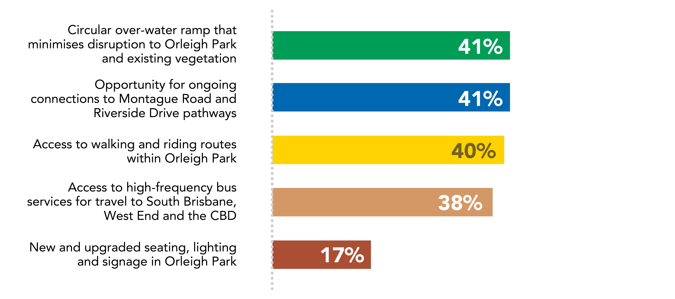

Bridge usage

Frequency of travel
Respondents were asked how often they would use the SLWEGB. The graph below outlines the percentage of respondents who would use the bridge at different frequencies.
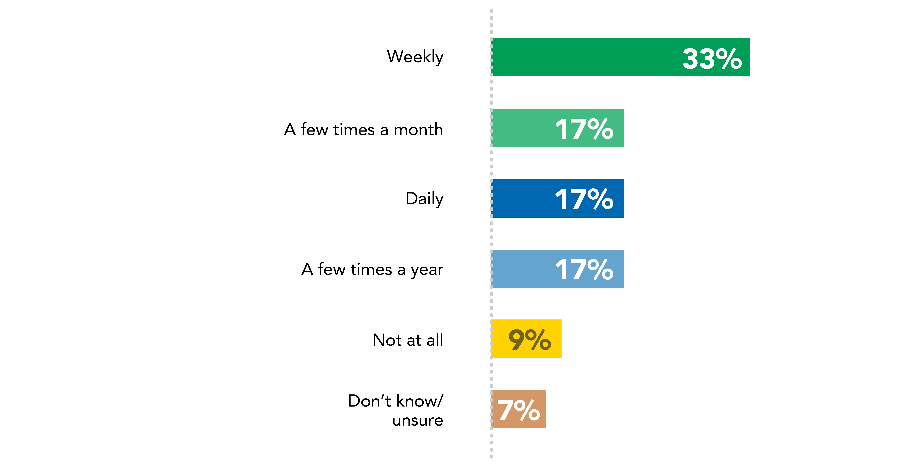

Travel purpose
Respondents were asked to indicate their main purpose for using the SLWEGB. The graph below outlines the percentage of respondents who would use the bridge for different purposes.
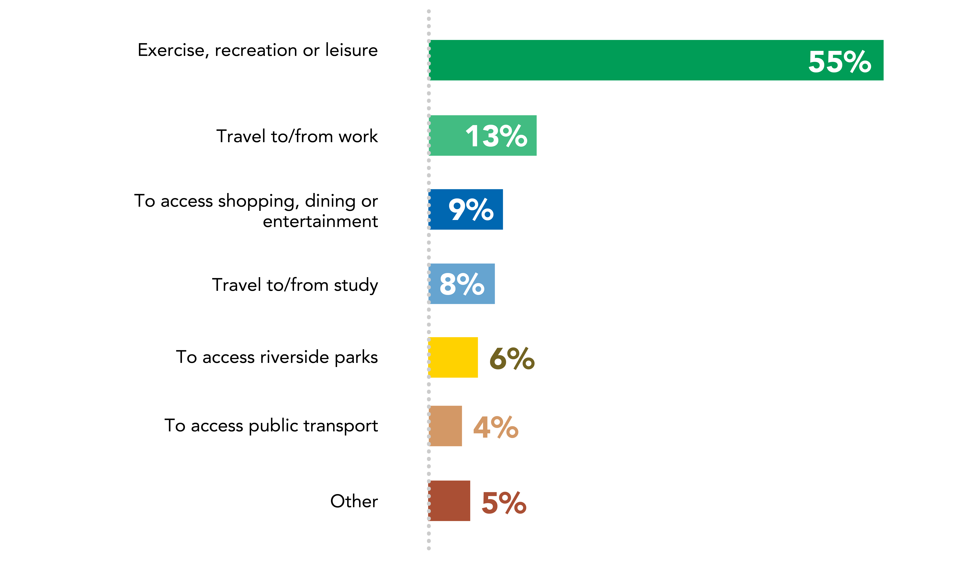

Travel mode
Respondents were asked how they would mainly travel on the SLWEGB. The graph below outlines the percentage of respondents who would use the bridge via different active transport modes.
Note: Survey respondents could select multiple responses.
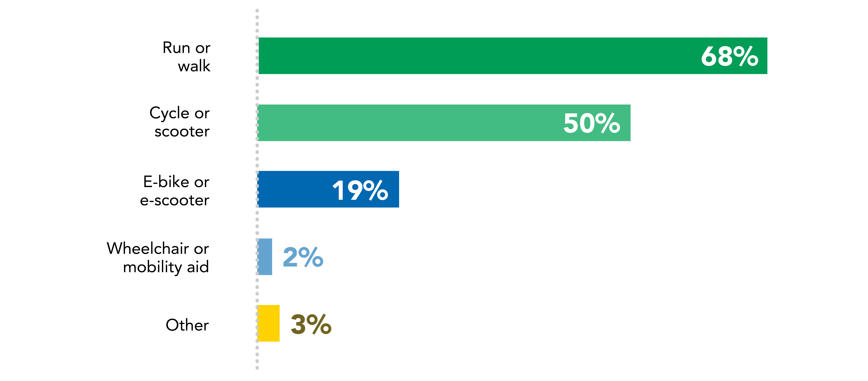

Survey respondent demographics

Gender of survey respondents
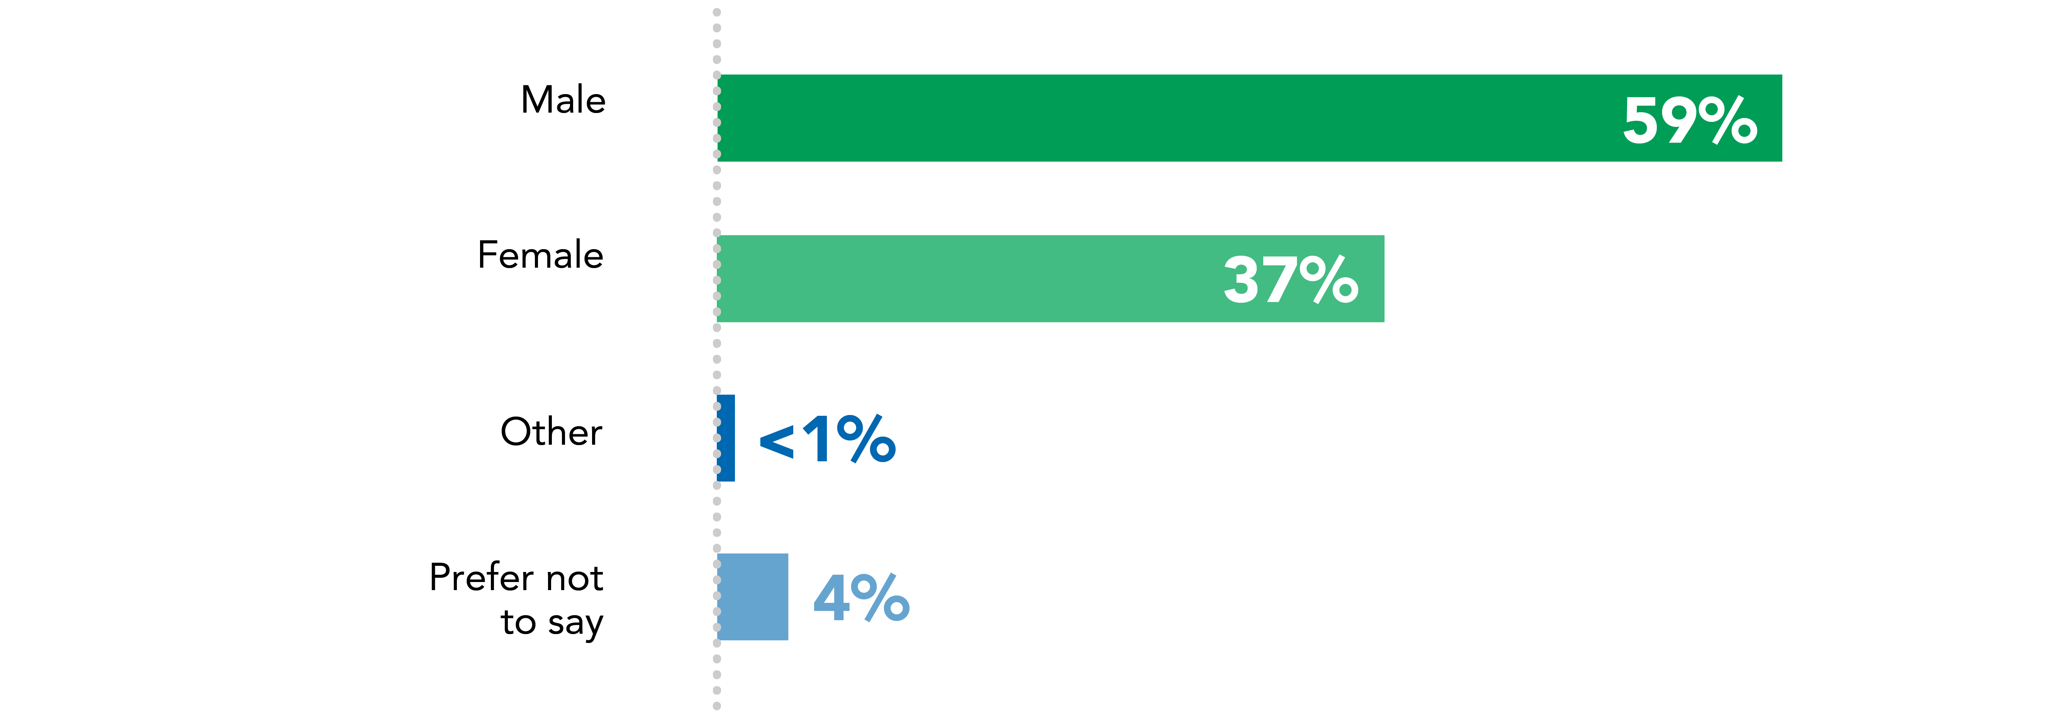

Age of survey respondents
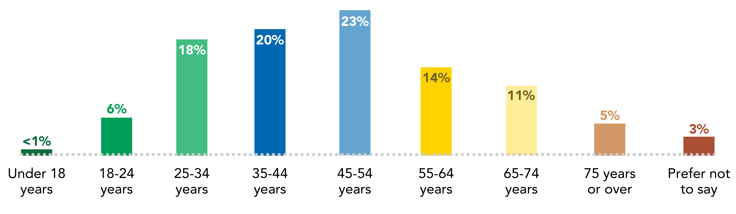

Residential postcode of survey respondents
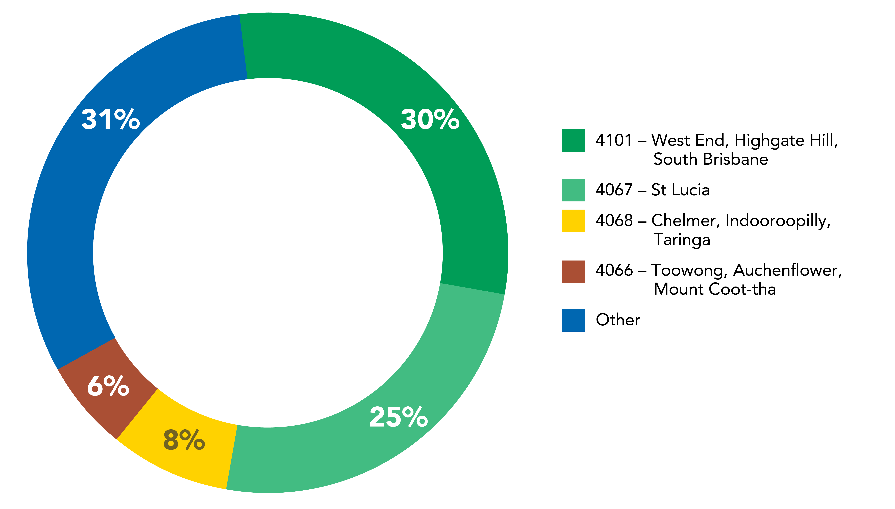

Conclusion
From 15 November 2021 to 28 February 2022, Council undertook community consultation on the concept designs for both the SLWEGB and TWEGB. The consultation period followed an initial consultation phase in late 2019, and further consultation on bridge alignment options from late 2020 to early 2021.
Residents, businesses and other key stakeholders were invited to provide their feedback on the concept design for the SLWEGB, which was based on the preferred alignment from the riverfront of Guyatt Park, St Lucia to Orleigh Park (near Morry Street), West End. Community feedback was provided across 10 community information sessions, six pop-up events, via an online survey, and through the project’s 1800 hotline and dedicated email inbox.
The project team also met with local stakeholder groups and received formal submissions. In total, 595 pieces of feedback were received for the SLWEGB, including 440 online survey responses.
Following the consultation period, Council reviewed and summarised all feedback to determine overall support for the SLWEGB concept design, as well as key issues for consideration during the next phase of the project.
Overall, key feedback included:
- general support for the SLWEGB concept design, with 76% of online survey respondents completely or somewhat supportive of the proposed design
- mixed overall feedback on the SLWEGB, with some people questioning the need / demand for the project, particularly if the TWEGB is delivered
- mixed responses to the proposed dual mast suspension bridge form, with some positive feedback that it is attractive, modern and suited the area, and some concerns it is obtrusive / unattractive and impacts on local amenity
- concerns around the durability and functionality of the proposed shade cover, as well as requests for additional shade cover on the bridge approach ramps
- some support for providing improved accessibility and connectivity for people of all ages and abilities between St Lucia and West End, and increasing walking and riding access to riverside parkland, UQ and public transport services
- interest in how bridge users will safely and easily connect with destinations in St Lucia and West End, and what upgrades to local roads / pathways may be required
- some concerns from local residents about the design and location of the St Lucia landing at Guyatt Park, including impacts on riverfront open space, existing vegetation, existing park facilities and the safety of park users
- mixed feedback on the West End landing design, with some positive feedback that it minimises impacts on Orleigh Park, and some concerns the over-water circular ramp is out of scale with the surrounds
- interest in potential construction timing and impacts, particularly from local residents and river users.

Next steps
Council recognises the positive level of support for the SLWEGB and TWEGB as vital cross-river links that will make it easier for residents and visitors to travel around our city into the future.
Feedback from consultation on the concept designs will play a critical role in the future development of each project, including final design treatments, ongoing connections to the city-wide walking and riding network, and management of impacts during construction.
While planning for the SLWEGB and TWEGB was paused in 2022 to prioritise flood recovery activities across Brisbane, Council will seek additional contributions from the Queensland and Australian governments to help Council deliver these critical projects. If funding is secured during the flood recovery effort, Council will consider progressing the detailed design and procurement process for these bridges to ensure they can be delivered sooner than anticipated.
Initial environmental and social assessments undertaken for the preliminary business case have identified a range of matters that will require further investigation and management through future planning phases. This includes potential flooding impacts, land matters, potential noise and vibration during construction, and potential impacts to local amenity.
In June 2022, the GPB was included in Infrastructure Australia’s Infrastructure Priority List as an early-stage proposal, confirming the program is economically significant to the nation and recognising the role it will play in in shaping our city for generations to come.
Council’s commitment of investing up to $550 million to deliver the GBP remains on track, with construction of both the Kangaroo Point and Breakfast Creek Green Bridges underway and expected to be complete by 2024.
Council will keep the community informed about the new green bridges and will provide a further opportunity for feedback on the SLWEGB and TWEGB during future phases of project planning.

Appendix A. Concept design project plan
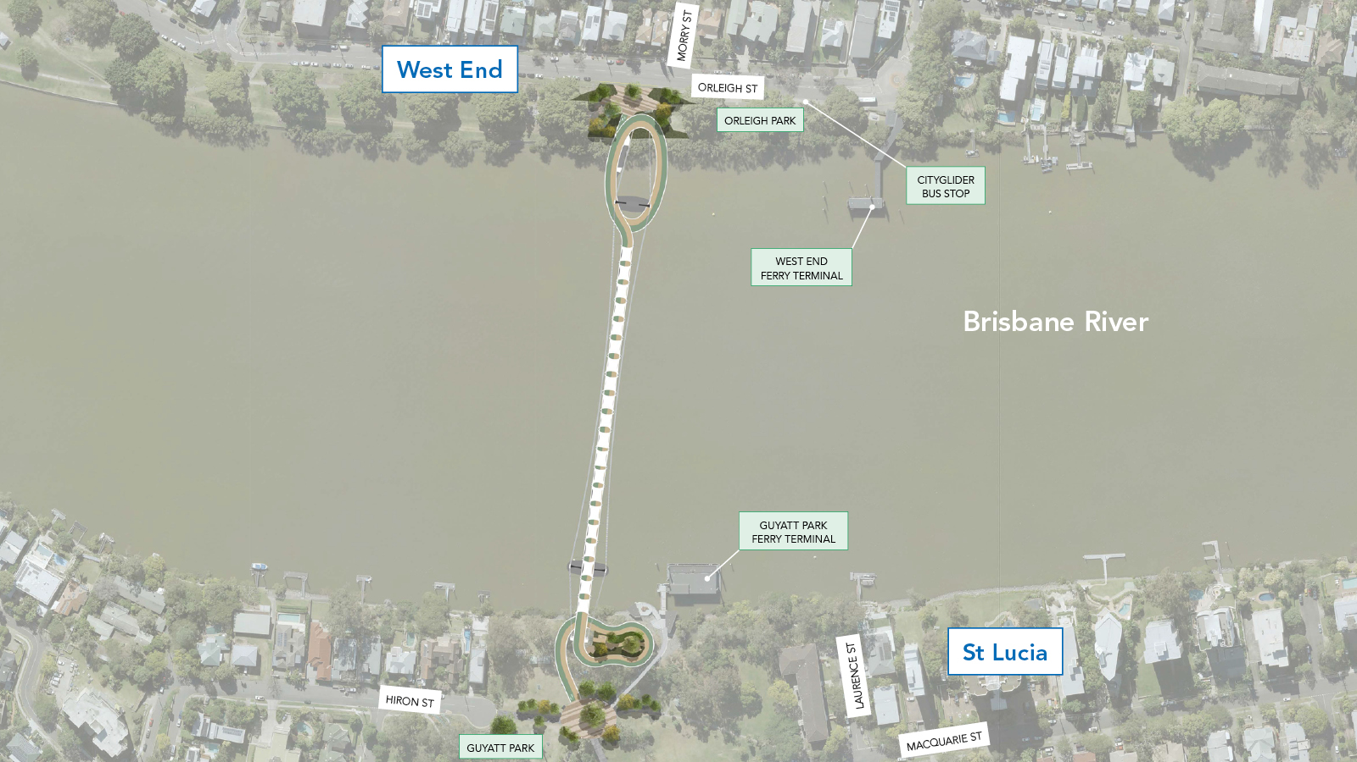

Appendix B. List of key stakeholders
Groups | Stakeholders
Aboriginal and Torres Strait Islander groups | - Turrbal Traditional Owners  - Moreton-Yuggera People  - Jagera Daran  - Yugara-Yugarapul Aboriginal Corporation  - Danggan Balun (Five Rivers Group)  - Quandamooka Yoolooburrabee Aboriginal Corporation (QYAC)  - Jinibara Aboriginal Corporation
Elected representatives | - Cr Jonathan Sriranganathan, The Gabba Ward  - Cr James Mackay, Walter Taylor Ward  - Amy MacMahon MP, State Member for South Brisbane  - Michael Berkman MP, State Member for Maiwar  - Julian Simmonds MP, Federal Member for Ryan (as at November 2021)  - Terri Butler MP, Federal Member for Griffith (as at November 2021)
Corridor stakeholders | - Residents, businesses and property owners on Hiron Street, Macquarie Street and Lawrence Street, St Lucia  - Residents, businesses and property owners on Orleigh Street, Morry Street, and Hoogley Street, West End  - Pedestrians  - Cyclists  - Scooter and e-mobility device users  - Motorists  - Commuters  - Taxi and rideshare operators  - Users with accessibility needs  - Utility providers including Telstra and Energex
Community, business and advocacy groups | - Bicycle User Groups (Brisbane CBD, East, West and UQ)  - Bicycle Queensland  - Brisbane Road Runners Club  - Brisbane Residents United  - Business South Bank  - Cancer Council of Queensland  - Choice, Passion, Life (CPL)  - Engineers Australia  - Friends of Guyatt Park  - Guide Dogs Qld  - Kurilpa Futures  - Queensland Walks  - RACQ  - Space4Cycling  - Spinal Life  - St Lucia Residents Association  - West End Community Association  - West End Traders Association
River users | - Brisbane and GPS Rowing Club  - Rowing Queensland  - South Brisbane Sailing Club  - Toowong Rowing Club  - West End Canoe Club  - Boat / cruise operators  - Residents with private moorings  - Dragon Boat Queensland  - Paddle Queensland  - Commercial Rowing Club  - Boating Industry Association  - Sailing Australia
Education providers | - Brisbane Boys’ College  - University of Queensland
Government departments and agencies | - Active Transport Advisory Committee  - Cross River Rail Delivery Authority  - Department of Transport and Main Roads / TransLink  - Department of Environment and Science  - Department of Tourism, Innovation and Sport  - Department of State Development, Infrastructure, Local Government and Planning  - Maritime Safety Queensland  - Queensland Police Service  - Queensland Fire and Emergency Services  - Queensland Ambulance
Appendix B - List of key stakeholders for SLWEGB concept design consultation.
