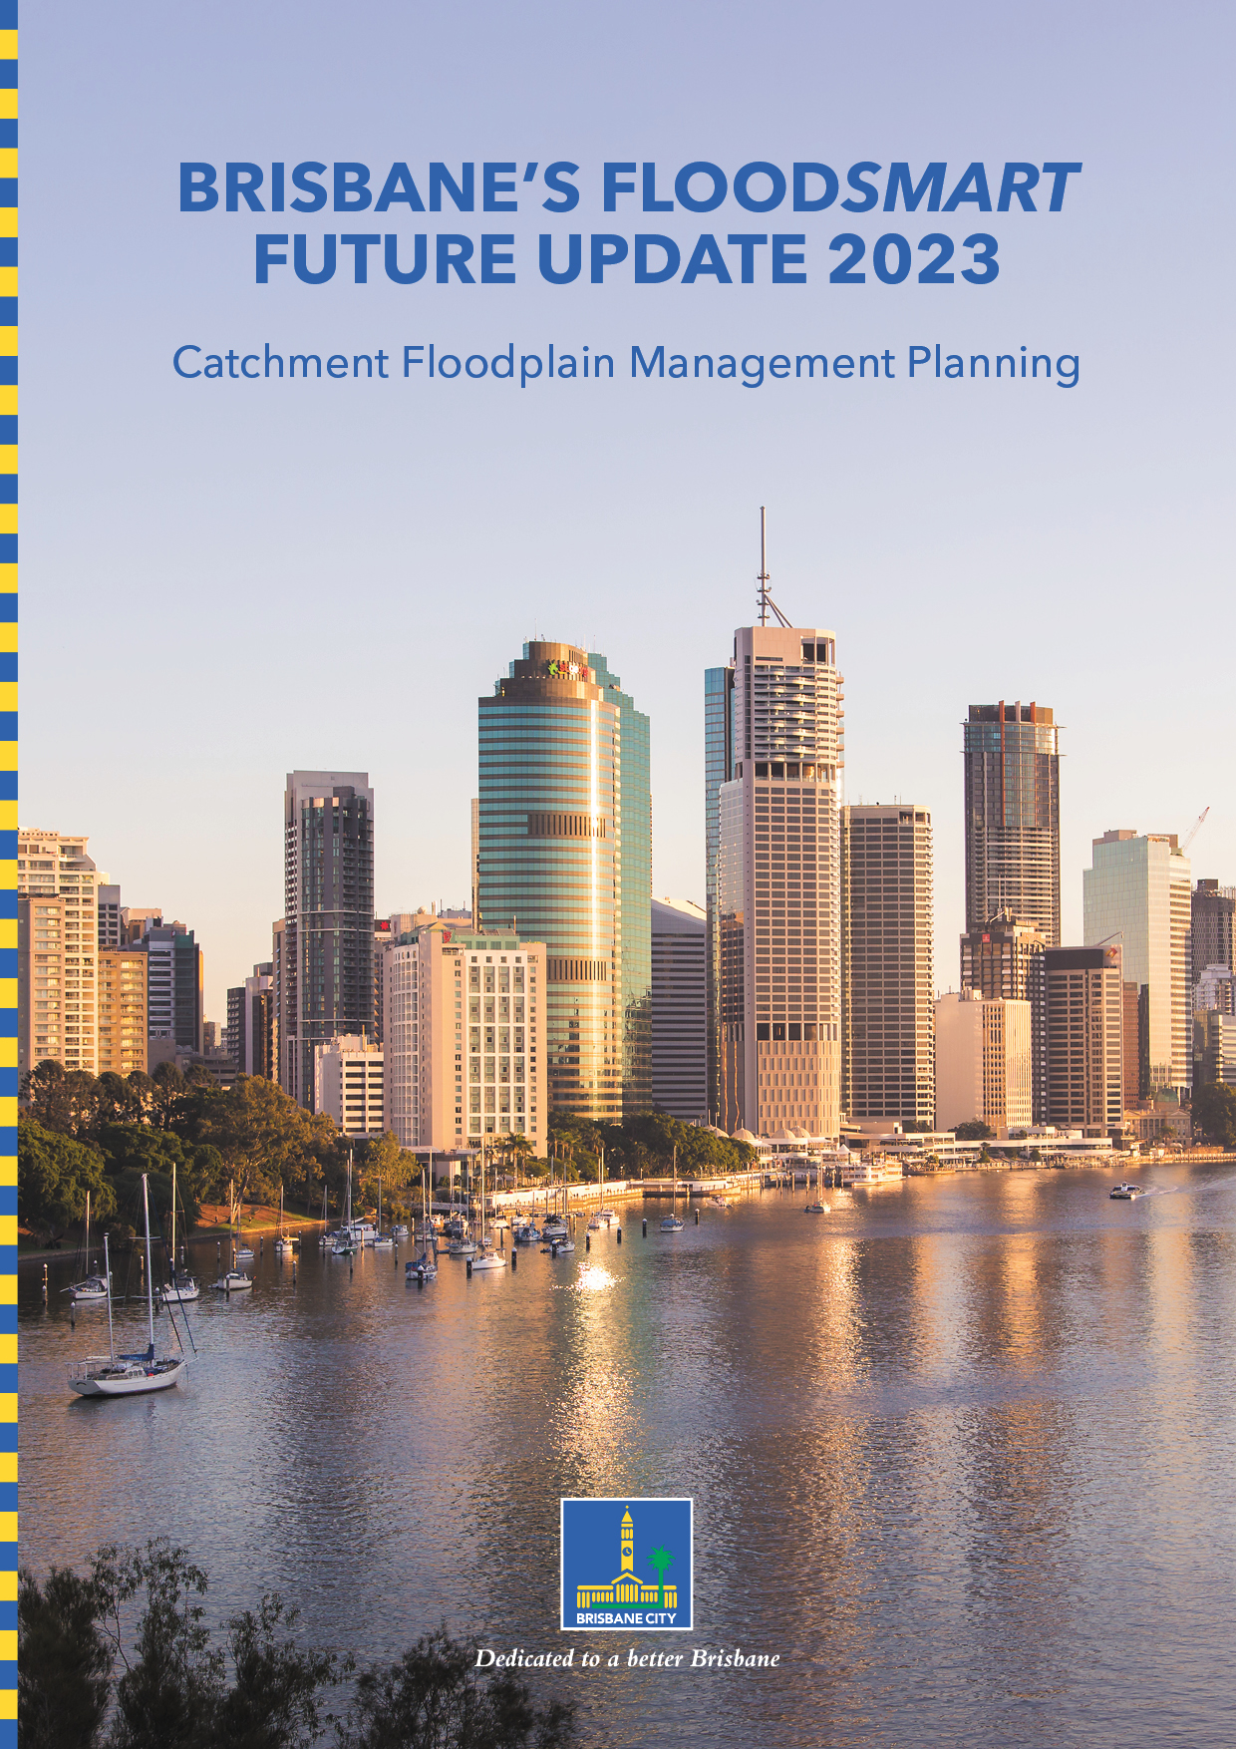

Brisbane is a city of resilience: Lord Mayor

Brisbane is known for its river, waterways and beautiful subtropical climate, but this can mean our city is prone to summer storms and flooding.

Every flood is different and while we will never be able to prevent these types of weather events, we can always be better prepared.

Brisbane is a resilient city and our proactive approach to flood management has helped Brisbane build back better from past flood events.

The rainfall and flooding we experienced in February 2022 was unlike anything ever seen in Brisbane. Over three consecutive days, more than 200 millimetres of rain fell each day, saturating catchments and causing a combination of river, creek and overland flow flooding. This triggered one of Brisbane’s biggest ever flood events, eclipsing the damage of 2011, affecting more than 20,000 properties across 179 suburbs, and damaging roads, parks, paths and bikeways.

As a Council, we jumped into action to help our city rebuild and recover, with 3357 flood-impacted streets cleared, 863 parks cleaned and reopened, 75,000 tonnes of flood waste collected, $4.8 million in rates relief provided, more than 117,000 potholes filled, nearly $15 million provided to flood-affected community groups, 170 kilometres of bikeways and shared paths cleaned and our ferry network restored within one year, compared to four years after the 2011 Flood.

We have learnt so much since the FloodSmart Future Strategy was first realised in 2012 and are eager to share our findings.

This FloodSmart Future Strategy update provides an overview of the planning we have undertaken to manage floodplains and outlines how we will continue to build a resilient city that is safe, confident and ready for the future.

Adrian Schrinner
Lord Mayor

CONTENTS

Brisbane is a city of resilience: Lord Mayor 1
BRISBANE – A RESILIENT CITY 3
OUR FLOODPLAIN MANAGEMENT STORY 4
OUR RECENT ACHIEVEMENTS 6
OUR FLOOD AWARENESS ACHIEVEMENTS 6
OUR RESILIENT BUILDINGS, ASSETS AND INFRASTRUCTURE ACHIEVEMENTS 7
OUR FLOOD EMERGENCY MANAGEMENT ACHIEVEMENTS 8
OUR LAND USE PLANNING ACHIEVEMENTS 8
WHAT COUNCIL IS CONSIDERING FOR THE FUTURE 9
OUR FLOOD AWARENESS OPPORTUNITIES 9
OUR RESILIENT BUILDINGS, ASSETS AND INFRASTRUCTURE OPPORTUNITIES 10
OUR FLOOD EMERGENCY MANAGEMENT OPPORTUNITIES 10
OUR LAND USE PLANNING OPPORTUNITIES 10
WHAT DOES COUNCIL DO WITH THE FLOODPLAIN MANAGEMENT OPPORTUNITIES ONCE THEY HAVE BEEN IDENTIFIED? 11
HOW YOU CAN BE PREPARED 11

This document is:
- a framework for planning and decision making
- a strategic guide for Brisbane City Council, businesses and the general public
- a suite of potential projects that could be implemented in the short medium or long term
- a continuation of work undertaken under the FloodSmart Future Strategy 2012-2031

This document does:
- consider flood impacts from the Brisbane River, local creeks and waterways, overland flow and storm tide
- seek to continually improve Brisbane’s readiness for and resilience to flooding

This document isn’t:
- a statutory plan, detailed advice on specific locations or projects or a budget plan

This document doesn’t:
- discuss specific management measures for storm tide and coastal hazards, as these will be addressed in Council’s Coastal Hazards Adaptation Strategy

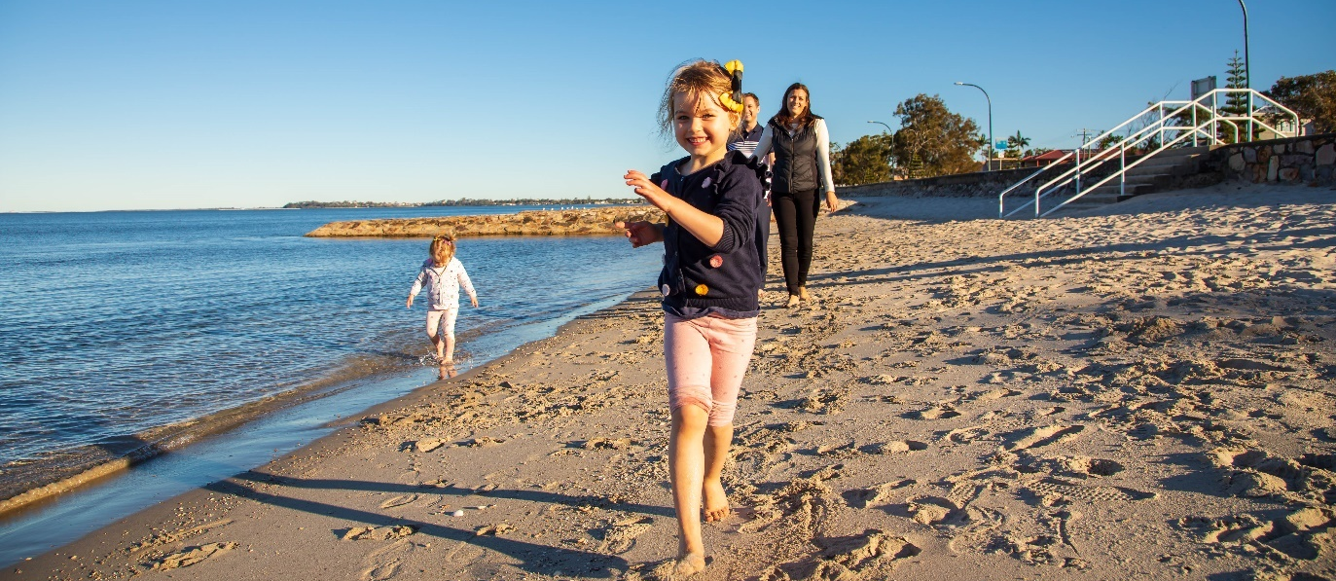

BRISBANE – A RESILIENT CITY

Brisbane is a coastal, subtropical city defined by its river and bay. Our lifestyle and recreation revolve around the city’s many water courses. We play, relax and celebrate on the banks of the Brisbane River, the tributaries and creeks that weave through our suburbs and along the shores of Moreton Bay.

Our relationship with water is complex, but it is a key part of Brisbane’s much-loved identity.

Flooding in Brisbane is a natural process, shaped by Brisbane’s climate, topography and geographical location on a floodplain. Flooding in Brisbane is multifaceted, with a range of flooding types caused by different interactions of those elements. Brisbane has always lived with flooding, with impacts experienced firsthand by our residents and businesses.

We want to ensure our community remains safe by adapting and preparing for future flood events from all sources including river, creek, coastal and overland flow.

Resilience is the ability to plan, prepare, respond and return to normal life with minimal disruption following an adverse event. It means that an informed and empowered community will have access to the information they need to act on to minimise the impact of future flooding.

The ability to be resilient is now seen as one of the key attributes of a sustainable city – economically, environmentally, socially and institutionally. A resilient city balances community, environment, built form and infrastructure to provide a liveable city now and for future generations.

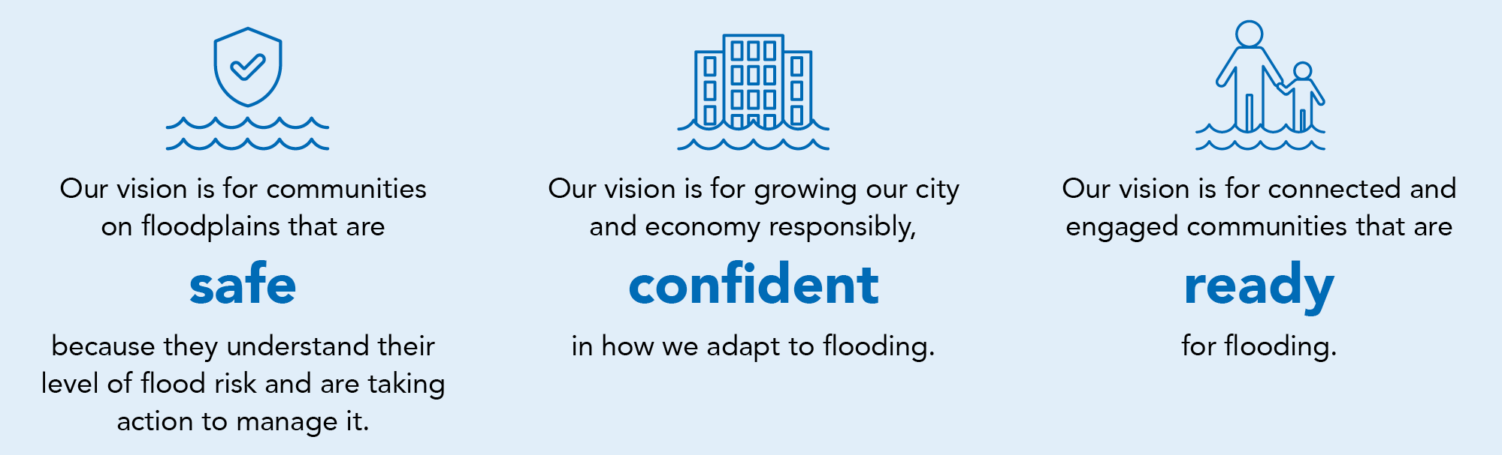

OUR FLOODPLAIN MANAGEMENT STORY

A floodplain is an area of land that is subject to inundation by floods. A catchment is an area of land surrounded by natural features such as hills, where water flows to a common low point, such as a creek, lake, river or bay. Catchment floodplain management involves assessing and managing flood risks within a catchment, or series of catchments, to reduce the impact on people and to property.

The FloodSmart Future Strategy 2012-2031 was developed as an overarching strategy outlining Council’s approach to floodplain management, focusing on four key areas of flood risk management.

The FloodSmart Future Strategy uses four tools for flood risk management including:
- flood resilient buildings, assets and infrastructure
- flood awareness and information
- land use planning and development control
- flood emergency management.

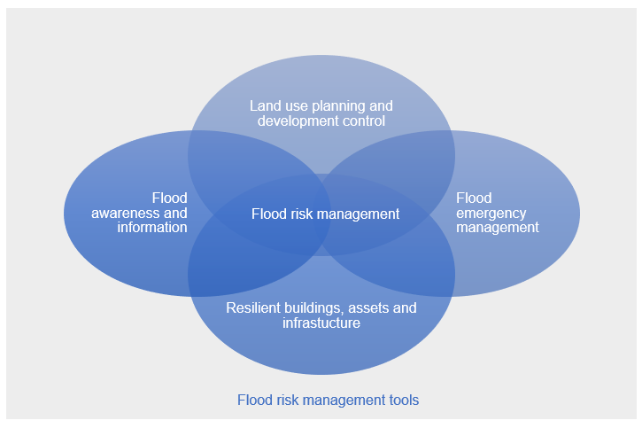

Up until the 1970s, flood mitigation infrastructure (e.g., dams, levees, channel modifications) was the primary method of managing flood risks in Australia.

A series of large floods in the 1970s resulted in a change of focus from mitigation infrastructure to land use planning as a means of controlling developments on floodplains. The 1990s saw a focus on flood emergency management and more recently there has been an emphasis on providing flood awareness and information.

Floodplain management tools are limited in their ability to completely prevent flooding. Some solutions, such as structural mitigation work well for frequent flood events but provide little benefit during rare or extreme events. Planning solutions such as minimum habitable floor levels provide flood immunity during rare events, but properties can become inundated during extreme events. Awareness and emergency management can provide benefit during frequent, rare and extreme events.

It is now recognised that best practice floodplain management requires the coordinated application of all these management tools. Catchment floodplain management planning makes use of these tools to identify a range of measures to better manage flood risk within a catchment.

The process of catchment floodplain management planning considers the consequences of flooding on the community, environment, businesses and infrastructure. It aims to:
- reduce the flood risk to people and property
- maintain local economic development and growth
- ensure appropriate land use planning
- protect the local environment
- minimise impacts to infrastructure and services.

Over the past 10 years Council has committed to a series of studies including the following, to provide the most up-to-date technical information regarding flood behaviour.

- Council commenced its current program of creek flood studies in 2011 and by 2015 had completed flood studies that provided the latest creek flood data for more than 80% of urbanised areas across the city.

- The Brisbane River Catchment Flood Studies commenced in 2012 as a partnership between the Queensland Government, Seqwater and the four local governments of Brisbane, Ipswich, Somerset and Lockyer Valley. This program of works has resulted in the completion of the Brisbane River Catchment Flood Study in 2017 and the Strategic Floodplain Management Plan in 2018.

- Council completed its Coastal Flood Study in 2015, providing a better understanding of tidal, storm surge and associated coastal flooding within Moreton Bay.

- Council’s Citywide Creek and Overland Flow Path Mapping Study was complete in 2017 and provides the latest data relating to overland flow and previously un-modelled creek flooding across the whole of Brisbane’s local government area.

The information provided by these studies has been used to understand the consequences of flooding and identify floodplain management measures, through a process known as catchment floodplain management planning.

Following the significant flood event in February 2022, Council has commenced updates to flood studies and floodplain management planning to ensure that data captured during the event and lessons learned from the event can be incorporated into future floodplain management planning.

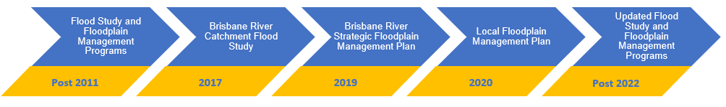

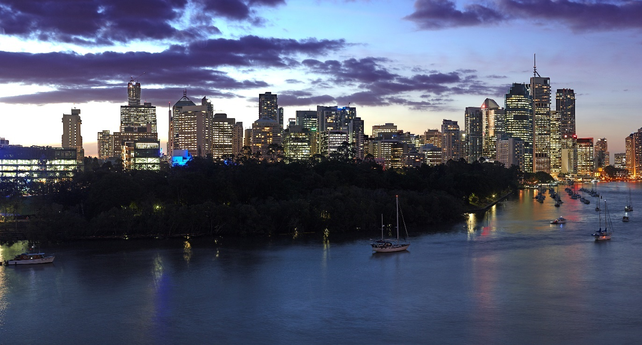

OUR RECENT ACHIEVEMENTS

Much work has been undertaken since the adoption of the FloodSmart Future Strategy in 2012, to ensure that Brisbane is working towards becoming a more resilient city; a city which is safe, confident and ready. Council has embraced the integrated approach promoted by the strategy, applying the four flood risk management tools to deliver floodplain management projects across the city.

OUR FLOOD AWARENESS ACHIEVEMENTS

An informed and empowered community will have access to the information they need to act, build resilience and minimise the impact of future floods.

Council has improved the ways in which it makes information available to residents and businesses. A range of awareness tools is available online and updated regularly with the best available flood study data.

Council’s Flood Information Online includes the Flood Awareness Map and FloodWise Property Report alongside improved education and awareness materials. Council updated Flood Information Online in September 2022, ensuring it is a resource which is easy-to-use and understand flood resource.

First made available in 2008, the FloodWise Property Reports continue to be updated when new flood information becomes available. The reports include information to ensure future building and development contributes to a safe, flood-resilient city.

The Flood Awareness Map launched in 2013 and provides an indication of the likelihood of a flood occurring from one or more sources: creek, river, overland flow and storm tide. Recent updates allow users to better understand the possible impacts of overland flow, while historical mapping provides the history of river floods in Brisbane.

The Flooding in Brisbane Guides are designed to help residents and businesses prepare for flooding and outline simple things they can do to be prepared.

Council’s Open Data platform supports re-usable, accessible, understandable and shareable Council data. Data sets are available for creek, coastal and overland flow flood studies, Brisbane City Plan 2014 (City Plan) flood overlays, waterways and wetland assets, and stormwater infrastructure.
Council engages with communities that may experience flooding, promoting flood preparedness, awareness and resilience. The Flood Hub provides an interactive space for the community to learn about flood resilience, touch and feel flood-resilient building materials and talk to flood engineers about flood-resilient building strategies. More than 10,500 people have been engaged through the Flood Hub since 2018.

OUR RESILIENT BUILDINGS, ASSETS AND INFRASTRUCTURE ACHIEVEMENTS

Maintaining and investing in flood mitigation assets to support the city’s economic growth. Council is designing with water in mind, a key priority in Brisbane. Clean, Green, Sustainable 2017-2031 is helping Brisbane become an even more attractive, liveable and resilient city.

Council continues to deliver ongoing flood mitigation and resilience building programs across Brisbane. The Rebuild & Recover: Flood Resilience Action Plan was developed in response to the February 2022 flood and outlines how works should be done to ensure Brisbane is more resilient, rebuilding and recovering as soon as possible.

Council commenced its pilot Flood Resilient Homes Program in 2018, offering homeowners at risk of frequent flooding from overland flow a free in-home service, a tailored property report and an incentive scheme for eligible properties. The program seeks to help residents prepare for, live through and then return to normal household routines following a flood, with the least amount of disruption. More than 297 free in-home services have been undertaken to date, with 164 homes retrofitted to improve flood resilience. Similar programs are now being rolled out in flood affected areas across Queensland and interstate.

In 2022, Council expanded its resilience building offering, launching the Flood Resilient Suburbs Program which delivers a range of flood resilience services to apartments, businesses, homes and community facilities. Services available include provision of resilience information, undertaking of resilience assessments, development of resilience recommendations and continuity planning for businesses – to ensure that they are prepared for, can respond to and recover from future flood events.

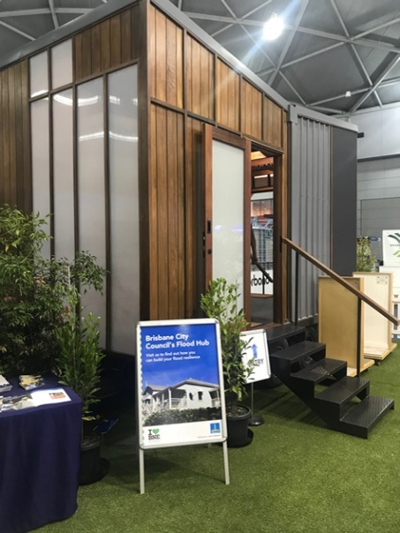 | 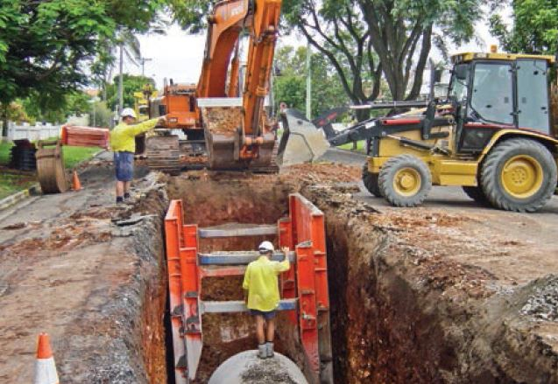

During river flood events, some parts of Brisbane are affected by water that flows from the river through the drainage networks and into our streets. Following on from technical investigations, a series of backflow prevention devices have been installed to help minimise water flowing back up stormwater pipes. Council continues to review, assess and prioritise flood mitigation opportunities across the city.

Council has invested more than $158 million since 2011 with the aim of minimising flooding impacts in local catchments by constructing major and local drainage infrastructure, obtaining drainage easements and acquiring land.

Council manages more than 270 km of urbanised open waterways and approximately 2700 km of natural waterways. Desilting and vegetation management activities are undertaken on 40 km of creek to ensure optimum flood conveyance.

Council has an ongoing CCTV inspection program of its drainage network to proactively identify siltation and potential failure. Following flood events, stormwater networks are inspected and cleaned to remove sludge which had the potential to compromise the capacity of the network.

Following a global competition, Council commissioned designs for flood-resilient ferry terminals and new terminals featuring the innovative design are now in action. Each terminal has a boat-hull-shaped pontoon to reduce drag and a gangway that automatically detaches from the shore during floods, swinging behind the pontoon and out of the path of debris. Council continues to recognise the need for resilience in the design, location, repair and replacement of Council owned assets and infrastructure.

Council is investing in the resilience of its built and natural assets. The Hanlon Park/Bur’uda transformation, turning an open concrete drain to a thriving urban park with a naturalised waterway, sets an exemplar for parks located within floodplains.

OUR FLOOD EMERGENCY MANAGEMENT ACHIEVEMENTS

We have further developed our capacity to respond to and recover from flood events. Disasters can strike with little or no warning and it’s important for Brisbane communities to be prepared, especially in areas that are likely to be isolated by flooding, or where there are vulnerable groups within the community.

Council continues to gain valuable knowledge about disaster prevention, preparation, response and recovery following each flood event. Brisbane City Council has created disaster management plans, guidelines and arrangements to help residents and businesses prepare, respond and recover from various hazards, weather events and emergencies.

The Brisbane Severe Weather Alert service provides residents and visitor with notification of severe thunderstorms, destructive winds and potential flooding. The alerts are location based, so residents only receive warnings if their registered residential address may be impacted.

Rainfall and stream height information is gathered from more than 80 hydrometric telemetry gauges located near creeks across the city, which feed into Council’s state-of-the-art FloodWise Information System. Council’s Creek Flooding Alert Service makes use of this information to issue alerts when rain or flow levels in nearby creeks indicate that properties may be at risk of flooding.

Council’s Be Prepared communication campaign informs the community on how to prepare for severe weather including bushfires, severe storms, flooding and heatwaves. It promotes the awareness of Council’s online tools including the severe weather alerts and Flood Awareness Map.

Council provides pre-filled sandbags to residents and businesses in Brisbane City to help reduce the impact of flooding on home or business. While sandbags will not stop the water entirely, they can reduce the amount of water entering.

OUR LAND USE PLANNING ACHIEVEMENTS

Shaping the city’s built form to increase our resilience to flooding.

City Plan is Council’s plan for the future development of Brisbane. It guides how land in Brisbane can be used and developed. It also helps plan for infrastructure to support growth and create a more diversified economy while continuing to protect our city’s enviable way of life.

As part of City Plan, a hazard-based Flood Overlay Code was introduced, to ensure that development adequately considers flooding. Flood Planning Areas were defined for the Brisbane River, creek flooding and overland flow to guide future development in flood-prone areas.

Since the adoption of the Flood Overlay Code many practical outcomes have been realised including:
- properties raised to achieve acceptable flood immunity
- developments designed in a way that maintain the conveyance of flood waters through a site
- essential electrical services suitably located to ensure public safety and minimise flood recovery following a flood.

Following the February 2022 flood event, Council published the Approvals for repairing, raising, or rebuilding flood-affected houses fact sheet, to ensure homeowners could quickly access key information to assist with rebuilding post flood.

Since 2006 Council has led the purchase of 112 residential properties at risk of flooding with an approximate spend of $58 million. Properties purchased under the Voluntary Home Purchase Scheme are used by Council for conservation, drainage easements and parklands, and it is Council’s policy not to redevelop these flood prone areas for future residential use. Post 2022, Council successfully lobbied the Queensland and Australian Government to fund an expanded program of buy back and home resilience within Brisbane. Brisbane City Council is pleased to be administering the Voluntary Home Buy-Back program in Brisbane, on behalf of the Queensland Reconstruction Agency, as part of the Queensland and Australian Government's Resilient Homes Fund.

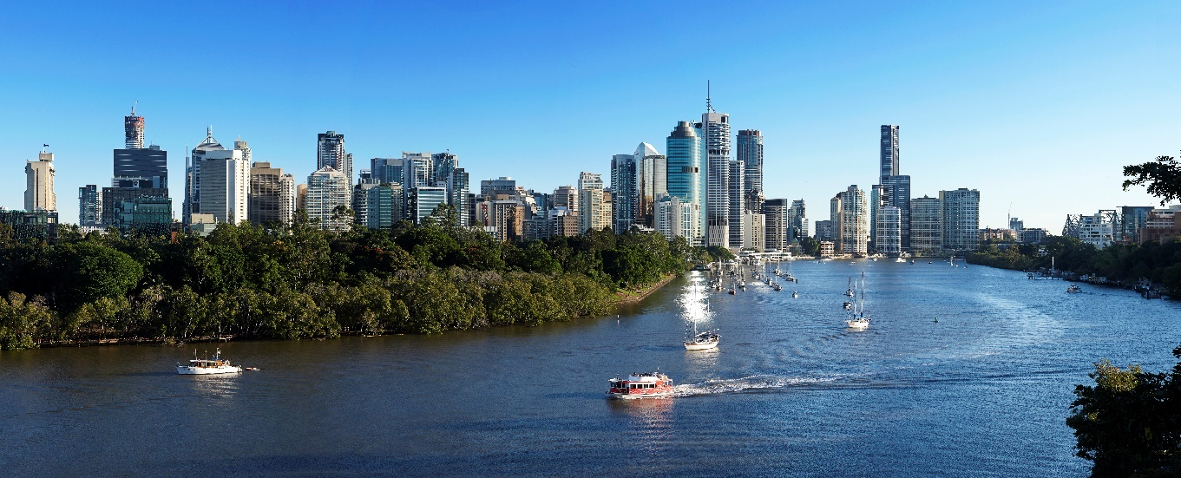

WHAT COUNCIL IS CONSIDERING FOR THE FUTURE

Catchment floodplain management planning allows us to better understand the consequences of flooding and identifies potential floodplain management opportunities that could be implemented in the short, medium, or long term by Council, businesses and the public.

The opportunities that have been identified include an integrated mixture of land use planning, flood emergency management, flood information and awareness, and flood resilient buildings, assets and infrastructure. Some of the opportunities that have been identified are likely to be applicable on a city-wide scale, while others target specific areas of interest. Examples of potential opportunities that Council may consider are presented below.

OUR FLOOD AWARENESS OPPORTUNITIES

- Maintain and update a detailed flood risk database to support future floodplain management planning.
- Continue to update the Flood Awareness Map and FloodWise Property Reports to reflect up-to-date information, best practice and regional recommendations for flood awareness mapping and communication.

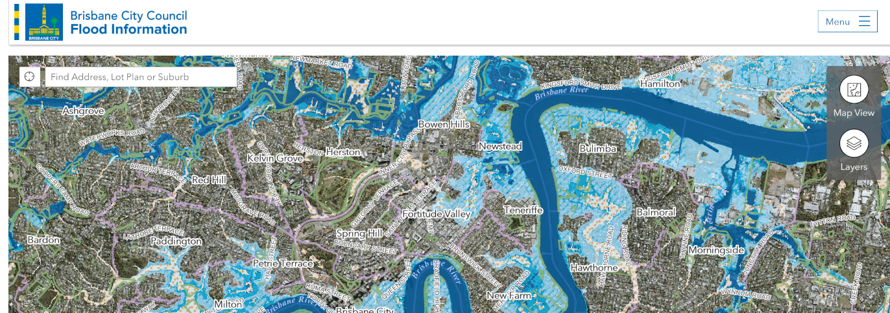

- Targeted community engagement with residents and businesses located within flood areas to help improve the safety and resilience of those most at risk of flooding.
- Place-based education installations and events to gather information about flooding experiences as part of consultation with community groups.
- Promote continued awareness of the future local impacts of climate change across the city, incorporating new information as it becomes available.

OUR RESILIENT BUILDINGS, ASSETS AND INFRASTRUCTURE OPPORTUNITIES

- Continue to use new information from Council’s ongoing program of works and from the Brisbane River Catchment Flood Studies program, to inform the design of new resilient buildings, assets and infrastructure.
- Planned road upgrade projects near creek crossings and waterway rehabilitation projects to be investigated and cross-referenced against known flood mitigation opportunities and consider possible avenues for implementation.
- Continue to deliver the Flood Resilient Suburb Program in Brisbane to improve the resilience of community facilities, homes, apartments and businesses to future floods.

OUR FLOOD EMERGENCY MANAGEMENT OPPORTUNITIES

- Continue to expand Council’s creek flood alert program and coverage to allow additional residents and businesses to register and receive alerts when rain or flow levels in nearby creeks indicate that properties may be at risk of flooding.
- Future expansions to Council’s existing flooded road warning signage program to assist in deterring traffic from entering flood waters at additional locations. During storm season, message boards could also be used to display flood safety messaging.
- Continue to work with the Bureau of Meteorology to develop a local flood warning system for Brisbane that would provide enhanced warning of severe weather and flash flooding.
- Continue to use new information from the Brisbane River Catchment Flood Studies program to undertake local evacuation planning and capability assessment.

OUR LAND USE PLANNING OPPORTUNITIES

- Continue to use the best available information to inform and improve Council’s planning scheme, including new information as it becomes available from Council’s ongoing program of works and from the Brisbane River Catchment Flood Studies program, including information relating to:
  - evacuation capability
  - available warning time
  - flood islands cut off or isolated by floodwaters
  - cumulative impacts of filling with in the floodplain.
- Incorporate Queensland Government’s State Planning Policy requirements to consider the full range of flood risk and climate change scenarios as part of future plan-making exercises.
- Flood planning scheme policy to require consideration of data from relevant studies (Brisbane River Catchment Flood Studies and Local Floodplain Management Plan) during development assessment, through flood risk assessment and flood emergency management plans.
- Transition from a single flood planning area to multiple risk-based planning areas for overland flow, similar to the River and Creek flood planning areas.

WHAT DOES COUNCIL DO WITH THE FLOODPLAIN MANAGEMENT OPPORTUNITIES ONCE THEY HAVE BEEN IDENTIFIED?

Council is the largest local government in Australia, delivering a broad program of works throughout our city. The process of catchment floodplain management planning is just one part of the work Council undertakes.

The floodplain management opportunities have been identified initially in isolation from Council’s broad program of works. The next step is to consider these opportunities alongside all of Council’s other competing priorities. This will be undertaken through Council’s annual budget process, which considers and prioritises all of Councils work in order to maximise value for the community.

Together with our partners, the floodplain management opportunities will be implemented through a range of delivery plans, projects and actions including when scheduling new flood resilient infrastructure and buildings during updates to planning schemes, planning new emergency response measures and when developing new flood information and awareness tools.

HOW YOU CAN BE PREPARED

We all have a role to play in managing flood risk in our local area. Council has the following range of free tools and information to help residents understand their property’s potential flood risk and how to be prepared.

- The Flooding in Brisbane webpage provides a range of useful information including links to Council's online flood tools.

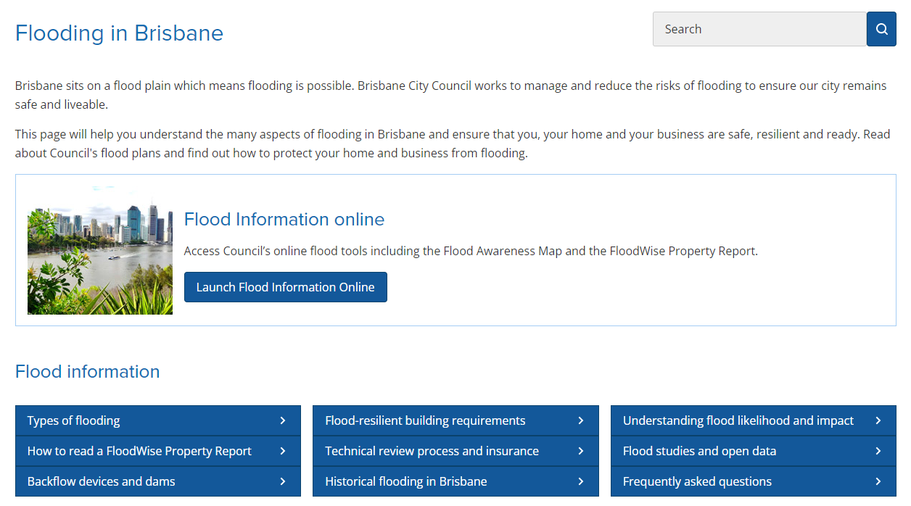

- Interactive Flood Awareness Map. Identify the flood risk for your local area, including:
  - Flood Awareness Map – download a printable Flood Awareness Map for your locality
  - Interactive Flood Source Map – Identify the type or sources of flooding that may affect your locality
  - Interactive Historical Flood Map – learn about the history of Brisbane’s major river floods.
- FloodWise Property Report. Download a FloodWise Property Report for flood information relating to purchasing, building or renovating your home.
- Sign up to receive free alert messages for severe weather through the Brisbane Severe Weather Alert service.
- Flooding in Brisbane guides for both residents and businesses help you prepare for flooding and help minimise the impact to your home, family, property or business if flooding does occur.
- The disasters and emergencies web page on Council’s website provides information about the different types of disasters that can occur in Brisbane, emergency management, the State Emergency Service and severe weather alerts.

For more information on being prepared for flooding visit brisbane.qld.gov.au/beprepared, your nearest Council regional business centre or call Council on (07) 3403 8888.

