Chelmer to Indooroopilly river crossing

May 2023

Pre- feasibility study

Key findings report

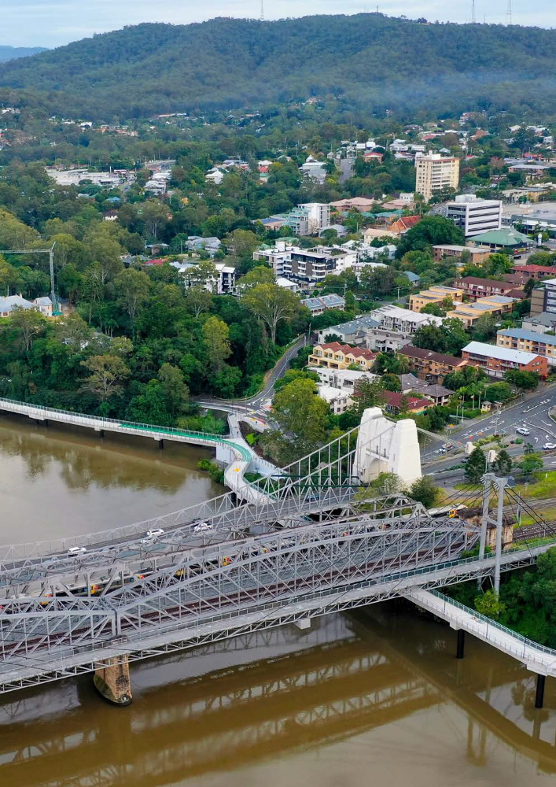

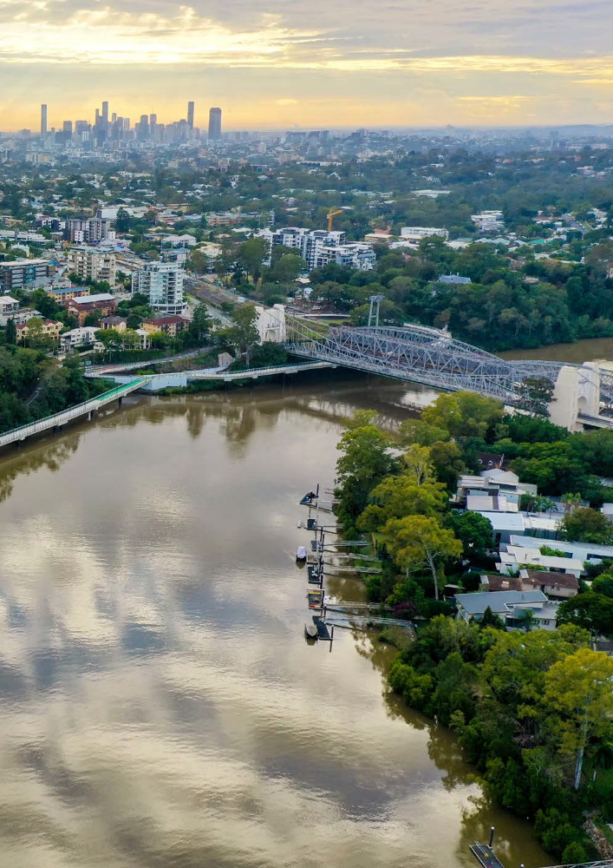

A message from the

Infrastructure Chair

Every day, Brisbane City Council works with residents and local communities to make sure the Brisbane of tomorrow is even better than the Brisbane of today. We’re committed to making Brisbane better and part of that is making sure our transport network is fit for purpose.

As the Walter Taylor Bridge approaches its 100-year anniversary, Council is planning for
the future by exploring options now to future-proof this important river crossing.

The first step has been to complete this pre-feasibility study to look at what our
community is currently experiencing, what the future looks like and what options we
may need to consider to make sure we can keep our city moving.

Whether you walk, ride, catch a bus or train, or drive, my vision for travel in Brisbane is
to plan the infrastructure we need to deliver a connected, integrated, reliable transport
system now and for the future.

Our commitment to this vision for the future will help improve quality of life for
residents while ensuring our city has the services and infrastructure to meet the needs
of future generations.

Cr Andrew Wines
Civic Cabinet Chair for Infrastructure

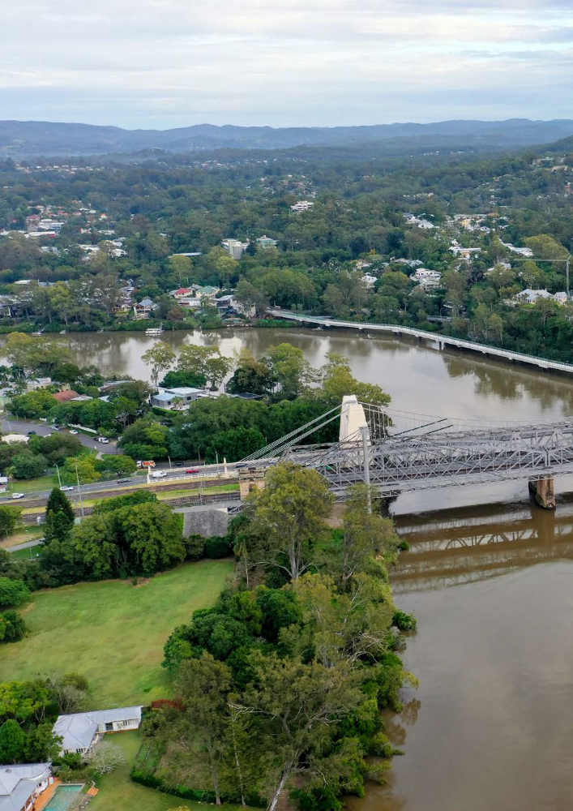

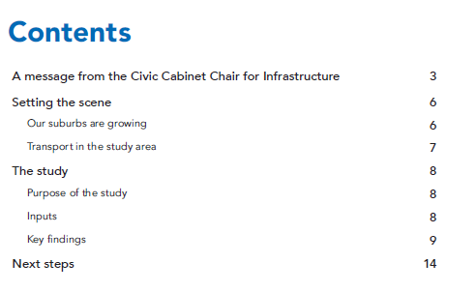
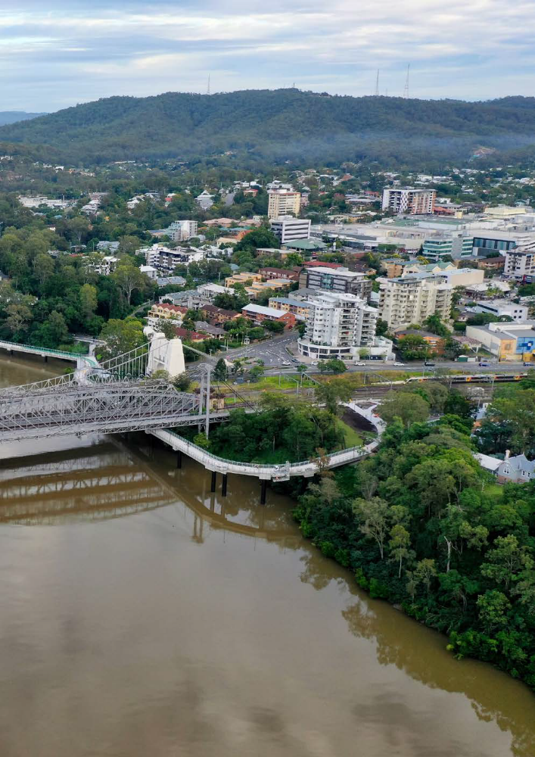

Setting the scene

The river crossing between Chelmer and Indooroopilly is serviced by four

bridges in total, including options for road, rail and active transport travel.

The heritage-listed Walter Taylor Bridge is a twoway, two-lane bridge that provides road transport across the river, and also includes a footpath. This bridge currently experiences congestion that impacts both private and public transport. It provides cross river road access between residential areas south of the river and major employment, health, retail and educational facilities north of the river.

The current road network, including Walter Taylor Bridge lacks spare capacity and is prone to significant delays for both planned and unplanned incidents due to the bridge being a single lane in each direction. Without another attractive route choice, people are faced with reduced travel time reliability, particularly at peak times and following
traffic incidents.There are also two rail bridges servicing the Ipswich/Springfield Rail Line and the Jack Pesch Bridge for walking and cycling.

The Indooroopilly Riverwalk was constructed by Brisbane City Council in 2019, providing a separated two-way cyclist and pedestrian riverwalk encouraging safe and accessible active transport between Twigg Street and the Jack Pesch Bridge.

Our suburbs are growing

Population in the local area (from Taringa to Corinda) is expected to increase by approximately 7,000 between 2021 and 2041. Employment in the local area is expected to increase by approximately 10,000 between 2021 and 2041.

As our suburbs continue to grow in both employment and population, there will be increased pressure on the existing transport networks to connect people to the places that matter most to them.

As the area develops, our networks are expected to do more, while opportunities to preserve future infrastructure solutions diminish.

6 Key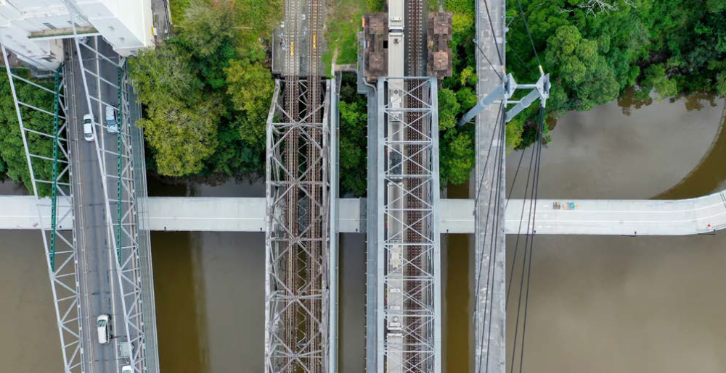

Transport in the study area

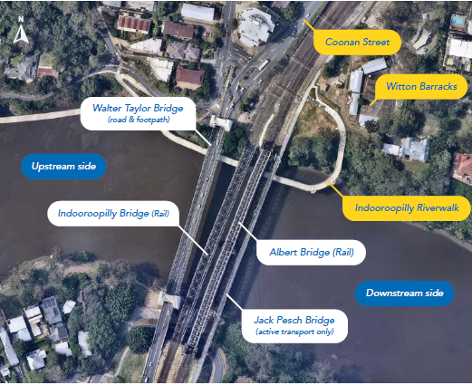
Figure 1: Chelmer to Indooroopilly bridge crossing

Walter Taylor Bridge carries more than 30,000 vehicles per day, significantly higher than the typical capacity for a two-way two-lane road link. People who travel at the current road crossing and surrounds experience congestion and unreliable travel times and most people are undertaking trips with local origins or destinations. Most people
are crossing the river between Chelmer and Indooroopilly several times per week.

While the rail corridor services Corinda to Chelmerwell for travel between the suburbs and the innercity during commuter peaks, public transport options for most traffic using Walter Taylor Bridge are unattractive, particularly for off peak trips and travel to Indooroopilly and the University of Queensland which are major trip generators.

The needs of users crossing the river for short trips are not well serviced by the available public transport options, and buses share the same lanes as general traffic, resulting in delays and unreliable service plans. This reduces the attractiveness of public transport for local trips.

Council delivered the Jack Pesch Bridge and Indooroopilly Riverwalk (Witton Barracks to Twigg Street) and is investigating improvements to walking and cycling connectivity along the rest of the route to connect to the Centenary Motorway. However, for other destinations north and south of the river, the walking and cycling networks still pose challenges to users.

Active travel uptake is limited due to a lack of connected and separated walking and cycling facilities from the river crossing to the local destinations. This particularly impacts the uptake of active school travel.

The study

Purpose

A pre-feasibility study is one of the earliest stages of the planning process for infrastructure in Council. This pre-feasibility study helps us understand current and projected travel and transport across the river between Chelmer and Indooroopilly.
The purpose of this study was to define the problem and explore whether there is merit in adding more capacity for travel across the river, as well as complete initial investigations into some potential options for improving cross-river capacity.

The intention of the pre-feasibility study is to identify issues people experience when crossing the river using the current infrastructure between Chelmer and Indooroopilly and to identify what we might need to consider for more in-depth investigations into potential improvements or upgrades to the crossing.

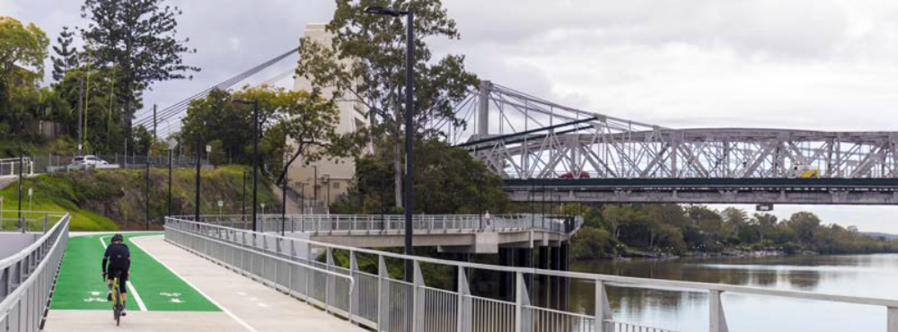

Inputs

Technical

Technical input assisted Council to consider the
high-level expected benefits, impacts, cost, risks,
and opportunities of a limited set of new cross-river
travel options in the vicinity of the Walter Taylor Bridge.
The study took into consideration Council and
Queensland Government policies, planning,
engineering and network modelling with some of
the key themes investigated below.

• Current and proposed land use in the local area.

• Local and network-wide traffic studies, including
both current and forecast traffic figures.

• Environmental & heritage planning advice.

• Council and Queensland Government
planning documents.

These informed an Investment Logic Mapping process, which defined problems and opportunities and identified strategic needs. These outcomes were used to assess options in the vicinity of Walter Taylor Bridge.

Community

Community input was gathered through extensive
community consultation between November 2021 and April 2022. The feedback received from the community played a vital part in this study to provide greater understanding of how, why and when the local community crosses the river, and the challenges they face when choosing a travel option.

The community was invited to provide feedback by completing a range of closed questions around how and when they travel, as well as one open question asking for their suggestions on what would improve their travel experience.

The responses supported the technical findings and helped to refine the problem definitions. Suggestions received from the community shaped recommendations for further investigations and will inform the case for future investment against other city-wide priorities.

8 Key findings: Chelmer to Indooroopilly river crossing

Key findings
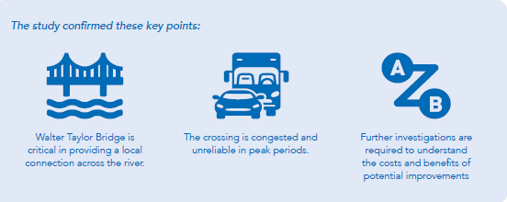

Technical findings

Traffic analysis was a key input into understanding the current and future transport context at and around the river crossing. With appropriate maintenance, Walter Taylor Bridge can continue carrying traffic into the future.

• The majority of trips using Walter Taylor Bridge are locally generated, and are expected to remain so into the future. These trips start or end within the local catchment, or are for
travel entirely within the local catchment. The local catchment includes Chelmer, Graceville, Sherwood, parts of Indooroopilly and Taringa.

• For most bridge travel, alternative travel paths are not viable or practical.

• Current travel demand for Walter Taylor Bridge exceeds its capacity, suggesting that additional lanes across the river are required to achieve a
good level of service.

• Even with additional capacity in the future, broader network constraints limit the increase in regional traffic volumes at the bridge, with the additional demand predominantly coming from the local catchment.

• The study identified a need to increase cross river capacity and improve traffic flow. However, the area is highly constrained which presents significant challenges to construction of additional river crossings.

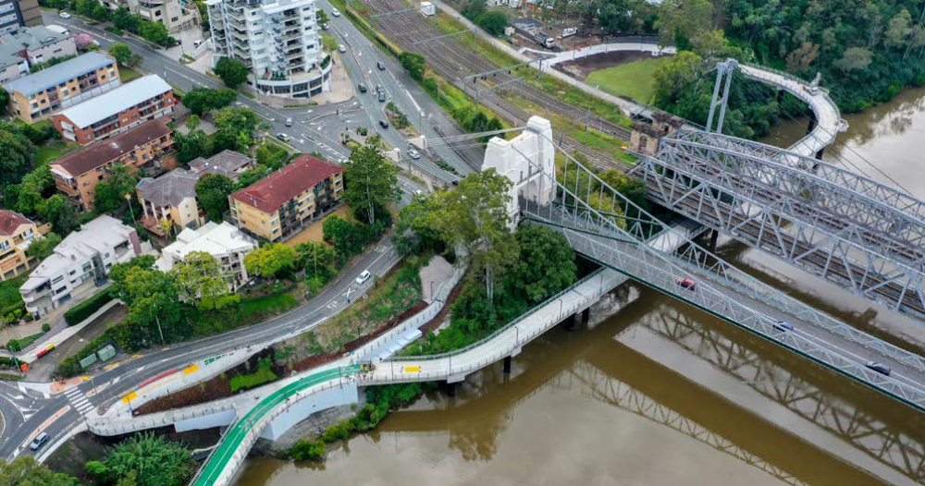

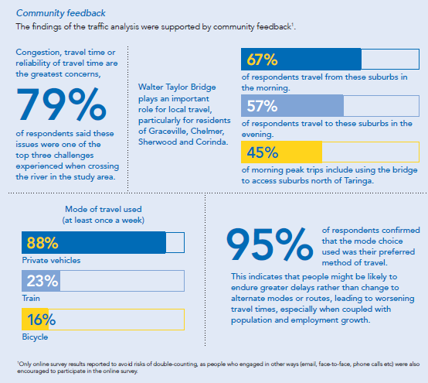

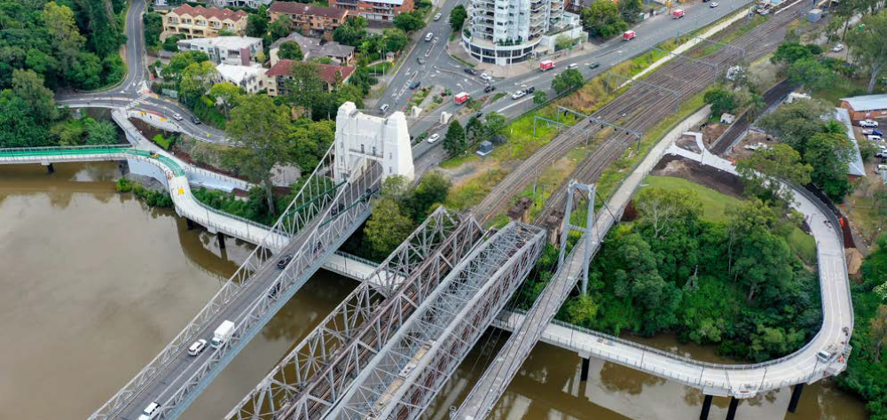

The main themes identified from open feedback included a mixture of

ideas to increase crossing capacity and other local road, active and

public transport improvements.

This feedback was largely made up of people suggesting building another river crossing (bridge/ tunnel) or by increasing the capacity of the existing Walter Taylor Bridge.

In addition to more bridge capacity, respondents suggested broader improvements to the transport network, intersection safety improvements and public and active transport improvements would positively affect their experience crossing the river in the study area.

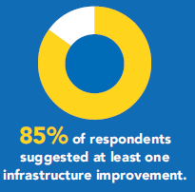
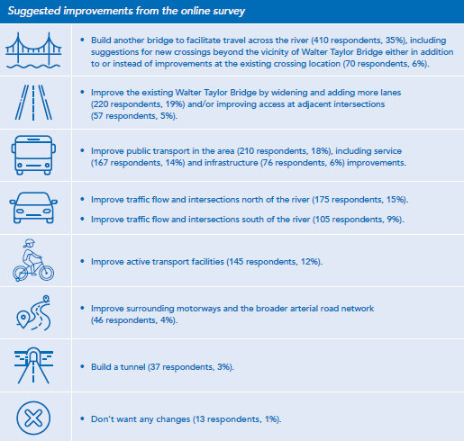

The relevant question was a free text response to the prompt: This question is about crossing the river at any time (weekday or weekend). What is one
improvement you believe would make a positive difference to your travel experience when crossing the Brisbane River between Chelmer and Indooroopilly?
31% of respondents provided more than one item of feedback / response, which together covered a range of themes. Therefore, there are more themed
responses counted than respondents (people who provided feedback). Proportions of respondents are relevant to the total number of people who provided
at least one response.

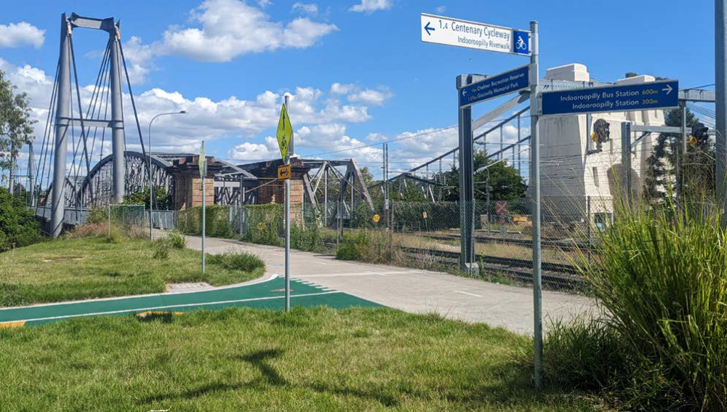

New crossing options

Council developed an indicative alignment for the purposes of corridor preservation when undertaking the purchase of Witton Barracks in 2015. This option consists of an overpass across the rail corridor from Witton Barracks to Coonan Street. Like all options considered, a review of this alignment as part of this study has identified significant risks and issues.

This alignment would require departures from Queensland Rail’s vertical clearance standards. It would also need to consider a substantial bridge structure above the rail corridor and potentially the Coonan Street / Westminster Road intersection.

Further schematic options were developed to consider alternatives including upstream and downstream bridges and one-way couplet options as presented in Figure 2. Given the scale of the potential project, this study is not comprehensive in terms of option development and should be considered as a starting point only for developing
the scope for any subsequent holistic feasibility study.

A high-level assessment was undertaken of options providing additional cross-river traffic flow capacity (including for buses, taxis and ride share vehicles).

This assessment revealed that all identified options were challenging to deliver, costly and high impact.

In particular, it was found that options for new bridges require complex engineering to tie in around the constraints on both sides of Coonan Street, including places with heritage significance,Queensland Government’s rail corridor, and development and topography constraints. High level cost estimates for the options tested range between $800 million and $1.3 billion. It was determined that any solution should also consider upgrades within the local transport network to achieve desired outcomes.



