Resolution of Rates and Charges

2023-24

Adopted by Council resolution on 22 June 2023
Brisbane City Council

Resolution of Rates and Charges

1. | Definitions |  |  | 148
2. | Land use codes |  |  | 148
3. | Averaging of land values |  |  | 148
4. | Differential general rates |  |  | 148
5. | Exemptions from rating |  |  | 174
 | 5.1 |  | Applying for an exemption | 174
 | 5.2 |  | Public purposes | 174
 | 5.3 |  | Religious purposes | 174
 | 5.4 |  | Charitable purposes | 175
 | 5.5 |  | Educational purposes | 175
 | 5.6 |  | Higher Voluntary Conservation Agreement | 175
 | 5.7 |  | Non-rateable land before 13 May 1992 | 175
6. | Special Rates |  |  | 175
7. | Separate Rates |  |  | 176
 | 7.1 | Environmental Management and Compliance Levy |  | 176
 | 7.2 | Bushland Preservation Levy - environment function |  | 181
8. | Special Charges |  |  | 185
 | 8.1 | Rural Fire Services Levy |  | 185
9. | Utility Charges |  |  | 185
10. | Fees and charges |  |  | 187
11. | Terms and conditions |  |  | 187
 | 11.1 | Rates and charges paid by instalments |  | 187
 | 11.2 | Discount on differential general rates |  | 188
 | 11.3 | Interest on overdue rates or charges |  | 188
 | 11.4 | Goods and Services Tax (GST) |  | 188
12. | Concessions |  |  | 188
 | 12.1 | Pensioners partial rebate of rates and charges |  | 188
 | 12.2 | Not-for-profit organisations partial rebate of general rates |  | 189
 | 12.3 | Not-for-profit kindergartens partial rebate of rates and charges |  | 189
 | 12.4 | Not-for-profit affordable housing providers partial rebate of general rates |  | 189
13. | Commonwealth Lands |  |  | 189
14. | Dictionary |  |  | 189
15. | Appendices |  |  | 196
 | 15.1 | Special Rates and Charges – Overall Plans |  | 196
 | 15.2 | Special Rates and Charges – Annual Implementation Plans |  | 218
 | 15.3 | Land Use Codes 2023-24 |  | 223
 | 15.4 | CBD differential rating boundary map |  | 230
 | 15.5 | CBD Frame differential rating boundary map |  | 231
 | 15.6 | Determining residential categorisation for differential rating |  | 232
 | 15.7 | Criteria for determining categorisation for differential rating categories 5ac, 5ad, 5b, 5c, 5d, 5e, 5f, 5g, 5h, 5i, 5j, 5k, 5l, 5m, 5n, 5o, 5p, 5q, 5r, 5s, 5t, 5u, 5v, 5w, 5x, 5y and 5z from 1 July 2023 |  | 234
 | 15.8 | Criteria for determining categorisation for differential rating categories 8a, 8b, 8c, 8d, 8e, 8f, 8g, 8h, 8i and 8j from 1 July 2023 |  | 242
 | 15.9 | Criteria for determining categorisation for differential rating categories 9a, 9b, 9c and 9d from 1 July 2023 |  | 243
 | 15.10 | Criteria for determining categorisation for differential rating categories 2b, 2c, 2d, 2e, 2f, 2g, 2h, 2i, 2j, 2k and 2m from 1 July 2023 |  | 243
 | 15.11 | Criteria for determining categorisation for differential rating categories 26, 27, 28, 29, 30 and 31 from 1 July 2023 |  | 244
 | 15.12 | Criteria for determining application of section 4(j)(ii) from 1 July 2023 |  | 245
 | 15.13 | Criteria for determining categorisation for differential rating categories 13a and 16b from 1 July 2023 |  | 246
 | 15.14 | Criteria for determining categorisation for differential rating categories 34a, 34b, 34c, 34d, 34e, 34f and 35 from 1 July 2023 |  | 246
 | 15.15 | Criteria for determining categorisation for differential rating category 36 from 1 July 2023 |  | 247
 | 15.16 | Differential rating category 5AB |  | 249

Presentation and Submission by
The Right Honourable, the Lord Mayor of Brisbane, Councillor Adrian Schrinner
for adoption by Council

In accordance with the City of Brisbane Act 2010 (COBA), the City of Brisbane Regulation 2012 (the Regulation), the Meetings Local Law 2001 and Council’s local laws, I present and submit to Council recommendations about the rates, charges and fees to be fixed for the financial year ending 30 June 2024, for adoption by Council.

- Definitions

In this resolution, a term appearing in bold italic text is defined in the Dictionary at section 14, unless otherwise stated.

- Land Use Codes

Until otherwise decided or amended, the Land Use Codes 2023-24 as set out in section 15.3 of this resolution constitute the land use codes for rating and charging purposes.

- Averaging of Land Values

Council must calculate the rates for land by using the rateable value of the land.

In accordance with section 67 of the Regulation, Council will use the 3-year averaged value of the land for the purpose of deciding the rateable value of land for the financial year.

The 3-year average value is calculated in accordance with section 69 of the Regulation with the 3-year averaging number for the financial year being 0.88.

Note: For land with land use code 72, the rateable value will be discounted by 40% in accordance with section 50(2) of the Land Valuation Act 2010.

- Differential General Rates

(a) Section 73(1) of the Regulation provides that Council may levy general rates that differ for different categories of rateable land in Brisbane (differential general rates).
(b) For the purpose of making and levying differential general rates for the financial year on all rateable land in the city, Council determines that:
- subject to section 4(c) of this resolution, there will be 136 different categories for rateable land in Brisbane
- the rating categories and a description of each rating category is set out in the Differential General Rating Table, below
- the criteria used to determine which rating category applies to rateable land is specified in the rating description column of the Differential General Rating Table.

Differential General Rating Table

Rating category | Rating description
1. Residential – Owner Occupied | This category will only apply where:  - the land is used solely as an owner-occupied residence OR  b) the:  i) land is used for the purpose described in land use code 01 vacant urban land or land use code 06 uninhabitable building/structure/improvements and  ii) sole purpose for which the land is presently used is vacant land and  iii) land:  A) is wholly contained within a zone or combination of zones defined under Part 6 of City Plan 2014 as:  - Conservation zone  - Environmental management zone  - Rural zone  - Rural residential zone  - where coexisting with another zone or code contained within rating description, Open space zone  - Emerging community zone  - Low density residential zone  - Character residential zone  - Low-medium density residential zone  - Medium density residential zone  - High density residential zone OR  B) is contained within the Moreton Island settlements neighbourhood plan defined under Part 7 of City Plan 2014 and as shown on the Moreton Island settlements neighbourhood plan map in schedule 2 of City Plan 2014, other than that contained within the resort area of the Tangalooma precinct or  C) has been purchased by an individual for the sole purpose of being an owner-occupied residence following the re-configuration of allotments (this will apply and continue until such time as the land is reclassified as residential).  The following land is specifically included in this category:  i) land that would otherwise meet the description set out in paragraph a) above, but where the owner is incapable of occupancy due to ill or frail health and is domiciled in a care facility, provided such land remains unoccupied by any other person/s OR  ii) land subject to a special disability trust, occupied by a deemed vulnerable owner.
2a. Commercial/Non-Residential – Group A | This category will apply:  a) where the land:  i) is used, or has the potential predominant use by virtue of its improvements or the activities conducted upon the land to be used for non-residential purposes and  ii) is located outside of the boundaries of the CBD and the CBD Frame and  iii) is used for the purpose described in one of the following land use codes:  01 vacant urban land 41 child care centre  05 educational – tertiary 42 hotel/tavern  06 uninhabitable building/structure/ improvement 43 Accommodation Hotel/Motel  10 combined multiple dwelling and shop(s) 44 nurseries/garden centres  11 shop - single 45 theatres and cinemas  12 shops – multiple 46 drive-in theatre  15 shop(s) – secondary retail 47 licensed clubs  17 restaurant/fast food outlet (non-drive through) 48 sports club/facilities  18 special tourist attraction 50 other clubs (non-business)  19 walkway/ramp 51 religious  20 marina 52 cemetery  21 residential care institution 54 art gallery/museum/zoo  24 sales area 55 library  25 office(s) 56 showgrounds/racecourses/airfields  26 funeral parlours 57 parks and gardens/bushland reserves  27 private hospital 58 education – school  28 warehouses/bulk stores 59 access restriction strips  32 wharves 63 boarding kennels/cattery  33 builders yard/contractors yard 72 vacant land provided the vacant land is not used for residential purposes or has the potential to be used for residential purposes  34 cold stores – ice works 91 utility installation  35 general industry 92 defence force establishments  36 light industry 96 public hospital  38 advertising hoarding 97 welfare home/premises  39 harbour industry 99 community protection centre  40 kindergarten  and  iv) has not been recorded in Council’s systems by reference to its common name, its location or its real property description in any table at section 15 of this resolution OR  b) where the land:  i) is used, or has the potential predominant use by virtue of its improvements or the activities conducted upon the land to be used for build to rent and  ii) consists of dwellings that are under construction and have not reached practical completion.  Vacant land outside of the CBD or the CBD Frame falls within this differential rating category where that land does not meet the description for differential rating category 1.  This category also includes land that would be used for residential purposes except that:  i) the activities conducted on the land exceed the allowable limits of non-residential activity in ‘Column 2’ and ‘Column 3’ of the table at section 15.6 of this resolution or  ii) the land includes non-residential improvements regardless of whether that non-residential improvement is presently used.
2b. Commercial/Non-Residential – Group B | This category will apply where the land:  a) meets the description of differential rating category 2a, with the exception of paragraph a)iv) and  b) has been recorded in Council’s systems by reference to its common name, its location or its real property description and identified as Group B in the table at section 15.10 of this resolution as at the date this resolution is adopted.
2c. Commercial/Non-Residential – Group C | This category will apply where the land:  a) meets the description of differential rating category 2a, with the exception of paragraph a)iv) and  b) has been recorded in Council’s systems by reference to its common name, its location or its real property description and identified as Group C in the table at section 15.10 of this resolution as at the date this resolution is adopted.
2d. Commercial/Non-Residential – Group D | This category will apply where the land:  a) meets the description of differential rating category 2a, with the exception of paragraph a)iv) and  b) has been recorded in Council’s systems by reference to its common name, its location or its real property description and identified as Group D in the table at section 15.10 of this resolution as at the date this resolution is adopted.
2e. Commercial/Non-Residential – Group E | This category will apply where the land:  a) meets the description of differential rating category 2a, with the exception of paragraph a)iv) and  b) has been recorded in Council’s systems by reference to its common name, its location or its real property description and identified as Group E in the table at section 15.10 of this resolution as at the date this resolution is adopted.
2f. Commercial/Non-Residential – Group F | This category will apply where the land:  a) meets the description of differential rating category 2a, with the exception of paragraph a)iv) and  b) has been recorded in Council’s systems by reference to its common name, its location or its real property description and identified as Group F in the table at section 15.10 of this resolution as at the date this resolution is adopted.
2g. Commercial/Non-Residential – Group G | This category will apply where the land:  a) meets the description of differential rating category 2a, with the exception of paragraph a)iv) and  b) has been recorded in Council’s systems by reference to its common name, its location or its real property description and identified as Group G in the table at section 15.10 of this resolution as at the date this resolution is adopted.
2h. Commercial/Non-Residential – Group H | This category will apply where the land:  a) meets the description of differential rating category 2a, with the exception of paragraph a)iv) and  b) has been recorded in Council’s systems by reference to its common name, its location or its real property description and identified as Group H in the table at section 15.10 of this resolution as at the date this resolution is adopted.
2i. Commercial/Non-Residential – Group I | This category will apply where the land:  a) meets the description of differential rating category 2a, with the exception of paragraph a)iv) and  b) has been recorded in Council’s systems by reference to its common name, its location or its real property description and identified as Group I in the table at section 15.10 of this resolution as at the date this resolution is adopted.
2j. Commercial/Non-Residential – Group J | This category will apply where the land:  a) meets the description of differential rating category 2a, with the exception of paragraph a)iv) and  b) has been recorded in Council’s systems by reference to its common name, its location or its real property description and identified as Group J in the table at section 15.10 of this resolution as at the date this resolution is adopted.
2k. Commercial/Non-Residential – Group K | This category will apply where the land:  a) meets the description of differential rating category 2a, with the exception of paragraph a)iv) and  b) has been recorded in Council’s systems by reference to its common name, its location or its real property description and identified as Group K in the table at section 15.10 of this resolution as at the date this resolution is adopted.
2l. Commercial/Non-Residential – Group L | This category will apply where the land:  - is used, or has the potential predominant use by virtue of its improvements or the activities conducted upon the land of being used for non-residential purposes and  - is located outside of the boundaries of the CBD or the CBD Frame and  - is used for the purpose described in one of the following land use codes:  i) 22 car park  ii) 29 transport terminal  iii) 30 fuel station  iv) 31 fuel depots  v) 37 noxious/offensive/extractive industry  vi) 73 restaurant/fast food outlet (drive-through) and  d) has not been recorded in Council’s systems by reference to its common name, its location or its real property description as shown in any table at section 15 of this resolution.
2m. Commercial/Non-Residential – Group M | This category will apply where the land:  a) meets the description of differential rating category 2a, with the exception of paragraph a)iv) and  b) has been recorded in Council’s systems by reference to its common name, its location or its real property description and identified as Group M in the table at section 15.10 of this resolution as at the date this resolution is adopted.
3. Rural | This category will apply where the land is:  - used, or has the potential predominant use by virtue of its improvements or the activities conducted upon the land of being used for non-residential purposes and  - used for the purpose described in one or more of the following land use codes:  i) 62 wholesale production nursery  ii) 64 agriculture – livestock production  iii) 65 agriculture – crop production  iv) 74 turf farms  v) 86 racing stables.
4a. Multi-Residential – single dwelling with one additional dwelling | This category will apply where the land:  a) consists of one dwelling plus one secondary dwelling AND  b) is used for the purpose described in land use code 03 multiple dwelling.
4b. Multi-Residential – more than two dwellings or living units | This category will apply where:  - the land:  i) consists of more than two dwellings AND  ii) is used for the purpose described in land use code 03 multiple dwelling OR  b) the land is used for the purpose described in one or more of the following land use codes:  i) 07 boarding house/rooming units  ii) 49 caravan park  iii) 53 re-locatable home park  iv) 60 retirement facilities.
5a. Central Business District – Group A | This category will apply where:  - the land:  - meets the description of differential rating category 2a or 2l, with the exception of paragraph a)iv) of differential rating category 2a and paragraph d) of differential rating category 2l AND  - is located within the boundary of the CBD AND  - has an average rateable value less than $5,000,000 OR  - the land:  - is used for the purpose described in land use code 14 shop(s) - main retail AND  - has an average rateable value less than $5,000,000.
5aa. Central Business District – Group AA | This category will apply where:  - the land:  - meets the description of differential rating category 2a or 2l, with the exception of paragraph a)iv) of differential rating category 2a and paragraph d) of differential rating category 2l AND  - is located within the boundary of the CBD AND  - has an average rateable value equal to or greater than $5,000,000 OR  - the land:  - is used for the purpose described in land use code 14 shop(s) – main retail AND  - has an average rateable value equal to or greater than $5,000,000 AND  - does not meet the rating description for differential rating categories 5ab, 5ac, 5ad and 5b to 5z.
5ab. Central Business District – Group AB | This category will apply where the land:  a) meets the description of differential rating category 5a, with the exception of paragraph a)iii) AND  b) is located within the boundary line shown on the map at section 15.16 of this resolution as at the date this resolution is adopted.
5ac. Central Business District – Group AC Public Carparks | This category will apply where the land:  a) is used for the purpose described in land use code 22 carpark AND  b) is open to the public as a public carpark AND  c) meets the description of differential rating category 5a, with the exception of paragraph a)iii) AND  d) is recorded in Council’s systems by reference to its common name, its location or its real property description and identified as Group AC in the table at section 15.7 of this resolution as at the date this resolution is adopted.
5ad. Central Business District – Group AD | This category will apply where the land:  a) meets the description of differential rating category 5a, with the exception of paragraph a)iii) AND  b) is recorded in Council’s systems by reference to its common name, its location or its real property description and identified as Group AD in the table at section 15.7 of this resolution as at the date this resolution is adopted.
5b. Central Business District – Group B | This category will apply where the land:  - meets the description of differential rating category 5a, with the exception of paragraph a)iii) and  - is recorded in Council’s systems by reference to its common name, its location or its real property description and identified as Group B in the table at section 15.7 of this resolution as at the date this resolution is adopted.
5c. Central Business District – Group C | This category will apply where the land:  - meets the description of differential rating category 5a, with the exception of paragraph a)iii) and  - is recorded in Council’s systems by reference to its common name, its location or its real property description and identified as Group C in the table at section 15.7 of this resolution as at the date this resolution is adopted.
5d. Central Business District – Group D | This category will apply where the land:  - meets the description of differential rating category 5a, with the exception of paragraph a)iii) and  - is recorded in Council’s systems by reference to its common name, its location or its real property description and identified as Group D in the table at section 15.7 of this resolution as at the date this resolution is adopted.
5e. Central Business District – Group E | This category will apply where the land:  - meets the description of differential rating category 5a, with the exception of paragraph a)iii) and  - is recorded in Council’s systems by reference to its common name, its location or its real property description and identified as Group E in the table at section 15.7 of this resolution as at the date this resolution is adopted.
5f. Central Business District – Group F | This category will apply where the land:  - meets the description of differential rating category 5a, with the exception of paragraph a)iii) and  - is recorded in Council’s systems by reference to its common name, its location or its real property description and identified as Group F in the table at section 15.7 of this resolution as at the date this resolution is adopted.
5g. Central Business District – Group G | This category will apply where the land:  - meets the description of differential rating category 5a, with the exception of paragraph a)iii) and  - is recorded in Council’s systems by reference to its common name, its location or its real property description and identified as Group G in the table at section 15.7 of this resolution as at the date this resolution is adopted.
5h. Central Business District – Group H | This category will apply where the land:  - meets the description of differential rating category 5a, with the exception of paragraph a)iii) and  - is recorded in Council’s systems by reference to its common name, its location or its real property description and identified as Group H in the table at section 15.7 of this resolution as at the date this resolution is adopted.
5i. Central Business District – Group I | This category will apply where the land:  - meets the description of differential rating category 5a, with the exception of paragraph a)iii) and  - is recorded in Council’s systems by reference to its common name, its location or its real property description and identified as Group I in the table at section 15.7 of this resolution as at the date this resolution is adopted.
5j. Central Business District – Group J | This category will apply where the land:  - meets the description of differential rating category 5a, with the exception of paragraph a)iii) and  - is recorded in Council’s systems by reference to its common name, its location or its real property description and identified as Group J in the table at section 15.7 of this resolution as at the date this resolution is adopted.
5k. Central Business District – Group K | This category will apply where the land:  - meets the description of differential rating category 5a, with the exception of paragraph a)iii) and  - is recorded in Council systems by reference to its common name, its location or its real property description and identified as Group K in the table at section 15.7 of this resolution as at the date this resolution is adopted.
5l. Central Business District – Group L | This category will apply where the land:  - meets the description of differential rating category 5a, with the exception of paragraph a)iii) and  - is recorded in Council’s systems by reference to its common name, its location or its real property description and identified as Group L in the table at section 15.7 of this resolution as at the date this resolution is adopted.
5m. Central Business District – Group M | This category will apply where the land:  - meets the description of differential rating category 5a, with the exception of paragraph a)iii) and  - is recorded in Council’s systems by reference to its common name, its location or its real property description and identified as Group M in the table at section 15.7 of this resolution as at the date this resolution is adopted.
5n. Central Business District – Group N | This category will apply where the land:  - meets the description of differential rating category 5a, with the exception of paragraph a)iii) and  - is recorded in Council’s systems by reference to its common name, its location or its real property description and identified as Group N in the table at section 15.7 of this resolution as at the date this resolution is adopted.
5o. Central Business District – Group O | This category will apply where the land:  - meets the description of differential rating category 5a, with the exception of paragraph a)iii) and  - is recorded in Council’s systems by reference to its common name, its location or its real property description and identified as Group O in the table at section 15.7 of this resolution as at the date this resolution is adopted.
5p. Central Business District – Group P | This category will apply where the land:  - meets the description of differential rating category 5a, with the exception of paragraph a)iii) and  - is recorded in Council’s systems by reference to its common name, its location or its real property description and identified as Group P in the table at section 15.7 of this resolution as at the date this resolution is adopted.
5q. Central Business District – Group Q | This category will apply where the land:  - meets the description of differential rating category 5a, with the exception of paragraph a)iii) and  - is recorded in Council’s systems by reference to its common name, its location or its real property description and identified as Group Q in the table at section 15.7 of this resolution as at the date this resolution is adopted.
5r. Central Business District – Group R | This category will apply where the land:  - meets the description of differential rating category 5a, with the exception of paragraph a)iii) and  - is recorded in Council’s systems by reference to its common name, its location or its real property description and identified as Group R in the table at section 15.7 of this resolution as at the date this resolution is adopted.
5s. Central Business District – Group S | This category will apply where the land:  - meets the description of differential rating category 5a, with the exception of paragraph a)iii) and  - is recorded in Council’s systems by reference to its common name, its location or its real property description and identified as Group S in the table at section 15.7 of this resolution as at the date this resolution is adopted.
5t. Central Business District – Group T | This category will apply where the land:  - meets the description of differential rating category 5a, with the exception of paragraph a)iii) and  - is recorded in Council’s systems by reference to its common name, its location or its real property description and identified as Group T in the table at section 15.7 of this resolution as at the date this resolution is adopted.
5u. Central Business District – Group U | This category will apply where the land:  - meets the description of differential rating category 5a, with the exception of paragraph a)iii) and  - is recorded in Council’s systems by reference to its common name, its location or its real property description and identified as Group U in the table at section 15.7 of this resolution as at the date this resolution is adopted.
5v. Central Business District – Group V | This category will apply where the land:  - meets the description of differential rating category 5a, with the exception of paragraph a)iii) and  - is recorded in Council’s systems by reference to its common name, its location or its real property description and identified as Group V in the table at section 15.7 of this resolution as at the date this resolution is adopted.
5w. Central Business District – Group W | This category will apply where the land:  - meets the description of differential rating category 5a, with the exception of paragraph a)iii) and  - is recorded in Council’s systems by reference to its common name, its location or its real property description and identified as Group W in the table at section 15.7 of this resolution as at the date this resolution is adopted.
5x. Central Business District – Group X | This category will apply where the land:  - meets the description of differential rating category 5a, with the exception of paragraph a)iii) and  - is recorded in Council’s systems by reference to its common name, its location or its real property description and identified as Group X in the table at section 15.7 of this resolution as at the date this resolution is adopted.
5y. Central Business District – Group Y | This category will apply where the land:  - meets the description of differential rating category 5a, with the exception of paragraph a)iii) and  - is recorded in Council’s systems by reference to its common name, its location or its real property description and identified as Group Y in the table at section 15.7 of this resolution as at the date this resolution is adopted.
5z. Central Business District – Group Z | This category will apply where the land:  - meets the description of differential rating category 5a, with the exception of paragraph a)iii) and  - is recorded in Council’s systems by reference to its common name, its location or its real property description and identified as Group Z in the table at section 15.7 of this resolution as at the date this resolution is adopted.
6. Other | This category will apply only where the land does not fall within any other differential rating category described in this Differential General Rating Table.
7. Residential: Non-owner occupied or Mixed Use | This category will apply where:  a) the land is used, or has the potential predominant use by virtue of any improvements or the activities conducted on the land, to be used as a non-owner occupied residence OR  b) the land is used, or has the potential predominant use by virtue of any improvements or the activities conducted on the land to be used as a mixed use residence OR  c) the land:  i) meets the description of paragraph c) of differential rating category 1 AND  ii) is used for the purpose described in land use code 72 vacant land (valuation discounted for subdivided land).
8a. Large Regional Shopping Centre – Group A | This category will apply where the land is used as a large regional shopping centre and is recorded in Council’s systems by reference to its common name, its location or its real property description and identified as Group A in the table at section 15.8 of this resolution as at the date this resolution is adopted.
8b. Large Regional Shopping Centre – Group B | This category will apply where the land is used as a large regional shopping centre and is recorded in Council’s systems by reference to its common name, its location or its real property description and identified as Group B in the table at section 15.8 of this resolution as at the date this resolution is adopted.
8c. Large Regional Shopping Centre – Group C | This category will apply where the land is used as a large regional shopping centre and is recorded in Council’s systems by reference to its common name, its location or its real property description and identified as Group C in the table at section 15.8 of this resolution as at the date this resolution is adopted.
8d. Large Regional Shopping Centre – Group D | This category will apply where the land is used as a large regional shopping centre and is recorded in Council’s systems by reference to its common name, its location or its real property description and identified as Group D in the table at section 15.8 of this resolution as at the date this resolution is adopted.
8e. Large Regional Shopping Centre – Group E | This category will apply where the land is used as a large regional shopping centre and is recorded in Council’s systems by reference to its common name, its location or its real property description and identified as Group E in the table at section 15.8 of this resolution as at the date this resolution is adopted.
8f. Large Regional Shopping Centre – Group F | This category will apply where the land is used as a large regional shopping centre and is recorded in Council’s systems by reference to its common name, its location or its real property description and identified as Group F in the table at section 15.8 of this resolution as at the date this resolution is adopted.
8g. Large Regional Shopping Centre – Group G | This category will apply where the land is used as a large regional shopping centre and is recorded in Council’s systems by reference to its common name, its location or its real property description and identified as Group G in the table at section 15.8 of this resolution as at the date this resolution is adopted.
8h. Large Regional Shopping Centre – Group H | This category will apply where the land is used as a large regional shopping centre and is recorded in Council’s systems by reference to its common name, its location or its real property description and identified as Group H in the table at section 15.8 of this resolution as at the date this resolution is adopted.
8i. Large Regional Shopping Centre – Group I | This category will apply where the land is used as a large regional shopping centre and is recorded in Council’s systems by reference to its common name, its location or its real property description and identified as Group I in the table at section 15.8 of this resolution as at the date this resolution is adopted.
8j. Large Regional Shopping Centre – Group J | This category will apply where the land is used as a large regional shopping centre and is recorded in Council’s systems by reference to its common name, its location or its real property description and identified as Group J in the table at section 15.8 of this resolution as at the date this resolution is adopted.
9a. Major Regional Shopping Centre – Group A | This category will apply where the land is used as a major shopping centre and is recorded in Council’s systems by reference to its common name, its location or its real property description and identified as Group A in the table at section 15.9 of this resolution as at the date this resolution is adopted.
9b. Major Regional Shopping Centre – Group B | This category will apply where the land is used as a major shopping centre and is recorded in Council’s systems by reference to its common name, its location or its real property description and identified as Group B in the table at section 15.9 of this resolution as at the date this resolution is adopted.
9c. Major Regional Shopping Centre – Group C | This category will apply where the land is used as a major shopping centre and is recorded in Council’s systems by reference to its common name, its location or its real property description and identified as Group C in the table at section 15.9 of this resolution as at the date this resolution is adopted.
9d. Major Regional Shopping Centre – Group D | This category will apply where the land is used as a major shopping centre and is recorded in Council’s systems by reference to its common name, its location or its real property description and identified as Group D in the table at section 15.9 of this resolution as at the date this resolution is adopted.
10. CTS – Residential: Owner-occupied  (subject to Section 4(c)) | This category will only apply:  - where the land is:  i) used solely as an owner-occupied residence AND  ii) part of a community titles scheme OR  - where the land:  i) meets the description of paragraph c) of differential rating category 1 AND  ii) is part of a community titles scheme.
11a. CTS – Commercial/Non-Residential – Group A  (subject to Section 4(c)) | This category will apply where:  a) the land is:  i) used, or has the potential predominant use by virtue of its improvements or the activities conducted upon the land to be used for non-residential purposes and  ii) located outside of the boundaries of the CBD or the CBD Frame and  iii) part of a community titles scheme AND  iv) used for one or more of the purposes described in the following land use codes:  01 vacant urban land 41 child care centre  05 educational – tertiary 42 hotel/tavern  06 uninhabitable building/structure/ improvement 43 Accommodation Hotel/Motel  10 combined multiple dwelling and shop(s) 44 nurseries/garden centres  11 shop - single 45 theatres and cinemas  12 shops – multiple 46 drive-in theatre  15 shop(s) – secondary retail 47 licensed clubs  17 restaurant/fast food outlet (non-drive through) 48 sports club/facilities  18 special tourist attraction 50 other clubs (non-business)  19 walkway/ramp 51 religious  20 marina 52 cemetery  21 residential care institution 54 art gallery/museum/zoo  24 sales area 55 library  25 office(s) 56 showgrounds/racecourses/airfields  26 funeral parlours 57 parks and gardens/bushland reserves  27 private hospital 58 education – school  28 warehouses/bulk stores 59 access restriction strips  32 wharves 63 boarding kennels/cattery  33 builders yard/contractors yard 72 vacant land provided the vacant land is not used for residential purposes or has the potential to be used for residential purposes  34 cold stores – ice works 91 utility installation  35 general industry 92 defence force establishments  36 light industry 96 public hospital  38 advertising hoarding 97 welfare home/premises  39 harbour industry 99 community protection centre  40 kindergarten  OR  b) the land:  i) is used, or has the potential predominant use by virtue of its improvements or the activities conducted upon the land to be used for build to rent and  ii) is part of a community titles scheme AND  iii) consists of dwellings that are under construction and have not reached practical completion.  This category also includes land located outside the boundaries of the CBD or the CBD Frame that would be used for residential purposes except that:  i) the activities conducted on the land exceed the allowable limits of non-residential activity in ‘Column 2’ and ‘Column 3’ of the table at section 15.6 of this resolution or  ii) the land includes non-residential improvements regardless of whether that non-residential improvement is presently used.  Note: Vacant land falls within this differential rating category where that land forms a lot within a community titles scheme and it does not meet the description of differential rating category 10.
11b. CTS – Commercial/Non-Residential – Group B  (subject to Section 4(c)) | This category will apply where the land:  a) meets the description of differential rating category 2l AND  b) is part of a community titles scheme.
12a. CTS – Multi-Residential – single dwelling plus one additional dwelling  (subject to Section 4(c)) | This category will apply where the land:  a) meets the description of differential rating category 4a AND  b) is part of community titles scheme.
12b. CTS – Multi-Residential – more than two dwellings or living units  (subject to Section 4(c)) | This category will apply where the land:  - meets the description of differential rating category 4b AND  b) is part of a community titles scheme.
13. CTS – Central Business District  (subject to Section 4(c)) | This category will apply where the land:  - meets the description of differential rating category 11a (with the exception of paragraph a)ii)) or 11b and  - is located within the boundaries of the CBD and  - is part of a community titles scheme.
13a. CTS – Central Business District Public Carpark  (subject to Section 4(c)) | This category will apply where the land is:  a) used for the purpose described in land use code 22 car park AND  b) open to the public as a public carpark AND  c) located within the boundaries of the CBD AND  d) part of a community titles scheme AND  e) recorded in Council’s systems by reference to its common name, its location or its real property description and identified as Group 13A in the table at section 15.13 of this resolution as at the date this resolution is adopted.
14. CTS – Residential: Non-owner occupied or Mixed Use  (subject to Section 4(c)) | This category will apply where:  a) the land is:  i) used, or has the potential predominant use by virtue of its improvements or the activities conducted upon the land of being used as a non-owner occupied residence AND  ii) part of a community titles scheme OR  b) the land is:  i) used, or has the potential predominant use by virtue of its improvements or the activities conducted upon the land to be used as a mixed residence and  ii) part of a community titles scheme.
15. CTS – Minor Lot  (subject to Section 4(c)) | This category will apply where the land:  - is used, or has the potential predominant use by virtue of its improvements or the activities conducted upon the land to be used for non-residential purposes and  - is part of a community title scheme AND  - does not meet the description of differential rating category 13a or 16b AND  - is being used for, or is capable of being used for, a car parking space, storage cupboard, storage unit, advertising hoarding or other similar purpose.
16. CBD Frame Commercial/Non-Residential | This category will apply where the land:  a) meets the description of differential rating category 2a or 2l, with the exception of paragraph a)iv) of differential rating category 2a and paragraph d) of differential rating category 2l and  b) is located completely within the boundary line of the CBD Frame.
16b. CBD Frame Public Carparks | This category will apply where the land is:  a) used for the purpose described in land use code 22 carpark AND  b) open to the public as a public carpark AND  c) located completely within the boundary line of the CBD Frame AND  d) recorded in Council’s systems by reference to its common name, its location or its real property description and identified as Group 16B in the table at section 15.13 of this resolution as at the date this resolution is adopted.
17. CTS – CBD Frame Commercial/Non-Residential  (subject to Section 4(c)) | This category will apply where the land:  - meets the description of differential rating category 11a (with the exception of paragraph a)ii)) or 11b and  - is located completely within the boundary line of the CBD Frame.
21a. Drive-In Shopping Centre < 20,000m² and < $2,000,000 ARV | The category will apply where the land:  - is used, or has the potential predominant use by virtue of its improvements or the activities conducted upon the land to be used for non-residential purposes and  - has a gross land area less than 20,000m² AND  - has an average rateable value less than $2,000,000 AND  - is used for the purpose described in land use code 16 drive-in shopping centres.
21b. Drive-In Shopping Centre < 20,000m² and $2,000,000 to $3,999,999 ARV | The category will apply where the land:  - is used, or has the potential predominant use by virtue of its improvements or the activities conducted upon the land to be used for non-residential purposes and  - has a gross land area less than 20,000m² AND  - has an average rateable value from $2,000,000 to $3,999,999 AND  - is used for the purpose described in land use code 16 drive-in shopping centres.
21c. Drive-In Shopping Centre < 20,000m² and $4,000,000 to $5,999,999 ARV | The category will apply where the land:  - is used, or has the potential predominant use by virtue of its improvements or the activities conducted upon the land to be used for non-residential purposes and  - has a gross land area less than 20,000m² AND  - has an average rateable value from $4,000,000 to $5,999,999 AND  - is used for the purpose described in land use code 16 drive-in shopping centres.
21d. Drive-In Shopping Centre < 20,000m² and equal to or > $6,000,000 ARV | The category will apply where the land:  - is used, or has the potential predominant use by virtue of its improvements or the activities conducted upon the land to be used for non-residential purposes and  - has a gross land area less than 20,000m² AND  - has an average rateable value equal to or greater than $6,000,000 AND  - is used for the purpose described in land use code 16 drive-in shopping centres.
21e. Drive-In Shopping Centre 20,000m² to 25,000m² and < $10,000,000 ARV | The category will apply where the land:  - is used, or has the potential predominant use by virtue of its improvements or the activities conducted upon the land to be used for non-residential purposes and  b) has a gross land area of 20,000m² to 25,000m² AND  c) has an average rateable value less than $10,000,000 AND  d) is used for the purpose described in land use code 16 drive-in shopping centres.
21f. Drive-In Shopping Centre 20,000m² to 25,000m² and equal to or > $10,000,000 ARV | The category will apply where the land:  a) is used, or has the potential predominant use by virtue of its improvements or the activities conducted upon the land to be used for non-residential purposes and  b) has a gross land area of 20,000m² to 25,000m² AND  c) has an average rateable value equal to or greater than $10,000,000 AND  d) is used for the purpose described in land use code 16 drive-in shopping centres.
21g. Drive-In Shopping Centre 25,001m² to 50,000m² and < $10,000,000 ARV | The category will apply where the land:  a) is used, or has the potential predominant use by virtue of its improvements or the activities conducted upon the land to be used for non-residential purposes and  b) has a gross land area of 25,001m² to 50,000m² AND  c) has an average rateable value less than $10,000,000 AND  d) is used for the purpose described in land use code 16 drive-in shopping centres.
21h. Drive-In Shopping Centre 25,001m² to 50,000m² and equal to or > $10,000,000 ARV | The category will apply where the land:  a) is used, or has the potential predominant use by virtue of its improvements or the activities conducted upon the land to be used for non-residential purposes and  b) has a gross land area of 25,001m² to 50,000m² AND  c) has an average rateable value equal to or greater than $10,000,000 AND  d) is used for the purpose described in land use code 16 drive-in shopping centres.
21i. Drive-In Shopping Centre > 50,000m² | The category will apply where the land:  a) is used, or has the potential predominant use by virtue of its improvements or the activities conducted upon the land to be used for non-residential purposes and  b) has a gross land area of greater than 50,000m² AND  c) is used for the purpose described in land use code 16 drive-in shopping centres.
22a. Retail Warehouse < 7,500m² and < $1,600,000 ARV | The category will apply where the land:  a) is used, or has the potential predominant use by virtue of its improvements or the activities conducted upon the land to be used for non-residential purposes and  b) has a gross land area of less than 7,500m² AND  c) has an average rateable value less than $1,600,000 AND  d) is used for the purpose described in land use code 23 retail warehouse.
22b. Retail Warehouse < 7,500m² and $1,600,000 to $4,500,000 ARV | The category will apply where the land:  a) is used, or has the potential predominant use by virtue of its improvements or the activities conducted upon the land to be used for non-residential purposes and  b) has a gross land area of less than 7,500m² AND  c) has an average rateable value of $1,600,000 to $4,500,000 AND  d) is used for the purpose described in land use code 23 retail warehouse.
22c. Retail Warehouse < 7,500m² and > $4,500,000 ARV | The category will apply where the land:  a) is used, or has the potential predominant use by virtue of its improvements or the activities conducted upon the land to be used for non-residential purposes and  b) has a gross land area of less than 7,500m² AND  c) has an average rateable value greater than $4,500,000 AND  d) is used for the purpose described in land use code 23 retail warehouse.
22d. Retail Warehouse 7,500m² to 20,000 m² and < $4,200,000 ARV | The category will apply where the land:  a) is used, or has the potential predominant use by virtue of its improvements or the activities conducted upon the land to be used for non-residential purposes and  b) has a gross land area of 7,500m² to 20,000m² AND  c) has an average rateable value less than $4,200,000 AND  d) is used for the purpose described in land use code 23 retail warehouse.
22e. Retail Warehouse 7,500m² to 20,000m² and $4,200,000 to $10,000,000 ARV | The category will apply where the land:  a) is used, or has the potential predominant use by virtue of its improvements or the activities conducted upon the land to be used for non-residential purposes and  b) has a gross land area of 7,500m² to 20,000m² AND  c) has an average rateable value of $4,200,000 to $10,000,000 AND  d) is used for the purpose described in land use code 23 retail warehouse.
22f. Retail Warehouse 7,500m² to 20,000m² and > $10,000,000 ARV | The category will apply where the land:  a) is used, or has the potential predominant use by virtue of its improvements or the activities conducted upon the land to be used for non-residential purposes and  b) has a gross land area of 7,500m² to 20,000m² AND  c) has an average rateable value greater than $10,000,000 AND  d) is used for the purpose described in land use code 23 retail warehouse.
22g. Retail Warehouse 20,001m² to 40,000m² and < $8,000,000 ARV | The category will apply where the land:  a) is used, or has the potential predominant use by virtue of its improvements or the activities conducted upon the land to be used for non-residential purposes and  b) has a gross land area of 20,001m² to 40,000m² AND  c) has an average rateable value less than $8,000,000 AND  d) is used for the purpose described in land use code 23 retail warehouse.
22h. Retail Warehouse 20,001m² to 40,000m² and equal to or > $8,000,000 ARV | The category will apply where the land:  a) is used, or has the potential predominant use by virtue of its improvements or the activities conducted upon the land to be used for non-residential purposes and  b) has a gross land area of 20,001m² to 40,000m² AND  c) has an average rateable value equal to or greater than $8,000,000 AND  d) is used for the purpose described in land use code 23 retail warehouse.
22i. Retail Warehouse 40,001m² to 80,000m² | The category will apply where the land:  a) is used, or has the potential predominant use by virtue of its improvements or the activities conducted upon the land to be used for non-residential purposes and  b) has a gross land area of 40,001m² to 80,000m² AND  c) is used for the purpose described in land use code 23 retail warehouse.
22j. Retail Warehouse > 80,000m² | The category will apply where the land:  a) is used, or has the potential predominant use by virtue of its improvements or the activities conducted upon the land to be used for non-residential purposes and  b) has a gross land area greater than 80,000m² AND  c) is used for the purpose described in land use code 23 retail warehouse.
23. Transitory Accommodation | This category will apply where the land is used for a transitory accommodation purpose.
24. CTS – Transitory Accommodation  (subject to Section 4(c)) | This category will apply where the land is:  a) used for a transitory accommodation purpose and  b) part of a community titles scheme.
25. CTS – Commercial Single Accommodation Unit  (subject to Section 4(c)) | This category will apply where the land consists of a single accommodation unit that:  a) operates as part of an Accommodation Hotel/Motel as described in land use code 77 AND  b) is part of a community titles scheme.
26. Reduced Rate 1 | This category will apply where the land is:  a) used, or has the potential predominant use by virtue of its improvements or the activities conducted upon the land to be used for non-residential purposes AND  b) recorded in Council’s systems by reference to its common name, its location or its real property description as shown in the table at section 15.11 of this resolution.
27. Reduced Rate 2 | This category will apply where the land is:  a) used, or has the potential predominant use by virtue of its improvements or the activities conducted upon the land to be used for non-residential purposes AND  b) recorded in Council’s systems by reference to its common name, its location or its real property description as shown in the table at section 15.11 of this resolution.
28. Reduced Rate 3 | This category will apply where the land is:  a) used, or has the potential predominant use by virtue of its improvements or the activities conducted upon the land to be used for non-residential purposes AND  b) recorded in Council’s systems by reference to its common name, its location or its real property description as shown in the table at section 15.11 of this resolution.
29. CTS Reduced Rate 1  (subject to Section 4(c)) | This category will apply where the land is:  a) used, or has the potential predominant use by virtue of its improvements or the activities conducted upon the land to be used for non-residential purposes AND  b) part of a community titles scheme AND  c) recorded in Council’s systems by reference to its common name, its location or its real property description as shown in the table at section 15.11 of this resolution.
30. CTS Reduced Rate 2  (subject to Section 4(c)) | This category will apply where the land is:  a) used, or has the potential predominant use by virtue of its improvements or the activities conducted upon the land to be used for non-residential purposes AND  b) part of a community titles scheme AND  c) recorded in Council’s systems by reference to its common name, its location or its real property description as shown in the table at section 15.11 of this resolution.
31. CTS Reduced Rate 3  (subject to Section 4(c)) | This category will apply where the land is:  a) used, or has the potential predominant use by virtue of its improvements or the activities conducted upon the land to be used for non-residential purposes AND  b) part of a community titles scheme AND  c) recorded in Council’s systems by reference to its common name, its location or its real property description as shown in the table at section 15.11 of this resolution.
32a. Build to rent – 50 to 100 dwellings | This category will apply where:  a) the land is used, or has the potential predominant use by virtue of its improvements or the activities conducted upon the land to be used for build to rent and  b) the land consists of 50 to 100 dwellings AND  c) construction of the dwellings on the land has reached practical completion.
32b. Build to rent – 101 to 150 dwellings | This category will apply where:  a) the land is used, or has the potential predominant use by virtue of its improvements or the activities conducted upon the land to be used for build to rent and  b) the land consists of 101 to 150 dwellings AND  c) construction of the dwellings on the land has reached practical completion.
32c. Build to rent – 151 to 200 dwellings | This category will apply where:  a) the land is used, or has the potential predominant use by virtue of its improvements or the activities conducted upon the land to be used for build to rent and  b) the land consists of 151 to 200 dwellings AND  c) construction of the dwellings on the land has reached practical completion.
32d. Build to rent – 201 to 225 dwellings | This category will apply where:  a) the land is used, or has the potential predominant use by virtue of its improvements or the activities conducted upon the land to be used for build to rent and  b) the land consists of 201 to 225 dwellings AND  c) construction of the dwellings on the land has reached practical completion.
32e. Build to rent – 226 to 250 dwellings | This category will apply where:  a) the land is used, or has the potential predominant use by virtue of its improvements or the activities conducted upon the land to be used for build to rent and  b) the land consists of 226 to 250 dwellings AND  c) construction of the dwellings on the land has reached practical completion.
32f. Build to rent – 251 to 275 dwellings | This category will apply where:  a) the land is used, or has the potential predominant use by virtue of its improvements or the activities conducted upon the land to be used for build to rent and  b) the land consists of 251 to 275 dwellings AND  c) construction of the dwellings on the land has reached practical completion.
32g. Build to rent – 276 to 300 dwellings | This category will apply where:  a) the land is used, or has the potential predominant use by virtue of its improvements or the activities conducted upon the land to be used for build to rent and  b) the land consists of 276 to 300 dwellings AND  c) construction of the dwellings on the land has reached practical completion.
32h. Build to rent – 301 to 325 dwellings | This category will apply where:  a) the land is used, or has the potential predominant use by virtue of its improvements or the activities conducted upon the land to be used for build to rent and  b) the land consists of 301 to 325 dwellings AND  c) construction of the dwellings on the land has reached practical completion.
32i. Build to rent – 326 to 350 dwellings | This category will apply where:  a) the land is used, or has the potential predominant use by virtue of its improvements or the activities conducted upon the land to be used for build to rent and  b) the land consists of 326 to 350 dwellings AND  c) construction of the dwellings on the land has reached practical completion.
32j. Build to rent – 351 to 375 dwellings | This category will apply where:  a) the land is used, or has the potential predominant use by virtue of its improvements or the activities conducted upon the land to be used for build to rent and  b) the land consists of 351 to 375 dwellings AND  c) construction of the dwellings on the land has reached practical completion.
32k. Build to rent – 376 to 400 dwellings | This category will apply where:  a) the land is used, or has the potential predominant use by virtue of its improvements or the activities conducted upon the land to be used for build to rent and  b) the land consists of 376 to 400 dwellings AND  c) construction of the dwellings on the land has reached practical completion.
32l. Build to rent – 401 to 425 dwellings | This category will apply where:  a) the land is used, or has the potential predominant use by virtue of its improvements or the activities conducted upon the land to be used for build to rent and  b) the land consists of 401 to 425 dwellings AND  c) construction of the dwellings on the land has reached practical completion.
32m. Build to rent – 426 to 450 dwellings | This category will apply where:  a) the land is used, or has the potential predominant use by virtue of its improvements or the activities conducted upon the land to be used for build to rent and  b) the land consists of 426 to 450 dwellings AND  c) construction of the dwellings on the land has reached practical completion.
32n. Built to rent – 451 to 475 dwellings | This category will apply where:  a) the land is used, or has the potential predominant use by virtue of its improvements or the activities conducted upon the land to be used for build to rent and  b) the land consists of 451 to 475 dwellings AND  c) construction of the dwellings on the land has reached practical completion.
32o. Build to rent – 476 to 500 dwellings | This category will apply where:  a) the land is used, or has the potential predominant use by virtue of its improvements or the activities conducted upon the land to be used for build to rent and  b) the land consists of 476 to 500 dwellings AND  c) construction of the dwellings on the land has reached practical completion.
32p. Build to rent – 501 to 525 dwellings | This category will apply where:  a) the land is used, or has the potential predominant use by virtue of its improvements or the activities conducted upon the land to be used for build to rent and  b) the land consists of 501 to 525 dwellings AND  c) construction of the dwellings on the land has reached practical completion.
32q. Build to rent – 526 to 550 dwellings | This category will apply where:  a) the land is used, or has the potential predominant use by virtue of its improvements or the activities conducted upon the land to be used for build to rent and  b) the land consists of 526 to 550 dwellings AND  c) construction of the dwellings on the land has reached practical completion.
32r. Build to rent – 551 to 575 dwellings | This category will apply where:  a) the land is used, or has the potential predominant use by virtue of its improvements or the activities conducted upon the land to be used for build to rent and  b) the land consists of 551 to 575 dwellings AND  c) construction of the dwellings on the land has reached practical completion.
32s. Build to rent – 576 to 600 dwellings | This category will apply where:  a) the land is used, or has the potential predominant use by virtue of its improvements or the activities conducted upon the land to be used for build to rent and  b) the land consists of 576 to 600 dwellings AND  c) construction of the dwellings on the land has reached practical completion.
32t. Build to rent – 601 to 625 dwellings | This category will apply where:  a) the land is used, or has the potential predominant use by virtue of its improvements or the activities conducted upon the land to be used for build to rent and  b) the land consists of 601 to 625 dwellings AND  c) construction of the dwellings on the land has reached practical completion.
32u. Build to rent – 626 to 650 dwellings | This category will apply where:  a) the land is used, or has the potential predominant use by virtue of its improvements or the activities conducted upon the land to be used for build to rent and  b) the land consists of 626 to 650 dwellings AND  c) construction of the dwellings on the land has reached practical completion.
32v. Build to rent – 651 to 675 dwellings | This category will apply where:  a) the land is used, or has the potential predominant use by virtue of its improvements or the activities conducted upon the land to be used for build to rent and  b) the land consists of 651 to 675 dwellings AND  c) construction of the dwellings on the land has reached practical completion.
32w. Build to rent – 676 dwellings to 700 | This category will apply where:  a) the land is used, or has the potential predominant use by virtue of its improvements or the activities conducted upon the land to be used for build to rent and  b) the land consists of 676 to 700 dwellings AND  c) construction of the dwellings on the land has reached practical completion.
32x. Build to rent – more than 700 dwellings | This category will apply where:  a) the land is used, or has the potential predominant use by virtue of its improvements or the activities conducted upon the land to be used for build to rent and  b) the land consists of more than 700 dwellings AND  c) construction of the dwellings on the land has reached practical completion.
33. CTS Build to rent  (subject to Section 4(c)) | This category will apply where:  a) the land is used, or has the potential predominant use by virtue of its improvements or the activities conducted upon the land to be used for build to rent AND  b) the land is part of a community titles scheme AND  c) construction of the dwellings on the land has reached practical completion.
34a. Student Accommodation – Group A | This category will apply where the land:  a) consists of one or more living units or dwellings and  b) is used, or has the potential predominant use by virtue of its improvements or the activities conducted upon the land to be used for student accommodation AND  c) is recorded in Council’s systems by reference to its common name, its location or its real property description and identified as Group A in the table at section 15.14 of this resolution as at the date this resolution is adopted.
34b. Student Accommodation – Group B | This category will apply where the land:  a) consists of one or more living units or dwellings and  b) is used, or has the potential predominant use by virtue of its improvements or the activities conducted upon the land to be used for student accommodation AND  c) is recorded in Council’s systems by reference to its common name, its location or its real property description and identified as Group B in the table at section 15.14 of this resolution as at the date this resolution is adopted.
34c. Student Accommodation – Group C | This category will apply where the land:  a) consists of one or more living units or dwellings and  b) is used, or has the potential predominant use by virtue of its improvements or the activities conducted upon the land to be used for student accommodation AND  c) is recorded in Council’s systems by reference to its common name, its location or its real property description and identified as Group C in the table at section 15.14 of this resolution as at the date this resolution is adopted.
34d. Student Accommodation – Group D | This category will apply where the land:  a) consists of one or more living units or dwellings and  b) is used, or has the potential predominant use by virtue of its improvements or the activities conducted upon the land to be used for student accommodation AND  c) is recorded in Council’s systems by reference to its common name, its location or its real property description and identified as Group D in the table at section 15.14 of this resolution as at the date this resolution is adopted.
34e. Student Accommodation – Group E | This category will apply where the land:  a) consists of one or more living units or dwellings and  b) is used, or has the potential predominant use by virtue of its improvements or the activities conducted upon the land to be used for student accommodation AND  c) is recorded in Council’s systems by reference to its common name, its location or its real property description and identified as Group E in the table at section 15.14 of this resolution as at the date this resolution is adopted.
34f. Student Accommodation – Group F | This category will apply where the land:  a) consists of one or more living units or dwellings and  b) is used, or has the potential predominant use by virtue of its improvements or the activities conducted upon the land to be used for student accommodation AND  c) is recorded in Council’s systems by reference to its common name, its location or its real property description and identified as Group F in the table at section 15.14 of this resolution as at the date this resolution is adopted.
35. CTS – Student Accommodation  (subject to Section 4(c)) | This category will apply where the land:  a) consists of one or more living units or dwellings and  b) is used, or has the potential predominant use by virtue of its improvements or the activities conducted upon the land to be used for student accommodation AND  c) is part of a community titles scheme AND  d) is recorded in Council’s systems by reference to its common name, its location or its real property description as shown in the table at section 15.14 of this resolution.
36. Kurilpa Industrial | This category will apply where the land is:  a) is used, or has the potential predominant use by virtue of its improvements or the activities conducted upon the land to be used for non-residential purposes AND  b) is recorded in Council’s systems by reference to its common name, its location or its real property description as shown in the table at section 15.15 of this resolution.

(c) Land that is contained within one of the above categories (the “Original Category”) that has a parity factor assigned to it by this resolution is automatically placed into a separate differential rating category referable to the Original Category and that parity factor. The criteria for this new category are the same as the Original Category with the addition of the parity factor.
(d) The parity factor applicable to land is calculated by reference to Table ‘A’.
(e) Council, using the description specified in the Differential General Rating Table identifies the differential rating category in which each parcel of rateable land in the city is included.
(f) For the financial year the differential general rate is first calculated as set out opposite a category determined under sections 4(b) and 4(c) and specified in Table ‘B’ and made equally on the rateable value of all rateable land in the city included in that category.
(g) The result of section 4(f) will then be multiplied by the parity factor corresponding to the differential rating category determined under sections 4(b) and 4(c) and specified in Table ‘B’ to derive the differential general rates levied on rateable land.
(h) The parity factor referred to in sections 4(b) and 4(c) and specified in Table ‘B’ and which forms part of the calculation of differential general rates is determined by reference to the Bands described in Table ‘A’.

Table ‘A’

Band |  | Factor 1 | Factor 2
A | for each dollar of rateable value of the land upon which a community titles scheme is constructed up to and including $2,250,000 | 0.00000 | 0.0000 | Plus
B | for each dollar of rateable value of the land upon which a community titles scheme is constructed from $2,250,001 up to and including $6,000,000 | 0.00760 | 0.0000 | Plus
C | for each dollar of rateable value of the land upon which a community titles scheme is constructed from $6,000,001 up to and including $10,000,000 | 0.00970 | 0.0000 | Plus
D | for each dollar of rateable value of the land upon which a community titles scheme is constructed in excess of $10,000,000 | 0.00225 | 0.0000 | Plus
 | for each dollar of rateable value apportioned to each lot within a community titles scheme by reference to its interest schedule lot entitlement under a community management statement | 1.0000 | 1.0000
- The parity factor referred to in Table ‘B’ is calculated to be the sum of factor 1 divided by the sum of factor 2.
- Where the parity factor determined above exceeds 5, the parity factor is deemed to be 5.

Table ‘B’

Category | Description | Differential general rate (cents in the dollar) |  | Minimum Differential general rate | Parity factor
1 | Residential: Owner Occupied | 0.2406 |  | 847.12 | 1.0000
2a | Commercial/Non-Residential – Group A | 0.8550 |  | 1,811.68 | 1.0000
2b | Commercial/Non-Residential – Group B | 0.9062 |  | 82,208.32 | 1.0000
2c | Commercial/Non-Residential – Group C | 0.9062 |  | 142,217.88 | 1.0000
2d | Commercial/Non-Residential – Group D | 0.4575 |  | 1,811.52 | 1.0000
2e | Commercial/Non-Residential – Group E | 0.9062 |  | 170,408.44 | 1.0000
2f | Commercial/Non-Residential – Group F | 0.9062 |  | 84,631.28 | 1.0000
2g | Commercial/Non-Residential – Group G | 0.9062 |  | 167,126.76 | 1.0000
2h | Commercial/Non-Residential – Group H | 0.9062 |  | 217,242.60 | 1.0000
2i | Commercial/Non-Residential – Group I | 0.7798 |  | 36,275.92 | 1.0000
2j | Commercial/Non-Residential – Group J | 0.9062 |  | 123,191.08 | 1.0000
2k | Commercial/Non-Residential – Group K | 0.9062 |  | 9,905.52 | 1.0000
2l | Commercial/Non-Residential – Group L | 0.9339 |  | 1,810.84 | 1.0000
2m | Commercial/Non-Residential – Group M | 0.8240 |  | 53,667.48 | 1.0000
3 | Rural | 0.2828 |  | 764.08 | 1.0000
4a | Multi-Residential – single dwelling with one additional dwelling | 0.3265 |  | 1,128.20 | 1.0000
4b | Multi-Residential more than 2 dwellings or living units | 0.4594 |  | 1,128.20 | 1.0000
5a | Central Business District – Group A | 1.4094 |  | 2,340.28 | 1.0000
5aa | Central Business District – Group AA | 1.4160 |  | 70,439.84 | 1.0000
5ab | Central Business District – Group AB | 3.3000 |  | 2,340.28 | 1.0000
5ac | Central Business District – Group AC Public Carpark | 1.5516 |  | 2,340.28 | 1.0000
5ad | Central Business District – Group AD | 1.9944 |  | 1,442,486.16 | 1.0000
5b | Central Business District – Group B | 1.2474 |  | 274,791.08 | 1.0000
5c | Central Business District – Group C | 1.3170 |  | 299,714.32 | 1.0000
5d | Central Business District – Group D | 1.3170 |  | 374,714.80 | 1.0000
5e | Central Business District – Group E | 1.3242 | 452,721.08 |  | 1.0000
5f | Central Business District – Group F | 1.4160 | 524,753.32 |  | 1.0000
5g | Central Business District – Group G | 1.6686 | 599,428.64 |  | 1.0000
5h | Central Business District – Group H | 1.4814 | 674,011.64 |  | 1.0000
5i | Central Business District – Group I | 1.2204 | 374,714.80 |  | 1.0000
5j | Central Business District – Group J | 1.3728 | 899,316.80 |  | 1.0000
5k | Central Business District – Group K | 1.5600 | 610,364.08 |  | 1.0000
5l | Central Business District – Group L | 1.2000 | 452,721.08 |  | 1.0000
5m | Central Business District – Group M | 1.7742 | 1,685,490.00 |  | 1.0000
5n | Central Business District – Group N | 1.4706 | 352,062.72 |  | 1.0000
5o | Central Business District – Group O | 1.9944 | 1,735,128.00 |  | 1.0000
5p | Central Business District – Group P | 2.0500 | 2,104,839.00 |  | 1.0000
5q | Central Business District – Group Q | 2.3674 | 2,521,300.28 |  | 1.0000
5r | Central Business District – Group R | 1.6998 | 748,416.44 |  | 1.0000
5s | Central Business District – Group S | 1.4406 | 179,234.44 |  | 1.0000
5t | Central Business District – Group T | 1.6998 | 916,906.44 |  | 1.0000
5u | Central Business District – Group U | 1.2318 | 320,264.04 |  | 1.0000
5v | Central Business District – Group V | 1.4544 | 622,508.00 |  | 1.0000
5w | Central Business District – Group W | 1.4136 | 129,804.40 |  | 1.0000
5x | Central Business District – Group X | 1.4406 | 235,043.96 |  | 1.0000
5y | Central Business District – Group Y | 1.4406 | 208,212.44 |  | 1.0000
5z | Central Business District – Group Z | 1.4406 | 151,329.68 |  | 1.0000
6 | Other | 0.8550 | 1,811.68 |  | 1.0000
7 | Residential: Non-owner Occupied or Mixed Use | 0.3265 | 1,128.20 |  | 1.0000
8a | Large Regional Shopping Centre – Group A | 1.2900 | 278,100.00 |  | 1.0000
8b | Large Regional Shopping Centre – Group B | 1.5054 | 255,122.76 |  | 1.0000
8c | Large Regional Shopping Centre – Group C | 1.6998 | 203,940.00 |  | 1.0000
8d | Large Regional Shopping Centre – Group D | 1.6128 | 231,155.72 |  | 1.0000
8e | Large Regional Shopping Centre – Group E | 1.6962 | 222,480.00 |  | 1.0000
8f | Large Regional Shopping Centre – Group F | 1.7200 | 436,720.00 |  | 1.0000
8g | Large Regional Shopping Centre – Group G | 1.8030 | 477,662.52 |  | 1.0000
8h | Large Regional Shopping Centre – Group H | 2.0778 | 524,888.00 |  | 1.0000
8i | Large Regional Shopping Centre – Group I | 2.0190 | 773,393.04 |  | 1.0000
8j | Large Regional Shopping Centre – Group J | 1.5588 | 657,140.00 |  | 1.0000
9a | Major Regional Shopping Centre – Group A | 1.9140 | 1,358,662.72 |  | 1.0000
9b | Major Regional Shopping Centre – Group B | 1.7772 | 1,574,775.24 |  | 1.0000
9c | Major Regional Shopping Centre – Group C | 1.8108 | 1,864,830.48 |  | 1.0000
9d | Major Regional Shopping Centre – Group D | 1.6944 | 2,004,815.72 |  | 1.0000
10 | CTS – Residential: Owner Occupied | 0.2787 | 879.88 |  | Refer Table ‘A’
11a | CTS – Commercial/Non-Residential – Group A | 0.9286 | 1,772.36 |  | Refer Table ‘A’
11b | CTS – Commercial/Non-Residential – Group B | 1.1049 | 1,805.60 |  | Refer Table ‘A’
12a | CTS – Multi-Residential single dwelling with one additional dwelling | 0.3390 | 1,171.84 |  | Refer Table ‘A’
12b | CTS – Multi-Residential more than 2 dwellings or living units | 0.5869 | 1,171.84 |  | Refer Table ‘A’
13 | CTS – Central Business District | 1.2841 | 2,315.56 |  | Refer Table ‘A’
13a | CTS – Central Business District Public Carparks | 1.5516 | 2,315.56 |  | Refer Table ‘A’
14 | CTS – Residential: Non-owner Occupied or Mixed Use | 0.3390 | 1,171.84 |  | Refer Table ‘A’
15 | CTS – Minor Lot | 1.1546 | 892.24 |  | Refer Table ‘A’
16 | CBD Frame Commercial/Non-Residential | 0.9134 | 1,976.48 |  | 1.0000
16b | CBD Frame Public Carparks | 1.1545 | 1,976.48 |  | 1.0000
17 | CTS – CBD Frame Commercial/Non-Residential | 0.9488 | 1,947.72 |  | Refer Table ‘A’
21a | Drive-In Shopping Centre < 20,000m² and < $2,000,000 ARV | 1.0746 | 11,589.48 |  | 1.0000
21b | Drive-In Shopping Centre < 20,000m² and $2,000,000 to $3,999,999 ARV | 1.0746 | 21,379.64 |  | 1.0000
21c | Drive-In Shopping Centre < 20,000m² and $4,000,000 to $5,999,999 ARV | 1.0746 | 42,759.28 |  | 1.0000
21d | Drive-In Shopping Centre < 20,000m² and equal to or > $6,000,000 ARV | 1.0746 | 64,138.92 |  | 1.0000
21e | Drive-In Shopping Centre 20,000m² to 25,000m² and < $10,000,000 ARV | 1.1976 | 33,356.36 |  | 1.0000
21f | Drive-In Shopping Centre 20,000m² to 25,000m² and equal to or > $10,000,000 ARV | 1.1976 | 125,086.32 |  | 1.0000
21g | Drive-In Shopping Centre 25,001m² to 50,000m² and < $10,000,000 ARV | 1.1976 | 67,904.00 |  | 1.0000
21h | Drive-In Shopping Centre 25,001m² to 50,000m² and equal to or > $10,000,000 ARV | 1.1976 | 125,086.32 |  | 1.0000
21i | Drive-In Shopping Centre > 50,000m² | 1.2234 | 158,266.16 |  | 1.0000
22a | Retail Warehouse < 7,500m² and < $1,600,000 ARV | 0.9708 | 3,620.60 |  | 1.0000
22b | Retail Warehouse < 7,500m² and $1,600,000 to $4,500,000 ARV | 0.9708 | 15,447.72 |  | 1.0000
22c | Retail Warehouse < 7,500m² and > $4,500,000 ARV | 0.9708 | 41,967.08 |  | 1.0000
22d | Retail Warehouse 7,500m² to 20,000m² and < $4,200,000 ARV | 1.0044 | 22,912.52 |  | 1.0000
22e | Retail Warehouse 7,500m² to 20,000m² and $4,200,000 to $10,000,000 ARV | 1.0044 | 41,967.08 |  | 1.0000
22f | Retail Warehouse 7,500m² to 20,000m² and > $10,000,000 ARV | 1.0044 | 139,890.16 |  | 1.0000
22g | Retail Warehouse 20,001m² to 40,000m² and < $8,000,000 ARV | 1.0764 | 46,041.36 |  | 1.0000
22h | Retail Warehouse 20,001m² to 40,000m² and equal to or > $8,000,000 ARV | 1.0764 | 88,870.48 |  | 1.0000
22i | Retail Warehouse 40,001m² to 80,000m² | 1.0764 | 115,078.56 |  | 1.0000
22j | Retail Warehouse > 80,000m² | 1.1000 | 34,278.40 |  | 1.0000
23 | Transitory Accommodation | 0.5387 | 1,861.52 |  | 1.0000
24 | CTS – Transitory Accommodation | 0.5387 | 1,861.52 |  | Refer Table ‘A’
25 | CTS – Commercial Single Accommodation Unit | 0.5387 | 1,861.52 |  | Refer Table ‘A’
26 | Reduced Rate 1 | 0.1283 | 1,811.68 |  | 1.0000
27 | Reduced Rate 2 | 0.2565 | 1,811.68 |  | 1.0000
28 | Reduced Rate 3 | 0.4275 | 1,811.68 |  | 1.0000
29 | CTS – Reduced Rate 1 | 0.1068 | 1,811.52 |  | Refer Table ‘A’
30 | CTS – Reduced Rate 2 | 0.2786 | 1,811.52 |  | Refer Table ‘A’
31 | CTS – Reduced Rate 3 | 0.4643 | 1,811.52 |  | Refer Table ‘A’
32a | Build to rent – 50 to 100 dwellings | 0.4594 | 89,059.84 |  | 1.0000
32b | Build to rent – 101 to 150 dwellings | 0.4594 | 147,651.84 |  | 1.0000
32c | Build to rent – 151 to 200 dwellings | 0.4594 | 206,243.84 |  | 1.0000
32d | Build to rent – 201 to 225 dwellings | 0.4594 | 250,187.84 |  | 1.0000
32e | Build to rent – 226 to 250 dwellings | 0.4594 | 279,483.84 |  | 1.0000
32f | Build to rent – 251 to 275 dwellings | 0.4594 | 308,779.84 |  | 1.0000
32g | Build to rent – 276 to 300 dwellings | 0.4594 | 338,075.84 |  | 1.0000
32h | Build to rent – 301 to 325 dwellings | 0.4594 | 367,371.84 |  | 1.0000
32i | Build to rent – 326 to 350 dwellings | 0.4594 | 396,667.84 |  | 1.0000
32j | Build to rent – 351 to 375 dwellings | 0.4594 | 425,963.84 |  | 1.0000
32k | Build to rent – 376 to 400 dwellings | 0.4594 | 455,259.84 |  | 1.0000
32l | Build to rent – 401 to 425 dwellings | 0.4594 | 484,555.84 |  | 1.0000
32m | Build to rent – 426 to 450 dwellings | 0.4594 | 513,851.84 |  | 1.0000
32n | Build to rent – 451 to 475 dwellings | 0.4594 | 543,147.84 |  | 1.0000
32o | Build to rent – 476 to 500 dwellings | 0.4594 | 572,443.84 |  | 1.0000
32p | Build to rent – 501 to 525 dwellings | 0.4594 | 601,739.84 |  | 1.0000
32q | Build to rent – 526 to 550 dwellings | 0.4594 | 631,035.84 |  | 1.0000
32r | Build to rent – 551 to 575 dwellings | 0.4594 | 660,331.84 |  | 1.0000
32s | Build to rent – 576 to 600 dwellings | 0.4594 | 689,627.84 |  | 1.0000
32t | Build to rent – 601 to 625 dwellings | 0.4594 | 718,923.84 |  | 1.0000
32u | Build to rent – 626 to 650 dwellings | 0.4594 | 748,219.84 |  | 1.0000
32v | Build to rent – 651 to 675 dwellings | 0.4594 | 777,515.84 |  | 1.0000
32w | Build to rent – 676 to 700 dwellings | 0.4594 | 806,811.84 |  | 1.0000
32x | Build to rent – more than 700 dwellings | 0.4594 | 835,521.92 |  | 1.0000
33 | CTS – Build to rent | 0.5869 | 89,059.84 |  | Refer Table ‘A’
34a | Student Accommodation – Group A | 1.0566 | 38,400.00 |  | 1.0000
34b | Student Accommodation – Group B | 1.1566 | 87,667.00 |  | 1.0000
34c | Student Accommodation – Group C | 1.2566 | 96,150.00 |  | 1.0000
34d | Student Accommodation – Group D | 1.3500 | 141,750.00 |  | 1.0000
34e | Student Accommodation – Group E | 1.4500 | 190,916.67 |  | 1.0000
34f | Student Accommodation – Group F | 1.6000 | 288,000.00 |  | 1.0000
35 | CTS – Student Accommodation | 1.6000 | 38,400.00 |  | Refer Table ‘A’
36 | Kurilpa Industrial | 1.0400 | 2,272.96 |  | 1.0000

(i) Despite sections 4(f) and 4(g), the minimum differential general rate payable in respect of all rateable land in each category determined under sections 4(b) and 4(c) is that shown against its corresponding category in Table ‘B’ above with the exception of any land to which land use code 72 (Vacant Land) applies or which is otherwise exempt from minimum general rating under section 70(3) of the Regulation.
(j) Limitation of general rate increases:
(i) In the case of land included in differential rating categories 1 or 10 determined under the Differential General Rating Table:
- Despite sections 4(f) and 4(g) the amount to be levied by way of differential general rates for the financial year in respect of any land to which this subsection applies is not to be more than the amount of the differential general rates levied in respect of that land for the previous financial year increased by 7.50 percent.
- Subject to sections 4(j)(i)(C) and 4(j)(i)(D), section 4(j)(i)(A) applies to any land that at the commencement of the financial year is in differential rating category 1 or 10 of the Differential General Rating Table.
- To avoid any doubt, section 4(j)(i)(A) does not apply to any land that is not held in full private ownership.
- If ownership of any land is transferred on or after the commencement of the financial year, section 4(j)(i)(A) will cease to apply on and from the date such transfer takes effect except in the following instances:
- change of name on title as a result of marriage or change of name by deed poll or
- transfer to, or inclusion of a spouse/de-facto/partner as a result of an amalgamation or separation of assets, or on the death of a spouse or
- transmissions to surviving joint tenant or tenants on death of other joint tenant/s.
- In the case of land that becomes an owner-occupied residence, after the commencement of the financial year, section 4(j)(i)(A) applies from the first rating quarter of the next financial year following the approved application of the owner.
(ii) In the case of land that is, as at the date of this resolution, recorded in Council systems by reference to its common name, its location or its real property description as shown in the table at section 15.12 of this resolution:
(A) Despite sections 4(f) and 4(g) the amount to be levied by way of differential general rates for the financial year in respect of any land to which this subsection applies is not to be more than the amount of the differential general rates levied in respect of that land for the previous financial year increased by 20.00 percent.
(B) If ownership of any land to which this subsection applies is transferred on or after the commencement of the financial year, section 4(j)(ii)(A) will cease to apply on and from the date such transfer takes effect.
(C) In the case of land that is included in the table at section 15.12 of this resolution, after the commencement of the financial year, section 4(j)(ii)(A) applies from the first rating quarter of the next financial year following the inclusion of the land in the table.

Land is eligible for inclusion in table 15.12 where the land is:
(A) eligible for a partial rebate of general rates and charges in accordance with section 12.2 or
(B) used for a religious, charitable, educational, trade union, industry association, community, sporting, arts and culture or club purpose or
(C) owned by a religious, charitable or not-for-profit organisation.

If the amount of differential general rates determined under section 4(j)(i) or 4(j)(ii) is lower than the relevant differential rating category minimum determined under section 4(i) or 4(ii), the ratepayer must pay the minimum differential general rate applicable to the differential rating category.

In the case of land included in differential rating categories 2b to 2k, 2m, 5b to 5z, 5ab to 5ad, 8a to 8j, 9a to 9d, 13a, 16b, 26, 27, 28, 29, 30, 31, 34a to 34f, 35 and 36 as determined under the Differential General Rating Table, a change in either the common name or the address of the rateable land will not affect the categorisation for the purpose of calculating differential general rates.

- Exemptions from Rating
5.1 Applying for an exemption
Section 95(2) of COBA provides that rates may be levied on rateable land, that is not exempted from rates. In addition to land that is exempted from rates under section 95(3)(a) to (f)(i) of COBA, Council may exempt land from rating by resolution for religious, charitable, educational or other public purposes.
Council has determined that land that meets the criteria set out below is exempted from specified rates and charges provided that:
the owner of the land makes an application to Council in the approved form for the exemption and
Council approves that land as exempted from rates.
Where Council has previously granted approval for land to be exempted from rates and the land undergoes redevelopment or refurbishment which results in the activities conducted on the land being temporarily suspended, Council may (at the discretion of the Chief Financial Officer) continue to exempt the land from rates provided that:
- there is an uninterrupted cycle from cessation of operations to construction and finally recommencement, of a duration not exceeding 18 months and
(b) the predominant use of the land after redevelopment or refurbishment remains unaltered, or if it does change, it complies with the criterion of another category of exemption and
(c) the ownership of the land does not change during the course of the redevelopment.
If redevelopment or refurbishment works are not completed within 18 months, but there is evidence of a continuing process of redevelopment or refurbishment, the Chief Financial Officer may allow an extension to that period for a further period not exceeding six months.
The Chief Financial Officer may, in their absolute discretion, determine whether or not particular land falls within any of the categories of exemption under this resolution.
The Chief Financial Officer may request all reasonable information from the owner of the land to verify that the land meets the criteria of an exemption specified in this resolution.
5.2 Public purposes
Council resolves that land is exempted from rates if that land is:
(a) vested in, or placed under the management or control of, a person under an Act for a public purpose that is a recreational or sporting purpose and
(b) currently used for a public purpose that is a recreational or sporting purpose and
(c) open to the public at all reasonable hours, free of charge.
For the avoidance of doubt, any land owned by a local government, other than Brisbane City Council, and used for a local government purpose, is deemed to be used for public purposes and is exempted from rates.
5.3 Religious purposes
Council resolves that land is exempted from rates if that land:
- is owned by a religious institution and
does not exceed eight hectares in area and
has a predominant use of public worship and
has a building used either:
- entirely for public worship or
- for public worship and educational purposes whether or not the land has other buildings on it that are used in conjunction with the place of public worship.
5.4 Charitable purposes
Council resolves that land is exempted from rates if that land:
- is owned by an organisation that:
  - is registered as a charity with the Australian Charities and Not-for-profits Commission and
  - has charity tax concession endorsement from the Australian Taxation Office and
has the predominant use of the giving of a gift of food, drink, clothing, temporary emergency accommodation or money to the destitute and/or homeless.
5.5 Educational purposes
Council resolves that land is exempted from rates if that land:
(a) is owned by:
- a religious institution or
- an organisation that:
- is registered as a charity with the Australian Charities and Not-for-profits Commission with the subtype of entity mentioned in column 2 of item 2 of the table in section 25-5(5) of the Australian Charities and Not-for-profits Commission Act 2012 (Cth) and
- has charity tax concession endorsement with the Australian Taxation Office and
- has the charitable purpose of Advancing education and
(b) has buildings and purpose-built facilities used entirely as a school providing primary or secondary education ranging from Prep to Year 12 (including boarding schools), whether or not that land has other buildings on it that are used in conjunction with the school.
For the purpose of this exemption, “used entirely as a school” means that the land has building/s constructed, or being constructed, upon it or sporting fields as evidenced by the provision of purpose-built facilities (for example football fields, running tracks, athletics facilities etc.) which are being actively used, or are intended to be actively used upon completion of construction, for the educational purposes of the school. Any such sporting facility must represent a majority use of the land if buildings do not exist upon the land.
Land that incorporates a mixture of education and commercial activity may not be eligible for exemption.
5.6 Higher Voluntary Conservation Agreement
Council resolves that land is exempted from rates if:
(a) that land would, but for the fact that the land exceeds eight hectares in area, be eligible to be exempted under section 5.3 of this resolution and
(b) part of that land is subject to a Higher Voluntary Conservation Agreement with Council and
(c) the part of the land that is subject to a Higher Voluntary Conservation Agreement does not exceed eight hectares in area.
5.7 Non-rateable land before 13 May 1992
Council resolves that land is exempted from rates if that land:
(a) was non-rateable prior to 13 May 1992 for the purpose of levying of rates under the repealed City of Brisbane Act 1924 and
(b) has, since 13 May 1992:
(i) been continuously used for the same purpose for which it was used immediately prior to 13 May 1992 and
(ii) been in the same ownership as it was immediately prior to 13 May 1992 and
(iii) does not meet any of the criteria for any other exemption under this section and
(iv) does not meet the criteria for a concession set out in section 12.3 of this resolution and
(v) is used for public, religious, charitable or educational purposes and
(vi) is deemed appropriate by Council to be exempted from rates despite the fact that the land does not meet any of the criteria for one of the other exemptions under this section.

- Special Rates
Council has determined that a special rate will be made and levied for the financial year on the rateable value of rateable land identified in Table ‘C’ below, for or towards meeting the development and/or operational costs of the benefitted areas.
Council considers that the land identified in Table ‘C’ below has, or will specifically benefit from, or has, or will have, special access to the services, facilities or activities supplied or provided by the benefitted area undertaken, or proposed to be undertaken, by or on behalf of Council.
The overall plans (O.P) in section 15.1 of this resolution for the supply or provision of services, facilities or activities and the annual implementation plans (A.I.P) in section 15.2 of this resolution setting out the actions or processes that are to be carried out and referred to below for each benefitted area are adopted.

Table ‘C’

Benefitted Area | Criteria | O.P | A.I.P | Region | Residential rate (cents in the dollar) | Non-Residential rate (cents in the dollar)
Queen Street Mall | All rateable land in the regions of the city coloured pink, orange and green on map SR-01 in section 15.1 | OP-1 | AIP-1 | Central (Pink) | 0.1100 | 0.5480
 |  |  |  | Intermediate (Orange) | 0.0416 | 0.2066
 |  |  |  | Outer (Green) | 0.0116 | 0.0576
Chinatown and Valley Malls | All rateable land in the regions of the city coloured pink, orange and green on map SR-02 in section 15.1 | OP-2 | AIP-2 | Central (Pink) | 0.2840 | 1.4199
 |  |  |  | Intermediate (Orange) | 0.0644 | 0.3217
 |  |  |  | Outer (Green) | 0.0172 | 0.0850
Manly Living Village Development Levy | All non-residential purposes, rateable land, in the region of the city coloured pink on map SR-14 in section 15.1 | OP-14 | AIP-14 | All | N/A | 0.1642
St Lucia Suburban Centre Improvement Project | All rateable land in the region of the city coloured pink on map SR-30 in section 15.1 | OP-30 | AIP-30 | All | 0.0824 | 0.4112
Kenmore Suburban Centre Improvement Project | All rateable land in the region of the city coloured pink on map SR-31 in section 15.1 | OP-31 | AIP-31 | All | 0.1116 | 0.5568
Cannon Hill Suburban Centre Improvement Project | All rateable land in the region of the city coloured pink on map SR-32 in section 15.1 | OP-32 | AIP-32 | All | 0.0464 | 0.2315
Graceville Suburban Centre Improvement Project | All rateable land in the region of the city coloured pink on map SR-33 in section 15.1 | OP-33 | AIP-33 | All | 0.0588 | 0.2920
Alderley Suburban Centre Improvement Project | All rateable land in the region of the city coloured pink on map SR-34 in section 15.1 | OP-34 | AIP-34 | All | 0.0740 | 0.3681

- Separate Rates
7.1 Environmental Management and Compliance Levy
(a) Council has determined that all rateable land in the city has benefitted from, or will benefit from:
(i) the protection and enhancement of the natural environment by activities undertaken by Council including:
(A) monitoring and enforcement of compliance by others with environmental and planning legislation
(B) managing of environmental programs and initiatives and
(C) remediation of environmental problems e.g. protection of air quality, waterways, sediment control, landfill issues and effluent discharge (the activities and facilities)
(ii) Council meeting its obligations under the Environmental Protection Act 1994.
(b) Council resolves that a separate rate be made and levied for the financial year on all land in the city towards the costs of the activities and facilities.
(c) Council considers that, it is appropriate that the separate rate shown in Table ‘D’, be made on the rateable value of all land in accordance with the differential general rating categories.
(d) The result of section 7.1(c) will be multiplied by the parity factor corresponding to the differential general rate category specified in section 4 and Table ‘B’ to derive the separate rates levied on individual rateable land.
(e) Despite section 7.1(c), the minimum differential separate rate payable in respect of all benefitted land as determined under section 7.1(a) is that shown against its corresponding category in Table ‘D’, with the exception of any land to which land use code 72 (Vacant Land) applies or which is otherwise exempt from minimum general rating under section 70(3) of the Regulation.

Table ‘D’

Category | Description | Differential separate rate (cents in the dollar) | Minimum Differential separate rate
1 | Residential: Owner Occupied | 0.0119 | 42.44
2a | Commercial/Non-Residential – Group A | 0.0423 | 90.64
2b | Commercial/Non-Residential – Group B | 0.0453 | 4,110.56
2c | Commercial/Non-Residential – Group C | 0.0453 | 7,111.00
2d | Commercial/Non-Residential – Group D | 0.0226 | 90.68
2e | Commercial/Non-Residential – Group E | 0.0453 | 8,520.48
2f | Commercial/Non-Residential – Group F | 0.0453 | 4,231.68
2g | Commercial/Non-Residential – Group G | 0.0453 | 8,356.48
2h | Commercial/Non-Residential – Group H | 0.0453 | 10,862.28
2i | Commercial/Non-Residential – Group I | 0.0388 | 1,800.28
2j | Commercial/Non-Residential – Group J | 0.0453 | 6,159.64
2k | Commercial/Non-Residential – Group K | 0.0453 | 495.36
2l | Commercial/Non-Residential – Group L | 0.0462 | 90.64
2m | Commercial/Non-Residential – Group M | 0.0409 | 2,662.40
3 | Rural | 0.0139 | 38.28
4a | Multi-Residential – single dwelling with one additional dwelling | 0.0161 | 56.52
4b | Multi-Residential more than 2 dwellings or living units | 0.0226 | 56.52
5a | Central Business District – Group A | 0.0702 | 117.08
5aa | Central Business District – Group AA | 0.0708 | 3,522.04
5ab | Central Business District – Group AB | 0.1651 | 117.08
5ac | Central Business District – Group AC Public Carpark | 0.0776 | 117.00
5ad | Central Business District – Group AD | 0.0997 | 72,124.32
5b | Central Business District – Group B | 0.0624 | 13,739.60
5c | Central Business District – Group C | 0.0660 | 14,985.72
5d | Central Business District – Group D | 0.0666 | 18,735.76
5e | Central Business District – Group E | 0.0666 | 22,636.08
5f | Central Business District – Group F | 0.0708 | 26,237.72
5g | Central Business District – Group G | 0.0840 | 29,971.44
5h | Central Business District – Group H | 0.0750 | 33,700.64
5i | Central Business District – Group I | 0.0618 | 18,735.76
5j | Central Business District – Group J | 0.0690 | 44,965.88
5k | Central Business District – Group K | 0.0780 | 30,518.28
5l | Central Business District – Group L | 0.0606 | 22,636.08
5m | Central Business District – Group M | 0.0894 | 84,274.52
5n | Central Business District – Group N | 0.0732 | 17,603.16
5o | Central Business District – Group O | 0.1008 | 86,756.44
5p | Central Business District – Group P | 0.1026 | 105,242.00
5q | Central Business District – Group Q | 0.1188 | 126,065.04
5r | Central Business District – Group R | 0.0852 | 37,420.84
5s | Central Business District – Group S | 0.0726 | 8,961.76
5t | Central Business District – Group T | 0.0858 | 45,845.36
5u | Central Business District – Group U | 0.0618 | 16,013.24
5v | Central Business District – Group V | 0.0732 | 31,125.44
5w | Central Business District – Group W | 0.0708 | 6,490.24
5x | Central Business District – Group X | 0.0726 | 11,752.24
5y | Central Business District – Group Y | 0.0720 | 10,410.64
5z | Central Business District – Group Z | 0.0726 | 7,566.52
6 | Other | 0.0423 | 90.64
7 | Residential: Non-owner Occupied or Mixed Use | 0.0161 | 56.52
8a | Large Regional Shopping Centre – Group A | 0.0648 | 13,905.00
8b | Large Regional Shopping Centre – Group B | 0.0756 | 12,756.20
8c | Large Regional Shopping Centre – Group C | 0.0852 | 10,197.00
8d | Large Regional Shopping Centre – Group D | 0.0810 | 11,557.80
8e | Large Regional Shopping Centre – Group E | 0.0852 | 11,124.00
8f | Large Regional Shopping Centre – Group F | 0.0864 | 21,836.00
8g | Large Regional Shopping Centre – Group G | 0.0906 | 23,883.16
8h | Large Regional Shopping Centre – Group H | 0.1044 | 26,244.40
8i | Large Regional Shopping Centre – Group I | 0.1014 | 38,669.68
8j | Large Regional Shopping Centre – Group J | 0.0780 | 32,857.00
9a | Major Regional Shopping Centre – Group A | 0.0960 | 67,933.16
9b | Major Regional Shopping Centre – Group B | 0.0894 | 78,738.88
9c | Major Regional Shopping Centre – Group C | 0.0912 | 93,241.60
9d | Major Regional Shopping Centre – Group D | 0.0852 | 100,240.92
10 | CTS – Residential: Owner occupied | 0.0139 | 44.08
11a | CTS – Commercial/Non-Residential – Group A | 0.0473 | 88.64
11b | CTS – Commercial/Non-Residential – Group B | 0.0549 | 90.36
12a | CTS – Multi-Residential single dwelling with one additional dwelling | 0.0137 | 58.68
12b | CTS – Multi-Residential more than 2 dwellings or living units | 0.0288 | 58.68
13 | CTS – Central Business District | 0.0641 | 115.88
13a | CTS – Central Business District Public Carparks | 0.0776 | 115.88
14 | CTS – Residential: Non-owner Occupied or Mixed Use | 0.0137 | 58.68
15 | CTS – Minor Lot | 0.0561 | 44.76
16 | CBD Frame Commercial/Non-Residential | 0.0495 | 98.96
16b | CBD Frame Public Carparks | 0.0578 | 98.96
17 | CTS – CBD Frame Commercial/Non-Residential | 0.0523 | 97.52
21a | Drive-In Shopping Centre < 20,000m² and < $2,000,000 ARV | 0.0540 | 579.48
21b | Drive-In Shopping Centre < 20,000m² and $2,000,000 to $3,999,999 ARV | 0.0540 | 1,069.04
21c | Drive-In Shopping Centre < 20,000m² and $4,000,000 to $5,999,999 ARV | 0.0540 | 2,138.00
21d | Drive-In Shopping Centre < 20,000m² and equal to or > $6,000,000 ARV | 0.0540 | 3,207.00
21e | Drive-In Shopping Centre 20,000m² to 25,000m² and < $10,000,000 ARV | 0.0600 | 1,667.84
21f | Drive-In Shopping Centre 20,000m² to 25,000m² and equal to or > $10,000,000 ARV | 0.0600 | 6,254.36
21g | Drive-In Shopping Centre 25,001m² to 50,000m² and < $10,000,000 ARV | 0.0600 | 3,395.24
21h | Drive-In Shopping Centre 25,001m² to 50,000m² and equal to or > $10,000,000 ARV | 0.0600 | 6,254.36
21i | Drive-In Shopping Centre > 50,000m² | 0.0612 | 7,913.36
22a | Retail Warehouse < 7,500m² and < $1,600,000 ARV | 0.0492 | 181.04
22b | Retail Warehouse < 7,500m² and $1,600,000 to $4,500,000 ARV | 0.0492 | 772.44
22c | Retail Warehouse < 7,500m² and > $4,500,000 ARV | 0.0492 | 2,098.36
22d | Retail Warehouse 7,500m² to 20,000m² and < $4,200,000 ARV | 0.0510 | 1,145.68
22e | Retail Warehouse 7,500m² to 20,000m² and $4,200,000 to $10,000,000 ARV | 0.0510 | 2,098.36
22f | Retail Warehouse 7,500m² to 20,000m² and > $10,000,000 ARV | 0.0510 | 6,994.56
22g | Retail Warehouse 20,001m² to 40,000m² and < $8,000,000 ARV | 0.0540 | 2,302.12
22h | Retail Warehouse 20,001m² to 40,000m² and equal to or > $8,000,000 ARV | 0.0540 | 4,443.56
22i | Retail Warehouse 40,001m² to 80,000m² | 0.0540 | 5,753.96
22j | Retail Warehouse > 80,000m² | 0.0552 | 1,713.92
23 | Transitory Accommodation | 0.0266 | 93.24
24 | CTS – Transitory Accommodation | 0.0266 | 93.24
25 | CTS – Commercial Single Accommodation Unit | 0.0266 | 93.24
26 | Reduced Rate 1 | 0.0063 | 90.64
27 | Reduced Rate 2 | 0.0127 | 90.64
28 | Reduced Rate 3 | 0.0212 | 90.64
29 | CTS – Reduced Rate 1 | 0.0054 | 90.68
30 | CTS – Reduced Rate 2 | 0.0142 | 90.68
31 | CTS – Reduced Rate 3 | 0.0237 | 90.68
32a | Build to rent – 50 to 100 dwellings | 0.0226 | 4,453.00
32b | Build to rent – 101 to 150 dwellings | 0.0226 | 7,382.60
32c | Build to rent – 151 to 200 dwellings | 0.0226 | 10,312.20
32d | Build to rent – 201 to 225 dwellings | 0.0226 | 12,509.40
32e | Build to rent – 226 to 250 dwellings | 0.0226 | 13,974.20
32f | Build to rent – 251 to 275 dwellings | 0.0226 | 15,439.00
32g | Build to rent – 276 to 300 dwellings | 0.0226 | 16,903.80
32h | Build to rent – 301 to 325 dwellings | 0.0226 | 18,368.60
32i | Build to rent – 326 to 350 dwellings | 0.0226 | 19,833.40
32j | Build to rent – 351 to 375 dwellings | 0.0226 | 21,298.20
32k | Build to rent – 376 to 400 dwellings | 0.0226 | 22,763.00
32l | Build to rent – 401 to 425 dwellings | 0.0226 | 24,227.80
32m | Build to rent – 426 to 450 dwellings | 0.0226 | 25,692.60
32n | Build to rent – 451 to 475 dwellings | 0.0226 | 27,157.40
32o | Build to rent – 476 to 500 dwellings | 0.0226 | 28,622.20
32p | Build to rent – 501 to 525 dwellings | 0.0226 | 30,087.00
32q | Build to rent – 526 to 550 dwellings | 0.0226 | 31,551.80
32r | Build to rent – 551 to 575 dwellings | 0.0226 | 33,016.60
32s | Build to rent – 576 to 600 dwellings | 0.0226 | 34,481.40
32t | Build to rent – 601 to 625 dwellings | 0.0226 | 35,946.20
32u | Build to rent – 626 to 650 dwellings | 0.0226 | 37,411.00
32v | Build to rent – 651 to 675 dwellings | 0.0226 | 38,875.80
32w | Build to rent – 676 to 700 dwellings | 0.0226 | 40,340.60
32x | Build to rent – more than 700 dwellings | 0.0226 | 41,776.12
33 | CTS – Build to rent | 0.0288 | 4,453.00
34a | Student Accommodation – Group A | 0.0528 | 1,920.00
34b | Student Accommodation – Group B | 0.0578 | 4,383.36
34c | Student Accommodation – Group C | 0.0628 | 4,807.52
34d | Student Accommodation – Group D | 0.0675 | 7,087.52
34e | Student Accommodation – Group E | 0.0725 | 9,545.84
34f | Student Accommodation – Group F | 0.0800 | 14,400.00
35 | CTS – Student Accommodation | 0.0800 | 1,920.00
36 | Kurilpa Industrial | 0.0400 | 113.80

7.2 Bushland Preservation Levy – environment function
(a) Council has determined that all rateable land in the city has benefitted from or will benefit from:
(i) the acquisition and protection of natural bushland or other areas in the city and the provision of facilities for public access to those areas and
(ii) the protection of other natural bushland areas in the city whether privately owned or otherwise and
(iii) the preservation, restoration, rehabilitation, management and enhancement of the city’s environment undertaken or proposed to be undertaken by Council (the activities and facilities).
(b) Council resolves that a separate rate be made and levied for the financial year on all land in the city towards the costs of the activities and facilities, except land where the owner has entered into a Voluntary Conservation Agreement or a Land for Wildlife Agreement with Council over all or part of that land.
(c) Council considers that, it is appropriate that the separate rate shown in Table ‘E’, be made on the rateable value of all land in accordance with the differential general rating categories.
(d) The result of section 7.2(c) will then be multiplied by the parity factor corresponding to the differential general rate category specified in section 4 and Table ‘B’ to derive the separate rates levied on individual rateable land.
(e) Despite section 7.2(c), the minimum differential separate rate payable in respect of all benefitted land as determined under section 7.2(a) is that shown against its corresponding category in Table ‘E’ with the exception of any land to which land use code 72 (Vacant Land) applies or which is otherwise exempt from minimum general rating under section 70(3) of the Regulation.

Table ‘E’

Category | Description | Differential separate rate (cents in the dollar) | Minimum Differential separate rate
1 | Residential: Owner Occupied | 0.0085 | 29.72
2a | Commercial/Non-Residential – Group A | 0.0300 | 63.48
2b | Commercial/Non-Residential – Group B | 0.0317 | 2,877.40
2c | Commercial/Non-Residential – Group C | 0.0317 | 4,977.76
2d | Commercial/Non-Residential – Group D | 0.0160 | 63.52
2e | Commercial/Non-Residential – Group E | 0.0317 | 5,964.40
2f | Commercial/Non-Residential – Group F | 0.0317 | 2,962.20
2g | Commercial/Non-Residential – Group G | 0.0317 | 5,849.52
2h | Commercial/Non-Residential – Group H | 0.0317 | 7,603.60
2i | Commercial/Non-Residential – Group I | 0.0269 | 1,258.24
2j | Commercial/Non-Residential – Group J | 0.0317 | 4,311.80
2k | Commercial/Non-Residential – Group K | 0.0317 | 346.76
2l | Commercial/Non-Residential – Group L | 0.0326 | 63.48
2m | Commercial/Non-Residential – Group M | 0.0288 | 1,878.56
3 | Rural | 0.0100 | 26.84
4a | Multi-Residential – single dwelling with one additional dwelling | 0.0113 | 39.52
4b | Multi-Residential more than 2 dwellings or living units | 0.0160 | 39.52
5a | Central Business District – Group A | 0.0492 | 81.96
5aa | Central Business District – Group AA | 0.0498 | 2,465.44
5ab | Central Business District – Group AB | 0.1156 | 81.96
5ac | Central Business District – Group AC Public Carpark | 0.0543 | 81.92
5ad | Central Business District – Group AD | 0.0698 | 50,487.00
5b | Central Business District – Group B | 0.0438 | 9,617.76
5c | Central Business District – Group C | 0.0462 | 10,490.04
5d | Central Business District – Group D | 0.0462 | 13,115.04
5e | Central Business District – Group E | 0.0468 | 15,845.28
5f | Central Business District – Group F | 0.0498 | 18,366.40
5g | Central Business District – Group G | 0.0588 | 20,980.04
5h | Central Business District – Group H | 0.0522 | 23,590.44
5i | Central Business District – Group I | 0.0432 | 13,115.04
5j | Central Business District – Group J | 0.0486 | 31,476.12
5k | Central Business District – Group K | 0.0510 | 21,362.80
5l | Central Business District – Group L | 0.0420 | 15,845.24
5m | Central Business District – Group M | 0.0624 | 58,992.16
5n | Central Business District – Group N | 0.0522 | 12,322.24
5o | Central Business District – Group O | 0.0714 | 60,729.52
5p | Central Business District – Group P | 0.0720 | 73,669.40
5q | Central Business District – Group Q | 0.0834 | 88,245.56
5r | Central Business District – Group R | 0.0600 | 26,194.60
5s | Central Business District – Group S | 0.0510 | 6,273.24
5t | Central Business District – Group T | 0.0600 | 32,091.76
5u | Central Business District – Group U | 0.0438 | 11,209.28
5v | Central Business District – Group V | 0.0510 | 21,787.80
5w | Central Business District – Group W | 0.0498 | 4,543.20
5x | Central Business District – Group X | 0.0510 | 8,226.60
5y | Central Business District – Group Y | 0.0510 | 7,287.48
5z | Central Business District – Group Z | 0.0510 | 5,296.60
6 | Other | 0.0300 | 63.48
7 | Residential: Non-owner Occupied or Mixed Use | 0.0113 | 39.52
8a | Large Regional Shopping Centre – Group A | 0.0456 | 9,733.52
8b | Large Regional Shopping Centre – Group B | 0.0528 | 8,929.32
8c | Large Regional Shopping Centre – Group C | 0.0600 | 7,137.92
8d | Large Regional Shopping Centre – Group D | 0.0570 | 8,090.52
8e | Large Regional Shopping Centre – Group E | 0.0594 | 7,786.80
8f | Large Regional Shopping Centre – Group F | 0.0602 | 15,285.20
8g | Large Regional Shopping Centre – Group G | 0.0636 | 16,718.24
8h | Large Regional Shopping Centre – Group H | 0.0732 | 18,371.08
8i | Large Regional Shopping Centre – Group I | 0.0708 | 27,068.80
8j | Large Regional Shopping Centre – Group J | 0.0552 | 22,999.92
9a | Major Regional Shopping Centre – Group A | 0.0672 | 47,553.24
9b | Major Regional Shopping Centre – Group B | 0.0624 | 55,117.16
9c | Major Regional Shopping Centre – Group C | 0.0636 | 65,269.12
9d | Major Regional Shopping Centre – Group D | 0.0594 | 70,168.60
10 | CTS – Residential: Owner Occupied | 0.0098 | 30.88
11a | CTS – Commercial/Non-Residential – Group A | 0.0325 | 62.12
11b | CTS – Commercial/Non-Residential – Group B | 0.0387 | 63.28
12a | CTS – Multi-Residential single dwelling with one additional dwelling | 0.0110 | 41.08
12b | CTS – Multi-Residential more than 2 dwellings or living units | 0.0207 | 41.08
13 | CTS – Central Business District | 0.0449 | 81.16
13a | CTS – Central Business District Public Carparks | 0.0544 | 81.16
14 | CTS – Residential: Non-owner Occupied or Mixed Use | 0.0110 | 41.08
15 | CTS – Minor Lot | 0.0404 | 31.28
16 | CBD Frame Commercial/Non-Residential | 0.0347 | 69.28
16b | CBD Frame Public Carparks | 0.0405 | 69.28
17 | CTS – CBD Frame Commercial/Non-Residential | 0.0370 | 68.20
21a | Drive-In Shopping Centre < 20,000m² and < $2,000,000 ARV | 0.0378 | 405.68
21b | Drive-In Shopping Centre < 20,000m² and $2,000,000 to $3,999,999 ARV | 0.0378 | 748.32
21c | Drive-In Shopping Centre < 20,000m² and $4,000,000 to $5,999,999 ARV | 0.0378 | 1,496.60
21d | Drive-In Shopping Centre < 20,000m² and equal to or > $6,000,000 ARV | 0.0378 | 2,244.88
21e | Drive-In Shopping Centre 20,000m² to 25,000m² and < $10,000,000 ARV | 0.0420 | 1,167.52
21f | Drive-In Shopping Centre 20,000m² to 25,000m² and equal to or > $10,000,000 ARV | 0.0420 | 4,378.04
21g | Drive-In Shopping Centre 25,001m² to 50,000m² and < $10,000,000 ARV | 0.0420 | 2,376.68
21h | Drive-In Shopping Centre 25,001m² to 50,000m² and equal to or > $10,000,000 ARV | 0.0420 | 4,378.04
21i | Drive-In Shopping Centre > 50,000m² | 0.0432 | 5,539.36
22a | Retail Warehouse < 7,500m² and < $1,600,000 ARV | 0.0348 | 126.76
22b | Retail Warehouse < 7,500m² and $1,600,000 to $4,500,000 ARV | 0.0348 | 540.72
22c | Retail Warehouse < 7,500m² and > $4,500,000 ARV | 0.0348 | 1,468.88
22d | Retail Warehouse 7,500m² to 20,000m² and < $4,200,000 ARV | 0.0354 | 801.96
22e | Retail Warehouse 7,500m² to 20,000m² and $4,200,000 to $10,000,000 ARV | 0.0354 | 1,468.88
22f | Retail Warehouse 7,500m² to 20,000m² and > $10,000,000 ARV | 0.0354 | 4,896.20
22g | Retail Warehouse 20,001m² to 40,000m² and < $8,000,000 ARV | 0.0378 | 1,611.48
22h | Retail Warehouse 20,001m² to 40,000m² and equal to or > $8,000,000 ARV | 0.0378 | 3,110.48
22i | Retail Warehouse 40,001m² to 80,000m² | 0.0378 | 4,027.76
22j | Retail Warehouse > 80,000m² | 0.0386 | 1,199.76
23 | Transitory Accommodation | 0.0186 | 65.20
24 | CTS – Transitory Accommodation | 0.0186 | 65.20
25 | CTS – Commercial Single Accommodation Unit | 0.0186 | 65.20
26 | Reduced Rate 1 | 0.0045 | 63.48
27 | Reduced Rate 2 | 0.0090 | 63.48
28 | Reduced Rate 3 | 0.0150 | 63.48
29 | CTS – Reduced Rate 1 | 0.0037 | 63.52
30 | CTS – Reduced Rate 2 | 0.0098 | 63.52
31 | CTS – Reduced Rate 3 | 0.0163 | 63.52
32a | Build to rent – 50 to 100 dwellings | 0.0160 | 3,117.12
32b | Build to rent – 101 to 150 dwellings | 0.0160 | 5,167.84
32c | Build to rent – 151 to 200 dwellings | 0.0160 | 7,218.56
32d | Build to rent – 201 to 225 dwellings | 0.0160 | 8,756.60
32e | Build to rent – 226 to 250 dwellings | 0.0160 | 9,781.96
32f | Build to rent – 251 to 275 dwellings | 0.0160 | 10,807.32
32g | Build to rent – 276 to 300 dwellings | 0.0160 | 11,832.68
32h | Build to rent – 301 to 325 dwellings | 0.0160 | 12,858.04
32i | Build to rent – 326 to 350 dwellings | 0.0160 | 13,883.40
32j | Build to rent – 351 to 375 dwellings | 0.0160 | 14,908.76
32k | Build to rent – 376 to 400 dwellings | 0.0160 | 15,934.12
32l | Build to rent – 401 to 425 dwellings | 0.0160 | 16,959.48
32m | Build to rent – 426 to 450 dwellings | 0.0160 | 17,984.84
32n | Build to rent – 451 to 475 dwellings | 0.0160 | 19,010.20
32o | Build to rent – 476 to 500 dwellings | 0.0160 | 20,035.56
32p | Build to rent – 501 to 525 dwellings | 0.0160 | 21,060.92
32q | Build to rent – 526 to 550 dwellings | 0.0160 | 22,086.28
32r | Build to rent – 551 to 575 dwellings | 0.0160 | 23,111.64
32s | Build to rent – 576 to 600 dwellings | 0.0160 | 24,137.00
32t | Build to rent – 601 to 625 dwellings | 0.0160 | 25,162.36
32u | Build to rent – 626 to 650 dwellings | 0.0160 | 26,187.72
32v | Build to rent – 651 to 675 dwellings | 0.0160 | 27,213.08
32w | Build to rent – 676 to 700 dwellings | 0.0160 | 28,238.44
32x | Build to rent – more than 700 dwellings | 0.0160 | 29,243.28
33 | CTS – Build to rent | 0.0207 | 3,117.12
34a | Student Accommodation – Group A | 0.0370 | 1,344.00
34b | Student Accommodation – Group B | 0.0405 | 3,068.36
34c | Student Accommodation – Group C | 0.0440 | 3,365.24
34d | Student Accommodation – Group D | 0.0472 | 4,961.24
34e | Student Accommodation – Group E | 0.0507 | 6,682.08
34f | Student Accommodation – Group F | 0.0560 | 10,080.00
35 | CTS – Student Accommodation | 0.0560 | 1,344.00
36 | Kurilpa Industrial | 0.0400 | 79.68

- Special Charges

8.1 Rural Fire Services Levy
(a) Council considers that all rateable land in the part of the city coloured pink on maps “SC-1.1”, “SC-1.2” and “SC-1.3” in section 15.1 of this resolution, has or will specially benefit from, or has, or will have, special access to the service, facility or activity supplied or provided by the Rural Fire Services Levy undertaken (or proposed to be undertaken) by the respective rural fire brigades.
(b) The overall plans (OPC-1.1, OPC-1.2 and OPC-1.3) in section 15.1 of this resolution for the supply or provision of services, facilities or activities by the Rural Fire Services Levy and the associated annual implementation plans (AIPC-1.1, AIPC-1.2, AIPC-1.3) by the Rural Fire Brigade districts in section 15.2 of this resolution set out the actions or processes that are to be carried out are adopted.
(c) Council resolves that a special charge will be made and levied for the financial year on rateable land identified above for or towards meeting the costs of the development of fire services in rural areas to provide adequate protection.
(d) Council further resolves that the special charge:
(i) on all such rateable land shown on map “SC-1.1” will be $35.00.
(ii) on all such rateable land shown on map “SC-1.2” will be $30.00.
(iii) on all such rateable land shown on map “SC-1.3” will be $20.00.

- Utility Charges

Under COBA, Council may levy utility charges relating to the provision of waste management, including recycling.
Additionally, under section 21 of the Health, Safety and Amenity Local Law 2021, Council may designate an area in which Council may conduct waste collection (a waste collection area). Council designates the city of Brisbane as defined by COBA as a waste collection area.

Council resolves to levy a Waste Utility Charge for the financial year on all improved premises within the waste collection area in accordance with Table ‘F’.

The Waste Utility Charge includes the ongoing provision of waste management services.

Commercial Waste Utility Charges are to be levied for the financial year on all non-residential improved premises within the waste collection area in accordance with Table ‘F’. The Commercial Waste Utility Charge will be levied on a one-to-one basis with the base Waste Utility Charge. Any exemptions from or removals of Commercial Waste Utility Charges is at the discretion of Council.

An extra Waste Utility Charge or an extra Commercial Waste Utility Charge may be levied at improved premises where either:
(a) more than the standard collection amount is required to be collected during the standard collection period for that ongoing service or
(b) more than one collection service is required during the standard collection period for that ongoing service.

The terms “standard collection amount” and “standard collection period” are defined in Council’s Waste Management Technical Notes.

In addition to the Waste Utility Charge on all improved premises, an Additional Waste Utility Charge may be levied on improved premises to include additional services provided by Council that are not included in a standard Waste Utility Charge. Additional Waste Utility Charges and relevant Service Establishment Fees are outlined in Table ‘F’. Currently, Council offers a Green Waste Recycling Service as an Additional Waste Utility Charge.

The Moreton Island Waste Utility Charge is a separate charge levied due to the complexity and difficulty of service provision on Moreton Island. The standard Waste Utility Charge does not apply to improved premises located on Moreton Island.

The supply of a particular collection service type such as Mobile Garbage Bins or Bulk Bins for any given improved premises is at the discretion of Council, based on the particulars of the location and improved premises in question. Council may make such determinations where required. Council’s Waste Management Technical Notes provide detail on how such discretion may be exercised.

Table ‘F’

Service Category | Charge per  Service
Standard Waste Utility Charges
Waste Utility Charge | $408.80
Extra Waste Utility Charge | $408.80
Moreton Island Waste Utility Charge | $518.28
Commercial Waste Utility Charge | $74.56
Extra Commercial Waste Utility Charge | $74.56
Additional Waste Utility Charges
Additional Waste Utility Charge – Green Waste Recycling Service | $45.00

Alteration of Waste Utility Charges
(a) Where a request for an alteration of the number of Waste Utility Charges represents a permanent change, the charges will be pro-rated for that period from the waste management service charges effective date. Where a request for an alteration is not going to be permanent, there will be a minimum period of 90 days when an alteration to the number of charges will be effective, even if the physical change is less than that.
(b) Where Waste Utility Charges are altered for reasons such as improved premises being erected, destroyed, removed or demolished during the financial year, these charges commence from the waste management service charges effective date.
(c) For an improved premises existing at the commencement of the financial year which has not been previously assessed, the estimated number of services will be a number determined by Council, and the Waste Utility Charges will be payable in respect of the whole of the financial year unless Council otherwise determines.
(d) Where an owner of improved premises can demonstrate that the number of services recorded for that improved premises is incorrect, the correct number will be substituted and the Waste Utility Charges will be adjusted accordingly for a period not exceeding 12-months or such time to be determined by Council.
Withdrawal of Waste Utility Charges for unoccupied improved premises
(a) Council may temporarily withdraw the charging of Waste Utility Charges for any unoccupied improved premises provided that:
(i) the improved premises is completely unoccupied for a period of not less than two consecutive rating quarters (six months) and
(ii) the owner of the improved premises provides written and signed notification to Council that the improved premises is or will be unoccupied at least 30 days before the commencement of a rating quarter.
(b) Where the improved premises is anticipated to remain unoccupied for a subsequent period of not less than two rating quarters (another six months), a fresh written and signed notification must be provided to Council at least 30 days before the expiration of the prior period.
(c) The owner must notify Council in writing immediately upon the occupation of the improved premises, providing the date on which occupancy recommenced.
(d) Waste Utility Charges will continue to be applied to the quarterly rate accounts until the owner notifies Council that the improved premises is again occupied. Upon this notification a retrospective credit of Waste Utility Charges for the period the improved premises was unoccupied will be raised against the rate account and be offset against charges for the rating quarter following such notification.
(e) Calculation of any credit of Waste Utility Charges will only commence from the rating quarter following receipt of the owner’s notification or the commencement date of vacancy, whichever is the later.
(f) Waste Utility Charges will be automatically reinstated at the end of two rating quarters (six months) unless written and signed notification has been provided by the owner seeking a continuation of the suspension within the time specified in subparagraph (b) above. Notifications not received within the 30 days before the commencement of a rating quarter may not be processed for the ensuing rating quarter. In these cases, suspension of the Waste Utility Charge may commence from the subsequent rating quarter.
(g) Despite subparagraph (d) above, at the discretion of Council, charges may be retrospectively credited at the end of each rating quarter, (or such other interval as deemed appropriate) that the improved premises remains unoccupied beyond the initial two consecutive rating quarter periods.

- Fees and charges

Pursuant to Council’s powers conferred by Queensland legislation and Council’s local laws, the fees, dues and general charges as set out in the “Schedule of Fees and Charges 2023-24” and the “Register of Cost-Recovery Fees 2023-24” are determined and adopted for the financial year. The fees and charges in this budget represent the fees and charges set by Council at the date of the Budget Resolution. Council may alter any of the fees and charges in this budget by resolution at any time during the financial year.

- Terms and Conditions

- Rates and charges paid by instalments

Section 96 of the Regulation provides that all differential general rates, separate rates, separate charges, special rates, special charges and utility charges must be levied by a rate notice.

In accordance with section 121 of the Regulation, Council may decide to allow ratepayers to pay rates or charges by instalments. Council resolves that all rates and charges will be payable by instalments for each rating quarter of the financial year.

Adjustments in respect of rates and charges appearing on the rate notice may be made from the date of effect of any such change.

- Discount on differential general rates

(a) In accordance with section 122 of the Regulation, Council may decide to allow a discount for paying an instalment of rates or charges within the period for paying the instalment.
(b) Subject to section 11.2(c), Council resolves that for all land included in differential rating categories 1 or 10 determined under section 4(b), differential general rates, whether paid by quarterly instalment or otherwise for the financial year, will be reduced by a fixed amount of $60 per annum provided always that the entire amount due on the rates notice (excluding any general charges) has been paid before the end of the discount period.
(c) In the case where differential general rates are less than the discount determined under section 11.2(b) per annum, the differential general rates payable will be nil.
(d) The discount period is 30 days after the date of issue of the rates notice.

- Interest on overdue rates or charges

If the full amount of a rate or charge is not paid to Council within 30 days after the date of issue of the rate notice, interest is payable on the overdue amount from the day the rates or charges become overdue.

Interest is calculated at an annual rate of 11.64 percent (compounding daily).
- Goods and Services Tax (GST)
Where GST is applicable, all rates, charges and/or fees that are subject to GST are deemed to be increased by the amount of any such GST.

- Concessions
12.1 Pensioners partial rebate of rates and charges
In accordance with Council’s Pensioners Partial Rebate of Rates and Charges Policy (the Pensioner Policy), pensioners may be eligible for one of the following rebates for the financial year.

Pre-2016 Owner/Resident (Full Pension) Rebate
Council will apply a:
(a) 40% rebate for Group 1 rates and charges as defined by the Pensioner Policy to a maximum of $1,202.00 per annum plus
(b) an additional 40% rebate of Group 1 rates and charges as defined by the Pensioner Policy to a maximum of $300.00 per annum plus
(c) 100% rebate of Group 2 rates and charges as defined by the Pensioner Policy.

Pre-2016 Owner/Resident (Part Pension) Rebate
Council will apply a:
(a) 20% rebate for Group 1 rates and charges as defined by the Pensioner Policy to a maximum of $601.00 per annum plus
(b) an additional 20% rebate of Group 1 rates and charges as defined by the Pensioner Policy to a maximum of $150.00 per annum plus
(c) 100% rebate of Group 2 rates and charges as defined by the Pensioner Policy.

Full Pension Rebate
Council will apply a:
(a) 40% rebate for Group 1 rates and charges as defined by the Pensioner Policy to a maximum of $1,202.00 per annum plus
(b) 100% rebate of Group 2 rates and charges as defined by the Pensioner Policy.
Part Pension Rebate
Council will apply a:
(a) 20% rebate for Group 1 rates and charges as defined by the Pensioner Policy to a maximum of $601.00 per annum plus
(b) 100% rebate of Group 2 rates and charges as defined by the Pensioner Policy.

Retirement facilities and Relocatable home parks Rebate
Ratepayers who reside at a Retirement facility or a Relocatable home park may be eligible for one of the rebates described above subject to the owner of the Retirement facility or Relocatable home park entering into an agreement with Council to ensure the benefit of the rebate is provided to residents who are approved to receive one of the rebates described above.

12.2 Not-for-profit organisations partial rebate of general rates
In accordance with Council’s Not-for-profit Organisations Partial Rebate of General Rates Policy, not-for-profit organisations may be eligible for a partial rebate of General rates (post application of rate capping) of 50%.
12.3 Not-for-profit kindergartens partial rebate of rates and charges
In accordance with Council’s Not-for-profit Kindergartens Partial Rebate of Rates and Charges Policy, not-for-profit kindergartens may be eligible for a 100% rebate of:
(a) General rates (post application of rate capping) and
(b) Separate rates and
(c) Special rates and charges.
12.4 Not-for-profit Affordable Housing Providers partial rebate of General Rates
In accordance with Council’s Not-for-profit Affordable Housing Providers Partial Rebate of General Rates Policy, not-for-profit affordable housing providers may be eligible for a partial rebate of General rates (post application of rate capping) of 20%.

- Commonwealth Lands
Charges to be made as per agreement from time to time with the occupiers of land owned by Commonwealth Government in accordance with any leasing arrangements between the Commonwealth Government and the occupier of the land.

- Dictionary

accommodation unit | means a room or set of rooms that:  (a) are not self-contained and  (b) cater for the needs of short staying guests.
average rateable value | means the value of the land averaged over three financial years.
build to rent | means a large-scale development containing 50 or more dwellings held in single ownership and professionally managed for use as rental housing.
CBD | means the area as shown on the CBD Differential Rating Boundary Map in section 15.4 of this resolution.
CBD Frame | means the area as shown on the CBD Frame Differential Rating Boundary Map in section 15.5 of this resolution, but excludes the CBD.
COBA | means the City of Brisbane Act 2010.
community titles scheme | means a community management statement recording scheme land that is registered in accordance with the Body Corporate and Community Management Act 1997.
dwelling | means any building or structure, or part of a building or structure, that is self-contained and used, or capable of being used for the purpose of a place of residence of one household.
financial year | means the financial year commencing on 1 July 2023 and ending on 30 June 2024.
family member | includes a person who is a spouse (including a de facto partner and a civil partner), child, parent or parent-in-law, grandparent, grandchild or sibling.
family occupied secondary dwelling | means a secondary dwelling that has a gross floor area not exceeding 80m2 that is used:  (a) for the care and shelter of an aged or infirm family member of the owner or an occupier or  (b) only by the owner or an occupier.
improved premises | means land that comprises, or upon which is constructed a building, buildings or other improvement. It does not include land upon which the sole improvement is an outbuilding or other minor structure not designed or used for human habitation or occupation.
land use codes | means those land use codes approved by Brisbane City Council as set out in the table at section 15.13 of this resolution.
living unit | means a room or set of rooms that:  (a) are not self-contained and  (b) are not the main place of residence of an owner and  (c) are provided for the exclusive use of the occupier as the occupier’s main place of residence.
local government purposes | means activities conducted by a local government for the provision of services, administration, management, development, welfare, benefit or enjoyment to its residents.
mixed use residence | means land containing a dwelling from which an owner or an occupier conducts a non-residential or commercial activity, and that activity exceeds the conditions set out in column 2 and conforms to but does not exceed the conditions set out in column 3 of the table at section 15.6 of this resolution.  This does not include land that falls within the definition of owner-occupied residence or non-owner occupied residence.
multiple dwelling | means land that contains more than one dwelling, either detached, semi-detached or integrated, whether for use by the same family or by unrelated occupants.  Multiple dwelling does not include:  (a) land that is used as:  (i) an owner occupied residence or  (ii) a non-owner occupied residence or  (iii) a mixed use residence or  (b) land that is used for the purpose described in land use code 07 (boarding house/rooming units)  (c) land that is used for the purpose described in land use code 43 (accommodation hotel/motel) or land use code 77 (commercial single accommodation unit).
non-owner occupied residence | means a dwelling that is the main place of residence of a person that:  (a) conforms to but does not exceed the conditions set out in column 3 of the table at section 15.6 of this resolution.  (b) is not an owner occupied residence  (c) may include a family occupied secondary dwelling  (d) does not contain non-residential improvements.  The definition:  (a) includes vacant display homes, provided that they are not being used as a sales or site office.  (b) does not include land used for a transitory accommodation purpose.
non-residential improvements | means any improvements of a business, commercial or industrial nature.
non-residential or commercial activities | includes the use of the land by the owner or occupier to work from home, where such activity exceeds and does not comply with the conditions set out in column 3 of the table shown in section 15.6 of this resolution.
non-residential purpose | means not used for residential purposes, including for example, used for shops, offices, restaurants, cafés, business, commercial, agricultural or industrial purposes.  For the purposes of this resolution, land will be deemed to be used for non-residential purposes if the land is not used as:  (a) an owner occupied residence or  (b) a non-owner occupied residence or  (c) a mixed use residence.  For differential rating categorisation purposes, land is determined to be used for non-residential purposes where, in the opinion of Council, one or more of the attributes indicate a level of non-residential or commercial activity which distinguishes the land from being used solely for residential purpose.
occupier | means a person, other than the owner of the land, who reasonably appears to be the occupier of land whether pursuant to a registered lease, rental agreement or arrangement or not.
owner | means:  - the registered proprietor of the land or  - a resident life tenant, nominated as such by the terms of a will or Family/Supreme Court Order, and having been specifically given responsibility for payment of all rates and charges or  - a resident lessee of an Auction Perpetual Lease or a Workers Home Perpetual Lease, the terms of any such lease must provide for the lessee to be responsible for the payment of rates and charges and the lessee must be granted title to the land in fee simple at the conclusion of the lease or  - a resident under a special disability trust.
owner-occupied multi-residence | means land which by its physical attributes would otherwise constitute a multiple dwelling but:  - is held in private ownership and  - comprises no more than two dwellings, where one dwelling is used as an owner-occupied residence and the other dwelling is occupied by the owner or a family member of the owner and  - is not subject to a residential tenancy agreement between the owner and the family member occupying the second dwelling.  In the case of multiple owners, each dwelling may be occupied by an owner of the land.  Land will only meet this definition if the owner makes a written application to Council and Council approves that application on the basis that the land meets the definition of an owner-occupied multi-residence.
owner-occupied residence | means a dwelling that is the main place of residence of at least one person who constitutes the owner and conforms to but does not exceed the conditions set out in column 2 of the table at section 15.6 of this resolution and:  (a) includes land that:  (i) also contains a family occupied secondary dwelling or  (ii) is used as an owner-occupied multi-residential or  (iii) would otherwise be the owner’s main place of residence but the owner is incapable of occupancy due to ill or frail health and is domiciled in a care facility, provided that the dwelling remains unoccupied by any other person.  (b) excludes land that:  (i) contains non-residential improvements  (ii) is not held in private ownership (whether in full or part)  (iii) is used for transitory accommodation purposes  (iv) is vacant, whether permanently or temporarily (for more than 120 days of the financial year), including for the purpose of renovation or redevelopment, except where the land:  (A) being renovated or redeveloped remains the main place of residence of at least one person who constitutes the owner and the owner does not own any other land that the owner is claiming is their main place of residence or  (B) is vacant for a period longer than 120 consecutive days of the financial year due to the owner’s absence on an extended holiday, provided that the land remains completely vacant for the entire period of the owner’s absence.  In establishing whether land is the main place of residence of at least one person who constitutes the owner, Council may consider the owner’s declared address for electoral, taxation, government social security or national health registration purposes, or any other form of evidence deemed acceptable by Council.
practical completion | means:  (a) the day practical completion of the work is achieved, as worked out under a contract or  (b) if a contract does not provide for the day practical completion of the work is achieved or reached—the day the work is completed:  (i) in compliance with the contract, including all plans and specifications for the work and all statutory requirements applying to the work; and  (ii) without any defects or omissions, other than minor defects or minor omissions that will not unreasonably affect the intended use of the work.
predominant use | means the single use, or in the case of multiple uses the main use, for which in the opinion of Council the land is being used or could potentially be used by virtue of improvements or activities conducted upon the land.  Council may form this opinion by examination of the visual, spatial and economic attributes of the land and/or where appropriate, the assessment criteria contained within the table at section 15.6 of this resolution.
private ownership | means land owned by one or more individuals but excludes land owned (in full or part) by a corporation, trust, incorporated association, or any other entity other than an individual.  Land that is occupied by a life tenant as their main place of residence where the life tenant is responsible for the payment of all rates and charges will be deemed to be held in private ownership, even if the land is owned by a corporation, trust, incorporated association or other entity other than an individual provided that the owner holds the land for the benefit of the life tenant in accordance with the terms of a will.
public worship | means:  (a) worship:  (i) that is conducted within the concept of “open doors” so that members of the public who are not regular congregation members of the particular religious institution may, without impediment or condition, gain access to and participate in such worship alongside the regular congregation members and  (ii) to which members of the public are actively invited to attend by means of signage which:  (A) is located at the main public entrance to the land  (B) is clearly legible from outside the boundaries of the land and  (C) includes an unambiguous and open invitation to members of the public to worship and  (D) includes a statement as to relevant worship times or a reference to a website of the religious institution which contains a statement as to relevant worship times or a telephone number to ring and  (iii) that is not pre-conditioned upon advance notice of any description and  (iv) that is not pre-conditioned upon the recommendation or approval of another congregation member or by the completion of any precursory instruction or induction or  (b) worship that is not:  (i) conducted within the concept of “open doors” provided that the religious institution:  (A) is able to establish that worship is not being conducted within the concept of “open doors” for the sole purpose of protecting the safety of its congregation from a real and credible threat and  (B) has provided supporting evidence, to the satisfaction of the Chief Financial Officer in their sole discretion, (such as written advice from an official agency involved in counter-terrorism, or reports documenting threats verified by an official agency) that there is a real and credible threat to the congregation meeting in the manner described in paragraph (a) and  (ii) pre-conditioned upon advance notice of any description and  (iii) pre-conditioned upon the recommendation or approval of another congregation member or by the completion of any precursory instruction or induction.
rateable land | has the meaning given by section 95 of COBA.
rateable value | means, pursuant to section 3 of this resolution, the value of the land upon which general rates and charges, separate rates and charges and special rates and charges are calculated.
rating quarter | means, in relation to a financial year, a part of the year or a period of three months commencing on 1 July, 1 October, 1 January and 1 April in any year.
Regulation | means the City of Brisbane Regulation 2012.
religious institution | means an institution that is  (a) a religious body or a religious organisation that is proclaimed under section 26 of the Marriage Act 1961 (Cth) by the Governor-General to be a recognised denomination for the purposes of the Marriage Act 1961 (Cth) or  (b) an exempt institution (of a religious nature, or a religious body) under section 545(1) of the Duties Act 2001 or  (c) registered as a charity under the Australian Charities and Not-for-profits Commission Act 2012 (Cth) as the subtype of entity mentioned in column 2 of item 4 of the table in section 25-5(5) of the Australian Charities and Not-for-profits Commission Act 2012 (Cth).
residential purpose | means the predominant use of land for the purposes of being occupied as a residence or as residential accommodation or is intended to be, and is capable of being, occupied as a residence or as residential accommodation.  Land is not used for residential purposes if:  (a) the land contains any non-residential improvements OR  (b) non-residential or commercial activities are carried out on the land.  For the purposes of this resolution, land is used for residential purposes if the land is used as:  (a) an owner occupied residence or  (b) a non-owner occupied residence or  (c) a mixed use residence.
Retirement facility | has the meaning as given to ‘retirement facility’ under schedule 1 of Brisbane City Plan 2014 and, unless owned and operated by a religious institution, is registered as such with the Department of Justice and Attorney General.
secondary dwelling | means a dwelling co-located with a primary dwelling, either detached, semi-detached or integrated.
self-contained | means used or is adapted to be used for the purposes of a place of residence for the exclusive use of one household and includes kitchen, bathroom and toilet facilities.  In determining whether a building or group of rooms is self-contained consideration may be given to:  (a) the existence of separate or multiple:  (i) kitchens/food preparation areas (identified by the presence of cooking and dishwashing facilities) or  (ii) metered water, electricity or gas supplies or  (iii) waste collection services or  (iv) mail boxes or  (v) displayed house/unit numbers or  (vi) pedestrian or vehicular entrances or  (b) the existence of dividing walls that prohibit free internal access from one residence to another or  (c) the number of occupants residing on the land or in the dwelling.
special disability trust | means a trust established to assist immediate family members and carers that complies with the requirements of Part 3.18A (Private financial provisions for certain people with disabilities) of the Social Security Act 1991 (Cth).
student accommodation | means land that contains residential accommodation that has been built or converted to be used for the purpose of housing students undertaking educational studies.
transitory accommodation purpose | means the use of a dwelling as temporary accommodation by a paying guest. The dwelling must be offered, available or used for a period of more than 60 days in any one-year period by renting the dwelling for period/s of less than 42 consecutive days at any one time.  This use does not include the use of a room or rooms within a dwelling for temporary accommodation by a paying guest where the dwelling is also the main place of residence of the owner or an occupier who remains within the dwelling to host the paying guest. The room or rooms must form an integral part of the primary dwelling with guests and occupier sharing areas such as living room, dining room, kitchen or bathroom.  Transitory accommodation includes a dwelling that is subject to a management agreement with a third party that permits the dwelling to be offered, made available or used for temporary accommodation by a paying guest.  (Note: Transitory accommodation listings or advertising/marketing, for example, on publicly available websites and/or with real estate agents, will constitute evidence of the land being offered, available or used for a transitory accommodation purpose).
vacant land | means land devoid of buildings or structures with the exception of outbuildings or other minor structures not designed or used for human habitation or occupation. It does not apply to land that is used for car parking or in conjunction with any commercial activity e.g. heavy vehicle or machinery parking, outdoor storage areas, assembly areas or rural activities such as cultivation, grazing or agistment.
visual, spatial and economic | means each of the following:  (a) visual: the visual impact any non-residential activity may have on the amenity and/or character of the neighbouring area including consideration of attributes such as signage, provision of car parking, increased traffic volume and the degree to which the land differs visually from neighbouring land because of the non-residential activity and  (b) spatial: the proportion of the total land or building area which is dedicated to the carrying out of a non-residential activity and  (c) economic: the actual or potential economic benefit of an activity conducted on the land in terms of the financial gain or saving to the owner or occupier.  These attributes are used to determine the type of activity being conducted on the land for differential rating categorisation purposes, or the nature of any activity conducted on the land for general rate exemption determination. These attributes may be considered in conjunction with the assessment criteria described in the table in section 15.6 of this resolution.
waste collection area | means an area defined in section 9.1 of this resolution and serviced by Council or its contractor for the collection and disposal of waste.
waste management service | means waste management services, facilities and activities provided by Council. These include general waste service provision, collection and disposal, street sweeping, litter collection, cleaning parks and footpaths, and provision of waste management facilities.
waste management service charges effective date | means the date of a change request, order or adjustment of the waste utility charge.
waste utility charge | means a utility charge for the provision of waste management services.

- Appendices
- Special Rates and Charges – Overall Plans
OP-1 |  | Overall Plan
 |  | Queen Street Mall

Council has determined that all rateable land in the part of the city coloured pink, orange or green on the map “SR-01” will benefit from:
(a) the provision of the works for, and/or works for access to and
(b) operational services including marketing, maintenance, cleaning, security and gardening for
the Queen Street Mall, undertaken or proposed to be undertaken by, or on behalf of Council (the works, service and activities).

A special rate will be made and levied on the rateable value of the rateable land coloured pink, orange or green on the map “SR-01”, for or towards meeting the costs of the works, services and activities.

The estimated cost of the works, service and activities for the financial year is estimated at $9,936,917.
The estimated time of carrying out the overall plan is one-year, commencing 1 July 2023 and ending on 30 June 2024.

Any unspent funds remaining at the end of the period may be transferred to a subsequent similar plan, if any.
The special rate for the Queen Street Mall was first adopted by Resolution of Council at the Budget Meeting for the Financial Year 1982-83.

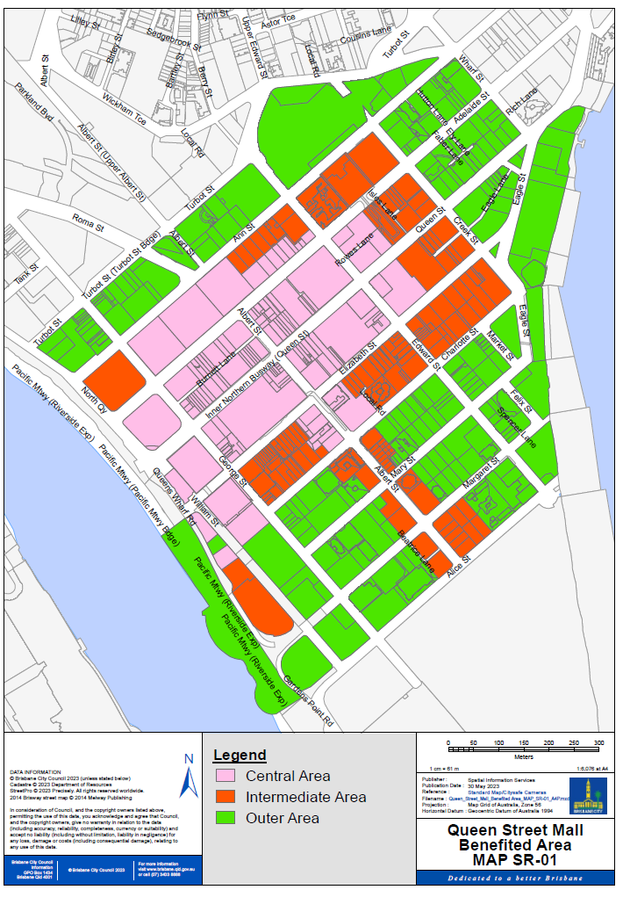

OP-2 |  | Overall Plan
 |  | Chinatown and Valley Malls

Council has determined that all rateable land in the part of the city coloured pink, orange or green on the map “SR-02” will benefit from:
(a) the provision of the works for, and/or works for access to and
(b) operational services including marketing, maintenance, cleaning, security and gardening for
the Chinatown and Valley Malls, undertaken or proposed to be undertaken by, or on behalf of Council (the works, service and activities).

A special rate will be made and levied on the rateable value of the rateable land coloured pink, orange or green on the map “SR-02”, for or towards meeting the costs of the works, services and activities.

The estimated cost of the works, service and activities for the financial year is estimated at $1,980,985.
The estimated time for carrying out the overall plan is one-year, commencing 1 July 2023 and ending on 30 June 2024.

Any unspent funds remaining at the end of the period may be transferred to a subsequent similar plan, if any.
The special rate for the Chinatown/Valley Mall was first adopted by Resolution of Council at the Budget Meeting for the Financial Year 1986-87.

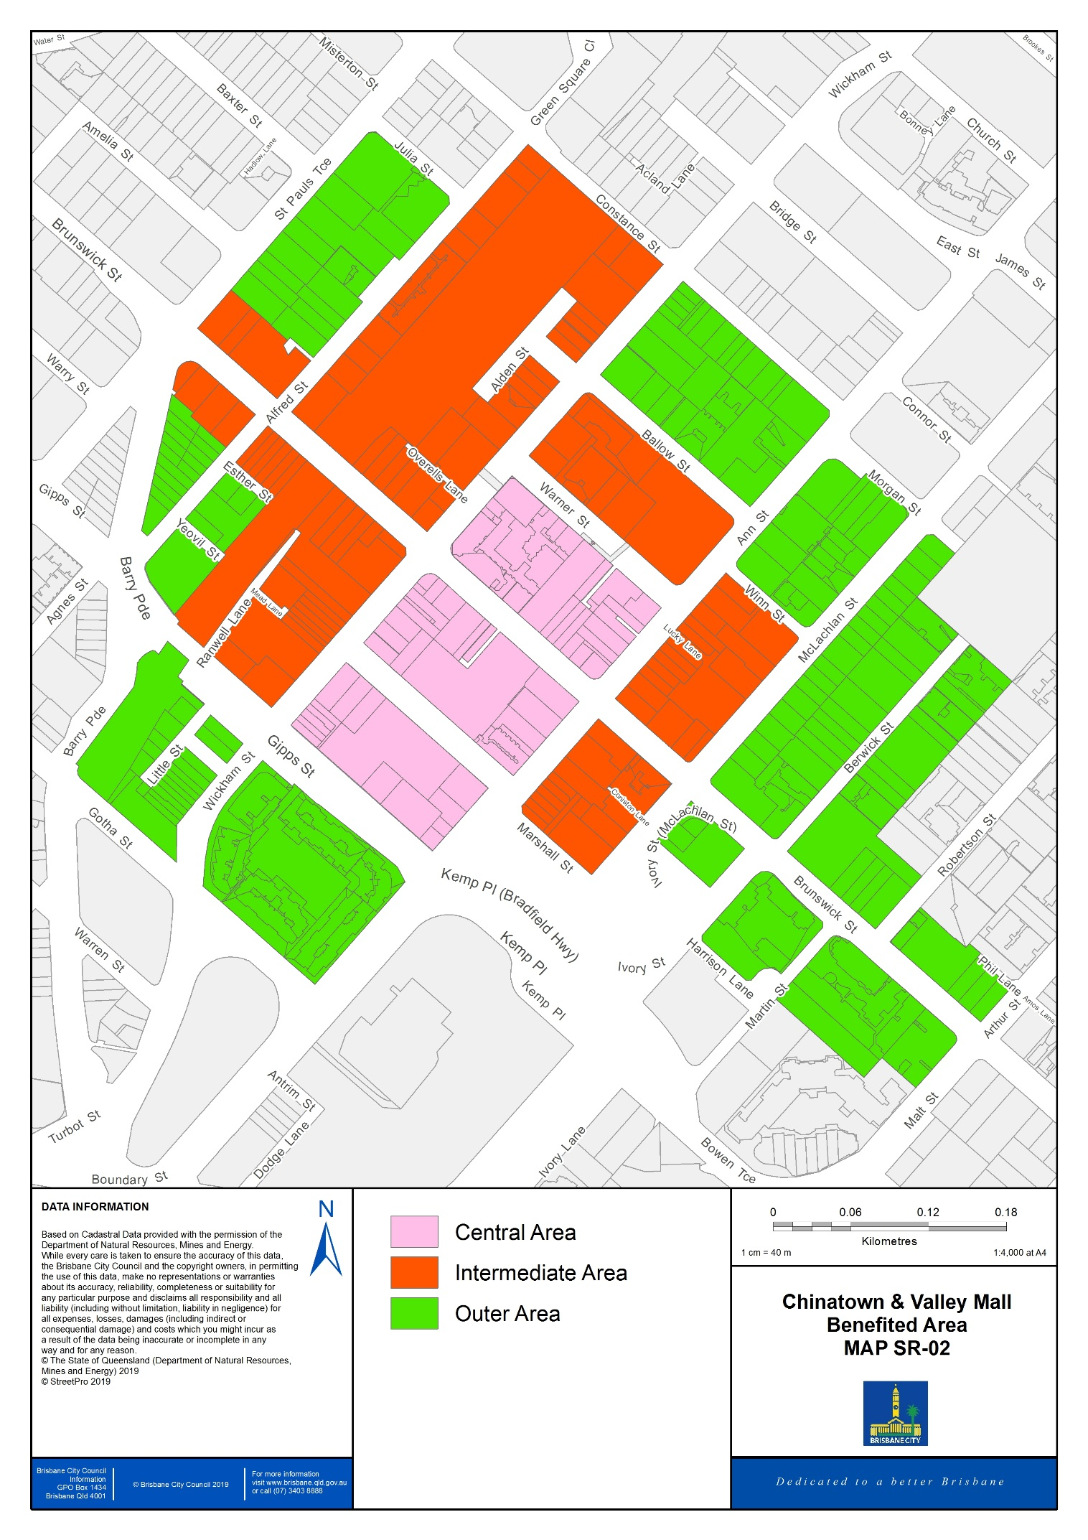

(Note: OP-3 to OP-13 not used)

OP-14 |  | Overall Plan
 |  | Manly Living Village Development

Council has determined that all rateable land used for non-residential purposes in the part of the city coloured pink on the map “SR-14” will benefit from funds to be used for coordination activities, marketing and communication strategies, including marketing and advertising campaigns, promotions and events, education, surveys, public relations and other business development activities undertaken or proposed to be undertaken by or on behalf of Council (the scheme). The object of the scheme is to provide a special benefit to the rateable land by promoting and encouraging business development.

A special rate will be made and levied on the rateable value of the rateable land coloured pink on map “SR-14”, for meeting the costs of the scheme.

The estimated cost of the scheme is $50,000 for the financial year.

The estimated time of carrying out the overall plan is one-year, commencing 1 July 2023 and ending on 30 June 2024.

The money received from the levy will be transferred to the Manly Harbour Village Chamber of Commerce Inc., which will expend the money in accordance with a funding agreement.

The special rate for the Manly Living Village Development was first adopted by Resolution of Council at the Budget Meeting for the Financial Year 2011-12.

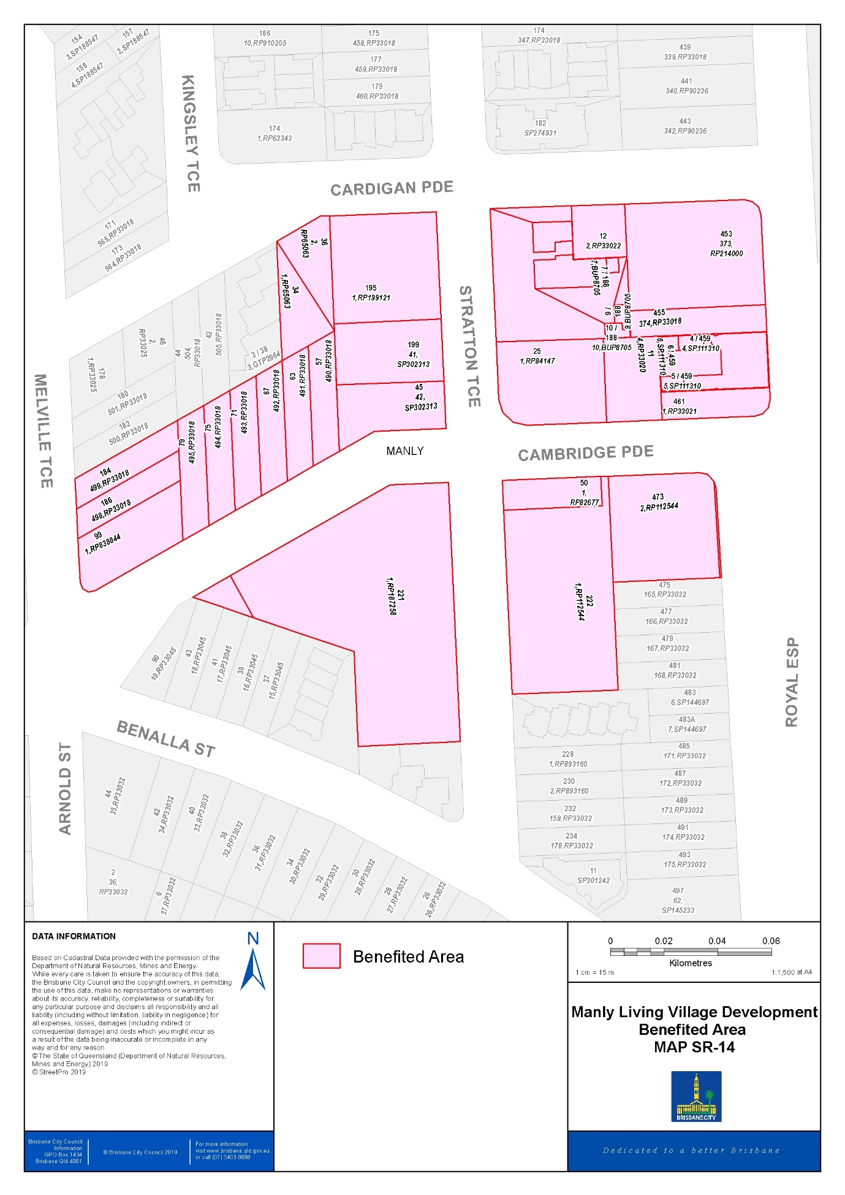

(Note: OP-15 to OP-29 not used)

OP-30 |  | Overall Plan
 |  | St Lucia Suburban Centre Improvement Project

Council has determined that all rateable land in the part of the city coloured pink on the map “SR-30” will benefit from:
(a) the provision of improvements to the public street scape environments, including the provision of new footpaths, street trees, garden beds, public artwork, street furniture, pedestrian lighting and the like for and
(b) the management, cleaning, operating, promoting and developing of,
the St Lucia Suburban Centre Improvement Project undertaken or proposed to be undertaken by, or on behalf of Council (the works, service or activities).

A special rate will be made and levied on the rateable value of the rateable land marked pink on map “SR-30”, for or towards meeting the costs of the works, service or activities.

The estimated cost of the works, service or activities was $2,500,000. The project will be funded by a special charge in the defined benefitted area covering approximately 15% of the cost ($375,000) with the remaining 85% funded from General Rates.

The charge will be levied over a 10-year period commencing financial year 2014-15 and concluding on 30 June 2024. The works, service or activities were completed prior to the commencement of the levy.

The special rate for the St Lucia Suburban Centre Improvement Project was first adopted by Resolution of Council at the Budget Meeting for the Financial Year 2014-15.

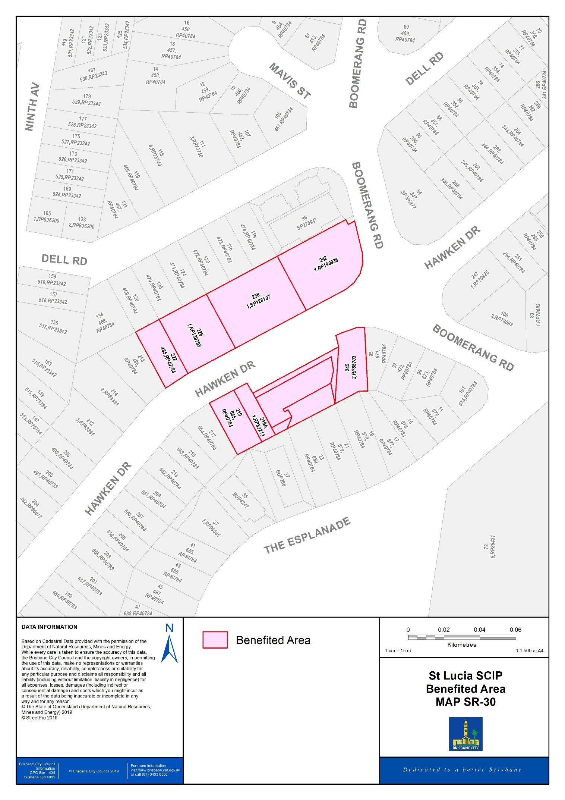

OP-31 |  | Overall Plan
 |  | Kenmore Suburban Centre Improvement Project

Council has determined that all rateable land in the part of the city coloured pink on the map “SR-31” will benefit from:
(a) the provision of improvements to the public street scape environments, including the provision of new footpaths, street trees, garden beds, public artwork, street furniture, pedestrian lighting and the like for and
(b) the management, cleaning, operating, promoting and developing of,
the Kenmore Suburban Centre Improvement Project undertaken or proposed to be undertaken by, or on behalf of Council (the works, service or activities).

A special rate will be made and levied on the rateable value of the rateable land marked pink on map “SR-31”, for or towards meeting the costs of the works, service or activities.

The estimated cost of the works, service or activities was $3,000,000. The project will be funded by a special charge in the defined benefitted area covering approximately 25% of the cost ($750,000) with the remaining 75% funded from General Rates.

The charge will be levied over a 10-year period commencing financial year 2015-16 and concluding on 30 June 2025. The works, service or activities were completed prior to the commencement of the levy.

The special rate for the Kenmore Suburban Centre Improvement Project was first adopted by Resolution of Council at the Budget Meeting for the Financial Year 2015-16.

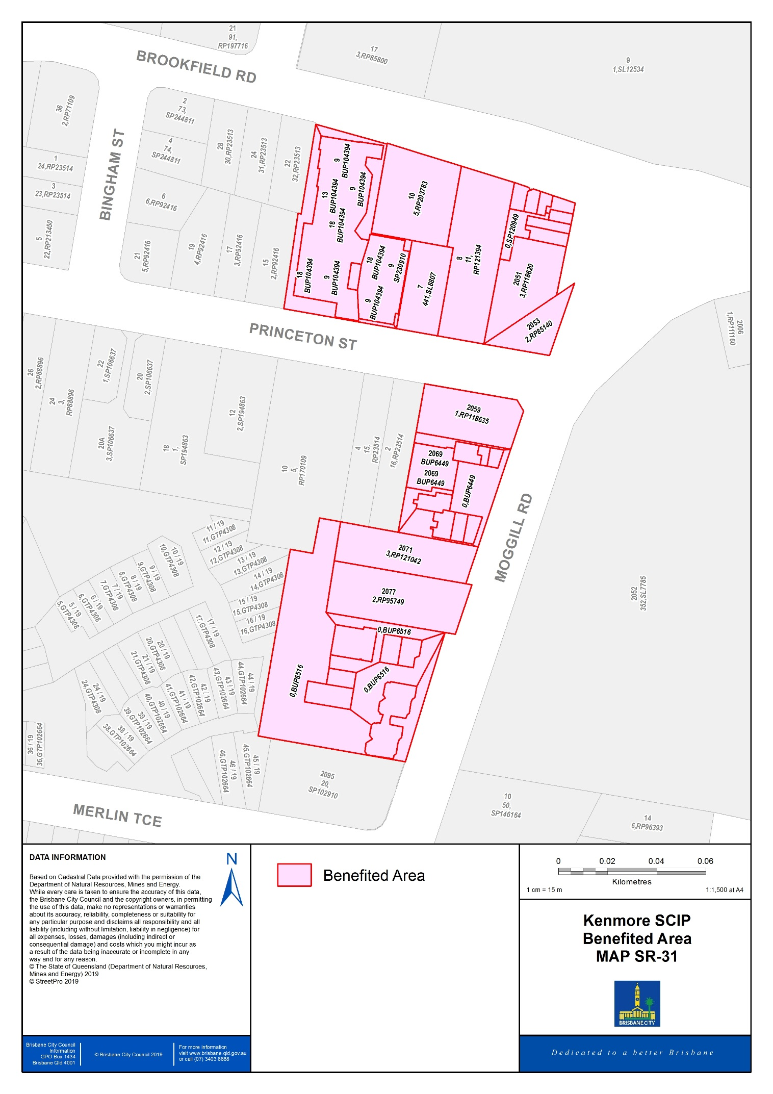

OP-32 |  | Overall Plan
 |  | Cannon Hill Suburban Centre Improvement Project

Council has determined that all rateable land in the part of the city coloured pink on the map “SR-32” will benefit from:
(a) the provision of improvements to the public street scape environments, including the provision of new footpaths, street trees, garden beds, public artwork, street furniture, pedestrian lighting and the like for and
(b) the management, cleaning, operating, promoting and developing of,
the Cannon Hill Suburban Centre Improvement Project undertaken or proposed to be undertaken by, or on behalf of Council (the works, service or activities).

A special rate will be made and levied on the rateable value of the rateable land marked pink on map “SR-32”, for or towards meeting the costs of the works, service or activities.

The estimated cost of the works, service or activities was $2,500,000. The project will be funded by a special charge in the defined benefitted area covering approximately 10% of the cost ($250,000) with the remaining 90% funded from General Rates.

The charge will be levied over a 10-year period commencing financial year 2015-16 and concluding on 30 June 2025. The works, service or activities were completed prior to the commencement of the levy.

The special rate for the Cannon Hill Suburban Centre Improvement Project was first adopted by Resolution of Council at the Budget Meeting for the Financial Year 2015-16.

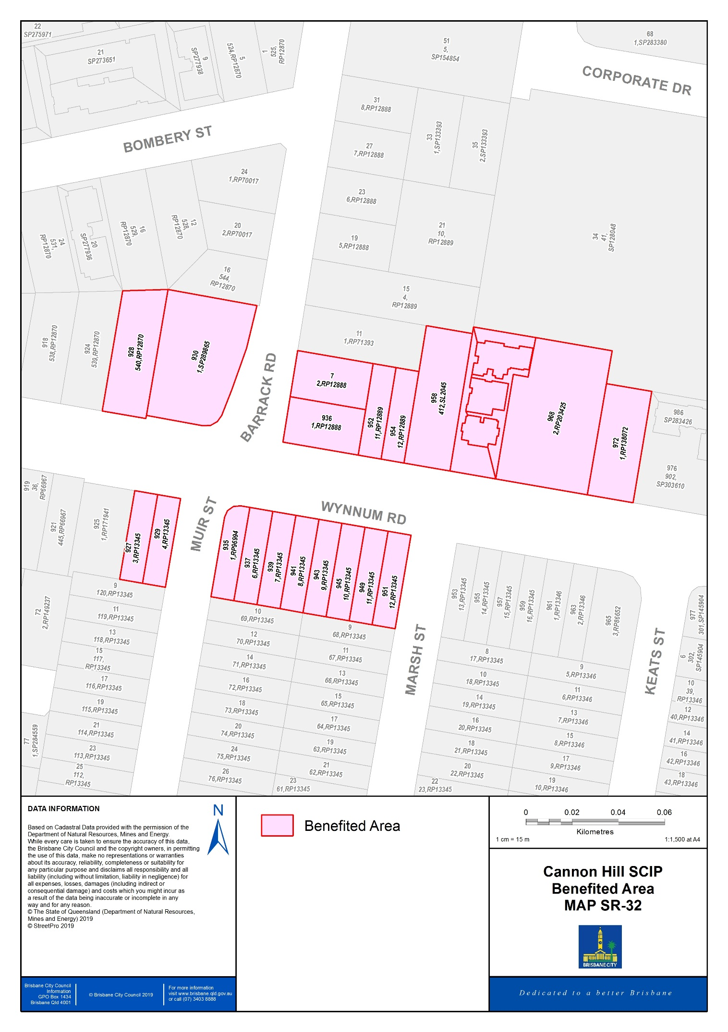

OP-33 |  | Overall Plan
 |  | Graceville Suburban Centre Improvement Project

Council has determined that all rateable land in the part of the city coloured pink on the map “SR-33” will benefit from:
(a) the provision of improvements to the public street scape environments, including the provision of new footpaths, street trees, garden beds, public artwork, street furniture, pedestrian lighting and the like for and
(b) the management, cleaning, operating, promoting and developing of,
the Graceville Suburban Centre Improvement Project undertaken or proposed to be undertaken by, or on behalf of Council (the works, service or activities).

A special rate will be made and levied on the rateable value of the rateable land marked pink on map “SR-33”, for or towards meeting the costs of the works, service or activities.

The estimated cost of the works, service or activities was $3,750,000. The project will be funded by a special charge in the defined benefitted area covering approximately 10% of the cost ($375,000) with the remaining 90% funded from General Rates.

The charge will be levied over a 10-year period commencing financial year 2016-17 and concluding on 30 June 2026. The works, service or activities were completed prior to the commencement of the levy.

The special rate for the Graceville Suburban Centre Improvement Project was first adopted by Resolution of Council at the Budget Meeting for the Financial Year 2016-17.

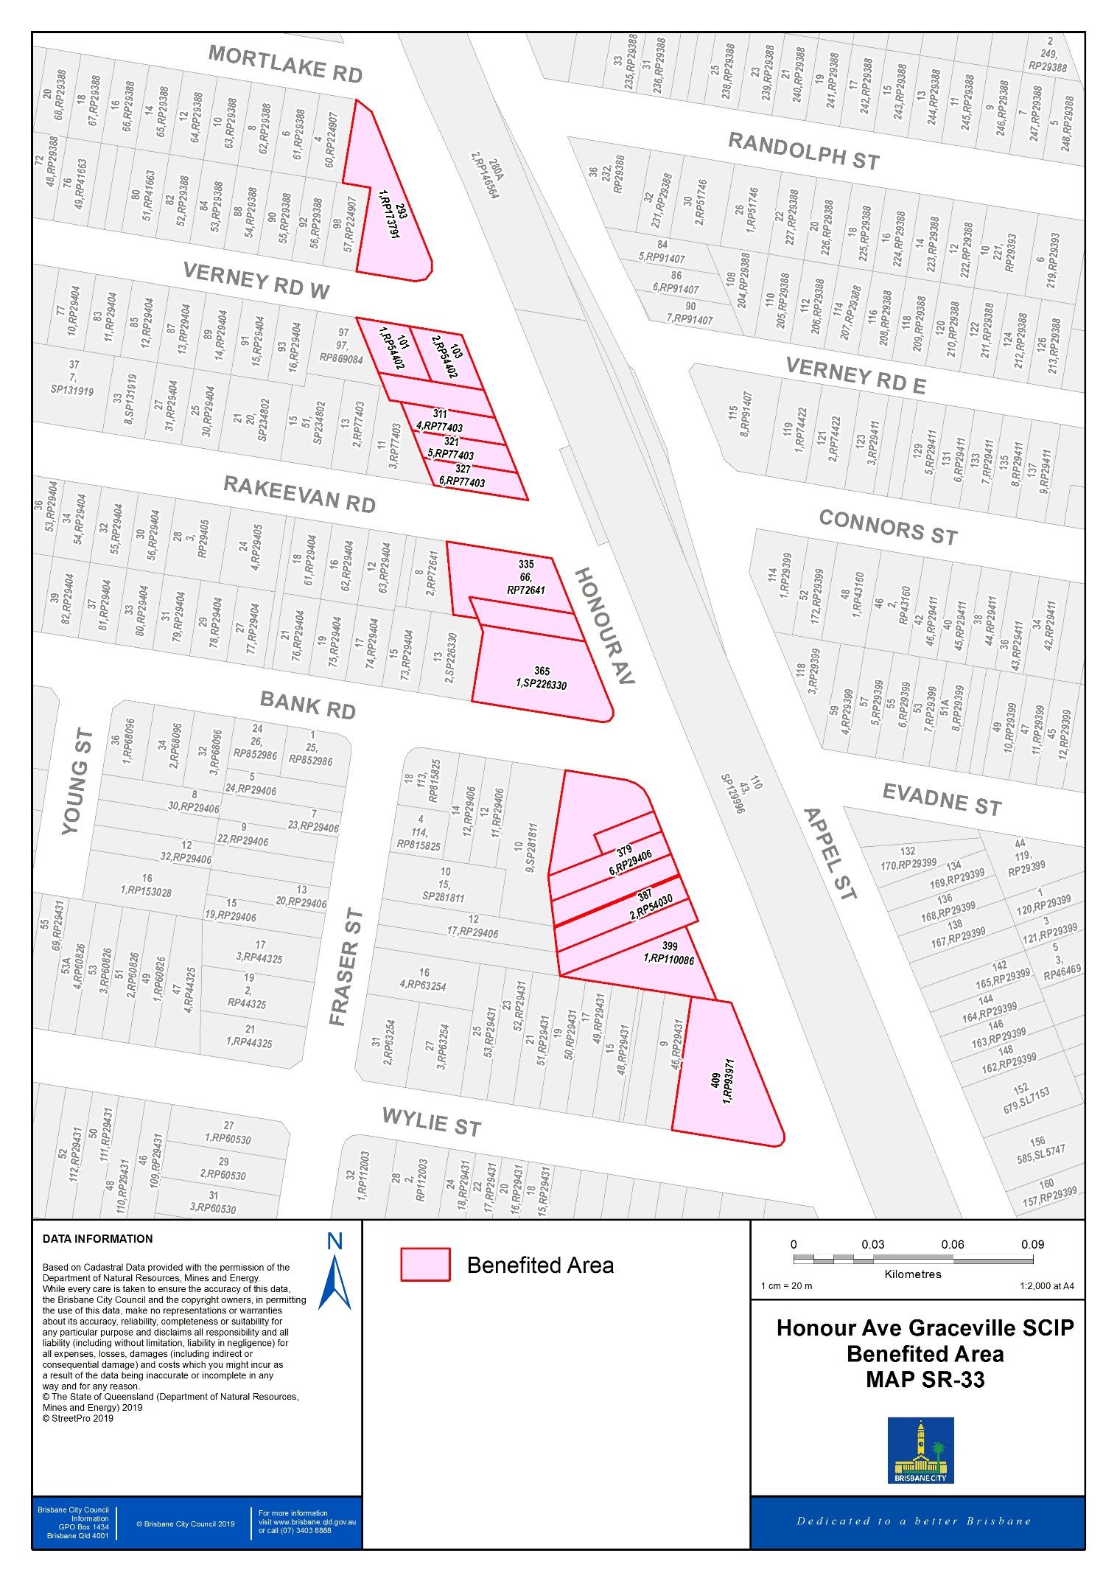

OP-34 |  | Overall Plan
 |  | Alderley Suburban Centre Improvement Project

Council has determined that all rateable land in the part of the city coloured pink on the map “SR-34” will benefit from:
(a) the provision of improvements to the public street scape environments, including the provision of new footpaths, street trees, garden beds, public artwork, street furniture, pedestrian lighting and the like for and
(b) the management, cleaning, operating, promoting and developing of,
the Alderley Suburban Centre Improvement Project undertaken or proposed to be undertaken by, or on behalf of Council (the works, service or activities).

A special rate will be made and levied on the rateable value of the rateable land marked pink on map “SR-34”, for or towards meeting the costs of the works, service or activities.

The estimated cost of the works, service or activities was $5,300,000. The project will be funded by a special charge in the defined benefitted area covering approximately 10% of the cost ($530,000) with the remaining 90% funded from General Rates.

The charge will be levied over a 10-year period commencing financial year 2017-18 and concluding on 30 June 2027. The works, service or activities were completed prior to the commencement of the levy.

The special rate for the Alderley Suburban Centre Improvement Project was first adopted by Resolution of Council at the Budget Meeting for the Financial Year 2017-18.

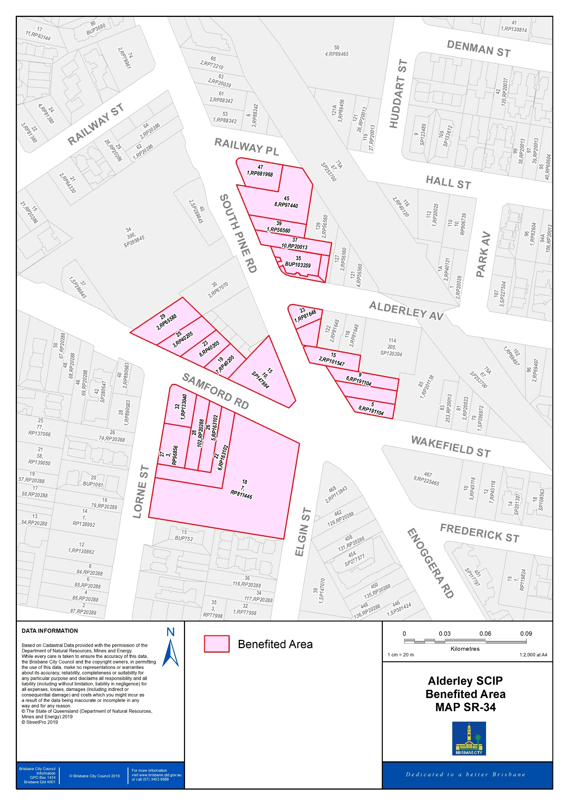

OPC-1.1 |  | Overall Plan
 |  | Brookfield Rural Fire Services Levy

Council has determined that all rateable land in the part of the city coloured pink on the map “SC-1.1” may receive benefit from the provision of fire services by the Brookfield Rural Fire Brigade.

A special charge will be made and levied for or towards meeting the costs of the development of fire services in the rural area to provide adequate protection.

Council considers that, as in general the benefit to any particular land from the development of fire services in the area cannot be distinguished from the benefit to any other particular land in the area, it is appropriate that the special charge be made and levied equally on all land in the area.

First adopted by Resolution of Council in the 1997-98 Financial Year, the Rural Fire Services Levy raised in the defined area will be contributed to the Brookfield Rural Fire Brigade. Council will review the necessity and the level of the charge on an annual basis upon request from the Rural Fire Brigade.

The estimated time of carrying out the overall plan is one-year, commencing 1 July 2023 and ending on 30 June 2024 and the estimated cost is approximately $19,670 per annum.

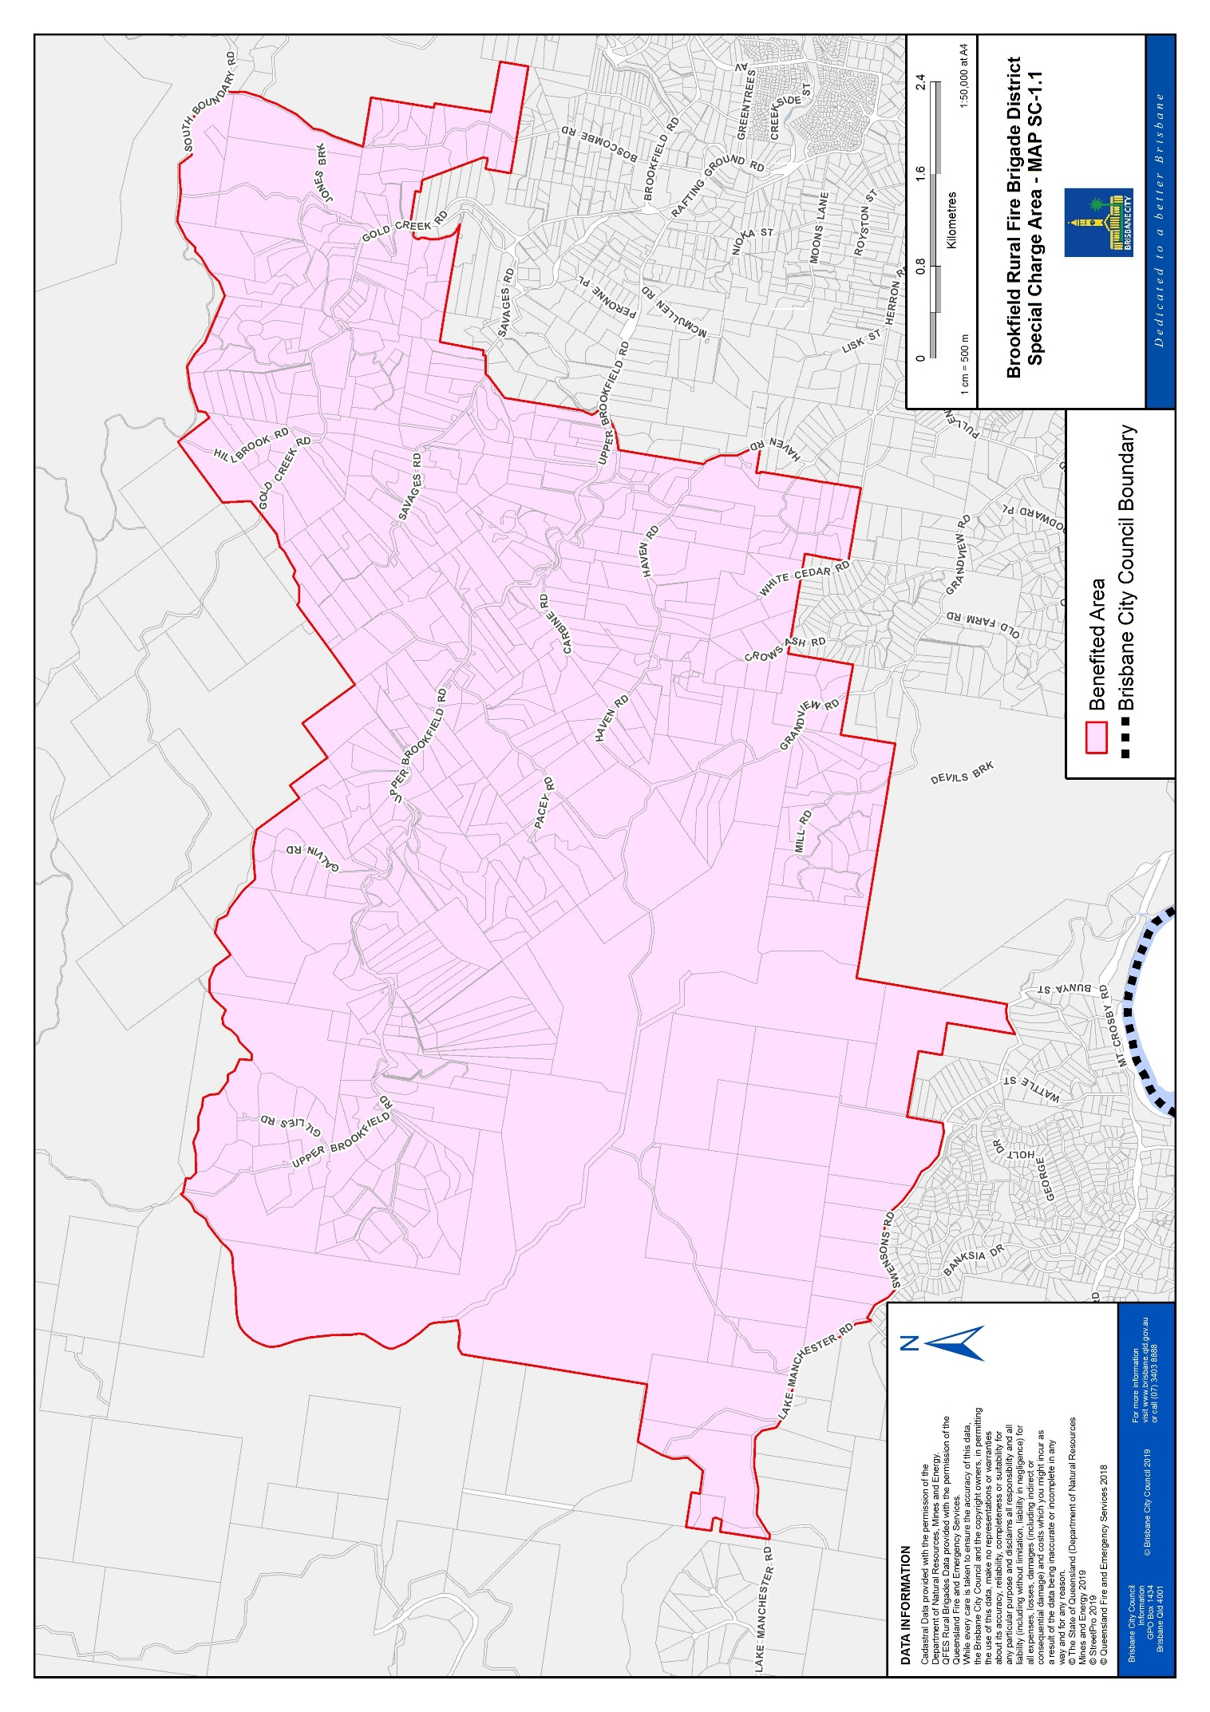

OPC-1.2 |  | Overall Plan
 |  | Pine Mountain Rural Fire Services Levy

Council has determined that all rateable land in the part of the city coloured pink on the map “SC-1.2” may receive benefit from the provision of fire services by the Pine Mountain Rural Fire Brigade.

A special charge will be made and levied for or towards meeting the costs of the development of fire services in the rural area to provide adequate protection.

Council considers that, as in general the benefit to any particular land from the development of fire services in the area cannot be distinguished from the benefit to any other particular land in the area, it is appropriate that the special charge be made and levied equally on all land in the area.

First adopted by resolution of Council in the 2000-01 Financial Year, the Rural Fire Services Levy raised in the defined area will be contributed to the Pine Mountain Rural Fire Brigade. Council will review the necessity and the level of the charge on an annual basis upon request from the Rural Fire Brigade.

The estimated time of carrying out the overall plan is one-year, commencing 1 July 2023 and ending on 30 June 2024 and the estimated cost is approximately $1,650 per annum.

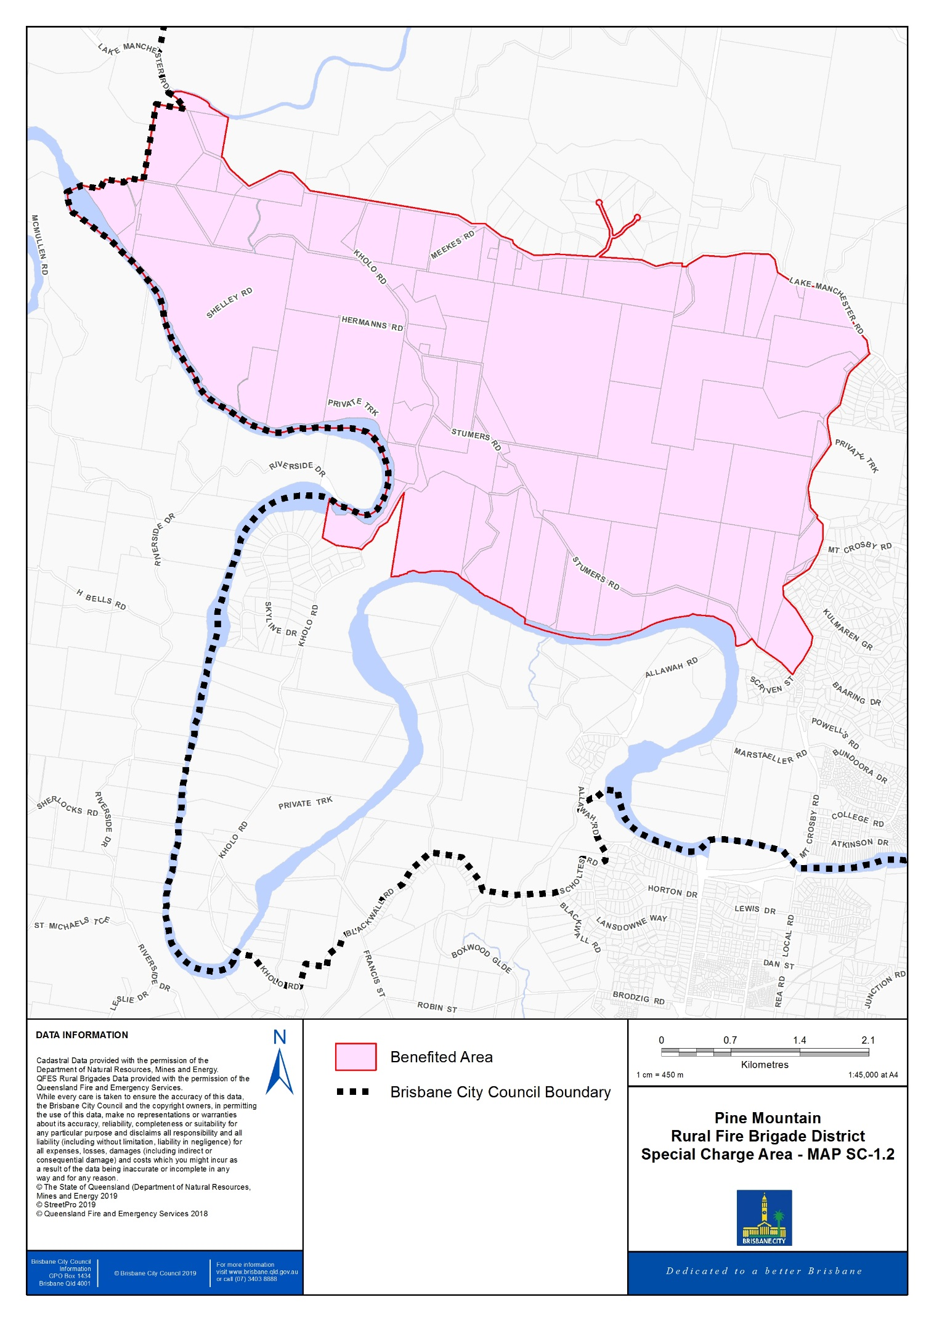

OPC-1.3 |  | Overall Plan
 |  | Moreton Island Rural Fire Services Levy

Council has determined that all rateable land in the part of the city coloured pink on the map “SC-1.3” may receive benefit from the provision of fire services by the Moreton Island Rural Fire Brigade.

A special charge will be made and levied for or towards meeting the costs of the development of fire services in the rural area to provide adequate protection.

Council considers that, as in general the benefit to any particular land from the development of fire services in the area cannot be distinguished from the benefit to any other particular land in the area, it is appropriate that the special charge be made and levied equally on all land in the area.

First adopted by resolution of Council in the 2013-14 Financial Year, the Rural Fire Services Levy raised in the defined area will be contributed to the Moreton Island Rural Fire Brigade. Council will review the necessity and the level of the charge on an annual basis upon request from the Rural Fire Brigade.

The estimated time of carrying out the overall plan is one-year, commencing 1 July 2023 and ending on 30 June 2024 and the estimated cost is approximately $6,140 per annum.

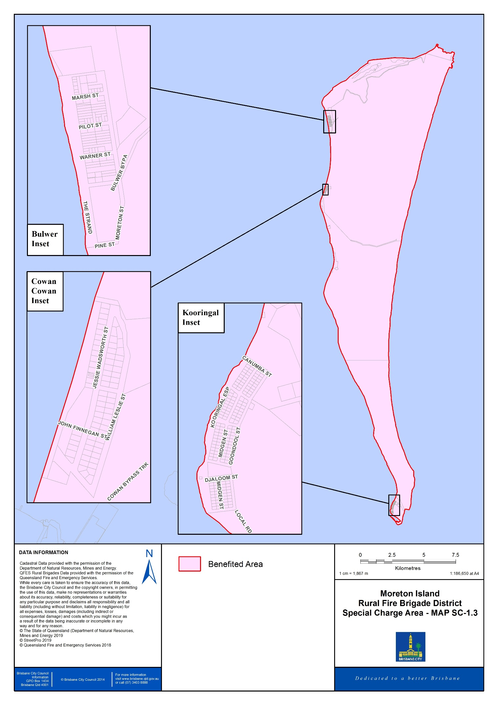

- Special Rates and Charges – Annual Implementation Plans

AIP-1 |  | Annual Implementation Plan
 |  | Queen Street Mall

This AIP-1 sets out the actions or processes that are to be carried out in the financial year for the scheme defined by the map labelled SR-01 as shown in the associated ‘Overall Plan’ OP-1.

Council or its agents will deliver the services required to achieve the objects of the overall plan in the 2023-24 year. The actions and processes to be undertaken for the Queen Street Mall (“the Mall”) will include:
(a) the provision of the works for, and/or works for access to the Mall
(b) operational services including maintenance, cleaning, security and gardening of the Mall
(c) liaison, survey and education with the Mall’s businesses and
(d) marketing activities for the Mall.

The funds, totalling $9,936,917 for the financial year, will be expended only on activities within the agreed activities described in OP-1 and this plan.

AIP-2 |  | Annual Implementation Plan
 |  | Valley and Chinatown Malls

This AIP-2 sets out the actions or processes that are to be carried out in the financial year for the scheme defined by the map labelled SR-02 as shown in the associated ‘Overall Plan’ OP-2.

Council or its agents will deliver the services required to achieve the objects of the overall plan in the 2023-24 year. The actions and processes to be undertaken for the Valley/Chinatown Mall (“the Mall”) will include:
(a) the provision of the works for, and/or works for access to the Mall
(b) operational services including maintenance, cleaning, security and gardening of the Mall
(c) liaison, survey and education with the Mall’s businesses and
(d) marketing activities for the Mall.

The funds, totalling $1,980,985 for the financial year, will be expended only on activities within the agreed activities described in OP-2 and this plan.

(Note: AIP-3 to AIP-13 not used)

AIP-14 |  | Annual Implementation Plan
 |  | Manly Living Village Development

This AIP-14 sets out the actions or processes that are to be carried out in the financial year for the scheme defined by the map labelled SR-14 as shown in the associated ‘Overall Plan’ OP-14.

Council will contract with the Manly Harbour Village Chamber of Commerce Inc. (trading as Manly Chamber of Commerce Inc.) to deliver the services required to achieve the objects of the overall plan in the financial year. The actions and processes will include:
(a) the appointment of a precinct coordinator to carry out the plan’s actions and processes
(b) liaison, survey and education with precinct businesses
(c) marketing activities
(d) advertising
(e) public relations
(f) business development
(g) reporting and accountability obligations.

The funds, totalling $50,000 for the financial year, will be collected from non-residential land which are:
(a) deemed to have benefitted from the agreed actions and processes and are located within the boundaries of the map labelled SR-14 as shown in the associated ‘Overall Plan’ and
(b) will be expended only on agreed activities defined in OP-14.

Manly Chamber of Commerce Inc. will provide Council with a mid-year report as to details of expenditure of funds to that date and, within 12 weeks of the end of the financial year, audited financial accounts that include details of the activities funded by the scheme for the year. The Manly Chamber of Commerce Inc. will provide any additional written reports on agreed activities requested by Council within a reasonable time-frame.

(Note: AIP-15 to AIP-29 not used)

AIP-30 |  | Annual Implementation Plan
 |  | St Lucia Suburban Centre Improvement Project

Suburban Centre Improvement Program (SCIP) projects deliver streetscape upgrades in consultation with the Brisbane community. These projects include the provision of new footpaths, street trees, garden beds, public artwork, street furniture, pedestrian lighting and the like.

In 2013, a SCIP project was undertaken in St Lucia and the area deemed to have benefitted is defined by the map labelled SR-30 as shown in the associated ‘Overall Plan’ OP-30. The estimated cost of the works, service and activities was $2,500,000. The project is funded by a special charge in the defined benefitted area covering approximately 15% of the cost ($375,000) with the remaining 85% funded from General Rates.

The benefitted area, total levy amount of $375,000 was agreed with owners in the defined benefitted area prior to the delivery of the SCIP. There is no interest charged or indexing of the total levy amount.

Brisbane City Council funded the $2,500,000 up front cost of the project. The owners within the defined benefitted area are paying Council back through their rates and charges over the 10-year period, following the completion of construction of the SCIP.

This implementation plan is in support of the recovery of the $375,000 over the 10-year period, which commenced in the financial year 2014-15 and concluding on 30 June 2024.

AIP-31 |  | Annual Implementation Plan
 |  | Kenmore Suburban Centre Improvement Project

Suburban Centre Improvement Program (SCIP) projects deliver streetscape upgrades in consultation with the Brisbane community. These projects include the provision of new footpaths, street trees, garden beds, public artwork, street furniture, pedestrian lighting and the like.

In 2014, a SCIP project was undertaken in Kenmore and the area deemed to have benefitted is defined by the map labelled SR-31 as shown in the associated ‘Overall Plan’ OP-31. The estimated cost of the works, service and activities was $3,000,000. The project is funded by a special charge in the defined benefitted area covering approximately 25% of the cost ($750,000) with the remaining 75% funded from General Rates.

The benefitted area, total levy amount of $750,000 was agreed with owners in the defined benefitted area prior to the delivery of the SCIP. There is no interest charged or indexing of the total levy amount.

Brisbane City Council funded the $3,000,000 up front cost of the project. The owners within the defined benefitted area are paying back Council through their rates and charges over the 10-year period, following the completion of construction of the SCIP.

This implementation plan is in support of the recovery of the $750,000 over the 10-year period, which commenced in the financial year 2015-16 and concluding on 30 June 2025.

AIP-32 |  | Annual Implementation Plan
 |  | Cannon Hill Suburban Centre Improvement Project

Suburban Centre Improvement Program (SCIP) project deliver streetscape upgrades in consultation with the Brisbane community. These projects include the provision of new footpaths, street trees, garden beds, public artwork, street furniture, pedestrian lighting and the like.

In 2014, a SCIP project was undertaken in Cannon Hill and the area deemed to have benefitted is defined by the map labelled SR-32 as shown in the associated ‘Overall Plan’ OP-32. The estimated cost of the works, service and activities was $2,500,000. The project is funded by a special charge in the defined benefitted area covering approximately 10% of the cost ($250,000) with the remaining 90% funded from General Rates.

The benefitted area, total levy amount of $250,000 was agreed with owners in the defined benefitted area prior to the delivery of the SCIP. There is no interest charged or indexing of the total levy amount.

Brisbane City Council funded the $2,500,000 up front cost of the project. The owners within the defined benefitted area are paying back Council through their rates and charges over the 10-year period, following the completion of construction of the SCIP.

This implementation plan is in support of the recovery of the $250,000 over the 10-year period, which commenced in the financial year 2015-16 and concluding on 30 June 2025.

AIP-33 |  | Annual Implementation Plan
 |  | Graceville Suburban Centre Improvement Project

Suburban Centre Improvement Program (SCIP) projects deliver streetscape upgrades in consultation with the Brisbane community. These projects include the provision of new footpaths, street trees, garden beds, public artwork, street furniture, pedestrian lighting and the like.

In 2015, a SCIP project was undertaken in Graceville and the area deemed to have benefitted is defined by the map labelled SR-33 as shown in the associated ‘Overall Plan’ OP-33. The estimated cost of the works, service and activities was $3,750,000. The project is funded by a special charge in the defined benefitted area covering approximately 10% of the cost ($375,000) with the remaining 90% funded from General Rates.

The benefitted area, total levy amount of $375,000 was agreed with owners in the defined benefitted area prior to the delivery of the SCIP. There is no interest charged or indexing of the total levy amount.

Brisbane City Council funded the $3,750,000 up front cost of the project. The owners within the defined benefitted area are paying back Council through their rates and charges over the 10-year period, following the completion of construction of the SCIP.

This implementation plan is in support of the recovery of the $375,000 over the 10-year period, which commenced in the financial year 2016-17 and will conclude on 30 June 2026.

AIP-34 |  | Annual Implementation Plan
 |  | Alderley Suburban Centre Improvement Project

Suburban Centre Improvement Program (SCIP) projects deliver streetscape upgrades in consultation with the Brisbane community. These projects include the provision of new footpaths, street trees, garden beds, public artwork, street furniture, pedestrian lighting and the like.

In 2015, a SCIP project was undertaken in Alderley and the area deemed to have benefitted is defined by the map labelled SR-34 as shown in the associated ‘Overall Plan’ OP-34. The estimated cost of the works, service and activities was $5,300,000. The project is funded by a special charge in the defined benefitted area covering approximately 10% of the cost ($530,000) with the remaining 90% funded from General Rates.

The benefitted area, total levy amount of $530,000 was agreed with owners in the defined benefitted area prior to the delivery of the SCIP. There is no interest charged or indexing of the total levy amount.

Brisbane City Council funded the $5,300,000 up front cost of the project. The owners within the defined benefitted area are paying back Council through their rates and charges over the 10-year period, following the completion of construction of the SCIP.

This implementation plan is in support of the recovery of the $530,000 over the 10-year period, which commenced in the financial year 2017-18 and will conclude on 30 June 2027.

AIPC-1.1 |  | Annual Implementation Plan
 |  | Brookfield Rural Fire Services Levy

This AIPC-1.1 sets out the actions or processes that are to be carried out in the financial year for the scheme described in the Overall Plan OPC-1.1.

Council will collect on behalf of the Brookfield Rural Fire Brigade a levy to deliver the services required to achieve the objects of the overall plan in the financial year.

Each year the Brookfield Rural Fire Brigade will utilise the funds collected by Council to the benefit of the district by providing actions and processes such as:
(a) upgrading of plant and equipment
(b) liaison, survey and education with the precinct on fire safety and strategy
(c) expansion of services
(d) education.

An annual levy of $35.00 for the financial year, will be collected from rateable land which are:
(a) deemed to have benefitted from the agreed actions and processes and
(b) located within the boundaries of the map labelled SC-1.1 as shown in the associated ‘Overall Plan’ and,
will be expended only on agreed activities defined in OPC-1.1.

AIPC-1.2 |  | Annual Implementation Plan
 |  | Pine Mountain Rural Fire Services Levy

This AIPC-1.2 sets out the actions or processes that are to be carried out in the financial year for the scheme described in the Overall Plan OPC-1.2.

Council will collect on behalf of the Pine Mountain Rural Fire Brigade a levy to deliver the services required to achieve the objects of the overall plan in the financial year.

Each year the Pine Mountain Rural Fire Brigade will utilise the funds collected by Council to the benefit of the district by providing actions and processes such as:
(a) upgrading of plant and equipment
(b) liaison, survey and education with the precinct on fire safety and strategy
(c) expansion of services
(d) education.

An annual levy of $30.00 for the financial year, will be collected from rateable land which are:
(a) deemed to have benefitted from the agreed actions and processes and
(b) located within the boundaries of the map labelled SC-1.2 as shown in the associated ‘Overall Plan’ and,
will be expended only on agreed activities defined in OPC-1.2.

AIPC-1.3 |  | Annual Implementation Plan
 |  | Moreton Island Rural Fire Services Levy

This AIPC-1.3 sets out the actions or processes that are to be carried out in the financial year for the scheme described in the Overall Plan OPC-1.3

Council will collect on behalf of the Moreton Island Rural Fire Brigade a levy to deliver the services required to achieve the objects of the overall plan in the financial year.

Each year the Moreton Island Rural Fire Brigade will utilise the funds collected by Council to the benefit of the district by providing actions and processes such as:
(a) upgrading of plant and equipment
(b) liaison, survey and education with the precinct on fire safety and strategy
(c) expansion of services
(d) education.

An annual levy of $20.00 for the financial year, will be collected from rateable land which are:
(a) deemed to have benefitted from the agreed actions and processes and
(b) located within the boundaries of the map labelled SC-1.3 as shown in the associated ‘Overall Plan’ and,
will be expended only on agreed activities defined in OPC-1.3.

- Land Use Codes 2023-24
The land use code is part of Council’s land record and indicates the predominant use for which the land is utilised or adapted to be utilised by virtue of its structure, fixtures and fittings or particular improvements and is an indicator of the land specific rating criteria.

The attribution of a land use code does not validate an unlawful or improper use of land. Council may review land uses of particular land to determine if they are permissible. Such a review may result in a notice to desist a particular activity.

The primary land use code identifies the predominant use for which the land is utilised and is an indicator of the land’s specific rating category, while the secondary land use code applies where a lesser but not insignificant use is also conducted on the land.

The description of each rating category is used to identify which differential rating category land will be placed in accordance with this resolution.

In determining the predominant use, consideration will be given, but is not limited to, the visual, spatial and economic attributes of the land. Area is not the principal basis for determining the predominant use. The predominant use may be determined and applied during the construction phase of a structure and will be identified by its ultimate land use code followed by a secondary land use code of 01.

Land Use Codes Table

Code | Description | Definition
01 | Vacant Urban Land | Land upon which no structure is erected and which is being put to no higher use, or land upon which is being constructed an approved single dwelling until completion.  Excluding:  - land during the construction of a building/s or structure/s (excluding approved single dwellings)  - land meeting the criteria of land use code 72  - vacant or disused building/s.
01 | Construction site (Secondary code only) | When used as a secondary code, 01 indicates that the primary use is under construction. It includes land upon which the construction of an improvement has commenced but may not be completed or a building is undergoing refurbishment and the building/s is/are uninhabitable/derelict.
02 | Single Unit Dwelling | Land on which is constructed a dwelling that provides self-contained accommodation for one household and is occupied by the owner as the owner’s main place of residence.
03 | Multiple Dwelling | Land on which is constructed a multiple dwelling (and includes groups of units held by single owners in a community title scheme).  Note: This code applies to building units and town houses prior to the registration of a Community Title Plan  The term includes flats, attached houses, duplex houses, community dwellings and detached houses where they occur on a single land holding.
Codes: 04, 09,13, 66-69, 78-84, 87-89 and 93-95 not used.
05 | Educational – Tertiary | Land that contains a building/s predominantly used for the provision of tertiary education, including:  - Universities  - Residential colleges of a tertiary education institution  - TAFE colleges  - Seminaries and colleges of religious studies  - Other tertiary education institutions providing courses approved for HECS support.
06 | Uninhabitable building/structure/ improvement | Land which contains improvements such as:  - a minor structure (shed or garage) of no more than 50m² gross floor area (GFA)  - a structure (shed or garage) of greater than 50m² GFA that is approved for domestic purposes only and not for commercial, warehousing, manufacturing or business use  - uninhabitable fire/flood damaged/derelict buildings  - toilet or toilet block  - private swimming pool or private tennis court,  provided there is no monetary return being derived from any activities or structures on the land.
07 | Boarding house/rooming units/ Private Hotel | Land that contains a building/s predominantly used or adapted to be used as non-self-contained rental accommodation excluding Accommodation Hotel/Motel. This includes:  - boarding houses  - boarding hostel  - private hotels  - tenement buildings  - flats  - rooming units  - other accommodation buildings such as convents.
08 | Community Title Scheme | Land that has been surveyed and registered as a community title scheme.  Note: the secondary use of each community title should refer to the actual use (i.e. residential, commercial etc.).
10 | Combined Multiple Dwelling and Shop(s) | Land that contains a building/s with a predominant use of or adapted to be used as combined residential flat/s with shop/s, but not registered as a community title scheme.
11 | Shop – Single | Land, less than 4,000m² in area that contains a building with a predominant use of or adapted to be used as a shop with or without attached accommodation but not a restaurant.
12 | Shops - Multiple | Land, less than 4,000m² in area that contains a building/s with a predominant use of or adapted to be used as more than 1 distinct retail/commercial areas.
14 | Shops(s) – Main Retail | Land that contains a building/s with a predominant use of or adapted to be used as retail shops and located within the CBD.
15 | Shop(s) – Secondary Retail | Land, with an area of 4,000m² or more, not conforming to the requirements of land use code 16 (Drive-In Shopping Centre) or land use code 23 (Retail Warehouse), that contains a building/s with the predominant use of or adapted to be used as retail shops(s) and located outside of the CBD.
16 | Drive-In Shopping Centres | Land, with an area of 4,000m² or more, that contains a building/s the predominant use of or adapted to be used as retail outlet/s and/or service provider/s with associated off-street parking that principally offer:  - consumable items such as groceries, clothing, homewares  - department store retail  - specialty stores including gift shops, newsagents, hairdressing etc.  - service provision offices such as banks, post offices, doctors/dental surgeries.
17 | Restaurant/Fast Food Outlet (non-drive-through) | Land that contains a building/s with the predominant use of or adapted to be used to provide dine-in or take-away food without a drive-through facility (see land use code 73).
18 | Special Tourist Attraction | Land that contains improvements with the predominant use of or adapted to be used for specific recreational, historical, cultural, fauna or flora features, including tourist villages and:  - wildlife sanctuaries  - theme parks  - Brisbane Entertainment Centre  - Brisbane Powerhouse  - Brisbane Exhibition and Convention Centre.
19 | Walkway/Ramp | An area in stratum used as a walkway or ramp.
20 | Marina | Land that contains improvements with the predominant use of or adapted to be used for a marina, including land-based services such as valet and storage facilities but excluding harbour industries or structural, mechanical repairs.
21 | Residential Care Institution | Land that contains a building/s with the predominant use of or adapted to be used for:  - convalescent or nursing care  - an orphanage or children’s home  - an institution for poor or disadvantaged persons  - a home for the care of disabled or aged persons and  - comprising residential facilities (non-self-contained) for more than six persons. Typically, residents would be unable to live independently and requiring medical/nursing care or in-house assistance/supervision provided by on-site carers.  Note: The term does not include hospitals, reformative institutions or registered retirement villages. For retirement facilities see land use code 60.
22 | Carpark | Land with or without improvements with the predominant use of or adapted to be used for the parking of motor vehicles whether fees are charged or not.
23 | Retail Warehouse | Land that contains a building/s with the predominant use of or adapted to be used as retail outlet/s and/or service provider/s with associated off-street parking that principally offer:  - hardware and home improvements, including gardening and landscaping  - electrical appliances including entertainment and white goods  - furnishings and décor  - motor vehicle parts and accessories  - retail sellers of particular categories of goods, i.e. household, office, leisure and pharmaceutical and bulk food.
24 | Sales Area | Land with the predominant use of or adapted to be used for the display and/or sale of:  - boats  - cars  - caravans  - motorcycles  - swimming pools  - timber etc.
25 | Office(s) | Land that contains a building/s with the predominant use of or adapted to be used for the transaction of business, the provision of professional services or the like.  Note: This code includes display homes or other structures that are utilised as a sales or site office.
26 | Funeral Parlours | Land that contains a building/s with the predominant use of or adapted to be used as a funeral parlour.
27 | Private Hospital | Land that contains a building/s with the predominant use of or adapted to be used for medical or surgical treatment of in-patients, out-patients or day surgeries on a fee for service basis.
28 | Warehouses/Bulk Stores | Land that contains a building/s with the predominant use of or adapted to be used for the storage of wholesale goods prior to distribution. (e.g. Coles or Woolworths distribution centres.)
29 | Transport Terminal | Land with the predominant use of or adapted to be used for the loading, discharging or transferring of freight and/or passengers.
30 | Fuel Station | Land that contains a building/s with the predominant use of or adapted to be used for the retail refuelling/recharging of vehicles.  Note: for predominantly servicing and/or repairs refer to land use code 36.
31 | Fuel Depots | Land that contains a building/s with the predominant use of or adapted to be used for the storage of fuels, oils or other flammable materials.
32 | Wharves | Land that contains a building/s or structure/s with the predominant use of or adapted to be used as wharves, jetties and barge landings.
33 | Builders Yard/Contractors Yard | Land with the predominant use of or adapted to be used for:  - building and/or garden material storage (not retail or hardware)  - secure area for parking heavy equipment or large construction materials  - motor vehicle wrecking, scrap dealers yard etc.
34 | Cold Stores – Ice Works | Land that contains a building/s or structure/s with the predominant use of or adapted to be used for the cold storage of food or other perishable items including the commercial production of ice and associated products.
35 | General Industry | Land that contains a building/s or structure/s with the predominant use of or adapted to be used for medium to high impact industries. Refer to medium and high impact industry in Schedule 1 of the Brisbane City Plan 2014.
36 | Light Industry | Land that contains a building/s with the predominant use of or adapted to be used for low impact industry and service industry. Refer to Low impact industry in Schedule 1 of the Brisbane City Plan 2014.
37 | Noxious/Offensive/Extractive Industry | Land with or without building/s or structure/s with the predominant use of or adapted to be used for special industry that may produce significant or offensive levels of noise, odour or dust e.g. quarries, abattoirs, tanneries or chemical production. Refer to Special Industry in Schedule 1 of the Brisbane City Plan 2014.
38 | Advertising Hoarding | Land solely used for the display of advertising.
39 | Harbour Industry | Land with or without building/s or structure/s with the predominant use of or adapted to be used for harbour or marine associated industries.
40 | Kindergarten | Land that is solely established for the purpose of providing government approved kindergarten programs taught by qualified early childhood teachers:  - recognised as an “income tax exempt charity” by the Australian Taxation Office; and  - holds current registration as a “charity” with the Australian Charities and Not-for-Profits Commission.  This definition specifically does not include any land on which is being conducted any form of day care or vocational care whether or not the centre is run as a not-for-profit.
41 | Child Care Centre | Land that contains a building/s used or adapted to be used for:  - child care or crèche  - child minding, excluding residential care,  for a fee and exceeds the criteria of column 3, section 15.6 of this resolution.
42 | Hotel/Tavern | Land that contains a building/s with the predominant use of or adapted to be used for a ‘licensed premises’ under the Liquor Act 1992 including a casino.
43 | Accommodation Hotel/Motel | Land that contains a building/s with the predominant use of or adapted to be used for providing itinerant accommodation to tourists, travellers and business people including:  - tourist hotels  - drive in motels  - backpacker hostels
44 | Nurseries/Garden Centres | Land with or without building/s or structure/s with the predominant use of or adapted to be used for the retail sales of plants, seeds, propagative and landscaping materials as well as garden features and tools.  Excludes: turf farms – land use code 74.
45 | Theatres and Cinemas | Land that contains a building/s with the predominant use of or adapted to be used for the presentation of live entertainment or motion pictures.
46 | Drive-in Theatre | Land with building/s or structure/s with the predominant use of or adapted to be used for the in-car presentation of motion pictures.
47 | Licensed Clubs | Land that contains a building/s with the predominant use of or adapted to be used as a club (excluding sporting clubs) licensed to serve liquor under the Liquor Act 1992.
48 | Sports Clubs/Facilities | Land with or without building/s or structure/s with the predominant use of or adapted to be used to provide sporting facilities or clubhouses with or without a liquor licence. As well as not-for-profit sporting bodies this includes commercial sporting facilities such as:  - skating rinks  - gymnasiums  - bowling alleys  - squash and tennis courts  - riding schools etc.
49 | Caravan Park | Land with building/s or structure/s with the predominant use of or adapted to be used for the siting of caravans or motorhomes for itinerant residential use.
50 | Other Clubs (Non-Business) | Land that contains a building/s with the predominant use of or adapted to be used as the meeting place of a non-licensed, not-for-profit club. Club includes:  - lodges  - friendly societies  - scouts  - guides  - memorial halls.
51 | Religious | Land that contains a building/s with the predominant use of or adapted to be used for religious purposes and owned by a religious institution. The code does not include residences owned by religious institutions.  Note: For Convents use land use code 07 and for Manses, Presbyteries, Rectories etc. use land use code 70.
52 | Cemetery | Land that is with the predominant use of or adapted to be used for the interment of human remains and may include a chapel, crematorium or columbarium.
53 | Relocatable Home Park  (Primary code only) | Land with building/s or structure/s with the predominant use of or adapted to be used for the siting of relocatable homes for residential purposes.
54 | Art Gallery/Museum/Zoo  (Primary code only) | Land with building/s or structure/s with the predominant use of or adapted to be used for the enjoyment, education or presentation of art, cultural or natural history attractions, regardless of whether an entry fee is charged.
55 | Library | Land with building/s or structure/s with the predominant use of or adapted to be used for the storage and access of printed or digital media.
56 | Showgrounds/Racecourses/ Airfields | Per description, including airfield parking – hangers.
57 | Parks and Gardens/ Bushland Reserves | Land developed as parkland, gardens or reserves, held in public ownership or under a perpetual trust for the use and enjoyment of the general public free of charge.
58 | Educational – School | Land that contains a building/s with the predominant use of the provision of primary or secondary education from Prep to Year 12 including boarding schools.
59 | Access Restriction Strips | A parcel of land abutting a roadway or other access point and used to restrict access to land for planning or regulatory purposes.
60 | Retirement Facilities | Land that contains a building/s with the predominant use of or adapted to be used as a ‘Retirement Facility’ registered or recorded as exempt from registration with the Department of Justice and Attorney General.  The term specifically does not include a ‘Residential care facility’ as defined under the Brisbane City Plan 2014.
61 | Mixed Residential Purposes | Land that contains a building/s used for residential purposes whether occupied by the owner as the owner’s main place of residence or not, where a non-residential or commercial activity is being performed which exceeds the criteria of column 2 but does not exceed the criteria of column 3 of the table in section 15.6 of this resolution.
62 | Wholesale Production Nursery | Land that contains a building/s with the predominant use of or adapted to be used for the cultivating, propagating, growing or growing on of plants for sale to other wholesale production nurseries, retail nurseries, garden centres and landscapers but does not include sale to the public.
63 | Boarding Kennels/Cattery | Land that contains a building/s with the predominant use of or adapted to be used for the keeping or breeding of dogs/cats for business or commercial purposes. This land use includes the keeping of dogs for racing purposes (i.e. greyhounds) and may include a residential component. In the presence of both kennel/cattery and residential uses this land use takes precedence.
64 | Agriculture – Livestock Production | Land used for the breeding, grazing, fattening and keeping of livestock including apiaries as a primary production business.
65 | Agriculture – Crop Production | Land used for the growing of crops as primary production business.
70 | Non-owner occupied purposes | Land on which is constructed one dwelling, used for residential purposes for one household, that is not the main place of residence of the owner
71 | Storage  (Secondary code only) | Land with the predominant use of storage (excluding wholesale or retail) where there is no physical sewerage or pedestal connection. This includes community title scheme storage cupboards.
72 | Vacant Land  (Valuation discounted for subdivided land) | Indicates a separate valuation record for a vacant lot on a plan of subdivision registered on or after 1 July 1997, provided the sub-divider owns the land and the parcel is not developed land, as prescribed by section 49 of the Land Valuation Act 2010.  (‘Developed land’ is defined as land improved by the construction of a building or other facility reasonably capable of being used.)
73 | Restaurant/Fast Food Outlet  (drive-through) | Land that contains a building/s with the predominant use of retail food outlet that would otherwise meet the criteria of land use code 17 but with a dedicated drive-through facility by which customers may order and be served without leaving their vehicle.
74 | Turf Farms | Land with or without permanent structures with the predominant use of growing turf for the purpose of harvesting and/or sale.
76 | Transitory Accommodation | Land that contains a building/s that is offered or available or used for transitory accommodation purposes.
77 | Commercial Single Accommodation Unit  (Secondary code only, primary code must be 08 community titles scheme) | Land that contains a room or rooms that are not self-contained with the predominant use of, or adapted to be used for providing itinerant accommodation to tourists, travellers and business people and used as part of an Accommodation Hotel/Motel.
85 | Build to rent | Land that contains a building or buildings that consist of large-scale development containing 50 or more dwellings held in single ownership and professionally managed with a predominant use of or adapted to be used for rental housing.
86 | Racing Stables | Land used for the stabling of race horses (track or harness). The land may include a residential component. In the presence of both stabling and residential uses this land use takes precedence.
90 | Stratum  (Secondary code only) | Use as a secondary code indicating stratum.
91 | Utility Installation | Land containing improvements used for carrying on a public utility undertaking for the purpose of providing and maintaining that undertaking but not including any building used or intended for use as an office or for administration or other like purpose. e.g. transformer and substation, television/radio/mobile phone transmission towers, reservoirs, dams and bores.
92 | Defence Force Establishments | Land with or without permanent buildings owned by the Commonwealth for the use of the Australian Defence Forces.
96 | Public Hospital | Land that contains a building/s with the predominant use of or adapted to be used for the medical or surgical care or treatment of in-patients, out-patients or day surgeries free of charge to the general public.
97 | Welfare Home/Premises | Land that contains a building/s with the predominant use of or adapted to be used for:  - social welfare purposes  - providing a counselling or advisory service  - land with the predominant use of or adapted to be used for the provision of education, therapy or instruction to some section of the public, e.g. Cerebral Palsy, Autistic Spectrum Disorders, Multiple Sclerosis and similar organisations.  The term does not include any land used for business or commercial purposes, or any club, educational establishment, licensed club or reformative institution. By its nature, inclusion in this land use code would be restricted to land owned by not-for-profit, religious or government bodies.
98 | Concessional Valuation (Secondary code only) | A coding relating to the application of Subdivision 2 sections 45-47 of the Land Valuation Act 2010 rather than land use. Secondary land use only.
99 | Community Protection Centre | Land that contains a building/s used as a Police Station, Ambulance Centre, Fire Station, State Emergency Service and Headquarters, Air Sea Rescue Station, Coast Guard, Correctional Centres and reformative institutions.

Secondary Land Use Codes

Primary Land Use | Secondary Land Use Code
ALL except 01, 08 | Code 01 indicates that the primary use is under construction.
ALL | Code 98 concessional valuation under Land Valuation Act 2010/substantive use
08 | Code 71 land predominantly used for storage.
08 | Code 77 use as a secondary code indicating commercial single accommodation unit
ALL | Code 90 use as a secondary code indicating stratum.

- CBD differential rating boundary map
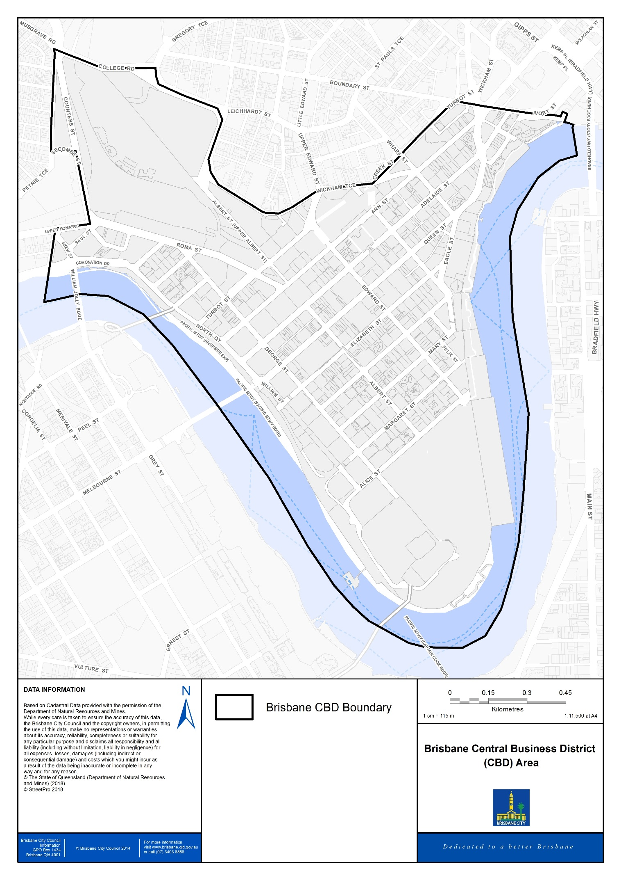

- CBD Frame differential rating boundary map
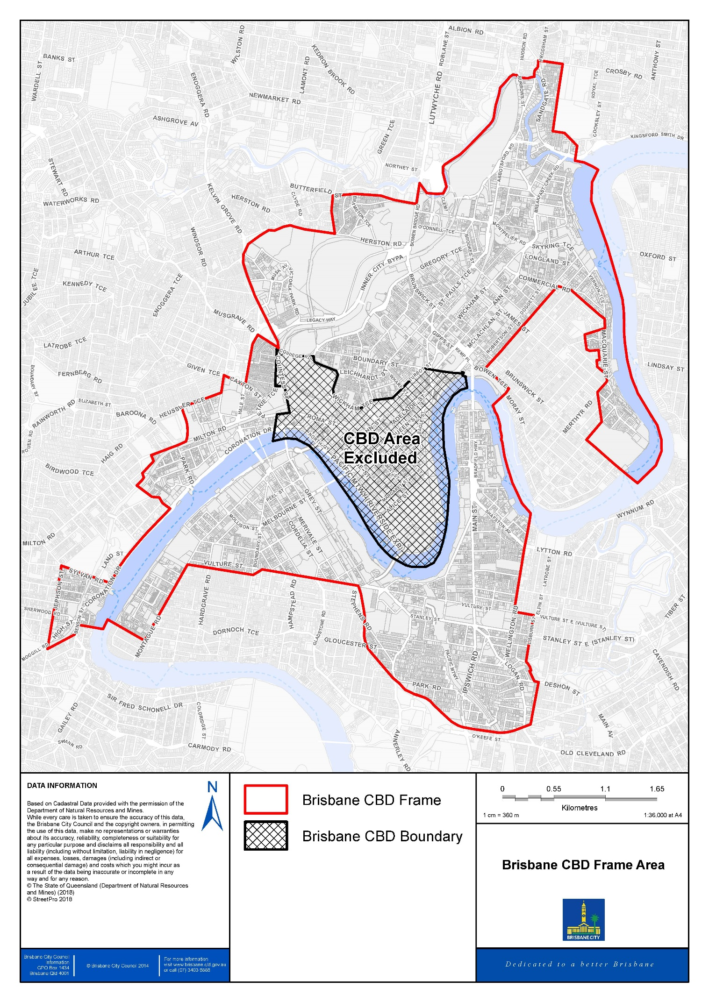

- Determining residential categorisation for differential rating
These criteria are used to determine whether a non-residential activity conducted on land also used for residential purposes is:
(a) allowable within the description of differential rating category 1 (Residential owner-occupied) or category 10 (CTS - Residential: Owner Occupied)
(b) of such a scale or nature as to categorise the land as being of a mixed residential nature and therefore to be included in differential rating category 7 (Non-owner occupied or mixed use) or category 14 (CTS – Residential: Non-owner Occupied or Mixed Use)
(c) of such a scale or nature that it is not allowable in differential rating category 1, 7, 10 or 14. In this case the land shall be deemed to be for non-residential purposes and categorised according to its non-residential activity.

Any land falling within land use code 76 Transitory Accommodation is not permitted in differential rating categories 1, 7, 10 or 14.

Column 1 |  | Column 2 |  | Column 3
Assessment Criteria |  | Allowable level of non-residential activity within differential rating category 1 or 10. |  | Allowable level of non-residential activity within differential rating category 7 or 14.
1.1.1. | An activity must be conducted on land. The predominant use of the land is for residential purposes by the operators of the activity. | 1.2.1. | The activity is conducted within a dwelling or another enclosed structure such as a shed or garage, or dedicated area on the land. | 1.3.1. | The activity is conducted within a dwelling; enclosed structure such as a shed or a garage or dedicated area on the land.
 |  | 1.2.2. | The activity is carried out by one or more of the residents of the dwelling. | 1.3.2. | The activity is carried out by one or more of the residents of the dwelling.
2.1.1. | An activity must be subordinate in size and function and be an inconspicuous component of the primary use of the dwelling as a permanent residence. | 2.2.1. | The activity involves no non-resident employees on site at any time, where the activity is conducted within a dwelling. | 2.3.1 | The activity involves no more than 1 non-resident employee on site at any one time.
 |  | 2.2.2. | The activity involves no non-resident employees on site at any time, where the activity is conducted within a multiple dwelling. | 2.3.2. | The activity does not use more than a total of 50m² or 30% of floor area, whichever is the lesser (except for a child care facility or dog/cat day care facility).
 |  | 2.2.3. | The activity does not use more than a total of 50m² or 30% of the total floor area of the dwelling whichever is the lesser (except for a home-based child care or dog/cat day care facility). | 2.3.3. | The activity does not involve display of goods or waste visible from outside the dwelling.
 |  | 2.2.4. | The activity does not involve display of goods or waste visible from outside of the dwelling. | 2.3.4 | The activity does not involve hiring out materials, goods, appliances or vehicles stored outside the maximum floor area allowable.
 |  | 2.2.5. | The activity does not involve hiring out materials, goods, appliances or vehicles stored outside the maximum floor area allowable. | 2.3.5. | The activity only involves display of signs:  i) required by law, and  ii) no larger than the minimum size identified in a local law, or if no minimum size identified, no larger than 0.6m2 in area.
 |  | 2.2.6. | The activity only involves display of signs:  i) required by law, and  ii) no larger than the minimum size identified in a local law, or if no minimum size identified, no larger than 0.6m² in area.
3.1.1.  (a)  (b) | An activity:  generates vehicular and pedestrian traffic of a volume no greater than reasonably expected in the surrounding residential area  exclusively uses or is visited by vehicle types reasonably expected in the surrounding residential area. | 3.2.1. | The activity does not involve more than 1 person waiting at or near the land at any time (excluding the permanent resident/s), (except if, home-based child care or a dog day-care facility). | 3.3.1. | The activity does not involve more than 1 person waiting at or near the land at any time (excluding the permanent resident/s and one non-resident employees).
 |  | 3.2.2 | The activity does not involve use of or visits by vehicles with a capacity of 2.5 tonnes or greater. | 3.3.2. | The activity does not involve use of or visits by vehicles with a capacity of 2.5 tonnes or greater.
4.1.1. | Hours of operation must be suited to a residential environment. | 4.2.1. | Hours of operation of any non-residential activity are limited to 8am to 6pm Monday to Saturday (except where such activity is restricted to office activities within the dwelling, such as book-keeping or computer work). Home-based child care or a dog day-care facility may operate outside these hours. | 4.3.1. | Hours of operation are limited to 8am to 6pm Monday to Saturday (except where such activity is restricted to office activities within the dwelling such as book-keeping or computer work). Paid guest accommodation, home-based child care or a dog day-care facility may operate outside these hours.
5.1.1 | An activity providing paid guest accommodation provides acceptable levels of privacy and amenity for residents in adjoining or nearby dwellings. | 5.2.1 | Not permitted | 5.3.1 | An activity providing paid guest accommodation involves:  - no more than 6 paying guests accommodated at any one time  - the total number of residents and paying guests does not exceed 10 persons at any one time  - serving of meals only to overnight guests
6.1.1 | In addition to the above criteria all aspects of the activity must meet the requirement of the Home-Based Business Code contained in Brisbane City Plan 2014 | 6.2.1 | All activity must comply with the requirements of the Home-Based Business Code | 6.3.1 | All activity must comply with the requirements of the Home-Based Business Code

- Criteria for determining categorisation for differential rating categories 5ac, 5ad, 5b, 5c, 5d, 5e, 5f, 5g, 5h, 5i, 5j, 5k, 5l, 5m, 5n, 5o, 5p, 5q, 5r, 5s, 5t, 5u, 5v, 5w, 5x, 5y and 5z from 1 July 2023
Ref. | Rateable land address | Real property description | Commonly known as (if named) | Differential rating category
5ac-1 | 81a Elizabeth St, Brisbane City | L.3 RP.607 PAR NTH BRISBANE  RIMS Act# 500000002187456 |  | 5ac. CBD Group AC (Public Carparks)
5ac-2 | 211 Elizabeth St, Brisbane City | L.7 9 RP.1038 PAR NTH BRISBANE  RIMS Act# 500000002187175
5ac-3 | 151a George St, Brisbane City | L.2 SP.148189 PAR NTH BRISBANE  RIMS Act# 500000004377228
5ac-4 | 5a Parkland Blvd, Brisbane City | L.817 SP.193965 PAR NTH BRISBANE  RIMS Act# 500000004582025
5ac-5 | 189a Edward St, Brisbane City | L.4 SP.148916 PAR NTH BRISBANE VOLUMETRIC LOT  RIMS Act# 500000004162349
5ac-6 | 169 Eagle St, Brisbane City | L.11 SP.151098 PAR NTH BRISBANE VOLUMETRIC LOT  RIMS Act# 500000004118879
5ac-7 | 363 Adelaide St, Brisbane City | L.4 SP.298336 PAR NTH BRISBANE VOLUMETRIC LOT  RIMS Act# 500000005882836
5ac-8 | 259a Queen St, Brisbane City | L.3 SP.148916 PAR NTH BRISBANE VOLUMETRIC LOT  RIMS Act# 500000004319071
5ac-9 | 466 Ann St, Brisbane City | L.65/66 RP.138763 PAR NTH BRISBANE  RIMS Act# 500000002205142
5ac-10 | 100 Adelaide St, Brisbane City | L.21 (BAL) SP.207228 PAR NTH BRISBANE  RIMS Act# 500000004972218
5ac-11 | 179 Turbot St, Brisbane City | L.179 SP.262727 PAR NTH BRISBANE  RIMS Act# 500000005091198
5ac-12 | 136 Wickham Tce, Spring Hill | L.458 SL.3561 PAR NTH BRISBANE  RIMS Act# 500000002200382 | Wickham Terrace Car Park
5ac-13 | 123 Albert St, Brisbane City | L.51 RP.890812 PAR NTH BRISBANE  RIMS Act# 500000002198040
5ad-1 | 111 Eagle St, Brisbane City | L.111 Sp.259700 Par Nth Brisbane Volumetric Lot  RIMS Act# 500000005132323 |  | 5ad.  Central Business District – Group AD
5ad-2 | 266 George St, Brisbane City | L.12 Sp.192709 Par Nth Brisbane  RIMS Act# 500000004637969 | Brisbane Square
5b-1 | 410 Ann St, Brisbane City | L.4 Rp.213466 Par Nth Brisbane  RIMS Act# 500000002204095 | Cathedral Square Plaza and Carpark | 5b.  Central Business District – Group B
5b-2 | 369 Ann St, Brisbane City | L.24 Rp.216272 Par Nth Brisbane  RIMS Act# 500000002216008 | Port Centre
5b-3 | 300 Elizabeth St, Brisbane City | L.31 Rp.173814 Par Nth Brisbane  RIMS Act# 500000002187084 | Northern Securities House
5b-4 | 31 Tank St, Brisbane City | L.3 Sp.172708 Par Nth Brisbane  RIMS Act# 500000004293086 | Santos Place
5b-5 | 49 Wharf St, Brisbane City | L.25 Rp.216272 Par Nth Brisbane  RIMS Act# 500000002216016 | Samuel Griffith Place
5b-6 | 240 Margaret St, Brisbane City | L.2 Rp.182958 Par Nth Brisbane  RIMS Act# 500000002192274
5b-7 | 260 Queen St, Brisbane City | L.1 Rp.119919 Par Nth Brisbane  RIMS Act# 500000002181624
5b-8 | 26 Charlotte St, Brisbane City | L.20 SP.315663 Par Nth Brisbane  RIMS Acct# 500000006024833 | Commercial Law Chamber
5b-9 | 120 Edward St, Brisbane City | L.5 Sp.135597 Par Nth Brisbane  RIMS Act# 500000003896732
5b-10 | 201 Charlotte St, Brisbane City | L.8 Rp.178809 Par Nth Brisbane  RIMS Act# 500000002187571
5b-11 | 100 Creek St, Brisbane City | L.30 Rp.145982 Par Nth Brisbane  RIMS Act# 500000002202024 | National Bank House
5b-12 | 100 Edward St, Brisbane City | L.1 Rp.188052 Par Nth Brisbane  RIMS Act# 500000002200135 | 100 Edward Street
5b-13 | 290 Adelaide St, Brisbane City | L.2 Rp.180959 Par Nth Brisbane  RIMS Act# 500000003897573
5c-1 | 144a George St, Brisbane City | L.11 Cp.866932 & L.303 Cp.866933 & L.304 Cp.866934 Par Nth Brisbane  RIMS Act# 500000002195301 | Treasury Casino Car Park | 5c.  Central Business District – Group C
5c-2 | 136 Queen St, Brisbane City | L.1 Rp.114640 Par Nth Brisbane  RIMS Act# 500000002181939
5c-3 | 161 Queen St, Brisbane City | L.1/2 Rp.45660 & L.2 Rp.49279 Par Nth Brisbane  RIMS Act# 500000002186821
5c-4 | 52 Queen St, Brisbane City | L.26 B.3149 & L.1/2 22 B.3153 Par Nth Brisbane  RIMS Act# 500000002181830 | Brisbane City Arcade
5c-5 | 144 Edward St, Brisbane City | L.3 Rp.209571 Par Nth Brisbane  RIMS Act# 500000002200176 | National Mutual Centre
5c-6 | 60 Edward St, Brisbane City | L.50 Rp.200074 Par Nth Brisbane  RIMS Act# 500000002200119 | A G L House
5c-7 | 288 Edward St, Brisbane City | L.1 Rp.132189 Par Nth Brisbane  RIMS Act# 500000002200366 | Brisbane Jetset Centre
5c-8 | 36 Wickham Tce, Spring Hill | L.2 Rp.124155 & Rl.06/215327 Par Nth Brisbane  RIMS Act# 500000004051070
5c-9 | 63 George St, Brisbane City | L.23 Sp.180748 Par Nth Brisbane  RIMS Act# 500000004454399 | David Longland Building
5c-10 | 147 Ann St, Brisbane City | L.102/103 Sp.253299 Par Nth Brisbane  RIMS Act# 500000005205640
5c-11 | 127 Creek St, Brisbane City | L.1 Rp.142803 Par Nth Brisbane  RIMS Act# 500000002201208 | Hooker House
5c-12 | 60 Albert St, Brisbane City | L.1 Sp.226353 Par Nth Brisbane  RIMS Act# 500000004775868
5c-13 | 450 Queen St, Brisbane City | L.2 Sp.261923 Par Nth Brisbane  RIMS Act# 500000005271352
5c-14 | 102 Adelaide St, Brisbane City | L.1 Rp.122123 Par Nth Brisbane  RIMS Act# 500000002201570
5c-15 | 160 Ann St, Brisbane City | L.12 Rp.128676 Par Nth Brisbane  RIMS Act# 500000002203998 | M I M Building
5c-16 | 35 Charlotte St, Brisbane City | L.3 Sp.102562 Par Nth Brisbane  RIMS Act# 500000003979710 | Charlotte Chamber & 111 George Street
5c-17 | 40 Tank St, Brisbane City | L.6 Rp.813314 Par Nth Brisbane  RIMS Act# 500000002216263
5c-18 | 150 Charlotte St, Brisbane City | L.1 Rp.189266 Par Nth Brisbane  RIMS Act# 500000002187555 | SEQEB Head Office & Substation
5c-19 | 515 Queen St, Brisbane City | L.5 Sp.100339 Par Nth Brisbane  RIMS Act# 500000002201935 | Marriott Hotel
5c-20 | 20 Makerston St, Brisbane City | L.12/13 B.361 Par Nth Brisbane  RIMS Act# 500000002216321 | Forbes House
5d-1 | 270 Queen St, Brisbane City | L.1 Rp.127671 Par Nth Brisbane  RIMS Act# 500000002181632 | Post Office Square | 5d.  Central Business District – Group D
5d-2 | 255 Queen St, Brisbane City | L.1 Sp.148916 Par Nth Brisbane  RIMS Act# 500000004162323
5d-3 | 21 Queen St, Brisbane City | Reserve.785 - L.492 Cp.855445 & L.300 Cp.866930 & L.301 Cp.866931 Par Nth Brisbane RIMS Act# 500000002186938 | Conrad Treasury Casino
5d-4 | 76 Queen St, Brisbane City | L.4 Rp.45632 & L.3 Rp.45762 Par Nth Brisbane  RIMS Act# 500000002181855 | Chifley At Lennons
5d-5 | 130 Queen St, Brisbane City | Tl.06/206671 - L.11 Cp.892144 & L.1 Rp.125108 Par Nth Brisbane  RIMS Act# 500000002181921
5d-6 | 307 Queen St, Brisbane City | L.34 Rp.146754 Par Nth Brisbane  RIMS Act# 500000002186169
5d-7 | 300 Queen St, Brisbane City | L.32 Rp.178652 & Sl.06/51430 - L.21 Sl.10753 & TI.06/234812 - L.22 SP.243732 Par Nth Brisbane RIMS Act# 500000005014638
5d-8 | 400 George St, Brisbane City | L.2 Sp.172708 Par Nth Brisbane  RIMS Act# 500000004293078
5d-9 | 324 Queen St, Brisbane City | L.1/2 Rp.887 Par Nth Brisbane  RIMS Act# 500000002181673 | A N Z Centre
5d-10 | 145 Eagle St, Brisbane City | L.1 Rp.905881 Par Nth Brisbane  RIMS Act# 500000002187019
5d-11 | 53 Albert St, Brisbane City | L.1 Rp.140881 Par Nth Brisbane  RIMS Act# 500000002198149
5d-12 | 545 Queen St, Brisbane City | L.10 Rp.185905 Par Nth Brisbane  RIMS Act# 500000002182564
5d-13 | 50 Ann St, Brisbane City | L.3&10 Rp.128822 & L.23 Rp.146830 Par Nth Brisbane  RIMS Act# 500000002195616 | State Law Building
5e-1 | 320 Adelaide St, Brisbane City | L.9 Rp.92926 Par Nth Brisbane  RIMS Act# 500000002201752 |  | 5e.  Central Business District – Group E
5e-2 | 140 Elizabeth St, Brisbane City | L.100 Sp.228870 & Tl.06/233996 - L.6/9 Sp.228871 Par Nth Brisbane  RIMS Act# 500000004817389
5e-3 | 61 Mary St, Brisbane City | L.22 Rp.178621 Par Nth Brisbane  RIMS Act# 500000002188660 | Queensland Minerals and Energy Centre
5e-4 | 166 Creek St, Brisbane City | L.1 Rp.122127 & Tl.06/216281 - L.53 Sp.121394 Par Nth Brisbane  RIMS Act# 500000004067910
5e-5 | 221 Adelaide St, Brisbane City | L.31 Rp.178577 Par Nth Brisbane  RIMS Act# 500000002202057 | Rowes Arcade, Rosies, Shops, Offices
5e-6 | 133 Mary St, Brisbane City | L.1 Rp.182958 Par Nth Brisbane  RIMS Act# 500000002200127
5e-7 | 357 Turbot St, Brisbane City | L.6 Rp.221165 Par Nth Brisbane  RIMS Act# 500000002204103
5e-8 | 119 George St, Brisbane City | L.1/4 Rp.43986 & L.2 Rp.640 & L.1 Rp.641 Par Nth Brisbane  RIMS Act# 500000003979777
5e-9 | 59 George St, Brisbane City | L.1 Rp.159900 Par Nth Brisbane  RIMS Act# 500000002195806
5e-10 | 163 Charlotte St, Brisbane City | L.506 B.118215 & L.1/3 Rp.182759 & L.1 Rp.626 Par Nth Brisbane  RIMS Act# 500000005186519
5e-11 | 205 North Quay, Brisbane City | L.14 B.32372 & L.7 B.361 & L.1 Rp.55922 Par Nth Brisbane  RIMS Act# 500000006074739
5f-1 | 249 Turbot St, Brisbane City | L.2 Sp.140773 Par Nth Brisbane  RIMS Act# 500000004553612 | Sofitel Hotel | 5f.  Central Business District – Group F
5f-2 | 16 Ann St, Brisbane City | L.1 Rp.123283 Par Nth Brisbane  RIMS Act# 500000002203949 | Mercure Hotel & Hotel Ibis
5f-3 | 66 Eagle St, Brisbane City | L.16 Rp.229111 Par Nth Brisbane  RIMS Act# 500000002187092 | Central Plaza Two
5f-4 | 2 Roma St, Brisbane City | L.1 Rp.172274 Par Nth Brisbane  RIMS Act# 500000002218988 | The Sebel and Citigate Hotels
5f-5 | 54 Mary St, Brisbane City | L.14 Sl.12186 Par Nth Brisbane  RIMS Act# 500000002188447
5f-6 | 360 Queen St, Brisbane City | L.200 Sp.291438 Par Nth Brisbane  RIMS Act# 500000006052446
5g-1 | 259 Queen St, Brisbane City | L.2 Sp.148916 Par Nth Brisbane  RIMS Act# 500000004319055 |  | 5g.  Central Business District – Group G
5g-2 | 73 Eagle St, Brisbane City | L.5 Sp.140665 Par Nth Brisbane  RIMS Act# 500000004423055
5g-3 | 12 Creek St, Brisbane City | L.4 Rp.173778 Par Nth Brisbane  RIMS Act# 500000002187100
5g-4 | 113 Margaret St, Brisbane City | L.1&4 Rp.1075 & L.1 Rp.45960 & L.100 Sp.278163 Par Nth Brisbane  RIMS Act# 500000005278142
5h-1 | 240 Queen St, Brisbane City | L.5 Rp.200175 Par Nth Brisbane  RIMS Act# 500000002181616 |  | 5h.  Central Business District – Group H
5h-2 | 110 Queen St, Brisbane City | L.1 Rp.886307 & L.2 Rp.886308 & Tl.06/214694 - L.1 SP.128099 Par Nth Brisbane  RIMS Act# 500000004621294
5h-3 | 170 Queen St, Brisbane City | L.4 Rp.221710 Par Nth Brisbane  RIMS Act# 500000002181566 | Broadway On The Mall
5h-4 | 480 Queen St, Brisbane City | L.1 Sp.257560 Par Nth Brisbane  RIMS Act# 500000005291582
5i-1 | 89 Adelaide St, Brisbane City | L.1 Rp.110131 Par Nth Brisbane  RIMS Act# 500000002202115 | King George Tower Commonwealth Bank Building | 5i.  Central Business District – Group I
5i-2 | 343 Albert St, Brisbane City | L.343 Sp.262727 Par Nth Brisbane Volumetric Lot  RIMS Act# 500000005091206
5i-3 | 167 Eagle St, Brisbane City | L.2 Rp.905881 Par Nth Brisbane  RIMS Act# 500000002187001 | Emirates House
5i-4 | 175 Eagle St, Brisbane City | L.10 Sp.151098 Par Nth Brisbane  RIMS Act# 500000004118796
5j-1 | 275 George St, Brisbane City | L.20 Sp.198665 Par Nth Brisbane  RIMS Act# 500000004687709 |  | 5j.  Central Business District – Group J
5j-2 | 39 Edward St, Brisbane City | L.2 SI.12006 Par Nth Brisbane  RIMS Act# 500000002201174 | Stamford Plaza
5j-3 | 152 Alice St, Brisbane City | L.22/23 36/37 B.118243 & L.1/3 Rp.1068 & L.1 Rp.110657 & L.2 RP.111828 Par Nth Brisbane  RIMS Act# 500000002195046 | Royal On The Park
5k-1 | 192 Ann St, Brisbane City | L.5 Sp.115364 Par Nth Brisbane  RIMS Act# 500000003799019 |  | 5k.  Central Business District – Group K
5k-2 | 345 Queen St, Brisbane City | L.5 Rp.200298 Par Nth Brisbane  RIMS Act# 500000002186151 | Central Plaza One
5k-3 | 197 Mary St, Brisbane City | L.40 Rp.817615 Par Nth Brisbane  RIMS Act# 500000003639736 | Waterfront Place
5l-1 | 62 Ann St, Brisbane City | L.2 Sp.326541 Par Nth Brisbane  RIMS Act# 500000006067154 |  | 5l.  Central Business District – Group L
5l-2 | 239 George St, Brisbane City | L.28 Rp.170279 Par Nth Brisbane  RIMS Act# 500000002195632 | Criterion Tavern, Offices
5l-3 | 443 Queen St, Brisbane City | L.1 Sl.805627 Par Nth Brisbane  RIMS Act# 500000002186078 | Prudential Building
5l-4 | 21 Saul St, Brisbane City | L.30 Rp.169792 Par Nth Brisbane  RIMS Act# 500000002216347
5m-1 | 2 George St, Brisbane City | L.654 & Reserve.636 - L.651 Sp.241925 Par Nth Brisbane  RIMS Act# 500000004931925 |  | 5m.  Central Business District – Group M
5n-1 | 167 Queen St, Brisbane City | L.217 B.11826 & L.1 Rp.574 & L.1 Rp.575 & L.2 Rp.49018 & L.1 Rp.65292 Par Nth Brisbane  RIMS Act# 500000002186813 | Hoyts Regent Building | 5n.  Central Business District – Group N
5n-2 | 30 Albert St, Brisbane City | L.11 Rp.1073 & L.9 Sp. 142332 Par Nth Brisbane  RIMS Act# 500000005128305
5n-3 | 81 North Quay, Brisbane City | L.4 Sp.301319 Par Nth Brisbane  RIMS Act# 500000005749803
5o-1 | 185 Queen St, Brisbane City | L.1/2 SP.134044 Par Nth Brisbane Volumetric Lot  RIMS Act# 500000003963805 | Wintergarden Complex & Hilton Hotel | 5o.  Central Business District – Group O
5p-1 | 226 Queen St, Brisbane City | L.32 Sp.156458 & Tl.06/234860 - L.33 Sp.182841 & L.1/3 Sp.182858 Par Nth Brisbane  RIMS Act# 500000005062777 | Queens Plaza | 5p.  Central Business District – Group P
5q-1 | 123 Eagle St, Brisbane City | L.122 Sp.259700 & L.123 Sp.208982 Par Nth Brisbane  RIMS Act# 500000005141670 |  | 5q.  Central Business District – Group Q
5q-2 | 91 Queen St, Brisbane City | L.41 Rp.218420 & Sl.06/52311 - L.711 Sl.802985 & Sl.06/52309 -  L.712 Sl.837761 & Sl.06/52310 -  L.710 Sl.12438 & Po.06/217663 -  L.42 Sp.145288 (L.42 - Volumetric Lot (Closed Road - Strata) Par Nth Brisbane  RIMS Act# 500000004130163
5r-1 | 45 Eagle St, Brisbane City | L.50 Rp.817615 & Sl.06/51313 - L.9 Sl.12596 Par Nth Brisbane  RIMS Act# 500000003639264 | Eagle Street Pier | 5r.  Central Business District – Group R
5r-2 | 1 William St, Brisbane City | L.1 Sp.287539 Par Nth Brisbane Leased From The State Of QLD From 20/10/2016 To 19/10/2115  RIMS Act# 500000005435023
5s-1 | 484 Queen St, Brisbane City | L.100 Sp.215065 Par Nth Brisbane  RIMS Act# 500000004676793 |  | 5s.  Central Business District – Group S
5s-2 | 500 Queen St, Brisbane City | L.1/3 Rp.88472 Par Nth Brisbane  RIMS Act# 500000002182481 | 500 Queen Street
5s-3 | 243 Edward St, Brisbane City | L.18 Rp.79119 Par Nth Brisbane  RIMS Act# 500000002200432 | Travel House
5s-4 | 388 Queen St, Brisbane City | L.7 B.118227 Par Nth Brisbane  RIMS Act# 500000002182283 | Q I D C House
5s-5 | 171 George St, Brisbane City | L.1 B.31910 Par Nth Brisbane  RIMS Act# 500000002195707 | Promoseven Place
5t-1 | 141 Queen St, Brisbane City | L.1/4 Rp.113488 & Tl.06/233650 - L.5 Sp.228408 Par Nth Brisbane  RIMS Act# 500000002186839 |  | 5t.  Central Business District – Group T
5u-1 | 200 Mary St, Brisbane City | L.9 Rp.196746 Par Nth Brisbane  RIMS Act# 500000002188553 | 200 Mary Street | 5u.  Central Business District – Group U
5u-2 | 313 Adelaide St, Brisbane City | L.5 Rp.195923 Par Nth Brisbane  RIMS Act# 500000002201992
5u-3 | 375 Turbot St, Spring Hill | L.50 Sp.134928 Par Nth Brisbane  RIMS Act# 500000004041311 | Spring Hill Marketplace
5u-4 | 55 Elizabeth St, Brisbane City | L.30/31 Sp.254940 Par Nth Brisbane  RIMS Act# 500000005063478
5u-5 | 280 Elizabeth St, Brisbane City | L.1/2 Rp.979 & L.26 Sl.11452 Par Nth Brisbane  RIMS Act# 500000002187076
5v-1 | 69 Ann St, Brisbane City | L.21 Sp.198665 Par Nth Brisbane  RIMS Act# 500000004687717 |  | 5v.  Central Business District – Group V
5v-2 | 245 Charlotte St, Brisbane City | L.2 Rp.157971 Par Nth Brisbane  RIMS Act# 500000002187563 | A M P Place
5w-1 | 142 George St, Brisbane City | Reserve.631 - L.682 Cp.855445 Par Nth Brisbane  RIMS Act# 500000002195277 | Conrad Treasury Hotel | 5w.  Central Business District – Group W
5w-2 | 126 Margaret St, Brisbane City | L.5 Rp.193122 Par Nth Brisbane  RIMS Act# 500000002192258
5w-3 | 249 Albert St, Brisbane City | L.1/2 4 Rp.707 Par Nth Brisbane  RIMS Act# 500000002197059
5w-4 | 180 Queen St, Brisbane City | L.1 Rp.676 & L.1/2 Rp.677 & L.2 Rp.45859 Par Nth Brisbane  RIMS Act# 500000002181574
5w-5 | 103 Mary St, Brisbane City | L.17 Rp.129686 Par Nth Brisbane  RIMS Act# 500000002188637
5w-6 | 261 Queen St, Brisbane City | L.33 Rp.48556 Par Nth Brisbane  RIMS Act# 500000002186714 | Brisbane G.P.O. and Exchange
5w-7 | 120 Queen St, Brisbane City | L.13/14 23 B.3153 Par Nth Brisbane  RIMS Act# 500000002181913 | Sportsgirl
5w-8 | 217 George St, Brisbane City | L.16 Rp.178645 Par Nth Brisbane  RIMS Act# 500000002181822 | Concorde House
5w-9 | 19 George St, Brisbane City | L.5 Rp.201074 Par Nth Brisbane  RIMS Act# 500000002196309 | Queensland Club
5w-10 | 84 Queen St, Brisbane City | L.26 Rp.119279 Par Nth Brisbane  RIMS Act# 500000002181863
5w-11 | 46 Charlotte St, Brisbane City | L.1 Rp.188148 Par Nth Brisbane  RIMS Act# 500000002187522
5w-12 | 33 Herschel St, Brisbane City | L.7 Rp.105382 Par Nth Brisbane  RIMS Act# 500000002216313
5w-13 | 342 George St, Brisbane City | L.2/4 Rp.778 Par Nth Brisbane  RIMS Act# 500000002195350 | George Cinema
5w-14 | 103 George St, Brisbane City | L.19 B.118241 Par Nth Brisbane  RIMS Act# 500000002195764 | Bellevue Hotel
5w-15 | 163 Ann St, Brisbane City | L.1&4 Sp.157241 Par Nth Brisbane  RIMS Act# 500000004273245
5w-16 | 333 Adelaide St, Brisbane City | L.12 Rp.125034 Par Nth Brisbane  RIMS Act# 500000002201984 | 333 Adelaide Street
5w-17 | 33 Queen St, Brisbane City | L.2 Rp.52526 Par Nth Brisbane  RIMS Act# 500000002186920 | Bank of New South Wales Chambers
5w-18 | 126 Adelaide St, Brisbane City | L.6 Rp.40997 Par Nth Brisbane  RIMS Act# 500000002201596 | Mayfair Arcade
5w-19 | 116 Adelaide St, Brisbane City | L.5 Rp.40997 Par Nth Brisbane  RIMS Act# 500000002201588 | M B F House
5w-20 | 300 Ann St, Brisbane City | L.3 Rp.211213 Par Nth Brisbane  RIMS Act# 500000004874323 | Oracle House
5w-21 | 40 Elizabeth St, Brisbane City | L.1 Rp.883066 Par Nth Brisbane  RIMS Act# 500000002187068
5w-22 | 146 Queen St, Brisbane City | L.2 Rp.114640 Par Nth Brisbane  RIMS Act# 500000002181947
5w-23 | 171 Edward St, Brisbane City | L.5/6 Rp.1038 Par Nth Brisbane  RIMS Act# 500000002200440 | Ulster Walk
5w-24 | 43 Herschel St, Brisbane City | L.3 Sp.235800 Par Nth Brisbane  RIMS Act# 500000005111772
5x-1 | 119 Charlotte St, Brisbane City | L.1 Sp.150759 Par Nth Brisbane  RIMS Act# 500000004120842 |  | 5x.  Central Business District – Group X
5x-2 | 89 Mary St, Brisbane City | L.5 Rp.202845 Par Nth Brisbane  RIMS Act# 500000002196598 | 80 Albert Street
5x-3 | 333 Ann St, Brisbane City | L.1 Rp.808928 Par Nth Brisbane  RIMS Act# 500000002207031
5x-4 | 193 North Quay, Brisbane City | L.8 B.118228 Par Nth Brisbane  RIMS Act# 500000002218798 | B P House
5y-1 | 80 Eagle St, Brisbane City | L.1 Sp.192432 Par Nth Brisbane  RIMS Act# 500000004674384 |  | 5y. Central Business District – Group Y
5y-2 | 95 North Quay, Brisbane City | L.1 Rp.108374 Par Nth Brisbane  RIMS Act# 500000002218954 | Quay Central
5z-1 | 111 Elizabeth St, Brisbane City | L.8 B.118233 Par Nth Brisbane  RIMS Act# 500000002196986 | Borders Bookstore | 5z. Central Business District – Group Z
5z-2 | 348 Edward St, Brisbane City | L.4 Rp.202682 Par Nth Brisbane  RIMS Act# 500000002216065
5z-3 | 179 North Quay, Brisbane City | L.15 B.32411 Par Nth Brisbane  RIMS Act# 500000002218913 | Brisbane Central Courts Building
5z-4 | 299 Adelaide St, Brisbane City | L.4 Rp.857048 Par Nth Brisbane  RIMS Act# 500000002202016
5z-5 | 264 Margaret St, Brisbane City | L.4 Rp.183707 Par Nth Brisbane  RIMS Act# 500000002192282 | Elders House
5z-6 | 241 Adelaide St, Brisbane City | L.1 Rp.948 & SL.06/207463 - L.695 Sl.12260 Par Nth Brisbane  RIMS Act# 500000002202040
5z-7 | 316 Adelaide St, Brisbane City | L.13/15 Rp.46148 Par Nth Brisbane  RIMS Act# 500000002201745 | Century House
5z-8 | 85 George St, Brisbane City | L.18 Rp.209685 Par Nth Brisbane  RIMS Act# 500000002195772 | Capital Hill
5z-9 | 124 Albert St, Brisbane City | L.11 B.118233 Par Nth Brisbane  RIMS Act# 500000002196622 | Pane Vino Bread and Wine Cafe
5z-10 | 237 Elizabeth St, Brisbane City | L.1 Sp.191262 Par Nth Brisbane  RIMS Act# 500000004487241
5z-11 | 406 Queen St, Brisbane City | L.2 Rp.61511 Par Nth Brisbane  RIMS Act# 500000002182309 | Credit Union Australia House
5z-12 | 166 Wickham Tce, Brisbane City | L.2/3 Rp.43451 Par Nth Brisbane  RIMS Act# 500000002215778
5z-13 | 111 Mary St, Brisbane City | L.102&104 Sp.282916 Par Nth Brisbane (Volumetric Lots)  RIMS Act# 500000005838226
5z-14 | 107 North Quay, Brisbane City | L.6 B.118221 Par Nth Brisbane  RIMS Act# 500000002218947 | Inns of Court
5z-15 | 300 Adelaide St, Brisbane City | L.21 Rp.133052 Par Nth Brisbane  RIMS Act# 500000002201737

- Criteria for determining categorisation for differential rating categories 8a, 8b, 8c, 8d, 8e, 8f, 8g, 8h, 8i and 8j from 1 July 2023
Ref. | Rateable land address | Real property description | Commonly known as (if named) | Differential rating category
8a-1 | 235 Forest Lake Blvd, Forest Lake | L.4 Sp.140074 Par Woogaroo  RIMS Act# 500000003962807 | Forest Lake Shopping Centre | 8a.  Large Regional Shopping Centre – Group A
8a-2 | 2021 Wynnum Rd, Wynnum West | L.100 SP.289458 Par Tingalpa  RIMS Act# 500000005435494 | Wynnum Plaza
8b-1 | 1909 Creek Rd, Cannon Hill | L.5 RP.121447 Par Bulimba  RIMS Act# 500000000111948 | Cannon Hill Kmart Plaza | 8b.  Large Regional Shopping Centre – Group B
8b-2 | 215 Church Rd, Taigum | L.4 SP.145646 Par Kedron  RIMS Act# 500000004057325 | Taigum Square
8c-1 | 180 Sinnamon Rd, Jindalee | L.2 SP.140553 Par Oxley  RIMS Act# 500000003970693 | Jindalee Home | 8c.  Large Regional Shopping Centre – Group C
8c-2 | 11 Pavilions Cl, Jindalee | L.10 SP.160043 Par Oxley  RIMS Act# 500000004213332 | D F O Jindalee
8c-3 | 9 Brookfield Rd, Kenmore | L.1 SL.12534 Par Indooroopilly  RIMS Act# 500000004372963 | Kenmore Village
8c-4 | 551 Lutwyche Rd, Lutwyche | L.100 SP.298374 Par Enoggera  RIMS Act# 500000006147634 | Lutwyche Shopping Centre
8c-5 | 815 Zillmere Rd, Aspley | L.1 RP.805963 Par Nundah  RIMS Act# 500000001532687 | Homemaker City Aspley
8d-1 | 55 Creek Rd, Mt Gravatt East | L.1 RP.180967 Par Bulimba  RIMS Act# 500000000250837 | Mt Gravatt Plaza | 8d.  Large Regional Shopping Centre – Group D
8d-2 | 142 Newmarket Rd, Windsor | L.1 SP.146479 Par Enoggera  RIMS Act# 500000004036352 | Home Zone Windsor
8d-3 | 661 Compton Rd, Sunnybank Hills | L.1 RP.214796 & L.1 SP.281927 Par Yeerongpilly  RIMS Act# 500000005383199 | Sunnybank Hills Shoppingtown
8f-1 | 400 Stafford Rd, Stafford | L.1 RP.853658 Par Kedron  RIMS Act# 500000001264638 | Stafford City | 8f.  Large Regional Shopping Centre – Group F
8f-2 | 59 Albany Creek Rd, Aspley | L.4 RP.164286 & L.1 RP.198020 Par Kedron RIMS Act# 500000001492114 | Aspley Hypermarket
8f-3 | 159 Osborne Rd, Mitchelton | L.5 RP.842671 & L.1 SP.271468 Par Enoggera  RIMS Act# 500000004024028 | Brookside
8g-1 | 358 Mains Rd, Sunnybank | L.20 RP.813380 Par Yeerongpilly  RIMS Act# 500000003144604 | Sunnybank Plaza | 8g.  Large Regional Shopping Centre – Group G
8h-1 | 9 Sherwood Rd, Toowong | L.3 RP.211016 & L.1 RP.844743 Par Enoggera  RIMS Act# 500000002165684 | Toowong Village | 8h.  Large Regional Shopping Centre – Group H
8i-1 | 1015 Sandgate Rd, Nundah | L.1 SP.310007 Par Toombul  RIMS Act# 500000005852029 | Toombul Shopping Centre | 8i.  Large Regional Shopping Centre – Group I
8j-1 | 171 Dandenong Rd, Mt Ommaney | L.3 SP.108533 Par Oxley  RIMS Act# 500000003781587 | Mt Ommaney Centre | 8j.  Large Regional Shopping Centre – Group J

- Criteria for determining categorisation for differential rating categories 9a, 9b, 9c, and 9d from 1 July 2023
Ref. | Rateable land address | Real property description | Commonly known as (if named) | Differential rating category
9a-1 | 322 Moggill Rd, Indooroopilly | L.1 SP.265258 & L.147 SP.265257 & TL.06/211040 – L.7 SP.112975 Par Indooroopilly  RIMS Act# 500000005403757 | Indooroopilly Shopping Centre | 9a.  Major Regional Shopping Centre – Group A
9b-1 | 1151 Creek Rd, Carindale | L.2 RP.909241 Par Bulimba  RIMS Act# 500000004096067 | Westfield Carindale | 9b.  Major Regional Shopping Centre – Group B
9c-1 | 2049 Logan Rd, Upper Mt Gravatt | L.1 SP.265246 Par Yeerongpilly  RIMS Act# 500000005437847 | Westfield Mt Gravatt | 9c.  Major Regional Shopping Centre – Group C
9d-1 | 395 Hamilton Rd, Chermside | L.1 SP.309376 Par Kedron  RIMS Act# 500000006078847 | Westfield Chermside | 9d.  Major Regional Shopping Centre – Group D

- Criteria for determining categorisation for differential rating categories 2b, 2c, 2d, 2e, 2f, 2g, 2h, 2i, 2j, 2k and 2m from 1 July 2023
Ref. | Rateable land address | Real property description | Commonly known as (if named) | Differential rating category
2b-1 | 603 Coronation Dve, Toowong | L.10 RP.209688 Par Enoggera  RIMS Act# 500000002165726 | Toowong Village Car Park | 2b. Commercial/Non-Residential – Group B
2c-1 | 52 Alfred St, Fortitude Valley | L.1 SP.196979 & L.40 (BAL) SP.196964 Par Nth Brisbane  RIMS Act# 500000004733644 | Valley Metro Shopping Centre | 2c. Commercial/Non-Residential – Group C
2d-1 | 600 Gregory Tce, Bowen Hills | L.112/115 703 & 705 SP.288048 & L.116 SP.288049 & L.704 SP.296435 Par North Brisbane  RIMS Act# 500000006037694 | RNA Showgrounds | 2d. Commercial/Non-Residential – Group D
2d-2 | 595 Gregory Tce, Bowen Hills | L.709 SP.238200 Par North Brisbane  RIMS Act# 500000005241918
2d-3 | 10 Symes St, Bowen Hills | L.121 SP.238200 Par North Brisbane  RIMS Act# 500000005241843
2d-4 | 191b Constance St, Bowen Hills | L.120 SP.238200 Par North Brisbane  RIMS Act# 500000005241835
2d-5 | 665 Gregory Tce, Bowen Hills | L.110/111 SP.336809 Par North Brisbane  RIMS Act# 500000006155041
2d-6 | 631 Gregory Tce, Bowen Hills | L.708 SP.288052 Par North Brisbane  RIMS Act# 500000005653229
2d-7 | 639 Gregory Tce, Bowen Hills | L.801 & 803 SP.288047 Par North Brisbane  RIMS Act# 500000005579861
2d-8 | 11 King St, Bowen Hills | L.802 SP.288047 Par North Brisbane  RIMS Act# 500000005493428
2d-9 | 7 King St, Bowen Hills | L.804, 806 & 808/809 SP.288047 & L.913 SP.288076 & L.813 SP.288077 & L.805 & 807 SP.288132 Par North Brisbane RIMS Act# 500000005892520
2d-10 | 492 St Pauls Tce, Bowen Hills | L.107 SP.238200 & L.108,811 & 815 SP.288047 Par North Brisbane  RIMS Act# 500000005579887
2e-1 | 584 Mains Rd, Nathan | L.3/4 SP.272422 Par Yeerongpilly  RIMS Act# 500000005817352 | Queensland Sport & Athletic Centre | 2e. Commercial/Non-Residential - Group E
2f-1 | 1699 Old Cleveland Rd, Chandler | L.1(BAL) SP.150590 Par Tingalpa  RIMS Act# 500000004129793 | Sleeman Sports Complex | 2f. Commercial/Non-Residential – Group F
2g-1 | 222 Stanworth Rd, Boondall | L.48/49 SP.151264 & L.45/46 SP.284827 Par Kedron  RIMS Act# 500000005385293 | Brisbane Entertainment Centre | 2g. Commercial/Non-Residential – Group G
2h-1 | 40 Castlemaine St, Milton | L.581 RP.227070 & L.354 RP.898660 & L.41 RP.904552 & L.471 SP.144611 & L.42 SP.161089 & L.357 SP.161706 Par Nth Brisbane  RIMS Act# 500000005129071 | Suncorp Stadium | 2h. Commercial/Non-Residential – Group H
2i-1 | 190 King Arthur Tce, Tennyson | L.7 Sp. 299715 Par Yeerongpilly  RIMS Act# 500000005845650 | Queensland Tennis Centre | 2i. Commercial/Non-Residential – Group I
2j-1 | 411 Vulture St, Woolloongabba | L.2 RP.803783 & TL.06/208598 - L.100 CP.900152 & L.101 SP.120175 & TL.06/218434 - L.103 SP.134698 & L.104 SP.179933 & TL.06/242083- L.105 SP.314738 & TL.06/242084 - L.106 SP.314739 PAR STH BRISBANE (L.100 100 103 10 105&106 - VOLUMETRIC LOTS)  RIMS Act# 500000006074218 | The Brisbane Cricket Ground (Part thereof) | 2j. Commercial/Non-Residential – Group J
2k-1 | 401 Vulture St, Woolloongabba | L.3/4 SP.182798 Par Sth Brisbane  RIMS Act# 500000004859746 | The Brisbane Cricket Ground (Part thereof) | 2k. Commercial/Non-Residential – Group K
2m-1 | 71 Clyde Rd, Herston | L.495 Sl.6366 & L.1/2 Rp.189805 Par Nth Brisbane  RIMS Act# 500000002335881 | Ballymore Park Rugby Union Stadium | 2m. Commercial/Non-Residential – Group M

- Criteria for determining categorisation for differential rating categories 26, 27, 28, 29, 30 and 31 from 1 July 2023
Rateable land address | Real property description | Commonly known as (if named) | Differential rating category
620 Seventeen Mile Rocks Rd, Sinnamon Park | L.2 RP.227041 PAR OXLEY  RIMS Act#500000002774220 | Sinnamon Village Aged Care | 26 Reduced Rate 1
930 Gympie Rd, Chermside | L.6 SP.246762 & PO.06/239486 PAR KEDRON (PO - L.A/B AP22970)  RIMS Act# 500000005558113 | Wheller Gardens Aged Care | 26 Reduced Rate 1
241 Church Rd, Taigum | L.7 SP.150429 PAR KEDRON  RIMS Act#500000004150112 | Greek Orthodox Church | 27 Reduced Rate 2
30 Mckechnie Dr, Eight Mile Plains | L.1303 CP.818297 PAR Y'PILLY  RIMS Act#500000000902023 | Presbyterian Church Eight Mile Plains | 27 Reduced Rates 2
537 Stanley St, South Brisbane | L.50&54/62 RP.11625 & L.1 RP.11630 & L.43/46 RP.11633 & L.2 RP.185046 & L.3 SP.163361 & L.1 SP.227481 & L.6 SP.241935 & L.5 SP.241936 & TL.06/213427 - L.100 & TL.06/213426 - L.101 SP.119005 & TL.06/232181 - L.100 SP.192428 Par Sth Brisbane (L.6 & TL.06/213426 - L.101 & TL.06/213427 - L.100 SP.119005 & TL.06/232181 - L.100 SP.192428 - Closed Road Strata (Volumetric Lots)  RIMS Act# 500000005258771 | Mater Public Hospital (Part thereof) | 28. Reduced Rate 3
1/547 Ann St, Fortitude Valley | L.1 SP.268187 PAR Nth Brisbane  RIMS Act# 500000005221969 | All Hallows’ School (Part thereof) | 29. CTS Reduced Rate 1
2/547 Ann St, Fortitude Valley | L.2 SP.268187 PAR Nth Brisbane  RIMS Act# 500000005221977 | All Hallows’ School (Part thereof) | 29. CTS Reduced Rate 1

- Criteria for determining application of section 4(j)(ii) from 1 July 2023
Rateable land address | Real property description | Commonly known as (if named) | Differential rating category
2 Ambleside St, West End | L.12 Rp.130450 Par Sth Brisbane  RIMS Act# 500000000547455 |  | 16. CBD Frame
18 Manning St, South Brisbane | L.3 Rp.209953 Par Sth Brisbane  RIMS Act# 500000000512970
109 Logan Rd, Woolloongabba | L.100 Rp.203369 Par Sth Brisbane  RIMS Act# 500000000598227
10 Wilton St, Woolloongabba | L.11 Rp.12250 Par Sth Brisbane  RIMS Act# 500000000587352
22 Qualtrough St, Woolloongabba | L.40 Rp.46700 Par Sth Brisbane  RIMS Act# 500000000590133
3 Allen St, South Brisbane | L.100 Sp.182876 Par Sth Brisbane  RIMS Act# 500000004912040
49 Gregory Tce, Spring Hill | L.2 5 Rp.10406 Par Nth Brisbane  RIMS Act# 500000002260667
619 Stanley St, Woolloongabba | L.8/10 Rp.11606 Par Sth Brisbane  RIMS Act# 500000000511337
78 Montague Rd, South Brisbane | L.3 Rp.42859 & L.1/3 Rp.129041 Par Sth Brisbane  RIMS Act# 500000000530584
419 Wickham Tce, Spring Hill | L.13 Rp.10227 & L.14/15 Rp.10229 & L.1 Sp.185278 Par Nth Brisbane  RIMS Act# 500000004517922
106 Victoria St, West End | L.1/2 Rp.123155 & L.3 Rp.205680 Par Sth Brisbane  RIMS Act# 500000000546762
22 Wellington Rd, East Brisbane | L.68/71&73 Rp.11809 & L.1 Rp.74539 Par Sth Brisbane  RIMS Act# 500000000598714
366 Upper Roma St, Brisbane City | L.9 Rp.213416 Par Nth Brisbane  RIMS Act# 500000002220067
276/33 North St, Spring Hill | L.276 Bup.12914 Par Nth Brisbane  RIMS Act# 500000002231668 |  | 17. CTS – CBD Frame
3/34 Nile St, Woolloongabba | L.3 Bup.7826 Par Sth Brisbane  RIMS Act# 500000000598581
1/70 Sylvan Rd, Toowong | L.1 Bup.1926 Par Enoggera  RIMS Act# 500000002142121

- Criteria for determining categorisation for differential rating categories 13a and 16b from 1 July 2023
Rateable property address | Real property description | Commonly known as (if named) | Differential rating category
8/418 Queen St, Brisbane City | L.8 SP.188572 PAR NTH BRISBANE 855/5160  RIMS Act# 500000004530982 |  | 13a. CTS – CBD Public Carparks
401/45 Charlotte St, Brisbane City | L.401 SP.227490 PAR NTH BRISBANE 364/429  RIMS Act# 500000005294057
166 Arthur St, Fortitude Valley | L.2 RP.9236 PAR NTH BRISBANE  RIMS Act# 500000002263091 |  | 16b. CBD Frame Public Carparks
15 Hancock St, South Brisbane | L.47 B.3885 PAR STH BRISBANE  RIMS Act# 500000005482793
37 O’Connell Tce, Bowen Hills | L.102 SP.259795 PAR NTH BRISBANE  RIMS Act# 500000005126986
373 Main St, Kangaroo Point | L.2 RP.10873 PAR STH BRISBANE  RIMS Act# 500000002338570
492 Vulture St, Kangaroo Point | L.85 94 RP.11335 PAR STH BRISBANE  RIMS Act# 500000002365714
325 Herston Rd, Herston | SL.06/48751 - L.568 SL.10178 & L.591&600/602 SL.11270 PAR NTH BRISBANE  RIMS Act# 500000002337630
114 Musk Ave, Kelvin Grove | L.33 SP.160395 PAR NTH BRISBANE  RIMS Act# 500000004216806
30 Cordelia St, South Brisbane | L.301 SPS.107341 PAR STH BRISBANE LEASED FROM SOUTH BANK CORPORATION  RIMS Act# 500000004770091
12 Little Cribb St, Milton | L.8 SP.113413 PAR ENOGGERA  RIMS Act# 500000003656201
5 Boundary St, Brisbane City | L.2 SP.305400 PAR NTH BRISBANE VOLUMETRIC LOT LEASED FROM B.C.C. FROM 25/03/2019 TO 05/11/2117  RIMS Act# 500000005841089
51 Astor Tce, Spring Hill | L.5 RP.10176 & L.6 RP.10177 & L.2 RP.10181 PAR NTH BRISBANE  RIMS Act# 500000002229555
40 Gipps St, Fortitude Valley | L.4 MCP.106902 PAR NTH BRISBANE COMMUNITY PROPERTY LOT  RIMS Act# 500000003555841
31 Ferry St, Kangaroo Point | L.1/3 RP.10904 & L.5/7 RP.10915 & L.19 RP.114070 & L.1 RP.73825 PAR STH BRISBANE  RIMS Act# 500000005130962
728 Ann St, Fortitude Valley | L.7 RP.223385 PAR NTH BRISBANE  RIMS Act# 500000002205761

- Criteria for determining categorisation for differential rating categories 34a, 34b, 34c, 34d, 34e, 34f and 35 from 1 July 2023
Rateable property address | Real property description | Commonly known as (if named) | Differential rating category
33 School St, Kelvin Grove | L.2 RP.551 PAR NTH BRISBANE  RIMS Act# 500000001117661 | Unilodge School Street | 34a. Student Accommodation - Group A
15 Regent St, Woolloongabba | L.114/116 RP.12076 PAR STH BRISBANE  RIMS Act# 500000005828466 | Scape Regent
121a Merivale St, South Brisbane | L.1 SP.213601 PAR STH BRISBANE VOLUMETRIC LOT LEASED FROM 07/01/2010 TO 06/01/2109  RIMS Act# 500000004699605 | Scape Tribune | 34b. Student Accommodation - Group B
33 Glen Rd, Toowong | L.3 SP.308384 PAR ENOGGERA  RIMS Act# 500000005886423 | Scape St Lucia
29 Archer St, Toowong | L.1 SP.313623 PAR ENOGGERA  RIMS Act# 500000005900448 | Unilodge Toowong | 34c. Student Accommodation - Group C
38b Wharf St, Brisbane City | L.1&3 SP.298335 PAR NTH BRISBANE VOLUMETRIC LOT 3  RIMS Act# 500000005828763 | Student One Wharf Street
611 Coronation Dve, Toowong | L.20 SP.309518 PAR ENOGGERA  RIMS Act# 500000005901438 | Scape Toowong
65 Mary Str, Brisbane City | L.6 RP.193122 PAR NTH BRISBANE  RIMS Act# 500000002188652 | Iglu Brisbane City
70 Bramston Tce, Herston | L.2 SP.326025 PAR NTH BRISBANE  RIMS Act# 500000006082377 | Unilodge Herston
8 Gillingham St, Woolloongabba | L.8 SP.121029 & L.100&200 SP.288110 PAR STH BRISBANE (L.8 VOLUMETRIC LOT - AIRSPACE BETWEEN RL7.634 - RL.13.314 & L.100 - VOLUMETRIC LOT)  RIMS Act# 500000005997469 | Unilodge Park Central | 34d. Student Accommodation - Group D
149 Merivale St, South Brisbane | L.3 SP.174540 PAR STH BRISBANE  RIMS Act# 500000005867084 | Scape South Bank
125 Colchester St, South Brisbane | L.1 B.32319 PAR STH BRISBANE  RIMS Act# 500000000520767 | Unilodge South Bank | 34e. Student Accommodation - Group E
88 Ernest St, South Brisbane  116 Merivale St, South Brisbane | L.3 SP.293009 PAR STH BRISBANE  RIMS Act# 500000005602861 | Scape Merivale
97 Elizabeth St, Brisbane City | L.1&3 SP.298372 PAR NTH BRISBANE (L.3 - VOLUMETRIC LOT)  RIMS Act# 500000005914043 | Student One Elizabeth Street | 34f. Student Accommodation - Group F
363 Adelaide St, Brisbane City | L.1&3 SP.298336 PAR NTH BRISBANE (L.3 - VOLUMETRIC LOT)  RIMS Act# 500000005899962 | Student One Adelaide Street
62 Blamey St, Kelvin Grove | L.23 SP.157087 PAR NTH BRISBANE 42/1550  RIMS Act# 500000004633646 | Iglu Kelvin Grove | 35. CTS – Student Accommodation

- Criteria for determining categorisation for differential rating category 36 from 1 July 2023
Rateable property address | Real property description | Commonly known as (if named) | Differential rating category
99 Montague Rd, South Brisbane | L.1/5&9/12 RP.10756 & L.2 RP.61667 & L.2 RP.65330 & L.10/12 RP.73327 & L.8 RP.73328 & L.6&9 RP.76836 & L.8 RP.806186 & L.13/16 SL.8980 & L.2 SP.223966 PAR STH BRISBANE  RIMS Act# 500000005642701 |  | 36. Kurilpa Industrial
25 Donkin St, West End | L.12 RP.887510 PAR STH BRISBANE  RIMS Act# 500000000532853
14 Nott St, South Brisbane | L.9 SL.806184 PAR STH BRISBANE  RIMS Act# 500000000532770
19 Nott St, South Brisbane | L.1 RP.61667 PAR STH BRISBANE  RIMS Act# 500000000532796
19 Montague Rd, South Brisbane | L.1 SP.195219 PAR STH BRISBANE (LEASE A SP.143583)  RIMS Act# 500000004530800
61 Montague Rd, South Brisbane | L.10 CP.852720 PAR STH BRISBANE  RIMS Act# 500000000532689
29a Montague Rd, South Brisbane | L.12 CP.852775 PAR STH BRISBANE RIMS Act# 500000000532697
25 Montague Rd, South Brisbane | L.3 RP.818264 PAR STH BRISBANE RIMS Act# 500000000532705
69 Montague Rd, South Brisbane | L.53 SP.117122 PAR STH BRISBANE  RIMS Act# 500000004278418
74 Montague Rd, South Brisbane | L.54 (PART) SP.117122 PAR STH BRISBANE  RIMS Act# 500000004278426
62 Montague Rd, South Brisbane | L.21&40 B.359 & L.3&9/12 RP.88791 & L.1/2 RP.211071 & L.21/22 RP.214199 & L.3 RP.173823 PAR STH BRISBANE  RIMS Act# 500000000530568
104 Montague Rd, South Brisbane | L.37/39&52 RP.10840 & L.5 RP.10855 & L.1/2 RP.10859 & L.1 RP.10860 & L.2 RP.10861 & L.1 RP.51965 & L.50 RP.885764 & L.1/2 RP.95549 & L.36 SP.100531 & L.2/5 SP.224104 PAR STH BRISBANE  RIMS Act# 500000005924372

- Differential rating category 5AB
All rateable land in the part of the city coloured pink on the map
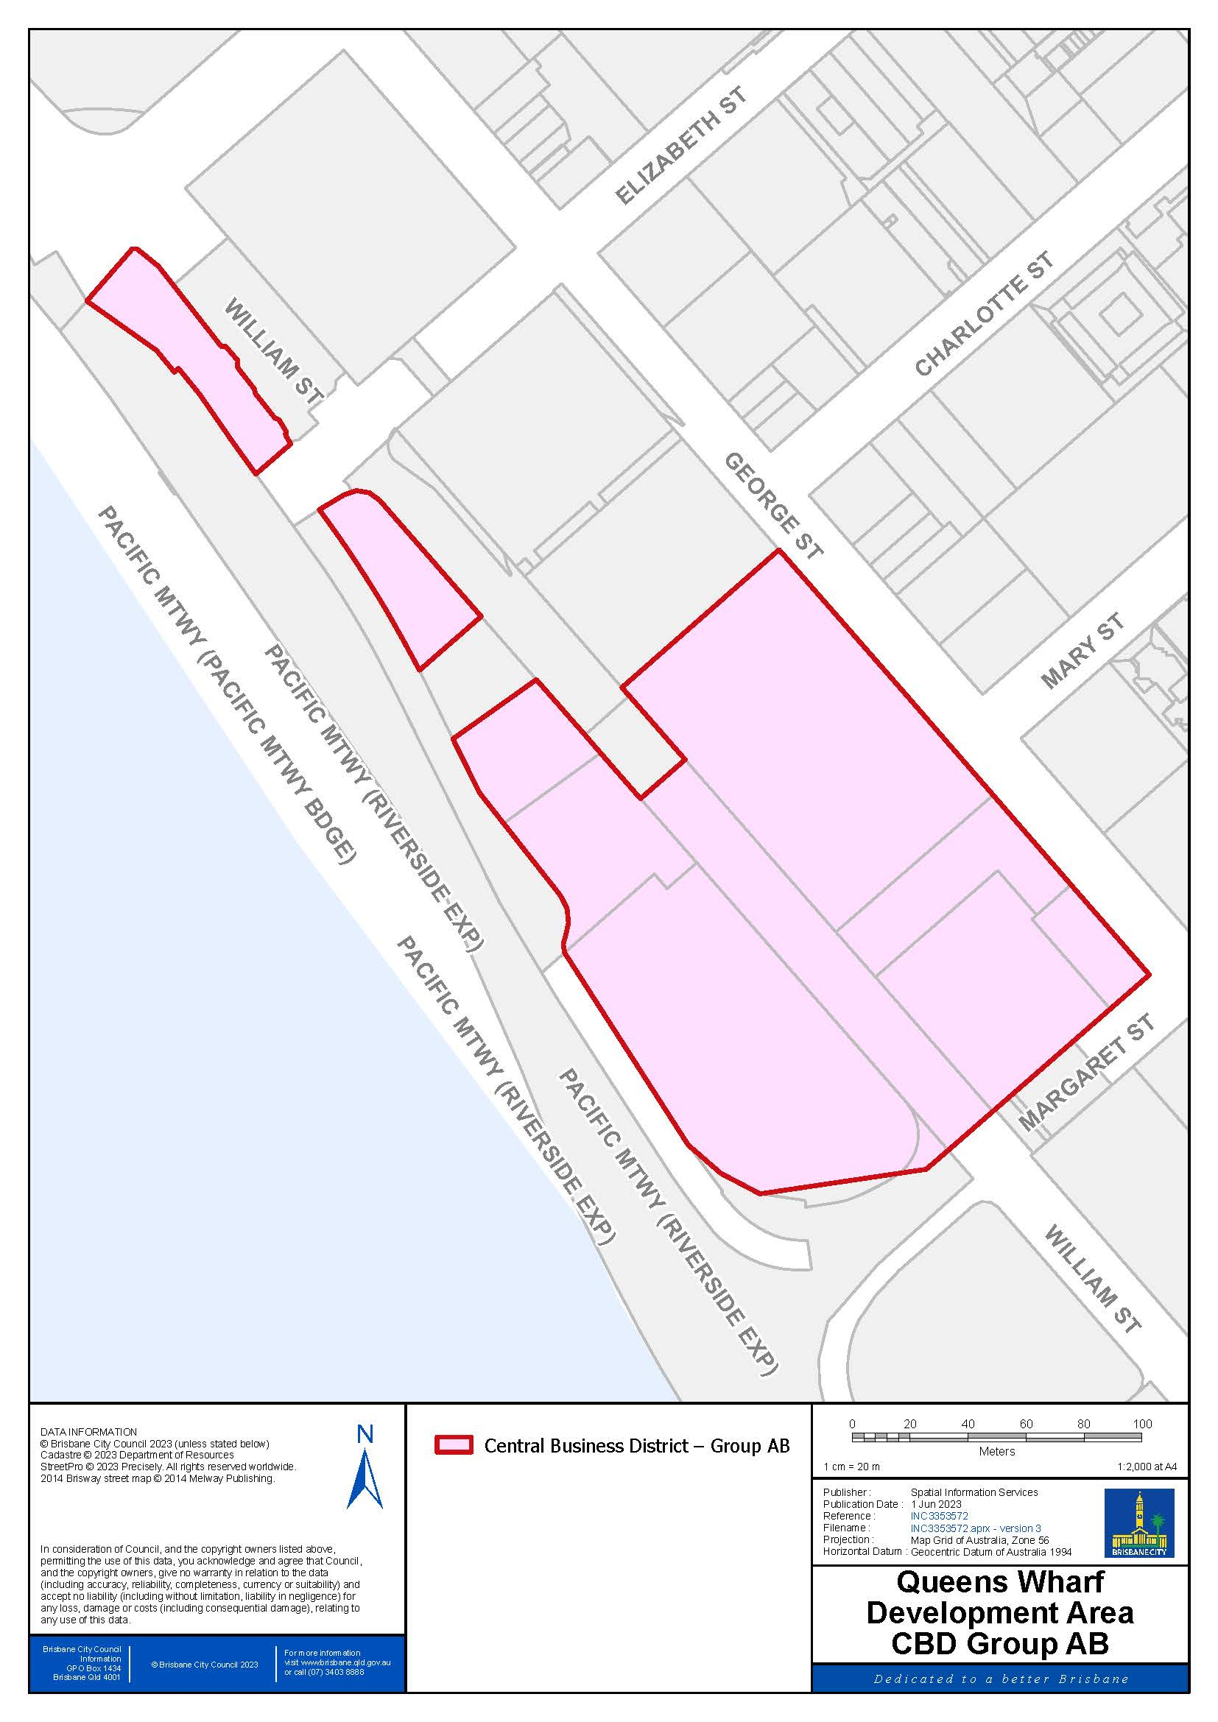
THIS PAGE INTENTIONALLY LEFT BLANK

