Wynnum Road and Hemmant-Tingalpa Road intersection upgrade

Concept design

December 2023

We are pleased to share the concept design for the Wynnum Road and Hemmant-Tingalpa Road intersection upgrade at Tingalpa.

Project overview
This intersection at Wynnum Road and Hemmant-Tingalpa Road is currently unsignalised and operates with a give way sign on Hemmant-Tingalpa Road, giving priority to motorists travelling along Wynnum Road.

Between 2016 and 2023, this intersection recorded 10 crashes involving personal injury, nine of which resulted in medical treatment or hospitalisation. High traffic volumes and extended wait times experienced at the intersection contribute to motorists misjudging safe gaps in traffic when turning into and out of Hemmant-Tingalpa Road.

To address safety concerns and improve travel time reliability, we are proposing to upgrade the intersection by installing traffic signals to control all movements at the intersection. To improve accessibility and connectivity for people walking and riding, we will also be installing signalised pedestrian crossings and new footpaths. These changes will improve the overall operation of the intersection, making it safer and easier for all road users.

View the project features
Scan the QR code to visit Council’s website for more detailed information about the project design.

Have your say
Council is seeking your input on the design. You can provide feedback by contacting the project team via the contact details below.
- Phone 1800 669 416 (business hours) or 3403 8888 (after hours).
- Email cityprojects@brisbane.qld.gov.au
- Visit brisbane.qld.gov.au and search ‘Wynnum Road and Hemmant-Tingalpa Road intersection upgrade’.
- Write to City Projects Office, Brisbane City Council, GPO Box 1434, Brisbane QLD 4001.

What’s next?
As part of our investigations, we are continuing to survey the local surroundings and are working with public utility providers to finalise the design of the underground services.

Feedback received from the community will be considered as we progress towards a final design.

As more information becomes available, we will provide you and the local community with an update.

If you would like to receive email updates about the project, please register via the online contact form found on the project webpage or by contacting the project team.

Project benefits
- Improve safety for all road users.
- Improve connectivity for people walking and riding.
- Improve travel time reliability.
- Improve intersection operation.

Proposed project features
- Installing new traffic lights with signalised crossing facilities, to fully control all movements through the intersection and improve safety for all road users.
- Modifying the centre traffic islands on Wynnum Road and constructing dedicated turn pockets on all approaches to the intersection to separate turning vehicles from through traffic.
- Installing a new path along Hemmant-Tingalpa Road to improve connectivity for people walking and riding.
- Installing a dedicated pocket with a signalised U-turn provision for vehicles travelling north on Wynnum Road.
- Upgrading footpaths and kerb ramps to enhance accessibility and connectivity for people walking and riding.

For more information
- phone 1800 669 416 (business hours) or 3403 8888 (after hours)
- email cityprojects@brisbane.qld.gov.au
- visit brisbane.qld.gov.au and search ‘Wynnum Road and Hemmant-Tingalpa Road intersection upgrade’.
- write to City Projects Office, Brisbane City Council, GPO Box 1434, Brisbane QLD 4001.

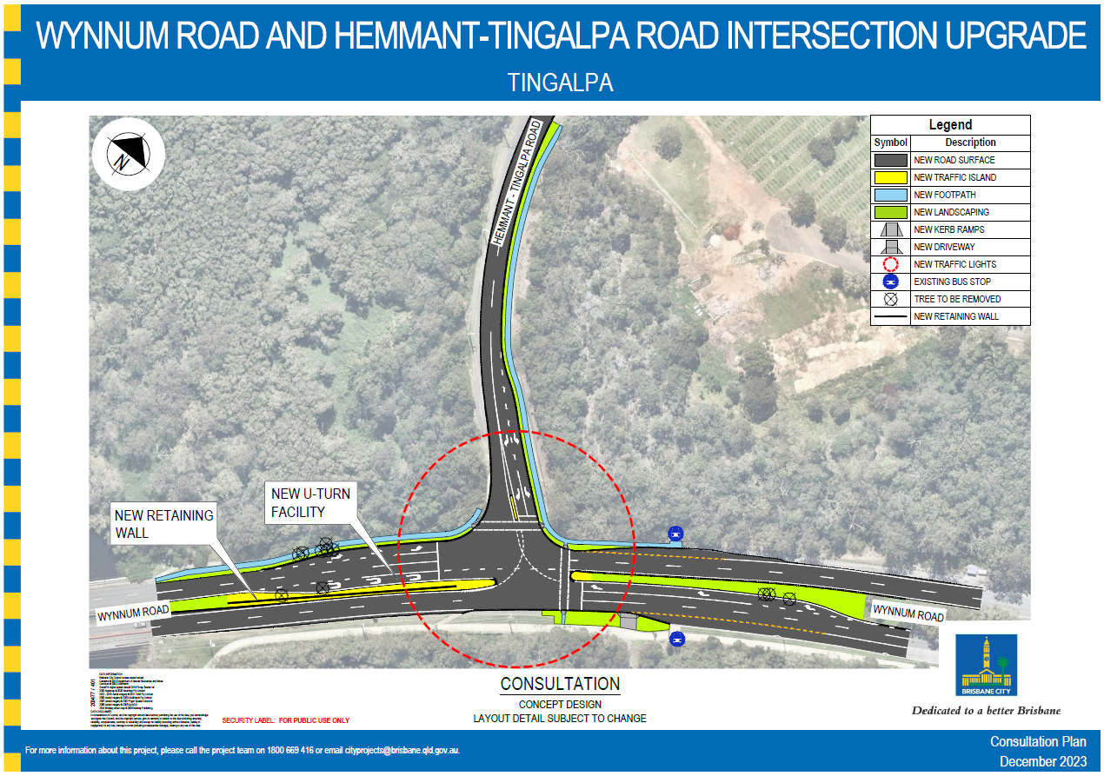

The proposed concept design is not for construction and may be subject to change.

